MA374 – Lab 10

Vibhanshu
120123049

1. Plot of Asset Price in the Real World:-

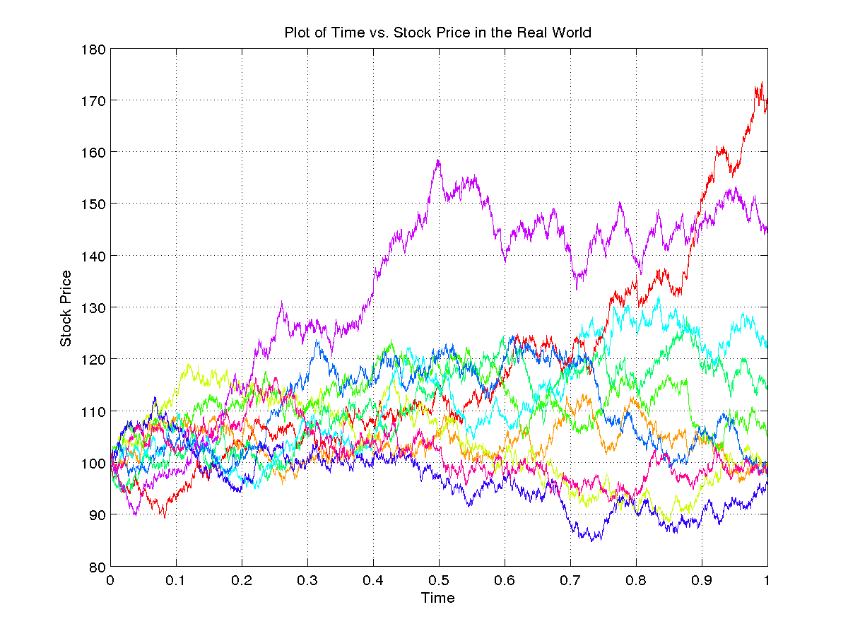

Plot of Asset Price in the Risk-Neutral World:-

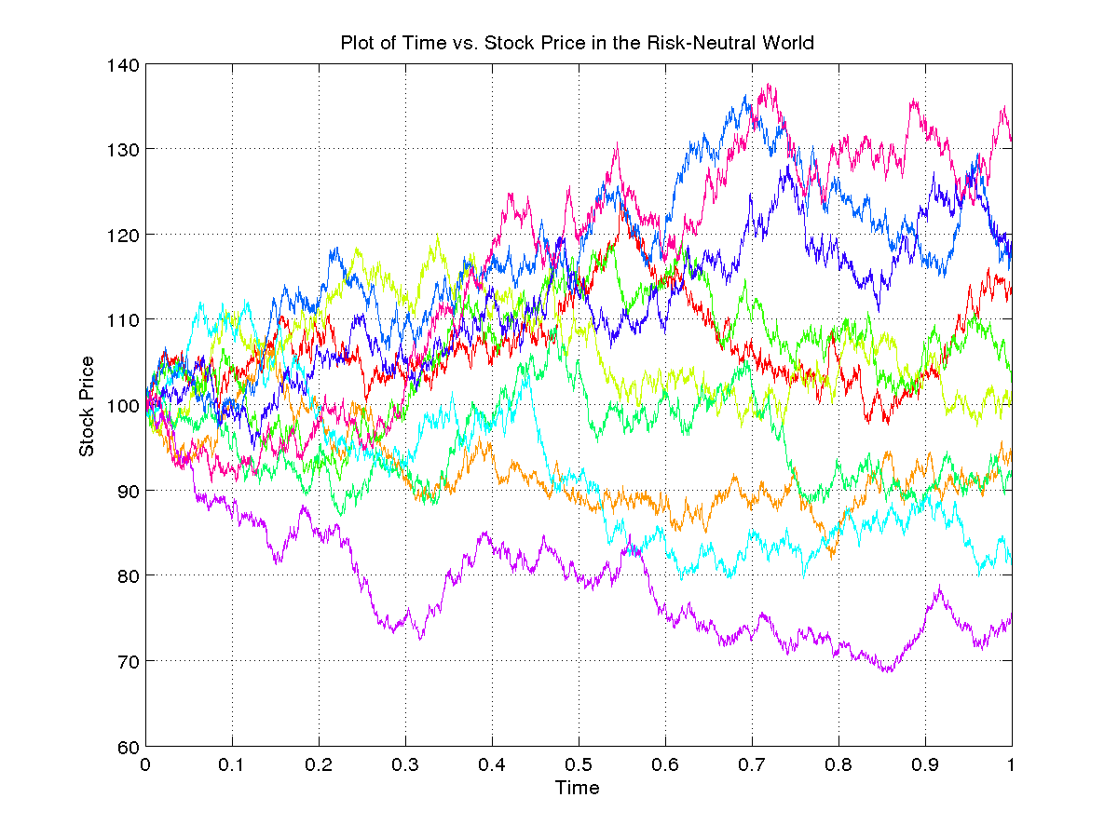

Prices of Asian Options:-
95% Confidence Interval for Asian Call Option with K = 105,
[1.744568, 1.788869]
95% Confidence Interval for Asian Put Option with K = 105,
[5.398761, 5.477017]

95% Confidence Interval for Asian Call Option with K = 110,
[0.687308, 0.716142]
95% Confidence Interval for Asian Put Option with K = 110,
[9.163448, 9.244487]

95% Confidence Interval for Asian Call Option with K = 90,
[11.165893, 11.261295]
95% Confidence Interval for Asian Put Option with K = 90,
[0.243764, 0.258083]

Sensitivity Analysis:-
Varying S0:-
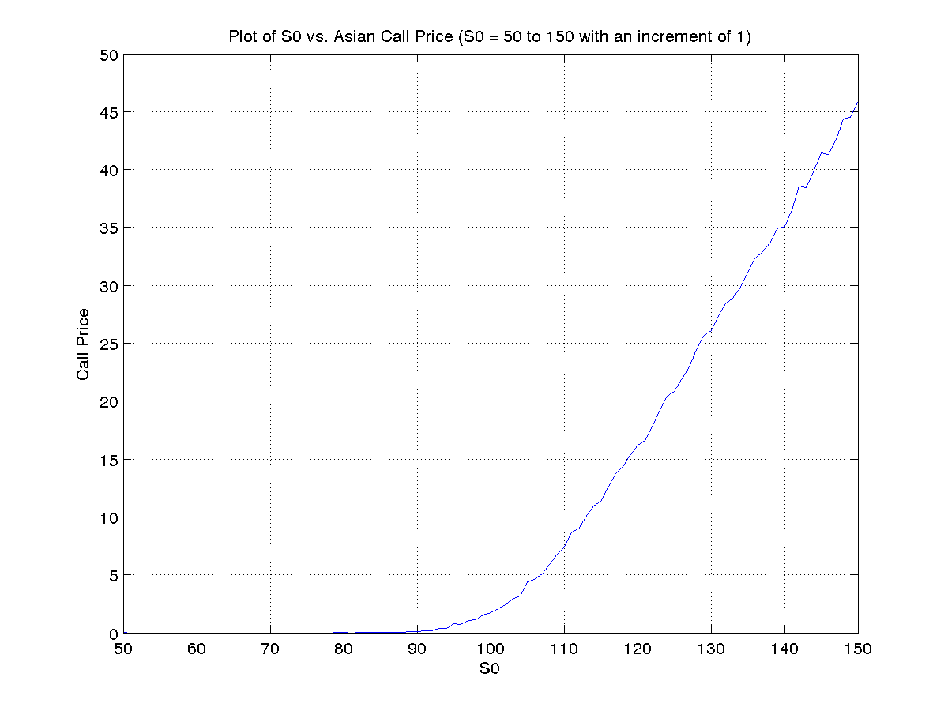
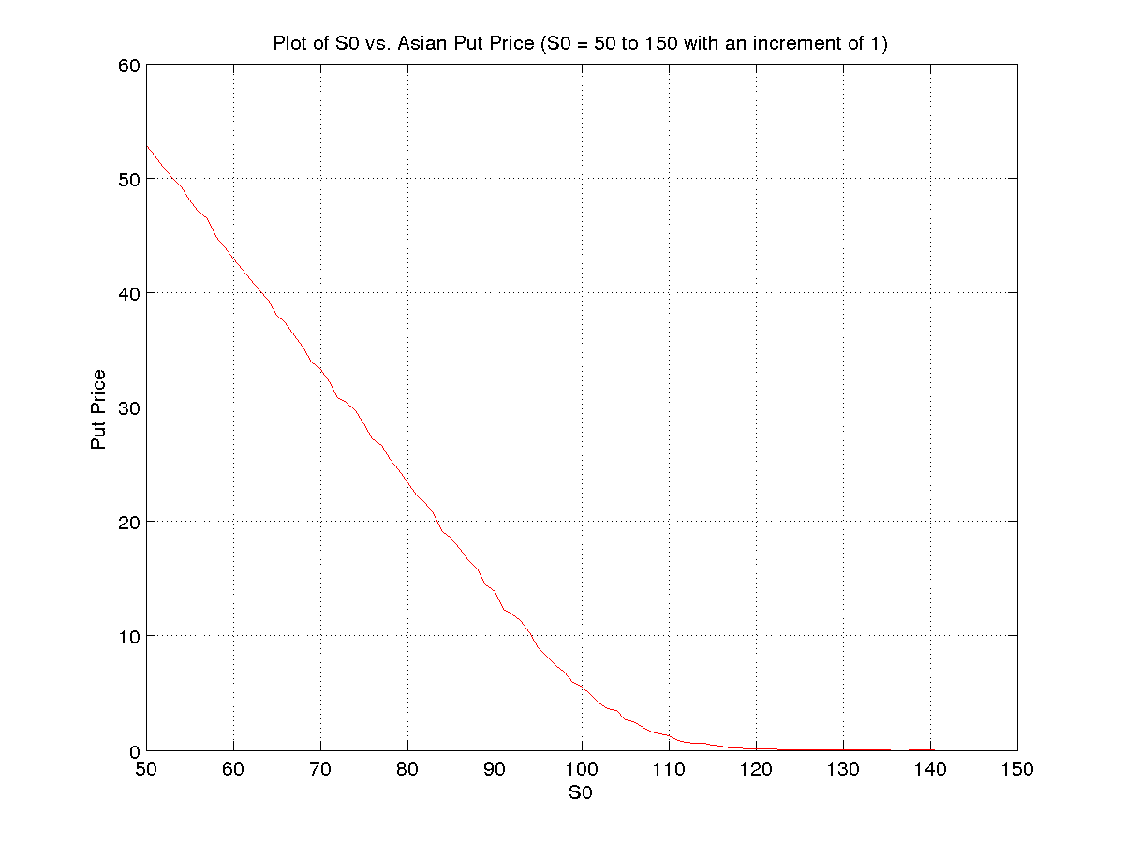
Varying r:-
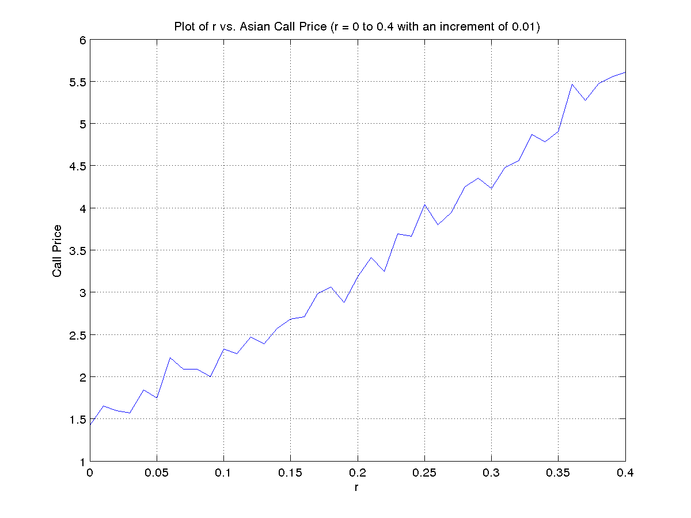
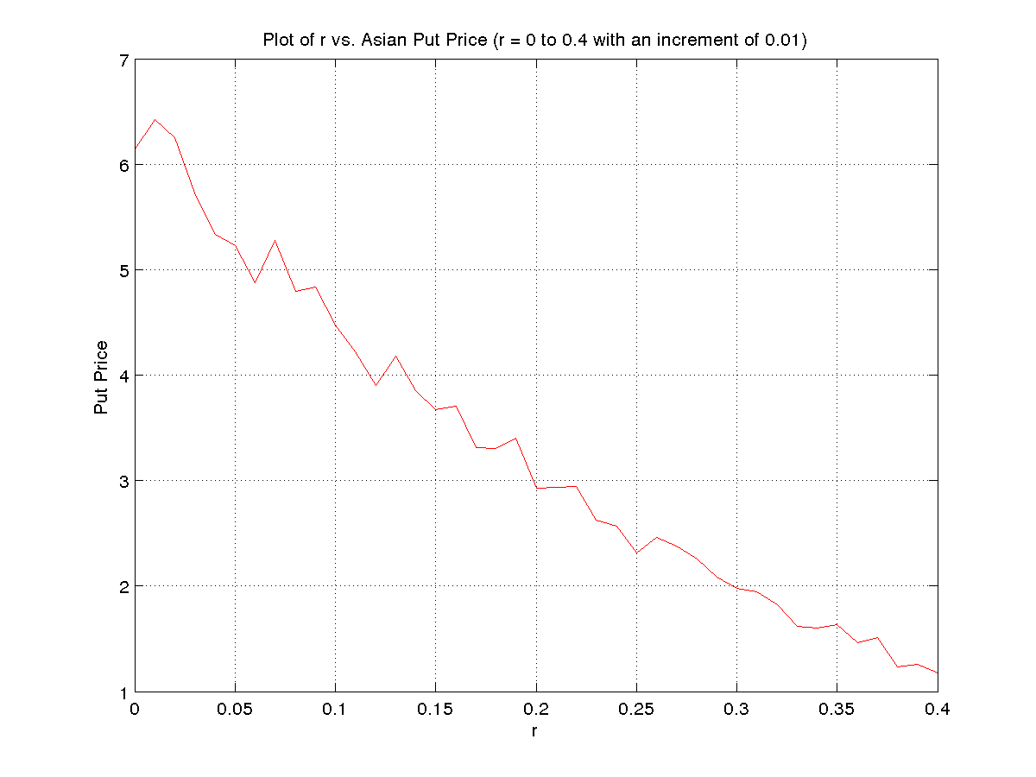
Varying σ:-
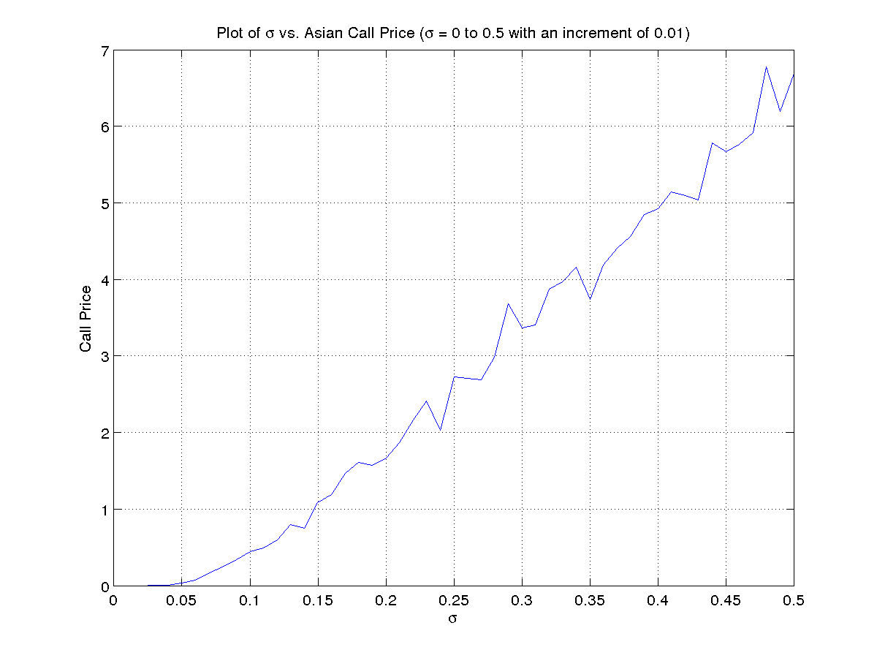
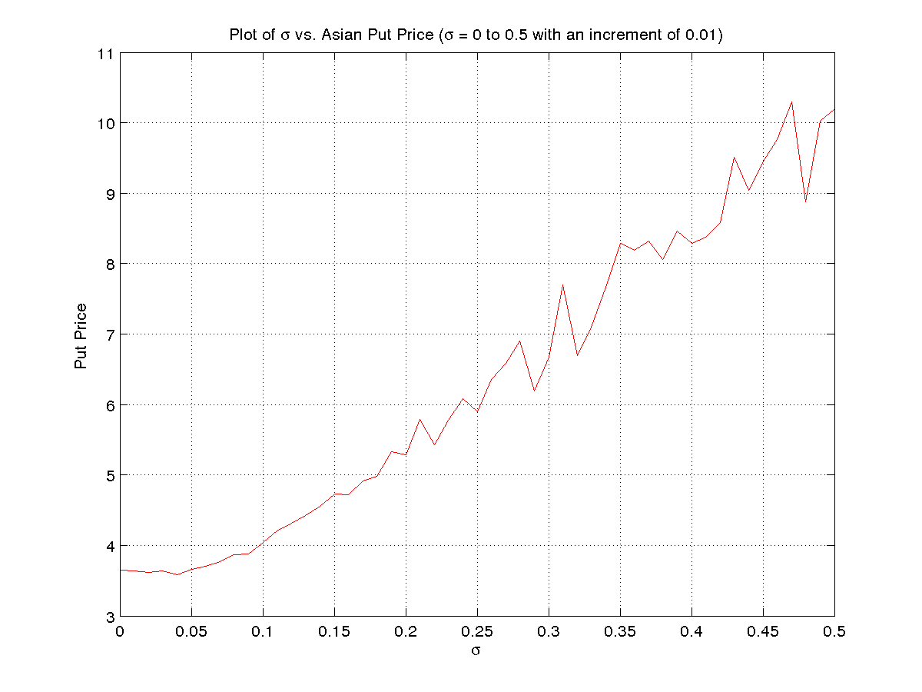
Varying K:-
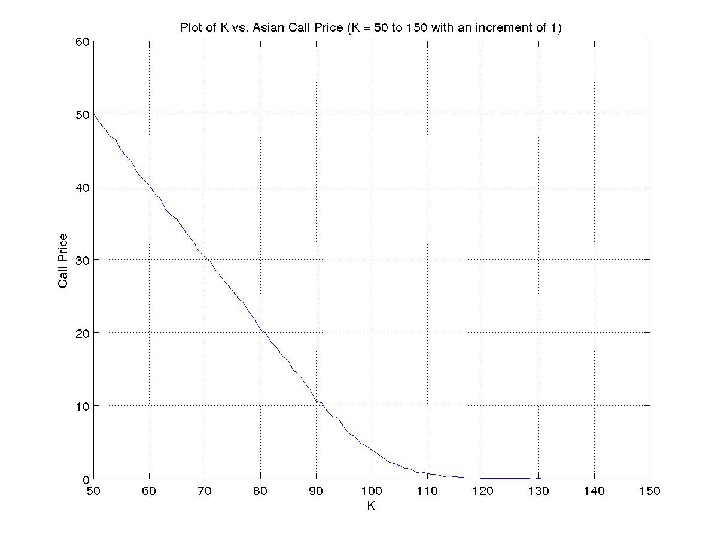
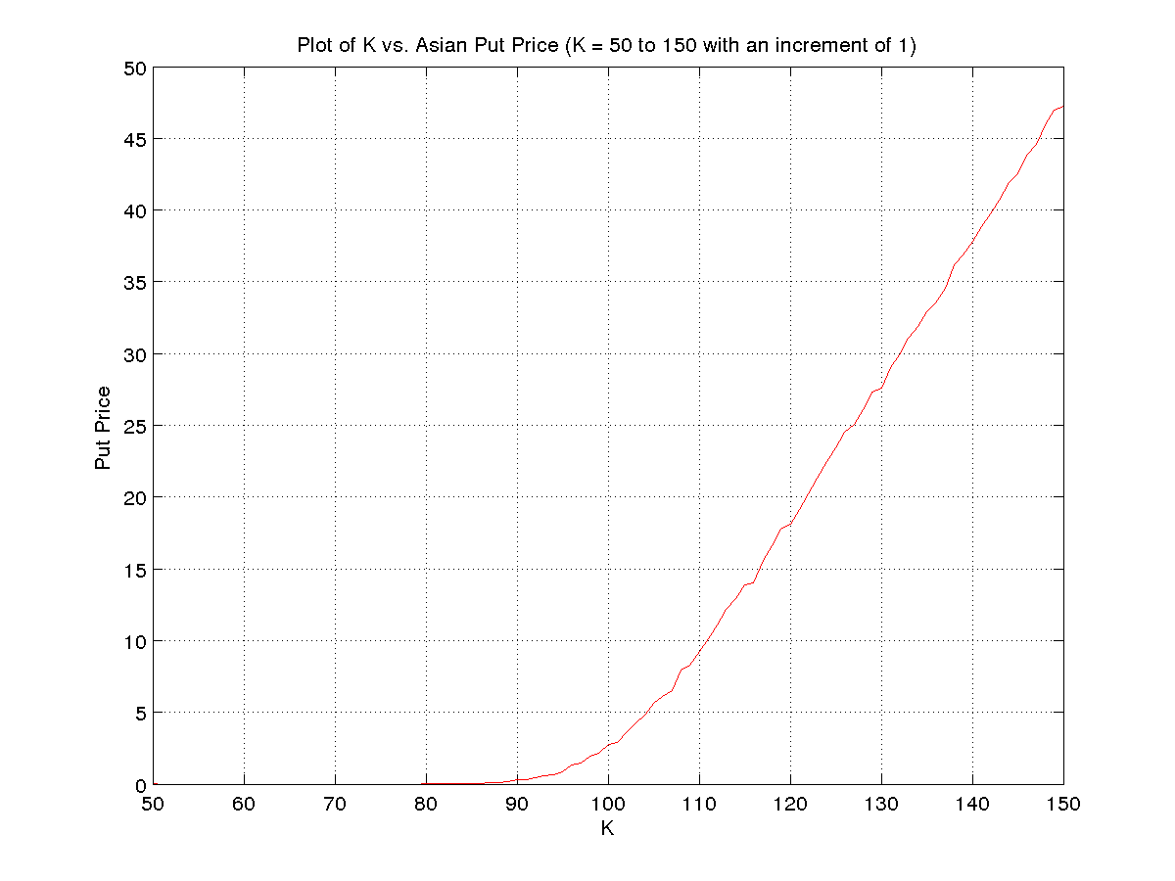
Varying T:-
