MA 374 – Financial Engineering II

Lab 2
Report

Name: Vibhanshu
Roll No. : 120123049

Q1. The C++ Program

#include<iostream>
#include<cstdio>
#include<cstdlib>
#include<cmath>
using namespace std;

float S0=100;
float K=100;
float T=1;
float r=0.08;
float sigma=0.2;
int M=100;

float max(float a,float b)
{
if( a>b ) return a;
else return b;
}

float u(float delta_t)
{
return exp(sigma*sqrt(delta_t));
}

float u2(float delta_t)
{
return exp( sigma*sqrt(delta_t) + (r-0.5*sigma*sigma )*delta_t );
}

float d(float delta_t)
{
return exp(-sigma*sqrt(delta_t));
}

float d2(float delta_t)
{
return exp( -sigma*sqrt(delta_t) + ( r-0.5*sigma*sigma )*delta_t );
}

float discount_rate(float t)
{
return exp(r*t);
}

float p(float delta_t)
{
return ( exp(r*delta_t) - d(delta_t) )/ ( u(delta_t) -d(delta_t) ) ;
}

float q(float delta_t)
{
return ( u(delta_t) - exp(r*delta_t) )/ ( u(delta_t) - d(delta_t) );
}

/// Calculated using u2,d2
float p2(float delta_t)
{
return ( exp(r*delta_t) - d2(delta_t) )/ ( u2(delta_t) -d2(delta_t) ) ;
}

float q2(float delta_t)
{
return ( u2(delta_t) - exp(r*delta_t) )/ ( u2(delta_t) - d2(delta_t) );
}

// This is for the call option(recursive)
float get_C(float t,float S,float delta_t) // returns the price of the option at time t if the price os stock is S )
{
if(t>=T)
{
if(S>=K) return (S-K);
else return 0;
}
else
{
float t1=get_C(t+delta_t , S*u(delta_t) , delta_t);
float t2=get_C(t+delta_t , S*d(delta_t) , delta_t);
return ( p(delta_t)*t1 +q(delta_t)*t2)/discount_rate(delta_t) ;
}
}

// This is for the put option(recursive)
float get_P(float t,float S,float delta_t) // returns the price of the option at time t if the price os stock is S )
{
if(t>=T)
{
if(S<=K) return (K-S);
else return 0;
}
else
{
float t1=get_P(t+delta_t , S*u(delta_t) , delta_t);
float t2=get_P(t+delta_t , S*d(delta_t) , delta_t);
return ( p(delta_t)*t1 +q(delta_t)*t2)/discount_rate(delta_t) ;
}
}

// This is the fast version of the algorithm CALL
float get_C_fast(float t,float S,float delta_t)
{
float U=u(delta_t);
float D=d(delta_t);
float P=p(delta_t);
float Q=q(delta_t);
float R=discount_rate(delta_t);
float* SS=new float[M+2];
float* value=new float[M+2];
int i,j,k;
for(i=0;i<=M;i++)
SS[i]=S0*(pow(U,(float)(M-i)))*(pow(D,(float)i));
for(i=0;i<=M;i++)
value[i]=max(SS[i]-K,0);
for(j=M; j>=0; j--)
{
for(k=0; k<j; k++)
value[k]= (P*value[k+1]+Q*value[k])/R;
}
return value[0];
}

// This is the fast version of the algorithm PUT
float get_P_fast(float t,float S,float delta_t)
{
float U=u(delta_t);
float D=d(delta_t);
float P=p(delta_t);
float Q=p(delta_t);
float R=discount_rate(delta_t);
float* SS=new float[M+2];
float* value=new float[M+2];
int i,j,k;
for(i=0;i<=M;i++)
SS[i]=S0*(pow(U,(float)(M-i)))*(pow(D,(float)i));
for(i=0;i<=M;i++)
value[i]=max(K-SS[i],0);
for(j=M; j>=0; j--)
{
for(k=0; k<j; k++)
value[k]= (P*value[k+1]+Q*value[k])/R;
}
return value[0];
}

//# =================================
// This is the fast version of the algorithm CALL
float get_C_fast1(float t,float S,float delta_t)
{
float U=u2(delta_t);
float D=d2(delta_t);
float P=p2(delta_t);
float Q=q2(delta_t);
float R=discount_rate(delta_t);
float* SS=new float[M+2];
float* value=new float[M+2];
int i,j,k;
for(i=0;i<=M;i++)
SS[i]=S0*(pow(U,(float)(M-i)))*(pow(D,(float)i));
for(i=0;i<=M;i++)
value[i]=max(SS[i]-K,0);
for(j=M; j>=0; j--)
{
for(k=0; k<j; k++)
value[k]= (P*value[k+1]+Q*value[k])/R;
}
return value[0];
}

// This is the fast version of the algorithm PUT
float get_P_fast1(float t,float S,float delta_t)
{
float U=u2(delta_t);
float D=d2(delta_t);
float P=p2(delta_t);
float Q=p2(delta_t);
float R=discount_rate(delta_t);
float* SS=new float[M+2];
float* value=new float[M+2];
int i,j,k;
for(i=0;i<=M;i++)
SS[i]=S0*(pow(U,(float)(M-i)))*(pow(D,(float)i));
for(i=0;i<=M;i++)
value[i]=max(K-SS[i],0);
for(j=M; j>=0; j--)
{
for(k=0; k<j; k++)
value[k]= (P*value[k+1]+Q*value[k])/R;
}
return value[0];
}

FILE* ptr;

int main()
{
float delta_t;

// Part (a)
S0=100;
K=100;
T=1;
M=100;
r=0.08;
sigma=0.2;
delta_t=T/M;
ptr=fopen("set1_a.dat","w");
for(S0 = 0; S0<=200; S0+=1 )
{ fprintf(ptr,"%f\t%f\t%f\n",S0,get_C_fast(0,S0,delta_t),get_P_fast(0,S0,delta_t)); }
fclose(ptr);
ptr=fopen("set2_a.dat","w");
for(S0 = 0; S0<=200; S0+=1 )
{ fprintf(ptr,"%f\t%f\t%f\n",S0,get_C_fast1(0,S0,delta_t), get_P_fast1(0,S0,delta_t)); }
fclose(ptr);

// Part(b)
S0=100;
K=100; T=1;
M=100;
r=0.08;
sigma=0.2;
delta_t=T/M;
ptr=fopen("set1_b.dat","w");
for(K = 0; K<=200; K+=1 )
{ fprintf(ptr,"%f\t%f\t%f\n",K,get_C_fast(0,S0,delta_t),get_P_fast(0,S0,delta_t)); }
fclose(ptr);
ptr=fopen("set2_b.dat","w");
for(K = 0; K<=200; K+=1 )
{ fprintf(ptr,"%f\t%f\t%f\n",K,get_C_fast1(0,S0,delta_t), get_P_fast1(0,S0,delta_t)); }
fclose(ptr);

// Part(c)
S0=100;
K=100; T=1;
M=100;
r=0.08;
sigma=0.2;
delta_t=T/M;
ptr=fopen("set1_c.dat","w");
for(r = 0; r<=0.2; r+=0.01 )
{ fprintf(ptr,"%f\t%f\t%f\n",r,get_C_fast(0,S0,delta_t),get_P_fast(0,S0,delta_t)); }
fclose(ptr);
ptr=fopen("set2_c.dat","w");
for(r = 0; r<=0.2; r+=0.01 )
{ fprintf(ptr,"%f\t%f\t%f\n",r,get_C_fast1(0,S0,delta_t), get_P_fast1(0,S0,delta_t)); }
fclose(ptr);

// Part(d)
S0=100;
K=100; T=1;
M=100;
r=0.08;
sigma=0.2;
delta_t=T/M;
ptr=fopen("set1_d.dat","w");
for(sigma = 0; sigma<=0.5; sigma+=0.01 )
{ fprintf(ptr,"%f\t%f\t%f\n",sigma,get_C_fast(0,S0,delta_t),get_P_fast(0,S0,delta_t)); }
fclose(ptr);
ptr=fopen("set2_d.dat","w");
for(sigma = 0; sigma<=0.5; sigma+=0.01 )
{ fprintf(ptr,"%f\t%f\t%f\n",sigma,get_C_fast1(0,S0,delta_t), get_P_fast1(0,S0,delta_t)); }
fclose(ptr);

// Part(e)
S0=100;
K=95; T=1;
M=100;
r=0.08;
sigma=0.2;
ptr=fopen("set1_e_k1.dat","w");
for(M = 1; M<=200; M+=1 )
{
delta_t=T/M;
fprintf(ptr,"%d\t%f\t%f\n",M,get_C_fast(0,S0,delta_t),get_P_fast(0,S0,delta_t));
}
fclose(ptr);
ptr=fopen("set2_e_k1.dat","w");
for(M = 1; M<=200; M+=1 )
{
delta_t=T/M;
fprintf(ptr,"%d\t%f\t%f\n",M,get_C_fast1(0,S0,delta_t), get_P_fast1(0,S0,delta_t));
}
fclose(ptr);

S0=100;
K=100; T=1;
M=100;
r=0.08;
sigma=0.2;
ptr=fopen("set1_e_k2.dat","w");
for(M = 1; M<=200; M+=1 )
{
delta_t=T/M;
fprintf(ptr,"%d\t%f\t%f\n",M,get_C_fast(0,S0,delta_t),get_P_fast(0,S0,delta_t));
}
fclose(ptr);
ptr=fopen("set2_e_k2.dat","w");
for(M = 1; M<=200; M+=1 )
{
delta_t=T/M;
fprintf(ptr,"%d\t%f\t%f\n",M,get_C_fast1(0,S0,delta_t), get_P_fast1(0,S0,delta_t));
}
fclose(ptr);

S0=100;
K=105; T=1;
M=100;
r=0.08;
sigma=0.2;
ptr=fopen("set1_e_k3.dat","w");
for(M = 1; M<=200; M+=1 )
{
delta_t=T/M;
fprintf(ptr,"%d\t%f\t%f\n",M,get_C_fast(0,S0,delta_t),get_P_fast(0,S0,delta_t));
}
fclose(ptr);
ptr=fopen("set2_e_k3.dat","w");
for(M = 1; M<=200; M+=1 )
{
delta_t=T/M;
fprintf(ptr,"%d\t%f\t%f\n",M,get_C_fast1(0,S0,delta_t), get_P_fast1(0,S0,delta_t));
}
fclose(ptr);
return 0;
}

OUTPUT

SET 1:

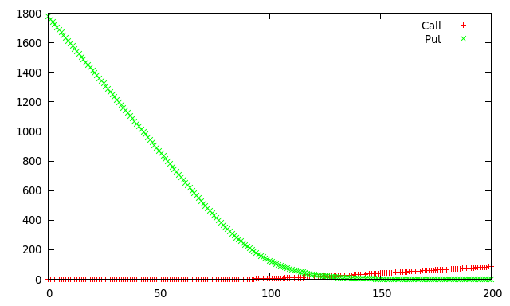
a). Varying S(0)
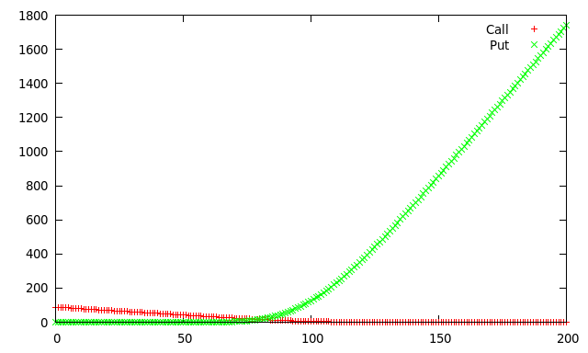
b). Varying K

c). Varying r

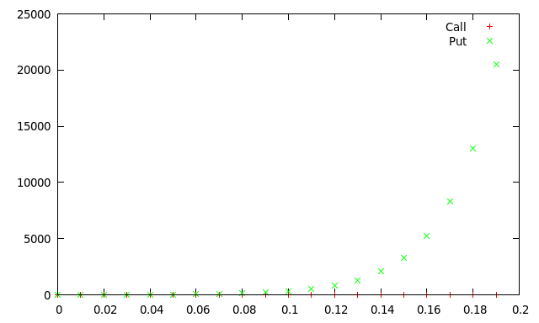

d). Varying (sigma)
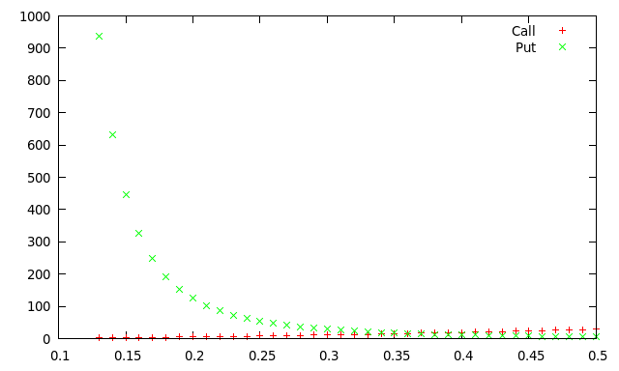
e). Varying M
K=95
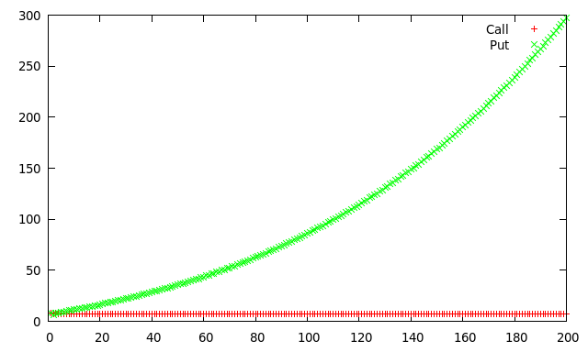

K = 100
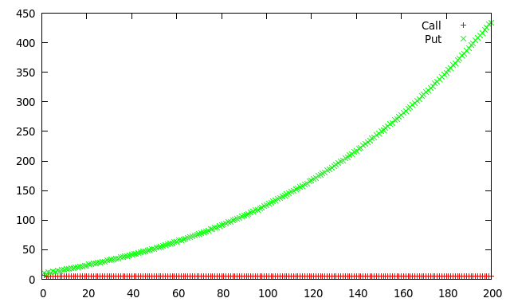

K = 105
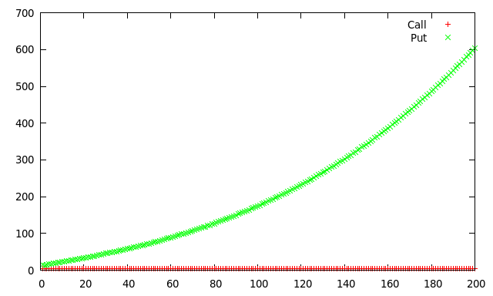

SET 2 :

a). Varying S(0)
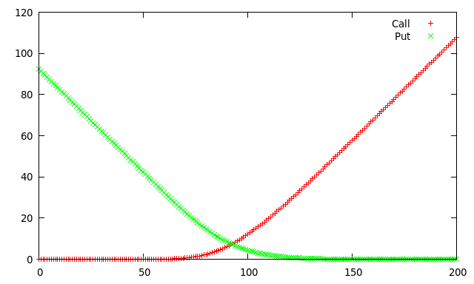
b). Varying K
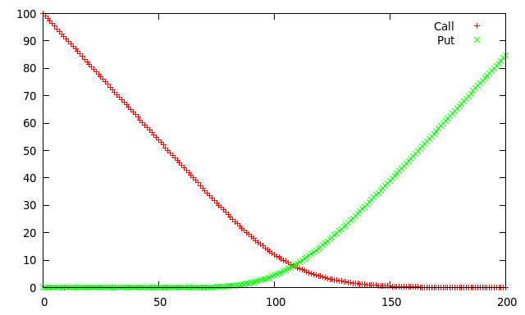

c). Varying r
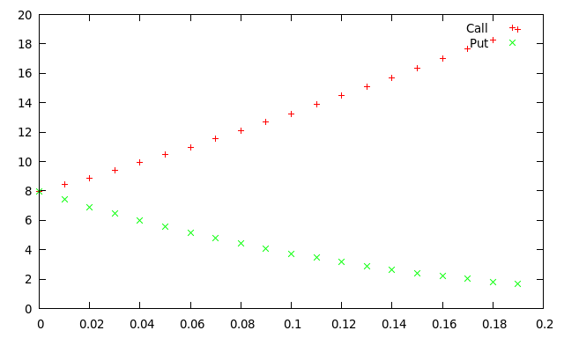

d). Varying (sigma)
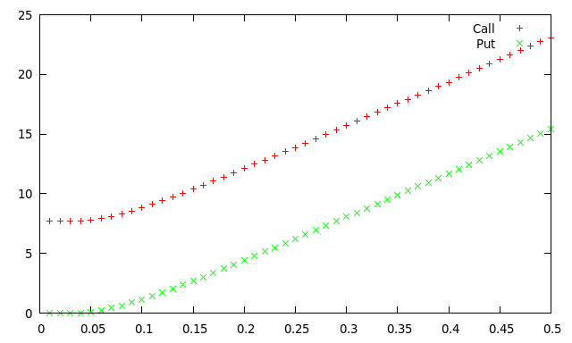

e). Varying M

K = 95
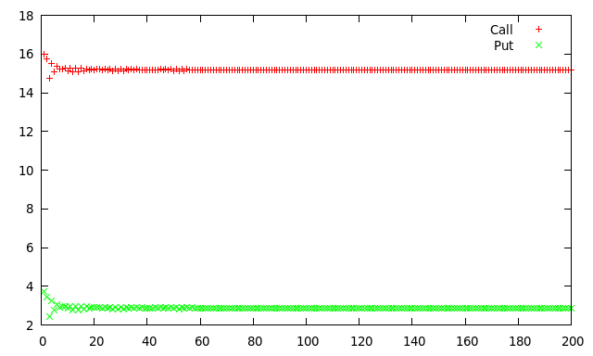
K=100
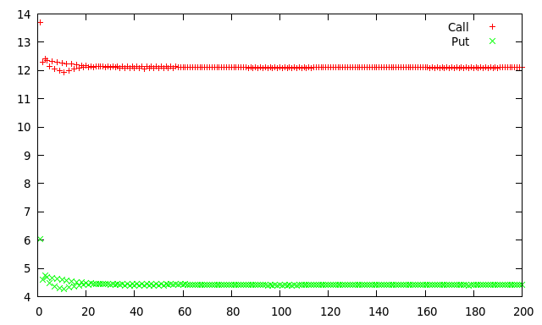

K = 105

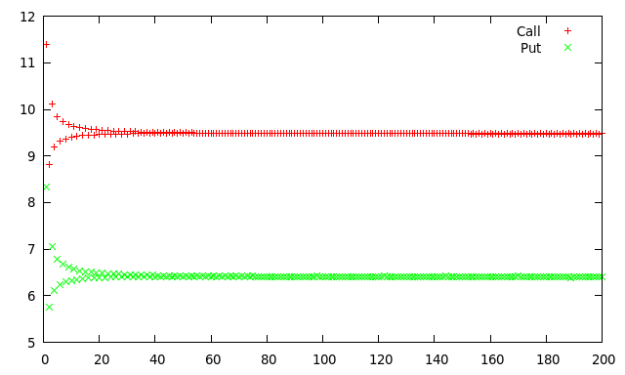

Q2. The path-dependent option is American Call-Put Option

The C++ program

#include<iostream>
#include<cstdio>
#include<cstdlib>
#include<cmath>
using namespace std;

float S0=100;
float K=100;
float T=1;
float r=0.08;
float sigma=0.2;
int M=100;

float max(float a,float b)
{
if( a>b ) return a;
else return b;
}

float u(float delta_t)
{
return exp(sigma*sqrt(delta_t));
}

float u2(float delta_t)
{
return exp( sigma*sqrt(delta_t) + (r-0.5*sigma*sigma )*delta_t );
}

float d(float delta_t)
{
return exp(-sigma*sqrt(delta_t));
}

float d2(float delta_t)
{
return exp( -sigma*sqrt(delta_t) + ( r-0.5*sigma*sigma )*delta_t );
}

float discount_rate(float t)
{
return exp(r*t);
}

float p(float delta_t)
{
return ( exp(r*delta_t) - d(delta_t) )/ ( u(delta_t) -d(delta_t) ) ;
}

float q(float delta_t)
{
return ( u(delta_t) - exp(r*delta_t) )/ ( u(delta_t) - d(delta_t) );
}

/// Calculated using u2,d2
float p2(float delta_t)
{
return ( exp(r*delta_t) - d2(delta_t) )/ ( u2(delta_t) -d2(delta_t) ) ;
}

float q2(float delta_t)
{
return ( u2(delta_t) - exp(r*delta_t) )/ ( u2(delta_t) - d2(delta_t) );
}

// This is for the call option(recursive)
float get_C(float t,float S,float delta_t) // returns the price of the option at time t if the price os stock is S )
{
if(t>=T)
{
if(S>=K) return (S-K);
else return 0;
}
else
{
float t1=get_C(t+delta_t , S*u(delta_t) , delta_t);
float t2=get_C(t+delta_t , S*d(delta_t) , delta_t);
return ( p(delta_t)*t1 +q(delta_t)*t2)/discount_rate(delta_t) ;
}
}

// This is for the put option(recursive)
float get_P(float t,float S,float delta_t) // returns the price of the option at time t if the price os stock is S )
{
if(t>=T)
{
if(S<=K) return (K-S);
else return 0;
}
else
{
float t1=get_P(t+delta_t , S*u(delta_t) , delta_t);
float t2=get_P(t+delta_t , S*d(delta_t) , delta_t);
return ( p(delta_t)*t1 +q(delta_t)*t2)/discount_rate(delta_t) ;
}
}

// This is the fast version of the algorithm CALL
float get_C_fast(float t,float S,float delta_t)
{
float U=u(delta_t);
float D=d(delta_t);
float P=p(delta_t);
float Q=q(delta_t);
float R=discount_rate(delta_t);
float* SS=new float[M+2];
float* value=new float[M+2];
int i,j,k;
for(i=0;i<=M;i++)
SS[i]=S0*(pow(U,(float)(M-i)))*(pow(D,(float)i));
for(i=0;i<=M;i++)
value[i]=max(SS[i]-K,0);
for(j=M; j>=0; j--)
{
for(k=0; k<j; k++)
value[k]= (P*value[k+1]+Q*value[k])/R;
}
return value[0];
}

// This is the fast version of the algorithm PUT
float get_P_fast(float t,float S,float delta_t)
{
float U=u(delta_t);
float D=d(delta_t);
float P=p(delta_t);
float Q=p(delta_t);
float R=discount_rate(delta_t);
float* SS=new float[M+2];
float* value=new float[M+2];
int i,j,k;
for(i=0;i<=M;i++)
SS[i]=S0*(pow(U,(float)(M-i)))*(pow(D,(float)i));
for(i=0;i<=M;i++)
value[i]=max(K-SS[i],0);
for(j=M; j>=0; j--)
{
for(k=0; k<j; k++)
value[k]= (P*value[k+1]+Q*value[k])/R;
}
return value[0];
}

//# =================================
// This is the fast version of the algorithm CALL
float get_C_fast1(float t,float S,float delta_t)
{
float U=u2(delta_t);
float D=d2(delta_t);
float P=p2(delta_t);
float Q=q2(delta_t);
float R=discount_rate(delta_t);
float* SS=new float[M+2];
float* value=new float[M+2];
int i,j,k;
for(i=0;i<=M;i++)
SS[i]=S0*(pow(U,(float)(M-i)))*(pow(D,(float)i));
for(i=0;i<=M;i++)
value[i]=max(SS[i]-K,0);
for(j=M; j>=0; j--)
{
for(i=0;i<j;i++)
SS[i]=S0*(pow(U,(float)(j-i)))*(pow(D,(float)i));
for(k=0; k<j; k++)
value[k]= max(SS[k],(P*value[k+1]+Q*value[k])/R);
}
return value[0];
}

// This is the fast version of the algorithm PUT
float get_P_fast1(float t,float S,float delta_t)
{
float U=u2(delta_t);
float D=d2(delta_t);
float P=p2(delta_t);
float Q=p2(delta_t);
float R=discount_rate(delta_t);
float* SS=new float[M+2];
float* value=new float[M+2];
int i,j,k;
for(i=0;i<=M;i++)
SS[i]=S0*(pow(U,(float)(M-i)))*(pow(D,(float)i));
for(i=0;i<=M;i++)
value[i]=max(K-SS[i],0);
for(j=M; j>=0; j--)
{
for(i=0;i<j;i++)
SS[i]=S0*(pow(U,(float)(j-i)))*(pow(D,(float)i));
for(k=0; k<j; k++)
value[k]= max(SS[k],(P*value[k+1]+Q*value[k])/R);
}
return value[0];
}

FILE* ptr;

int main()
{
float delta_t;

// Part (a)
S0=100;
K=100;
T=1;
M=100;
r=0.08;
sigma=0.2;
delta_t=T/M;
ptr=fopen("set1_a.dat","w");
for(S0 = 0; S0<=200; S0+=1 )
{ fprintf(ptr,"%f\t%f\t%f\n",S0,get_C_fast1(0,S0,delta_t),get_P_fast1(0,S0,delta_t)); }
fclose(ptr);

// Part(b)
S0=100;
K=100; T=1;
M=100;
r=0.08;
sigma=0.2;
delta_t=T/M;
ptr=fopen("set1_b.dat","w");
for(K = 0; K<=200; K+=1 )
{ fprintf(ptr,"%f\t%f\t%f\n",K,get_C_fast1(0,S0,delta_t),get_P_fast1(0,S0,delta_t)); }
fclose(ptr);

// Part(c)
S0=100;
K=100; T=1;
M=100;
r=0.08;
sigma=0.2;
delta_t=T/M;
ptr=fopen("set1_c.dat","w");
for(r = 0; r<=0.2; r+=0.01 )
{ fprintf(ptr,"%f\t%f\t%f\n",r,get_C_fast1(0,S0,delta_t),get_P_fast1(0,S0,delta_t)); }
fclose(ptr);

// Part(d)
S0=100;
K=100; T=1;
M=100;
r=0.08;
sigma=0.2;
delta_t=T/M;
ptr=fopen("set1_d.dat","w");
for(sigma = 0; sigma<=0.5; sigma+=0.01 )
{ fprintf(ptr,"%f\t%f\t%f\n",sigma,get_C_fast1(0,S0,delta_t),get_P_fast1(0,S0,delta_t)); }
fclose(ptr);

// Part(e)
S0=100;
K=95; T=1;
M=100;
r=0.08;
sigma=0.2;
ptr=fopen("set1_e_k1.dat","w");
for(M = 1; M<=200; M+=1 )
{
delta_t=T/M;
fprintf(ptr,"%d\t%f\t%f\n",M,get_C_fast1(0,S0,delta_t),get_P_fast1(0,S0,delta_t));
}
fclose(ptr);

S0=100;
K=100; T=1;
M=100;
r=0.08;
sigma=0.2;
ptr=fopen("set1_e_k2.dat","w");
for(M = 1; M<=200; M+=1 )
{
delta_t=T/M;
fprintf(ptr,"%d\t%f\t%f\n",M,get_C_fast1(0,S0,delta_t),get_P_fast1(0,S0,delta_t));
}
fclose(ptr);

S0=100;
K=105; T=1;
M=100;
r=0.08;
sigma=0.2;
ptr=fopen("set1_e_k3.dat","w");
for(M = 1; M<=200; M+=1 )
{
delta_t=T/M;
fprintf(ptr,"%d\t%f\t%f\n",M,get_C_fast1(0,S0,delta_t),get_P_fast1(0,S0,delta_t));
}
fclose(ptr);

return 0;
}

OUTPUT:

SET 2:

a). Varying S(0)
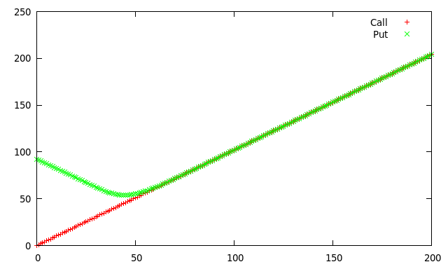
b). Varying K
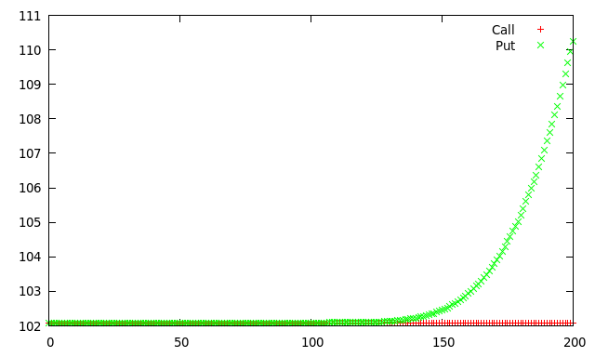
c). Varying r
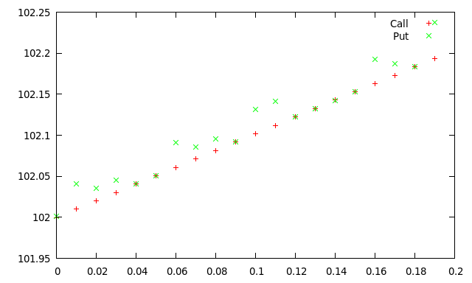

d). Varying (sigma)

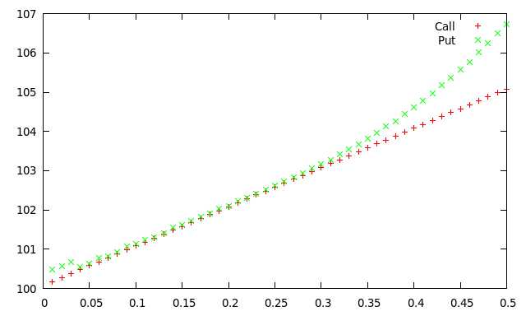

e). Varying M

K=95
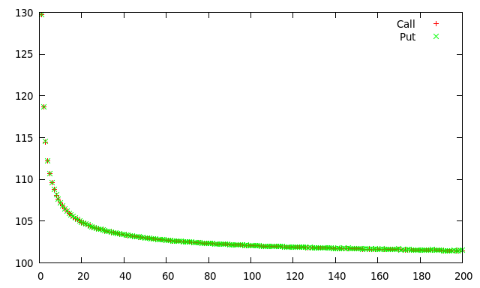
K=100

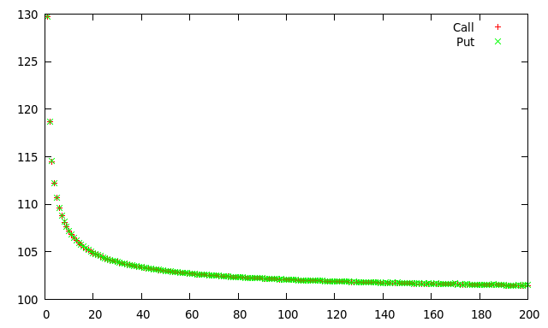

K=105

