MA 374 – Financial Engineering II

Lab 2
Report

Name: Vibhanshu
Roll No. : 120123049

1).
#include<iostream>
#include<cstdio>
#include<cstdlib>
#include<cmath>
using namespace std;

float S0=100;
float K=100;
float T=1;
float r=0.08;
float sigma=0.2;
int M=100;

float max(float a,float b)
{
if( a>b ) return a;
else return b;
}

float u(float delta_t)
{
return exp(sigma*sqrt(delta_t));
}

float u2(float delta_t)
{
return exp( sigma*sqrt(delta_t) + (r-0.5*sigma*sigma )*delta_t );
}

float d(float delta_t)
{
return exp(-sigma*sqrt(delta_t));
}

float d2(float delta_t)
{
return exp( -sigma*sqrt(delta_t) + ( r-0.5*sigma*sigma )*delta_t );
}

float discount_rate(float t)
{
return exp(r*t);
}

float p(float delta_t)
{
return ( exp(r*delta_t) - d(delta_t) )/ ( u(delta_t) -d(delta_t) ) ;
}

float q(float delta_t)
{
return ( u(delta_t) - exp(r*delta_t) )/ ( u(delta_t) - d(delta_t) );
}

/// Calculated using u2,d2
float p2(float delta_t)
{
return ( exp(r*delta_t) - d2(delta_t) )/ ( u2(delta_t) -d2(delta_t) ) ;
}

float q2(float delta_t)
{
return ( u2(delta_t) - exp(r*delta_t) )/ ( u2(delta_t) - d2(delta_t) );
}

// This is for the call option(recursive)
float get_C(float t,float S,float delta_t) // returns the price of the option at time t if the price os stock is S )
{
if(t>=T)
{
if(S>=K) return (S-K);
else return 0;
}
else
{
float t1=get_C(t+delta_t , S*u(delta_t) , delta_t);
float t2=get_C(t+delta_t , S*d(delta_t) , delta_t);
return ( p(delta_t)*t1 +q(delta_t)*t2)/discount_rate(delta_t) ;
}
}

// This is for the put option(recursive)
float get_P(float t,float S,float delta_t) // returns the price of the option at time t if the price os stock is S )
{
if(t>=T)
{
if(S<=K) return (K-S);
else return 0;
}
else
{
float t1=get_P(t+delta_t , S*u(delta_t) , delta_t);
float t2=get_P(t+delta_t , S*d(delta_t) , delta_t);
return ( p(delta_t)*t1 +q(delta_t)*t2)/discount_rate(delta_t) ;
}
}

// This is the fast version of the algorithm CALL
float get_C_fast(float t,float S,float delta_t)
{
float U=u(delta_t);
float D=d(delta_t);
float P=p(delta_t);
float Q=q(delta_t);
float R=discount_rate(delta_t);
float* SS=new float[M+2];
float* value=new float[M+2];
int i,j,k;
for(i=0;i<=M;i++)
SS[i]=S0*(pow(U,(float)(M-i)))*(pow(D,(float)i));
for(i=0;i<=M;i++)
value[i]=max(SS[i]-K,0);
for(j=M; j>=0; j--)
{
for(k=0; k<j; k++)
value[k]= (P*value[k+1]+Q*value[k])/R;
}
return value[0];
}

// This is the fast version of the algorithm PUT
float get_P_fast(float t,float S,float delta_t)
{
float U=u(delta_t);
float D=d(delta_t);
float P=p(delta_t);
float Q=p(delta_t);
float R=discount_rate(delta_t);
float* SS=new float[M+2];
float* value=new float[M+2];
int i,j,k;
for(i=0;i<=M;i++)
SS[i]=S0*(pow(U,(float)(M-i)))*(pow(D,(float)i));
for(i=0;i<=M;i++)
value[i]=max(K-SS[i],0);
for(j=M; j>=0; j--)
{
for(k=0; k<j; k++)
value[k]= (P*value[k+1]+Q*value[k])/R;
}
return value[0];
}

//# =================================
// This is the fast version of the algorithm CALL
float get_C_fast1(float t,float S,float delta_t)
{
float U=u2(delta_t);
float D=d2(delta_t);
float P=p2(delta_t);
float Q=q2(delta_t);
float R=discount_rate(delta_t);
float* SS=new float[M+2];
float* value=new float[M+2];
int i,j,k;
for(i=0;i<=M;i++)
SS[i]=S0*(pow(U,(float)(M-i)))*(pow(D,(float)i));
for(i=0;i<=M;i++)
value[i]=max(SS[i]-K,0);
for(j=M; j>=0; j--)
{
for(i=0;i<j;i++)
SS[i]=S0*(pow(U,(float)(j-i)))*(pow(D,(float)i));
for(k=0; k<j; k++)
value[k]= max(SS[k],(P*value[k+1]+Q*value[k])/R);
}
return value[0];
}

// This is the fast version of the algorithm PUT
float get_P_fast1(float t,float S,float delta_t)
{
float U=u2(delta_t);
float D=d2(delta_t);
float P=p2(delta_t);
float Q=p2(delta_t);
float R=discount_rate(delta_t);
float* SS=new float[M+2];
float* value=new float[M+2];
int i,j,k;
for(i=0;i<=M;i++)
SS[i]=S0*(pow(U,(float)(M-i)))*(pow(D,(float)i));
for(i=0;i<=M;i++)
value[i]=max(K-SS[i],0);
for(j=M; j>=0; j--)
{
for(i=0;i<j;i++)
SS[i]=S0*(pow(U,(float)(j-i)))*(pow(D,(float)i));
for(k=0; k<j; k++)
value[k]= max(SS[k],(P*value[k+1]+Q*value[k])/R);
}
return value[0];
}

FILE* ptr;

int main()
{
float delta_t;

// Part (a)
S0=100;
K=100;
T=1;
M=100;
r=0.08;
sigma=0.2;
delta_t=T/M;
ptr=fopen("set1_a.dat","w");
for(S0 = 0; S0<=200; S0+=1 )
{ fprintf(ptr,"%f\t%f\t%f\n",S0,get_C_fast1(0,S0,delta_t),get_P_fast1(0,S0,delta_t)); }
fclose(ptr);

// Part(b)
S0=100;
K=100; T=1;
M=100;
r=0.08;
sigma=0.2;
delta_t=T/M;
ptr=fopen("set1_b.dat","w");
for(K = 0; K<=200; K+=1 )
{ fprintf(ptr,"%f\t%f\t%f\n",K,get_C_fast1(0,S0,delta_t),get_P_fast1(0,S0,delta_t)); }
fclose(ptr);

// Part(c)
S0=100;
K=100; T=1;
M=100;
r=0.08;
sigma=0.2;
delta_t=T/M;
ptr=fopen("set1_c.dat","w");
for(r = 0; r<=0.2; r+=0.01 )
{ fprintf(ptr,"%f\t%f\t%f\n",r,get_C_fast1(0,S0,delta_t),get_P_fast1(0,S0,delta_t)); }
fclose(ptr);

// Part(d)
S0=100;
K=100; T=1;
M=100;
r=0.08;
sigma=0.2;
delta_t=T/M;
ptr=fopen("set1_d.dat","w");
for(sigma = 0; sigma<=0.5; sigma+=0.01 )
{ fprintf(ptr,"%f\t%f\t%f\n",sigma,get_C_fast1(0,S0,delta_t),get_P_fast1(0,S0,delta_t)); }
fclose(ptr);

// Part(e)
S0=100;
K=95; T=1;
M=100;
r=0.08;
sigma=0.2;
ptr=fopen("set1_e_k1.dat","w");
for(M = 1; M<=200; M+=1 )
{
delta_t=T/M;
fprintf(ptr,"%d\t%f\t%f\n",M,get_C_fast1(0,S0,delta_t),get_P_fast1(0,S0,delta_t));
}
fclose(ptr);

S0=100;
K=100; T=1;
M=100;
r=0.08;
sigma=0.2;
ptr=fopen("set1_e_k2.dat","w");
for(M = 1; M<=200; M+=1 )
{
delta_t=T/M;
fprintf(ptr,"%d\t%f\t%f\n",M,get_C_fast1(0,S0,delta_t),get_P_fast1(0,S0,delta_t));
}
fclose(ptr);

S0=100;
K=105; T=1;
M=100;
r=0.08;
sigma=0.2;
ptr=fopen("set1_e_k3.dat","w");
for(M = 1; M<=200; M+=1 )
{
delta_t=T/M;
fprintf(ptr,"%d\t%f\t%f\n",M,get_C_fast1(0,S0,delta_t),get_P_fast1(0,S0,delta_t));
}
fclose(ptr);

return 0;
}

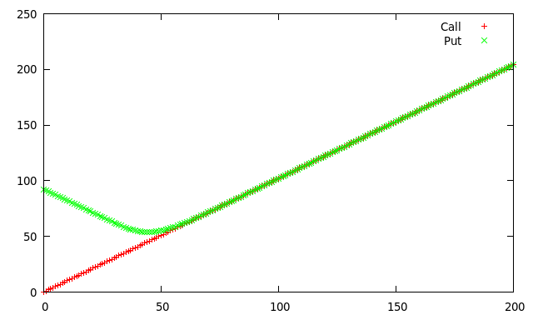
a).

b).
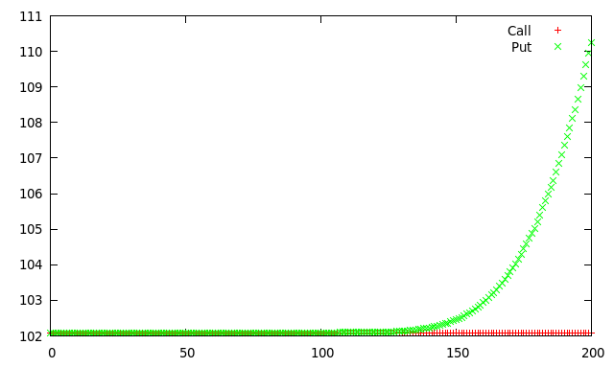

c).

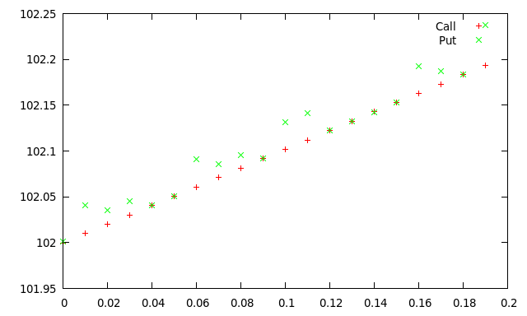
d).

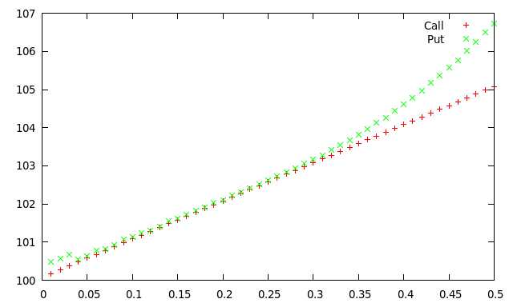

e).

K= 95
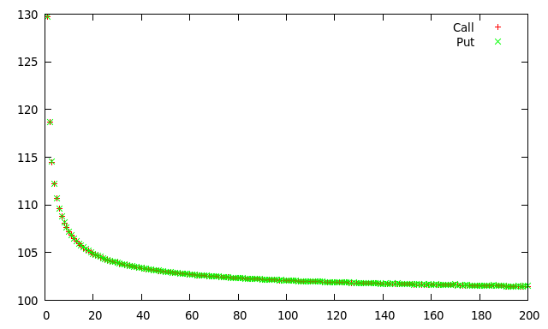

K= 100

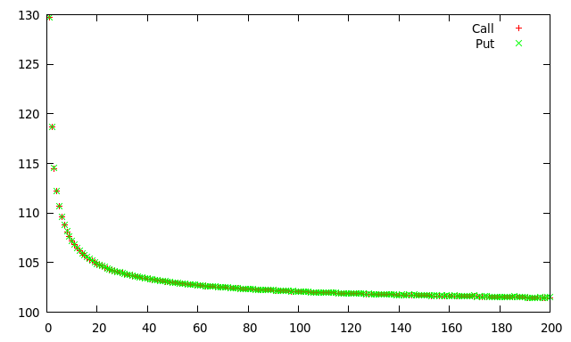
K = 105

2).

Part (a) and (b):

#include<iostream>
#include<cstdio>
#include<cstdlib>
#include<cmath>
using namespace std;

float S0=100;
float K=100;
float T=1;
float r=0.08;
float sigma=0.2;
int M=100;

float max(float a,float b)
{
if( a>b ) return a;
else return b;
}

float u(float delta_t)
{
return exp(sigma*sqrt(delta_t));
}

float u2(float delta_t)
{
return exp( sigma*sqrt(delta_t) + (r-0.5*sigma*sigma )*delta_t );
}

float d(float delta_t)
{
return exp(-sigma*sqrt(delta_t));
}

float d2(float delta_t)
{
return exp( -sigma*sqrt(delta_t) + ( r-0.5*sigma*sigma )*delta_t );
}

float discount_rate(float t)
{
return exp(r*t);
}

float p(float delta_t)
{
return ( exp(r*delta_t) - d(delta_t) )/ ( u(delta_t) -d(delta_t) ) ;
}

float q(float delta_t)
{
return ( u(delta_t) - exp(r*delta_t) )/ ( u(delta_t) - d(delta_t) );
}

/// Calculated using u2,d2
float p2(float delta_t)
{
return ( exp(r*delta_t) - d2(delta_t) )/ ( u2(delta_t) -d2(delta_t) ) ;
}

float q2(float delta_t)
{
return ( u2(delta_t) - exp(r*delta_t) )/ ( u2(delta_t) - d2(delta_t) );
}

// This is for the call option(recursive)
// maxpath -> it is used to store the max value until now
float get_lookback(float t,float S,float delta_t,float mx_path) // returns the price of the option at time t if the price os stock is S )
{
if(t>=T)
{
return (mx_path - S);
}
else
{
float t1=get_lookback(t+delta_t , S*u2(delta_t) , delta_t, max( S*u2(delta_t), mx_path) );
float t2=get_lookback(t+delta_t , S*d2(delta_t) , delta_t, max( S*d2(delta_t), mx_path) );
return ( p2(delta_t)*t1 +q2(delta_t)*t2)/discount_rate(delta_t) ;
}
}

FILE* ptr;

int main()
{
float delta_t;

// Part (a)
S0=100;
K=100;
T=1;
r=0.08;
sigma=0.2;

M=5;
delta_t=T/M;
cout<<"For M = 5 : "<< get_lookback(0,S0, delta_t, S0 )<<endl;

M=10;
delta_t=T/M;
cout<<"For M = 10 : "<< get_lookback(0,S0, delta_t, S0 )<<endl;

M=25;
delta_t=T/M;
cout<<"For M = 25 : "<< get_lookback(0,S0, delta_t, S0 )<<endl;

M=50;
delta_t=T/M;
cout<<"For M = 50 : "<< get_lookback(0,S0, delta_t, S0 )<<endl;

return 0;
}

Part(c):

#include<iostream>
#include<cstdio>
#include<cstdlib>
#include<cmath>
using namespace std;

float S0=100;
float K=100;
float T=1;
float r=0.08;
float sigma=0.2;
int M=100;

float max(float a,float b)
{
if( a>b ) return a;
else return b;
}

float u(float delta_t)
{
return exp(sigma*sqrt(delta_t));
}

float u2(float delta_t)
{
return exp( sigma*sqrt(delta_t) + (r-0.5*sigma*sigma )*delta_t );
}

float d(float delta_t)
{
return exp(-sigma*sqrt(delta_t));
}

float d2(float delta_t)
{
return exp( -sigma*sqrt(delta_t) + ( r-0.5*sigma*sigma )*delta_t );
}

float discount_rate(float t)
{
return exp(r*t);
}

float p(float delta_t)
{
return ( exp(r*delta_t) - d(delta_t) )/ ( u(delta_t) -d(delta_t) ) ;
}

float q(float delta_t)
{
return ( u(delta_t) - exp(r*delta_t) )/ ( u(delta_t) - d(delta_t) );
}

/// Calculated using u2,d2
float p2(float delta_t)
{
return ( exp(r*delta_t) - d2(delta_t) )/ ( u2(delta_t) -d2(delta_t) ) ;
}

float q2(float delta_t)
{
return ( u2(delta_t) - exp(r*delta_t) )/ ( u2(delta_t) - d2(delta_t) );
}

// This is for the call option(recursive)
// maxpath -> it is used to store the max value until now
float get_lookback(float t,float S,float delta_t,float mx_path=-1) // returns the price of the option at time t if the price os stock is S )
{
if( mx_path==-1 ) mx_path=S ; // i.e. the starting point of the loop
if(t>=T)
{
return (mx_path - S);
}
else
{
float t1=get_lookback(t+delta_t , S*u2(delta_t) , delta_t, max( S*u2(delta_t), mx_path) );
float t2=get_lookback(t+delta_t , S*d2(delta_t) , delta_t, max( S*d2(delta_t), mx_path) );
return ( p2(delta_t)*t1 +q2(delta_t)*t2)/discount_rate(delta_t) ;
}
}

FILE* ptr;

int main()
{
float delta_t;

// Part (a)
S0=100;
K=100;
T=1;
r=0.08;
sigma=0.2;

cout<<"All the intermediate values for M = 5 "<<endl;
M=5;
delta_t=T/M;
cout<<"At i=0 "<< get_lookback(0,S0, delta_t, S0 )<<endl;
cout<<"At i=1 "<< get_lookback(delta_t , S0*u2(delta_t), delta_t, S0*u2(delta_t) )<<" "<< get_lookback(delta_t , S0*d2(delta_t) , delta_t, S0*d2(delta_t) )<<endl;
cout<<"At i=2 "<< get_lookback(delta_t*2 , S0*pow(u2(delta_t),2) ,delta_t )<<" "<<get_lookback(delta_t*2, S0*pow(u2(delta_t),1)*pow(d2(delta_t),1) , delta_t ) << " "<< get_lookback( delta_t*2 , S0*pow(d2(delta_t),2) ,delta_t ) <<endl;
cout<<"At i=3 "<< get_lookback(delta_t*3 , S0*pow(u2(delta_t),3) ,delta_t )<<" "<<get_lookback(delta_t*3, S0*pow(u2(delta_t),2)*pow(d2(delta_t),1) , delta_t ) <<" "<< get_lookback(delta_t*3 , S0*pow(u2(delta_t),1)*pow(d2(delta_t),2) , delta_t )<<" "<<get_lookback( delta_t*4, S0*pow(d2(delta_t),3) , delta_t )<<endl;

cout<<"At i=4 "<< get_lookback(delta_t*4 , S0*pow(u2(delta_t),4) ,delta_t )<<" "<<get_lookback(delta_t*4, S0*pow(u2(delta_t),3)*pow(d2(delta_t),1), delta_t ) <<" "<< get_lookback(delta_t*4 , S0*pow(u2(delta_t),2)*pow(d2(delta_t),2) , delta_t )<<" "<< get_lookback(delta_t*4 , S0*pow(u2(delta_t),1)*pow(d2(delta_t),3 ) , delta_t ) <<" "<< get_lookback(delta_t*4, S0*pow(d2(delta_t),4) , delta_t ) <<endl;

return 0;
}

OBSERVATION:

Part (a) and (b):
For M = 5 : 9.11931
For M = 10 : 10.0806
For M = 25 : 11.0034

Part(c):
All the intermediate values for M = 5
At i=0 9.11931
At i=1 9.02796 7.5492
At i=2 8.54809 7.14792 5.97711
At i=3 7.41678 6.20192 5.18606 2.9065
At i=4 5.50165 4.60048 3.84693 3.21681 2.6899

3).
#include<iostream>
#include<cstdio>
#include<cstdlib>
#include<set>
#include<vector>
#include<map>
#include<cmath>
#include<climits>
using namespace std;

float S0=100;
float K=100;
float T=1;
float r=0.08;
float sigma=0.2;
int M=100;

float max(float a,float b)
{
if( a>b ) return a;
else return b;
}

double max( double a, double b)
{
if( a> b) return a;
else return b;
}

float u(float delta_t)
{
return exp(sigma*sqrt(delta_t));
}

float u2(float delta_t)
{
return exp( sigma*sqrt(delta_t) + (r-0.5*sigma*sigma )*delta_t );
}

float d(float delta_t)
{
return exp(-sigma*sqrt(delta_t));
}

float d2(float delta_t)
{
return exp( -sigma*sqrt(delta_t) + ( r-0.5*sigma*sigma )*delta_t );
}

double discount_rate(double t)
{
return exp(r*t);
}

float p(float delta_t)
{
return ( exp(r*delta_t) - d(delta_t) )/ ( u(delta_t) -d(delta_t) ) ;
}

float q(float delta_t)
{
return ( u(delta_t) - exp(r*delta_t) )/ ( u(delta_t) - d(delta_t) );
}

/// Calculated using u2,d2
double p2(double delta_t)
{
return ( exp(r*delta_t) - d2(delta_t) )/ ( u2(delta_t) -d2(delta_t) ) ;
}

double q2(double delta_t)
{
return ( u2(delta_t) - exp(r*delta_t) )/ ( u2(delta_t) - d2(delta_t) );
}

// This is for the call option(recursive)
// maxpath -> it is used to store the max value until now
double get_lookback(double t,double S,double delta_t,double mx_path) // returns the price of the option at time t if the price os stock is S )
{
if(t>=T)
{
return (mx_path - S);
}
else
{
double t1=get_lookback(t+delta_t , S*u2(delta_t) , delta_t, max( S*u2(delta_t), mx_path) );
double t2=get_lookback(t+delta_t , S*d2(delta_t) , delta_t, max( S*d2(delta_t), mx_path) );
return ( p2(delta_t)*t1 +q2(delta_t)*t2)/discount_rate(delta_t) ;
}
}

// This function returns a Brownian path
vector<double> get_path(double delta_t,double S0)
{
double U= u2(delta_t);
double D= d2(delta_t);
double P = p2(delta_t);
vector<double> out; // the output to be appended;
double i=0;
double curr;
curr=S0;
for(i=0; i<=1 ; i+=delta_t )
{
if( ((double)rand()/RAND_MAX ) < P ) // i.e. stock going up
{
curr = curr*U;
out.push_back( curr );
}
else
{
curr = curr*D;
out.push_back( curr );
}
}
return out;
}

double get_price( vector<double> path ) // return the price of the option according to the vector
{
double mx = 0; //
vector<double>::iterator it;
for(it= path.begin() ; it!=path.end() ; it++)
{
mx = max( mx, *it );
}
return (mx - path[ path.size()-1 ] );
}

double get_lookback_price(double delta_t, double S0 ) // Generates thousands of path and then take their average
{
double price =0;
int count =0;
for(count =0 ;count < 1000000; count++)
price += get_price( get_path(delta_t, S0 ));
return (price/count)/discount_rate(1.0);
}

FILE* ptr;

int main()
{
double delta_t;

// Part (a)
S0=100;
K=100;
T=1;
r=0.08;
sigma=0.2;

M=5;
delta_t=T/M;
cout<<"For M = 5 : "<< get_lookback_price(delta_t, S0 )<<endl;

M=10;
delta_t=T/M;
cout<<"For M = 10 : "<< get_lookback_price(delta_t, S0 )<<endl;

M=25;
delta_t=T/M;
cout<<"For M = 25 : "<< get_lookback_price( delta_t, S0 )<<endl;

M=50;
delta_t=T/M;
cout<<"For M = 50 : "<< get_lookback_price( delta_t, S0 )<<endl;

return 0;
}

OBSERVATION:

For M = 5 : 8.16982
For M = 10 : 9.57383
For M = 25 : 11.0504
For M = 50 : 11.533

