MA374 : Financial Engineering

Assignment 4

Name: Vibhanshu
Roll. No.: 120123049

1.

a) The Markowitz efficient frontier is:-

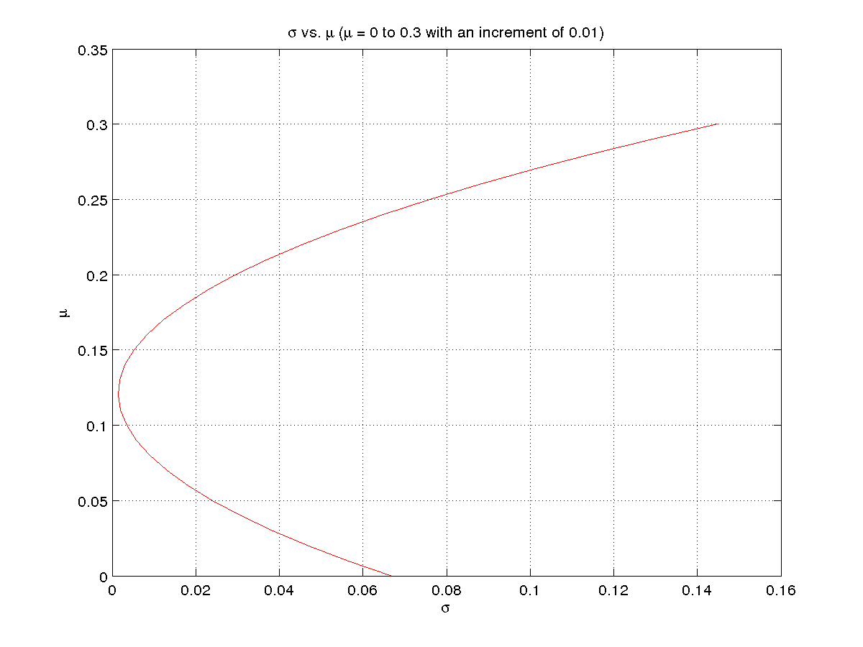
b)

For mean = 0.01000000, variance = 0.05659413,
weights =

2.407339449541299 -0.392660550458720 -1.014678899082576

For mean = 0.03000000, variance = 0.03852147,
weights =

2.121100917431201 -0.278899082568812 -0.842201834862391

For mean = 0.05000000, variance = 0.02402752,
weights =

1.834862385321107 -0.165137614678903 -0.669724770642206

For mean = 0.07000000, variance = 0.01311229,
weights =

1.548623853211016 -0.051376146788993 -0.497247706422022

For mean = 0.09000000, variance = 0.00577578,
weights =

1.262385321100924 0.062385321100917 -0.324770642201837

For mean = 0.11000000, variance = 0.00201798,
weights =

0.976146788990832 0.176146788990827 -0.152293577981652

For mean = 0.13000000, variance = 0.00183890,
weights =

0.689908256880733 0.289908256880734 0.020183486238533

For mean = 0.15000000, variance = 0.00523853,
weights =

0.403669724770642 0.403669724770644 0.192660550458717

For mean = 0.17000000, variance = 0.01221688,
weights =

0.117431192660543 0.517431192660552 0.365137614678902

For mean = 0.19000000, variance = 0.02277394,
weights =

-0.168807339449557 0.631192660550459 0.537614678899087
c) Returns are 0.189554799608066 and 0.052446841081024

d) Minimum Risk is 0.017048073394496

e) The Market Portfolio has weights 0.593750000000000, 0.328125000000000 and 0.078125000000000

The Capital Market Line is :-

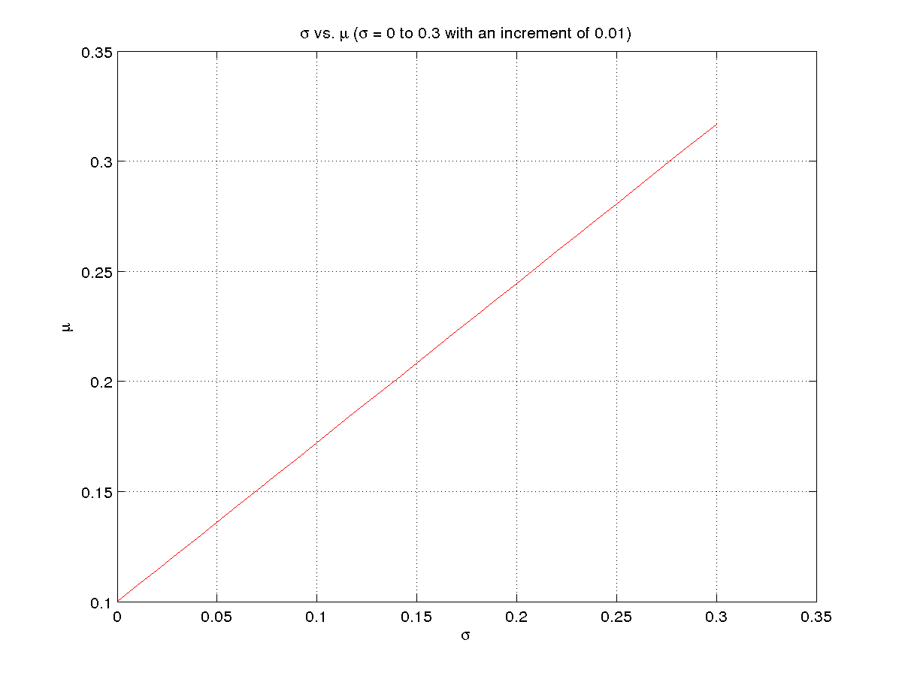
2.

a) The Markowitz Efficient Frontier is:-

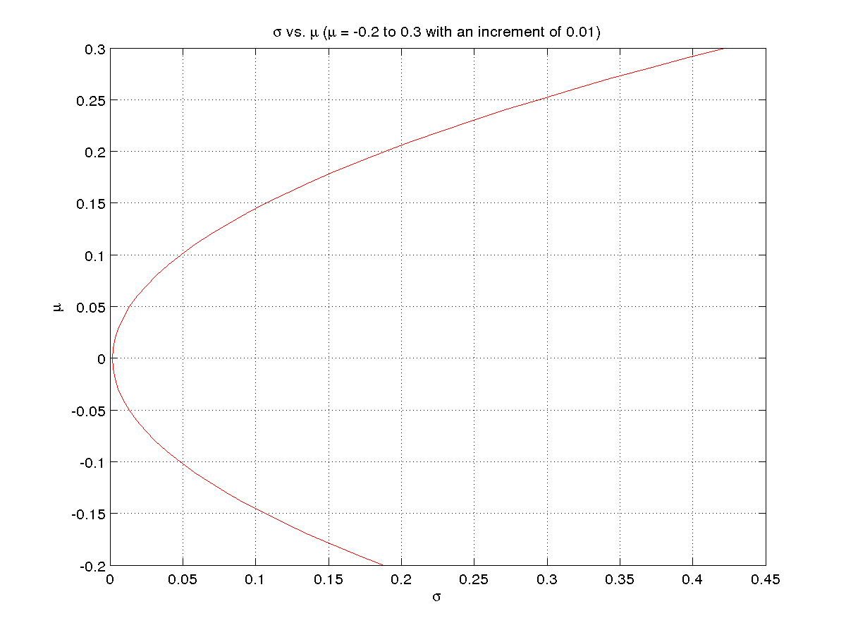

b) The Market Portfolio has weights:-

0.347025256233099, 0.250619815421355, -0.087226854582322, -0.076440180608388, 0.052366699315659, 0.046895339223592, -0.035720766443429, 0.004720874674299, 0.359815798353330, 0.137944018412804
c) The Capital Market Line is:-

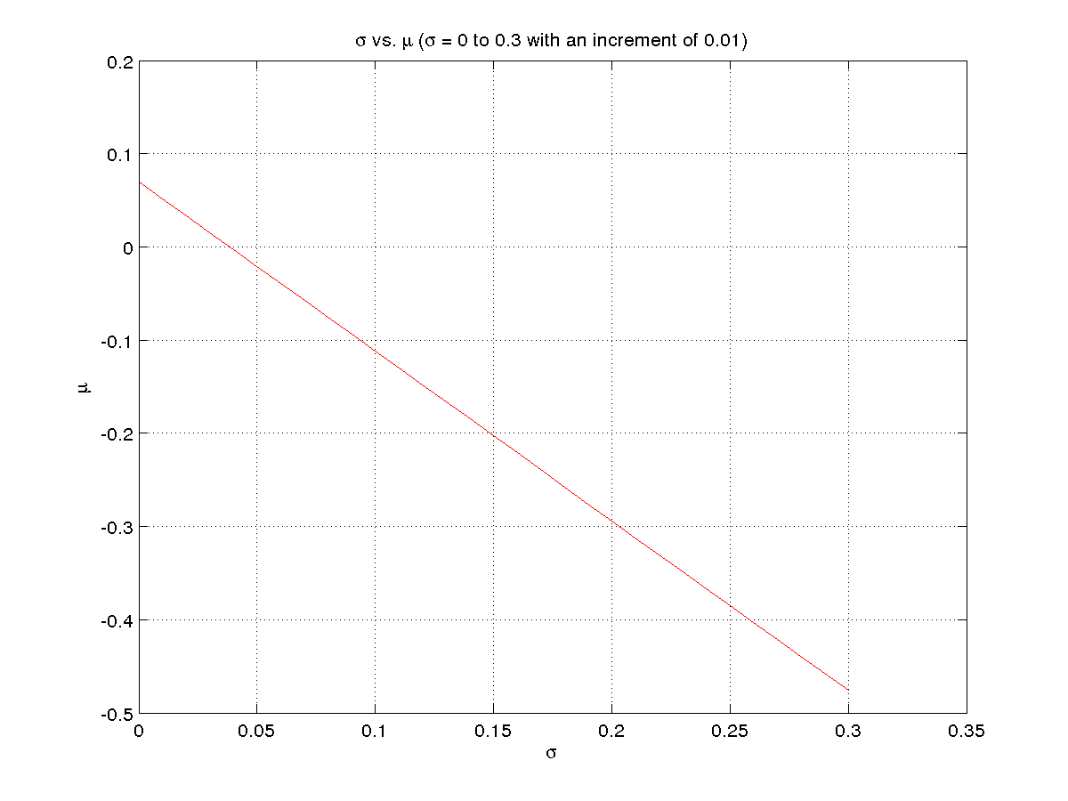
d) The Security Market Line is:-
