MA374 – Lab 5
Vibhanshu
110123049

1. All Minimum Variance Efficient Frontiers:-

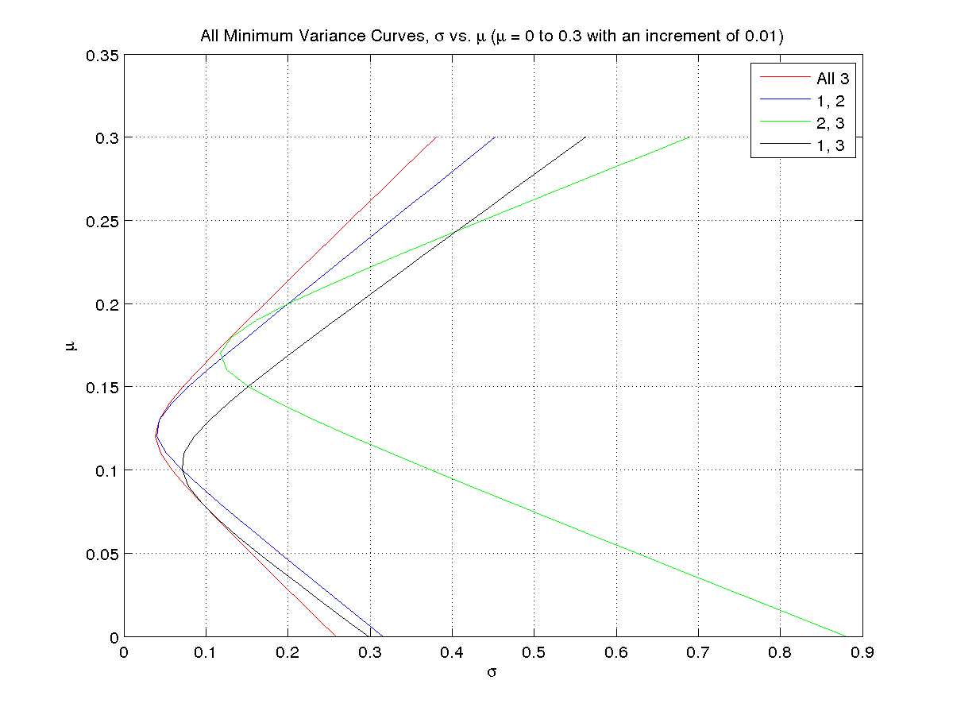

Feasible Region for No Short Sales with the Minimum Variance Curves:-
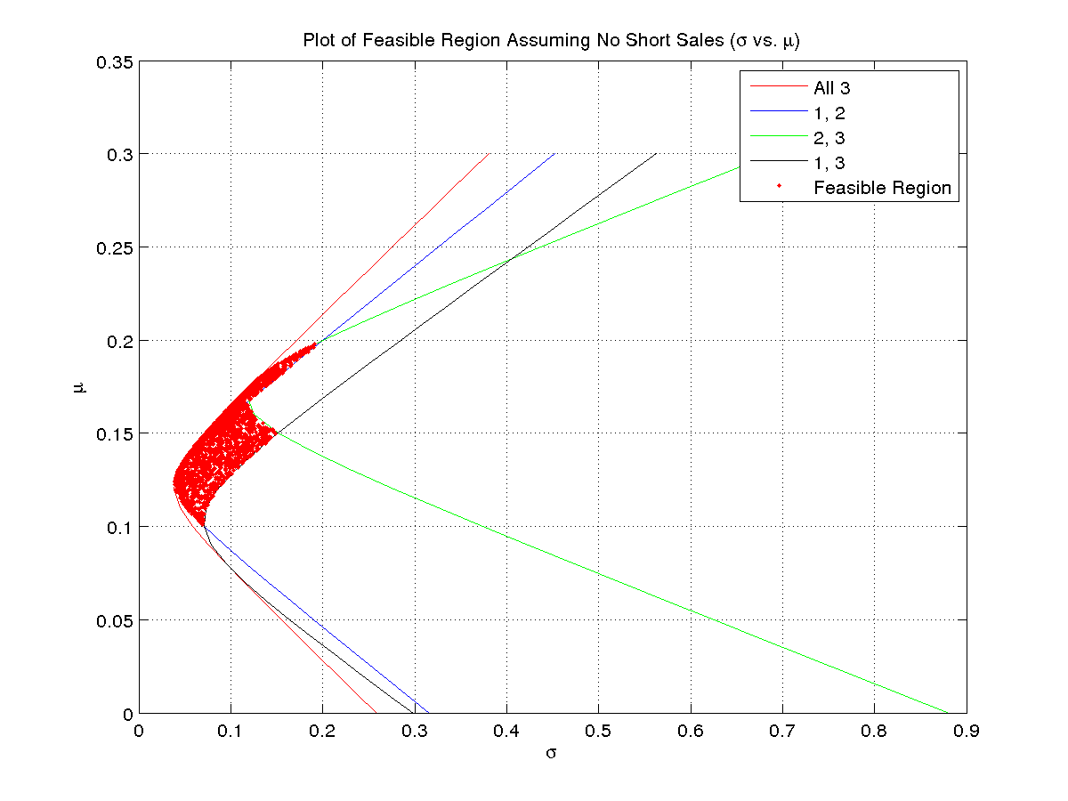
Plots of Weights Corresponding to Minimum Variance Curve:-
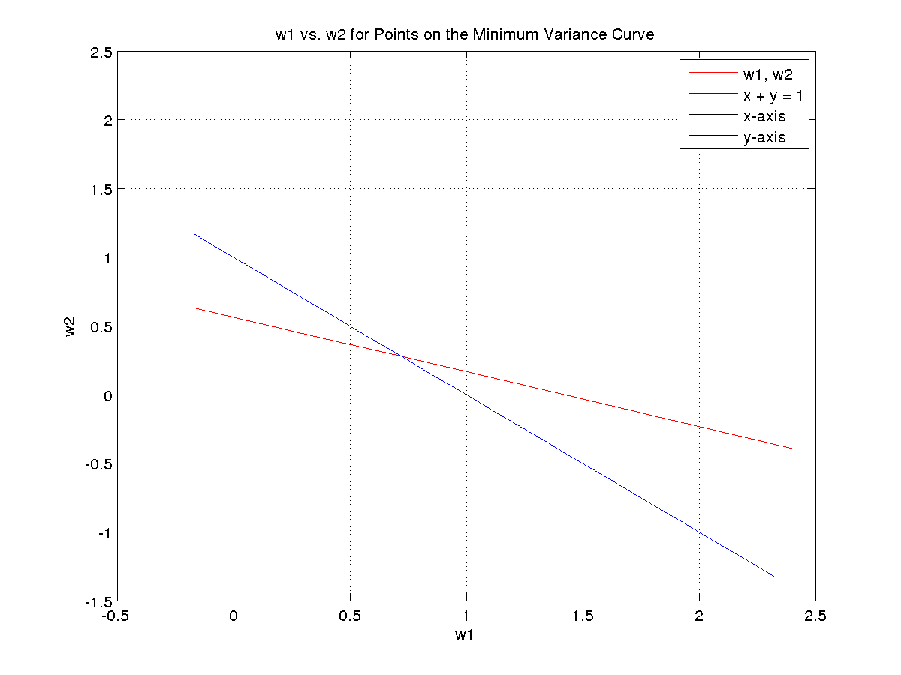

Equation that the weights satisfy (in terms of the portfolio mean):-

w1 = 278/109 - (1560*x)/109,
w2 = (620*x)/109 – 49/109,
w3 = (940*x)/109 - 120/109
2. The indexes used are BSE Sensex and the NSE Nifty

NSE Indexed Betas -

5.1952, 5.0821, 4.1228, 4.0638, 1.9081, 11.2026, 8.0336, 1.9682, 1.8892, 5.2775

NSE Non-Indexed Betas -

4.7400, 0.7467, 2.6398, 0.6630, 1.6079, 3.7564, 5.5485, 0.3539, 0.8213, 5.6021

BSE Indexed Betas -

2.5924, 7.8200, 3.2783, 20.4147, 1.9642, 6.4435, 1.8478, 4.8490, 2.4868, 0.0336

BSE Non-Indexed Betas -

1.2354, 4.0483, -0.2759, -0.3363, 0.5233, -0.0763, 6.3481, 4.0977, 0.9485, 3.2391

Inferences:-

A beta above one generally means that the asset is volatile and tends to move up and down with the market. Negative betas imply that the investments tend to go down when the market goes up, and vice versa.

