MA374 – Lab 7

Vibhanshu
120123049

2. Plot of s vs. C(t, s) :-
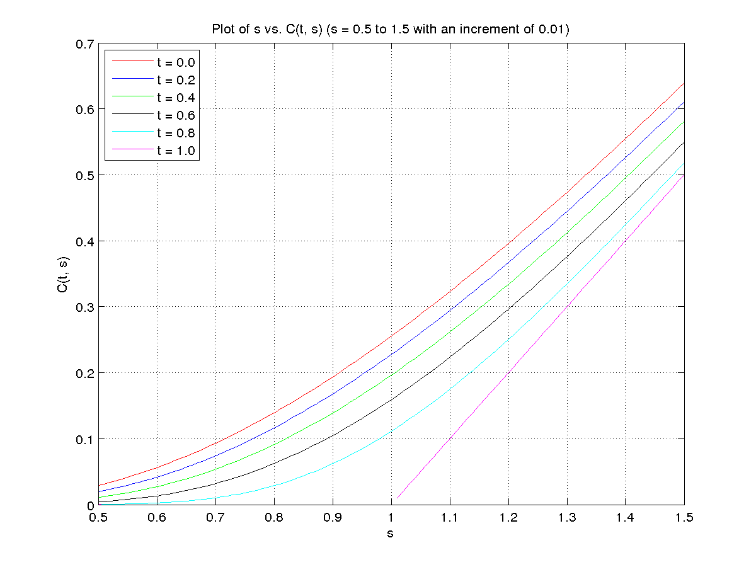

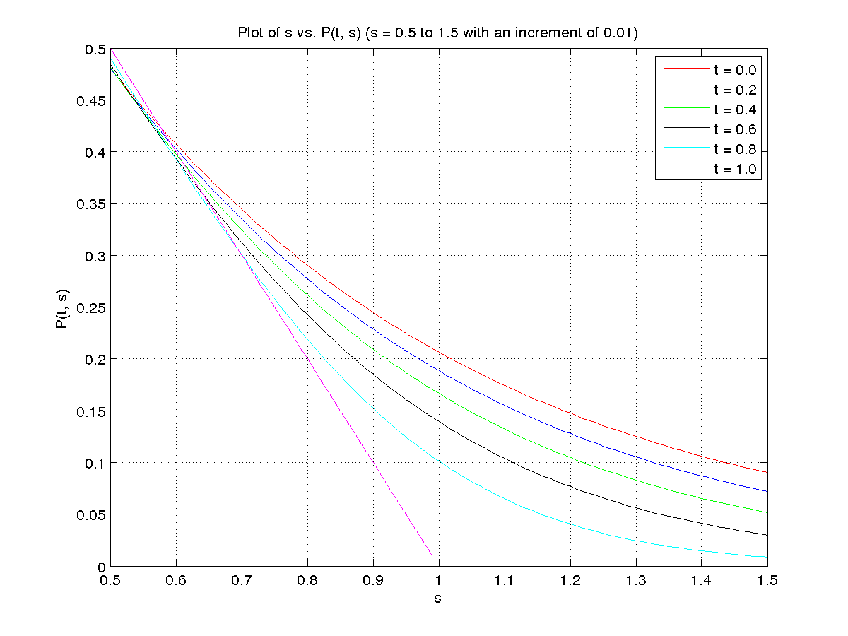
Plot of s vs. P(t, s) :-
3D Plot of s vs. C(t, s) :-
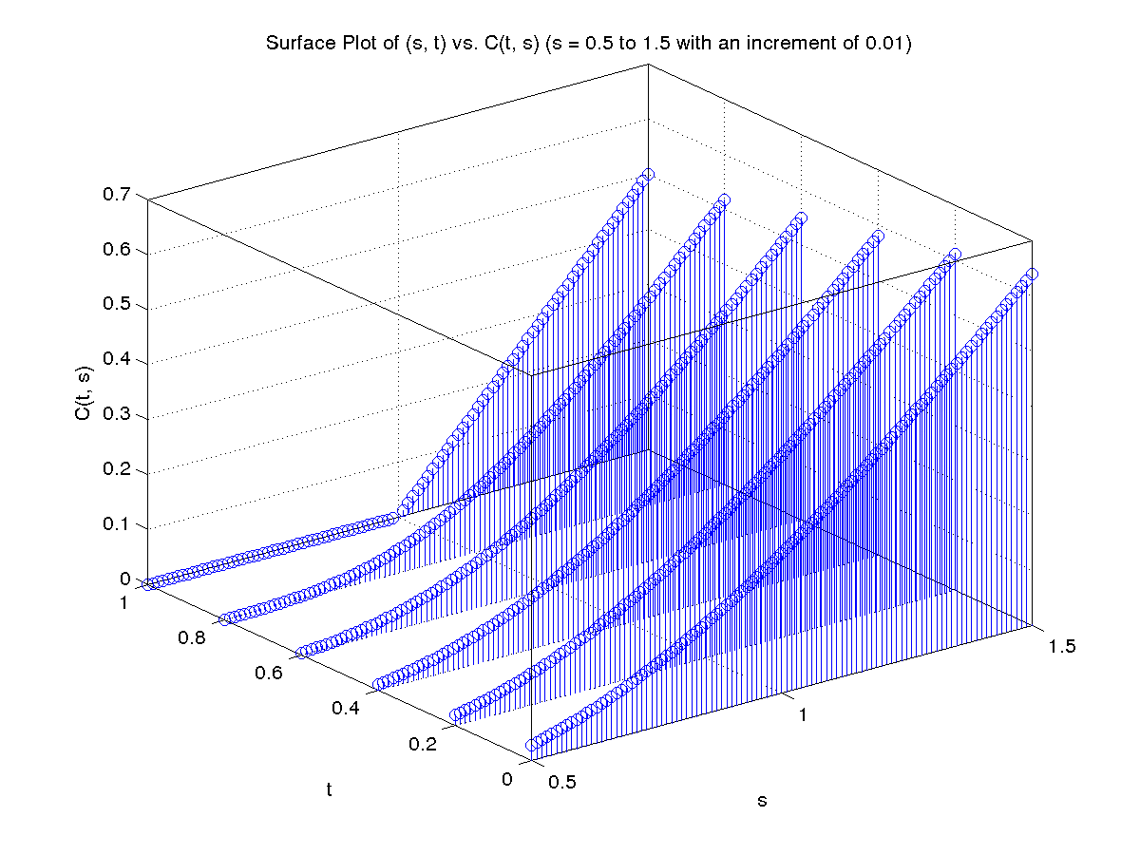
3D Plot of s vs. P(t, s) :-
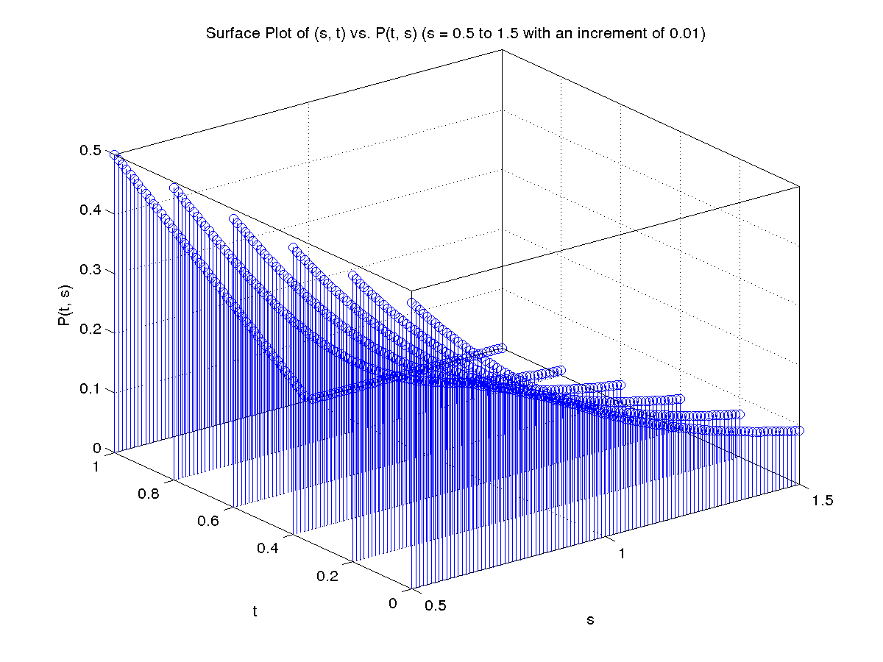
3. Surface Plot of (s, t) vs. C(t, s) :-
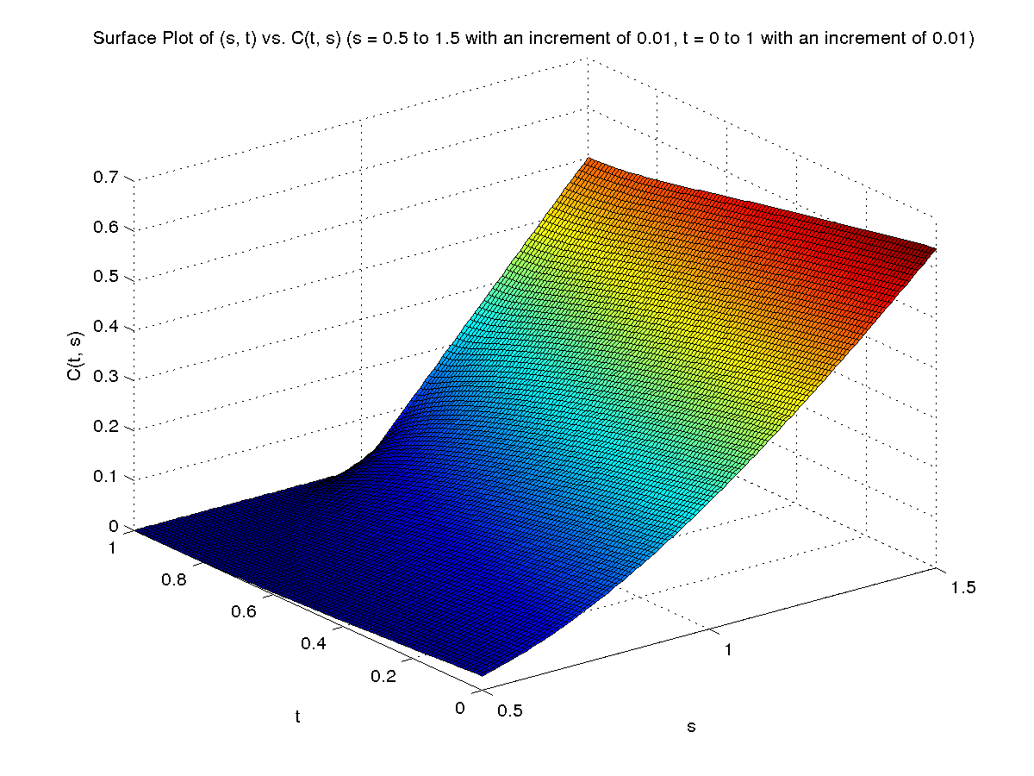
Surface Plot of (s, t) vs. P(t, s) :-
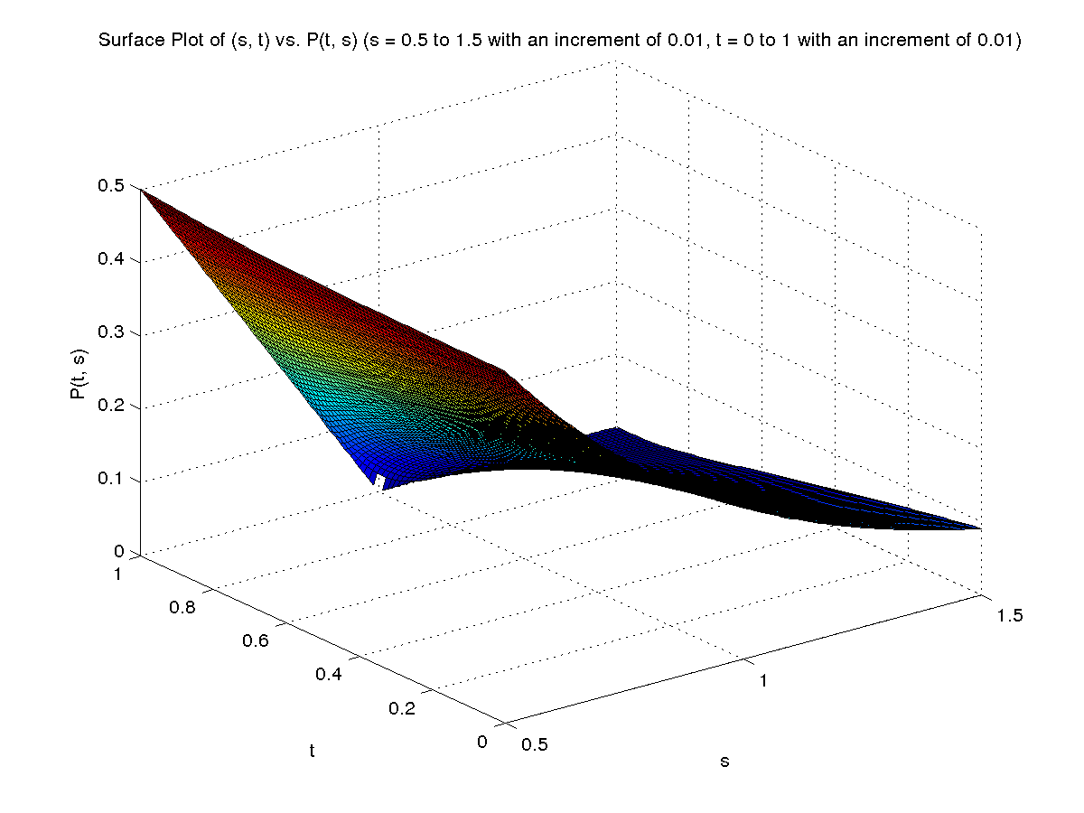
4. Sensitivity of C for changes in Stock Price :-
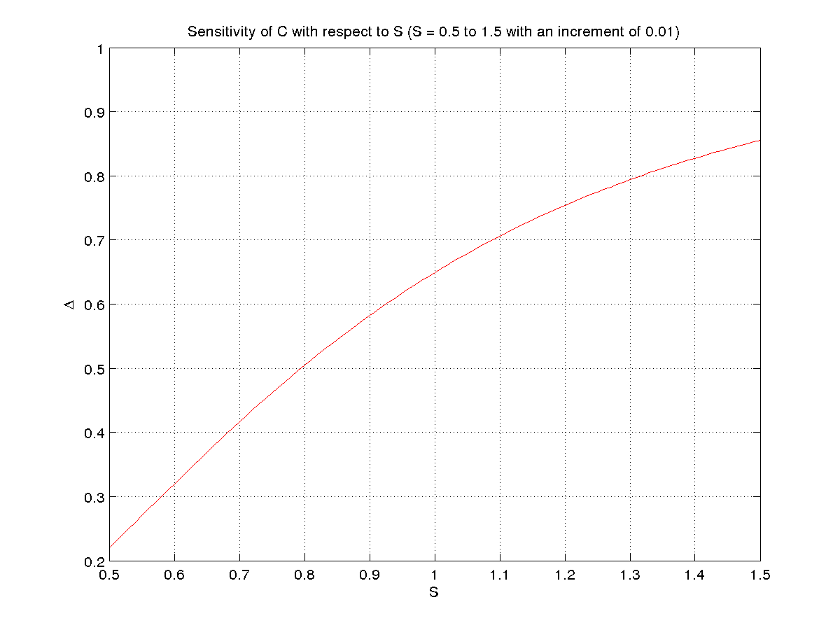
Sensitivity of C for changes in σ :-
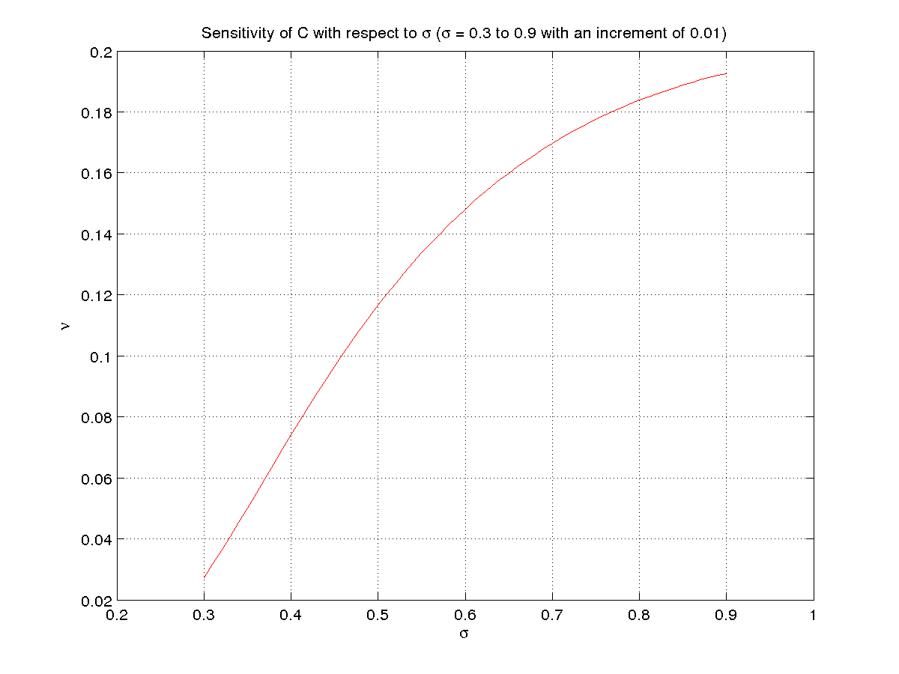
Sensitivity of C for changes in t :-
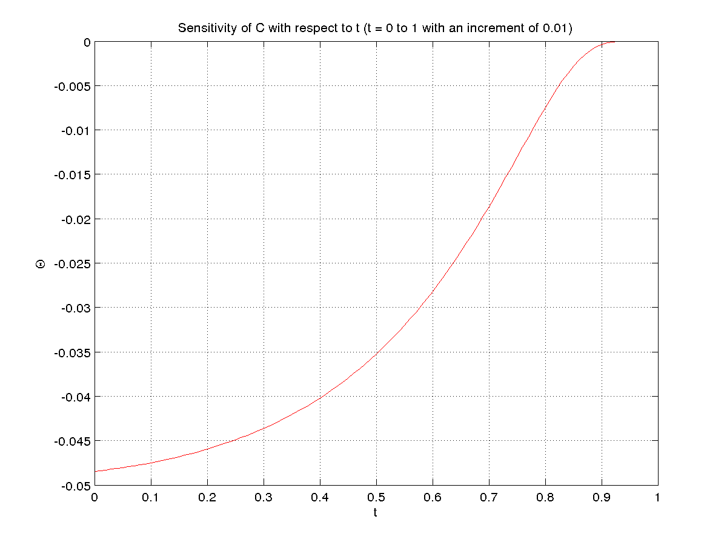
Sensitivity of C for changes in r :-
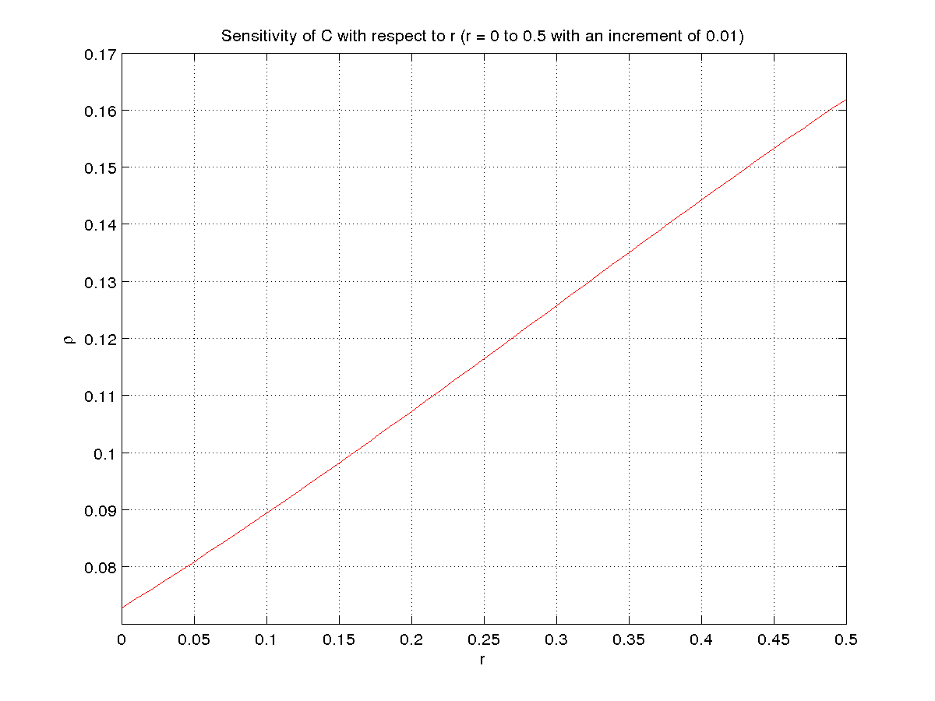

Sensitivity of P for changes in Stock Price :-
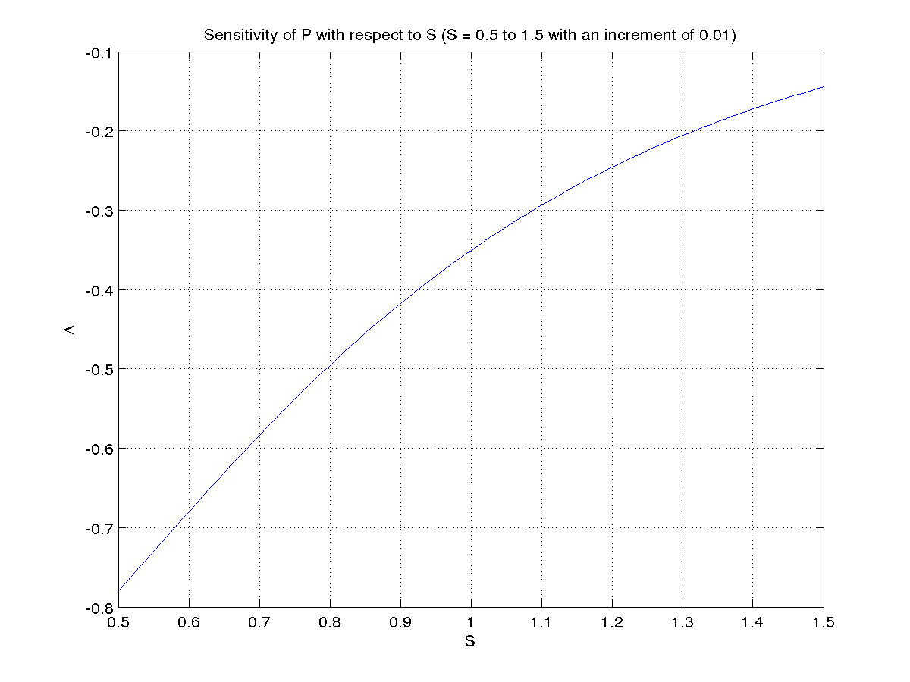
Sensitivity of P for changes in σ :-
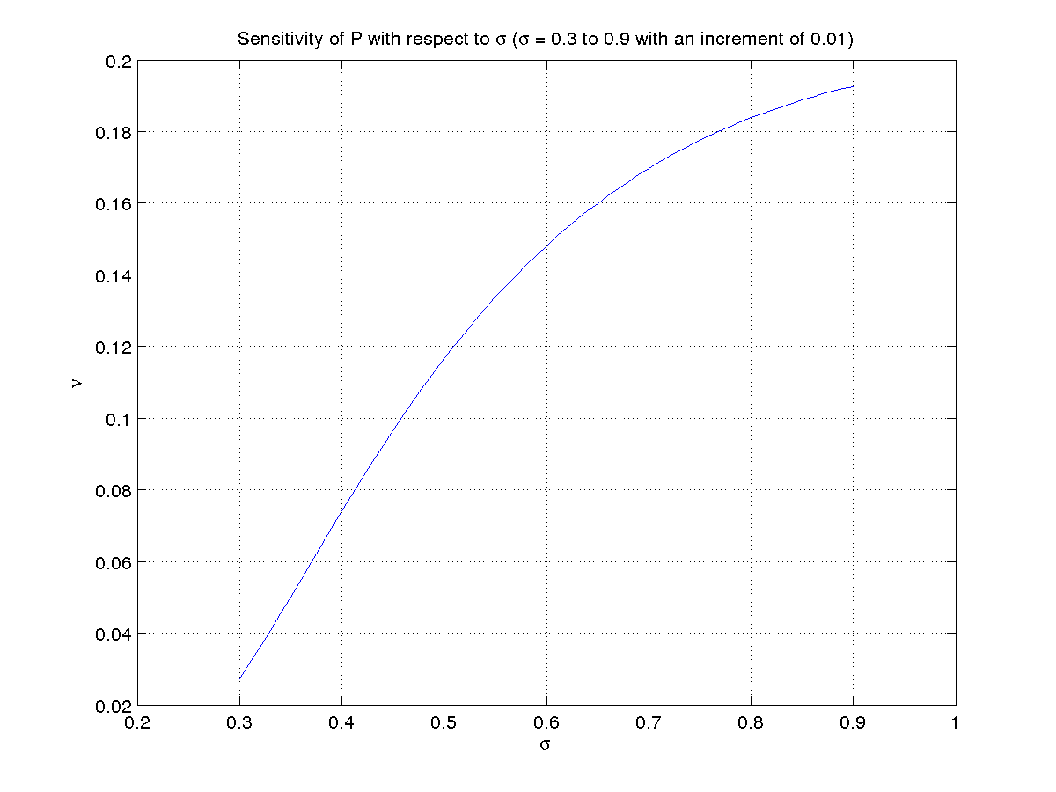
Sensitivity of P for changes in t :-
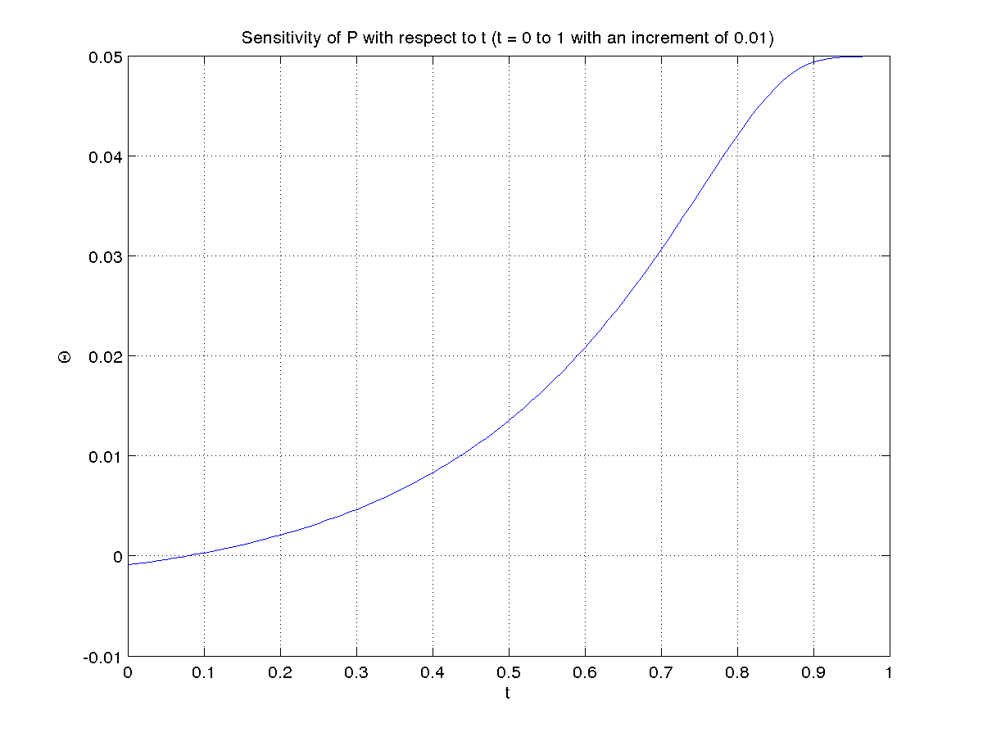
Sensitivity of P for changes in r :-
