MA374 – Lab 9

Vibhanshu
11012333

1. For Call Options

3D Plot:-

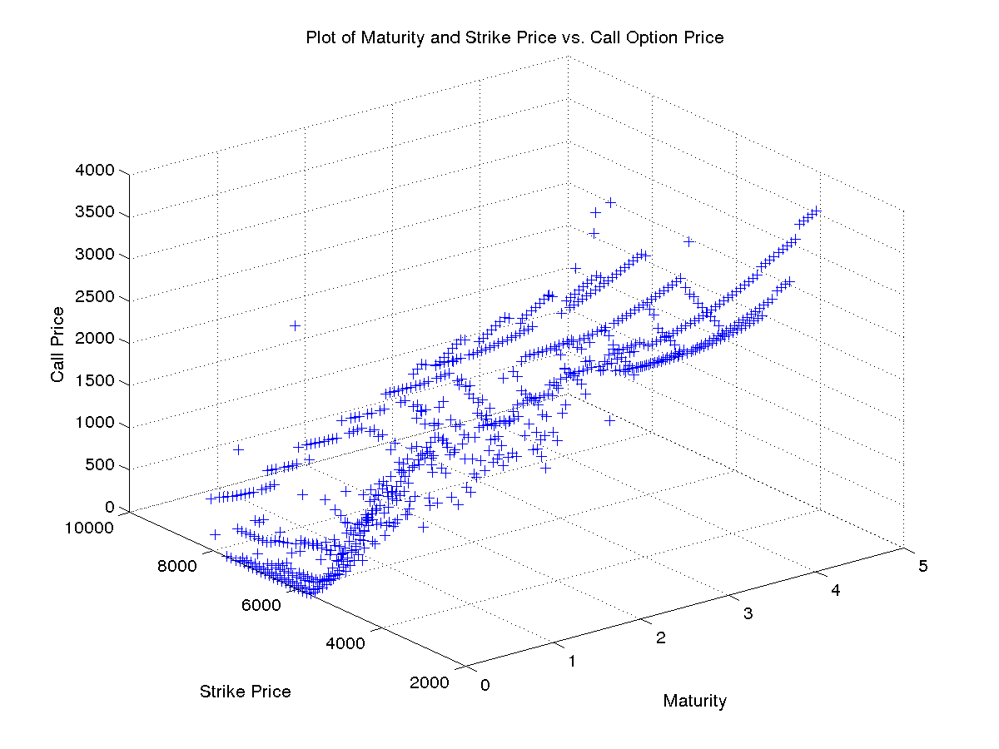

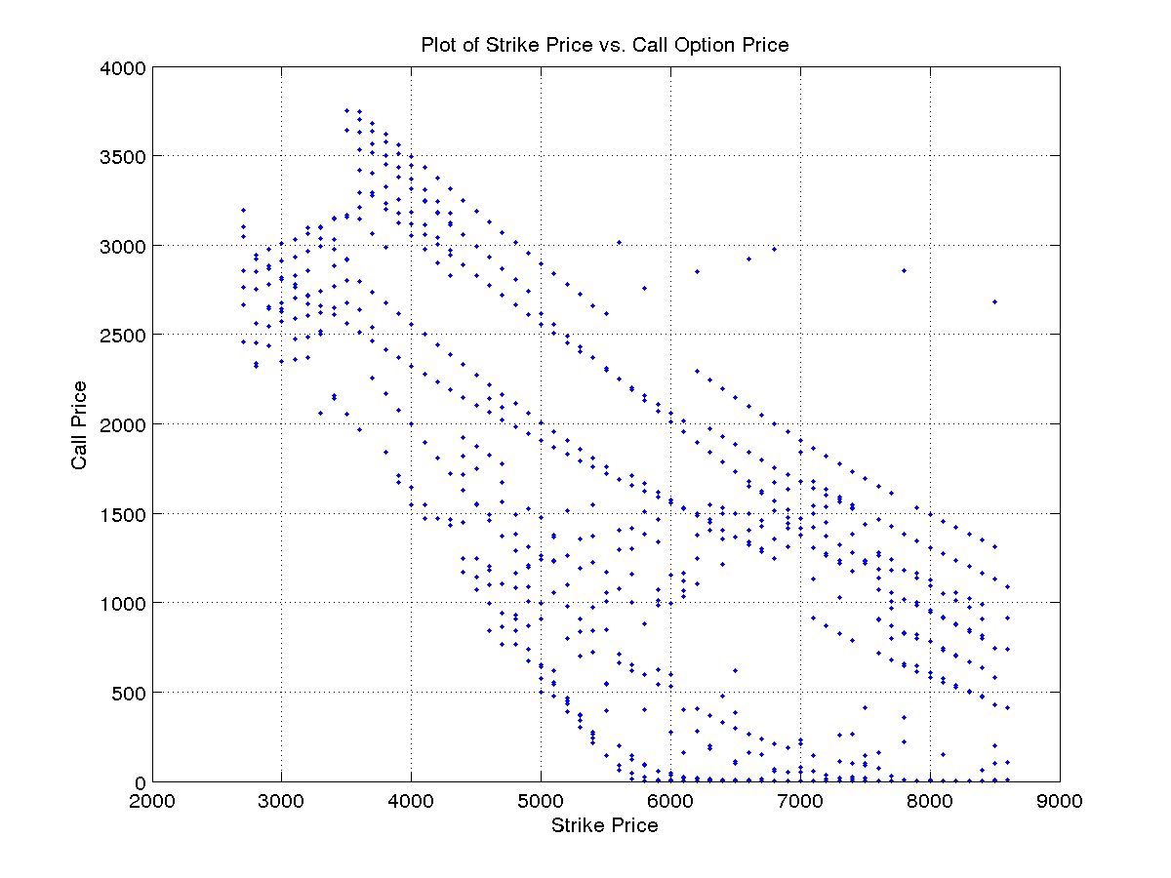
Plot of Strike Price vs. Option Price:-
Plot of Maturity vs. Option Price:-
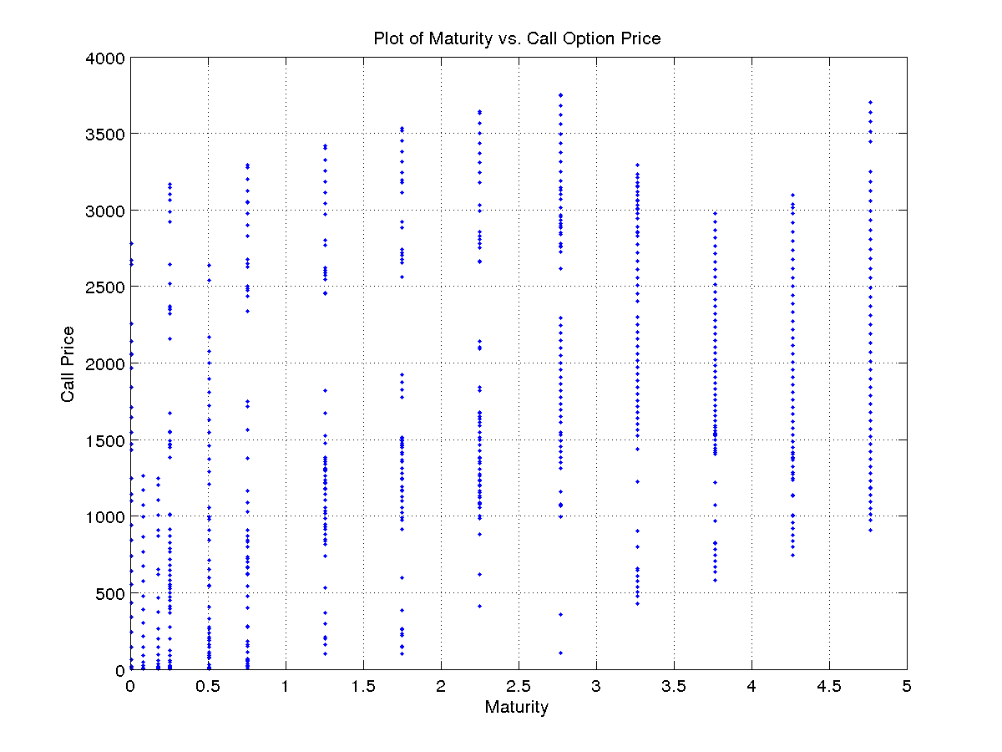
For Put Options

3D Plot:-
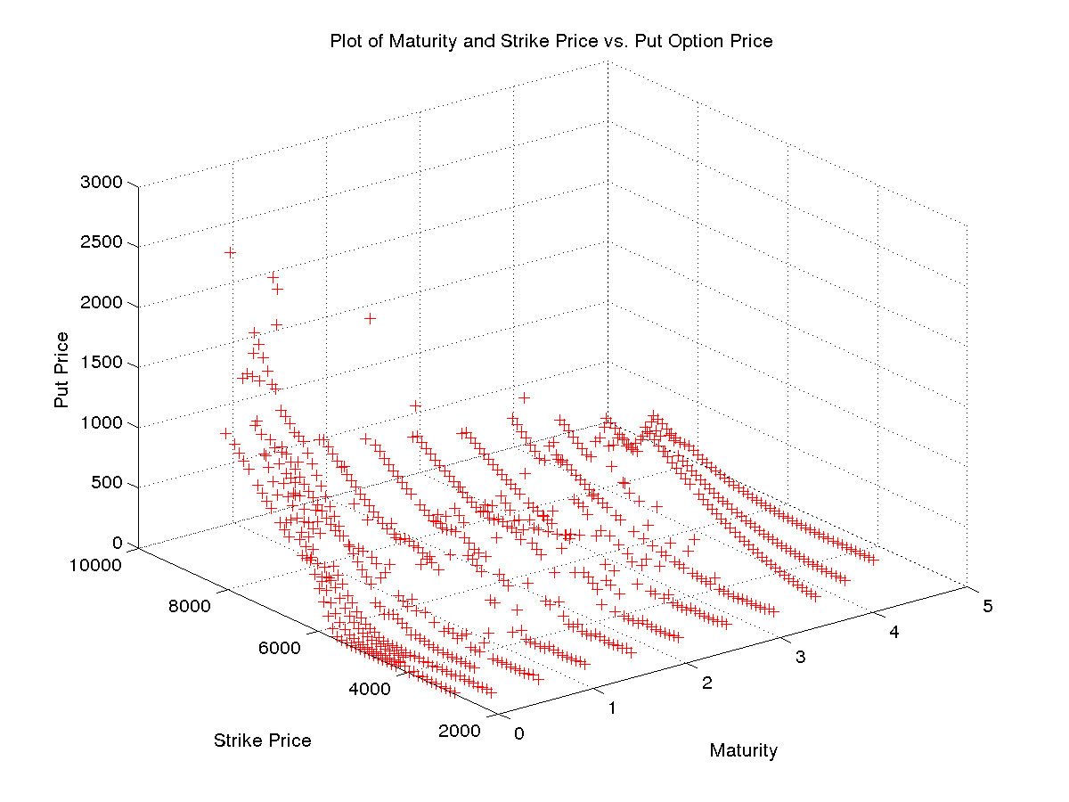
Plot of Strike Price vs. Option Price:-
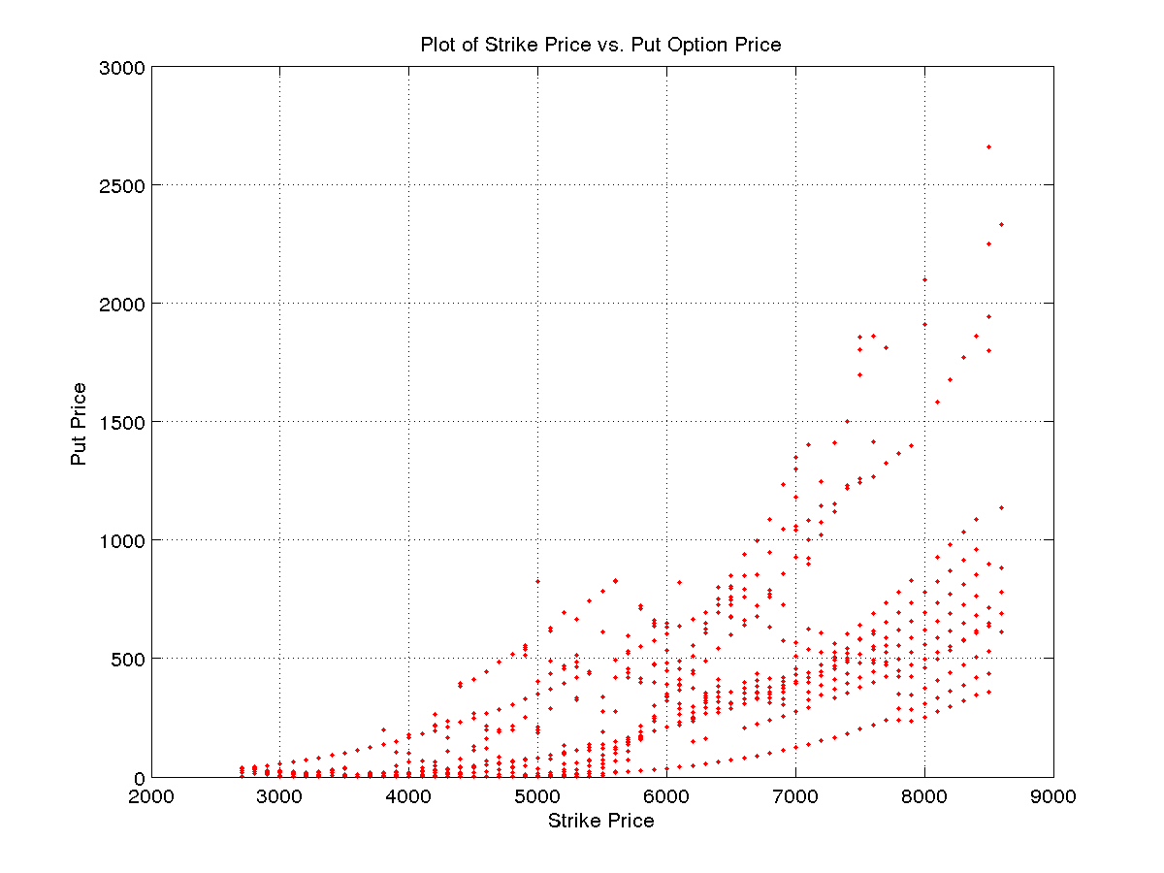
Plot of Maturity vs. Option Price:-
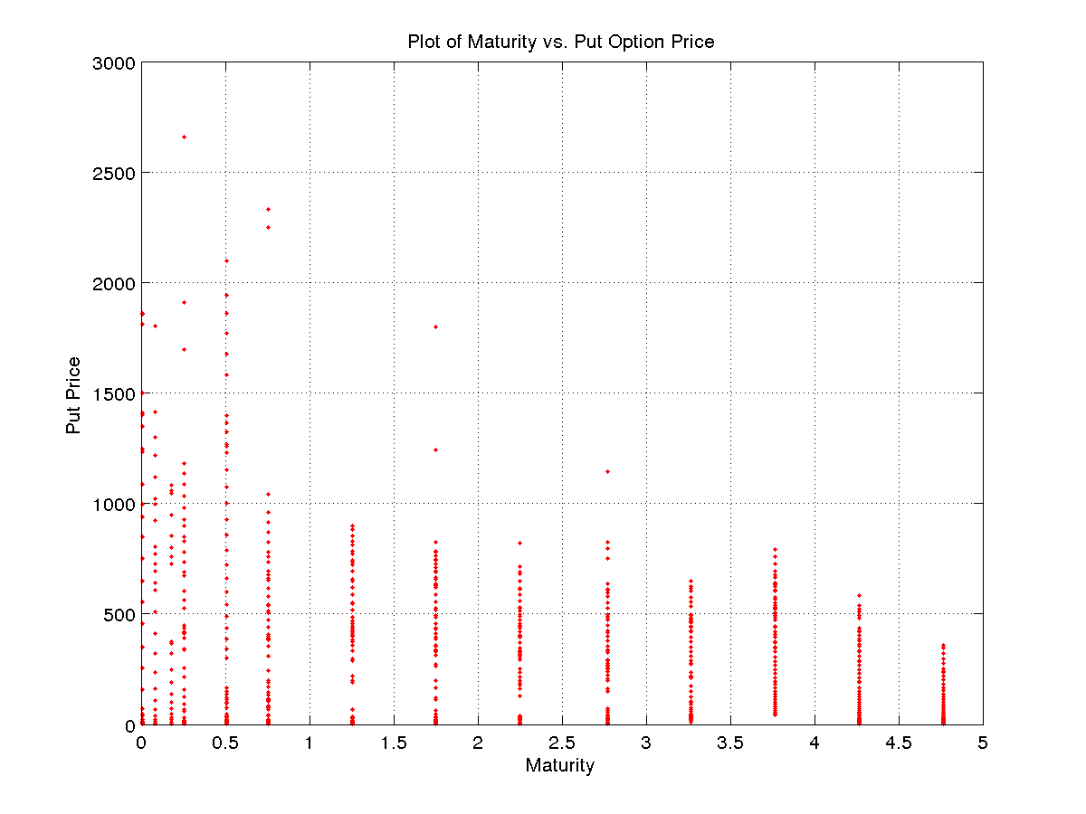

2. Implied volatility was calculated only for call options.

3D Plot:-

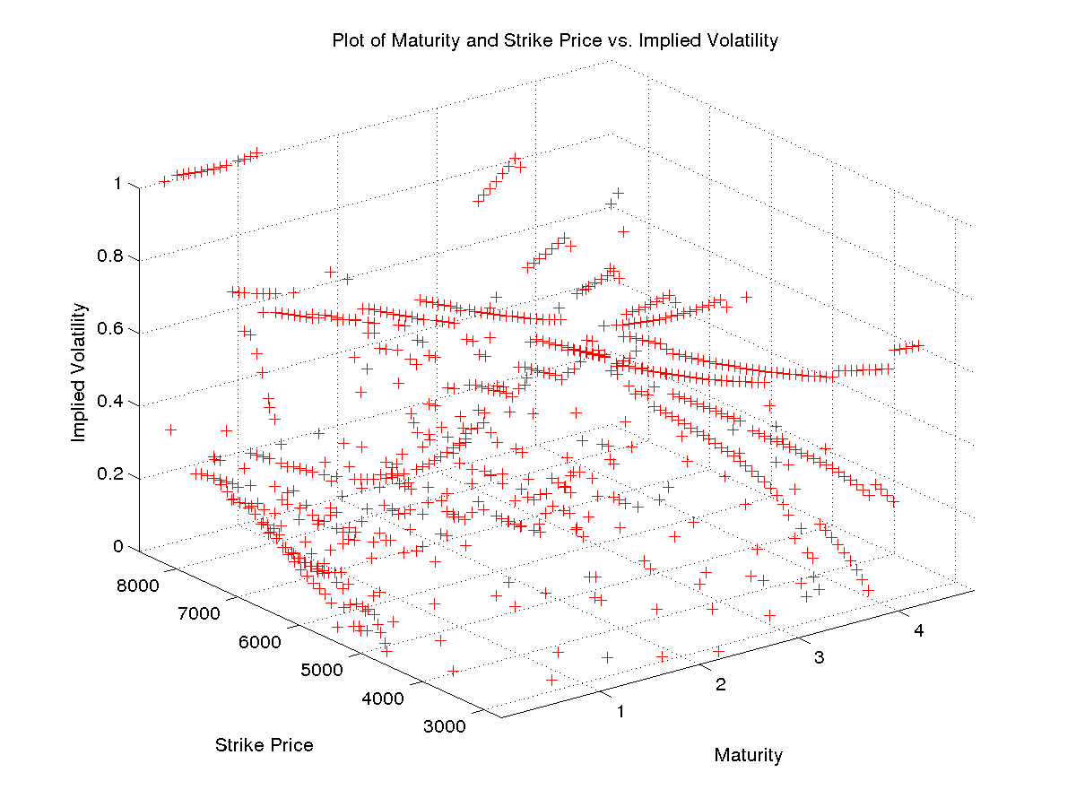
Plot of Strike Price vs. Implied Volatility:-
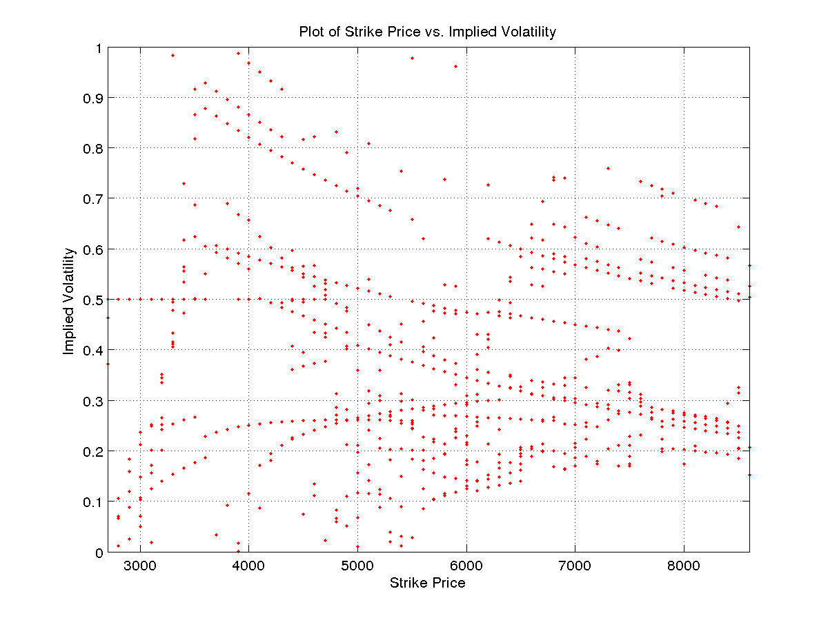
Plot of Maturity vs. Implied Volatility:-
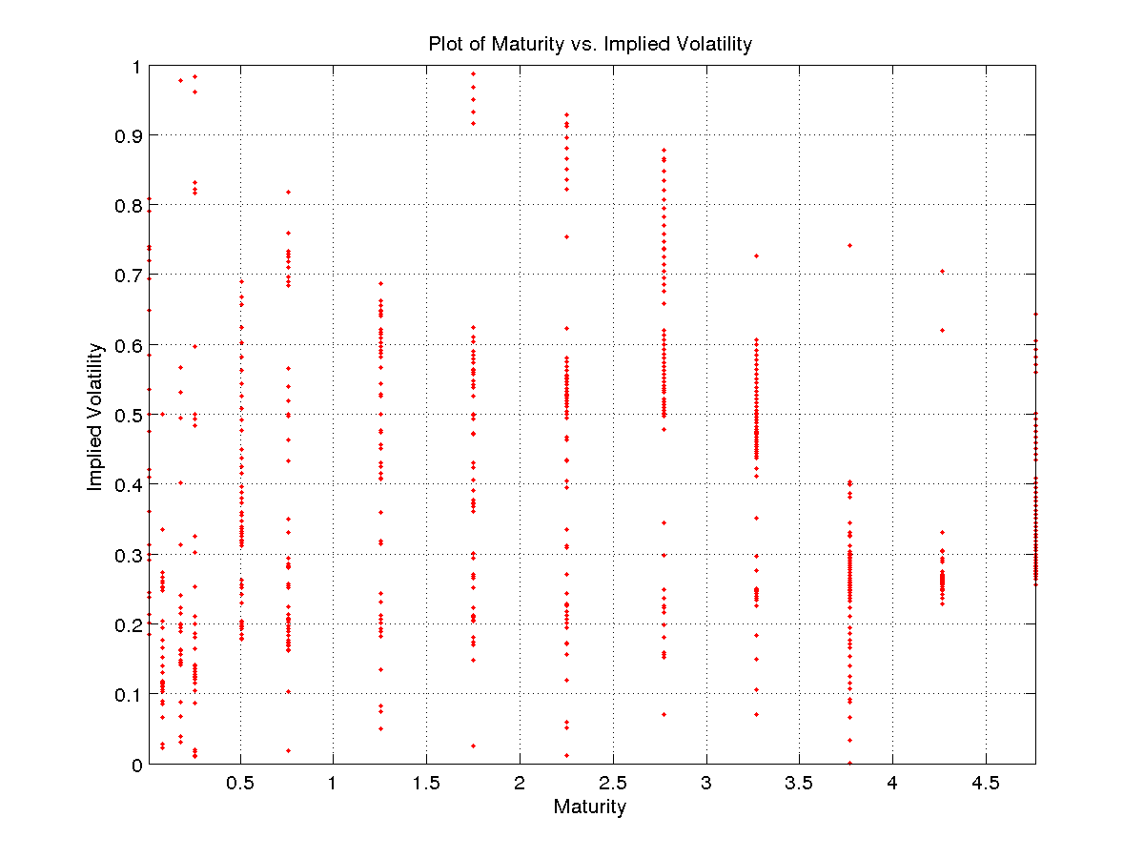
3. 3D Plot:-

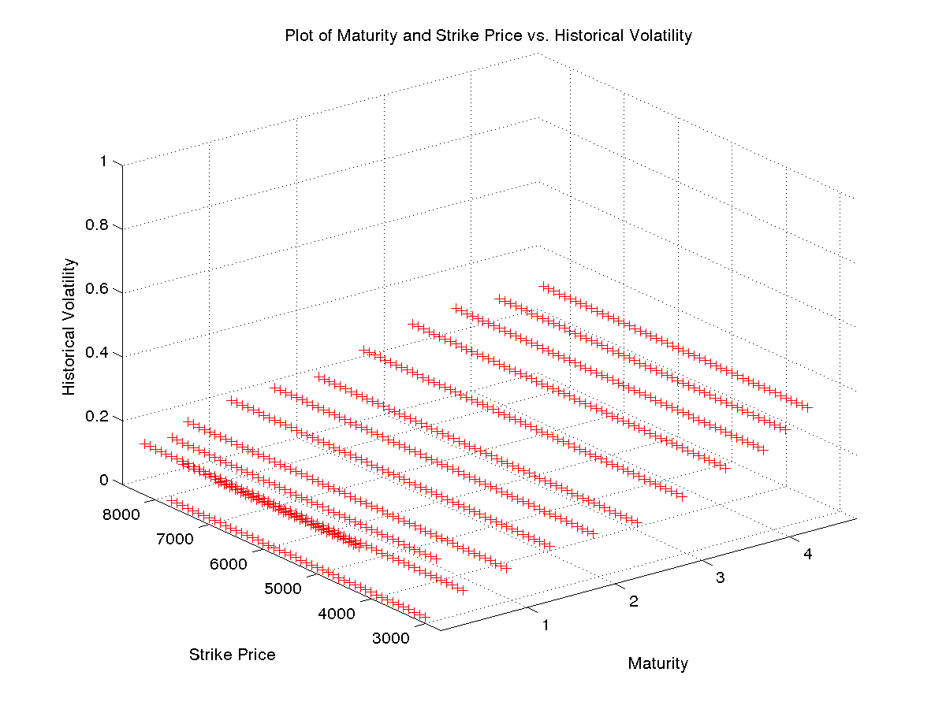
Plot of Strike Price vs. Historical Volatility:-

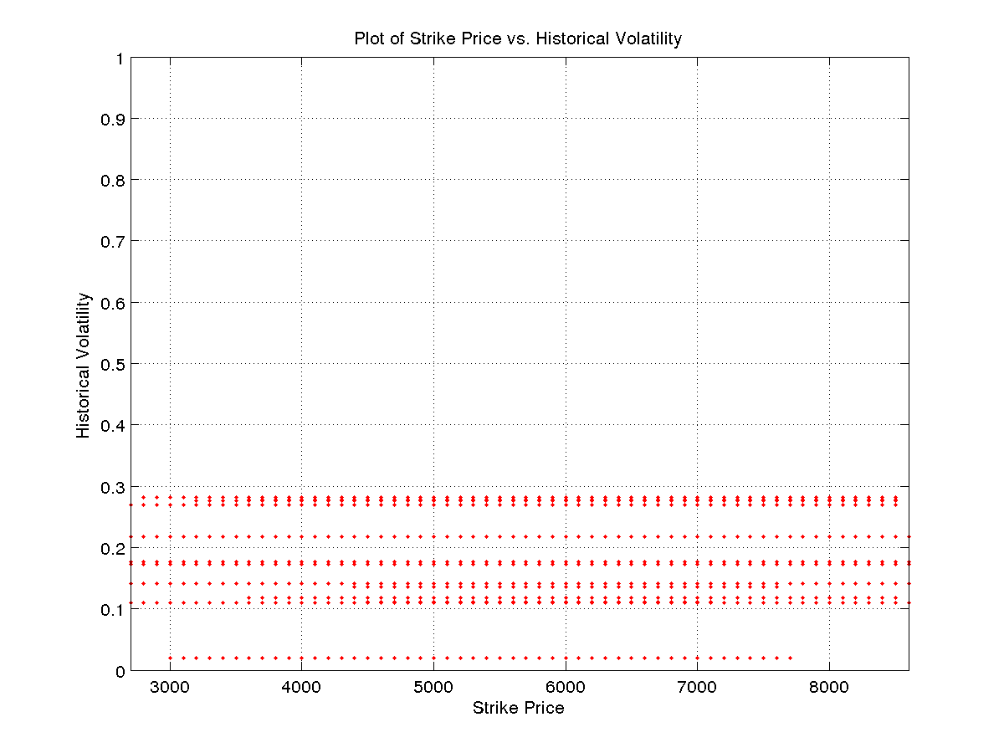
Plot of Maturity vs. Historical Volatility:-
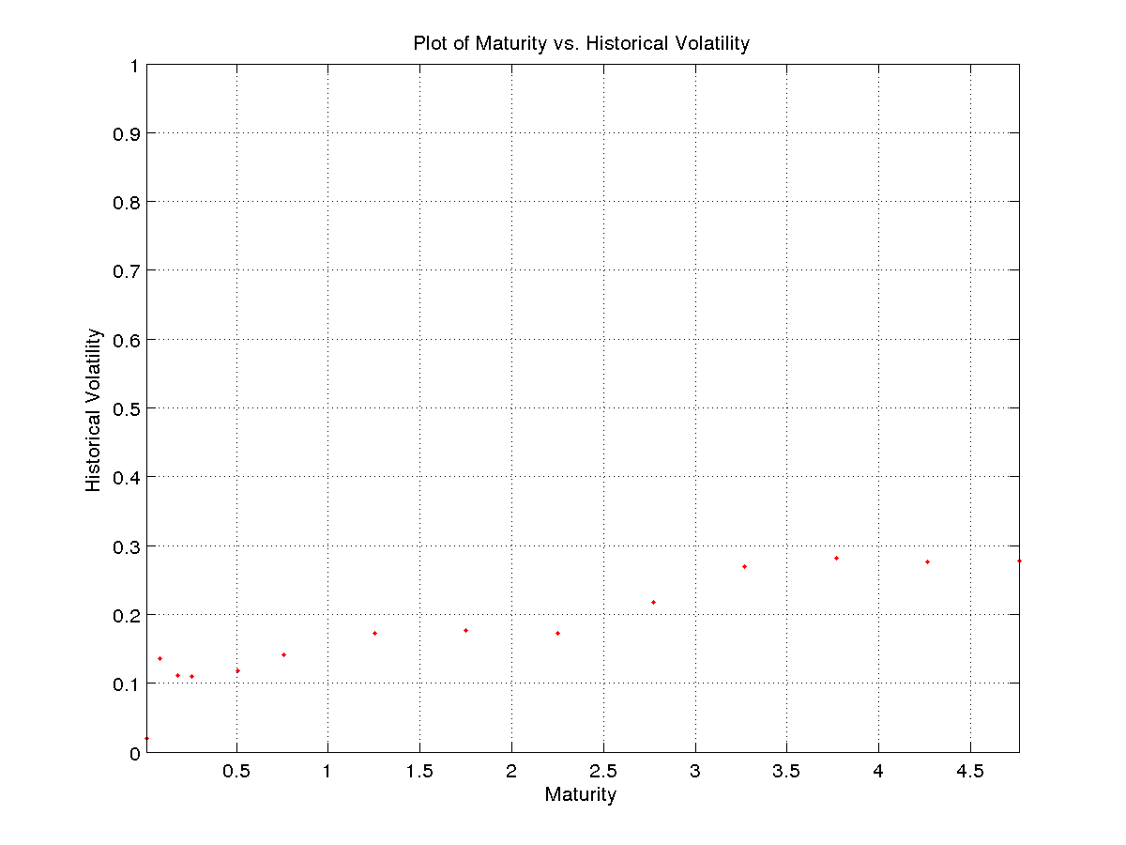

From these plots, it is clear that the implied volatility and historical volatility only match for a small fraction of the call options.

