**How to install mysql server 5.6 on Ubuntu 14.04 LTS**

**Install mysql server 5.6 on Ubuntu 14.04 LTS**

Installing mysql-server 5.6 is very easy. Follow the given below steps

**Step 1: Install MySQL Server 5.6**

Install mysql-server 5.6 with apt-get command.

sudo apt-get update

sudo apt-get install mysql-server-5.6

During installation of MySQL Server packages,on your terminal you will screen of setting mysql root password. Hence, give the mysql user root password.

Given below is screenshot of screen.

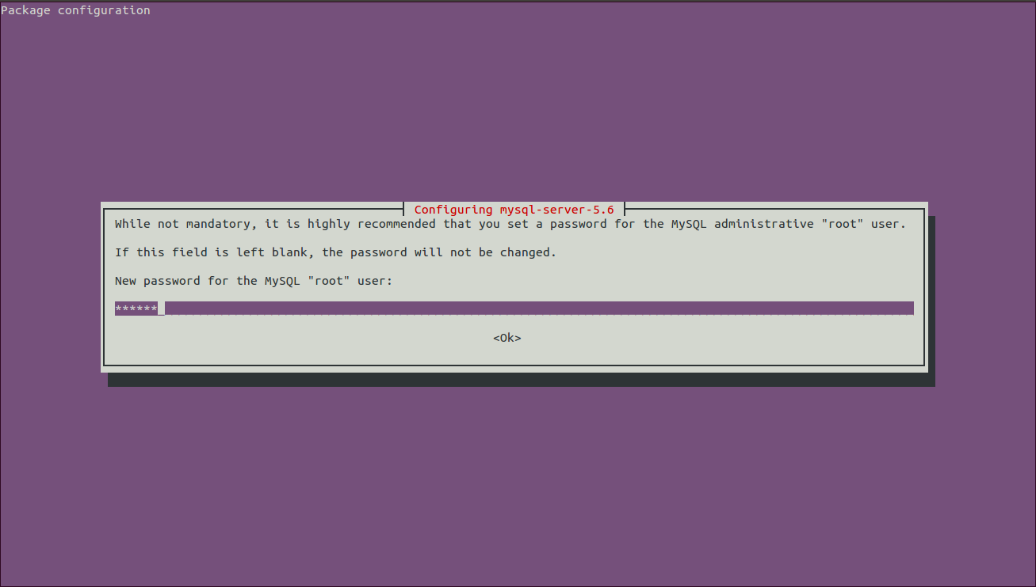

Now it will again ask mysql root password for confirmation. Rewrite the same mysql root password which you have given on first screen.

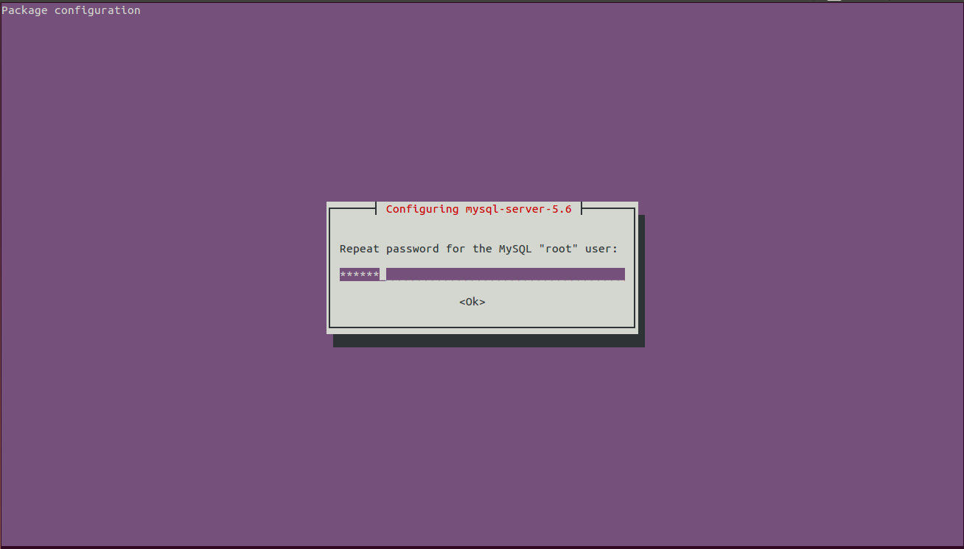

**Step 2 : Login into MySQL Server**

After mysql server installation get finishes , it start the mysql service automatically. Hence, you can login now in MySQL Server with user root.

To login into MySQL Server, use the below given command.It will ask the mysql root password which you have set during mysql server installation.

mysql -u root -p

Given below is the **reference** from my server

sharad@ubuntu:~$ mysql -u root -p

Enter password:

Welcome to the MySQL monitor. Commands end with ; or \g.

Your MySQL connection id is 36

Server version: 5.6.17-0ubuntu0.14.04.1 (Ubuntu)

Copyright (c) 2000, 2014, Oracle and/or its affiliates. All rights reserved.

Oracle is a registered trademark of Oracle Corporation and/or its

affiliates. Other names may be trademarks of their respective

owners.

Type 'help;' or '\h' for help.Type '\c' to clear the current input statement.

mysql> show databases;

+--------------------+

| Database |

+--------------------+

| information_schema |

| mysql |

| performance_schema |

+--------------------+

3 rows in set (0.04 sec)

mysql> exit

Bye

**Step 3 :MySQL Service to Start/Stop/Restart/Status**

(a) To restart the mysql service

sudo service mysql restart

(b) To start mysql Service

sudo service mysql start

(c) To stop mysql service

sudo service mysql stop

(c) To get status of mysql service

sudo service mysql status

**NOTE:** For start/stop/restart/status of mysql , use service command.

## How to Install MySql Workbench on Ubuntu

To install Workbench go to terminal(ctrl + alt + T) and type following commands.

|  |  |
| --- | --- |
| 1 | $sudoadd-apt-repository ppa:olivier-berten/misc |

If you are beginner and not familiar with Linux commands then you check my tutorial on [Linux Commands with example](http://webrewrite.com/linux-commands-with-examples-for-beginners/).

**apt-get update** commands downloads the package lists from the repositories and “updates” them to get information on the newest versions of packages and their dependencies so that you’ll install the latest version of software packages.

|  |  |
| --- | --- |
| 1 | $sudoapt-get update |

Now all the packages information is updated, let’s install workbench.

|  |  |
| --- | --- |
| 1 | $sudoapt-get install mysql-workbench |

Now installation is complete to start this application, typing following command on terminal.

|  |  |
| --- | --- |
| 1 | $mysql-workbench& |

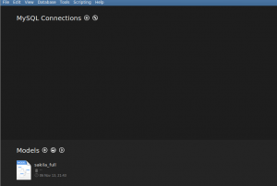

We have done workbench installation through debian apt-get package manager. If you want to know more about this utility. Read about package management through [apt-get utility](http://webrewrite.com/installuninstallremoveupdate-package-apt-get-ubuntu/).

**Assignment I**

Domain types in SQL-

The SQL standard supports a variety of built in domain types, including-

• Char (n)- A fixed length character length string with user specified length .

• Varchar (n)- A variable character length string with user specified maximum

length n.

• Int- An integer.

• Small integer- A small integer.

• Numeric (p, d)-A Fixed point number with user defined precision.

• Real, double precision- Floating point and double precision floating point

numbers with machine dependent precision.

• Float (n)- A floating point number, with precision of at least n digits.

• Date- A calendar date containing a (four digit) year, month and day of the month.

• Time- The time of day, in hours, minutes and seconds Eg. Time ’09:30:00’.

• Number- Number is used to store numbers (fixed or floating point).

**DDL statement for creating a table-**

Syntax-

Create table tablename

(columnnamedatatype(size), columnnamedatatype(size));

**Creating a table from a table-**

Syntax-

CREATE TABLE TABLENAME

[(columnname, columnname, .........)]

AS SELECT columnname, columnname........FROM tablename;

**Insertion of data into tables-**

Syntax-

INSERT INTO tablename

[(columnname, columnname, .........)]

Values(expression, expression);

**Inserting data into a table from another table:**

Syntax-

INSERT INTO tablenameSELECTcolumnname, columnname, .......

FROM tablename;

**Insertion of selected data into a table from another table:**

Syntax-

INSERT INTO tablename

SELECT columnname, columnname........

FROM tablename

WHERE columnname= expression;

**Retrieving of data from the tables-**

Syntax-

SELECT * FROM tablename;

**The retrieving of specific columns from a table-**

Syntax-

SELECT columnname, columnname, ....

FROM tablename;

**Elimination of duplicates from the select statement-**

Syntax-

SELECT DISTINCT columnname, columnname

FROM tablename;

**Selecting a data set from table data-**

Syntax-

SELECT columnname, columnname

FROM tablename

WHERE searchcondition;

**Q. 1. Create the following tables;**

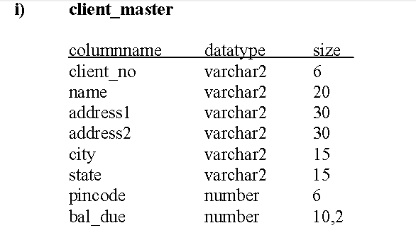

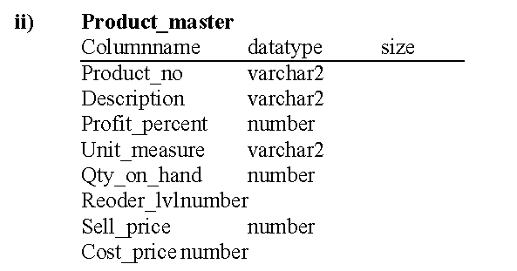

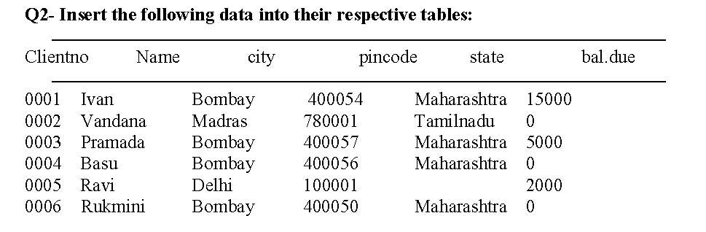

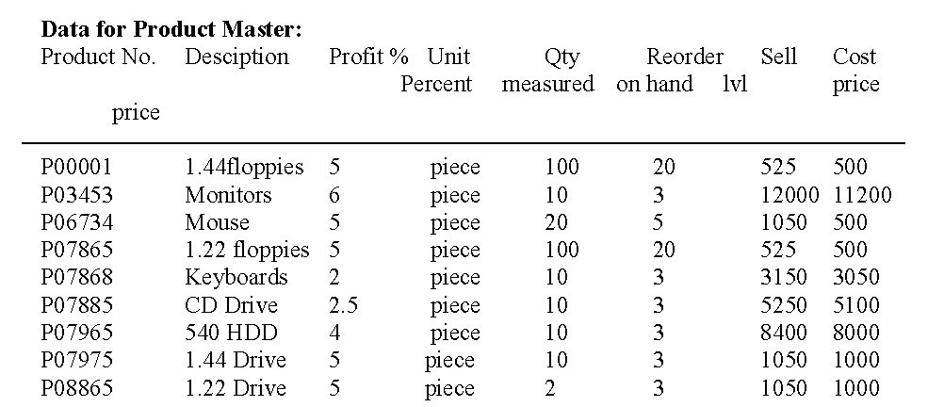

Q3:- On the basis of above two tables answer the following Questionries:

i) Find out the names of all the clients.

ii) Retrieve the list of names and cities of all the clients.

iii) List the various products available from the product_master table.

iv) List all the clients who are located in Bombay.

v) Display the information for client no 0001 and 0002.

vi) Find the products with description as ‘1.44 drive’ and ‘1.22 Drive’.

vii) Find all the products whose sell price is greater then 5000.

viii) Find the list of all clients who stay in in city ‘Bombay’ or city ‘Delhi’ or

‘Madras’.

ix) Find the product whose selling price is greater than 2000 and less than or

equal to 5000.

x) List the name, city and state of clients not in the state of ‘Maharashtra’.