Figure1（from Introduction V1）
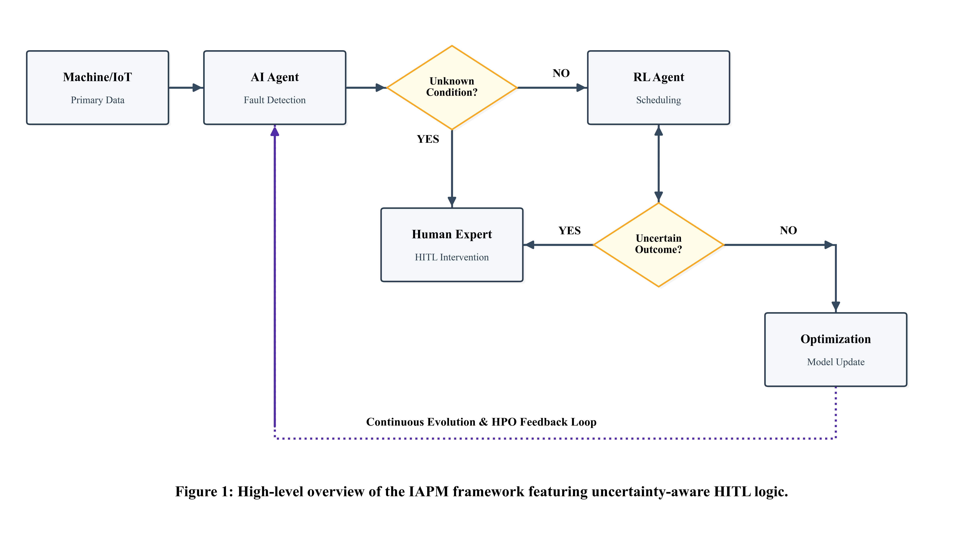

Figure2 (from IAPM framework V2)：

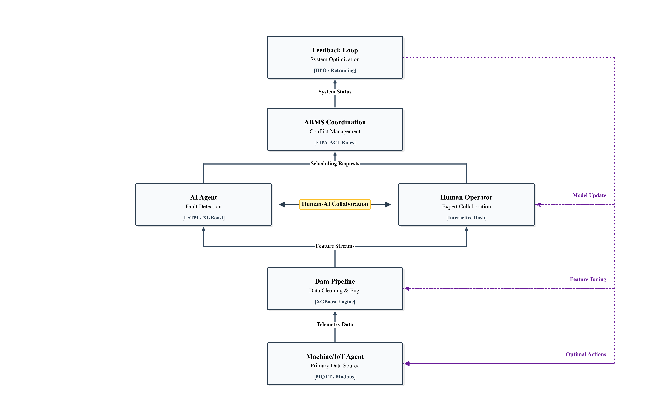
Figure3 (from IAPM framework V2)：
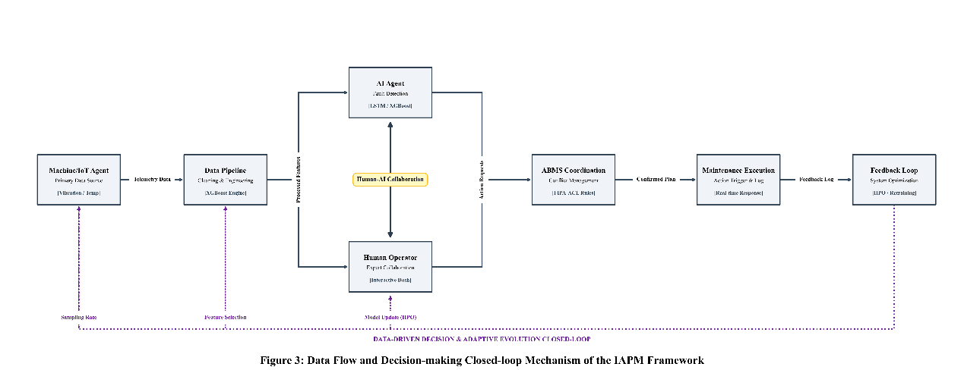

Figure4 (from IAPM framework V2)：
Perhaps be like this

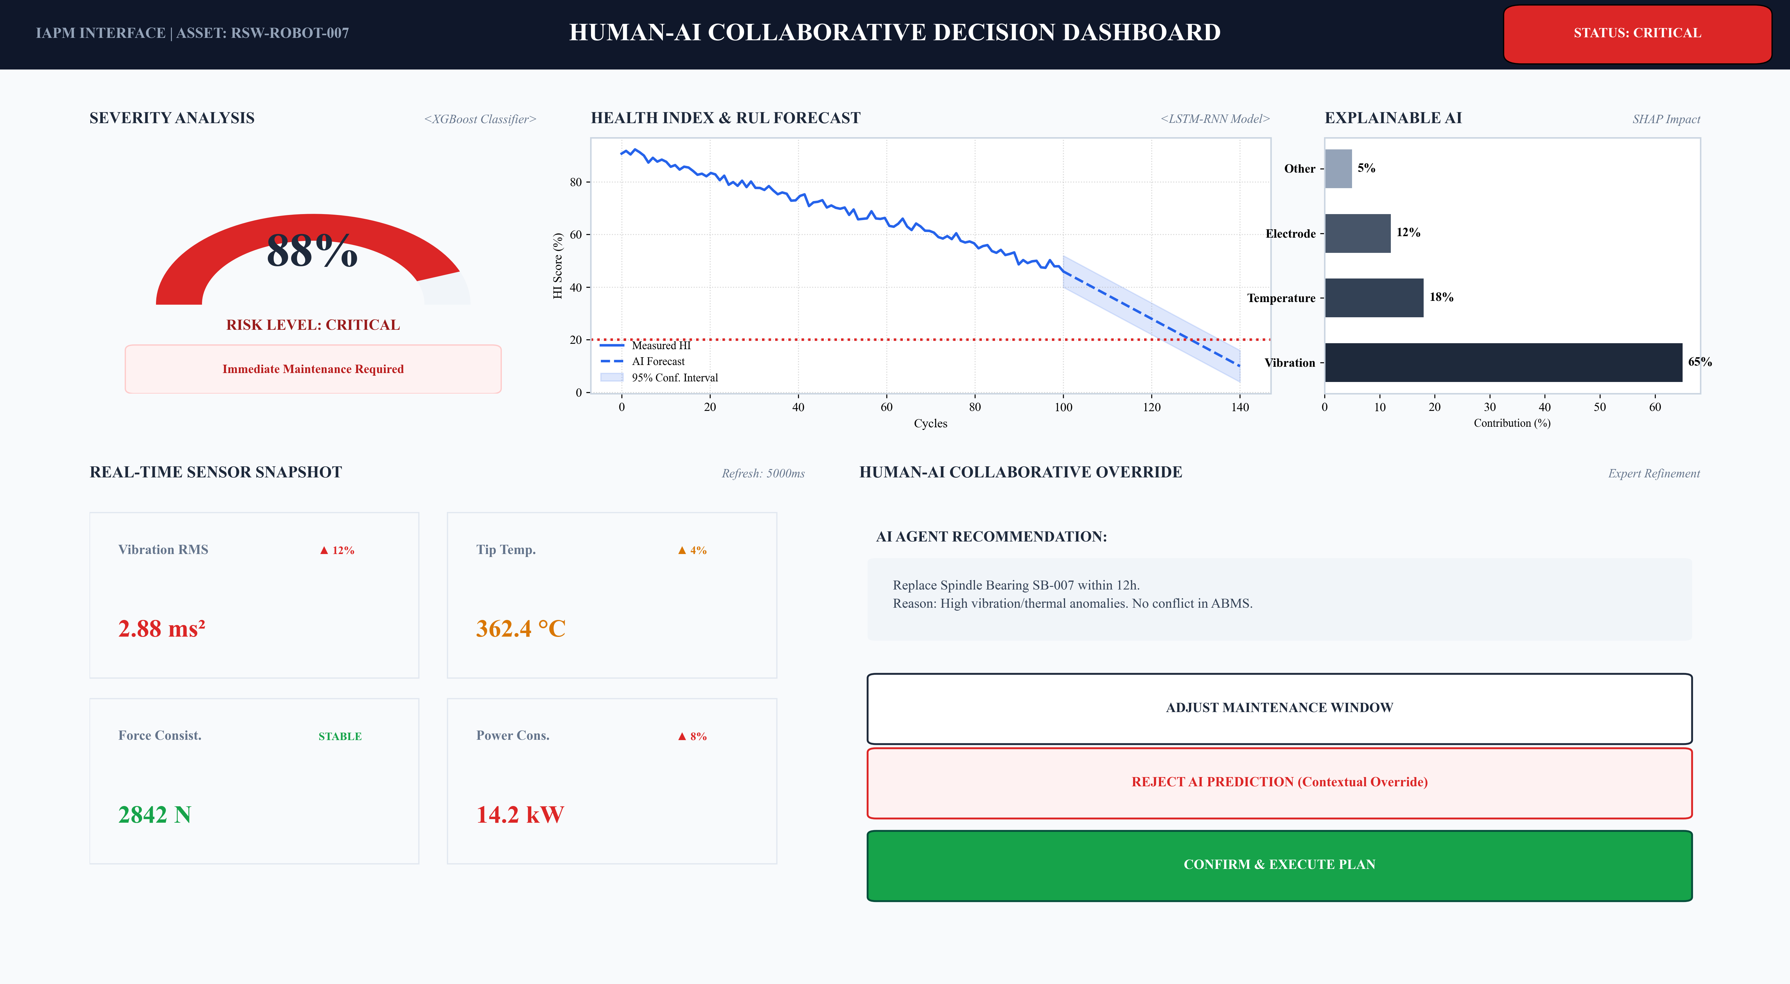

Figure5 (from Methodology V3)
100,000 data simulation:
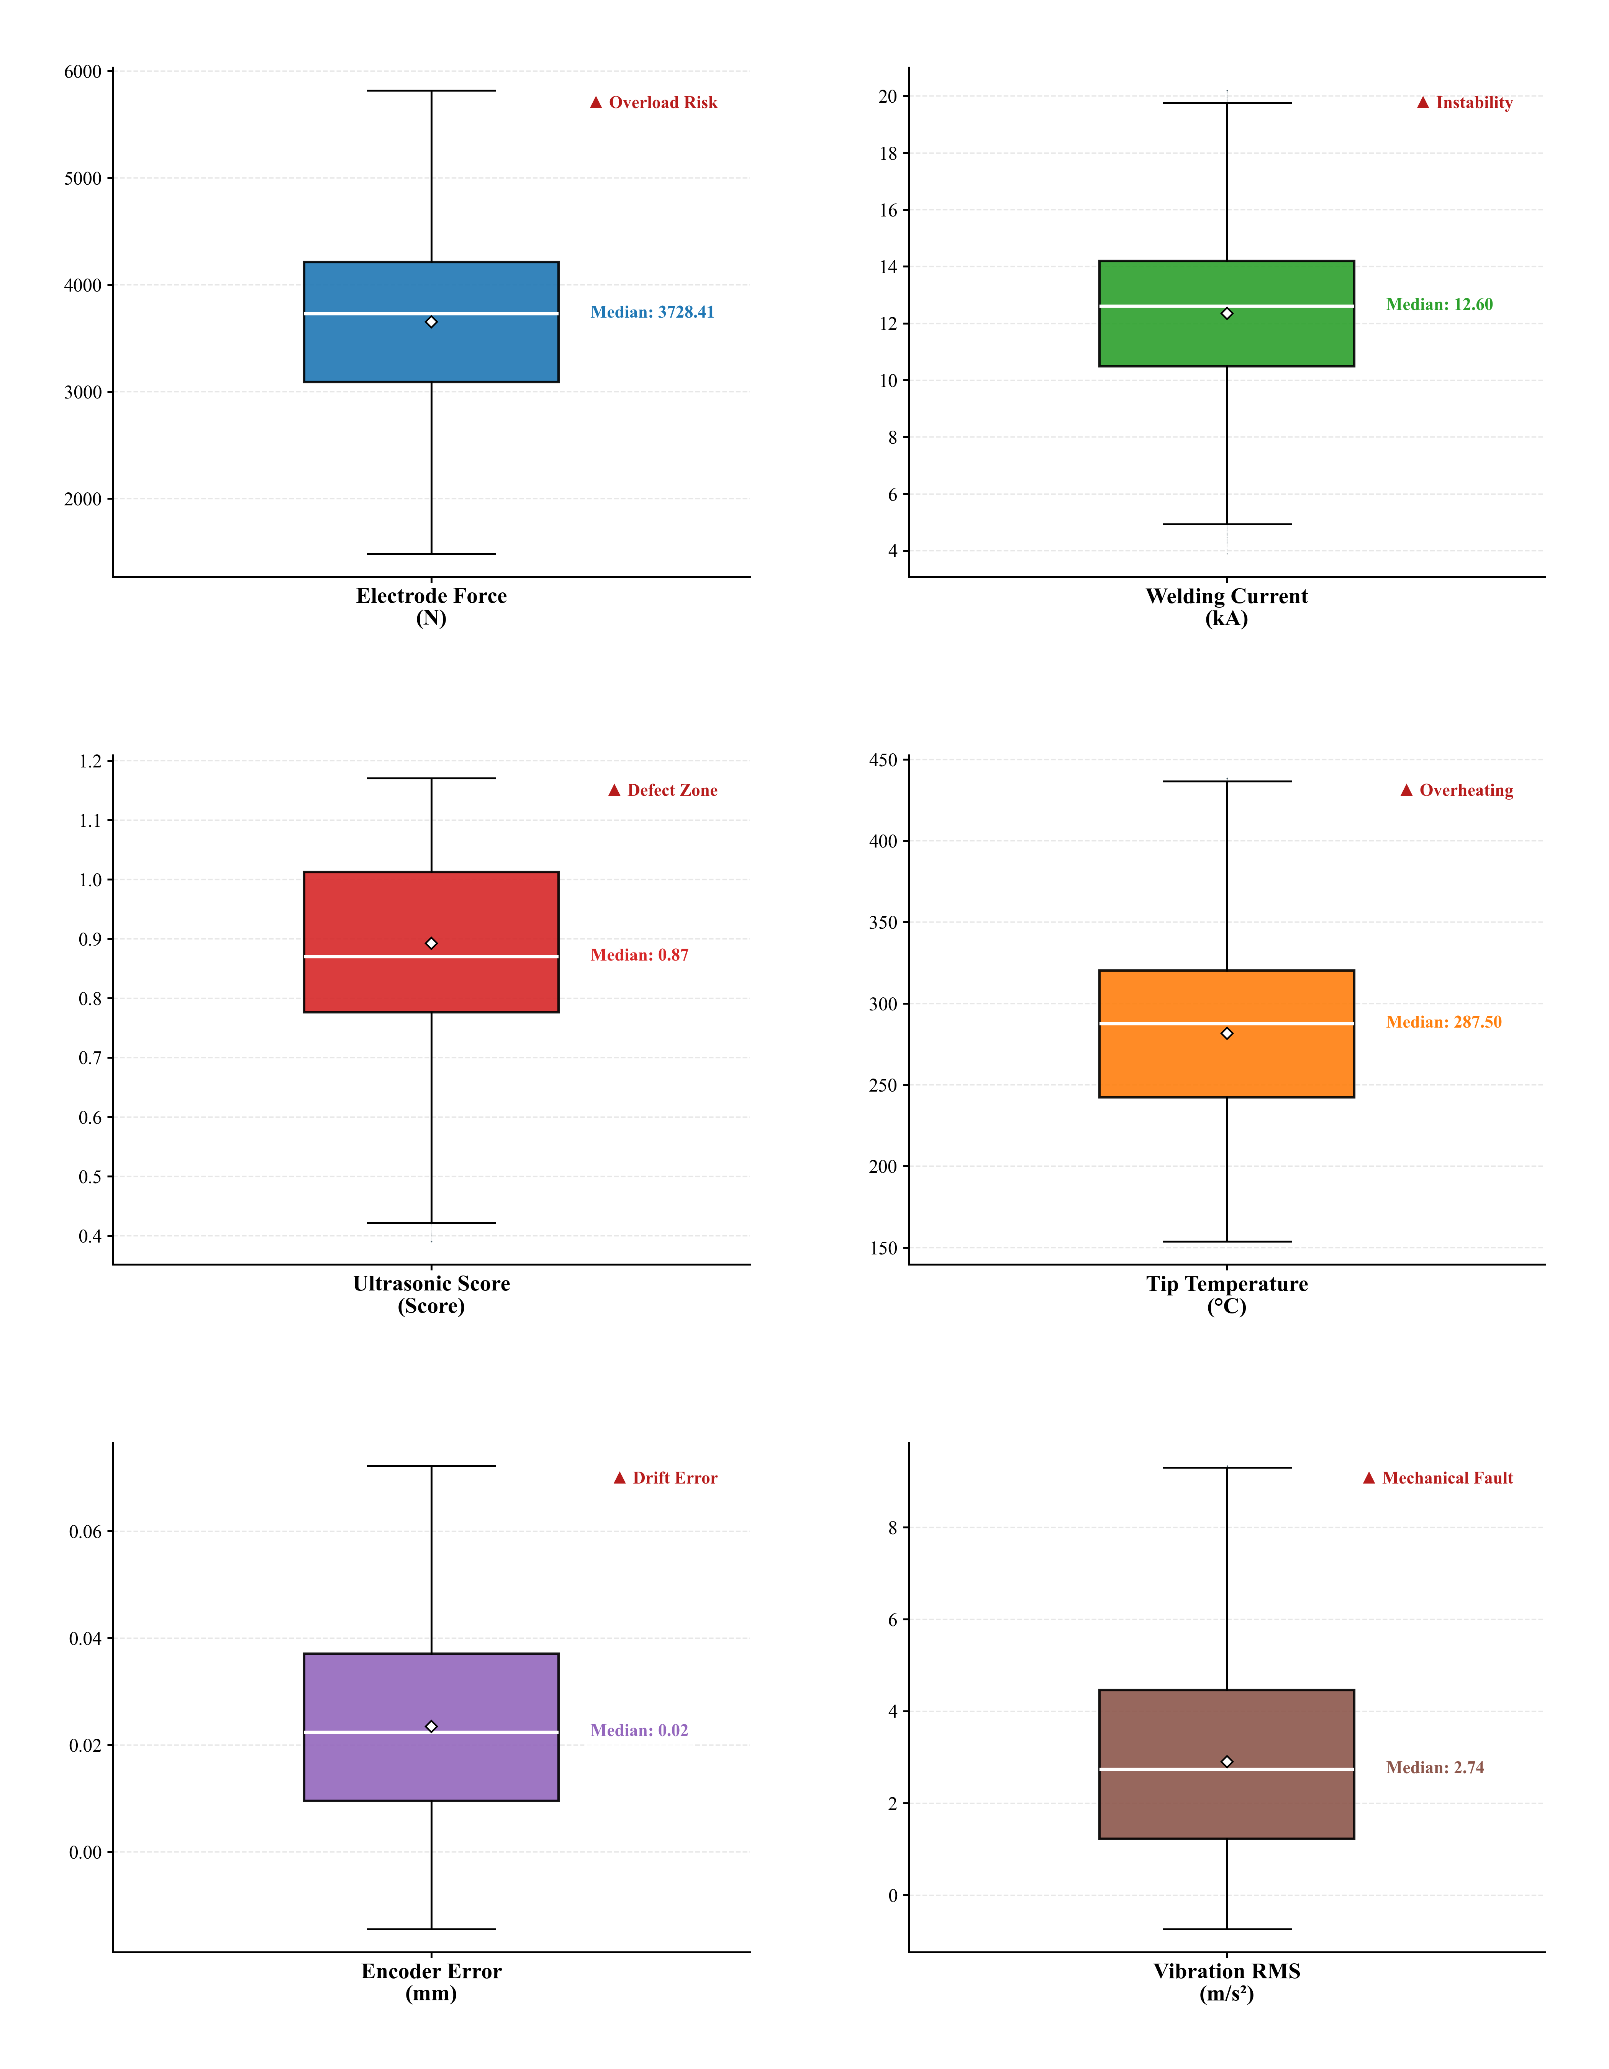

Figure X(from Experimental Results):
