Virat Kohli Test Career Analysis

Deepak Kumar

2025-05-13

#Load neccessary libraries

library(readxl)  
library(dplyr)

##   
## Attaching package: 'dplyr'

## The following objects are masked from 'package:stats':  
##   
## filter, lag

## The following objects are masked from 'package:base':  
##   
## intersect, setdiff, setequal, union

library(ggplot2)

## Warning: package 'ggplot2' was built under R version 4.4.3

library(lubridate)

##   
## Attaching package: 'lubridate'

## The following objects are masked from 'package:base':  
##   
## date, intersect, setdiff, union

###level-1 data cleaning and preprocessing #load the dataset

data<-read_excel("C:/virat kohli analysis/testcareermatchwise.xlsx")

## New names:  
## • `` -> `...8`  
## • `` -> `...12`

View(data)

# Rename columns for readability

colnames(data) <- c("Bat1", "Bat2", "Runs", "BallsFaced", "StrikeRate", "Fours", "Sixes",   
 "Unused", "Opposition", "Ground", "StartDate", "TestNumber")

# Drop unused column

data <- data %>% select(-Unused)

# Remove “v” prefix from Opposition

data$Opposition <- gsub("^v\\s+", "", data$Opposition)

# Convert StartDate to Date format

library(lubridate)  
  
data$StartDate <- dmy(data$StartDate)

## Warning: All formats failed to parse. No formats found.

# Handle missing values and extract not out flag

clean_innings <- function(score) {  
 score <- as.character(score)  
 score[score %in% c("DNB", "TDNB", "absent")] <- NA  
 score <- gsub("\\*", "", score) # Remove not-out asterisk  
 return(as.numeric(score))  
}  
not_out_flag <- function(score) {  
 score <- as.character(score)  
 return(grepl("\\*", score))  
}

# Apply cleaning to Bat1 and Bat2

data <- data %>%  
 mutate(  
 Bat1_NotOut = not_out_flag(Bat1),  
 Bat2_NotOut = not_out_flag(Bat2),  
 Bat1 = clean_innings(Bat1),  
 Bat2 = clean_innings(Bat2)  
 )

## Warning: There was 1 warning in `mutate()`.  
## ℹ In argument: `Bat2 = clean_innings(Bat2)`.  
## Caused by warning in `clean_innings()`:  
## ! NAs introduced by coercion

# Combine total runs in both innings  
data <- data %>%  
 mutate(  
 TotalRuns = rowSums(cbind(Bat1, Bat2), na.rm = TRUE),  
 TotalNotOuts = Bat1_NotOut + Bat2_NotOut,  
 PlayedInnings = (!is.na(Bat1)) + (!is.na(Bat2)),  
 Year = year(StartDate)  
 )

# Clean other numeric columns

data <- data %>%  
 mutate(  
 Runs = as.numeric(Runs),  
 BallsFaced = as.numeric(BallsFaced),  
 StrikeRate = as.numeric(StrikeRate),  
 Fours = as.numeric(Fours),  
 Sixes = as.numeric(Sixes)  
 )

## Warning: There were 5 warnings in `mutate()`.  
## The first warning was:  
## ℹ In argument: `Runs = as.numeric(Runs)`.  
## Caused by warning:  
## ! NAs introduced by coercion  
## ℹ Run `dplyr::last_dplyr_warnings()` to see the 4 remaining warnings.

Add placeholder for match duration

data$MatchDuration <- 5 # By default, Test match = 5 days

# Preview the cleaned data

str(data)

## tibble [123 × 18] (S3: tbl_df/tbl/data.frame)  
## $ Bat1 : num [1:123] 4 0 30 52 11 23 44 116 58 103 ...  
## $ Bat2 : num [1:123] 15 27 NA 63 0 9 75 22 NA 51 ...  
## $ Runs : num [1:123] 19 27 30 115 11 32 119 138 58 154 ...  
## $ BallsFaced : num [1:123] 64 109 53 225 22 65 217 275 107 275 ...  
## $ StrikeRate : num [1:123] 29.7 24.8 56.6 51.1 50 ...  
## $ Fours : num [1:123] 3 1 2 8 1 5 15 13 8 23 ...  
## $ Sixes : num [1:123] 0 1 0 1 0 0 0 1 0 1 ...  
## $ Opposition : chr [1:123] "v West Indies" "v West Indies" "v West Indies" "v West Indies" ...  
## $ Ground : chr [1:123] "Kingston" "Bridgetown" "Roseau" "Wankhede" ...  
## $ StartDate : Date[1:123], format: NA NA ...  
## $ TestNumber : chr [1:123] "Test # 1997" "Test # 1998" "Test # 1999" "Test # 2019" ...  
## $ Bat1_NotOut : logi [1:123] FALSE FALSE FALSE FALSE FALSE FALSE ...  
## $ Bat2_NotOut : logi [1:123] FALSE FALSE FALSE FALSE FALSE FALSE ...  
## $ TotalRuns : num [1:123] 19 27 30 115 11 32 119 138 58 154 ...  
## $ TotalNotOuts : int [1:123] 0 0 0 0 0 0 0 0 0 1 ...  
## $ PlayedInnings: int [1:123] 2 2 1 2 2 2 2 2 1 2 ...  
## $ Year : num [1:123] NA NA NA NA NA NA NA NA NA NA ...  
## $ MatchDuration: num [1:123] 5 5 5 5 5 5 5 5 5 5 ...

head(data)

## # A tibble: 6 × 18  
## Bat1 Bat2 Runs BallsFaced StrikeRate Fours Sixes Opposition Ground   
## <dbl> <dbl> <dbl> <dbl> <dbl> <dbl> <dbl> <chr> <chr>   
## 1 4 15 19 64 29.7 3 0 v West Indies Kingston   
## 2 0 27 27 109 24.8 1 1 v West Indies Bridgetown  
## 3 30 NA 30 53 56.6 2 0 v West Indies Roseau   
## 4 52 63 115 225 51.1 8 1 v West Indies Wankhede   
## 5 11 0 11 22 50 1 0 v Australia Melbourne   
## 6 23 9 32 65 49.2 5 0 v Australia Sydney   
## # ℹ 9 more variables: StartDate <date>, TestNumber <chr>, Bat1_NotOut <lgl>,  
## # Bat2_NotOut <lgl>, TotalRuns <dbl>, TotalNotOuts <int>,  
## # PlayedInnings <int>, Year <dbl>, MatchDuration <dbl>

*after performing all cleanig check the data type of columns and retrieve first 8 data using head function

###Level -2 stastical analysis of my dataset # 1. Overall career batting average (runs per innings)

career_average <- sum(data$TotalRuns, na.rm = TRUE) / sum(data$PlayedInnings, na.rm = TRUE)

*this average may differ from real average because in real average for cricket matches consider not out inning then calculate*

# 2. Career not-out percentage

not_out_percentage <- mean(data$TotalNotOuts > 0) * 100

# 3. Highest score in a single innings

highest_score <- max(c(data$Bat1, data$Bat2), na.rm = TRUE)

*this score was made by kohli against south africa*

# 4. Total career runs

total_runs <- sum(data$TotalRuns, na.rm = TRUE)

*in test matches virat has scored total 9230 runs*

# 5. Total centuries (100+ in any single innings)

centuries <- sum(data$Bat1 >= 100, na.rm = TRUE) + sum(data$Bat2 >= 100, na.rm = TRUE)

*virat has scroed total 30 test centuries*

# 6. Total fifties (50–99 in any innings)

fifties <- sum(data$Bat1 >= 50 & data$Bat1 < 100, na.rm = TRUE) +  
 sum(data$Bat2 >= 50 & data$Bat2 < 100, na.rm = TRUE)

*virat has scored 31 total fifites*

# 7. Average runs per year

avg_runs_year <- data %>%  
 group_by(Year) %>%  
 summarise(RunsInYear = sum(TotalRuns, na.rm = TRUE)) %>%  
 mutate(AveragePerYear = round(RunsInYear / n(), 2))

# 8. Average against each opposition

avg_opposition <- data %>%  
 group_by(Opposition) %>%  
 summarise(Average = round(sum(TotalRuns, na.rm = TRUE) / sum(PlayedInnings, na.rm = TRUE), 2),  
 Matches = n())

*this table shows batting average of virat kohli against each teams*

# 9. Ground-wise batting average

avg_ground <- data %>%  
 group_by(Ground) %>%  
 summarise(Average = round(sum(TotalRuns, na.rm = TRUE) / sum(PlayedInnings, na.rm = TRUE), 2),  
 Matches = n())

*this table shows average of different grounds*

# 10. Strike Rate analysis: mean and max

mean_strike_rate <- mean(data$StrikeRate, na.rm = TRUE)  
max_strike_rate <- max(data$StrikeRate, na.rm = TRUE)  
print(mean_strike_rate)

## [1] 51.20223

print(max_strike_rate)

## [1] 105.55

*virat mean strike rate is 51.20223* *virat max strike rate in test is 105.55*

###Level-3 visualization of my dataset #loading required libraries visualization

library(ggplot2)  
library(dplyr)  
library(tidyr)

#virat kohli runs against opponents

ggplot(data %>% group_by(Opposition) %>% summarise(TotalRuns = sum(TotalRuns, na.rm = TRUE)),  
 aes(x = reorder(Opposition, -TotalRuns), y = TotalRuns)) +  
 geom_col(fill = "tomato") +  
 coord_flip() +  
 labs(title = "Total Runs vs Each Opposition", x = "Opposition", y = "Runs")

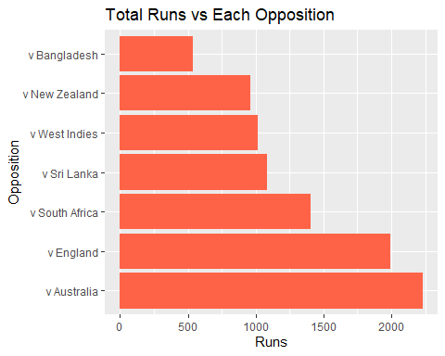

#vira kohli batting average per oppositon

data %>%  
 group_by(Opposition) %>%  
 summarise(Average = sum(TotalRuns, na.rm = TRUE) / sum(PlayedInnings, na.rm = TRUE)) %>%  
 ggplot(aes(x = reorder(Opposition, -Average), y = Average)) +  
 geom_col(fill = "purple") +  
 coord_flip() +  
 labs(title = "Batting Average vs Opposition", x = "Opposition", y = "Average")

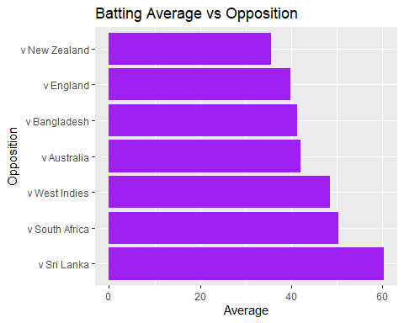

# virat kohli performence over time innings-by-innings

data %>%  
 mutate(MatchNumber = row_number()) %>%  
 ggplot(aes(x = MatchNumber, y = TotalRuns)) +  
 geom_line(color = "blue") +  
 geom_smooth(se = FALSE, color = "red") +  
 labs(title = "Match-by-Match Total Runs", x = "Match Number", y = "Runs")

## `geom_smooth()` using method = 'loess' and formula = 'y ~ x'

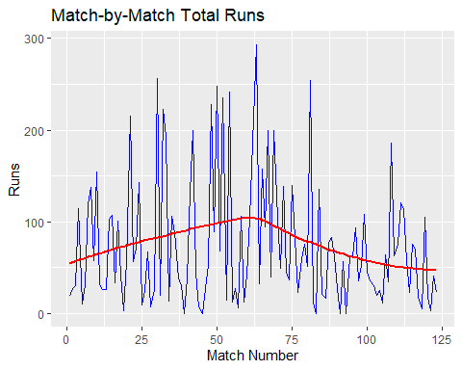

# virat kohli runs distributions using histogram

ggplot(data, aes(x = TotalRuns)) +  
 geom_histogram(binwidth = 10, fill = "orange", color = "black") +  
 labs(title = "Runs Distribution per Match", x = "Runs", y = "Frequency")

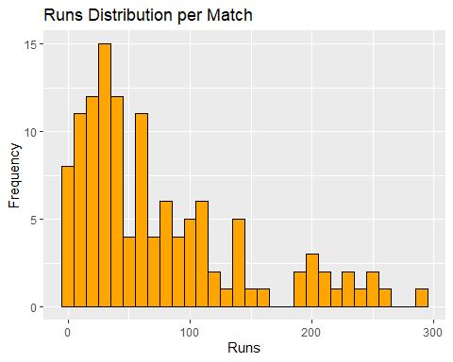

# virat kohli strike rate over time

data %>%  
 mutate(MatchNumber = row_number()) %>%  
 ggplot(aes(x = MatchNumber, y = StrikeRate)) +  
 geom_line(color = "darkred") +  
 geom_point() +  
 labs(title = "Strike Rate Match-by-Match", x = "Match Number", y = "Strike Rate")

## Warning: Removed 2 rows containing missing values or values outside the scale range  
## (`geom_point()`).

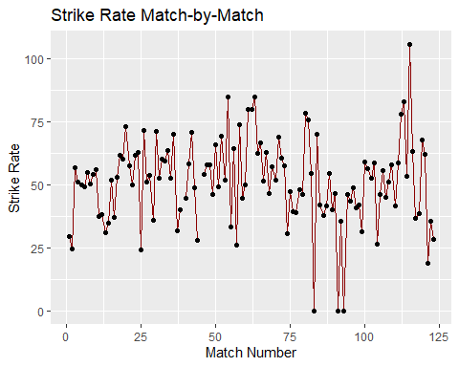

#virat kohli runs by ground

data %>%  
 group_by(Ground) %>%  
 summarise(Runs = sum(TotalRuns, na.rm = TRUE)) %>%  
 arrange(desc(Runs)) %>%  
 head(10) %>%  
 ggplot(aes(x = reorder(Ground, -Runs), y = Runs)) +  
 geom_col(fill = "navy") +  
 coord_flip() +  
 labs(title = "Top 10 Grounds with Most Runs", x = "Ground", y = "Runs")

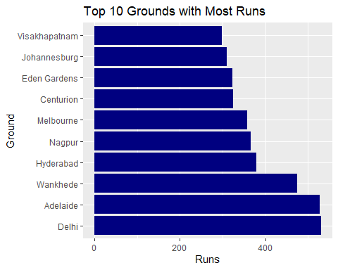

# virat kohli total fours and sixes

data %>%  
 summarise(TotalFours = sum(Fours, na.rm = TRUE),  
 TotalSixes = sum(Sixes, na.rm = TRUE)) %>%  
 pivot_longer(cols = everything(), names_to = "Type", values_to = "Count") %>%  
 ggplot(aes(x = Type, y = Count, fill = Type)) +  
 geom_col() +  
 labs(title = "Total Fours vs Sixes", x = "Type", y = "Count")

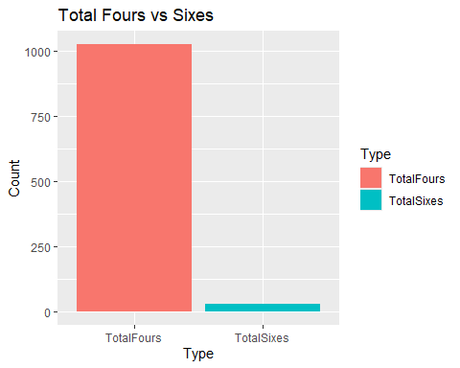

#virat kohli bat1 vs bat2 comparison using bar plot

# Step 1: Add Match number  
data <- data %>%  
 mutate(Match = row_number())  
  
# Step 2: Reshape data into long format  
data_long <- data %>%  
 select(Match, Bat1, Bat2) %>%  
 pivot_longer(cols = c(Bat1, Bat2), names_to = "Innings", values_to = "Runs")  
  
# Step 3: Ensure Runs is numeric  
data_long$Runs <- as.numeric(data_long$Runs)  
  
# Step 4: Create the plot  
ggplot(data_long, aes(x = Match, y = Runs, color = Innings)) +  
 geom_line(size = 1) +  
 labs(title = "Innings-wise Batting Comparison", x = "Match Number", y = "Runs Scored") +  
 theme_minimal()

## Warning: Using `size` aesthetic for lines was deprecated in ggplot2 3.4.0.  
## ℹ Please use `linewidth` instead.  
## This warning is displayed once every 8 hours.  
## Call `lifecycle::last_lifecycle_warnings()` to see where this warning was  
## generated.

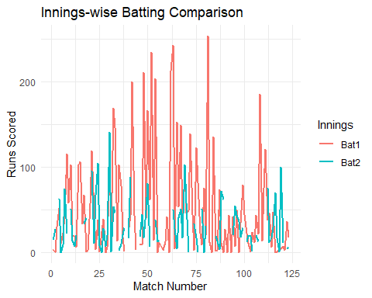

# 100s and 50s highlight chart

ggplot(data, aes(x = Match, y = TotalRuns, fill = TotalRuns)) +  
 geom_col() +  
 scale_fill_gradient2(low = "skyblue", high = "darkred", midpoint = 100) +  
 geom_hline(yintercept = 50, linetype = "dashed", color = "orange") +  
 geom_hline(yintercept = 100, linetype = "dashed", color = "green") +  
 labs(title = "Test Scores with 50 & 100 Milestones", x = "Match", y = "Total Runs") +  
 theme_minimal()

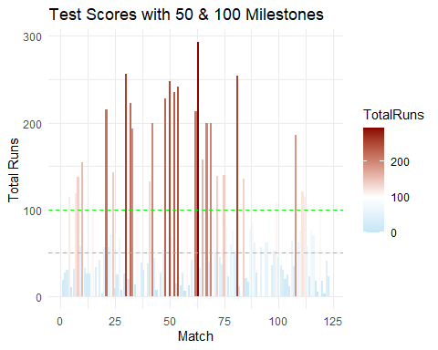

##Runs Over Time

data <- data %>%  
 mutate(CumulativeRuns = cumsum(TotalRuns))  
  
ggplot(data, aes(x = Match, y = CumulativeRuns)) +  
 geom_line(color = "darkgreen", size = 1) +  
 labs(title = "Cumulative Runs Over Test Career", x = "Match Number", y = "Cumulative Runs") +  
 theme_minimal()

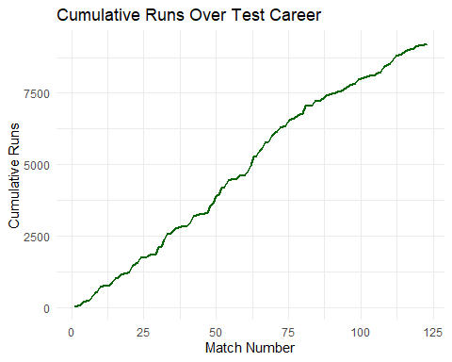 *this graph shows total runs have accumulayed across his career*