Postbeam integrations
LinkedIn is connected to Gnaneshwari Pinna and Slack is connected to GTM-agent in this screenshot.
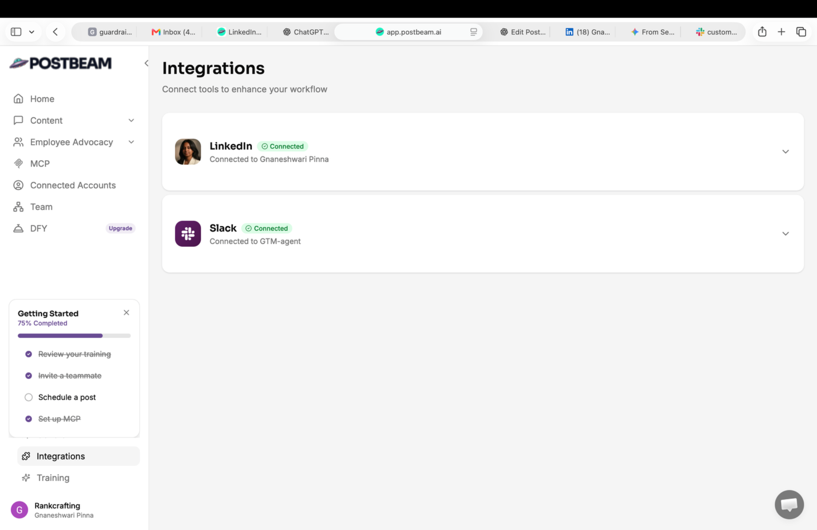

Postbeam LinkedIn drafts
The Draft tab shows LinkedIn post drafts for Gnaneshwari Pinna.
