5 4 3 2 1

VCC_5_MCU

U1

BS[7:0]

VCC_5_MCU

U2

16 VCC

D

C1

7

QD 5

QE 4

QF 6

QG 14

QH 13

QI 15

QJ

CLK_320 CLK_160 CLK_80 CLK_40

BS7 BS6 BS5 BS4 BS3 BS2 BS1

1. D7
2. D6
3. D5
4. D4
5. D3
6. D2
7. D1

VCC 16

5

Y

6

W

D

0.1uF

12

11

8



CLR CLKI GND

74HC4060

QL 1

QM 2

QN 3

CLKO 9

CLKO 10

U3

1 P1.0/ADC0/CLKOUT2

C3 0.1uF

VCC 40

VCC_5_MCU

BS0

BS_G

4 D0

7 G

1. C
2. B
3. A

74HC151

GND 8

C2 0.1uF



R1 1M

Y1 20MHz

C

C6

C4 22pF

C7

RXD2 TXD2

RXD

2 P1.1/ADC1

1. P1.2/ADC2/ECI/RXD2
2. P1.3/ADC3/CCP0/TXD2
3. P1.4/ADC4/CCP1/SS
4. P1.5/ADC5/MOSI
5. P1.6/ADC6/MISO
6. P1.7/ADC7/SCLK 9 P4.7/RST

10 P3.0/RXD

P0.0/AD0 39

P0.1/AD1 38

P0.2/AD2 37

P0.3/AD3 36

P0.4/AD4 35

P0.5/AD5 34

P0.6/AD6 33

P0.7/AD7 32

P4.6/EX_LVD/RST2 31

BS0

BS1

BS2

BS3

BS4

BS5

BS6

BS7

VCC_5_MCU

C5 0.1uF

C

U4A

4

22pF

22pF

TXD

I2C_SCL

11 P3.1/TXD 12 P3.2/INT0 13 P3.3/INT1

1. P3.4/T0/INT/CLKOUT0
2. P3.5/T1/INT/CLKOUT1

P4.5/ALE 30

P4.4/NA 29

P2.7/A15 28

P2.6/A14 27

P2.5/A13 26

PWR_EN [3]

CSEL1 [3]

* 1. 1D
  2. 1CLK

1PRE 1Q

5 CLK_40D [2]

VCC_5_MCU

J1

4

4

3

3

2

2

1 1

I2C_SDA

16 P3.6/WR

17 P3.7/RD

1. XTAL2
2. XTAL1
3. GND STC12C5A60S2

P2.4/A12 25

P2.3/A11 24

P2.2/A10 23

P2.1/A9 22

P2.0/A8 21

CSEL0 [3]

DAC_LOAD [3]

DAC_CS [3]

DAC_CLK [3]

DAC_DATA [3]

14 VCC

7 GND 1CLR 1Q 6

74HC74

1

VCC_5_MCU

JP0104

B J2

4 4

3 3

2 2

VCC_5_MCU

C23

+

VCC_5_MCU

U4B

12 2D

11 2CLK

2PRE

2Q 9

10

ZOUT [3]

B

1 1

JP0104

VCC_5_MCU

R55 10K

VCC_5_MCU

U5

C8 0.1uF

220uF 16V

R2 3.3K

R3 3.3K

R59 1K

8

2CLR 2Q

74HC74

13

ZOUT# [3]

VCC_5_MCU

J4

5 ENC_B

5 4 ENC_A

4 3 ENC_PB 3 2

2 1

R4 3.3K

Q1



R5 100R

1. 32KHZ
2. VCC
3. INT/SQW
4. RST
5. NC_5
6. NC_6

SCL 16

SDA 15

VBAT 14

GND 13

NC_12 12

NC_11 11

C20

BT1

D1

LED RED

VCC_5

VCC_5_MCU

1

JP0105

A

VCC_5_MCU

R56 10K

R57 10K

R58 10K

2N3906

R7 10K

S1

SW-TC-1

1. NC_7
2. NC_8 DS3231

|  |  |  |
| --- | --- | --- |
|  |  |  |

NC_10 10

NC_9 9

0.1uF_NP

CR2032

R6 0R_NP

A

Title

MCU

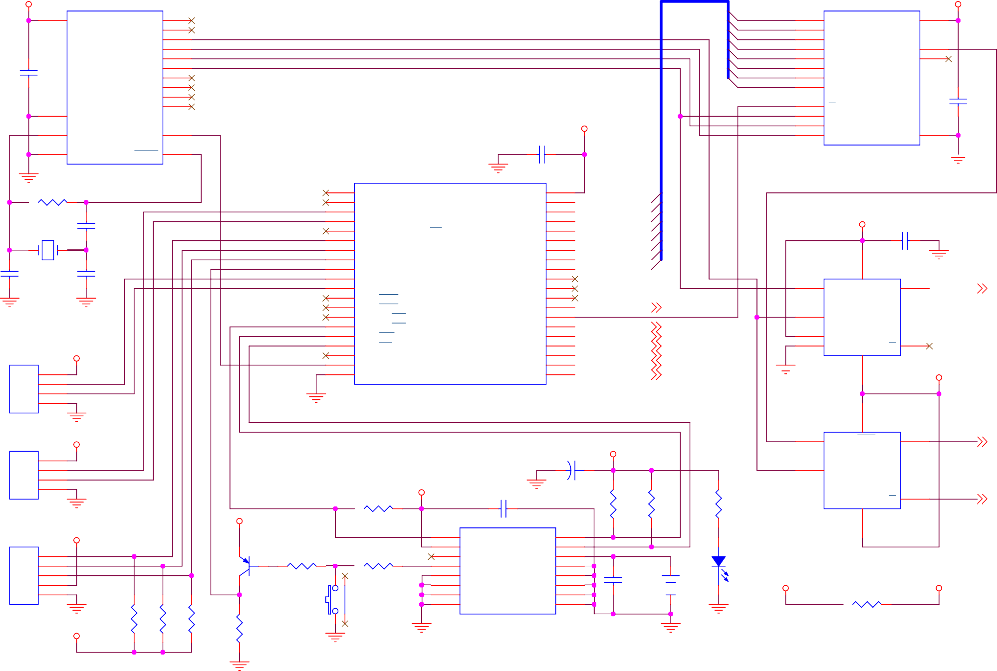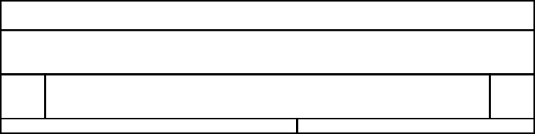

5 4 3

Size A4

Date:

2

Document Number CRT-SC-CON-02

Wednesday, July 31, 2019

Sheet 1

1

of 3

Rev

1.0

5 4 3 2 1

[1]

CLK_40D

C9 0.1uF

R8 20K

C10 1nF

VCC_5_N VCC_5

R60 10K

D

C11 1nF

R15 220R

R10 80.6K

2

3

VCC_5

U6A TL082

8

1

4

VCC_5_N

R12 4.7K

R16 4.7K

R13 2K

R11 7.5K

R14 10K

**SN OFST**

U8B

6 TL082

7

5

D

**SN AMP**

CSSN [3]



R21 20K

C

R22 10K

R23 10K

R24 10K

VCC_5

**SIZE**

R17 4.7K

R25 4.7K

R18 2K

R19 10K

R20 10K VCC_5

**S OFST**

C

U8A

8

R28 20K

6

7

5

U6B

4

4

R27 10K

8

**ROT**

2

3

C13

U7A TL082

1

R26 10K

2

3

R29

TL082 1

CSS [3]

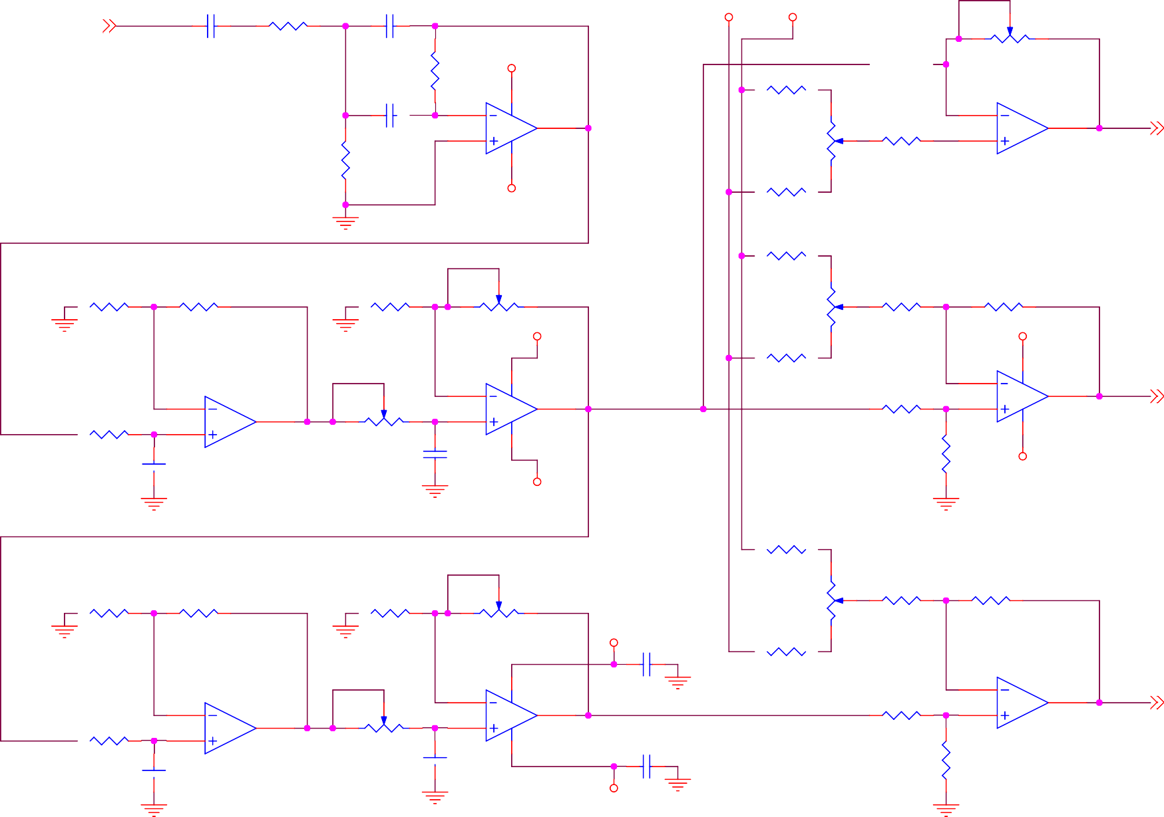

 C12

470pF

TL082

100pF

VCC_5_N

10K

VCC_5_N

R30 4.7K

**C OFST**

B

R34 10K

R35 20K

R36 10K

# HEIGHT

R37 10K

VCC_5

C14 0.1uF

R38 4.7K

R31 2K

R32 10K

R33 10K B



R41 20K

6

7

5

U7B

4

R40 10K

**SHAPE**

2

3

C15

U9A TL082

1

C16 0.1uF

R39 10K

6

5

R42

7

8

U9B TL082

CSC [3]

C17

1nF

TL082

100pF

VCC_5_N

10K

A A

5 4 3



Title

Circle Generator 1

Size A4

Document Number CRT-SC-CON-02

Rev

1.0

Date:

2

Saturday, September 21, 2019

Sheet

2

of

3

1

5 4 3 2 1

|  |  |  |
| --- | --- | --- |
| D |  | |
|  | [2] | CSS |
|  | [2] | CSC |
|  | [2] | CSSN |
|  | [1] | CSEL1 |
|  | [1] | CSEL0 |

U10

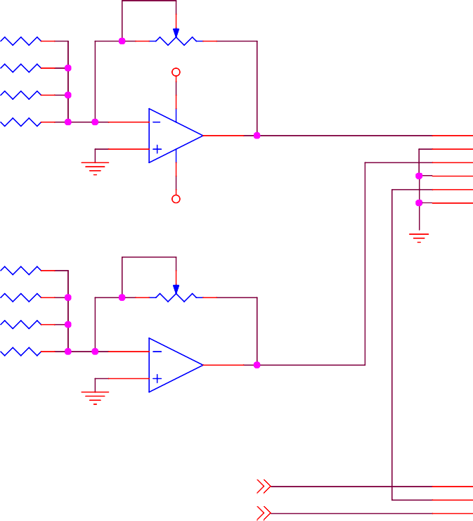

R44 10K

R43 20K

R45 20K

VCC_5

R46 20K

U11A TL082

R47 40.2K 2

J6

1 XOUT

3

1

2

4

5

6

VCC_5_N

XH

R49 20K

R51 10K

R50 20K

R52 20K U11B

TL082

R53 40.2K 6

7 YOUT

5

J7

[1]

ZOUT

1

[1]

ZOUT#

3

2

1

2

3

3

1

2

3

4

5

6

**V SIZE**

**H SIZE**

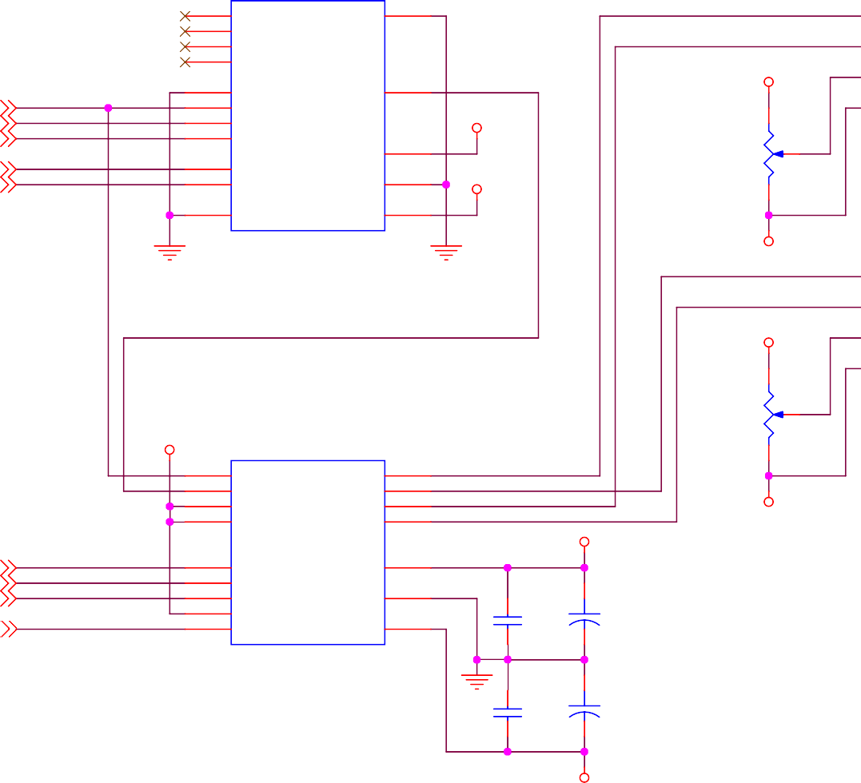

11

15

14

12

X3 X2 X1 X0

X

13

VCC_5

4

2

5

1

Y3 Y2 Y1 Y0

Y

3

VCC_5

9

10

VDD

16

A1 A0

GND

8

VCC_5_N

R48 10K

6

INH

CD4052

VSS

7

VCC_5_N

VCC_5

VCC_5

R54 10K

4

5

13

12

U12

VREFA VREFB VREFC VREFD

VOUTA VOUTB VOUTC VOUTD

2

1

16

15

VCC_5_N

VCC_5

10

11

7

8

9

CLK

SDI/SHDN

LDAC

CLR CS

AD7304

VDD

14

GND

6

+

VSS

3

C18 0.1uF

C24 220uF 16V

+

C19 0.1uF

C25 220uF 16V

**V POS**

**H POS**

D

8



-6

4

C C



[1]

[1]

[1]

[1]

B

DAC_CLK DAC_DATA DAC_LOAD

DAC_CS

JP0103

B

VCC_5_N VCC_5

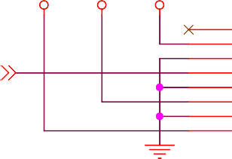

1

2

3

8

7

6

5

4

1

2

3

4

5

6

7

8

VCC_5_MCU

J8

VCC_5_N

[1]

PWR_EN

XH-8

A A

5 4 3



Title

Circle Generator 2

Size A4

Document Number CRT-SC-CON-02

Rev

1.0

Date:

2

Saturday, August 03, 2019

Sheet

3

of

3

1