5 4 3 2 1

TP1 12V U6 78L05

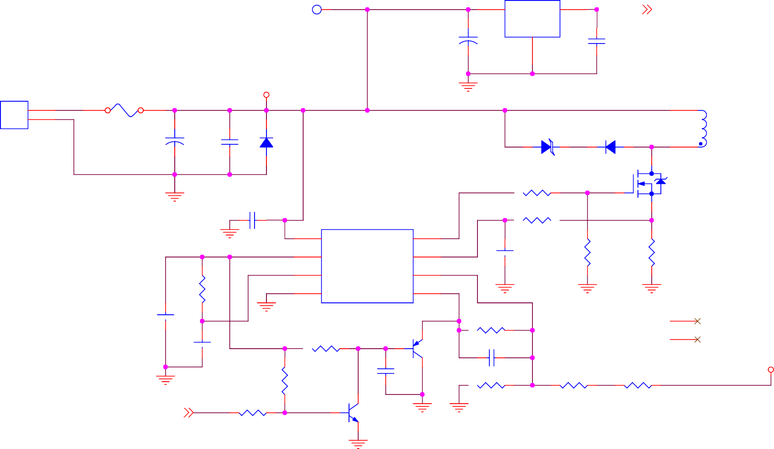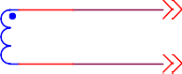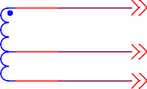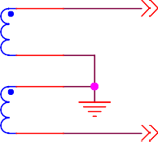

3

IN

OUT

1

VCC_5_AUX

[2]

+

GND

C33 10uF 25V

C34 0.1uF

VCC_12

J1

F1 F2A

1

2

VH-2

11 T1

8

+

D39 P6KE18A

D1 UF4007

9

C1 C2

1000uF 25V 0.1uF

D20 UF4007

10

6

Q3 IRF540N

7

R2 10R

1

C3 0.1uF

R4 3.3K

U1

VCC

2

7

OUTPUT

6

3

8

VREF

ISENSE

3

C7

470pF

R6 10K

R26 0.08R

4

RT/CT

VFB

2

4

R1 7.5K

5

GND

UC3843

COMP

1

5

T-SC-1

HS1

C5 1

1uF

R10 100K

2

C4

2.2nF

R24 100K

Q16 2N3906

C8 100pF

HS-2

VCC_300

R49 C37

100K 1uF R9 2.49K R7 150K R8 150K

[2]

PWR_ON

R70 10K

Q2 2N3904

1

2

D D

2



C C

|  |  |
| --- | --- |
| TSEC_8 | [2] |
| TSEC_7 | [2] |
| TSEC_1 | [2] |
| TSEC_2 | [2] |
| TSEC_3 | [2] |
| TSEC_4 | [2] |
| TSEC_5 | [2] |



B B



A A

5 4 3

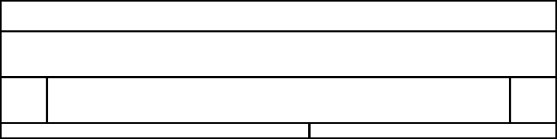

Title

Power Primary

Size A4

Document Number CRT-SC-XYZ-03

Rev

1.0

Date:

2

Saturday, September 21, 2019

Sheet

1

of

3

1

5 4 3 2 1

C16 10uF 25VD12 1N4148

+

L1 100uH

U8 78L05

VCC_5

VCC_12

J5

[1]

TSEC_8

D10

+

C18

3

+

C27

IN OUT 1 GND

C29

[1]

[1]

2

VCC_5_AUX PWR_ON

8

7

7

8

6

PWR_ON 5 6

4 5

4

1N4148

D

D11 1N4148

+

10uF 25V

+

C19 10uF 25V

100uF 25V

+

C28 100uF 25V

2 IN

GND

1

OUT 3

0.1uF

C32

1uF

VCC_5_N

VCC_300

3 3

2 2

1 1 D

XH-8

C17 10uF 25VD13 1N4148



L2 100uH

U7 79L05

U9

1 VCC

NC_6 6

HV 5

C20

VCC_300 D15 UF4007

[1,2] TSEC_7

1. GND
2. PULSE

NC_4 4

[1,2] TSEC_7

C

2.2uF 400V

+

D14 UF4007

R51

+

C21

2.2uF 400V

3 30K

NL1 NL5MM

2

1

R15 5.1M

R20 2M

**FOCUS**

R68 10K

R21 1M

**INTEN**

R69 10K

VOLTAGE_MULTIPLIER

C

C9 22nF 500V

C11 22nF 500V

C13 22nF 500V

C15 22nF 500V



D2 UF4007

D3 D4

UF4007 UF4007

D5 D6

UF4007 UF4007

D7 D8

UF4007 UF4007

D9 UF4007

R48 100K

J2

A1 6

5 6

M 4 5

C 3 4

F1 2 3

2

C26 22nF 500V

C10 22nF 500V

C12 22nF 500V

C14 22nF 500V

F2 1 1

B [1]



[1]

[1]

TSEC_3

TSEC_4

TSEC_5

C22 1uF 50V

C24 10uF 25V

+

+

D17 1N4148

+

D16 1N4148

D19 1N4148

+

D18 1N4148

C23 1uF 50V

C25 10uF 25V

C38 0.1uF

 R19 330R

U3

1. NC_1
2. A
3. C
4. NC_2

6N137

VCC 8

VE 7

VO 6

GND 5

R16 5.1K

R18 5.1K

Q1 MPSA06

R50 100K

[1]

[1]

TSEC_1 TSEC_2

F2 F1A

VH-6

B

A [3] BLANK A

Title

Power Second

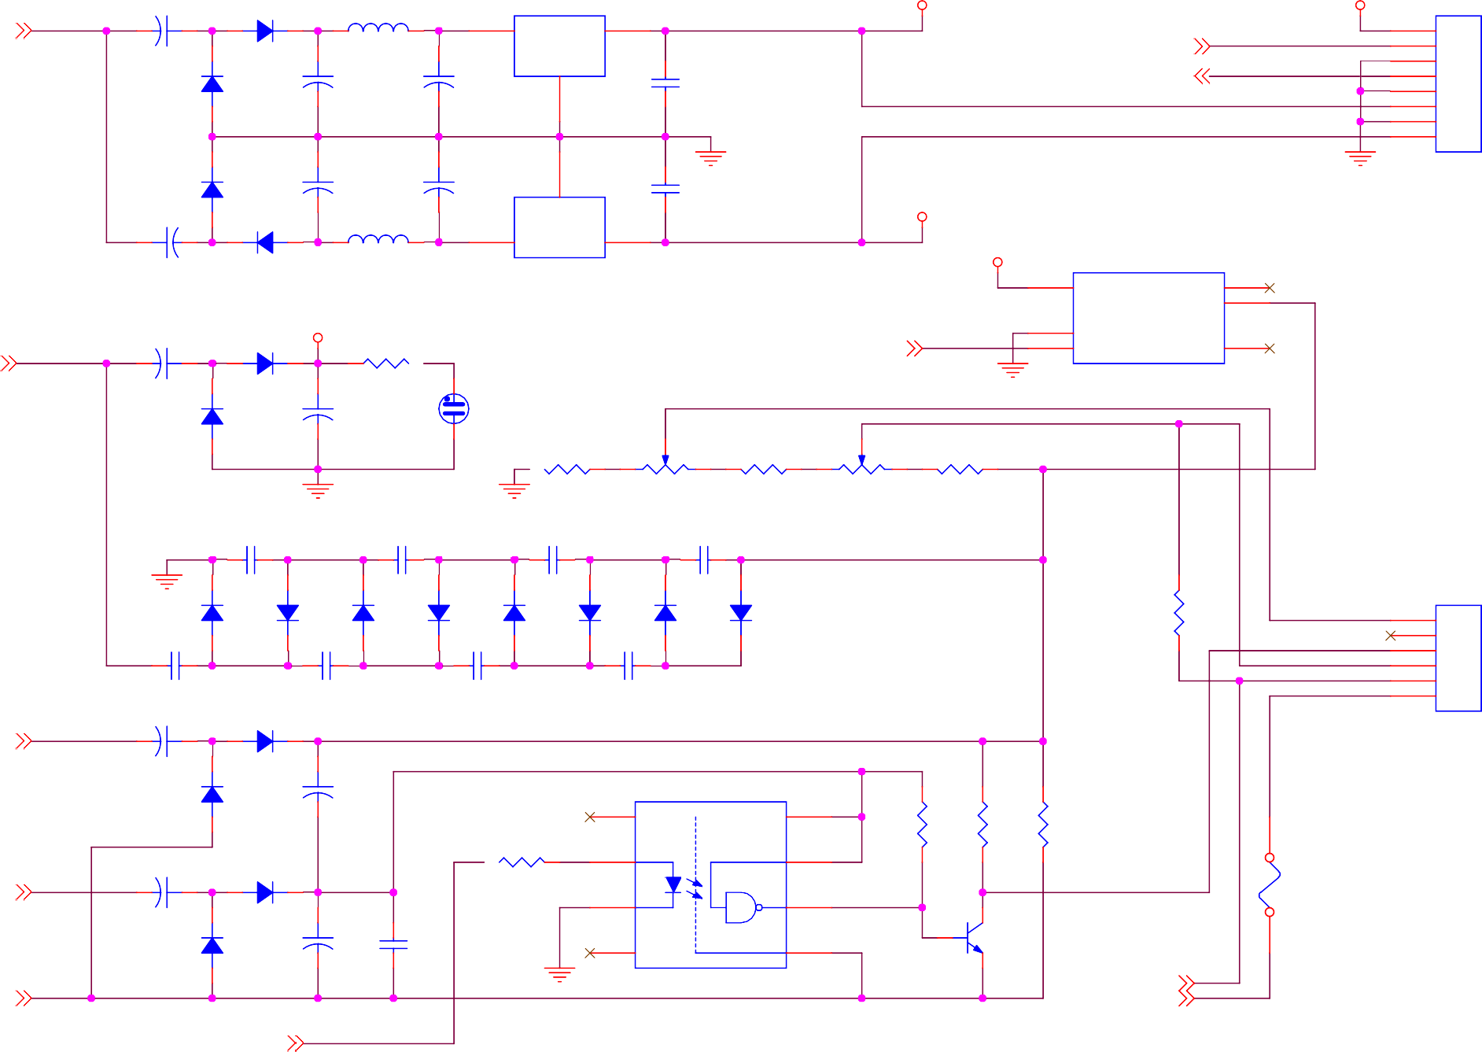

5 4 3

Size A4

Date:

2

Document Number CRT-SC-XYZ-03

Saturday, September 21, 2019

Sheet 2

1

of 3

Rev

1.0

5 4 3 2 1

D

VCC_300

YP 5

YN 4

XP 3

XN 2

1

J6 5

4

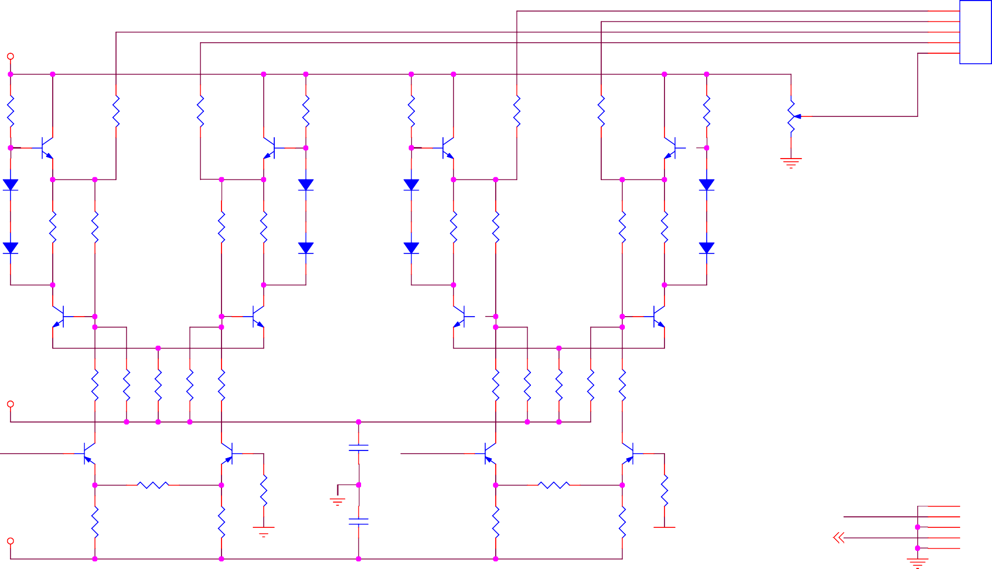

3 D

2

1

VH-5

R29 220K



Q6 MPSA44

R54 100R

R55 100R

Q9 MPSA44

R36 220K

R38 220K

Q12 MPSA44

R60 100R

R61 100R

Q15 MPSA44

R45 220K

R46 1M

ASTIG

# ASTIG

D22 1N4148

D27 1N4148

D30 1N4148

D35 1N4148

C D23

1N4148

R52 1K

R28 220K

R35 220K

R53 1K

D26 1N4148

D31 1N4148

R62 1K

R37 220K

R44 220K

R63 1K

D34 C

1N4148

Q8 MPSA44

Q7 MPSA44

Q14

MPSA44

Q13 MPSA44



VCC_5_N

R56 100R

R33 2K

R58 1K

R34 2K

R57 100R

R64 100R

R42 2K

R66 1K

R43 2K

R65 100R

X_IN

B

Q4 MPSA56

Q5 MPSA56

C35 0.1uF

Y_IN

Q10 MPSA56

Q11

MPSA56 B

J7

6

5

4

3

2

1

VCC_5



R30 5.1K

R32 5.1K

R31

5.1K

R59

100R

C36 0.1uF

R39 5.1K

R41 5.1K

R40

5.1K

R67 100R

[2]

BLANK

X_IN Y_IN

6

5

4

3

2

1

XH-6

A A

5 4 3



Title

Deflection Amplifier

Size A4

Document Number CRT-SC-XYZ-03

Rev

1.0

Date:

2

Saturday, September 21, 2019

Sheet

3

of

3

1