**Prithvi Narayan Campus**

**Tribhuvan University**

Bagar-1, Pokhara



**PROJECT PROPOSAL**

**On**

**“Routine Management System”**

**(System for Scheduling classes)**

**Submitted to:**

**Faculty of Humanities and Social Sciences**

BCAprogram

Prithvi Narayan Campus

***In partial fulfillment of the requirements for the Bachelors in Computer Application***

**Submitted by:**

Deep Darshan Thapa: 4802034

Manoj Paudel: 4802041

**Aug 2024**

**Abstract**

Managing class schedules in educational institutions often involves significant administrative effort, especially when routines are changed frequently. Traditional methods of handling class schedules can lead to inefficiencies and difficulties in communication. To address these challenges, this project proposes the development of a **Routine Management System** a **web-based application** designed to streamline the scheduling process. This project aims to provide a user-friendly platform that helps to update class schedules in real-time, ensuring that changes are communicated to all users within the institution. The system supports **role-based access control**, allowing administrators to manage schedules, teachers to view and request schedule changes, and students to access updated routines easily.

This system is expected to reduce administrative workload, improve communication regarding schedule changes, and provide a more efficient method for managing class routines. The successful implementation of this system will lead to a more organized and effective learning environment by making easy to schedule routines and by reducing the hassles associated with routine changes.

***Keywords: routine management, web application, role based access control***

Contents

1. Introduction 1

2. Problem Statement 2

3. Objective 3

4. Scope and limitations 4

4.1 Scope 4

4.2 Limitation 4

5. Literature Review 5

6. Methodology 6

7. System Analysis 7

7.1 Requirement Identification 7

7.2 Feasibility Study 7

7.3 Tools 8

7.4 System design 8

8. Gantt chart 10

9. Expected Outcome 11

10. Reference 12

**List of figures**

Figure 1: Prototyping model 6

Figure 2: Use case diagram of Routine Management System 9

Figure 3: Flow chart of Routine Management System 9

Figure 4: Gantt chart 10

# 1. Introduction

Colleges use routines to allocate time for different classes. These routines are manually prepared. When schedules are to be changed administration has to notify days before. In current scenario if the schedules are to be changed for the day it’s quite a hassle to manage classes. This process often leads to administrative challenges and delays when adjustments need to be made on short notice. This affects both teachers and students.

Routine management system is a web application that solves the above problems by allowing to update class schedule in the system which can be viewed only by the users that have been added by admin. This system ensures that any changes are accessible to everyone within the institution instantly. This system will be helpful to minimize the burden of administrators. The proposed system will be role based meaning teacher, students and administrator will have different roles to access different permissions. Admin will have full permission where others will have limited permission.

# 2. Problem Statement

**Administrative burden**

Current system requires significant administrative effort to manage schedule changes. It could result in inefficiencies in the operation and also it is a hassle to reschedule the classes and to inform students.

**Inefficient access to updated information**

In current system staffs and students don’t have real time updates. It leads to potential conflicts and misunderstanding the timing of classes. Students have to check multiple sources to confirm class schedule

**Communication delays**

Currently communicating schedule changes have inconsistency. The use of traditional methods sometimes delays information.

# 3. Objective

Our Routine Management System aims:

* To develop an online platform for managing class routine
* To develop a system to relay updated scheduled efficiently
* To implement role based access control
* To provide real time information to its users
* To make a system to manage flexible class routine

# 4. Scope and limitations

## 4.1 Scope

**Routine management system can be helpful to create and maintain class routines in computerized system. This system helps to create and update routines using web app with simple interface. With its objectives the system will enhance the overall scheduling process and will improve resource management in the institution.**

## ****4.2 Limitation****

* System is only available as web app
* System is functional only with internet connection
* Limited offline access could affect usability in areas with poor connectivity

# ****5. Literature Review****

Effective management of class schedules is crucial for the smooth operation of educational institutions. This project plays a significant role in addressing the complexities of scheduling routine. This literature review explores existing research, technologies, providing a foundation for the development of our proposed system

Roy, Kabir and Ahmed. proposed a web-based smart class routine management system for easing the task of maintaining a schedule of classes. This system allows real-time updates to the schedules, which can be accessed by teachers and students alike from the web. The adopted approach eased communication and saved the confusions that arose with last-minute schedule changes[1].

Jeswani, Itankar, and Sanghvi have also identified automated timetable management systems as imperative in educational institutions. In this study, the researchers look at how such systems can alleviate the burden from administrators by automating the scheduling of classes. By doing so, administrators will have more free time to attend to other activities as well as help in smoothing the flow of work for the whole institution[2].

# ****6. Methodology****

After evaluating different software development methodologies and ultimately it is decided to use Prototyping model due to its unique advantages and suitability for our specific project requirements.

Using the Prototyping model for our project can be helpful in several ways. It will allow us to plan and organize the project well and identify any issues quickly. Overall, Prototyping model is decided as it can help us to achieve success of our project

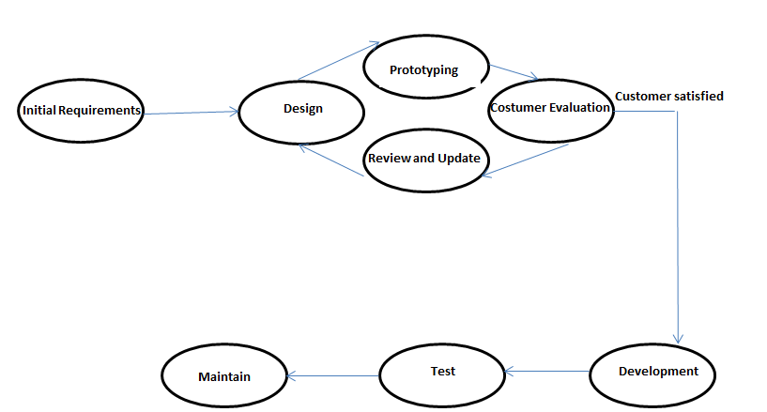

Figure 1: Prototyping model

# 7. System Analysis

**To ensure the success of the Routine Management System a extensive system analysis is essential. This involves understanding the problem and executing a well-defined solution. A robust analysis model is crucial for framing the problem and defining an effective solution.**

## ****7.1 Requirement Identification****

**As we enter the requirement analysis phase, it is imperative to identify and prioritize** **both functional and non-functional requirements to address user needs effectively.**

**Functional Requirements:**

**Role based access control:**

* **User with admin role should have full access to the system.**
* **User with Teacher role should have access to view routine and request changes if necessary**
* **User with student role should only have access to view routine**

**Schedule management:**

**Admin should be able to** create schedules for classes, assigning teachers and students to specific time slots based on availability**.**

**Non-Functional Requirements:**

* **System should be able to run on different browsers.**
* **System must follow legal rules for storing data.**
* **System should be developed with clean code for easy update.**

## ****7.2 Feasibility Study****

**A feasibility study has been conducted to assess the viability of the Routine Management System, covering technical, economic, and legal aspects.**

**Technical Feasibility:**

After the technical needs have been carefully analyzed, we have the technical skills and resources needed to system. The user interface of the website is clear and simple to use. It is made sure the website works technically.

**Economic Feasibility:**

**No additional costs are associated with hiring a development team as existing members possess the required technical skills. Minimal expenses are expected, covering documentation printing and website hosting.**

**Legal Feasibility:**

**Research has been conducted on legal requirements for operating a Routine management system. Steps have been taken to ensure compliance with data privacy laws and regulations**

## ****7.3 Tools****

* + - * Front-end development: There are various tool to develop the front-end of the website, including the user interface,

1. HTML
2. CSS
3. JavaScript
   * + - Back-end development: PHP will be used to develop the back-end of the website, including the database and user login.
       - Database management: MySQL will be used to manage the website's database.

## 7.4 System design

**Detail plan is sketching that explains how** teachers and students will use it. Our goal is to build a system that is easy to use and meets everyone's needs. It helps teachers update their schedule and students can view the updated schedule. Admin can add teachers.

**Use Case**

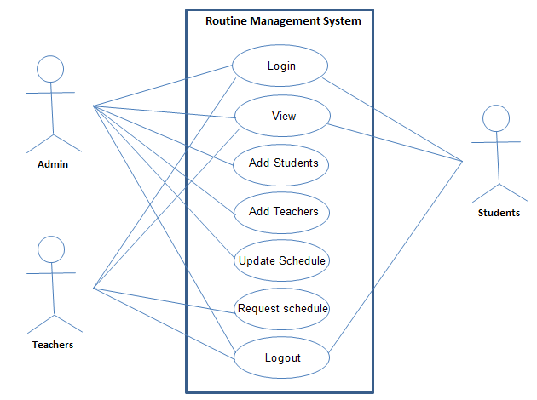

Figure 2: Use case diagram of Routine Management System

**High level Diagram**

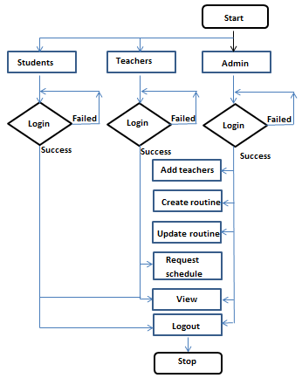

Figure 3: Flow chart of Routine Management System

# 8. Gantt chart

The Gantt chart below shows the timeline for the development of the project.

Figure 4: Gantt chart

# 9. Expected Outcome

The finished product will lead to a number of key improvements. This system will facilitate the creation, updating, and management of class schedules in a more efficient way by reducing the time and effort required for administrators to perform the various tasks.

After completion of the project students, teachers, and administrators will always be informed of any kind of schedule changes, reducing confusion which will indirectly improve communication. It will also improve the resource management in the institution.

Teachers could be able to adjust their schedules, allowing them to use their time more effectively With schedules readily available, students will experience fewer interruptions, leading to a more organized academic routine.

# 10. Reference

[1] Sujit Roy, Md. Humaun Kabir, Md. Tofail Ahmed, " Design and Implementation of Web-based Smart Class Routine Management System for Educational Institutes", International Journal of Education and Management Engineering (IJEME), Vol.12, No.2, pp. 38-48, 2022. DOI: 10.5815/ijeme.2022.02.05

[2] Jeswani, R., Itankar, P., & Sanghvi, A. (2022). [Importance of timetable management system in educational institutions](https://edgeservices.bing.com/edgesvc/chat?udsframed=1&form=SHORUN&clientscopes=chat,noheader,udsedgeshop,channelstable,ntpquery,devtoolsapi,udsinwin10,udsdlpconsent,udscstart,cspgrd,&shellsig=964c6ea26e5ccb724362d36527ce3d7ed2879f17&setlang=en-US&darkschemeovr=1&udsps=0&udspp=0#sjevt%7CDiscover.Chat.SydneyClickPageCitation%7Cadpclick%7C0%7C65e57b65-6130-4e4e-b4ed-49792012eb84). *ANVESAK*, 52(1), 15-24.