

**Tribhuvan university**

**Faculty of Humanities and Social Sciences**

**Prithvi Narayan Campus**

**Supervisor’s recommendation**

The supervisor wholeheartedly endorses the project titled "Routine Management System," exclusively developed by **Deep Darshan Thapa and Manoj Paudel**, acknowledging its exceptional execution and successful fulfillment of the requirements for the Bachelor of Computer Application degree. This project is highly recommended for final evaluation.

………………………….

**Gyaneshwor Dhungana**

Signature of supervisor



**Tribhuvan University**

**Faculty of Humanities and Social Sciences**

**Prithvi Narayan Campus**

**LETTER OF APPROVAL**

This document certifies that **Deep Darshan Thapa** and **Manoj Paudel’s** project, "Routine Management System" has undergone a comprehensive evaluation to fulfill the requirements for the degree of Bachelor in Computer Application. In our expert opinion, this project demonstrates satisfactory scope and exceptional quality, meeting the standards expected for the degree.

|  |  |
| --- | --- |
| …………………….  Gyaneshwor Dhungana  **Supervisor** | …………………….  Chandramani Acharya  **HOD/Coordinator** |
| ……………….…..  **Internal Examiner** | ………………….…  **External Examiner** |

**Acknowledgement**

We would like to extend my sincere gratitude to the authorities at Tribhuvan University for providing us with the invaluable opportunity to work on the project titled 'Routine Management System.' This project has offered us a platform to apply and explore the practical implications of the theoretical knowledge and expertise we have acquired during our academic journey.

We are deeply appreciative of the unwavering support and guidance extended to us by the Prithvi Narayan Campus throughout this endeavor. We wish to express our heartfelt thanks to our supervisor, **Gyaneshwor Dhungana**, whose scholarly mentorship and valuable suggestions have been instrumental in navigating the complexities of this research. Without his continuous encouragement and belief in the project, this undertaking would have been immensely challenging.

Undoubtedly, this project has not only allowed us to delve deeper into the subject matter but has also significantly enhanced our practical acumen and skills. We are indebted to our friends and teachers who generously shared their insights and perspectives, which have greatly contributed to the improvement and enrichment of this project work.

Furthermore, we extend our deepest appreciation to all individuals who have directly or indirectly contributed to the successful completion of this project. Their guidance and encouragement have been a source of motivation throughout this journey.

With heartfelt thanks,

**Deep Darshan Thapa**

**Manoj Paudel**

**Abstract**

Managing class schedules in educational institutions often involves significant administrative effort, especially when routines are changed frequently. Traditional methods of handling class schedules can lead to inefficiencies and difficulties in communication. To address these challenges, this project proposes the development of a **Routine Management System** a **web-based application** designed to streamline the scheduling process. This project aims to provide a user-friendly platform that helps to update class schedules in real-time, ensuring that changes are communicated to all users within the institution. The system supports **role-based access control**, allowing administrators to manage schedules, teachers to view and request schedule changes, and students to access updated routines easily.

This system is expected to reduce administrative workload, improve communication regarding schedule changes, and provide a more efficient method for managing class routines. The successful implementation of this system will lead to a more organized and effective learning environment by making easy to schedule routines and by reducing the hassles associated with routine changes.

**Keywords**: Routine management system, web-based application, role based accessed control

­­­­

Table of Contents

CHAPTER 1: INTRODUCTION 3

1.1 Introduction 3

1.2 Problem statement 3

1.3 Objectives 3

1.4 Scope and limitation 3

1.5 Report organization 4

1.6 Methodology of the proposed system 5

Chapter 2: Background Study and Literature Review 6

2.1 Background study 6

2.2 Literature Review 6

Chapter 3: System Analysis and Design 8

3.1 Requirement Analysis 8

3.2 Feasibility study 10

3.2 Schedule 11

3.3 System Design 11

3.3.1 Architectural Design 11

3.3.2 Database schema design: 12

3.3.3Interface Design 12

CHAPTER 4: IMPLEMENTATION AND TESTING 16

4.1 Implementation 16

4.1.1 Tools Used 17

4.2 Unit testing 18

4.2.1 Test Cases for Unit Testing 18

4.2.2 Test Cases for System Testing 18

CHAPTER5: CONCLUSION AND FUTURE RECOMMENDATION 19

5.1 Outcome 19

5.2 Conclusion 19

5.3 Future recommendation 19

Reference 20

# CHAPTER 1: INTRODUCTION

## 1.1 Introduction

Colleges use routines to allocate time for different classes. These routines are manually prepared. When schedules are to be changed administration has to notify days before. In current scenario if the schedules are to be changed for the day it’s quite a hassle to manage classes.

Routine management system is a web application that solves the above problems by allowing teachers to update their schedule in the system which can be viewed by anybody in the premises. It can be helpful when teachers couldn’t attend their class at scheduled time

## 1.2 Problem statement

It is a hassle to reschedule the classes and to inform students.

When routines keep changing with time it makes class management difficult.

Routine management system will help to create and relay the rescheduled routines more effectively and efficiently.

## 1.3 Objectives

Our Routine Management System aims :

* To develop an online platform for managing class routine.
* To develop a system to relay updated scheduled efficiently.
* To make a system to manage flexible class routine

## **1.4 Scope and limita**tion

**Scope:**

Routine management system can be helpful to create and maintain class routines in computerized system. This system helps to create and update routines using web app with simple interface.

**Limitation:**

System is only available as web app

System is functional only with internet connection

**Security Concerns:** Despite robust user authentication, the platform may face security vulnerabilities and threats, requiring constant monitoring and updates to ensure data protection.

**User Adoption:** The success of the project depends on user adoption and engagement. Convincing users to switch from traditional methods to the new platform may present challenges.

**Technical Constraints:** The project's scope may be limited by technical constraints such as budget, time, and resources available for development and maintenance.

Overall, the project aims to create a viable and user-friendly platform for managing the routine in the college and schools, but its success will depend on addressing these limitations and continuously adapting to meet user demands and market conditions.

## 1.5 Report organization

**Chapter 1**: Topic “Introduction” contains the introduction to the project. It explains the project's objectives, scope, and limitations, as well as provides a brief description and summary. It also explains why we're working on this project.

**Chapter 2:** Topic “Background Study and Literature Review” presents a critical evaluation of the context of our system-critical analysis of existing literature. It includes a description of our perspective of the previous system, as well as what our project wants to accomplish.

**Chapter 3:** Topic, “System Analysis and Design,” includes a data flow diagram, modules, and architecture, as well as contains the requirement of the system, its hardware requirement, and the software required to run our system. It also relates to shaping organizations, improving performance, and achieving objectives for profitability and growth.

**Chapter 4:** Topic “Implementation and Testing” includes the process of testing implementations of technical specifications. It consists of all the ways how the functions are implemented and what functions are used to implement them.

**Chapter 5:** Topic, “Conclusion and Future Recommendations,” includes how well we have achieved our original aim and objectives, what the limitations and scopes of our system are, what we should do differently next time and the consequences for research funding and practice.

## 1.6 Methodology of the proposed system

The **Prototyping Methodology** will be used in developing this project, ensuring iterative development and gathering feedback for continuous product improvement. Prototyping involves creating a working model of the system in the early stages of development, which is then refined based on user feedback. This approach allows for adjustments to be made in response to user needs before the final version is developed.

Given that routine management requirements can vary and evolve, prototyping will be ideal for this project, as it will allow us to clarify and refine user expectations as we proceed. This approach also helps address uncertainties, identify potential issues early, and manage risks effectively. By incorporating regular feedback and adjustments, the final Routine Management System will align more closely with the needs and expectations of its users.

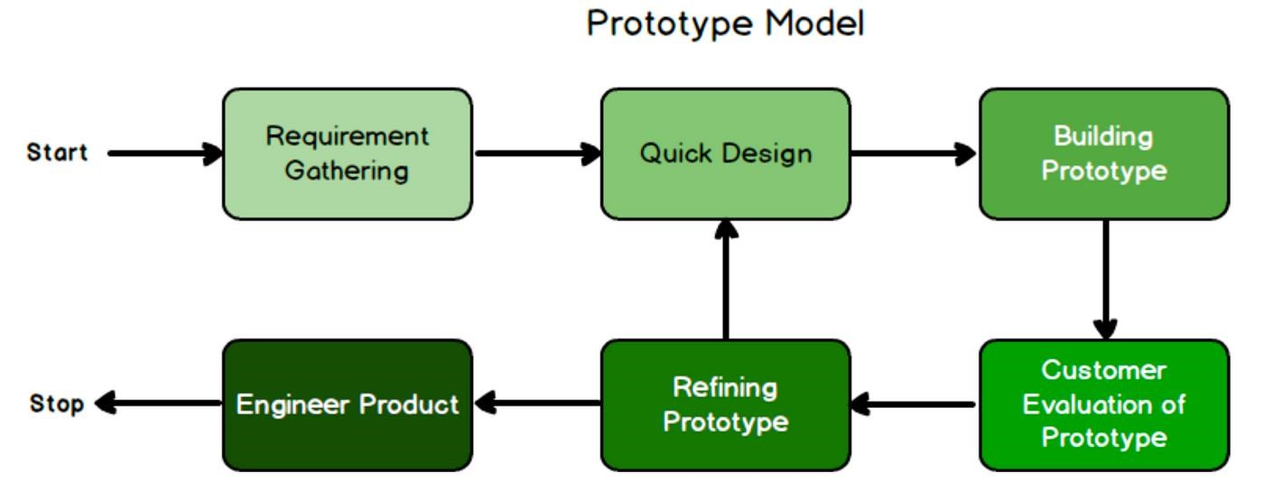

**Figure 1: Prototyping method**

# Chapter 2: Background Study and Literature Review

## 2.1 Background study

As part of the background study for the **"Routine Management System"** project, we conducted thorough research and analysis to understand the challenges faced in managing schedules and routines efficiently. Through extensive online research and discussions with students, employees, and professionals, we gathered valuable insights into their struggles with time management, task organization, and schedule coordination.

We explored existing routine management tools and scheduling applications to identify gaps and limitations. We closely examined their features, user interfaces, notification systems, and synchronization capabilities to determine what works well and where improvements could be made. During the research process, users expressed a strong need for a system that prioritizes simplicity, flexibility, and automation, enabling them to manage their daily tasks without unnecessary complexity.

Based on the study’s findings, it became evident that certain aspects required special attention, such as intuitive scheduling, real-time updates, and customizable reminders. We recognized the importance of addressing these pain points to create a seamless and efficient user experience. Additionally, we explored emerging trends in time management strategies and productivity-enhancing technologies, recognizing the potential of digital solutions in improving routine management.

By incorporating the insights gained from the background study, the **"Routine Management System"** project is designed to provide a solution that aligns with users' needs and expectations. The platform aims to offer a structured yet flexible system where individuals can efficiently organize their schedules, set priorities, and track progress with ease. Ultimately, the background study played a crucial role in shaping the project’s vision and guiding its development, ensuring that it effectively addresses real-world scheduling challenges.

## 2.2 Literature Review

Effective management of class schedules is crucial for the smooth operation of educational institutions. This project plays a significant role in addressing the complexities of scheduling routine. This literature review explores existing research, technologies, providing a foundation for the development of our proposed system

Roy, Kabir and Ahmed. proposed a web-based smart class routine management system for easing the task of maintaining a schedule of classes. This system allows real-time updates to the schedules, which can be accessed by teachers and students alike from the web. The adopted approach eased communication and saved the confusions that arose with last-minute schedule changes[1].

Jeswani, Itankar, and Sanghvi have also identified automated timetable management systems as imperative in educational institutions. In this study, the researchers look at how such systems can alleviate the burden from administrators by automating the scheduling of classes. By doing so, administrators will have more free time to attend to other activities as well as help in smoothing the flow of work for the whole institution[2].

# Chapter 3: System Analysis and Design

## 3.1 Requirement Analysis

In this web-based application user should register students, teachers and schedule details. Some important collections of requirements that need in this system are as follows:

**i) Functional Requirements:**

* System should verify users
* Admin should be able to view and modify users details
* Admin should be able to modify schedule

**ii) Non-functional requirement**

* **Portability:** Ensure the website is accessible across various devices and operating systems for user convenience.
* **Flexibility**: Adopt a modular structure to accommodate future updates and changes in product offerings ad customer needs.
* **Scalability:** Design the platform to handle increased traffic and product listings as the business grows.
* **Reliability:** Implement robust backup and recovery mechanisms to ensure uninterrupted service and minimal downtime.

**Use case**

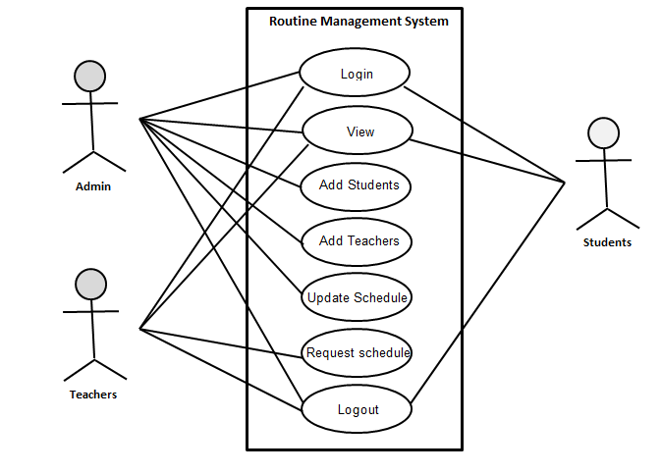

**Figure 2: Use case diagram**

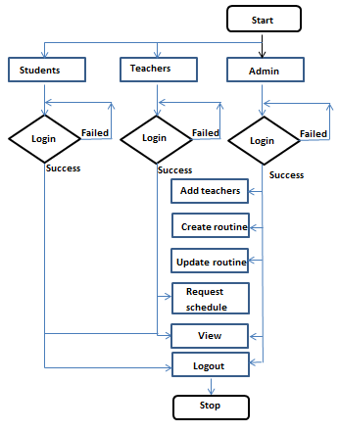

**Figure 3: System flow chart**

## 3.2 Feasibility study

A feasibility study is the initial design stage of any project, which brings together the elements of knowledge that indicate if a project is possible or not. A feasibility study was conducted for the project to see if a system idea is feasible. So far, during the development of the project Routine Management System, we have four major categories of the feasibility study.

* **Operational feasibility:**

This examines whether the Routine Management System will be accepted and successfully used by its intended users. The focus is on the usability, training, and system adoption. Teachers, students, and admins are expected to benefit from an intuitive user interface, and training can be provided to ensure smooth onboarding. The operational feasibility of the project suggests that the system will likely improve users' time management and productivity.

* **Economical feasibility:**

The economic feasibility focuses on the cost-effectiveness of the project. This includes development costs, maintenance, user support, and infrastructure costs. Based on the project's scope and available budget, the Routine Management System is financially viable. The potential benefits, such as improved time management and reduced administrative workload, justify the investment required for system development and deployment**.**

* **Technical feasibility:**

This aspect of the feasibility study evaluates whether the current technology and resources are sufficient to develop the **Routine Management System**. It looks at the hardware, software, and development tools available to ensure that the system can be built within the constraints of the project. After the technical needs have been carefully analyzed, we have the technical skills and resources needed to system. The user interface of the website is clear and simple to use. It is made sure the website works technically

## 3.2 Schedule

Aug

09-

Aug

29-

18-

Sep

08-

Oct

28-

Oct

17-

Nov

Team formation

Proposal Defense

Requirement Gathering

System Design

Development

Testing

Midterm Defense

Final Defense

Documentation

**Figure 4: GANTT chart**

## 3.3 Analysis

After the gathering of the requirement and analysis of the of the functional and nonfunction features of the System the following ER diagram and Data flow diagram was constructed:

**ER diagram**

**DFD**

# 3.3 System Design

System design is the process of defining the structure, components, interfaces, and data flow for a system based on the specified requirements. It is a crucial phase in software development, where the overall architecture is established to ensure that the system meets the defined functional and non-functional requirements. For the **Routine Management System**, the design phase focuses on creating an effective and efficient system that addresses the needs of all users, including admins, teachers, and students.

### 3.3.1 Architectural Design

An architectural diagram is a high-level visual representation of the system’s overall structure, illustrating how various components interact with each other and how data flows through the system. For the **Routine Management System**, the architectural design provides an overview of the system components, including the user interface, backend services, database, and notifications system. The diagram also helps identify areas that might require optimization and ensures that the components work together seamlessly.

### 3.3.2 Database schema design:

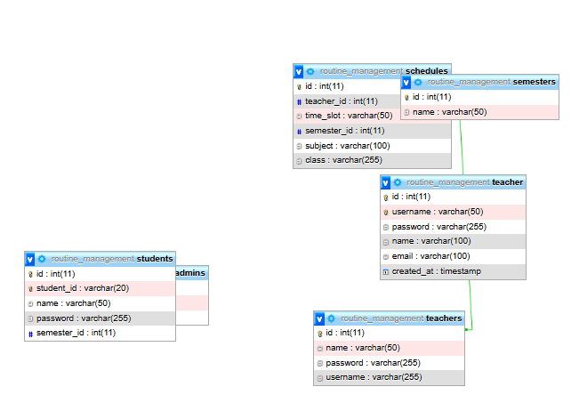

**Figure 5 Database Design**

### 3.3.3Interface Design

The interface design for the **Routine Management System** focuses on creating an intuitive and user-friendly experience for all types of users—Admin, Teacher, and Student. The design ensures that users can easily navigate through the platform and manage their routines and tasks. Below is a breakdown of the key interfaces for the system:

**1. Homepage (Landing Page)**

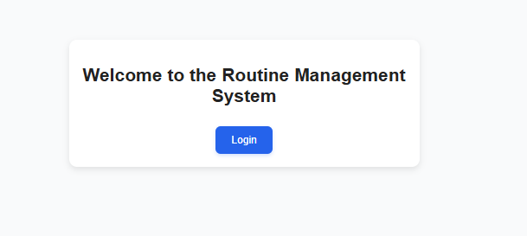

**Figure 6 Landing Page**

* **Header**:
  + Contains the system's logo, navigation menu (Home, My Routine, Notifications, Profile, Log Out), and a user login/register option.
* **Login/Registration Section**:
  + Provides access to login for existing users and the option to register for new users.
* **Overview of Features**:
  + A brief section explaining the purpose of the system and how it helps manage daily routines and schedules effectively.

**2. User Profile (Dashboard)**

* **Students Dashboard**:
  + After login, student can view schedule in their dashboard. This dashboard will have easy access to the following:
    - Subject
    - Time table
    - Teachers info
* **Admin Dashboard**:

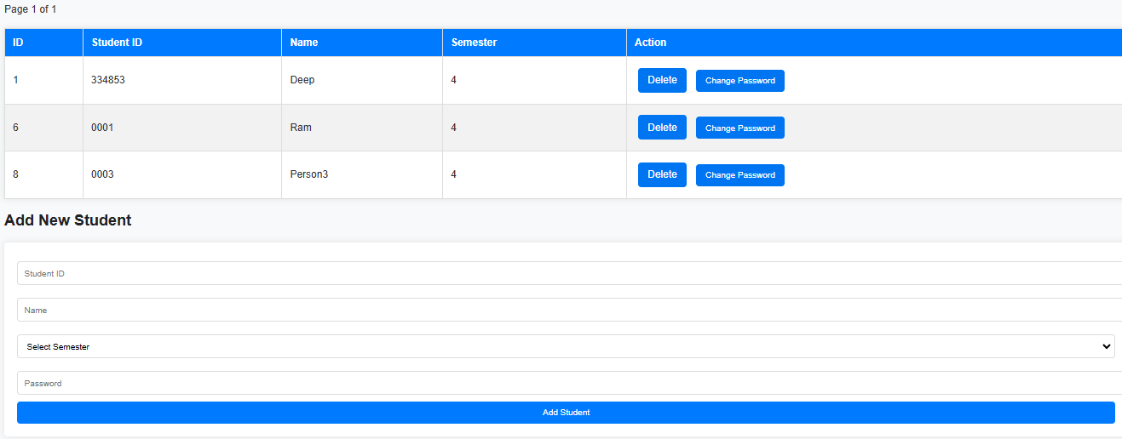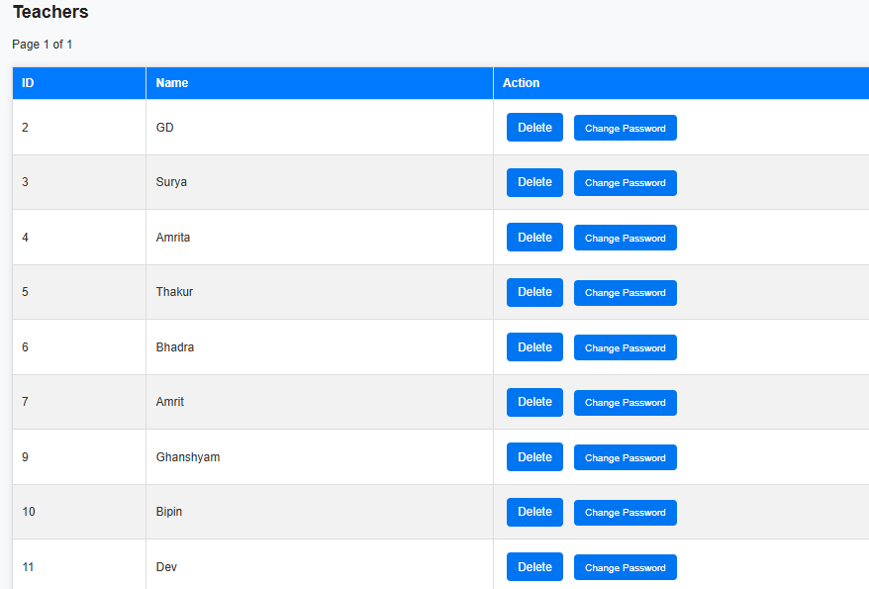

**Figure 7 Admin Dashboard**

**Add and remove students and teachers**

**Change password**

**3. Teachers Dashboard**

Teachers can view their routine

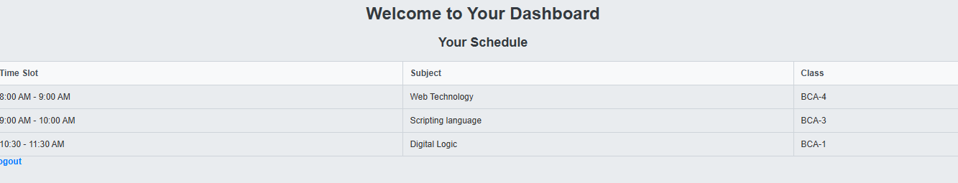

**Figure 8 Teachers Dashboard**

# CHAPTER 4: IMPLEMENTATION AND TESTING

## 4.1 Implementation

This chapter focuses on transforming the technical specifications of the **Routine Management System** into a working system, covering development phases, technology selection, and system enhancements.

**System Development Phases**

1. **Requirement Refinement**: Finalizing system features based on feedback from teachers, students, and admins.
2. **Technology Selection**: Choosing tools like **PHP, MySQL**, and frontend frameworks like **HTML, CSS**, and **JavaScript** for an intuitive experience.
3. **Frontend Development**: Designing user-friendly interfaces for managing routines and tasks.
4. **Backend Development**: Building secure and efficient server-side functionality for data handling.
5. **Database Integration**: Using **MySQL** to store user and task data, ensuring quick access and integrity.

**System Enhancements**

* **User Management**: Secure logins and profile management for teachers, students, and admins.
* **Admin Features**: Admins manage add student and teacher and update schedule

### 4.1.1 Tools Used

The development of the **Routine Management System** involved a combination of frontend, backend, and database management tools. Below are the key tools and technologies utilized:

**HTML and CSS**

* **HTML** (HyperText Markup Language) was used to structure the content and layout of the web pages. It defined the key elements such as headings, paragraphs, lists, tables, forms, and buttons.
* **CSS** (Cascading Style Sheets) controlled the design and presentation, including font styles, colors, spacing, and positioning, ensuring a visually appealing and consistent interface across the platform.

**JavaScript**

* **JavaScript (JS)** added interactivity and dynamic features, such as event handling and system time management. It allowed users to interact smoothly with the platform and enabled the real-time display of date and time.

**PHP with MySQL**

* **PHP** is a server-side scripting language used for handling backend logic, including user interactions, task management, and system notifications.
* **MySQL** managed the database, storing essential data such as user profiles, tasks, and schedules. It facilitated CRUD (Create, Read, Update, Delete) operations.

**XAMPP Server**

* **XAMPP** is a cross-platform web server that was used for local development and testing. It hosted the project on a local server environment, allowing centralized database management.

**Visual Studio Code**

* **Visual Studio Code** (VS Code) served as the primary source code editor. It offered features like debugging, code refactoring, and extensions for added functionality, enhancing the development process.

## 4.2 Unit testing

Unit testing plays a crucial role in ensuring that the **Routine Management System** functions as expected and meets its requirements. The goal of unit testing is to verify that each individual component of the system works correctly, both independently and when integrated into the larger system.

### 4.2.1 Test Cases for Unit Testing

Unit testing is a key approach to ensure that each unit or component of the **Routine Management System** functions as expected. The objective is to validate the correctness and reliability of individual components within the system. Unit testing is performed during the development phase to verify that all features work as intended.

The **Routine Management System** was divided into several components, such as the admin component, teacher component, and student component. Each compone

nt was tested independently to verify its performance. During the testing process, various inputs and conditions were applied to ensure that the system behaves as expected.

### 4.2.2 Test Cases for System Testing

System testing is a level of testing that validates the complete and fully integrated software product. In software testing the behavior of whole system is tested as defined by the scope of the developed project. It is the most of the final test top verify that the system to be delivered meets the specification and purpose. System testing should focus on testing interactions between the components and objects that make up a system as well as test the reusable components or system to check that they work as expected when they integrated with new component.

# CHAPTER5: CONCLUSION AND FUTURE RECOMMENDATION

## 5.1 Outcome

The finished product will lead to a number of key improvements. This system will facilitate the creation, updating, and management of class schedules in a more efficient way by reducing the time and effort required for administrators to perform the various tasks.

After completion of the project students, teachers, and administrators will always be informed of any kind of schedule changes, reducing confusion which will indirectly improve communication.

Teachers will be able to adjust their schedules as needed, allowing them to use their time more effectively

With schedules readily available, students will experience fewer interruptions, leading to a more organized academic routine.

## 5.2 Conclusion

In conclusion, the Routine management system has demonstrated significant potential and value for educational institute. Throughout the project, it became evident that the project will simplify the task of admins in the institute Overall, the project showed promise in better scheduling of classes.

## 5.3 Future recommendation

In addition to the unfinished requirements, there are other possibilities for further improving the project. This improvement may include:

* Notification : notification for schedule changes
* Mobile application

# Reference

[1] Sujit Roy, Md. Humaun Kabir, Md. Tofail Ahmed, " Design and Implementation of Web-based Smart Class Routine Management System for Educational Institutes", International Journal of Education and Management Engineering (IJEME), Vol.12, No.2, pp. 38-48, 2022. DOI: 10.5815/ijeme.2022.02.05

[2] Jeswani, R., Itankar, P., & Sanghvi, A. (2022). [Importance of timetable management system in educational institutions](https://edgeservices.bing.com/edgesvc/chat?udsframed=1&form=SHORUN&clientscopes=chat,noheader,udsedgeshop,channelstable,ntpquery,devtoolsapi,udsinwin10,udsdlpconsent,udscstart,cspgrd,&shellsig=964c6ea26e5ccb724362d36527ce3d7ed2879f17&setlang=en-US&darkschemeovr=1&udsps=0&udspp=0#sjevt%7CDiscover.Chat.SydneyClickPageCitation%7Cadpclick%7C0%7C65e57b65-6130-4e4e-b4ed-49792012eb84). *ANVESAK*, 52(1), 15-24.