# Allen atlas registration tools Freiburg

## System requirements

Matlab 2012b incl. Symbolic Math Toolbox maybe: Curve Fitting Toolbox, Image Processing Toolbox, Signal Processing Toolbox, Statistics Toolbox, Optimization Toolbox, Parallel Computing Toolbox

## Add relevant paths

* All scripts are located under /Volumes/VCI/matlabToolsFreiburg/
* Add paths in following order
  + spm8
  + matlab_new
  + allen, AMA, Fiberviewer3D (no subfolders necessary)
* Important: remove all other SPM versions from matlab path

## Description of main toolboxes

* Access to main GUIs: BrAt_StartGui
* AMA (Automatic Mouse Analyser, Datenimport): AMA_gui2
* Visualization: fiberViewer3D; für fMRI: StartGui_fv3d

## Import Bruker dataset (AMA)

* In case data import fails, remove AMA-unknown scans first
* AMA_gui2
* Choose Folder: folder containing raw data
* Start AMA: new folder p_data_automatic is generated
* Optional: crop/repair to reduce processing time by reducing image volume
* Save Pathfile: p_data_automatic/pathfile-sorted_folders.txt is generated

## Image alignment (AMA)

* + **Load SPM Mouse**
  + **Load** **Paths** 🡪 p_data_automatic/**pathfile-sorted_folders.txt**
  + **Extract t2** 🡪 select all, two files are created per subject (t2_1.nii and t2_safe which will not be modified in further processing steps)
  + Caution: coregistration t2 is meant for T2🡪B0 matching
  + **Segmentation**🡪Select TPM: "**New**" copies SPM mouse TPMs in local p_data_automatic/template directory
    - Caution: don't click on "Check template to t2 registration"
    - R. click on TPM, **reorient image**🡪**current image** 🡪 opens menu to rigid transform image to TPM
    - Several files (c1, c2, c3) are generated under results
    - Typical parameter settings

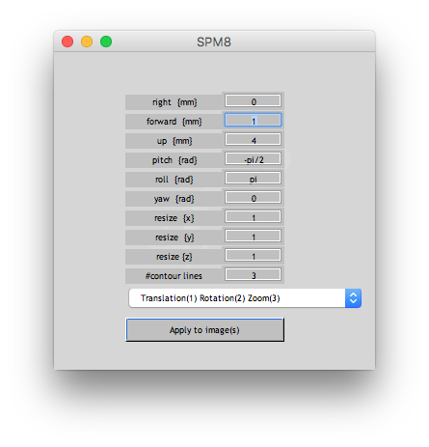

* + - "Apply to images" in rigid transform menu
    - Transform all three TPMs, save matrix for future reference "yes", name "reorient.mat", store in p_data_automatic/template
    - Check template to t2 registration "OK"
  + Check image alignment
    - Load paths
    - Deformation🡪select mouse🡪t2 several "wc…" niftis are generate
    - Checkreg under Load SPM Mouse
  + Repeat procedure for misregistrations
    - Load paths🡪Segmentation🡪select misregistered subjects, old TPMs are stored under p_data_automatic/template/tpm_# where # is ascending integer, newest TPM is always under p_data_automatic/template/
    - repeat previous steps
  + Final registration results are stored in y_forward and y_inverse (concatenation of manual and automatic registration)

## Transform other images into Allen space (AMA/SPM)

* y_forward.nii and y_inverse.nii contain the full information and can be used together with SPM's "Deformations" function, sketch attached

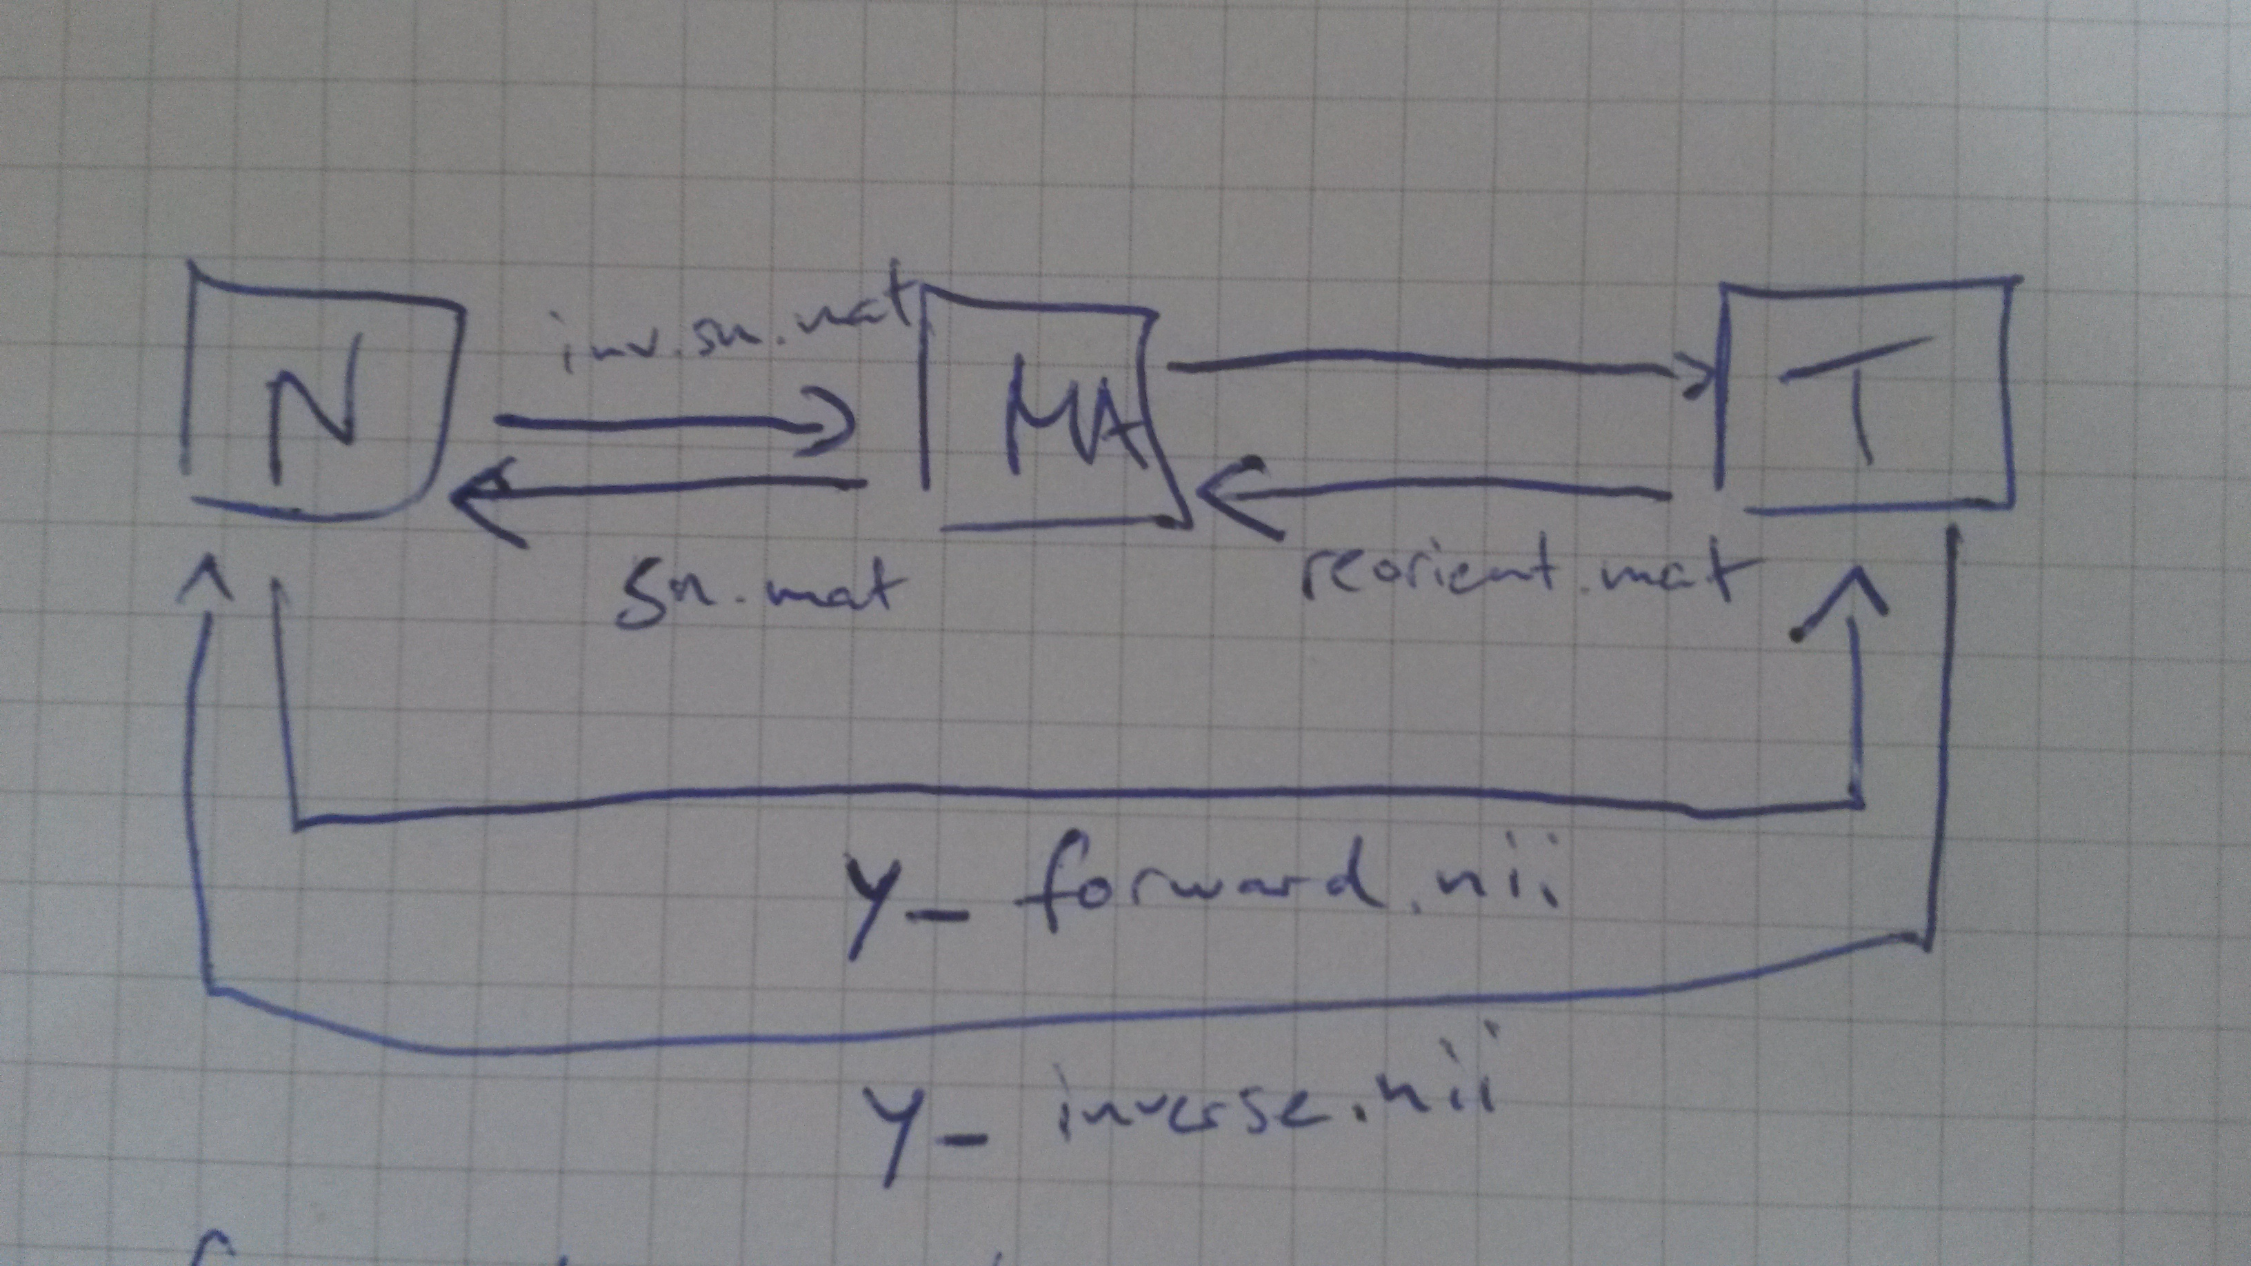

## Measure parameter maps in Allen space (BrAt_StartGui)

* Allen atlas: matlabToolsFreiburg/allen/ANO.nii, warped to SPM TPMs wANO.nii
* Allen template: matlabToolsFreiburg/allen/AVGT.nii
* Input: wmasks (weighted)
  + Will be converted to mask with threshold 0.3 (everything above 0.3)
* List nii components (top left)
* Documentation about overlap under AMIR Allen BrAt Readme.pdf