**COIT 20268: Responsive Web Design**

**Term 2, 2022**

**Assignment 2-Portfolio One**

Lecturer:

Tutor:

Prepared by:

Student Name: Deependra Karki

Student Number: 12151622

Contents

Portfolio 1.1 (Chapter 1) 3

Project Proposal: 3

Planning the site: 3

Portfolio 1.2 5

Portfolio 1.3: 7

Site Specification 7

Mission Statement: 8

Site’s Success Measurement: 8

Intended Audience: 8

User Satisfaction: 8

Technological Issues of the site’s functionality: 8

Web Structure Flowchart: 9

Portfolio 1.4 10

Portfolio 1.5 12

Type Hierarchy 12

Portfolio 1.6 14

Box Model Convention (BMC) 14

Portfolio 1 Summary: 16

# Portfolio 1.1 (Chapter 1)

## Project Proposal:

* **Site Title**: Robot Tech 2022
* **Developer**: WIMP Engineering R&D Consultant
* **Rationale or focus:** The main goal of this site is to provide information to tourists who are visiting the Robot Exhibition 2022. The site provides the detail of robot’s types that will be shown in the exhibition along with opening hours and entrance fees of the exhibition. Besides this, the site also provides the additional information such as address of the exhibition centre, public transportation routes, floor plans and many more.

## Planning the site:

* **Main Elements Outline:**

The website has several elements which are briefly discussed as below:

1. Home Page
2. Navigation Bar: Navigation bar is present at the top of the home page which has navigation links to floor plan, robots’ categories, business hours, and contact information.
3. Exhibition Highlights: Carousel is used to show the welcome message and exhibition highlights. The carousel has five movable items out of which one is used to display welcome message and four are used to provide summary information of domestic robots, educational robots, industry robots, and military robots.
4. Floor Plan and exhibition address: This section represents floor plan as well as the address of the exhibition centre. The floor plan image has four circles which are linked to different robot’s type. The address includes the google map image and public transportation routes available.
5. Robots: This section provides the image and brief description of all the robots that will be shown in an exhibition.
6. Footer: This section of the page will have some quick useful links to the page, social media follow up icons and address of the exhibition. The footer will also have hyperlinked icon ©, which provides visitor about business related legitimate facts.
7. Business Hour and Fees Page

This page will provide the information about the opening hours of the exhibition as well as entrance fees for child, adult and senior citizens.

1. Robot Details Page:

This page will show the detail information about the robot such as robot manufacturing company, country, year and other detail specifictaions.

1. About Us Page:

This section will provide the information about the Robot Expo management that organizes this exhibition.

* **Content:** The website has 4 pages altogether. The pages are index.html, business_hour.html, robot_details.html and about_us.html.
* **Target Audience:** The exhibition is targeted for all aged people like children, adults, and senior citizens.
* **Design Considerations:**

The design considerations are:

1. The website should be user friendly.
2. The website must work with several browsers, including IE, Firefox, Safari, Chrome, and others.
3. The only languages to be used on the website are HTML5 and CSS3.
4. The W3C school's design standards must be adhered by the website.
5. Website is rendered by a web browser to fit a desktop computer of resolution 1024*768 and 1280*1024 pixels.
6. No web server will be utilised, and the website won't have a database.

* **Limiting Factors:**

1. We are allowed to use HTML5 and CSS3 only.
2. RAD tools such as Python, AJAX, Dreamweaver are not allowed to use.
3. We should specify the targeted desktop browser as the main working browser.
4. No web servers are to be used instead the website is rendered from the localized desktop computer.

# Portfolio 1.2

Home Page:

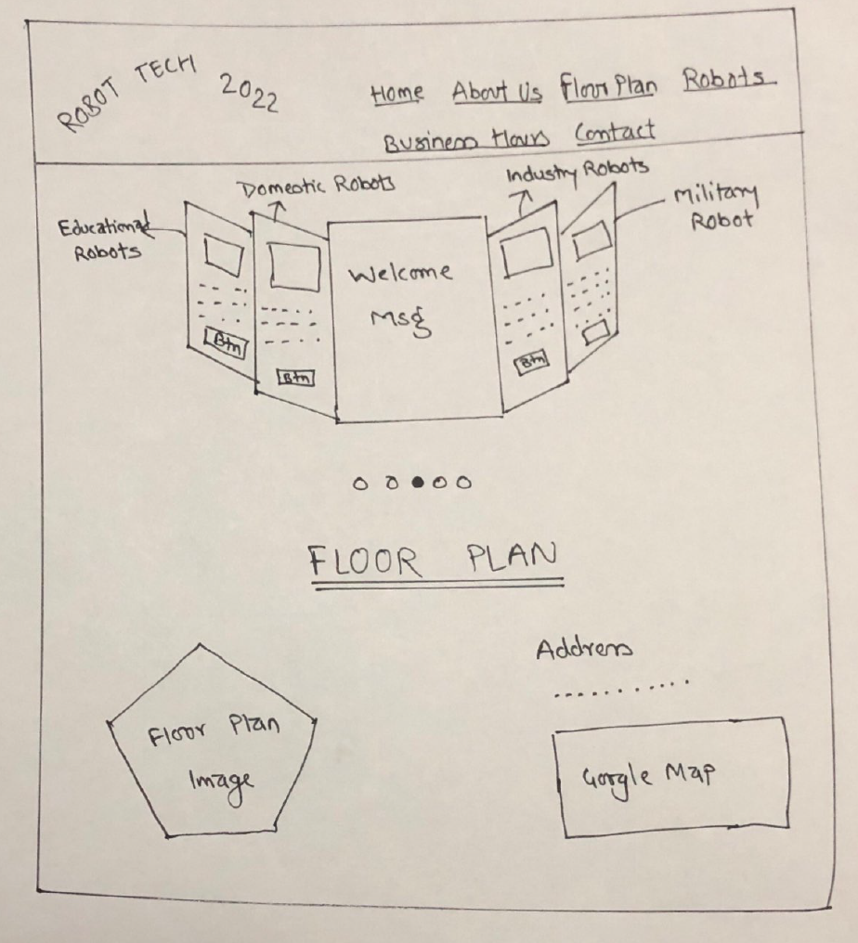

* As shown above, the navigation bar will have logo and links to several section of the page. This also contains the highlight of the exhibition and floor plans as well as address of the exhibition.

Robots:

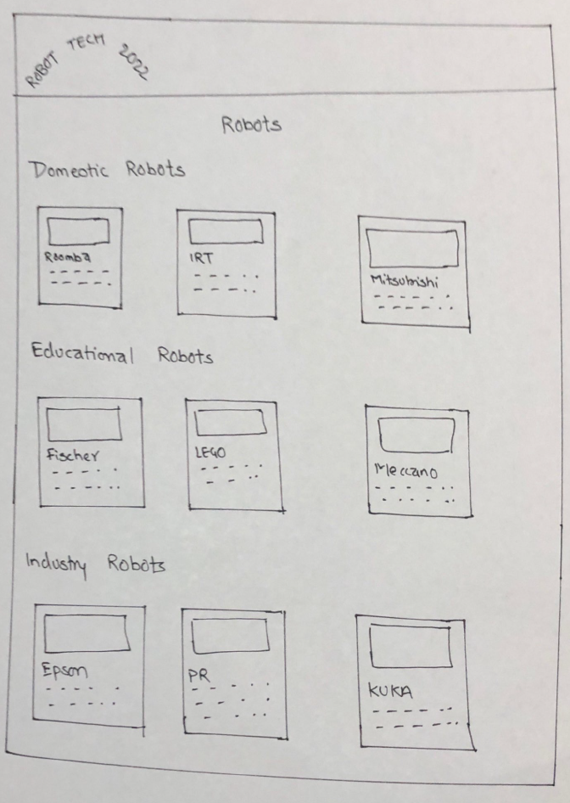

* This page will have description of all the robots that will be shown in the exhibition.

Business Hours and Fees:

* This page will have information about opening hours and entrance fees.
* This will also have a footer section that shows information regarding social media links, address as well as useful links to several section of the page.

# Portfolio 1.3:

## Site Specification

* **Client:**

Robot Expo, Senior Management is the client of this website.

* **Requirement of the client:**

The requirements of the client are:

1. The Robot Expo logo should be visible on every page of the website.
2. The picture provided can be edited, however the font type, style, and colour should remain as it is in the original.
3. The proper name of the items should not be changed.
4. The provided images can be resized maintaining their aspect ratio, but not crop, modify (such as by changing the colour, sharpening, or contrast), or rename them in any way.
5. All the images should be used on the website either on a single webpage or multiple web page.
6. The website should have a separate web page for business hours.
7. There is no text description for each item as of now so can use dummy text, such as lorem ipsum in website designing.

## Mission Statement:

This website's goal is to give visitors a detailed information about the exhibition such as robot types (domestic, educational, industrial, and military), floor layout plan and opening and business hours. Additionally, visitors can access other information such as a about page, robot details page which includes information such as robot manufacturer, price, size, and other specifications. The website also provides the information on exhibition location and contact information.

## Site’s Success Measurement:

The success of a website can be determined by its performance. The several website performance metrics that should be taken into consideration are overall traffic, organic traffic, bounce rate, average time on site, average page view per site, conversions, keyword rankings, website speed, broken links, backlinks, hardware utilization, error rate and DNS lookup time. All these metrices can be accessed from google analytics. Also, the site success can be measured by analysing the previous statistics data and server log files.

## Intended Audience:

The exhibition is targeted for all aged people like children, adults and senior citizens who has passion on robotic technology.

## User Satisfaction:

User satisfaction is the most important thing once the website is developed and delivered. The review of the exhibition and website traffic would help to know how satisfied the user are. The online feedback form as well as review section in website would come of great help to determine the user satisfaction.

## Technological Issues of the site’s functionality:

The technological issues of the site’s functionality could be platform incompatibility as the website is intended for desktop and laptop only as of now and the browser compatibility as it is tested on latest version of browsers so may not work properly on earlier versions.

Moreover, In general the technological issues in website could be weak internet connection issue, database connection issue, DNS errors, SSL certificate expirations, service providers issues, and hardware failures.

## Web Structure Flowchart:

The flowchart of Robot Expo website is shown below:

Fig: Website Flowchart

**Description of Flowchart:**

* The website has home page as index.html.
* Home page has several sections and link to other pages. Home page has welcome section, robots’ section, floor plan section, and footer. Further it has link to business hour page (business_hour.html) and about us page (about_us.html).
* The robot section has information of several types of robots. Each robot name has a link that takes to robot detail page (robot_details.html).
* Red link indicates the external navigation and blue link indicates internal navigation.

**Why choose this structure:**

* WIMP Engineering R&D consultant has chosen hierarchical structure to present the website and its structure.
* This structure is easy to understand, flexible and simple.
* With this structure, the navigation from one page to another is easy, consistent, and faster.
* The structure helps to maintain credibility, increase centricity with users and improves site performance.

# Portfolio 1.4

CSS can be implemented in three different ways:

* **Inline**

Inline CSS uses the style attribute inside html element.

Example:

   <img src="./assets/domestic_robots/d6.jpg" alt="" style="border: 1px solid #eeeeee;">

* **Internal**

Internal CSS uses <style> element in the <head > section.

Example:

<style>

        .tabs {

            display: flex;

            flex-wrap: wrap;

        }

        .tabs>section {

            order: 999;

            width: 100%;

            display: none;

        }

        .tabs>input {

            opacity: 0;

            position: absolute;

        }

</style>

* **External**

External CSS uses <link> element to link to an external CSS file.

Example:

 <link rel="stylesheet" href="css/style.css">

Some examples of CSS used in the website are:

.navbar {

    box-shadow: 0px 5px 10px 0px #aaa;

    /* position: fixed; */

    width: 100%;

    background: #fff;

    color: #000;

    opacity: 0.85;

    /* z-index: 100; */

}

.navbar-container {

    display: flex;

    justify-content: space-between;

    height: 64px;

    align-items: center;

}

.menu-items {

    order: 2;

    display: flex;

}

.logo {

    order: 1;

    font-size: 2.3rem;

}

.menu-items li {

    list-style: none;

    margin-left: 1.5rem;

    font-size: 1.3rem;

    height: 30px;

}

.navbar a {

    color: #444;

    text-decoration: none;

    font-weight: 500;

    transition: color 0.3s ease-in-out;

    font-size: 18px;

}

.navbar a:hover {

    color: #a82b33;

}

.logo-img {

    height: 50px;

    width: 100%

}

Above is the CSS used for navigation bar.

# Portfolio 1.5

## Type Hierarchy

* **Typeface and styles**
  + 1. Body Styles

@font-face {

    font-family: Roboto;

    src: url(https://fonts.googleapis.com/css2?family=Roboto&display=swap)

}

body {

    background-color: #fafafa;

    font-family: 'Roboto';

    font-size: 16px;

}

* + 1. Heading Styles

<h3> <span class="blue-txt" style="font-size:20px"> Floor Plan</h3>

It is recommended that the website does not have more than three font sizes. Having more than three font sizes can make the user disoriented with so many shifts in visual design.

* **Levels of headings**

|  |  |  |  |
| --- | --- | --- | --- |
| **HTML Element** | **Rank** | **Default Stylesheet** | **Pixel Height** |
| <h1></h1> | 1 | font-size: 2em | 32px |
| <h2></h2> | 2 | font-size: 1.5em | 24px |
| <h3></h3> | 3 | font-size: 1.17em | 18.72px |
| <h4></h4> | 4 | font-size: 1em | 16px |
| <h5></h5> | 5 | font-size: .83em | 13.28px |
| <h6></h6> | 6 | font-size: .67em | 10.72px |

**Example:**

  <h1>Heading 1</h1>

    <h2>Heading 2</h2>

    <h3>Heading 3</h3>

    <h4>Heading 4</h4>

    <h5>Heading 5</h5>

    <h6>Heading 5</h6>

**Output:**

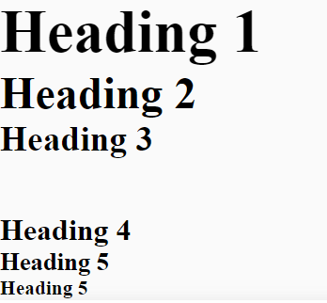

* **Hypertext Links**

1. **Logo :**

Logo will have a link to the home page.

1. **Navigation Bar:**

Navigation bar will have several tabs such as home, about us, robots, business hour, contact that will have link to respective page or section on the website. Business hour, about us and robot detail have separate page.

1. **Footer:**

The footer will have a short organization summary, quick links, follow us icons of facebook, Instagram, twitter and contact section. This section will also have a copyright notice.

* **Text Emphasis**

Text are emphasised by using text-emphasis property of CSS. Example:

.element{

text-emphasis: filled;

}

Text emphasis style css can be defined by either keyword values or string values.

The possible keyword values are:

1. Filled
2. open
3. dot
4. circle
5. double-circle
6. triangle
7. sesame
8. none

Likewise, string values could be any valid string. Example: ‘x’, ‘@’ etc.

* **Line Height**

The line-height property provides the height of a line. It sets the line for several html elements.

Example:

div.a {

line-height: normal;

}

div.b {

line-height: 1.6;

}

div.c {

line-height: 80%;

}

div.d {

line-height: 200%;

}

# Portfolio 1.6

## Box Model Convention (BMC)

In Robot Expo website, Box Model Convention is used in several section of the website in order to design and layout the html element. BMC consists of margins, padding, borders, and the content. The image below shows the box model used in one of the section of business hour.

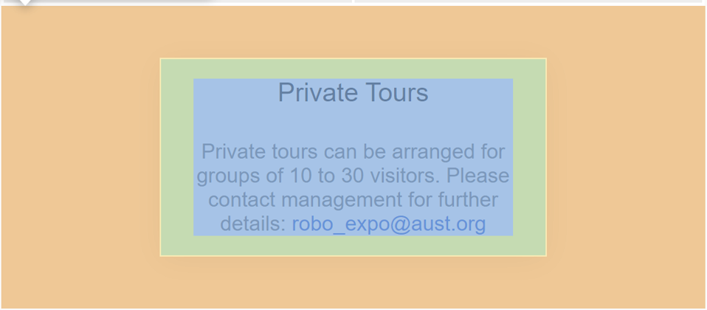 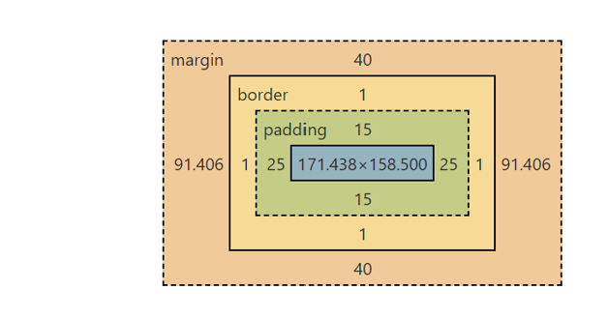

Fig: Box Model

CSS used for above box model is:

.tours {

    margin: 40px auto;

    text-align: center;

    border: 1px solid #fafafa;

    padding: 15px 25px;

    color: #666666;

}

CSS used for robots image in Our Robots section is:

.robots .border-shadows {

    box-shadow: 0px 5px 10px 0px #aaa;

    padding: 15px 15px 11px 15px;

    width: 100%;

    margin: 0px 3px;

    border: 1px solid #ffffff;

}

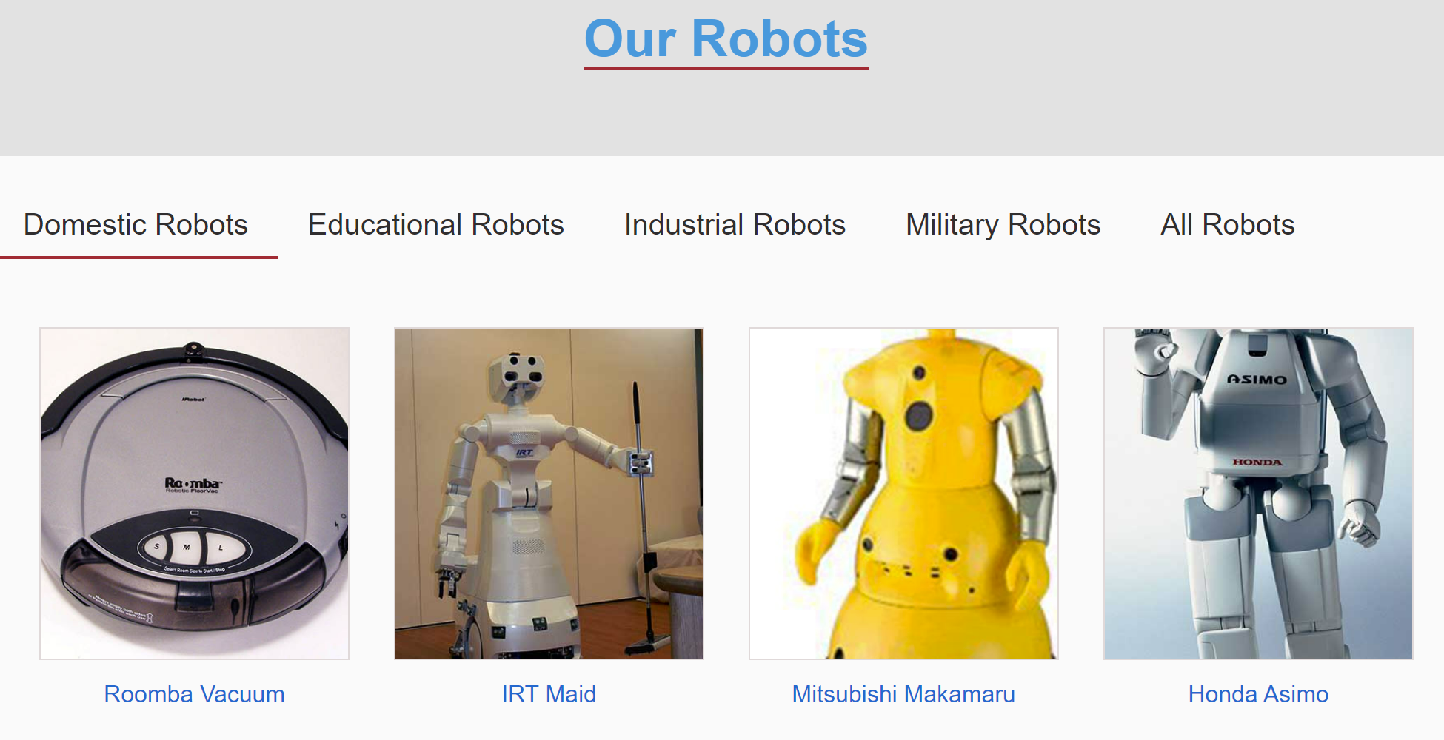

Fig: Before Applying CSS

Fig: After Applying CSS

# Portfolio 1 Summary:

**Files Provided:** All the portfolios from 1.1 to 1.6 is included in docx file.

**Designed For:**  Client (Robot Expo, Senior Management)