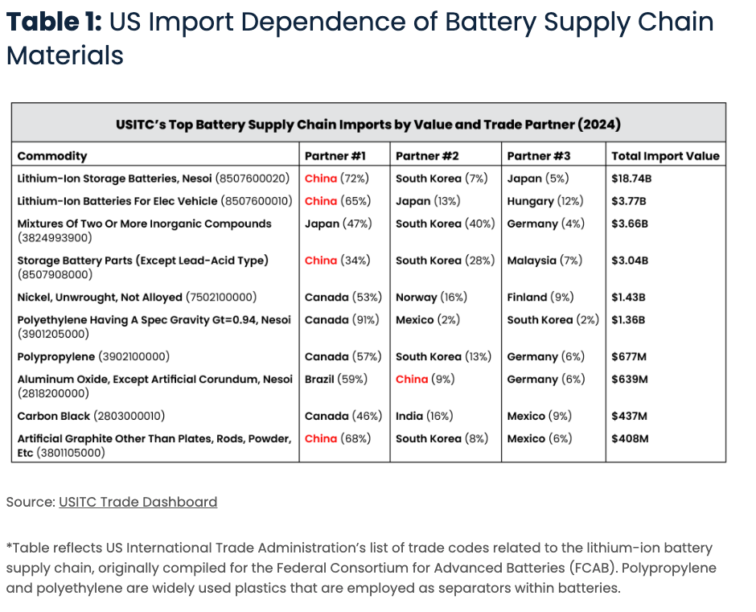
(Source: The Devil is in the Details: Minerals, Batteries, and US Dependence on Chinese Imports)

- U.S. and Taiwan classification:

# | Commodity (US Table) | US HS Code | TW HS code | 台灣分類 | 備註說明
1 | Lithium-Ion Storage Batteries, Nesoi | 8507600020 | 8507.60.00.00-5 | 鋰離子蓄電池 | 可重複充電；屬「蓄電池」，非「原電池」。
2 | Lithium-Ion Batteries for Electric Vehicles | 8507600010 | 8507.60.00.00-5（相同） | 鋰離子蓄電池（車用） | 台灣未再細分用途（EV vs 一般用），皆歸8507.60。
3 | Mixtures of Two or More Inorganic Compounds | 3824993900 | 3824.99.90.00-7 | 其他未列名化學品（無機化合物混合物） | 可涵蓋電解液、電極材料前驅物。
4 | Storage Battery Parts (Except Lead-Acid Type) | 8507908000 | 8507.90.00.00-8 | 蓄電池零件 | 包含模組外殼、導電片、端子。
5 | Nickel, Unwrought, Not Alloyed | 7502100000 | 7502.10.00.00-3 | 未合金鎳（未加工） | 原料級鎳，屬金屬礦物材料供應鏈。
6 | Polyethylene (Spec. Gravity ≥ 0.94) | 3901205000 | 3901.20.00.00-4 | 聚乙烯（高密度） | 用於隔膜或包裝材料。
7 | Polypropylene | 3902100000 | 3902.10.00.00-3 | 聚丙烯 | 亦為電池隔膜與封裝材料。
8 | Aluminum Oxide (Except Artificial Corundum) | 2818200000 | 2818.20.00.00-2 | 氧化鋁（非人工剛玉） | 電池隔膜塗層與陶瓷材料常用。
9 | Carbon Black | 2803000010 | 2803.00.00.00-9 | 炭黑 | 導電劑或陰極添加物。
10 | Artificial Graphite (Other than Plates/Rods/Powders) | 3801105000 | 3801.10.00.00-1 | 人造石墨 | 電池負極材料。

- Data source: Taiwan Customs Import and Export Statistics
- Data: TW/JP/KR battery

Taiwan-Japa-South Korea HS Code Cross-Reference Table (Including 8–10 Digit Codes)
HS 6-digit | Taiwan HS 10-digit | Taiwan Description | Japan HS 9-digit | Japan Description | Korea HS 10-digit | Korea Description
850760 | 8507.60.00.00-5 | 鋰離子蓄電池 | 8507.60-000 | Lithium-ion batteries | 8507600020 / 8507600090 | Li-ion battery (EV / Others)
382499 | 3824.99.90.00-7 | 其他未列名化學品 | 3824.99-099 / 900 | Other chemical products | 3824990000 / 3824999090 | Other chemical preparations
850790 | 8507.90.00.00-8 | 蓄電池零件 | 8507.90-000 | Parts of batteries | 8507900000 | Battery parts
750210 | 7502.10.00.00-3 | 未合金鎳（未加工） | 7502.10-000 | Unwrought nickel, not alloyed | 7502100000 | Unwrought nickel, not alloyed
390120 | 3901.20.00.00-4 | 聚乙烯（高密度） | 3901.20-000 | HDPE | 3901200000 | HDPE
390210 | 3902.10.00.00-3 | 聚丙烯（PP） | 3902.10-000 | Polypropylene | 3902100000 | Polypropylene
281820 | 2818.20.00.00-2 | 氧化鋁（非人工剛玉） | 2818.20-000 | Aluminium oxide | 2818200000 | Aluminium oxide
280300 | 2803.00.00.00-9 | 炭黑 | 2803.00-000 | Carbon black | 2803000000 | Carbon black
380110 | 3801.10.00.00-1 | 人造石墨 | 3801.10-000 | Artificial graphite | 3801100000 | Artificial graphite

Taiwan’s Top Battery Supply Chain Imports by Value and Trade Partners (2024)
Commodity | Partner #1 | Partner #2 | Partner #3 | Total Import Value  (USD thousand)
Lithium-Ion Storage Batteries  (Include EV batteries) | China (64.9%) | U.S. (11.4%) | South Korea (10.3%) | $ 1,286,832
Mixtures of Two or More Inorganic Compounds | Japan (39.8%) | China (20.4%) | U.S. (16.2%) | $ 1,537,149
Storage Battery Parts (Except Lead-Acid Type) | China (94.0%) | Japan (1.9%) | South Korea (1.4%) | $ 49,413
Nickel, Unwrought, Not Alloyed | China (64.4%) | Indonesia (17.7%) | Madagascar  (17.7%) | $ 872,349
Polyethylene (Spec. Gravity ≥ 0.94) | Saudi Arabia (15.9%) | Qatar (12.2%) | United Arab Emirates (11.5%) | $ 133,915
Polypropylene | South Korea (21.8%) | China (19.3%) | Japan (12.8%) | $ 93,217
Aluminum Oxide (Except Artificial Corundum) | China (38.7%) | Japan (17.1%) | India (12.7%) | $ 72,568
Carbon Black | China (41.9%) | South Korea (28.4%) | Japan (6.3%) | $ 67,514
Artificial Graphite (Other than Plates/Rods/Powders) | Japan (31.7%) | China (29.3%) | U.S. (21.8%) | $ 26,329

Regional dependency on China for battery materials (Korea and Japan)

- [South Korea] Source: Korea Customs Service

South Korea’s Top Battery Supply Chain Imports by Value and Trade Partners (2024)
Commodity | Partner #1 | Partner #2 | Partner #3 | Total Import Value  (USD thousand)
Lithium-Ion Storage Batteries  (Include EV batteries) | China (85.3%) | Indonesia (10.3%) | U.S. (0.9%) | $ 475,503
Mixtures of Two or More Inorganic Compounds | Japan (31.2%) | China (29.2%) | U.S. (12.9%) | $ 1,698,655
Storage Battery Parts (Except Lead-Acid Type) | China (77.1%) | Vietnam (7.4%) | Italy (3.8%) | $ 258,283
Nickel, Unwrought, Not Alloyed | Australia (28.1%) | Madagascar (22.9%) | Canada (13.1%) | $ 467,791
Polyethylene (Spec. Gravity ≥ 0.94) | U.S. (36.5%) | Japan (19.8%) | Qatar (12.0%) | $ 98,407
Polypropylene | China (30.5%) | Singapore (20.5%) | Japan (9.9%) | $ 40,323
Aluminum Oxide (Except Artificial Corundum) | Germany (18.0%) | China (16.6%) | Australia (14.3%) | $ 106,133
Carbon Black | India (19.8%) | China (15.5%) | Germany (15.2%) | $ 220,277
Artificial Graphite (Other than Plates/Rods/Powders) | China (66.0%) | Japan (17.7%) | U.S. (10.3%) | $ 140,051

- [Japan] Source: Trade Statistics of Japan

Japan’s Top Battery Supply Chain Imports by Value and Trade Partners (2024)
Commodity | Partner #1 | Partner #2 | Partner #3 | Total Import Value  (USD thousand)
Lithium-Ion Storage Batteries  (Include EV batteries) | China (76.8%) | South Korea (9.9%) | Singapore (4.2%) | $ 2,577,663
Mixtures of Two or More Inorganic Compounds | China (39.7%) | U.S. (17.3%) | Taiwan (7.2 %) | $ 1,336,309
Storage Battery Parts (Except Lead-Acid Type) | China (84.3%) | U.S. (4.2%) | Philippines (4.0%) | $ 436,603
Nickel, Unwrought, Not Alloyed | Australia (57.1%) | Madagascar (17.0%) | Canada (9.2%) | $ 833,318
Polyethylene (Spec. Gravity ≥ 0.94) | Thailand (62.3%) | South Korea (12.9%) | Malaysia (5.4%) | $ 235,521
Polypropylene | South Korea (24.9%) | Thailand (16.3%) | Vietnam  (15.5%) | $ 203,211
Aluminum Oxide (Except Artificial Corundum) | South Korea (18.5%) | Germany (16.7%) | Australia (16.7%) | $ 90,242
Carbon Black | Thailand (27.5%) | South Korea (23.3%) | China (17.3%) | $ 221,893
Artificial Graphite (Other than Plates/Rods/Powders) | China (58.4%) | U.S. (10.9%) | Poland (9.6%) | $ 131,566

Methodology and Description:
This report uses the Harmonized System (HS Code) to define the components and other essential parts of the battery supply chain. The HS Code is an internationally standardized classification system used to identify and categorize traded goods for customs, taxation, and statistical purposes. The World Customs Organization (WCO) is the international organization responsible for developing and maintaining the code, setting global customs standards, and facilitating international trade cooperation. While Taiwan is not a member of the WCO, the HS system is widely adopted around the world. Accordingly, Taiwan officially implemented an HS-based customs tariff schedule on January 1, 1989, and has continued updating its tariff classifications in line with subsequent WCO revisions (2002, 2007, 2012, 2017, 2022 and others).

For classifying each HS code of essential battery elements, this report refers to the categorizations used in the U.S. Energy Trade Dashboard for identifying key materials and components within the battery supply chain. The reason for referencing the US classification system is that Japan, Korea and Taiwan do not maintain dedicated HS Code lists for the battery industry. All three economies rely on the WCO’s standard six digit HS codes and only apply limited domestic extensions to the 8 to 10 digit level, which do not constitute an industry specific classification framework. In contrast, the US Energy Trade Dashboard organizes key goods and HS codes related to specific sectors such as the Battery Supply Chain, Civil Nuclear and Electrical Energy, using a sub sector structure that maps the essential materials and components within each supply chain. Accordingly, this report adopts that classification approach. In addition, this report also incorporates analysis from the Council on Strategic Risks, whose study of the battery industry likewise relies on the US Energy Trade Dashboard as a foundational reference and builds a more comprehensive dataset from that framework. In sum, this report adopts the sectoral classifications and reporting structure used in these official and research sources to evaluate the import dependence of Japan, Korea and Taiwan in their battery supply chains and to examine the extent of China’s influence within them.

Although most HS code classifications across the three countries are similar, there are still some differences for certain items. For instance, there are slight variations in how some categories are coded across the three economies. While the six digit HS codes are standardized globally by the WCO, distinctions arise at the domestically defined eight to ten digit levels. For example, in the case of 8507.60 (Lithium-ion batteries), Taiwan distinguishes between automotive and non automotive batteries through Mandarin annotations, although both categories remain under the same ten digit code. Japan does not assign separate HS codes for automotive and non automotive batteries, whereas Korea further divides the category into 8507.60.0020 (Vehicles) and 8507.60.0090 (Other lithium-ion batteries). Furthermore, differences in the level of disaggregation for HS Code 3824.99 among Taiwan, Japan and Korea have significant implications for the analysis of battery-related trade, this code represents the area of greatest divergence across the three countries.

HS 3824.99 encompasses a broad range of battery-critical chemical products, including electrolyte precursors, fluorinated compounds associated with LiPF6 and various inorganic mixtures used in precursor production. The classification of these additives and chemical inputs directly affects the comparability of raw material statistics, the visibility of battery-specific chemical flows and the reliability of supply-chain risk assessments. In terms of granularity, Taiwan employs the least detailed approach, consolidating most items under 3824.99.90.00. Korea adopts an intermediate level of differentiation, dividing items into 3824.99.0000 and 3824.99.9090, with some additional distinctions based on use or purity. Japan applies the most detailed classification scheme, further subdividing 3824.99 into numerous categories according to chemical properties or intended applications. Consequently, the broader classifications used in Taiwan and Korea tend to obscure battery-related materials within aggregate trade statistics, whereas Japan’s finer disaggregation allows for a more precise identification of import dependencies. However, to ensure a fair comparison of import items across countries, this report relies solely on the WCO six digit HS codes, which means that differences arising from more detailed domestic classifications may not be fully captured. Since some economies do not employ extensive sub-classifications and because the additional granularity does not substantially alter the aggregate level data used in this analysis, this report consolidates all relevant items under the six digit category and groups them collectively as “Other chemical products.”

[Coding and how to summarize customs data from each country]
TW: Data from Taiwan Customs Import and Export Statistics /
JP: Data from Trade Statistics of Japan /
KR: Data from Korea Customs Service /
Taiwan’s, Japan’s and Korea’s customs data were collected and matched to the battery supply chain import categories identified in the U.S. Energy Trade Dashboard using HS six digit codes. For Japan, since domestic trade statistics report import values in yen rather than in U.S. dollars, all figures were converted using the prevailing exchange rate (1 USD to 155 JPY) before calculating total import values.

[Analysis of the data tables and the differences among the three countries]

- 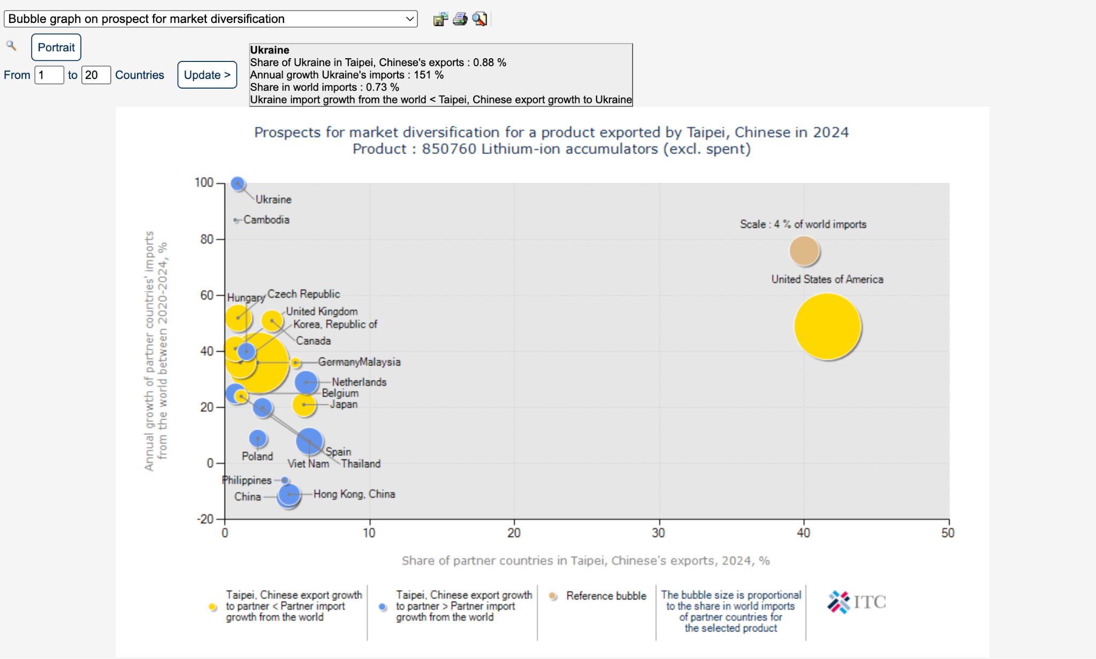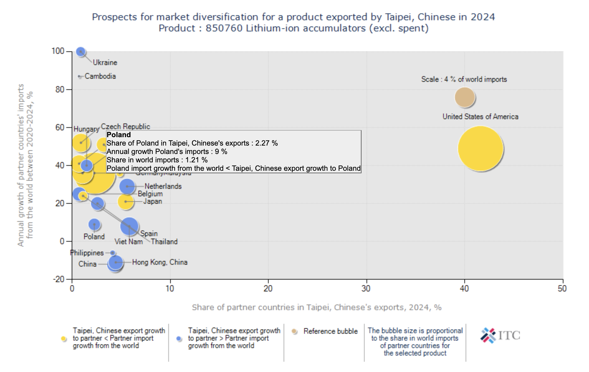

 |  | 正極材料 |  | 電池成品
4碼 |  | 2833 Sulphates |  | 8507 電池總類
 |  | 2833.29  Other sulphates |  | 8507.40  Lithium-ion accumulators

 | 4碼 | 6碼 | 說明
正極材料 | 2833 Sulphates | 2833.29 Other sulphates | Cobalt sulfate、Nickel sulfate、Manganese sulfate  幾乎所有 NMC / NCA 前驅體的起點
 | 2822 Cobalt Oxides And Hydroxides
 | 2825 Hydrazine and hydroxylamine and their inorganic salts; other inorganic bases; other metal oxides, hydroxides and peroxides: | 2825.20  Lithium oxides and hydroxides | 鋰材料
 |  | 2825.40  Nickel oxides and hydroxides | 鎳材料
 | 2836 Carbonates | 2836.91 Lithium carbonates (Li₂CO₃) | LFP、NMC 都會用到
負極材料 | 2504 Natural graphite | 2504.10 Natural graphite in powder or in flakes
 | 3801 Artificial graphite; colloidal or semi-colloidal graphite; preparations based on graphite or other carbon in the form of pastes, blocks, plates or other semimanufactures: | 3801.10 Artificial graphite
電解液與功能化學品 | 3824 Prepared binders, chemical products | 3824.99  Other chemical products | 電解液、添加劑、功能化學品
 | 2915 Saturated acyclic monocarboxylic acids and their anhydrides, halides, peroxides and peroxyacids; their halogenated, sulfonated, nitrated or nitrosated derivatives: |  | 電解液上游，但不適合拿來做統計。可以拿來看台灣有沒有自產特用化學品能力。
 | 2917 Polycarboxylic acids, their anhydrides, halides, peroxides and peroxyacids; their halogenated, sulfonated, nitrated or nitrosated derivatives:
電池 | 8507 Electric storage batteries, including separators therefor, whether or not rectangular (including square); parts thereof: | 8507.60 Lithium-ion batteries
電池回收 | 8105 Cobalt mattes and other intermediate products of cobalt metallurgy; cobalt and articles thereof, including waste and scrap: | 8105.20 Cobalt powders
 | 7502 Nickel, unwrought | 7502.10 Nickel, not alloyed
 | 2841 Salts of oxometallic or peroxometallic acids: |  | 回收後再製鋰鹽、鎳鹽常見分類

