FUNCTIONAL SPECIFICATION DOCUMENT

GENERAL

Background
Validation is confirmation through objective evidence that the requirements of an activity/object have been fulfilled. Validation is based on tangible evidence and provides confidence in contract actualization. Such factual results include inspection, measurement, test, analysis, calculation, etc.

Various services/ products exchange hands every day as part of interaction and business. The need to validate these services using tangible means comes into play to meet customer confirmation/confidence or avoid fraud/corruption practices. This project looks at validating tangible services/products. The validation system will a structure in which products (such as a carton of beer) and services (such as dinner).

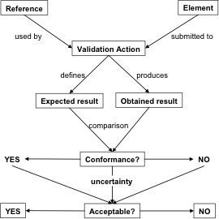

Project Description.
The system shall define a validations process which has to be met through physical confirmation, system validation and or person validation. A list of predefined validation object shall be included in the system which includes (object recognition, customer feedback/rating, documentation, email confirmation, system check, approver). A validation task shall be one or more validation objects utilized to approve an activity/object. The validation system, for now, shall only confirm object receipt for deliveries and customer service satisfaction.

Purpose
The objective of this system is to provide assurance to the upper-level supervisor/manager that lower level activities are being executed through factual pre-defined evidence. This improves the quality of assurance, supervision/management of a system and reduces fraud/corruption.

Assumptions and Constraints
Several AI systems can be used to validate processes like speech recognition, object recognition, digital live measurement of products, etc. Only the output of the AI system will be implemented in the project. So many verification objects can be defined on the system but on those indicated above will be considered for this project.

Interfaces to External Systems
The users of the system will include the stakeholders/approvers that provide the validation required and the nature of the validation, the system that automatically validates, the owners/implementers of the task that will provide objective validation evidence, the system administrator that inputs the tasks.

Admin:
- Defines projects/new services to be carried out
- Defines validation objects (object recognition, customer feedback/rating, documentation, email confirmation, system check, approver) and type
- Defines object evidence
- Defines approvers/stakeholders

User/System:
- Confirms completion of the job
- Requests for approval
- Approves verification

System
- Confirms validation type, tasks, and inputs
- Checks evidence against database/algorithm
- Sends to approver

Approver
- Confirms all validation objects have been provided and approved
- Confirm validation task has been completed
- Approves validation task/project

Document References
The Functional requirement document references the definition validation according to the Systems Engineering Body of Knowledge (SEBoK)
https://www.sebokwiki.org/wiki/System_Validation

FUNCTIONAL REQUIREMENTS

Data Flow Model
The data model shows the flow of data of the validation system.

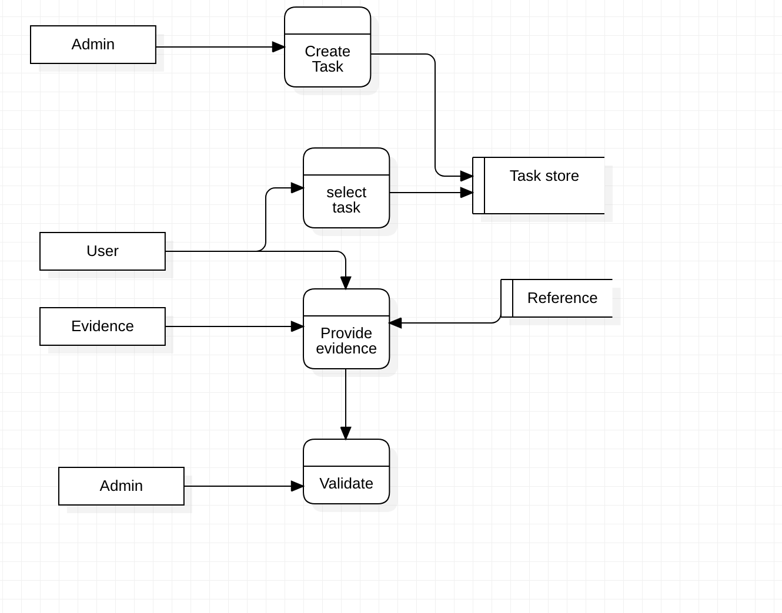

Class Responsibility Collaborator Card

The class responsibility collaborator shows the various classes and their roles and interrelations with other classes.

STAKEHOLDERS/ APPROVER

Approves predefined task process

Approves completed task process

ADMIN
Inputs list of tasks object | Task objects

Has admin password

VALIDATING SYSTEM
Approves task objects | Stakeholder/Approver

Compiles task objects until it meets the task process

Send completed tasks process for final approval

TASK OWNER
Selects a list of task objects | Approver
Sets task objects in a process | Task process

Saves task process

Sends pre-defined task process for approval

Assigns tasks to Users

TASKS OBJECT
Has a list of task objects | Task process

Has a task object description

TASK PROCESS
Compiles task objects | Task Owner

Receives predefined task process

REFERENCE
Has reference AI database (signature, document, object database, etc) | Validating system

Provides output of database

2.3 Class Diagram
The class diagram consists of nine classes. The administrator defines the task objects for validation. The task objects are selected by the task process owner and set up one or more task objects as a task process. The pre-task process is approved by the approver and the task object owners then receive their task object and provide evidence which is matched against a database. when all tasks are completed they are sent to the approver for final approval.
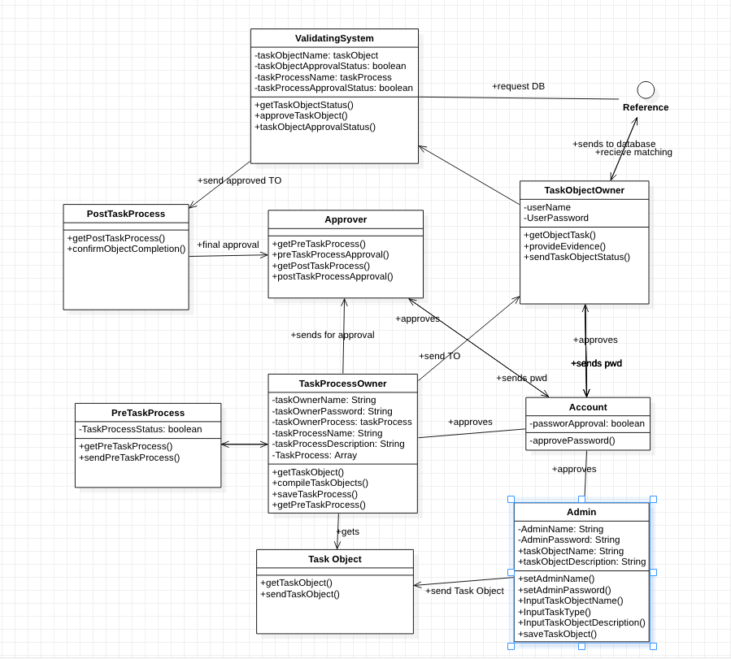

2.3 Sequence Diagram
The sequence diagram shows how the larger process is interconnected via smaller processes. The sequence diagram takes from the class diagram in what is defined, how the defined objects are related, etc.
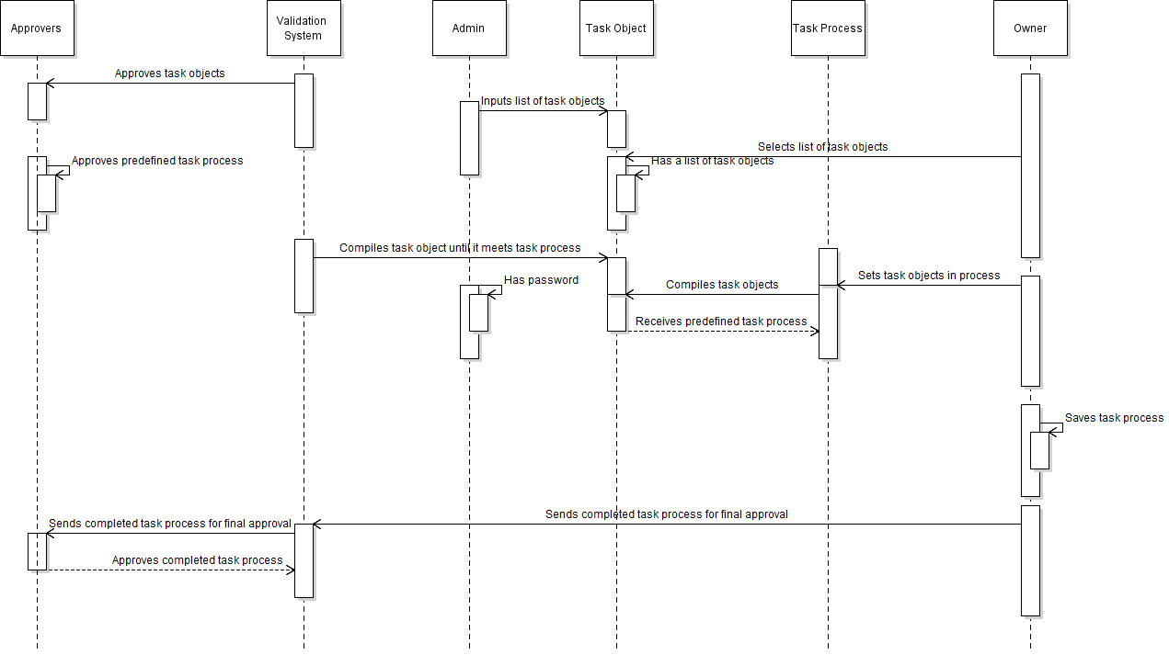

2.3 State Diagram
The state diagram describes the order in which the operation will be performed. The user will request the database, and depending on whether or not the task process is predefined, will either go to the validating system or the task object owner. In the case of the latter, a password will be required to gain admin privileges, and then the user is free to send and receive task objects to be added. In the event of the validation sys

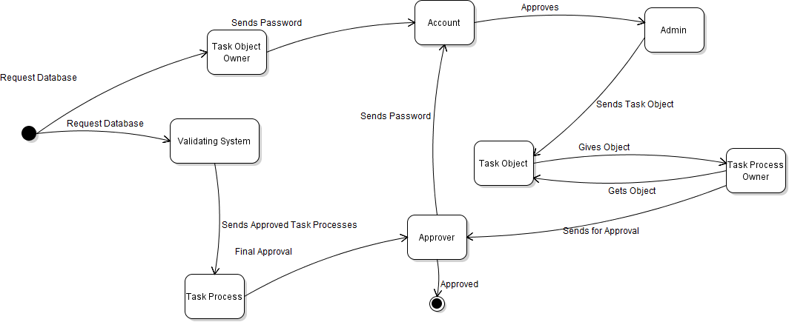

SYSTEM REQUIREMENT
The system implemented as a web-based application, the operating platform will be for windows platform and the language will be implemented in Java

SECURITY
Security will be based on the user account authentication system over the web

CONCLUSION
Acceptance of the validation system will be based on user testing against the functional specification document.

FUNCTIONAL SPECIFICATION DOCUMENT

GENERAL

Background
Validation is confirmation through objective evidence that the requirements of an activity/object have been fulfilled. Validation is based on tangible evidence and provides confidence in contract actualization. Such factual results include inspection, measurement, test, analysis, calculation, etc.

Various services/ products exchange hands every day as part of interaction and business. The need to validate these services using tangible means comes into play to meet customer confirmation/confidence or avoid fraud/corruption practices. This project looks at validating tangible services/products. The validation system will a structure in which products (such as a carton of beer) and services (such as dinner).

Project Description.
The system shall define a validations process which has to be met through physical confirmation, system validation and or person validation. A list of predefined validation object shall be included in the system which includes (object recognition, customer feedback/rating, documentation, email confirmation, system check, approver). A validation task shall be one or more validation objects utilized to approve an activity/object. The validation system, for now, shall only confirm object receipt for deliveries and customer service satisfaction.

Purpose
The objective of this system is to provide assurance to the upper-level supervisor/manager that lower level activities are being executed through factual pre-defined evidence. This improves the quality of assurance, supervision/management of a system and reduces fraud/corruption.

Assumptions and Constraints
Several AI systems can be used to validate processes like speech recognition, object recognition, digital live measurement of products, etc. Only the output of the AI system will be implemented in the project. So many verification objects can be defined on the system but on those indicated above will be considered for this project.

Interfaces to External Systems
The users of the system will include the stakeholders/approvers that provide the validation required and the nature of the validation, the system that automatically validates, the owners/implementers of the task that will provide objective validation evidence, the system administrator that inputs the tasks.

Admin:
- Defines projects/new services to be carried out
- Defines validation objects (object recognition, customer feedback/rating, documentation, email confirmation, system check, approver) and type
- Defines object evidence
- Defines approvers/stakeholders

User/System:
- Confirms completion of the job
- Requests for approval
- Approves verification

System
- Confirms validation type, tasks, and inputs
- Checks evidence against database/algorithm
- Sends to approver

Approver
- Confirms all validation objects have been provided and approved
- Confirm validation task has been completed
- Approves validation task/project

Document References
The Functional requirement document references the definition validation according to the Systems Engineering Body of Knowledge (SEBoK)
https://www.sebokwiki.org/wiki/System_Validation

FUNCTIONAL REQUIREMENTS

Data Flow Model
The data model shows the flow of data of the validation system.

Class Responsibility Collaborator Card

The class responsibility collaborator shows the various classes and their roles and interrelations with other classes.

STAKEHOLDERS/ APPROVER

Approves predefined task process

Approves completed task process

ADMIN
Inputs list of tasks object | Task objects

Has admin password

VALIDATING SYSTEM
Approves task objects | Stakeholder/Approver

Compiles task objects until it meets the task process

Send completed tasks process for final approval

TASK OWNER
Selects a list of task objects | Approver
Sets task objects in a process | Task process

Saves task process

Sends pre-defined task process for approval

Assigns tasks to Users

TASKS OBJECT
Has a list of task objects | Task process

Has a task object description

TASK PROCESS
Compiles task objects | Task Owner

Receives predefined task process

REFERENCE
Has reference AI database (signature, document, object database, etc) | Validating system

Provides output of database

2.3 Class Diagram
The class diagram consists of nine classes. The administrator defines the task objects for validation. The task objects are selected by the task process owner and set up one or more task objects as a task process. The pre-task process is approved by the approver and the task object owners then receive their task object and provide evidence which is matched against a database. when all tasks are completed they are sent to the approver for final approval.

2.3 Sequence Diagram
The sequence diagram shows how the larger process is interconnected via smaller processes. The sequence diagram takes from the class diagram in what is defined, how the defined objects are related, etc. The owner has the most options to use, whereas the validation system is the core of the sequence’s operations. The approvers have the decision to appr

2.3 State Diagram
The state diagram describes the order in which the operation will be performed. The user will request the database, and depending on whether or not the task process is predefined, will either go to the validating system or the task object owner. In the case of the latter, a password will be required to gain admin privileges, and then the user is free to send and receive task objects to be added. In the event of the validation system being used, the task process will be taken to the approver for final approval.

SYSTEM REQUIREMENT
The system implemented as a web-based application, the operating platform will be for windows platform and the language will be implemented in Java

SECURITY
Security will be based on the user account authentication system over the web

CONCLUSION
Acceptance of the validation system will be based on user testing against the functional specification document.

