Boot overview

* + **Tips with "secure boot”**
  + **Purpose**
  + **Give an overview of secure boot steps**
  + **How to activate authentication in boot and authentication procedure**
  + **Overview of Boot Rom**
  + **STM32MP1 ROM Code and secure boot chain overview**
  + **Overview of binary format**

<https://wiki.st.com/stm32mpu/index.php/STM32MP15_secure_boot>



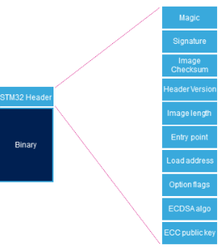 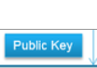

* + **How to generate Keys with KeyGen Tool:**

**What is generated by KeyGenTool (must be done in secure environment)**

**Public Key**

**Private Key**

**Public key hash**

<https://wiki.st.com/stm32mpu/index.php/KeyGen_tool>

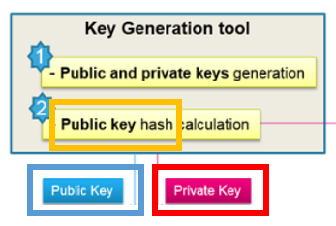

* + **How to sign with Signing Tool**

**Signing Tool adds the Public Key and the Image Signature into the Image Header**

**(must be done in secure environment)**

<https://wiki.st.com/stm32mpu/index.php/Signing_tool>

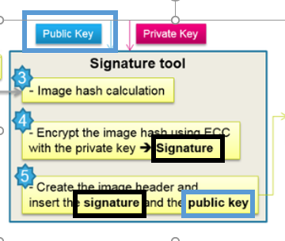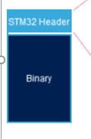

* + **How to program OTP with hash of public key**

**Use CubeProgrammer to flash the Public hash key in OTP**

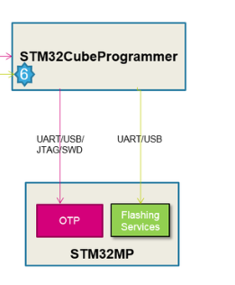

[**https://wiki.st.com/stm32mpu/index.php/STM32MP15_ROM_code_overview**](https://wiki.st.com/stm32mpu/index.php/STM32MP15_ROM_code_overview)

8.2 OTP configuration

<https://wiki.st.com/stm32mpu/index.php/STM32CubeProgrammer_OTP_management>

<https://wiki.st.com/stm32mpu/index.php/STM32MP15_secure_boot>

3.2 Target configuration

* + **How to activate authentication**

<https://wiki.st.com/stm32mpu/index.php/STM32MP15_secure_boot>

3.2.4 Close the device

**Use** **CubeProgrammer or U-Boot command to force authentication**

At this point all images must be signed by signing tool

* + **Authentication procedure on device**

<https://wiki.st.com/stm32mpu/index.php/STM32MP15_secure_boot>

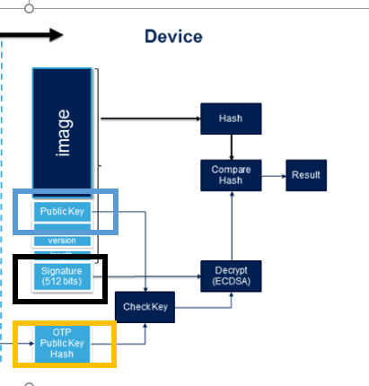

* + **Overview of Rom Code**

https://wiki.st.com/stm32mpu/index.php/STM32MP15_ROM_code_overview