**Software Design (International Year 1)**

[**XFX1061-2021 : Software Design**](https://brightspace.hud.ac.uk/d2l/home/135410)

Coursework Title **Authentication Manager**

**Submitted by Rohit Verma**

[**U2079600@unimail.hud.ac.uk**](mailto:U2079600@unimail.hud.ac.uk)

**Table of contents:-**

**1.Introduction**

**2.Objectives**

**3.Aim**

**4. Project Methodology**

**5.Diagrams/ diagrams breakdown**

**6.Source code**

**Introduction:-**

Authentication manager is basically a user log in system in which a user can register with by given his details , when the details successfully stored you are able to log in with your given details and also you can reset your password if you forgot its just a basic model but in the software development field it is used in many of the system as like facebook, Instagram not just for the social apps in any type of website or app always there is a log in system to keep your data private. If we start from the scratch everything which you gonna make should be a design first so in this coursework/project there are uml diagrams , class diagrams, sequence diagrams ,activity diagram which will give a great idea and understanding how this project is going to work

**Objectives:-**

The objectives to making this project is utilize a basic idea to be in function by modifying and designing it own your way , this will focus on the software design.

For making the software first of all you need a design how you going to make it. So there are different ways to show your designs maybe it can be on paper or digitally it depends on you how you are perfect on your designs.

**Aim:-**

The aim of making this project/coursework to show my skills in software design environment and to make me perfect for the future in which I am going to work . Its all depends on my design and hardwork it will give me an experience .

**Project methodology:-**

For making the designs for this project I have used draw.io in which there are lot of facilities available which are very useful to define your design .

I have made uml diagram ,class diagram , sequence diagram and flowchart for this project so it will be easy to understand the functionality of the project(authentication manager).

For making the source code of this project I have used visual studio there are lot of IDE’s available online as well as offline but it has a lot of features which other doesn’t have.

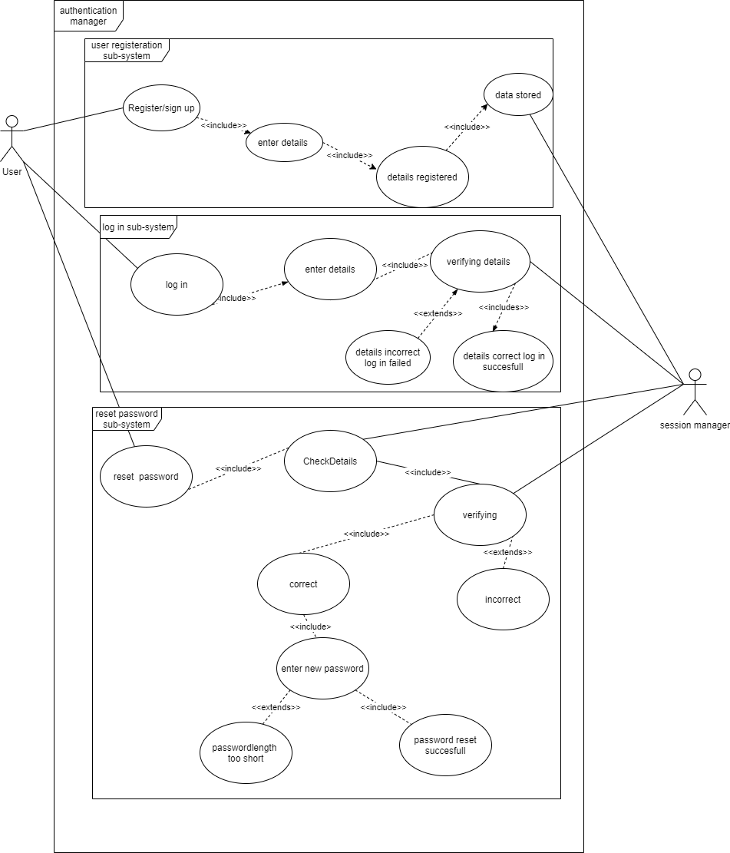

This is my UML diagram in which I have used three sub -systems first one is for user registration that shows how user can register his details step by step. Second one is log in sub-system in which user can log in by enter his details and the last one is reset password in which user can change his password by entering his details.

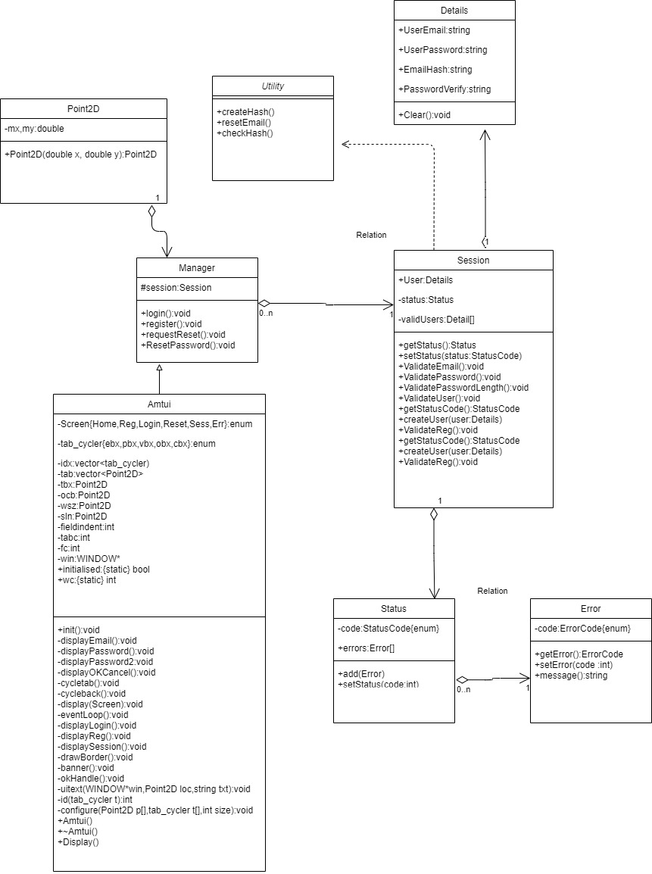

In this class diagram there are 8 classes in which between Error class and Status class has aggregate relation. Status and Details class are aggregates from the session class . Session class aggregates from Manager class. Utility class is inheriting from Session class. Point2D class is aggregates from Manager class. Amtui class is depends on Manager class.

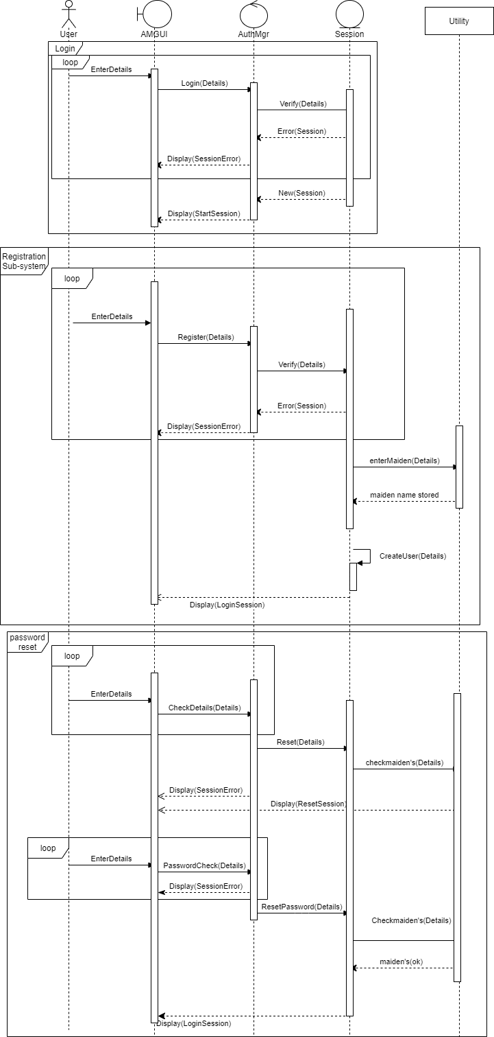

In this sequence diagram, we can there is a actor name user which will interact in the system and there is Amtui is a boundary object which will display the interface . AuthMgr is a control abject which will help user to control the interface and the Session is a entity object which will manage or handle, helps to verify the details of the user. Utility is object it will used to store data (details) of the user .

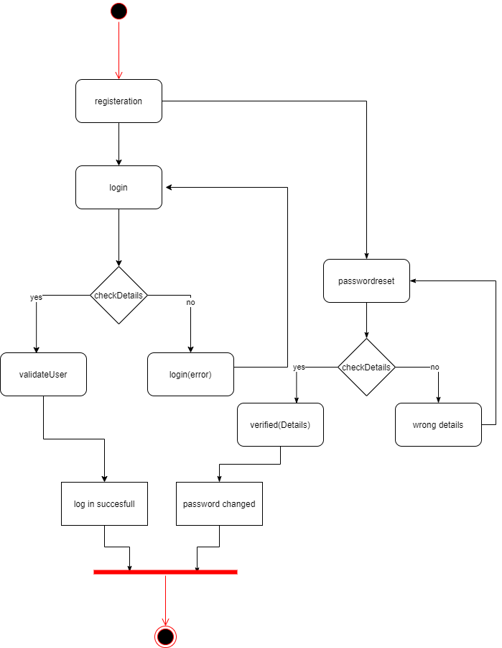

In this activity diagram you can get a simple idea how in which steps the program is going to work.