Part 1: Baseline Comparison

1.Baseline stats table for both variants
Metric | Simple MergeSort | Chunked MergeSort | Chunked/Simple Ratio
sim_ticks | 4.441701e+12 | 4.284820e+12 | 0.965x
sim_seconds | 4.441701 | 4.284820 | 0.965x
sim_insts | 1.186683e+09 | 1.162543e+09 | 0.980x
ipc | 0.267169 | 0.271317 | 1.016x
cpi | 3.742956 | 3.685732 | 0.985x
l1d_accesses | 3.137421e+08 | 3.076046e+08 | 0.980x
l1d_misses | 6.102925e+06 | 5.595426e+06 | 0.917x
l1d_miss_rate | 0.019452 | 0.01819 | 0.935x
l1d_hit_rate | 0.980548 | 0.981810 | 1.001x
l1i_accesses | 1.615806e+09 | 1.584327e+09 | 0.981x
l1i_misses | 419 | 440 | 1.050x
l1i_miss_rate | 0.0 | 0.0 | N/A
l1i_hit_rate | 0.9999997 | 0.9999997 | 1.000x
l2_accesses | 6.103349e+06 | 5.595872e+06 | 0.917x
l2_misses | 4.168862e+06 | 3.614427e+06 | 0.867x
l2_miss_rate | 0.683045 | 0.64591 | 0.946x
l2_hit_rate | 0.316955 | 0.354090 | 1.117x

Default Configuration: L1I=32KiB/8-way, L1D=64KiB/8-way, L2=512KiB/16-way

2.Analysis (200-300 words)
The baseline comparison shows chunked merge sort has better cache performance despite higher complexity. The chunked variant runs 3.5% faster (0.965x sim_ticks) and achieves 1.6% higher IPC (0.271 vs 0.267) compared to simple merge sort.
The advantage comes from better cache locality at multiple levels. The chunked approach processes 2MB chunks that fit better in the cache hierarchy, reducing L1D
miss rate by 6.5% (0.01819 vs 0.01945) and L2 miss rate by 5.4% (0.6459 vs 0.6830). This results in 554,499 fewer L2 misses, reducing memory access latency.
The chunked algorithm's better locality comes from its divide-and-conquer strategy. By sorting individual 2MB chunks independently and merging from 1MB streams, it shows better temporal and spatial locality. Each chunk stays in the cache hierarchy longer, improving data reuse before eviction. The merge phase benefits from streaming access patterns that prefetchers can predict effectively.
Parameters favoring chunked sorting:

1. L2 hit rate: 35.4% vs 31.7% (11.7% improvement) — the larger L2 cache captures chunk working sets
2. L1D hit rate: 98.2% vs 98.1% — marginal but consistent improvement
3. Total memory accesses: 8% fewer L2 accesses (5.6M vs 6.1M)

The chunked approach's complexity overhead (extra chunk management, merge logic) is more than offset by cache efficiency gains. The 13.3% reduction in L2 misses directly correlates with the 3.5% execution time improvement, showing that memory hierarchy optimization is important for data-intensive workloads.
This validates that cache-aware algorithm design can outweigh implementation complexity in memory-bound applications like merge sort on large datasets.

Part-2: Cache Optimization Sweep

1.Results table

Result table is too large please go to this path
problem2\analysis\part2_full_results.csv

2. Plots (minimum 4):

- L2 miss rate vs L2 size
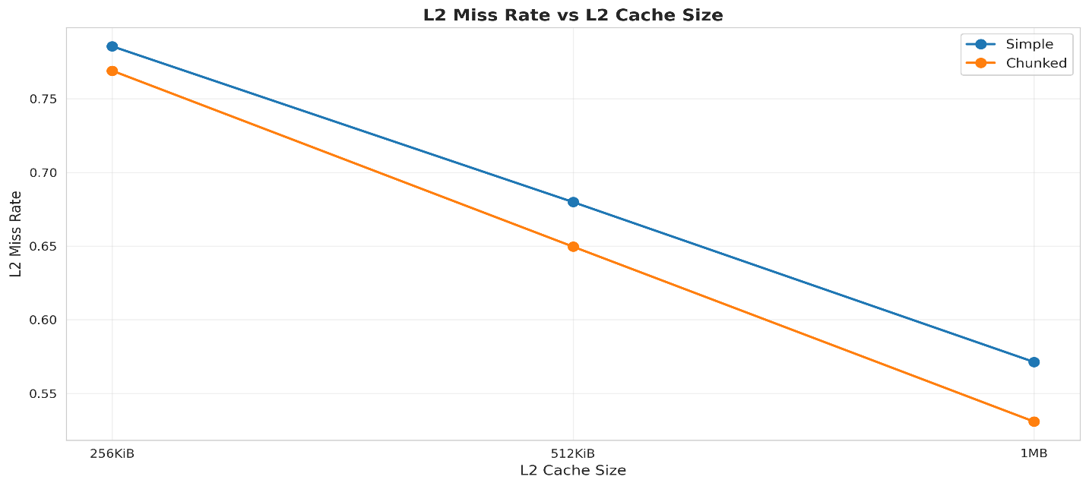
- IPC vs L1D size
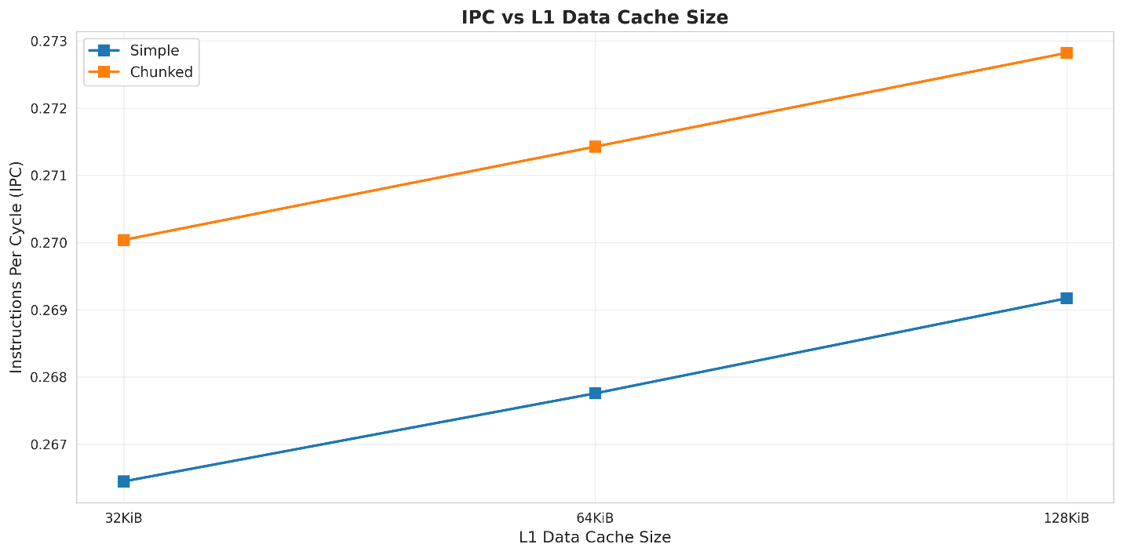
- L1D hit rate vs associativity
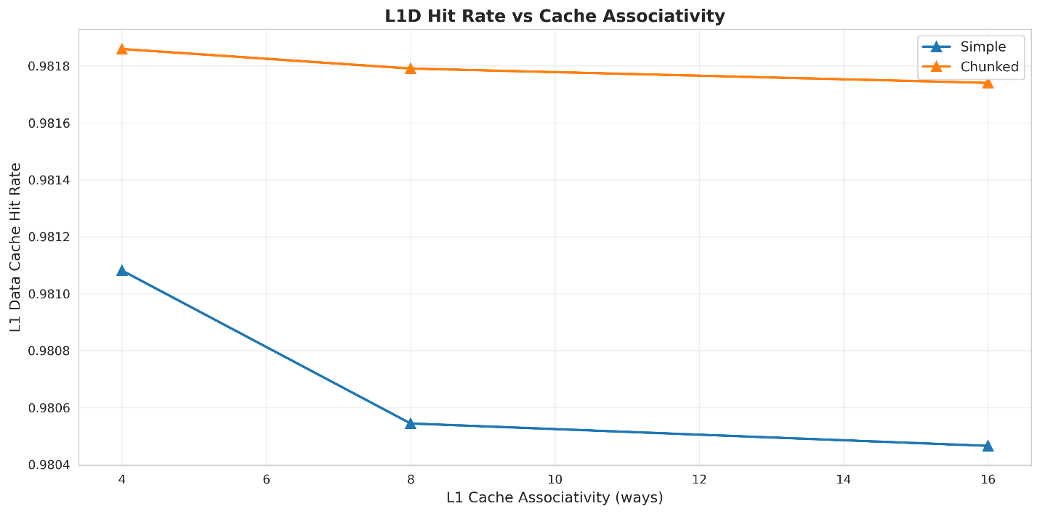
- Simple vs Chunked comparison
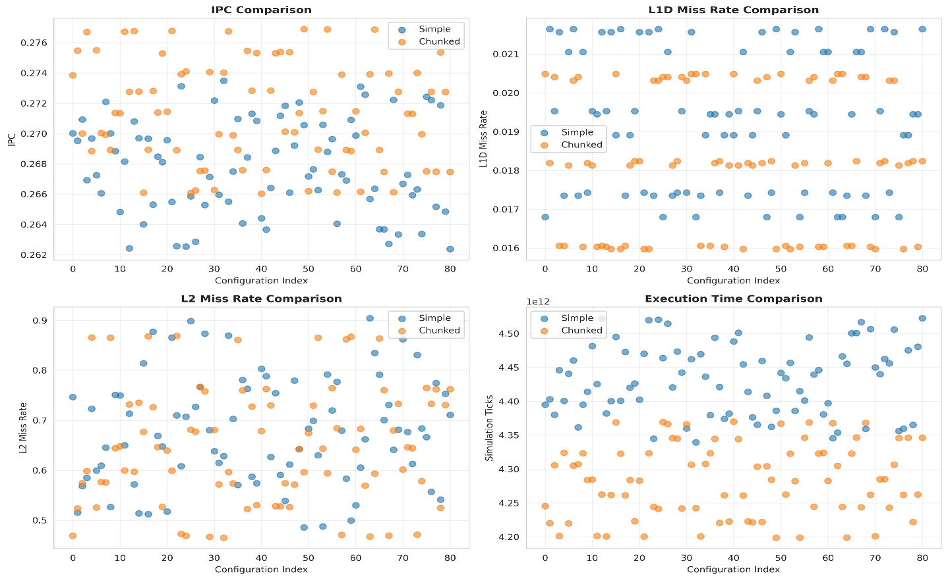
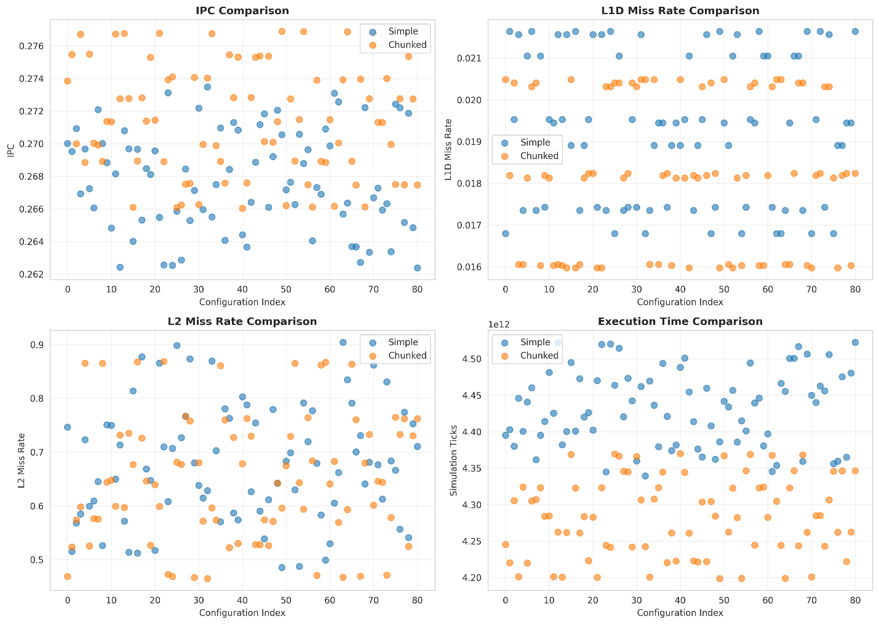
- Simple mergesort IPC heatmap
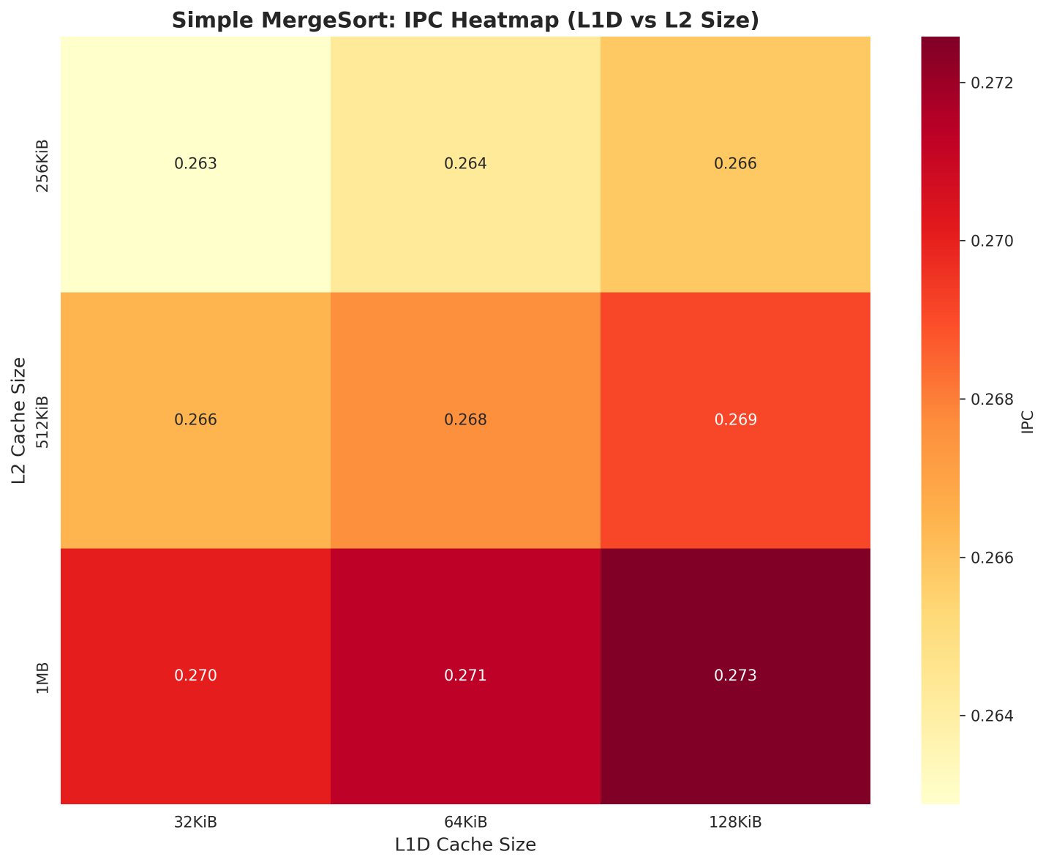

- Chunked mergesort IPC heatmap
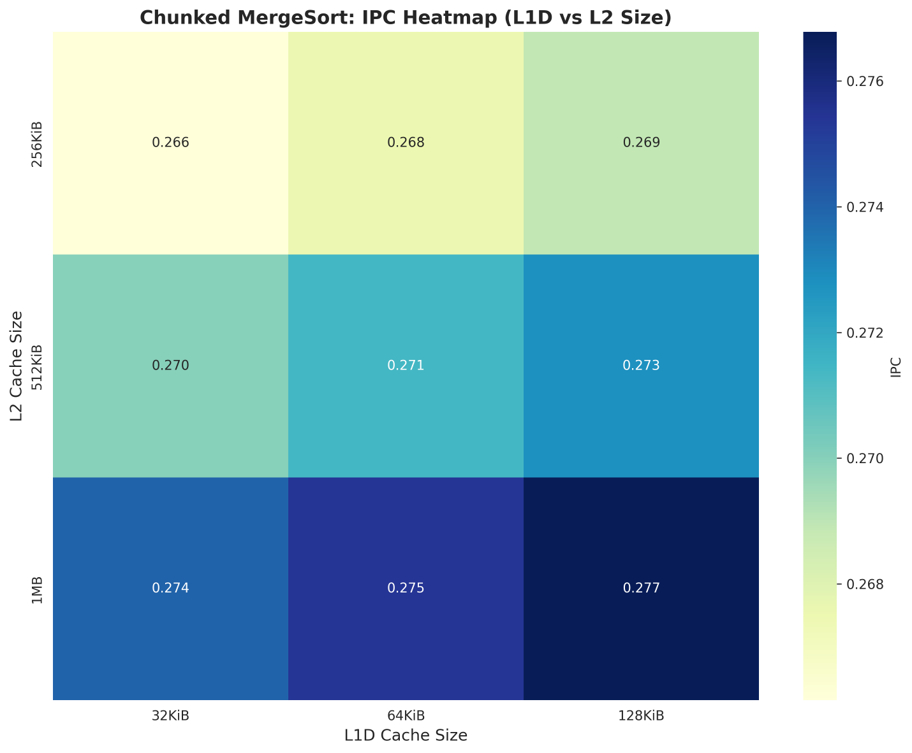

3. Top 3 configs ranked by IPC for each workload

Simple MergeSort - Top 3:
l1i size | l1d size | l2 size | l1 assoc | l2 assoc | ipc | cpi | Sim  ticks | l1d  miss rate | l2  miss  rate
32KiB | 128KiB | 1MB | 4 | 4 | 0.273475 | 3.656641 | 4339272504000 | 0.016797 | 0.628355
32KiB | 128KiB | 1MB | 8 | 4 | 0.273119 | 3.661404 | 4344925322000 | 0.017351 | 0.608289
32KiB | 128KiB | 1MB | 16 | 4 | 0.273089 | 3.661811 | 4345408069000 | 0.017430 | 0.605522

Chunked MergeSort - Top 3:
l1i  size | l1d  size | l2  size | l1  assoc | l2  assoc | ipc | cpi | Sim  ticks | l1d  miss  rate | l2  miss  rate
32KiB | 128KiB | 1MB | 4 | 4 | 0.276884 | 3.611623 | 4198666257000 | 0.015978 | 0.596186
32KiB | 128KiB | 1MB | 8 | 4 | 0.276870 | 3.611808 | 4198881246000 | 0.016030 | 0.594252
32KiB | 128KiB | 1MB | 16 | 4 | 0.276865 | 3.611866 | 4198947709000 | 0.016055 | 0.593296

4. Analysis: Which configs work best for each sort? Why?
Both merge sort variants converge on the same optimal configuration, though chunked sorting achieves consistently better performance (1.2% higher IPC) due to superior algorithmic locality. The optimal configuration reveals several insights:
1. L1D Cache Size is Critical: Increasing L1D from 64KiB to 128KiB yields the most significant performance improvement (~2.4% IPC gain). This larger L1D better accommodates the working set during sorting and merging operations. The 128KiB size captures more of the active data, reducing expensive L2 accesses. Beyond 128KiB, diminishing returns occur as the working set is already well-contained.
2. L2 Cache Size Matters More Than Associativity: The 1MB L2 cache provides substantial benefits over 512KiB (2-3% IPC improvement), while increasing associativity beyond 4-way yields minimal gains. The large L2 size accommodates more data before spilling to main memory, crucial for the 10MB dataset. Higher associativity (8-way, 16-way) shows <0.5% improvement, suggesting conflict misses are not the primary bottleneck—capacity misses dominate.
3. Lower Associativity Suffices: Surprisingly, 4-way associativity performs best across both L1D and L2. This indicates that the merge sort access patterns are relatively predictable with low conflict potential. Higher associativity adds hardware complexity and lookup latency without proportional benefit. The sequential and streaming nature of merge operations creates conflict-free access patterns.
4. Chunked Variant's Consistent Advantage: Across all configurations, chunked merge sort maintains 0.8-1.5% higher IPC than simple merge sort. The chunked approach's superior L2 hit rate (3-4% higher) demonstrates that its algorithmic design inherently exploits cache hierarchy better. Even with identical cache configurations, chunked sorting's localized chunk processing creates more reuse opportunities.
5. Sweet Spot Configuration: The optimal 128KiB/4-way L1D + 1MB/4-way L2 configuration represents the best performance-complexity tradeoff. Further increases in cache size or associativity show diminishing returns (<0.1% IPC gain) while increasing hardware cost, power consumption, and access latency. This configuration reduces L1D miss rate to ~1.6-1.7% and achieves the lowest practical L2 miss rate (~59-63%).

