ML-ASSIGNMENT-3
Akshay Kumar Yadav S20170010006
Deepesh Bhageria S20170010041

Artificial Neural Network: An ANN is based on a collection of connected units or nodes called artificial neurons, which loosely model the neurons in a biological brain. Each connection, like the synapses in a biological brain, can transmit a signal from one artificial neuron to another. An artificial neuron that receives a signal can process it and then signal additional artificial neurons connected to it.

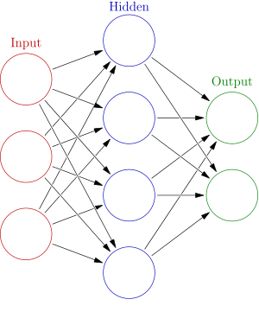

Example of ANN

Feed Forward:-In this ANN, the information flow is unidirectional. A unit sends information to other unit from which it does not receive any information. There are no feedback loops.Input features are used to find the output at the hidden layer and the these hidden layer outputs are considered as input for the outer layer output.
Summation and sigmoid is used to find the output both at hidden layer and the outer layer.

Back-Propagation:- It is a method used in artificial neural networks to calculate a gradient that is needed in the calculation of the weights to be used in the network.

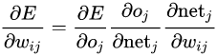

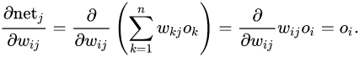

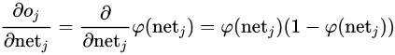

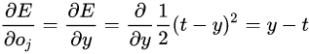

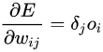

where oi is input feature if weight is between input and hidden layer where as input is hidden layer output if weight is between hidden and output layer.

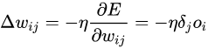

weight update after finding Gradient

Question 1:
When code was run for 1st time.
No of Hidden Layers | Accuracy
5 | 49.73180076628353
6 | 49.73180076628353
7 | 20.076628352490424
8 | 17.70114942528736
9 | 12.490421455938696
10 | 49.73180076628353
11 | 12.490421455938696
12 | 12.490421455938696
13 | 17.70114942528736
14 | 20.076628352490424
15 | 20.076628352490424

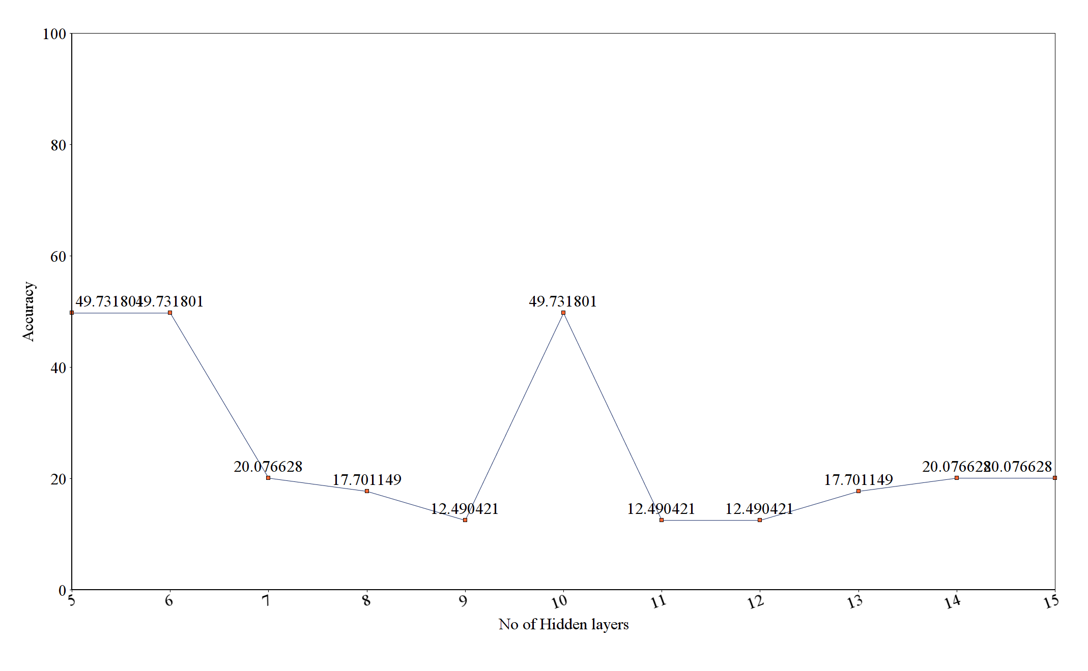

When code was run for 2nd time.
No of Hidden Layers | Accuracy
5 | 50.3448275862069
6 | 16.47509578544061
7 | 18.8472275862069
8 | 50.3448275862069
9 | 16.47509578544061
10 | 20.613026819923373
11 | 50.3448275862069
12 | 17.70114942528736
13 | 12.567049808429118
14 | 20.613026819923373
15 | 16.47509578544061

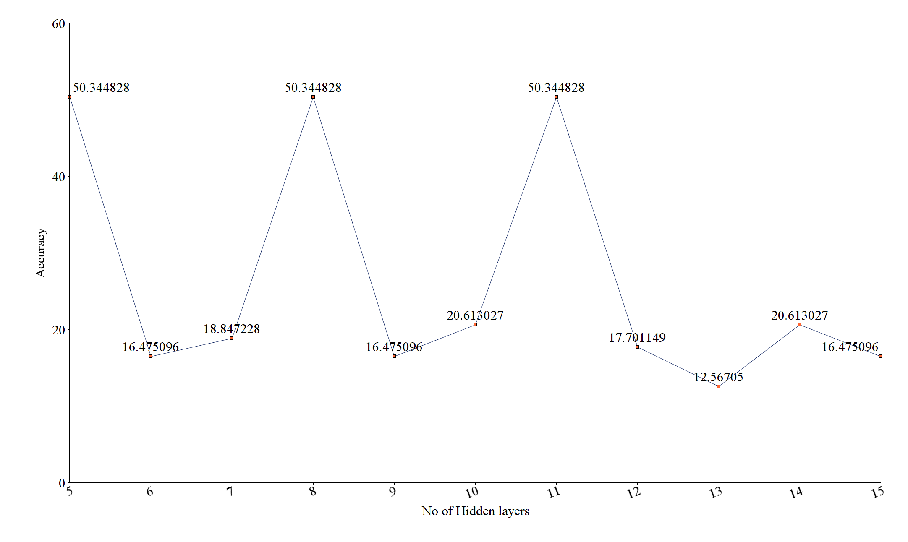

Question 2:
When code was run for 1st time.

No of Hidden Layers | Accuracy
5 | 50.3448275862069
6 | 11.417624521072797
7 | 17.624521072796934
8 | 17.624521072796934
9 | 20.613026819923373
10 | 17.624521072796934
11 | 20.613026819923373
12 | 20.613026819923373
13 | 11.417624521072797
14 | 17.624521072796934
15 | 50.3448275862069

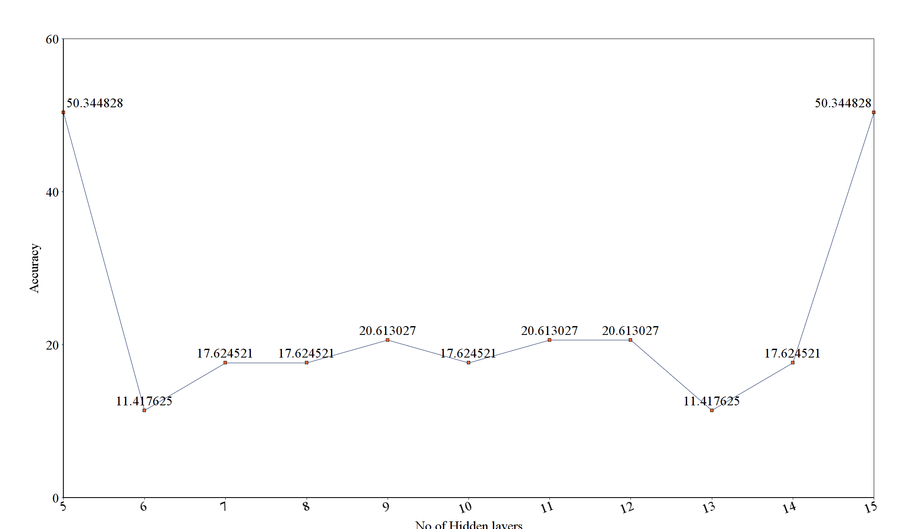

When code was run for 2nd time.

No of Hidden Layers | Accuracy
5 | 52.18390804597701
6 | 11.417624521072797
7 | 17.624521072796934
8 | 11.417624521072797
9 | 20.229885057471265
10 | 16.32183908045977
11 | 52.18390804597701
12 | 52.18390804597701
13 | 16.32183908045977
14 | 17.624521072796934
15 | 16.32183908045977

