EUREKA / PRODUCT CONCEPT

DrillLoop
Evidence-linked exercise reviews and action closure
A local-first review workspace for hospital preparedness evaluators. The proposed first use case is reviewing records from a hospital tabletop exercise; other sectors remain future candidates.
Product thesis
Turn fragmented exercise evidence into a source-linked timeline, evaluator-reviewed findings, and corrective actions that remain open until an authorized reviewer checks closure evidence.

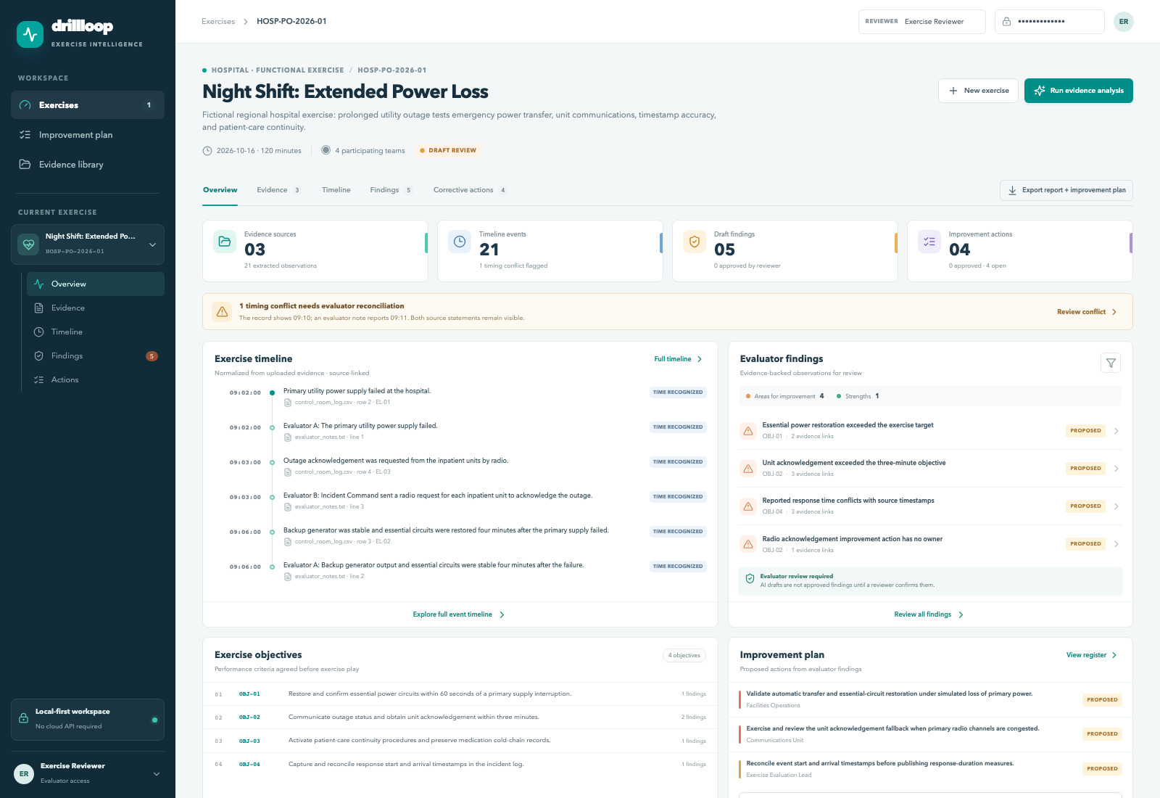
DrillLoop hospital demo · interface screenshot · all records are synthetic
  - Prepared 27 October 2026 · Hackathon MVP concept and implementation

Start here: one-minute example
In the fictional hospital exercise, the control-room log records a power failure at 09:02 (EL-01) and essential power restored at 09:06 (EL-02). The exercise target is 60 seconds.
What DrillLoop proposes
The recorded restoration took about four minutes, longer than the one-minute target. Evidence: EL-01 and EL-02 in control_room_log.csv. The cause is not in these records, so it stays unknown. The finding remains proposed until an evaluator reviews it.

Source says | System suggests | Person decides
Power failed at 09:02; stable at 09:06. | Possible improvement gap against OBJ-01. | Accept, edit, or reject the proposal; assign an owner only when known.

For a glossary, audience-specific reading paths, and a conceptual example for AI agents, see DRILLLOOP_READER_GUIDE.md.

1. Executive summary
The proposed first use case is a hospital preparedness evaluator reviewing records from a tabletop exercise and preparing an After-Action Report and Improvement Plan (AAR/IP). Notes, event logs, transcripts, and timelines may need reconciliation; timing conflicts need review; and improvement tasks can lack an owner or completion proof. DrillLoop keeps proposed findings connected to source records and leaves decisions with a human evaluator.
The working MVP imports notes, CSV event logs, JSON transcripts, and PDFs with selectable text. It builds a timeline from recorded times, proposes findings for one fictional hospital power-outage fixture, supports evaluator approval or rejection, tracks owners and completion evidence, and exports an AAR/IP PDF. The rules have not been evaluated on an unfamiliar exercise.
The default analysis uses fixed local rules and needs no cloud service. An optional local language model can reword an action draft but cannot create findings or citations. An optional speech-to-text path needs a model installed on the computer. Neither optional model was used in the reported benchmark.

First use case and roles to validate
Initial segment hypothesis: hospital preparedness teams reviewing tabletop exercises. The likely report preparer is an exercise evaluator or preparedness staff member. A preparedness lead or exercise sponsor is a candidate approver; the budget owner and procurement path are unknown. Municipal emergency teams, airports, civil defense, training providers, defense-support organizations, and critical-infrastructure operators are possible later segments, not validated customers.

Why now / product value to test
The value hypothesis is that source-level traceability and reviewer-controlled actions can reduce evidence hunting and make follow-up easier to verify. No user interviews, reporting-time baseline, evaluator correction study, pilot interest, or time-savings result is recorded. These measures remain to be established with a pilot partner.

2. Workflow and practical demo scenario
Step | Evaluator workflow | DrillLoop output
Plan | Set scenario, date, targets, criteria, roles, teams, and milestones. | Planning record connects findings to the targets being tested.
Collect | Upload notes, event logs, transcripts, and reports. | Original file, file-change checksum, extracted observations, and source locations.
Reconstruct | Put recorded times in order and compare sources. | Missing or conflicting times stay marked as uncertain.
Review | Read the draft and its supporting records; edit, approve, or reject. | The reviewer’s decision is recorded; proposals remain distinct from approvals.
Improve | Assign an owner, due date, and a test for completion. | The action cannot be approved until its finding is approved and required fields exist.
Verify | Check the completion proof before closure. | A reviewer closes the task only after checking evidence.

Fictional hospital prolonged power outage
Exercise HOSP-PO-2026-01 (“Night Shift: Extended Power Loss”) tests four objectives. Included evidence is synthetic and deliberately covers failure, improvement, a positive performance example, conflicts, and missing details.
Time / signal | Synthetic source statement | Expected treatment
09:02 | Primary utility power supply failed. | Source-backed event; link to OBJ-01.
09:06 | Backup generator stabilized and essential circuits restored four minutes later. | Proposed gap against the 60-second objective.
09:03 → 09:10 | Radio acknowledgement request; ICU acknowledgement arrived by runner after seven minutes. | Proposed communications finding; evaluator also reports 09:11, unresolved.
09:02 → 09:08 | Outage start and facilities arrival; incident log says response time was two minutes. | Show the discrepancy; retain the original source value.
09:18 | ICU team completed cold-chain relocation and logged chain of custody. | Proposed strength against OBJ-03.
Debrief | Radio follow-up action has no owner; separate note says generator lagged, without time or measure. | Owner remains blank; ambiguous note is not promoted.

The provided transcript includes a synthetic 0.58-confidence ‘two’ → ‘too’ recognition substitution. It stays uncertain and the incorrect-response-time draft cites the independent event log, not that transcript phrase.

3. AI and evidence architecture
The workflow is a fixed local pipeline: parse source → extract observations → detect candidate findings → map to a stated objective → attach exact observation IDs → surface timing/recognition uncertainty → draft an action → wait for a human decision. The same evidence IDs resolve to file name and row, line, page, or transcript segment.
Evidence rule
Every displayed candidate includes supporting evidence. If the source is incomplete, the gap is explicit. A model may not fill it with a plausible event or resolve a time conflict.

MVP technical choices
Layer | Selection | Rationale / boundary
Server and data checks | FastAPI 0.162.0 · Pydantic 2.14.1 | Receives website requests and checks that uploaded data has the expected fields.
Saved data | SQLAlchemy 2.0.48 · SQLite default · PostgreSQL 18.6 Compose | One data-access path supports a local file database or a deployed server database.
Website screen | React 19.3.1 · TypeScript 5.9.3 · Vite 8.3.5 | Pages people use to plan exercises, review evidence, and manage tasks.
PDF import | pypdf 6.21.2 (BSD-3-Clause) | Selectable text only; chosen over an AGPL/commercial-dual-license parser.
Speech-to-text (ASR) | faster-whisper 1.2.1 optional (MIT) | Runs locally when a model is installed; it creates a draft transcript and does not identify speakers.
Optional writing model (LLM) | Ollama + Qwen3-4B optional (Apache 2.0 model weights) | May reword an action draft only; not used in the recorded evaluation.
Reports | python-docx 1.2.0 · ReportLab 5.1.0 · PptxGenJS 4.0.1 | Editable DOCX/PPTX; PDF report/export and speaker notes.
Quality | pytest 9.1.1 · Ruff 0.17.2 | Parser, status transition, citation, and API tests.

Why fixed workflow instead of agents and retrieval
This MVP uses a short list of pre-written rules. The same input gives the same draft, so a reviewer can inspect why it appeared. The sample has only a few files, so a separate search system for similar text would add complexity without a clear benefit. A tool such as LangGraph could be considered later if teams need long-running review queues or several people must sign off in sequence.

4. Differentiation and competitive context
After-action reports and corrective-action workflows are available in existing products. Veoci publicly describes after-action reporting and follow-up; D4H serves emergency-response readiness and related team workflows. FEMA’s Homeland Security Exercise and Evaluation Program (HSEEP) provides exercise-planning and evaluation guidance. A report template alone is not a unique product claim. No same-workflow comparison with Veoci or another alternative has been run.
Option | Publicly visible scope | DrillLoop implication
FEMA HSEEP / Preparedness Toolkit | Federal exercise-planning and evaluation guidance, including after-action and improvement planning. | Use familiar concepts; do not imply official status or replace an organization’s required reports.
Veoci | Emergency-management platform; after-action reporting, timestamping, records, and corrective-action follow-up. | Direct competitor and integration/market-fit question; evidence trace must be tested in product demos.
D4H | Emergency response team readiness and adjacent incident/personnel/equipment workflows. | Adjacent incumbent; confirm evaluator evidence-review and closure workflows with customers.
DrillLoop positioning hypothesis | Exact source observation → proposed finding → reviewer decision → closure evidence. | Potential niche: evidence-to-review trace, uncertainty, and action closure. Uniqueness is unvalidated.

Differentiator to validate
For each finding, the evaluator can open the exact source text at its filename and row/line/page/segment, see the claim separated from interpretation, confirm or reject it, and later inspect reviewer-approved closure evidence. The differentiator hypothesis is trustworthy traceability across the review lifecycle—not automated prose by itself.
Research references include a public hospital power-loss exercise scenario from California Department of Public Health and a public health-coalition exercise AAR/IP example. These support scenario familiarity and report format; they do not validate product demand.

5. Feasibility, security, and governance

Feasibility
The app runs without a cloud AI service. It uses SQLite for the local demo and can use PostgreSQL in Docker Compose. The website lets a user create an exercise, upload evidence, inspect proposed findings, review actions, and download a PDF report. The server checks uploads, runs the fixed analysis rules, and records reviewer decisions. Optional speech-to-text and local text-generation paths were not used in the benchmark.

Security boundary
- The demo uses one shared reviewer password. It has no named-user login or role-specific permissions.
- Original files and extracted text are saved in the configured database. The demo has no configured encryption at rest, file scanning, retention/deletion controls, tenant isolation, or security assessment.
- The packaged demo and benchmark use fictional records. The system has not been validated for protected patient or operational data. A deployment handling such records would require approved hosting, encryption and key management, role controls, access auditing, retention/deletion rules, dependency scanning, and threat modeling.
- The default workflow makes no cloud model call. Optional faster-whisper runs with a locally staged model; optional Ollama is configured as a local/private service for action wording. Neither optional path was included in the benchmark.

Human review and professional judgment
An authorized reviewer must approve or reject a proposed finding. An action needs an approved finding, owner, and due date before action approval. Closing it also requires reviewer confirmation and completion evidence. The report borrows concepts from FEMA’s Homeland Security Exercise and Evaluation Program (HSEEP), but it is not FEMA-certified.

6. Evaluation, commercialization, and roadmap

Recorded technical benchmark
Measure | Observed | Interpretation
Observation extraction | 8/8 · precision 1.00 · recall 1.00 | Labeled CSV rows in one synthetic fixture.
Finding detection | 5/5 · precision 1.00 · recall 1.00 | Closed ground-truth finding set; not generalization.
Exact cited event IDs | 9/9 | All labeled supporting IDs were present.
Timeline row times | 8/8 exact matches | Event-log rows only; conflicts remain surfaced separately.
Action register fields | 31/32 | One intentionally missing owner.
Rule route latency | p50 4.61 ms · p95 9.13 ms | Local TestClient call; no LLM or ASR inference.

Manual evaluator performance, report-preparation time, correction workload, performance on an unfamiliar exercise, ASR word error rate, local LLM quality, and monetary savings have not been measured. The results are a technical check of the synthetic fixture, not field-accuracy evidence.

Commercial hypotheses
The first commercial model proposed for discovery is a per-exercise pilot fee. No price, delivery cost, staffing plan, customer volume, or willingness-to-pay evidence is established. Annual subscriptions, private deployment, custom templates, and support services remain options to evaluate after user and buyer discovery.
Time saved and monetary value are unknown. A future business case would need a customer-measured preparation-time baseline, verified change in staff effort, finance-approved labor costs, and evidence that capacity can be redeployed or cash costs reduced.

Roadmap
Stage | Proposed work | Evidence required to proceed
Discovery | Interview 2–3 prospective hospital preparedness users and observe one current review process with permission. | Role map, baseline measures, data permissions, and a willing pilot contact.
Paired pilot | Compare the current process with DrillLoop on the same permitted exercise records; include a tabletop exercise and uncertainty cases. | Partner-defined thresholds for preparation time, reviewer corrections, citations, and action completeness.
Generalization and deployment review | Evaluate evaluator-labeled evidence from an unfamiliar exercise; compare missed/incorrect findings and review effort. Review data flow and access controls. | Independent labels, false-positive/missed-finding results, security and retention requirements.

The Eureka form identifies the lead function as Product–Synergy / AI Engineering. Specific delivery allocation, emergency-preparedness experience, and an adviser or pilot partner are not documented. The proposed stages have no confirmed schedule or staffing commitment.

Key risks
Incomplete inputs; timestamp ambiguity; ASR errors; rules that overfit; confidential evidence exposure; weak adoption; existing platforms that already satisfy the need; and the risk that buyers pay only for convenience instead of measurable improvement. Pilot success criteria should emphasize source-supported findings, reviewer workload, action ownership, and independently verifiable closure.

7. Sources and review notes
The public references below informed workflow and positioning. Accessed or version-checked 26 October 2026. Competitor features are summarized from public product materials, not a scored product teardown. A potential fit with Presight public-safety work is a hypothesis; no integration or customer demand is established.
[1] FEMA, Homeland Security Exercise and Evaluation Program Doctrine, January 2020: https://www.fema.gov/sites/default/files/2020-04/Homeland-Security-Exercise-and-Evaluation-Program-Doctrine-2020-Revision-2-2-25.pdf
[2] FEMA Preparedness Toolkit, Exercise Evaluation: https://preptoolkit.fema.gov/web/training/evaluation
[3] California Department of Public Health, Power Loss scenario and hospital objectives: https://www.cdph.ca.gov/Programs/EPO/Pages/swmhe_scenarios_power_loss.aspx
[4] Veoci, After-action reporting product page: https://veoci.com/emergency-management/after-action-reporting/
[5] D4H, Emergency response team readiness software: https://www.d4h.com/team-readiness-software
[6] Mid-South Emergency Planning Coalition, 2023 Full Scale Exercise AAR/IP example: https://midsouthepc.org/wp-content/uploads/2024/03/Mid-South-HCC-2023-Non-Hospital-FSE-AAR.pdf
[7] Python release history: https://www.python.org/doc/versions/ ; FastAPI 0.162.0: https://pypi.org/project/fastapi/0.162.0/
[8] React versions: https://react.dev/versions ; PostgreSQL versioning policy: https://www.postgresql.org/support/versioning/
[9] faster-whisper: https://github.com/SYSTRAN/faster-whisper ; MIT English-small model card: https://huggingface.co/Systran/faster-whisper-small.en ; Whisper license: https://github.com/openai/whisper/blob/main/README.md
[10] Qwen3 model licenses and local use: https://qwenlm.github.io/blog/qwen3/ ; Ollama local API: https://github.com/ollama/ollama/blob/main/docs/api.md
[11] pypdf 6.21.2 license metadata (BSD-3-Clause): https://pypi.org/project/pypdf/6.21.2/
[12] PptxGenJS speaker notes: https://gitbrent.github.io/PptxGenJS/docs/speaker-notes.html
Review disclaimer
DrillLoop provides a working, synthetic demonstration. It does not make safety-critical decisions or replace exercise evaluator judgment, organizational procedures, or jurisdictional reporting requirements.

