BALAJI AMINES LIMITED
Equity Research Report
BSE: 530999 | NSE: BALAMINES | Sector: Specialty Chemicals
May 2026
India's Largest  Aliphatic Amine Manufacturer | World's Largest  DMAHCL Producer (~70% global share)  (source: Tijori Finance) | Zero Debt  Standalone Balance Sheet | 50+ Countries  Export Reach

Section 1: About the Company

1.1 Corporate Identity
Balaji Amines Limited (BAL), incorporated in 1988, is a pioneering Indian chemical powerhouse headquartered in Solapur, Maharashtra. Over nearly four decades, the company has grown from a domestic amine producer into a globally integrated specialty chemical player and an Indian multinational with a presence in over 50 to 55 nations. BAL is the largest manufacturer of Aliphatic Amines in India and holds the unique distinction of being the only company in India to have developed indigenous technology for manufacturing amines. Its primary listing is on both BSE (530999) and NSE (BALAMINES).
The company operates primarily in two business segments: its Chemicals division (accounting for over 97% of turnover) and a smaller Hotel division through Balaji Sarovar Premier, Solapur's first five-star hotel.

1.2 Core Business Activities
BAL's chemical business encompasses three vertically connected product categories:
- Aliphatic Amines: Methylamines, Ethylamines, and Isopropylamines — the foundational building blocks of the entire derivative value chain.
- Amine Derivatives: High-margin downstream products including DMAHCL (the critical Metformin intermediate), DMF, DMAc, and Choline Chloride.
- Specialty Chemicals & Solvents: Niche import-substitute products such as Acetonitrile, Morpholine, NMP, GBL, N-Butylamine, Electronic Grade DMC, and the newly commissioned Dimethyl Ether (DME).
Through its subsidiary Balaji Speciality Chemicals Limited (BSCL), the group is the sole manufacturer in India of niche chemicals including Ethylenediamine (EDA), Piperazine (Anhydrous), and Diethylenetriamine (DETA), manufactured via the specialised Monoethanol Amine (MEA) process.
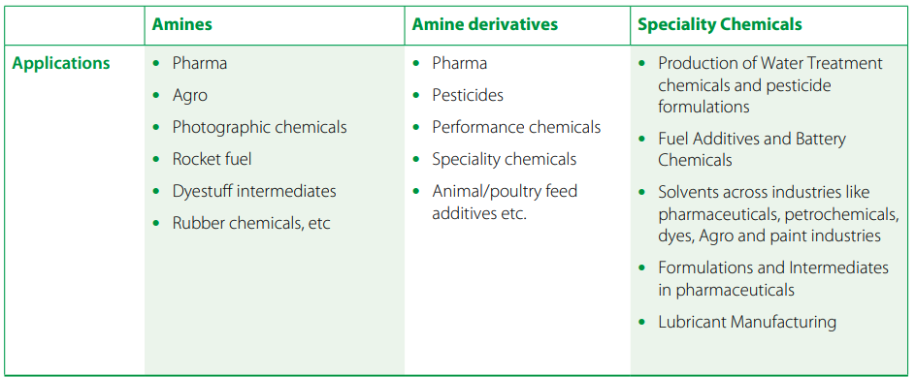
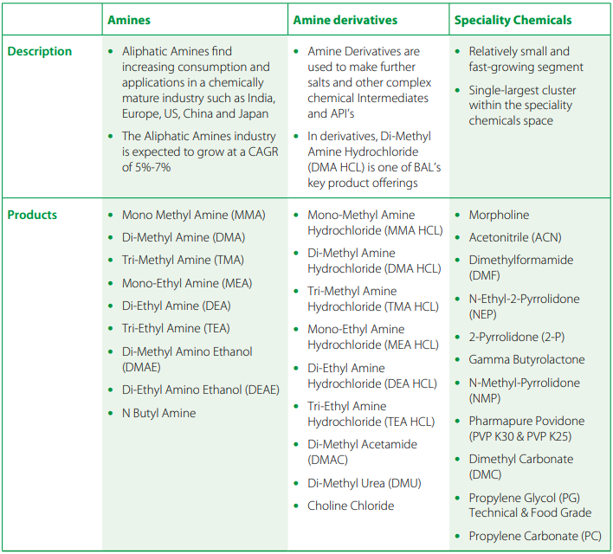
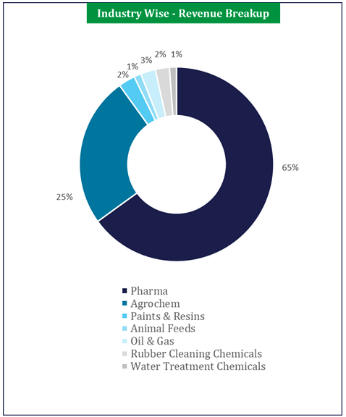

1.3 Strategic Philosophy
The company's growth philosophy is built on three interlocking pillars:
- Import Substitution: BAL systematically identifies chemicals that India currently imports and develops domestic manufacturing capabilities to replace them.
- Vertical Integration: Approximately 80% of basic amine production is consumed captively to manufacture high-value downstream derivatives, capturing significantly better margins and providing operational resilience.
- Atmanirbhar Bharat Alignment: The company's capex pipeline is explicitly aligned with the government's self-reliance mission, making it a strategic beneficiary of industrial policy tailwinds.

1.5 Clients

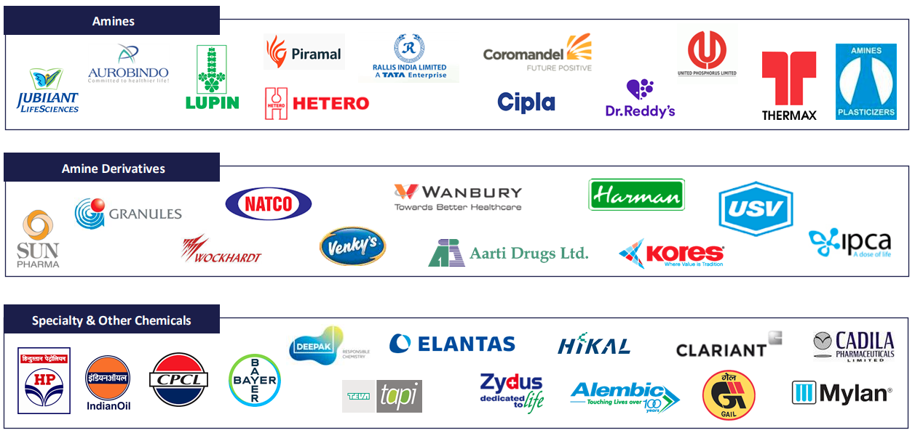

1.5 Historical Timeline
The table below charts Balaji Amines' key strategic milestones from inception through its most recent capex commissioning:
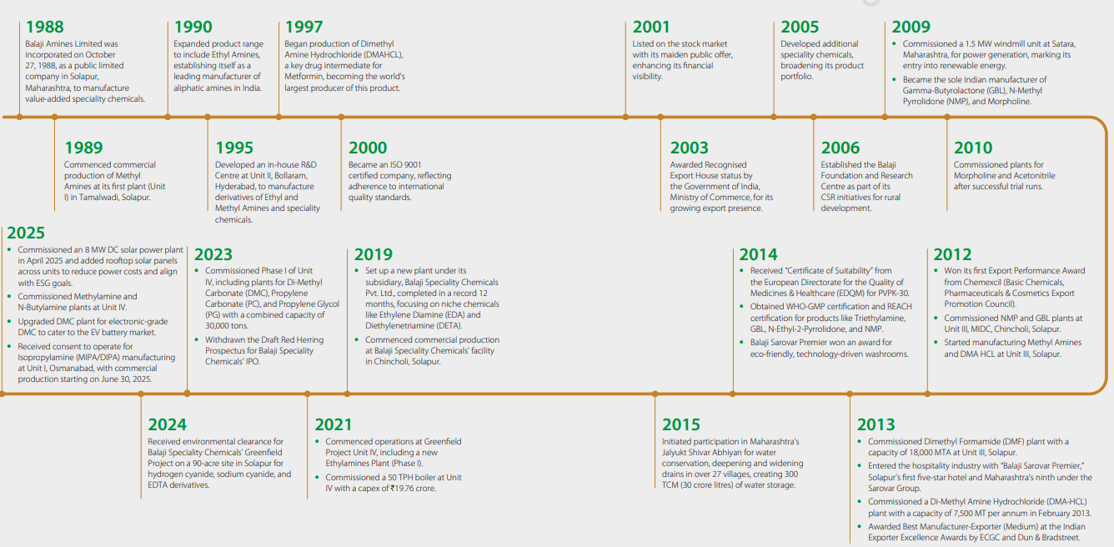

1988 | Incorporation of Balaji Amines Limited
1989 | Commenced commercial production of Methyl Amines at Unit I, Solapur
1990 | Expanded product range to include Ethyl Amines
1997 | Began DMAHCL production; became world's largest producer of this Metformin intermediate
2001 | Listed on BSE and NSE
2009 | Entered renewable energy via windmill; became sole Indian manufacturer of GBL, NMP, and Morpholine
2010 | Commissioned Morpholine & Acetonitrile plants; incorporated subsidiary BSCL
2013 | Commissioned large-scale DMF plant; entered hospitality with Balaji Sarovar Premier hotel
2019 | Commenced commercial operations at BSCL for niche import-substitute chemicals
2021 | Commenced operations at 90-acre Greenfield Unit IV with new Ethylamines plant
2022 | Commissioned DMC, Propylene Carbonate, and Propylene Glycol plants at Unit IV
2024 | Commissioned new Methylamine plant (88,000 TPA) and N-Butylamine facility at Unit IV
2025 | Commissioned 8 MW DC solar power plant; began Isopropylamine (MIPA/DIPA) production
2026 | Commercially commissioned 1,00,000 TPA DME plant — India's only commercial-scale DME producer

Section 2: Manufacturing Footprint & Capacity

2.1 Overview
Balaji Amines operates four world-class, fully automated manufacturing facilities in Maharashtra and Telangana, strategically located near major customer hubs in western and southern India. All plants are equipped with Distributed Control System (DCS) technology and are Zero Liquid Discharge (ZLD) facilities. Total installed capacity for the standalone entity and its subsidiary stands at approximately 2,92,000 MTPA, with the ongoing capex cycle targeting expansion to 4,15,000–4,16,000 MTPA by the end of FY2026-27.

2.2 Unit-wise Manufacturing Profile

Unit | Location | Focus | Key Products / Notes
Unit I | Solapur, Maharashtra | Basic Amines & Key Derivatives | Methylamines, Ethylamines, Isopropylamines (MIPA/DIPA), DMAc, Dimethyl Urea, Choline Chloride
Unit II (Bollaram) | Medak, Telangana | Regional Production & Distribution | Supports western/southern customer clusters
Unit III | Solapur, Maharashtra | High-Value Solvents & Specialty Chemicals | DMF, Morpholine, Acetonitrile, PVPK-30, DMAHCL (world's largest)
Unit IV (Greenfield) | Solapur, Maharashtra (90 acres) | Capacity Expansion Hub | Ethylamines, DMC, PC, PG, N-Butylamine (Ph1&2); DME 1,00,000 TPA, NMM (Ph3)
BSCL Facility | Solapur, Maharashtra | Sole Indian manufacturer — MEA process | EDA, Piperazine (Anhydrous), DETA, AEEA, AEP — 30,000 MTPA installed capacity

2.3 The Vertical Integration Advantage
Vertical and horizontal integration is the cornerstone of BAL's competitive advantage, providing a dual benefit of cost competitiveness and product switching flexibility
- Captive Consumption: BAL consumes approximately 80% of its basic amine production captively to manufacture high-value derivatives, protecting margins from raw material price swings that would otherwise pass directly through to competitors.
- Value Chain Uplift: By using basic amines as raw materials for derivatives, the company captures significantly higher realisations. For example, while basic Methylamines are relatively commoditised, downstream derivatives like DMAHCL, DMF, and DMAc command premium pricing due to their specialised nature and pharmaceutical-grade specifications.
- Import Substitution Targeting: Most capacity expansion targets chemicals where India relies on imports. DMC and N-Butylamine plants, for instance, were built to replace products previously 100% imported.
- Operational Resilience: During geopolitical volatility in early 2026, BAL maintained supplies through prudent inventory planning and its integrated model, while competitors without captive raw materials faced greater pressure.
- Utility Integration: The company has commissioned an 8 MW DC solar power plant (scaling to 20 MW) providing captive green power, substantially reducing manufacturing costs. This now covers approximately 80% of manufacturing power needs.

Section 3: Industry Analysis

3.1 What Are Amines?
Amines are organic compounds derived from ammonia (NH₃) where one or more hydrogen atoms are replaced by carbon-based groups. Think of them as ammonia's chemical cousins. They're the foundational building block — BAL manufactures three primary types: Methylamines, Ethylamines, and Isopropylamines. These are produced in bulk through a continuous process and are relatively commoditised in nature.
Amine Derivatives are what you get when you react basic amines with other chemicals to produce a higher-value, more specialised output. BAL consumes ~80% of its basic amine production captively to make these. Examples include DMAHCL (Methylamine + Hydrochloric Acid → the key ingredient for the diabetes drug Metformin), DMF, DMAc, and Choline Chloride. These are where the real margin sits — you're no longer selling a commodity, you're selling a pharma-grade or industrial-grade intermediate with specific purity requirements and long customer approval cycles attached.
Specialty Chemicals are niche, application-specific products that often serve a very particular industrial need and have very few global producers. In BAL's case this includes things like Morpholine, Acetonitrile, Electronic Grade DMC (for EV batteries), Propylene Carbonate, and DME. The "specialty" tag essentially means high barrier to entry, limited competition, and better pricing power — either because the chemistry is complex, the safety clearances are stringent, or the company is the sole domestic manufacturer.
The way to think about all three together: amines are the raw material, derivatives are the value-add, and specialty chemicals are the moat. BAL's entire competitive strategy is built on moving as far right along that chain as possible.

3.2 Global Dynamics: The China+1 Structural Shift
The global amines market is undergoing a fundamental structural realignment. China currently accounts for approximately 60% of global production but several converging factors are prompting global supply chain diversification:
- Environmental Crackdown: Stringent pollution norms in China have led to abrupt shutdowns of chemical units, creating supply-demand mismatches and forcing global buyers to seek alternate vendors.
- Rising Costs: China's labour costs have risen sharply, and the withdrawal of government subsidies has weakened its traditional cost advantage.
- De-risking by Global MNCs: Global users are actively scouting for alternative suppliers to reduce over-dependence on Chinese supply chains. This 'China+1' strategy directly benefits Indian companies like BAL that possess the technical expertise to meet international quality standards.

3.3 The European Energy Crisis Opportunity
Since March 2022, the European energy crisis — driven by a surge in natural gas prices — has caused significant production outages and cost escalation for European specialty chemical manufacturers. Because 45–55% of Indian amine export revenue comes from Europe, this has created a strategic opening for Indian players to gain market share as European production lines become less competitive.
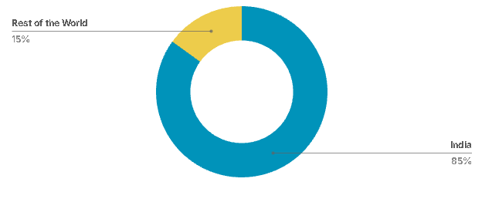
Balaji Amines Location Wise Breakup

3.4 The Indian Amine Market
The Indian amine market is characterised by high growth potential and structural under-consumption:
- Global Market Size: The global amines market is projected to reach US$23.5 billion by 2030, growing at a CAGR of 7.8%.
- Consumption Gap: India's per capita chemical consumption stands at approximately US$91, strikingly low compared to over US$1,200 in mature markets like the US and China. As India corrects this structural under-consumption, the chemical sector — already contributing 7% to national GDP — is poised for robust acceleration.

3.5 High Barriers to Entry: The Oligopoly Moat
The amine industry is inherently oligopolistic, with only a few manufacturers catering to demand in any given region. This is due to several formidable barriers to entry:
- Logistical Complexity: Amines are corrosive and hazardous, making them extremely difficult and expensive to transport over long distances. This creates a natural 'local' market dynamic favouring credible nearby suppliers.
- Technical Know-How: Manufacturing processes are continuous and complex, requiring high levels of technical expertise. BAL is the only company in India to have developed its own indigenous amine manufacturing technology.
- Capital Intensity: The industry requires high fixed costs, with fixed asset turns typically hovering between 1.5x–2x. A new plant often takes 2–3 years to achieve break-even due to lengthy customer approval processes in regulated pharmaceutical sectors.
- Regulatory Approval Cycles: Because primary end-users operate in regulated pharma and agrochemical sectors, supplier qualification can take 2–3 years, creating significant switching costs that lock in incumbent relationships.

3.6 Demand Drivers: End-User Industries
- Pharmaceuticals (51–65% of demand): Amines are vital solvents and intermediates for life-saving drugs. BAL's DMAHCL is the essential raw material for Metformin (the leading Type 2 diabetes drug). Growth of India's CDMO segment and Western drug-maker migration to Indian suppliers are primary tailwinds.
- Agrochemicals (~26% of demand): Amines and derivatives are essential for herbicides, pesticides, and fungicides. Modernisation of Indian agriculture and higher crop-yield requirements continue to drive demand.
- New-Age Sectors: EV battery electrolytes (DMC, Propylene Carbonate), electronics-grade solvents, and clean aerosol fuels (DME) represent the next growth frontier. Animal feed additives (Choline Chloride) and water treatment chemicals provide additional diversification.

Section 4: Product Portfolio & End-User Segments

4.1 Core Product Categories
BAL's chemical offerings span three vertically connected categories that together form an integrated value chain from basic amines through to high-barrier specialty intermediates:

Aliphatic Amines
As India's largest manufacturer, BAL produces Methylamines (capacity recently expanded to 88,000 TPA), Ethylamines, and Isopropylamines (MIPA/DIPA). These serve as the foundational building blocks for the entire derivative value chain. Approximately 80% of this production is consumed captively.

Amine Derivatives
- DMAHCL (Dimethyl Amine Hydrochloride): BAL is the world's largest producer of this chemical, commanding approximately a 70% global market share. DMAHCL is the essential raw material for Metformin, the leading global drug for Type 2 diabetes.
- DMF (Dimethyl Formamide): A versatile solvent used in pharmaceutical and industrial applications.
- DMAc (Dimethyl Acetamide): Used in the fibre and pharmaceutical sectors.
- Choline Chloride: An essential nutrient used in poultry and animal feed.

Specialty Chemicals & Solvents
- Acetonitrile & Morpholine: Critical solvents for the pharmaceutical industry.
- N-Butylamine: New facility commissioned at Unit IV replacing products previously 100% imported.
- DMC & Propylene Carbonate (PC): Critical electrolytes for EV battery and semiconductor industries; BAL is India's sole Electronic Grade DMC manufacturer.
- DME (Dimethyl Ether): Successfully commissioned May 2026 at 1,00,000 TPA. A clean alternative to LPG for the aerosol industry and eligible for up to 8% industrial blending under BIS norms. BAL is the only Indian company manufacturing this at commercial scale.
- PVPK-30: Used as a binder in pharmaceutical formulations.
- Aliphatic Amines — Methylamines · Ethylamines · Isopropylamines
Industry | Product / Chemical | Specific Name | End Use / Role
Pharma | API intermediates | Metformin, Ephedrine, Theophylline | Basic amines act as the starting raw material; Methylamine is the precursor molecule in Metformin synthesis (world's most-used diabetes drug)
Agro | Herbicides / Pesticides | Glyphosate, Atrazine, Chlorpyrifos | Methylamines and Ethylamines are core building blocks in herbicide and pesticide formulation; used in salt-form conversion of active molecules
Agro | Fungicides | Mancozeb, Iprodione | Isopropylamine (DIPA/MIPA) used in fungicide intermediate synthesis; protects crops from mold and soil-borne disease
Industrial | Rubber chemicals | Accelerators (TMTD, CBS) | Methylamines used to synthesise rubber vulcanisation accelerators — speed up and control rubber hardening in tyre manufacturing
Industrial | Gas treatment | CO₂/H₂S scrubbing | Ethylamines (MEA, DEA) used in gas sweetening to remove CO₂ and H₂S from natural gas and refinery streams
Water treatment | Corrosion inhibitors | Cyclohexylamine, Morpholine | Amines neutralise acidic condensate in steam boilers and pipelines, preventing corrosion
- Amine Derivatives — DMAHCL · DMF · DMAc · Morpholine · Choline Chloride · Acetonitrile
Industry | Product / Chemical | Specific Name | End Use / Role
Pharma | DMAHCL | Metformin (diabetes), Ranitidine (ulcer) | BAL is the world's largest producer (~70% global share); DMAHCL is the direct precursor molecule in synthesising Metformin — the No.1 anti-diabetic drug globally
Pharma | DMF (Dimethyl Formamide) | API solvent — antibiotics, antivirals | High-polarity solvent used to dissolve and react API molecules during drug synthesis; also used in synthetic leather and acrylic fibre production
Pharma | DMAc (Dimethyl Acetamide) | API solvent — injectable drugs | Solvent for pharmaceutical synthesis, particularly injectable formulations; also used in manufacturing Lycra / spandex fibre
Pharma | Acetonitrile | HPLC solvent, DNA synthesis | The primary solvent in HPLC (lab analysis for drug purity testing); used in oligonucleotide (DNA/RNA) synthesis for biotech drugs
Pharma | Morpholine | Antifungals, analgesics | Used as intermediate in synthesis of several antifungal and pain-relief drugs; also used as a corrosion inhibitor in steam boilers
Agro | DMF | Pesticide formulation | Serves as a carrier and reaction solvent in manufacturing certain pesticide active ingredients
Animal feed | Choline Chloride | Poultry feed, livestock nutrition | Essential B-vitamin supplement (Vitamin B4) added to poultry and livestock feed to support liver function, egg production and growth
Industrial | Morpholine | Wax coatings, fruit coating | Used as a surface coating on fruits (approved food-grade wax) and in industrial surface treatment agents
- Specialty Chemicals — DMC · DME · EDA · Piperazine · DETA · EDTA · PVPK
Industry | Product / Chemical | Specific Name | End Use / Role
EV / Energy | DMC (Electronic Grade) | Lithium-ion battery electrolyte | Key solvent in the electrolyte solution of lithium-ion batteries (EVs, smartphones, laptops); BAL is India's sole Electronic Grade DMC manufacturer
EV / Energy | Propylene Carbonate (PC) | Li-ion battery electrolyte | Used alongside DMC in battery electrolyte formulations; also used as a polar solvent in cosmetics and industrial cleaners
Aerosol / Fuel | DME (Dimethyl Ether) | Deodorants, paints, insecticides; LPG blend | Replaces LPG as aerosol propellant in personal care and household products; BIS-approved for up to 20% blending with LPG for cooking/industrial use; BAL is India's only commercial-scale producer
Agro | EDA (Ethylenediamine) | Fungicides — Mancozeb, Zineb | EDA is a core building block for dithiocarbamate fungicides widely used in protecting fruits, vegetables, and cereal crops from fungal disease; BSCL is India's sole EDA producer
Pharma | Piperazine (Anhydrous) | Anthelmintics (deworming drugs) | Direct active ingredient in anti-parasitic/deworming drugs; also an intermediate for antihistamines (Cetirizine) and anti-anxiety drugs
Industrial | DETA (Diethylenetriamine) | Epoxy hardeners, coatings, adhesives | Curing agent for epoxy resins used in industrial coatings, flooring, marine paints, and structural adhesives; also a chelating agent in water treatment
Water treatment | EDTA (from BSCL expansion) | Chelating agent — industrial water, healthcare | Binds and removes heavy metal ions from water; used in IV-administered chelation therapy for heavy metal poisoning; also used in food preservation and cleaning products
Pharma | PVPK-30 | Tablet binder | Polyvinylpyrrolidone used as a binding agent in pharmaceutical tablet manufacturing; holds active ingredients together and controls drug release
Industrial | NMM (N-Methyl Morpholine) | Catalyst in polyurethane foam | Used as a catalyst in polyurethane foam production (mattresses, car seats, insulation panels); also a solvent in pharmaceutical synthesis

4.2 Subsidiary Portfolio: BSCL
Through Balaji Speciality Chemicals Limited (BSCL), the group further strengthens its portfolio as the sole manufacturer in India of:
- Ethylenediamine (EDA): Used in pharmaceuticals, agrochemicals (fungicides), and polymers.
- Piperazine Anhydrous (PIP): Used in pharmaceuticals and oilfield applications.
- Diethylenetriamine (DETA): Essential for coatings, polymers, and pharma.
- AEEA & AEP: Catering to diverse specialty chemical applications.
All EDA and DETA products are REACH certified, allowing frictionless exports to the European Union and other regulated international markets. BSCL currently serves over 250 customers globally.

4.3 End-User Segment Analysis
- Pharmaceuticals (Primary Driver — 51–61% of demand): Beyond DMAHCL for Metformin, BAL provides a wide range of solvents and intermediates for APIs and drug formulations. This segment provides stable, long-cycle demand with significant switching costs for customers.
- Agrochemicals (~26% of demand): Vital for herbicides, pesticides, and fungicides. Growth in Indian agricultural modernisation and global crop-protection demand provide a steady tailwind.
- EV & Energy Sectors: DMC and Propylene Carbonate serve as critical electrolytes for the growing electric vehicle market.
- Animal Feed: Choline Chloride serves the poultry and livestock nutrition segment.
- Industrial & Others: Water treatment, rubber chemicals, dyes, and oil & gas sectors further diversify the revenue base.
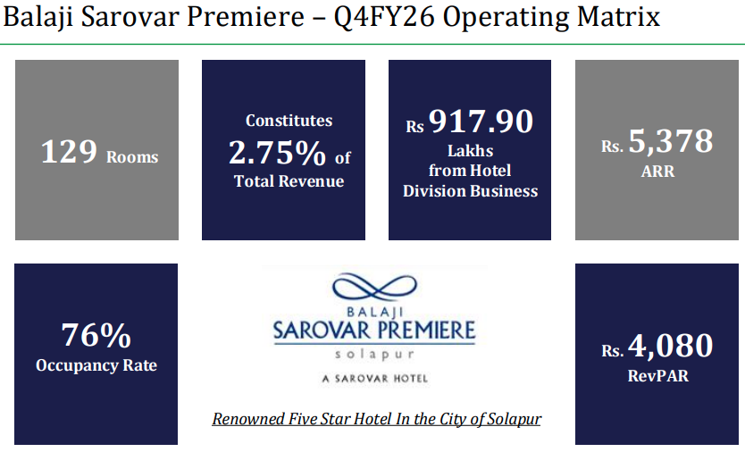

Section 5: Subsidiary Deep-Dive — Balaji Speciality Chemicals Limited (BSCL)

5.1 Overview & Market Position
Balaji Speciality Chemicals Limited (BSCL) functions as the group's specialised arm for high-margin import substitutes and niche chemistries. Incorporated in 2010 and located in Solapur, Maharashtra, BAL holds a 55% stake in BSCL (the remaining 45% held privately by the promoter group). BSCL is uniquely positioned as the sole manufacturer in India of several critical niche chemicals using the advanced Monoethanol Amine (MEA) process, with current installed capacity of 30,000 MTPA.

5.2 Current Performance & Near-Term Challenges
In FY2024-25, BSCL faced significant headwinds, primarily due to aggressive dumping practices by China, which led to persistent pricing pressure across its EDA and DETA product lines. The plant also operated intermittently to facilitate necessary technical modifications. These factors combined to produce a temporary decline in revenue and EBITDA versus previous high-growth years.
Management expects this pressure to ease as the group's INR 750 crore expansion shifts BSCL's product mix toward higher-value chemicals where Chinese dumping is less economically viable due to the extreme hazardous nature and safety clearances involved.

5.3 The INR 750 Crore Expansion Plan
BSCL is executing a transformative INR 750 crore expansion that has been accorded Mega Project Status by the Government of Maharashtra under the Package Scheme of Incentives (PSI), 2019. The plan has two strategic pillars:

Pillar 1 — Brownfield Expansion (Unit I, Solapur)
Installation of additional reactors to manufacture advanced EDA-based value-added products:
- TETA (Triethylenetetramine) and PEHA (Pentaethylenehexamine) — products that command significantly better realisations than standard EDA.
- Expected commissioning: H1 FY2026-27.

Pillar 2 — Greenfield Expansion (Unit II, MIDC Chincholi)
A massive project centred on Cyanation Chemistry — a high-barrier segment characterised by extreme entry barriers due to the hazardous nature of the products and the stringent safety clearances required:
- Phase I: Hydrogen Cyanide (HCN), Sodium Cyanide (NaCN — both solution and pellets), EDTA, and EDTA-2Na derivatives (indispensable in mining, water treatment, and healthcare). Expected commissioning: Q4 FY2026-27.
- Phase II: Benzyl Cyanide (BnCN) and Phenylacetic Acid (PAA) — downstream extensions of the cyanide value chain.

5.4 Funding Strategy for the INR 750 Crore Expansion
Management has guided that the expansion will be funded primarily through internal accruals and BSCL's operating profitability, aligned with the group's broader self-funded growth narrative. Key components of the funding strategy include:
- Internal Accruals: BSCL's own cash balances and operating profitability are expected to fund the bulk of the capex.
- Phased Execution: The phased approach is designed to generate incremental cash flows from early project stages, which are then reinvested to support subsequent investments.
- IPO Deferral: The group had originally planned a BSCL IPO to partially fund growth, but the draft prospectus was withdrawn in September 2023. Management has guided that they prefer to have all new products fully operational before revisiting an IPO.
- Tactical Borrowing: The group's FY26 consolidated financials show INR 133 crore in debt, which management explicitly attributes to 'ongoing expansion-related activities' — a minor tactical lever to ensure timely execution of the Cyanide complex.

Section 6: Strategic Growth & Capex Pipeline

6.1 The Transformative Capex Cycle
Balaji Amines is currently at the inflection point of a multi-year capital expenditure cycle aimed at doubling its installed capacity to approximately 4,15,000–4,16,000 MTPA by the end of FY2026-27. The strategy involves moving beyond basic amines into high-value specialty intermediates, new-age energy solutions, and high-barrier cyanide chemistries — transitioning BAL into 'blue ocean' territories where it faces little to no domestic competition.

6.2 Full Capex Pipeline

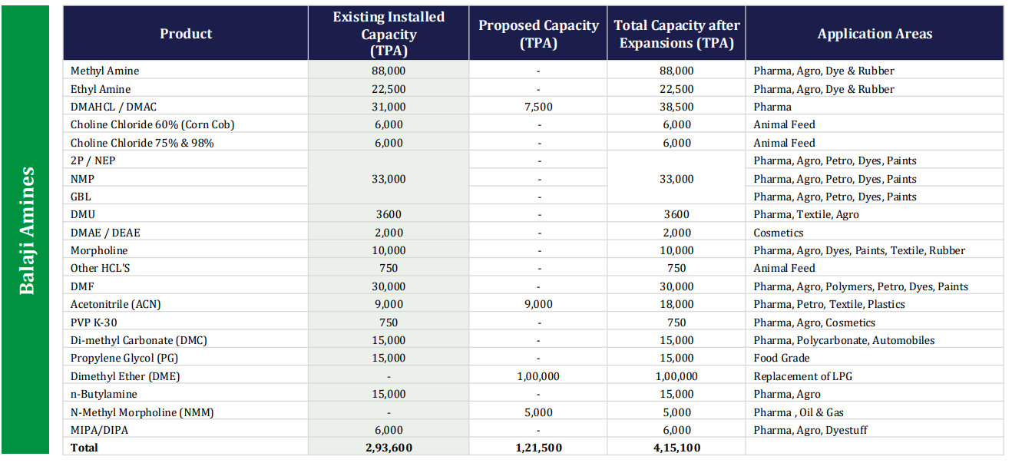

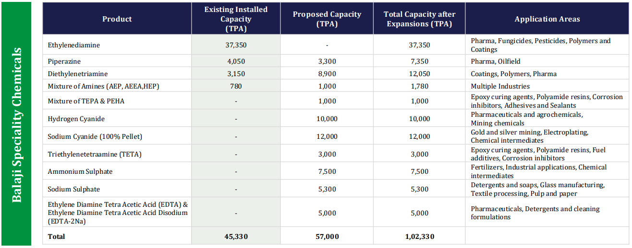

6.3 The DME Opportunity in Detail
The 1,00,000 TPA Dimethyl Ether (DME) plant, commissioned on May 20, 2026, is a landmark project that makes BAL the only company in India to manufacture DME at commercial scale. DME is a 'new-age gas' that serves as:
- A clean, eco-friendly substitute for LPG in the aerosol industry (deodorants, paints, insecticides).
- An industrial and commercial fuel blend — BIS has sanctioned up to 8% DME blending with LPG — opening a massive domestic market opportunity.
- A potential alternative fuel for transportation and power generation applications.

6.4 Financial Discipline & Management Guidance
- Zero-Debt Funding Model: All ongoing capex projects at the parent level are funded entirely through internal accruals. The standalone entity remains completely debt-free.
- Consolidated Debt (FY26): INR 133 crore, attributable entirely to BSCL's expansion, representing a negligible leverage ratio of 0.01x on a net worth of INR 2,152 crore.
- Volume Growth Guidance: Management guides for 10–15% volume growth in FY2026-27.
- Revenue Target: Consolidated revenue of INR 3,000 crore by FY2027-28, implying roughly 2x recovery from the FY25-26 normalised base.
- ESG Capex: Solar power plant scaling from 8 MW to 20 MW to cover manufacturing power needs; Air Cooled condensers and ZLD systems reducing fresh water consumption by 80–85%.

Section 7: Competitive Moats & SWOT Analysis

7.1 Structural Competitive Advantages

Moat 1: Indigenous Technology
BAL is the only company in India to have developed its own indigenous technology for manufacturing amines. While competitors rely on expensive foreign technical collaborations, BAL's in-house R&D allows it to indigenise solutions, meaningfully lowering manufacturing costs and improving process efficiency. This know-how is proprietary and essentially non-replicable without decades of investment.

Moat 2: Vertical & Horizontal Integration
Approximately 80% captive consumption of basic amines for derivative manufacture provides a dual advantage: cost competitiveness and the flexibility to shift product mix based on market demand. This integration protects margins during pricing downturns in a way that non-integrated competitors cannot match.

Moat 3: Logistical & Hazardous Handling Barriers
Amines are corrosive and hazardous, making international transportation extremely difficult and expensive. This creates a natural 'local' market advantage for BAL, whose plants are strategically located near major customer clusters in western and southern India. These logistical barriers make sustained dumping from international competitors structurally challenging.

Moat 4: First-Mover in Import Substitution
BAL's philosophy is to 'cherry-pick' chemicals that are currently 100% imported into India and become the first domestic manufacturer. By establishing itself as the first mover — in DMC, EDA derivatives, and now DME — it typically enjoys a 'product space of one' for several years, during which it can establish customer relationships and quality certifications that create durable switching costs.

Moat 5: Customer Approval Cycle as a Moat
In regulated sectors like pharma and agrochemicals, obtaining supplier qualification from a new vendor takes 2–3 years. Once BAL is approved, this creates significant inertia in favour of the incumbent. Competitors seeking to displace BAL face this same qualification burden, providing a durable revenue protection mechanism.

Moat 6: Scale in High-Barrier Niches
BAL's status as the world's largest DMAHCL producer (~70% global market share) and the sole Indian manufacturer of DMC, DME, EDA, Piperazine, and DETA gives it pricing power that no domestic competitor can challenge. The upcoming Cyanide complex at BSCL will add further 'sole manufacturer' designations in an even higher-barrier segment.

Section 8: Leadership Structure
The promoter group is primarily composed of the Ande, Dundurapu, and Nomula families, who have spearheaded the company since its inception in 1988.
- Mr. Ande Prathap Reddy (Executive Chairman)
  - Brief Profile: He incorporated Balaji Amines Limited in 1988 and has more than 52 years of total experience, including 34 years specifically in the chemical industry. He is recognized for his entrepreneurial skills and vision, which established the company as a global leader in amines.
  - Educational Background: He holds a Diploma in Civil Engineering (LCE) from the State Board of Technical Education and Training.
  - Relationship: He is the father of Mr. Ande Srinivas Reddy (Whole-time Director & CFO), the uncle of Mr. Dundurapu Ram Reddy (Managing Director), and the father-in-law of Mr. Hemanth Reddy Gaddam.
- Mr. Dundurapu Ram Reddy (Managing Director)
  - Brief Profile: Associated with the company since 1988, he has more than 38 years of experience in procurement, marketing, sales, and general administration. He has been instrumental in securing landmark supply contracts with global specialty chemical leaders and received a Lifetime Achievement Award in July 2024.
  - Educational Background: He joined Bharat Cement Pipe Industries as a Manager in 1980 before promoting Balaji Cement Products Pvt. Ltd. and eventually joining BAL.
  - Relationship: He is the nephew of Mr. Ande Prathap Reddy and the cousin of Mr. Ande Srinivas Reddy.
- Mr. Rajeshwar Reddy Nomula (Whole-time Director)
  - Brief Profile: He has over 48 years of experience across various industries and joined the Board in 1988. He is responsible for the day-to-day operations at the manufacturing plants in Solapur and is known for executing projects cost-effectively and within schedule.
  - Educational Background: He is a Commerce Graduate (B.Com).
  - Relationship: He is the brother-in-law of Mr. Hemanth Reddy Gaddam (a member of the promoter group and director of the subsidiary BSCL).
- Mr. Ande Srinivas Reddy (Whole-time Director & CFO)
  - Brief Profile: He has over 28 years of experience in project management, having worked with Fortune 100 companies in the USA (e.g., Sprint, Goodyear, Agilent). He joined the BAL board in 2013 and is currently responsible for new expansion projects, new technologies, and financial functions.
  - Educational Background: He is a Post Graduate in Computer Science and completed the Executive Management Programme at the Indian School of Business (ISB), Hyderabad.
  - Relationship: He is the son of Mr. Ande Prathap Reddy, the cousin of Mr. Dundurapu Ram Reddy, and the brother-in-law of Mr. Hemanth Reddy Gaddam.

Key Managerial Personnel (KMP)
As per the latest regulatory filings, the following individuals are designated as the Key Managerial Personnel of the company:
- Mr. Ande Prathap Reddy: Executive Chairman.
- Mr. Dundurapu Ram Reddy: Managing Director.
- Mr. Rajeshwar Reddy Nomula: Whole-time Director.
- Mr. Ande Srinivas Reddy: Whole-time Director & Chief Financial Officer (CFO).
- Mr. Abhijeet Shailesh Kothadiya: Company Secretary & Compliance Officer.
  - Brief Profile: Appointed as Company Secretary effective December 31, 2024, following the resignation of the previous CS, Mr. Lakhan Dargad.
  - Educational Background: He is a member of the Institute of Company Secretaries of India (ICSI Membership No. A68288).
  - Relationship: No familial relationship with the promoters is mentioned in the sources; he functions as a professional officer of the company.

Section 9: Financial Profile & Credit Metrics

9.1 Revenue & Profitability Trends
BAL's financial performance has reflected the broader volatility in the global specialty chemical cycle, moving through a sharp pandemic-era boom followed by a normalisation period driven by Chinese dumping and global destocking:
- FY23 (Peak): Consolidated revenue reached INR 2,371 crore with EBITDA margins of 26–28%, driven by post-pandemic supply shortages and elevated pricing.
- FY25 (Trough): Revenue normalised to INR 1,430 crore as Chinese imports returned aggressively and global destocking pressured volumes and realisations across the amine value chain.
- FY26 (Recovery Underway): Consolidated revenue recovered modestly to INR 1,454 crore with a full-year EBITDA margin of 20% (standalone: 21%).
- Q4 FY26 Inflection: A significant margin recovery was noted in Q4 FY26, where consolidated EBITDA margins jumped to 25% (from 19% in Q4 FY25), driven by a favourable product mix, improved operating leverage, and prudent inventory planning.
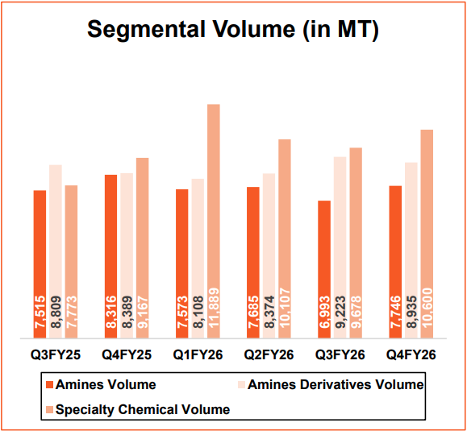

9.2 Capital Structure & Solvency Metrics
- Standalone Zero-Debt Status: The parent company has maintained a completely debt-free balance sheet throughout its expansion, showcasing exceptional financial discipline. All parent-level capex projects are funded via internal accruals.
- Consolidated Debt Transition (FY26): The group reported INR 133 crore in total consolidated debt in FY26 (up from INR 11 crore in FY25), attributed entirely to expansion activities at BSCL. This represents a negligible leverage ratio of 0.01x against a consolidated net worth of INR 2,152 crore.
- Net Cash Position: Despite the increase in consolidated debt, the company maintains a net cash position at the group level, given the significant equity base.
- Working Capital Efficiency: Peak average utilisation of working capital facilities has historically remained extremely low (approximately 1.2% for fund-based limits), reflecting strong liquidity and cash-generation capability.
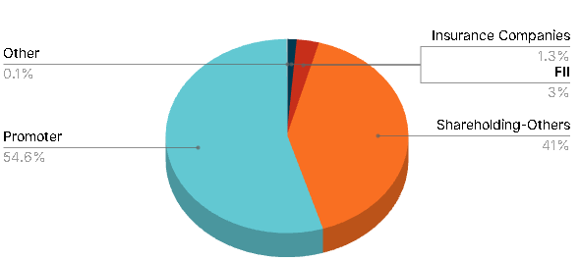

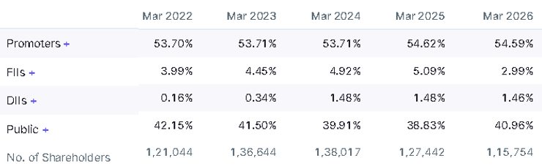

9.3 Credit Rating & Outlook
As of June 2025, India Ratings (Ind-Ra) revised the outlook on BAL's bank facilities to Negative from Stable while affirming the 'IND AA' rating.
- Rationale for Negative Outlook: Reflects the sharp decline in revenue and margins during FY25, coupled with underutilisation of newly commissioned capacities (DMC, Butylamine) and subdued BSCL performance amid Chinese dumping.
- Affirmation Drivers: The 'IND AA' rating is supported by BAL's strong market position in an oligopolistic industry, comfortable credit metrics, zero standalone debt, and the structural strength of its integrated business model.

9.4 Return Ratios & Efficiency
- Core ROCE: Consolidated ROCE dropped to 11% in FY25 during the heavy capex phase. However, the core chemical business (excluding hotel and non-productive CWIP) delivered a Core ROCE of 13% in FY26, demonstrating the underlying earnings quality of the chemical operations.
- Earnings Inflection Ahead: Management anticipates that as new capacities (particularly the Cyanide complex and DME) stabilise, they will drive a meaningful earnings inflection beginning in FY2026-27, with the group targeting consolidated revenue of INR 3,000 crore by FY2027-28.

9.5 Financial Snapshot (Consolidated)
