Universal Cables Limited
NSE: UNIVCABLES | MP Birla Group | Cable Manufacturing

₹3,023 Cr  Revenue (FY26)  25.5% YoY growth | ₹163 Cr  PAT (FY26)  82% YoY growth | ₹2,889 Cr  Order Book  as of Dec 2025 | ₹550+ Cr  Capex Pipeline  FY24-FY27
Section 1: Company Snapshot

1.1 Strategic Identity & Business Model
Universal Cables Limited (UCL), a key entity within the M.P. Birla Group, was established in 1945 and began power cable manufacturing in 1962. Operating under the flagship brand UNISTAR, the company has evolved from a manufacturer of paper-insulated cables into a specialised high-technology player in the Indian power infrastructure sector.
UCL utilises an integrated Concept-to-Commissioning business model combining manufacture of specialised electrical cables (Low Voltage to Extra High Voltage 500kV) and capacitors with a dedicated EPC (Engineering, Procurement & Construction) Division that executes turnkey underground power transmission projects for utilities and industrial clients.

1.2 Promoter Background & Financial Ecosystem
The company is backed by the diversified M.P. Birla Group, which provides significant financial flexibility and inter-group support.
Promoter Entity | Stake (as at Mar 2025)
Vindhya Telelinks Limited | 23.85%
The Punjab Produce & Trading Co. Pvt. Ltd. | 14.77%
Gwalior Webbing Co. Pvt. Ltd. | 8.32%
Birla Corporation Limited | 2.31%
Group Support: As of March 31, 2025, UCL maintained inter-corporate deposits and unsecured loans from group entities totalling ₹248 crore (from August Agents, Insilco Agents, and Laneseda Agents).

1.3 Consolidated Financial Trajectory (FY23–FY26)
Metric (₹ Cr) | FY 2022-23 (A) | FY 2023-24 (A) | FY 2024-25 (A) | FY 2025-26 (Audited)
Revenue from Operations | 2,201.95 | 2,020.67 | 2,408.39 | 3,022.67
Profit After Tax (PAT) | 118.15 | 108.22 | 89.39 | 163.11
Order Book | N/A | 1,085.00 | 1,792.00 | 2,889.00*
*Order book as of December 31, 2025. FY23-FY26 figures sourced from consolidated financial tables.

1.4 Revenue Mix & Segment Profile
UCL operates under a single reportable primary business segment: Electrical and other Cables, Capacitors, Wires and Conductors, and related Turnkey Projects. Export trajectory is as follows:

Year | Export Revenue / Share
FY 2022-23 | 4.31% of total turnover
FY 2023-24 | ₹101.91 Cr (~5.04% of turnover)
FY 2024-25 | 8.68% of total turnover
FY 2025-26 | ₹169.04 Cr (5.59%) | Target: >15%

Notes:
- The revenue dip in FY23-24 (to ₹2,020.67 Cr) was due to a planned VCV line shutdown for modernisation.
- No single customer exceeded 10% of revenue in FY25, but one client contributed ~16% (~₹331 Cr) in FY24 — lumpy project revenue risk.
- Standalone inventories surged by ₹107 Cr in FY26, flagging build-up ahead of large dispatches.
- EPC milestone payments create elongated operating cycles (100–110 days per CARE Ratings, Feb 2026).

Footnote — Governance Sensitivity: UCL excludes three wholly-owned subsidiaries of its Associate (Vindhya Telelinks Ltd) from consolidation as ex-directors allegedly hold unauthorised and illegal possession of books of account — matter under legal proceedings as of FY26.

Section 2: Product Portfolio

2.1 Power Cables Segment

Extra High Voltage (EHV) Cables
- Voltage range: up to 500kV XLPE cables.
- UCL was the first Indian company to supply 400kV, 2,500sqmm Copper XLPE cables to TNEB (Tamil Nadu Electricity Board).
- Two Vertical Continuous Vulcanising (VCV) lines provide better insulation quality and shorter delivery periods.

Medium Voltage (MV) & Low Voltage (LV) Cables
- MV: XLPE insulated distribution cables; recent development of Solid Aluminium Conductor MV cables for export markets.
- LV: Predominantly real estate and infrastructure-facing; grew ~17% in FY23 and ~9% in FY25.
- Aerial Bunched Cables for overhead distribution to prevent power theft.

2.2 Capacitors & Quality Power Solutions
- LT & HT Capacitors up to 132kV class, Automatic Switched Capacitors, Harmonic Filter Banks.
- Advanced solutions: Active Harmonic Filters (AHF) and Static VAR Generators (SVG) for renewable energy grid stability.
- FY 2024-25 milestone: Quality Power Solutions division surpassed ₹100 Cr turnover for the first time, growing 6% YoY.
- Commissioned 33kV Auto Switched PF Correction banks at wind power stations in Gujarat, Rajasthan, and Karnataka

2.3 Speciality & Rubber Cables
- UCL is the only company in India utilising Pressurised Liquid Salt Bath Curing (PLCV) for rubber specialty cables.
- Serves mining (oil rigs), railways, defence, and heavy engineering OEMs.
- FY25 revenue declined ~12% due to market cannibalisaton by Electron Beam Irradiated Cables — structural headwind.

2.4 Wires, Flexibles & New Launches
- Light-duty wires including winding wires for submersible pumps, manufactured at the Goa plant.
- Goa unit recorded ~16% aggregate revenue growth in FY 2024-25.
- EV Infrastructure (FY25): Developed 450/750V EV Charging Cables compliant with EN 50620 standard.

2.5 EPC Turnkey Solutions
- Full Concept-to-Commissioning model: system design, supply, cable jointing (up to 400kV), installation, and testing.
- Cable Monitoring Systems (CMS) using Distributed Temperature Sensor (DTS) technology for post-installation monitoring.
Notes:
- OFC (Optical Fibre Cable) turnover remains negligible in FY25 due to global demand slowdown — JV (Birla Furukawa) is a watch item.
- Rubber cable market shrinking as customers shift to Electron Beam Irradiated cables; legacy PLCV moat under pressure.
- Higher share of lower-margin aluminium conductor cables in FY25 compressed profitability.

Section 3: Industry & Competitive Positioning

3.1 Total Addressable Market (TAM) & Industry Drivers
- Revamped Distribution Sector Scheme (RDSS): outlay >3 lakh crore, driving sustained demand for distribution cables and capacitors.
- PM-KUSUM: solarisation of agricultural feeders specifically benefits the capacitor and distribution cable segments.
- Urban underground transition: ROW constraints in metropolitan areas accelerate the shift from overhead lines to EHV underground cabling — UCL's highest-margin addressable market.

3.2 UCL’s Competitive Moats
Moat | Evidence
EHV Pioneer | First Indian company to supply 400kV Copper XLPE cables; capability now extends to 500kV
VCV Manufacturing | Two VCV lines for EHV — capital-intensive, few domestic peers
PLCV Technology | Only Indian manufacturer using Pressurised Liquid Salt Bath Curing for specialty rubber cables
Integrated EPC | Concept-to-Commissioning including design, jointing, and CMS — higher project value capture
Global Collaborations | Technical tie-ups with NKT GmbH (Germany) and Furukawa Electric (Japan)
NABL Accreditation | EHV Cable Laboratory NABL accredited as of Nov 2025 — prerequisite for high-value utility tenders

3.3 Competitive Pressure & Peer Benchmarking
UCL operates in a highly fragmented and competitive market for MV and LV segments. While peers like Polycab and KEI have larger footprints in the retail/FMEG and generic wire segments, UCL’s strategy is weighted toward high-spec industrial and utility projects.

3.4 Entry Barriers & Sustainability
- Type Testing: Expensive international laboratory qualification required to maintain EHV credentials; ongoing certification costs.
- Group Synergy: MP Birla backing provides financial flexibility (₹248 Cr ICDs as of Mar 2025) and institutional credibility.
- Tender Dependence: Significant utility tender exposure creates L1 pricing pressure and lumpy order inflows.
Notes:
⚠ High tender dependence exposes UCL to aggressive price-based bidding (L1) and potential margin erosion.
⚠ Electron Beam Irradiated cable substitution threatens legacy PLCV rubber cable volumes — structural, not cyclical.
⚠ Raw material (copper/aluminium) price pass-through via PV clauses must be tracked each quarter.

Section 4: Manufacturing Footprint

4.1 Manufacturing Locations
Plant | Location | Key Products
Satna (Flagship) | Madhya Pradesh | EHV, HV, MV Power Cables; Capacitor Division
Goa | Verna Industrial Estate | Light Duty Wires, Winding Wires, OFC

4.2 Specialised Manufacturing Technologies
Technology | Application | Competitive Significance
VCV (Vertical Continuous Vulcanizing) (2 lines) | EHV cables up to 500kV | Capital-intensive barrier; few domestic peers
CCV (Continuous Catenary Vulcanization) (4 existing + 4 new) | HV and MV cables | Expanding to meet utility demand
PLCV (Pressurised Liquid Salt Bath Curing) | Specialty rubber cables (mining, ships) | Only Indian manufacturer using this process

4.3 Capacity Expansion & Modernisation (FY24–FY27)
UCL is executing one of its largest brownfield expansion phases to capitalise on the Indian T&D capex cycle.
Initiative | Outlay | Status (as at Jun 2026)
Capex Programme (original) (FY24) | ₹277 Cr | Revised upwards twice
Capex Programme (revised) | ₹505 Cr → ₹550 Cr | Ongoing
4 New CCV Lines at Satna | Part of ₹550 Cr | 2 commissioned Q2 FY26; final 2 by Aug–Sep 2026
LV Cable Facility at Satna | Part of ₹550 Cr | Commissioned FY26
Goa Unit (Wires/Flexibles) | Part of ₹550 Cr | Commissioned mid-FY26
EHV Facility Modernisation | ₹73 Cr (new, May 2026) | Board approved; execution commencing

4.4 Operational Efficiency & Sustainability
- Fuel Transition: Satna unit installed LPG system for boiler and Properzi plant, replacing furnace oil.
- Renewable Energy (FY24): ~20% renewable energy mix; targeting 65% via 4MW Wind-Solar Hybrid PPA.
- Zero Liquid Discharge: Both Satna and Goa units have implemented ZLD systems.
Notes:
⚠ Final two CCV lines slipped from Q4 FY26/Q1 FY27 to Aug–Sep 2026 — delays revenue ramp-up in MV/HV segment.
⚠ Capacity utilisation percentages and installed capacity in MT/km not disclosed in source documents.
⚠ Fixed assets rose from ₹178 Cr (FY24) to ₹234 Cr (FY25); elevated depreciation burden through FY27.

Section 5: Subsidiaries & Joint Ventures
As at FY 2025-26, Universal Cables Limited has no direct subsidiary companies.

5.1 Associate: Vindhya Telelinks Limited (VTL)
Parameter | Detail
UCL Ownership Stake | 29.15% as at Mar 2025
Business Profile | Diversified telecom cables & EPC; MP Birla Group entity
Share in Profit (FY26) | ₹82.27 Cr (~50% of UCL’s consolidated PAT of ₹163.11 Cr)
Related Party Purchases (FY24) | ₹51.88 Cr (raw materials from VTL)
Related Party Sales (FY24) | ₹41.47 Cr (sales to VTL)

5.2 Joint Venture: Birla Furukawa Fibre Optics Pvt. Ltd. (BFFOPL)
Parameter | Detail
UCL Ownership Stake | 26.14% as at Mar 2025
JV Partner | Furukawa Electric Co. Ltd., Japan
Focus | Optical Fibre Cable (OFC) manufacturing
Facility | Leasehold land and buildings at UCL’s Satna facility (12-year lease from Nov 2017)
Lease Income (FY24) | ₹5.46 Cr
Corporate Guarantee | ₹22 Cr from UCL as collateral for BFFOPL

5.3 Strategic Investments
- UCL holds a substantial portfolio of quoted and unquoted equity instruments in other MP Birla Group companies (e.g., Birla Corporation Ltd).
- Fair value of consolidated investments: ₹1,639.13 Cr as at Mar 2025.
- FY25: Decrease in fair value led to Return on Investments of (31.67%) — non-cash but significant balance-sheet optics.
Notes:
⚠ UCL’s consolidated PAT is ~50% dependent on VTL’s performance — monitor VTL independently.
⚠ Corporate guarantee of ₹22 Cr extended to BFFOPL represents contingent liability.
⚠ OFC market faces global slowdown; BFFOPL JV growth prospects limited near-term.

Section 6: End User Segment Analysis

6.1 Power Utilities (Transmission & Distribution) — Primary Driver
Dominant demand source for high-margin EHV and EPC businesses. Urban underground shift, ROW constraints, and RDSS outlay (>3 lakh crore) create a multi-year demand runway.

Client | Project | Year
TNEB (Tamil Nadu) | First Indian supply of 400kV Copper XLPE cables | Historical
TSTRANSCO (Telangana) | 132/33kV GIS Substation + EHV underground cabling (Manikonda) | 2022
TSTRANSCO (Telangana) | 132/33kV Moulali ZTS Substation turnkey (4km EHV cabling) | 2021-22
BESCOM (Bangalore) | Model Subdivision Works (₹155.03 Cr) | 2020

6.2 Renewable Energy
- Commissioned 33kV Auto Switched PF Correction banks at wind stations in Gujarat, Rajasthan, and Karnataka (FY25).
- PM-KUSUM driving agricultural feeder solarisation — sustained capacitor and LV cable demand.

6.3 Industrial & Niche Segments
Segment | Product | FY25 Outlook
Mining & Oil Rigs | PLCV rubber cables | Revenue -12%; structural decline vs. Electron Beam cables
Railways (Rolling Stock) | Specialty power cables | Stable; long-term electrification tailwind
Shipbuilding & Defence | Marine-grade specialty cables | Niche; specification-driven
Real Estate / Infrastructure | LV cables | Goa unit +16% in FY25; linked to construction cycle

6.4 Emerging Verticals
- EV Charging (FY25): EN 50620 compliant 450/750V EV Charging Cables developed for the burgeoning Indian charging station network.
- HVDC (FY26+): UCL is targeting the EHV HVDC segment for long-distance power evacuation.
- Export Markets: Europe, Australia, and Middle East targeted; management expects >15% export share by FY27.

Section 7: Strategic Growth & Capex Pipelines

7.1 Strategic Growth Pillars
- EHV Leadership: Optimise resources toward high-end, high-margin EHV products rather than low-margin volume.
- Export Acceleration: Target >15% export revenue (up from 5.59% / ₹169 Cr in FY26). Key markets: Europe, Latin America, Middle East.
- HVDC Entry: Targeting EHV HVDC segment for emerging long-distance power evacuation demand.
- Power Quality Expansion: Growing Capacitor Division into SVG and STATCOM for renewable energy zones.

Section 8: Management & Governance

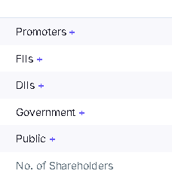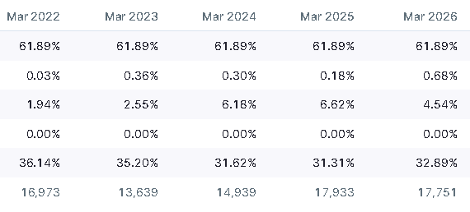

8.1 Key Management Personnel (KMP)
Role | Name | Tenure / Notes
Chairman (Non-Exec) | Shri Harsh V. Lodha | Concurrent Chairman at Birla Corp & VTL
Managing Director & CEO | Shri Y.S. Lodha | Since Feb 2019; re-appointed Feb 2025–Feb 2029; also MD & CEO of VTL
Chief Financial Officer | Shri Gopal Agarwal | Designated May 23, 2026 (third CFO since Sep 2023)
Company Secretary | Shri Sudeep Jain | Incumbent

8.2 Board Composition
- Four Independent Directors: Shri Bachh Raj Nahar (Audit Committee Chair), Shri Kishore Kumar Mehrotra, Dr. Ananya Ghosh Dastidar, Shri Siddharth Swarup.

8.3 Managerial Remuneration
KMP | FY 2023-24 (₹ Cr) | FY 2024-25 (₹ Cr)
Shri Y.S. Lodha (MD & CEO) | 1.96 | 2.17
Shri Amit Kumar Chopra (CFO) | 0.13* | 0.36
Shri Sudeep Jain (Co. Secretary) | 0.25 | 0.33
*Partial year (appointed Nov 2023). Figures converted from lakhs.

8.4 Related Party Governance
- RPT as % of total purchases (FY25): 3.89%
- RPT as % of total sales (FY25): 1.76%
- Common MD across UCL and VTL: operational synergy but potential conflict-of-interest risk.
- Whistleblower / Vigil Mechanism: in place. Nil regulatory fines or penalties reported in FY25.

Section 9: Business Quality Assessment

9.1 Margin Profile (Standalone)
Metric | FY 2022-23 | FY 2023-24 | FY 2024-25 | FY 2025-26
EBITDA Margin | 8.4% | 8% | 7.2% | 8.6%
PAT Margin | 2.3% | 1.7% | 1.8% | 2.7%
FY25 margin bottomed due to higher aluminium cable mix and volatile metal prices. FY26 recovery driven by EHV volume and operating leverage as new CCV lines contributed.

9.2 Working Capital Intensity
- Standalone trade receivables (FY25): ₹804.83 Cr (~33% of annual revenue) — reflects milestone-based utility payment patterns.
- Operating cycle: 100–110 days (CARE Ratings, Feb 2026) — elevated vs. industry due to utility-tendered project mix.
- Standalone inventories (FY25): ₹395.32 Cr, up from ₹334.39 Cr (FY24); FY26 standalone inventories rose further by ₹107 Cr.

Section 10: Financial Analysis — Historical

10.1 Consolidated P&L Summary

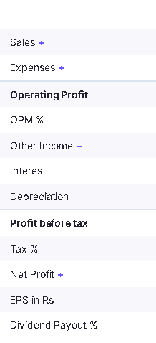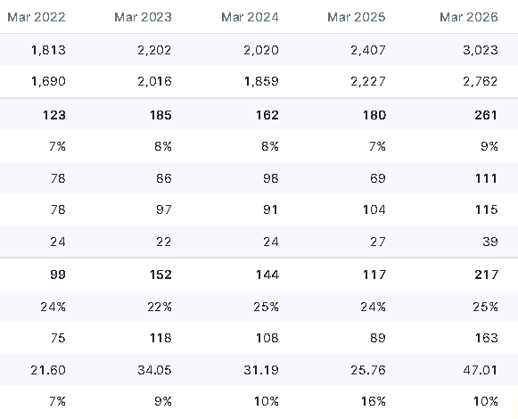

10.2 Balance Sheet

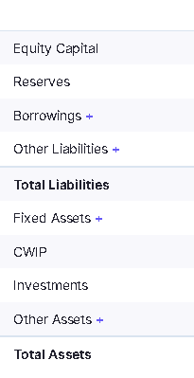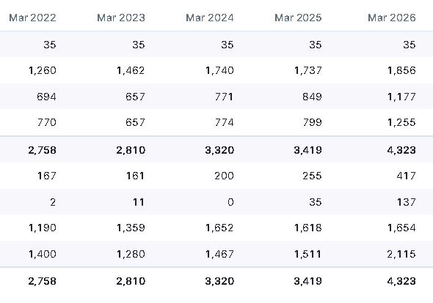

10.3 Cash Flow Summary

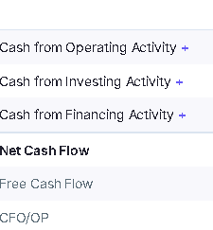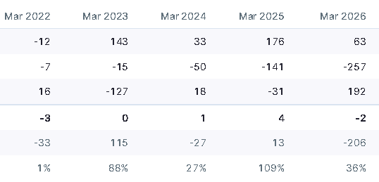

Section 11: Growth Drivers & Risk Factors

11.1 Key Growth Drivers
Driver | Mechanism | Beneficiary Segments
Grid Modernisation / Underground Shift | ROW constraints in urban areas — EHV underground cabling preferred over overhead | EHV, EPC
RDSS (>3 lakh crore outlay) | Distribution network upgrade across all states | MV, LV, Capacitors
Renewable Energy Evacuation | Wind/solar farms need grid stability solutions | Capacitors, EHV
New CCV Lines Commissioning | 4 additional CCV lines by Sep 2026 add MV/HV capacity | MV, HV
Export Push (>15% target) | Europe, Latin America, Middle East penetration | EHV, Specialty
EHV Facility Modernisation (₹73 Cr) | International quality standards enabling global tenders | EHV, Export
EV Charging Cables | EN 50620 compliant cables for growing EV infrastructure | Specialty / New vertical

11.2 Key Risk Factors
Risk | Category | Analyst Assessment
Raw material (Cu/Al) price volatility + Middle-East supply disruption | Commodity / External | High impact; PV clause effectiveness is the mitigant
Elongated operating cycle (100–110 days) | Working Capital | Structural; inherent to utility-tender business model
CCV line commissioning delays | Execution | Minor (1–2 months); monitor for FY27 revenue ramp
ROW and government clearance delays in EPC | Project Execution | Lumpy cash flows; can block receivables for quarters
Associate profit concentration (~50% PAT from VTL) | Earnings Quality | High risk; VTL health must be tracked independently
Rising finance costs (₹115 Cr + NCD ₹200 Cr) | Financial | Coverage at 2.46x — thin; needs FY27 EBITDA growth
OFC market slowdown (BFFOPL JV) | Structural | Low absolute impact but trend is negative
Electron Beam substitution in rubber cables | Technology / Structural | Secular volume decline; not recoverable via pricing

