Step 1

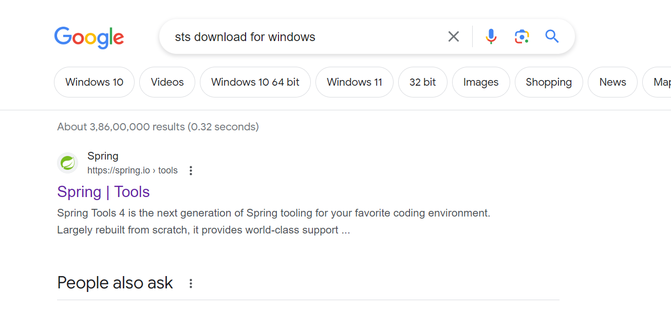

Step2

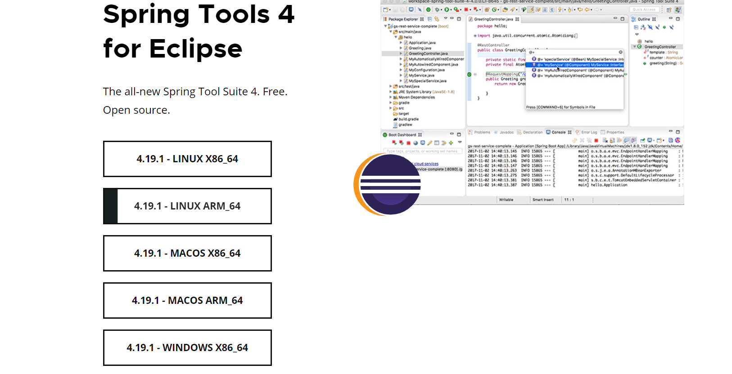

Step3

Extract the sts



Step4—double click and open the sts

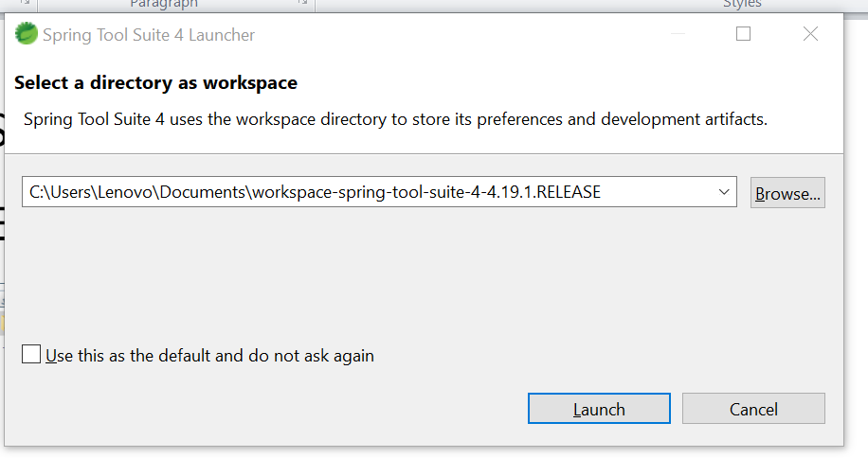and the lunch

The create spring starter project

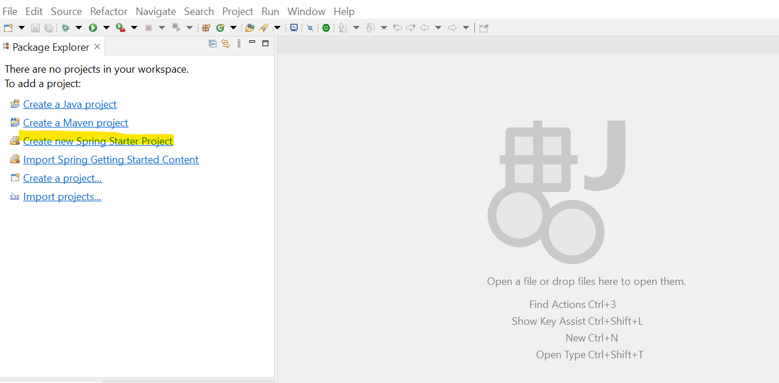

Step 4

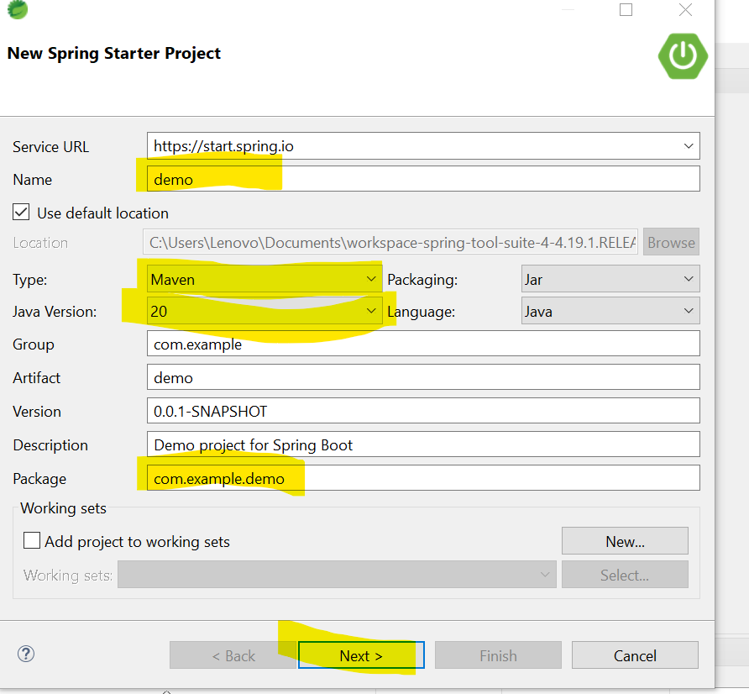

Step5 select the

1)Spring web-- for rest apis

2)spring boot dev tool –like nodemon

3)Lombok ---togenerate setter and getters

4)spring data mongodb

