SIMATS ENGINEERING
Department of Computer Science and Engineering
ASSESSMENT TOOL2 - CONCEPT MAPPING

Course Code: | CSA1205 | Course Title: | Computer Architecture for Multicore Systems
CO Assessed: | CO1 | Assessment: | ASSESSMENT TOOL 2- CONCEPT MAPPING
Weightage: | 35% | Total Marks: | 25
CO1 Statement: | Analyze the functional units of a computer system including CPU, memory, bus structures, and I/O components by examining instruction execution cycles, addressing modes, and performance metrics such as CPI, clock cycles, and benchmarking (BL4)
Student Name: |  | Reg.No.:
Department: |  | Date:

ANNEXURE A
- Construct a detailed concept map showing the relationship between CPU (ALU, Control Unit, Registers), memory (cache, RAM), and I/O devices. Extend the map to include single-bus, multi-bus, and hierarchical bus structures, and clearly illustrate how data and control signals flow among these components during execution. Indicate possible points of delay or bottlenecks and how different bus structures help in improving performance.
- Develop a comprehensive concept map linking the instruction execution cycle (fetch, decode, execute) with CPU performance parameters such as CPI, clock cycles, and execution time. Show how each stage contributes to overall execution time, and include connections to factors like memory access, instruction complexity, and pipeline stalls. Also, represent how benchmarking is used to evaluate performance.
- Create a concept map comparing 8085 and 8086 architectures, including their instruction sets, register organization, addressing modes, and memory segmentation (in 8086). Clearly show how these architectural features influence program execution, multitasking capability, and efficiency in real-time applications.
- Draw a detailed concept map that connects various addressing modes (immediate, direct, register, indirect, indexed) with instruction types (data transfer, arithmetic, control instructions). Illustrate how each addressing mode affects memory access time, instruction size, and execution speed, and show real-world scenarios where specific addressing modes are preferred.
- Prepare an elaborate concept map integrating number systems (binary and hexadecimal) with instruction representation, memory storage, and debugging processes. Show how data is converted between formats, how instructions are stored and interpreted by the CPU, and why hexadecimal representation is commonly used in low-level programming and system design.

Code of Conduct:

I ____________________ (Name / Reg No) certify that this submission is my original work and that I have adhered to the guidelines specified for this assessment.
I understand that any violation of academic integrity rules will result in disciplinary action.

Signature of the student:

MARKS ALLOCATION
Criteria | Concept Identification (25%) | Linkages (25%) | Organization (20%) | Integration of Literature (20%) | Clarity (10%)
Q1
Q2
Q3
Q4
Q5

RUBRICS FOR CALCULATION:

Criteria | Weightage | Level 4 – Exemplary | Level 3 – Proficient | Level 2 – Developing | Level 1 – Beginning
Concept Identification | 25% | Identifies all key concepts from literature accurately and comprehensively | Identifies most key concepts with minor omissions | Identifies limited concepts; some are irrelevant or missing | Fails to identify essential concepts
Linkages | 25% | Establishes clear, meaningful, and accurate relationships between concepts | Shows correct relationships with minor gaps | Relationships are weak, unclear, or partially incorrect | No meaningful relationships established
Organization | 20% | Concepts are well-structured hierarchically with logical flow and grouping | Mostly organized with minor structural issues | Some organization but lacks clear hierarchy | No logical organization or structure
Integration of Literature | 20% | Integrates multiple studies effectively to show connections and comparisons | Shows some integration of literature | Limited integration; mostly isolated concepts | No integration of literature evidence
Clarity | 10% | Concept map is clear, neat, visually structured, and easy to interpret | Generally clear with minor readability issues | Clarity is reduced; difficult to interpret in parts | Poorly presented and hard to understand

1)
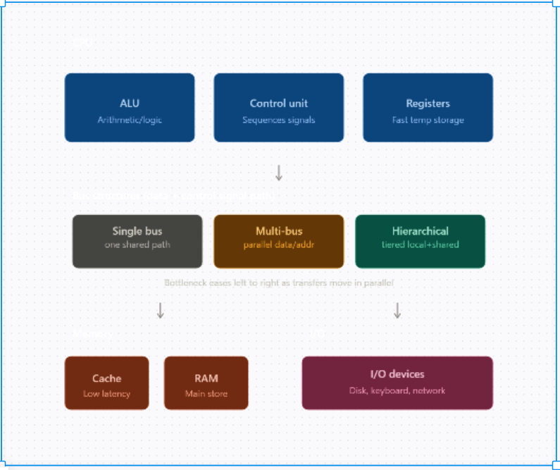

2)
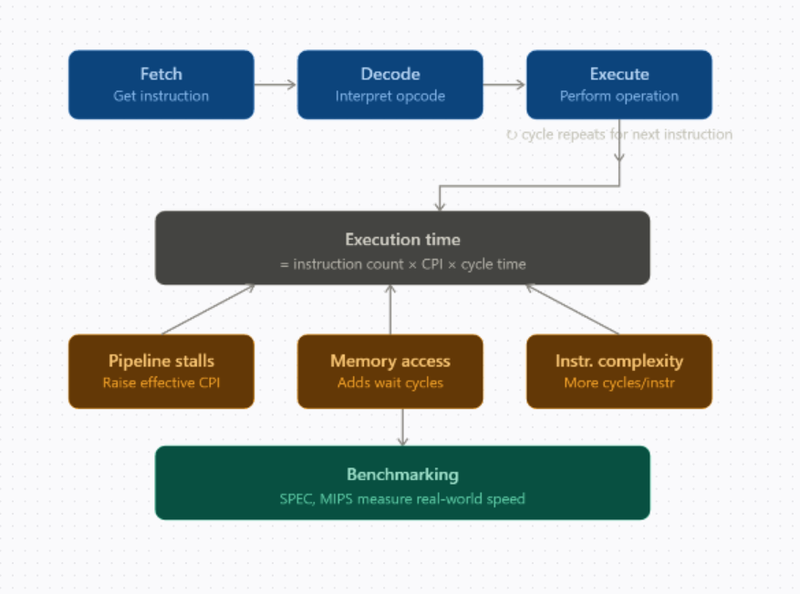

3)
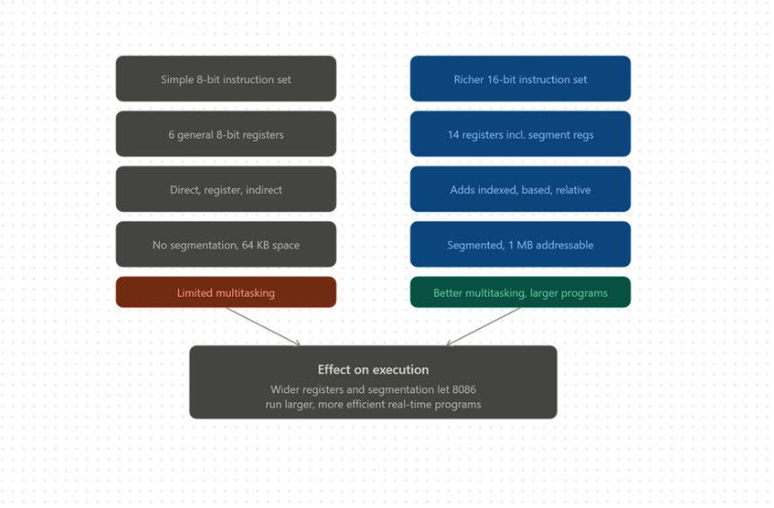

4)
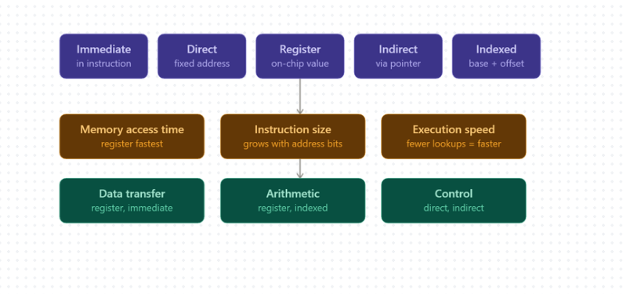

5)
