Umut Can Gulmez 2099067

Original.bmp

Aes-128-cbc encryption algorithm totally encrypted the image so no one can observe any useful information about the original picture.

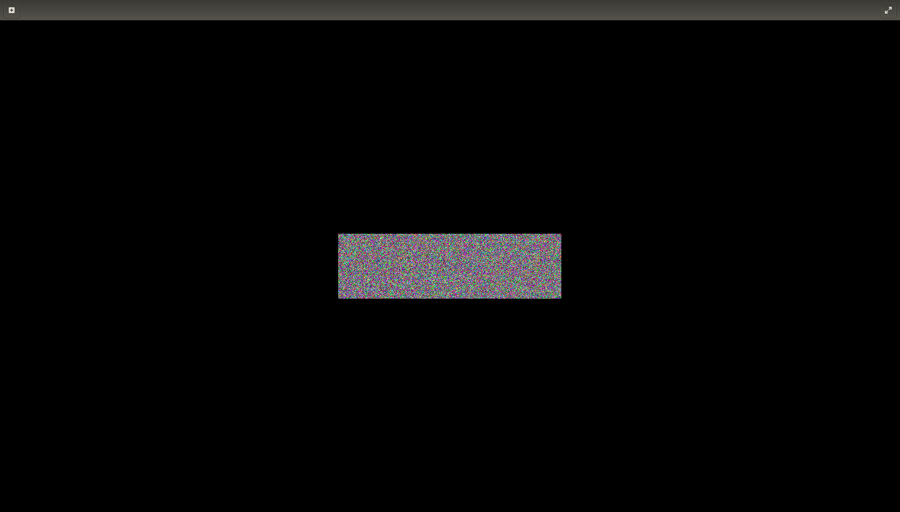
Aes-128-cbc

On the other hand, although Aes-128-EBC encrypted the image , there are lots of information of original picture can be retrieved from this encrypted file. For example, in this specific example shapes and colors can be seen from encrypted file.

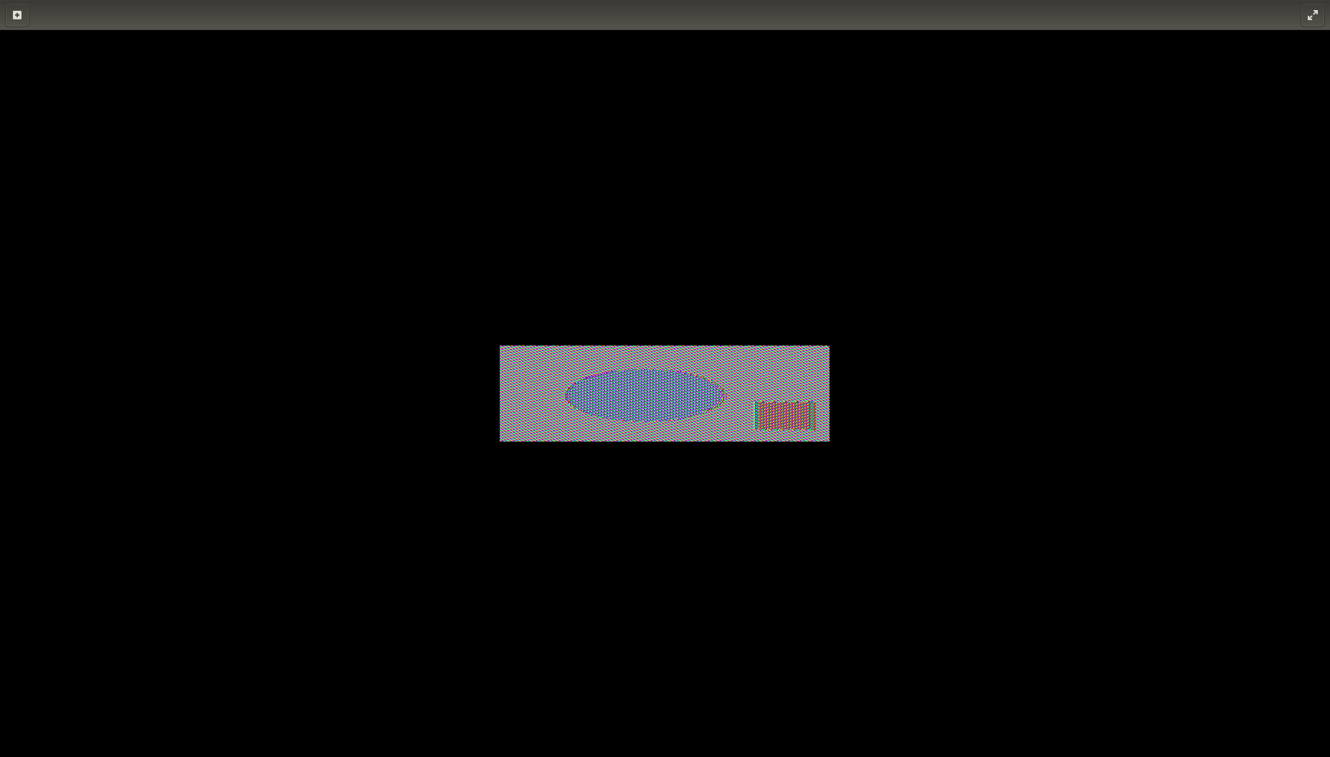
aes-128-EBC

