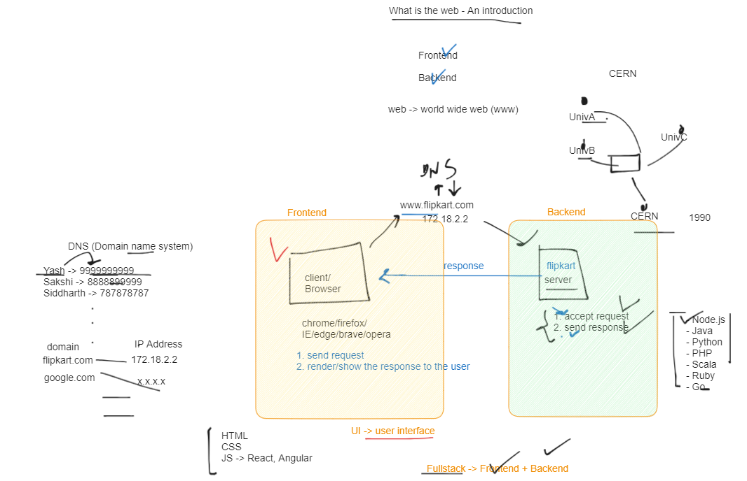

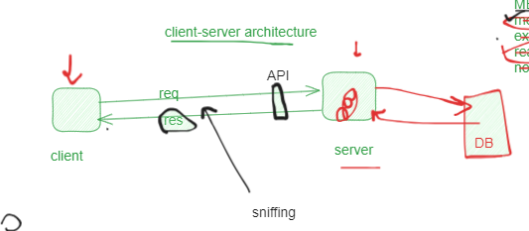

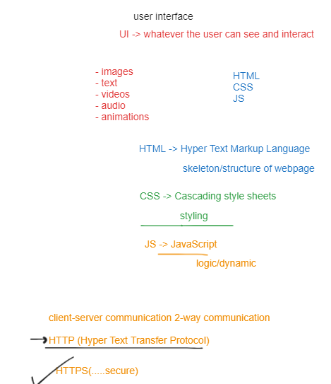

**HTML**

**Forms in HTML**

Type in form:-Text, number, email, password, radio, select, option, checkbox, colour, date, file, text area, submit, reset….

<!DOCTYPE html>

<html lang="en">

<head>

  <meta charset="UTF-8">

  <meta name="viewport" content="width=device-width, initial-scale=1.0">

  <title>Forms</title>

</head>

<body>

  <form action="">

    <label for="firstname">Name</label>

    <input type="text" name="firstname" id="firstname">

    <br>

    <label for="lastname">Last Name</label>

    <input type="text" name="lastname" id="lastname">

    <br>

    <label for="age">Age</label>

    <input type="number" name="age" id="age" min="25" max="60">

    <br>

    <label for="email">Email</label>

    <input type="email" name="email" id="email" placeholder="Hello@gmail.com">

    <br>

    <label for="password">Password</label>

    <input type="password" name="password" id="password">

    <br>

    <p>Select your stream:</p>

    <input type="radio" name="stream" id="science">

    <label for="science">Science</label>

    <input type="radio" name="stream" id="commerce">

    <label for="commerce">Commerce</label>

    <input type="radio" name="stream" id="art">

    <label for="art">Art</label>

    <br>

    <label for="course">Select your course</label>

    <select name="course" id="course">

      <option value="">Btech</option>

      <option value="">BCA</option>

      <option value="">MCA</option>

      <option value="">Mtech</option>

    </select>

    <br>

    <input type="checkbox" name="policy" id="policy" >

    <label for="policy">I agree all the policies of this from</label>

    <br>

    <label for="color">Select your color</label>

    <input type="color" name="color" id="color">

    <br>

    <label for="date">Enter your DOB</label>

    <input type="date" name="date" id="date">

    <br>

    <label for="photo">Enter your profile photo</label>

    <input type="file" name="photo" id="photo">

    <br>

    <label for="message">Enter about yourself</label>

    <br>

    <textarea name="message" id="message" cols="30" rows="10"></textarea>

    <br>

    <input type="submit" value="Submit">

    <input type="reset">

  </form>

</body>

</html>

