Architecture for this requirement

Data pipeline to Load the data into the data warehouse and for visualization purpose we are using Apache Superset.

As per the above Diagram I have used the following service to achieve this requirement.

1. **S3 Bucket**: The parquet files are stored in S3 bucket.

1. **Lambda Function**: When a new parquet file has been uploaded, the lambda function will be triggered for creating Glue Crawler.

newyork-taxi-data/lambda/ data_pipeline_trigger.py

1. **Glue Crawler**: The Lambda function creates a new Glue crawler, which is configured to crawl the S3 bucket and the parquet file(s) that triggered the Lambda function. So, key advantages of using AWS Glue Crawler are that they can automatically create databases and tables in the AWS Glue Data Catalog without manual intervention.

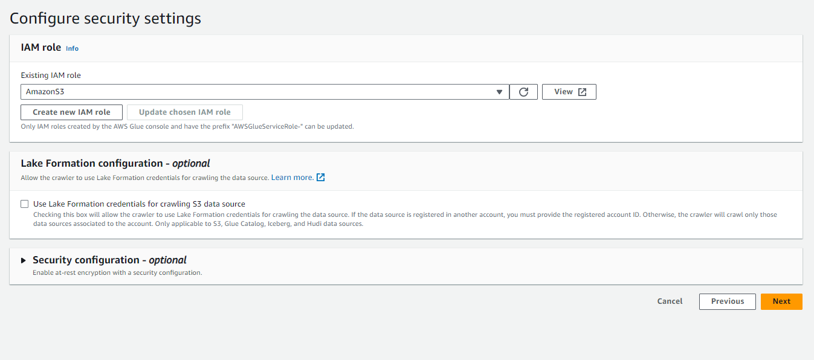

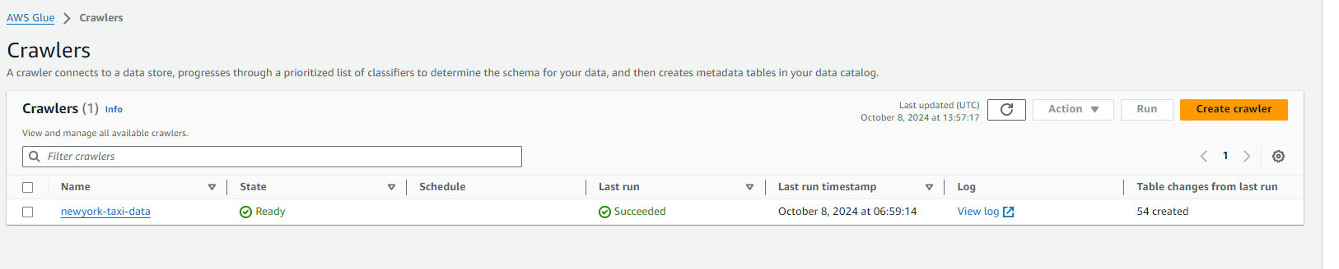

1. **Glue Job**: After the crawler is created and has processed the parquet file(s), the Lambda function triggers a Glue job which will reads the data from the source (**S3 bucket**) based on the metadata in the Glue Data Catalog, performs necessary transformations, and loads the data into the target data store (**Amazon Redshift**). For connecting AWS Glue and Redshift cluster we need username and password so for making more secure manner we have used secret manager and passed an argument in Glue job.

**Glue Job** has been written at the following path in project directory

**ecommerce-datawarehouse/glue/etl.py**

1. **Redshift:** Once the data is loaded into Redshift then we can do further analysis and querying on the data using SQL queries.

Table Structure in Redshift

FHV Trip Data Tables

dev.public.fhv_tripdata_2022_01

dev.public.fhv_tripdata_2022_02

dev.public.fhv_tripdata_2022_03

dev.public.fhv_tripdata_2022_04

dev.public.fhv_tripdata_2022_05

dev.public.fhv_tripdata_2022_06

dev.public.fhv_tripdata_2023_01

dev.public.fhv_tripdata_2023_02

dev.public.fhv_tripdata_2023_03

dev.public.fhv_tripdata_2023_04

dev.public.fhv_tripdata_2023_05

dev.public.fhv_tripdata_2023_06

dev.public.fhv_tripdata_2024_01

dev.public.fhv_tripdata_2024_02

dev.public.fhv_tripdata_2024_03

dev.public.fhv_tripdata_2024_04

dev.public.fhv_tripdata_2024_05

dev.public.fhv_tripdata_2024_06

Green Trip Data Tables

dev.public.green_tripdata_2022_01

dev.public.green_tripdata_2022_02

dev.public.green_tripdata_2022_03

dev.public.green_tripdata_2022_04

dev.public.green_tripdata_2022_05

dev.public.green_tripdata_2022_06

dev.public.green_tripdata_2023_01

dev.public.green_tripdata_2023_02

dev.public.green_tripdata_2023_03

dev.public.green_tripdata_2023_04

dev.public.green_tripdata_2023_05

dev.public.green_tripdata_2023_06

dev.public.green_tripdata_2024_01

dev.public.green_tripdata_2024_02

dev.public.green_tripdata_2024_03

dev.public.green_tripdata_2024_04

dev.public.green_tripdata_2024_05

dev.public.green_tripdata_2024_06

Yellow Trip Data Tables

dev.public.yellow_tripdata_2022_01

dev.public.yellow_tripdata_2022_02

dev.public.yellow_tripdata_2022_03

dev.public.yellow_tripdata_2022_04

dev.public.yellow_tripdata_2022_05

dev.public.yellow_tripdata_2022_06

dev.public.yellow_tripdata_2023_01

dev.public.yellow_tripdata_2023_02

dev.public.yellow_tripdata_2023_03

dev.public.yellow_tripdata_2023_04

dev.public.yellow_tripdata_2023_05

dev.public.yellow_tripdata_2023_06

dev.public.yellow_tripdata_2024_01

dev.public.yellow_tripdata_2024_02

dev.public.yellow_tripdata_2024_03

dev.public.yellow_tripdata_2024_04

dev.public.yellow_tripdata_2024_05

dev.public.yellow_tripdata_2024_06