**1. Create a table named ‘matches’ with appropriate data types for columns.**

CREATE TABLE matches(

id INT PRIMARY KEY,

city VARCHAR(40),

date DATE,

player_of_match VARCHAR(40),

venue VARCHAR(80),

neutral_Venue INT,

team1 VARCHAR(80),

team2 VARCHAR(80),

toss_winner VARCHAR(80),

toss_decision VARCHAR(20),

winner VARCHAR(80),

result VARCHAR(40),

result_margin INT,

eliminator VARCHAR(10),

method VARCHAR(10),

umpire1 VARCHAR(40),

umpire2 VARCHAR(40)

);

**2. Create a table named ‘deliveries’ with appropriate data types for columns.**

CREATE TABLE deliveries (

id INT,

inning INT,

over INT,

ball INT,

batsman VARCHAR(40),

non_striker VARCHAR(40),

bowler VARCHAR(40),

batsman_runs INT,

extra_runs INT,

total_runs INT,

is_wicket INT,

dismissal_kind VARCHAR(40),

player_dismissed VARCHAR(40),

fielder VARCHAR(100),

extras_type VARCHAR(40),

batting_team VARCHAR(40),

bowling_team VARCHAR(40),

FOREIGN KEY(id) REFERENCES matches(id)

);

**3. Import data from CSV file ’IPL_matches.csv’ attached in resources to ‘matches’**

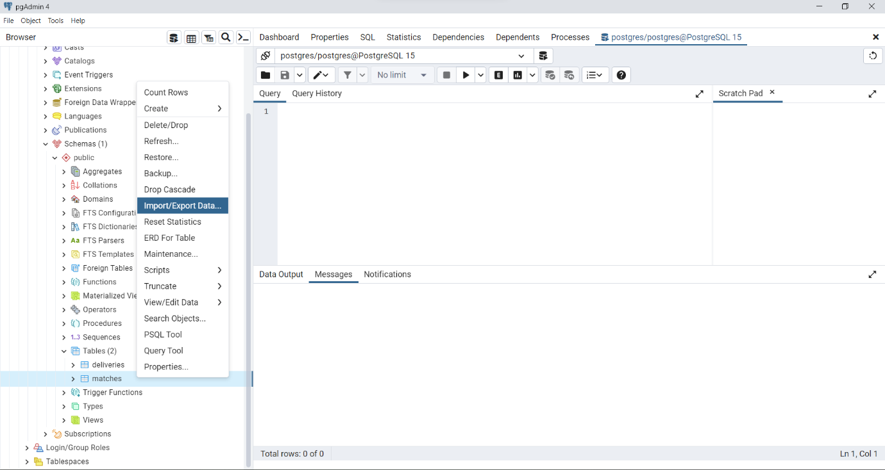

**4. Import data from CSV file ’IPL_Ball.csv’ attached in resources to ‘deliveries’**

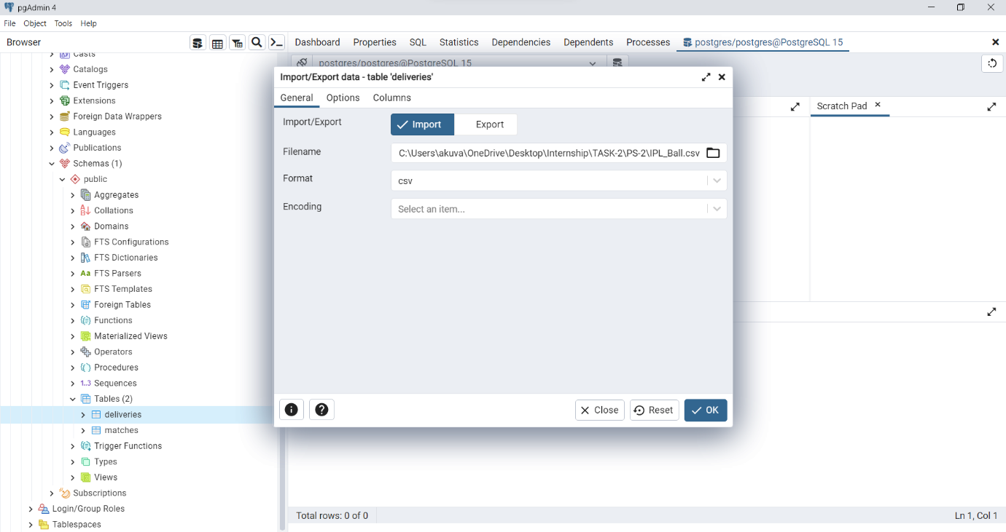

**5. Select the top 20 rows of the deliveries table**.

select *from deliveries LIMIT 20;

**6. Select the top 20 rows of the matches table.**

select *from matches LIMIT 20;

**7. Fetch data of all the matches played on 2nd May 2013.**

select * from matches where date='02-05-2013';

**8. Fetch data of all the matches where the margin of victory is more than 100 runs.**

select *from matches where result_margin>100;

**9. Fetch data of all the matches where the final scores of both teams tied and order it in descending order of the date.**

select *from matches where result='tie' order by date DESC;

**10. Get the count of cities that have hosted an IPL match.**

select count(distinct city)from matches;