**Hindi Speech Typer**

Hindi Speeck Typer is a software which is type hindi words by speechs. Simple you say on Microphone in hindi the words which say automatic type in inbuilt notepad.

If any problem on running software Click SpeechTyper.bat file and view the problem.

**Requirement’s :-**

1. You need jre (java runtime environment)
2. SpeechTyper Softeare
3. Windows Platform
4. Mic (You can use inbuilt Mice Lick Laptop)

Or

You can Use Smart Phone Microphone

Use Android Microphone in Your pc ……….

1. Download WO Mic from htttp://www.wirelessstorage.com

Download : wo mic for Andorid and wo mic for Windows , and wo mic windows driver .

1. Install both side software android and windows.
2. Connect software .
3. Now you can use external microphone.

**Working With software : -**

1. Open SpeechTyper software

Now Loading Hindi Speech Library ………..

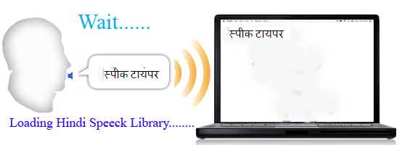

**2 )** After Loading , Microphone is disable to enable microphone click

start button now speck .

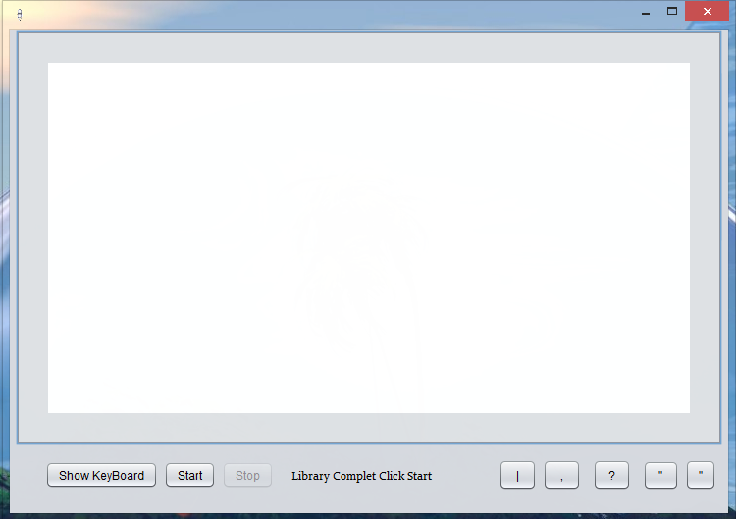

Start

1. **)** For correction in word you can click show keyboard
2. **)** to cut , copy hindi text Right click on text area. An select operation.

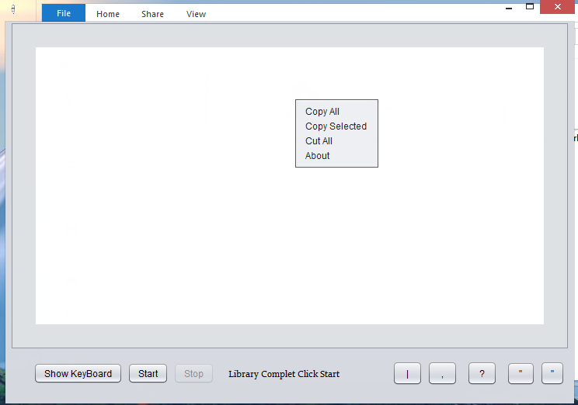

**About Developer : -**

**Deep Govind . Diploma in Computer Science and Engg.**

**Email : deepgovind4@gmail**

**Mobile No : 73889661541**