Mapping Superconductivity Research for AI: A Two-Axis Survey of 10,249 Preprints and Where Machine Learning Can Actually Help
Mingguang Chen
2026-09-07
Abstract
Superconductivity research generates enormous quantities of data and has a poor record of predicting its own discoveries, which makes it an obvious target for AI for Science and a poorly understood one. We map the field systematically. Every arXiv preprint filed under cond-mat.supr-con between September 2021 and September 2026 was harvested month by month, giving 10,303 records, of which 10,049 survive off-topic filtering at a measured bleed rate of 2.5%; a targeted supplement adds 200 on-topic records on AI for materials. Each record is classified along two axes – material family and mode of inquiry – by a language-model pass validated against hand labels at 85.6% and 88.4% agreement, with per-class recall reported. We then assess each cell of the resulting grid for data availability, benchmark maturity and validation cost. Three findings emerge. Machine learning has barely entered the field: 1.2% of the systematic corpus uses an AI method in its own work. Adoption tracks validation cost rather than data volume or scientific stakes, concentrating in ab initio screening and neural quantum states, where a calculation can check a prediction, and in device metrology, where instruments generate their own labels. And synthesis, which Section 3 finds to be the rate-limiting step across material families, contains a single AI-tagged paper. The gap between prediction and measurement is concrete: recent screens advertise candidates above 200 K, while the one closed prediction-synthesis-measurement loop in the recent literature delivered superconductors between 2.5 and 6.5 K. We conclude that the highest-value interventions are releasing labelled characterization data, building a time-stamped benchmark of experimentally confirmed superconductors, and modelling synthesizability rather than automating synthesis. Corpus, labels and scripts are released.

Introduction
Superconductivity is an unusually well-instrumented field with an unusually poor prediction record. A century after Onnes, the mechanism of the highest-$T_{c}$ families is still contested, the compounds that matter were mostly found by chemical intuition and persistence, and two of the most prominent recent claims of room-temperature superconductivity have been retracted. It is exactly the sort of field that AI-for-Science rhetoric promises to transform.
Whether it can, and where, is an empirical question about the field’s structure rather than about the capability of models. A machine-learning method needs three things: data in a form it can consume, a target quantity worth predicting, and a way of finding out whether a prediction was right. Different parts of superconductivity research supply these to wildly different degrees. High-pressure hydride work has a computable target and a mature calculation pipeline. Cuprate physics has four decades of spectra and no agreed quantity to predict. Thin-film synthesis has the field’s real bottleneck and almost no machine-readable record of what has been tried.
This survey makes that structure explicit. We harvest every arXiv preprint filed under cond-mat.supr-con between September 2021 and September 2026, classify each along two axes – the material family it studies and the mode of inquiry it uses – and then evaluate each cell of the resulting grid for what a machine-learning method could contribute to it. The corpus is 10,249 records after off-topic filtering, and the classification is validated against hand labels with the agreement rates and per-class recall reported in full.
Three results follow. Machine learning has barely entered this field: 1.2% of the systematically harvested corpus uses an AI method in its own work. Where it has entered, it tracks validation cost, clustering in the cells where a calculation can check a prediction and in device metrology where instruments generate their own labels, rather than in the cells with the most data or the greatest scientific stakes. And the field’s actual bottleneck is the emptiest cell: synthesis, where the corpus contains a single AI-tagged paper.
The contribution is therefore threefold: a systematically harvested and openly released corpus of the field’s recent literature; a two-axis taxonomy that has been tested against hand labels rather than asserted; and a per-cell assessment of AI readiness that identifies where effort is likely to pay off and, more usefully, where current enthusiasm is misdirected. Section 2 fixes the vocabulary, states the taxonomy, positions the survey against existing reviews and documents the corpus. Sections 3 and 4 walk the two axes. Section 5 reports what AI has actually done in this field, critical literature included. Section 6 gives the readiness assessment and the resulting priorities, and Section 7 offers three testable hypotheses about why the field looks the way it does.

Preliminaries and taxonomy

Terms this field overloads
A survey that spans nine material families and five modes of work has to fix its vocabulary first, because several of the terms below carry different meanings in different corners of the literature.
Critical temperature. $T_{c}$ is quoted from several inequivalent operational definitions: the onset of a resistive drop, the midpoint of the transition, the zero-resistance point, and the temperature at which diamagnetic screening appears. The gap between onset and zero resistance is small in clean conventional samples and large in inhomogeneous ones, which is exactly where contested claims live. Throughout this survey we say which definition a reported number uses when the distinction bears on the claim, and we treat a resistive onset without a magnetic signature as weaker evidence than the two together.
Conventional and unconventional. We use conventional to mean pairing mediated by electron-phonon coupling and describable within Migdal-Eliashberg theory (Bardeen et al. 1957), and unconventional to mean a gap function that changes sign or breaks a lattice symmetry, whatever the glue. High-pressure hydrides are therefore conventional in mechanism while being extreme in $T_{c}$, and this survey groups them with the electron-phonon family rather than with the cuprates they are often headlined against.
Prediction versus discovery. A computed structure with a favourable calculated $T_{c}$ is a prediction. A material that has been made and measured is a discovery. Papers routinely use “discovery” for the former, and the AI-for-materials literature does so more often than the superconductivity literature does. We reserve discovery for the experimental sense and say predicted candidate otherwise. This distinction carries most of the weight in Section 5.
AI-discovered. We treat a material as AI-discovered only when a machine-learning model selected or generated the candidate, the material was subsequently synthesised, and superconductivity was measured. Weaker uses of the phrase – a screen that ranked a known compound highly, or a model that reproduced a $T_{c}$ after the fact – are described as such.

The two axes
The taxonomy has two axes plus a lens (Figure 1).
Axis 1, material family, is what the paper is about: conv (conventional and electron-phonon systems, including high-pressure hydrides), cuprate, febased, nickelate, unconv_other (heavy fermion, ruthenate, organic, noncentrosymmetric bulk systems), lowd (two-dimensional, interface, moiré and kagome systems), topo (topological superconductivity and Majorana platforms), device (qubits, detectors, magnets, cables, circuits), and general (material-agnostic theory, formalism and instrumentation).
Axis 2, mode of inquiry, is how the work was done: theory, abinitio, discovery, synthesis, characterization. This axis deliberately does not encode whether a topic is applied. An earlier version of this taxonomy carried a sixth value, application, and it failed a measurement: it mixed how the work was done with what it was for, and characterization-versus-application was the single largest source of disagreement both for keyword rules and for two independently benchmarked language models. Application context is carried by the device family instead, so a qubit paper is labelled theory, synthesis or characterization like any other paper.
The AI lens applies only to papers that use a machine-learning method in their own work: surrogate (regression and classification models, symbolic regression), gnn_potential (graph networks and machine-learned interatomic potentials), generative (diffusion, VAE, flow models for structures and compositions), llm (language models, agents, literature mining), nqs (neural quantum states), and autonomous_exp (self-driving laboratories, closed-loop active learning).
The axes are the contribution of this survey, and Sections 3 through 5 are organised along them. Section 6 evaluates each cell for what AI can currently do in it.
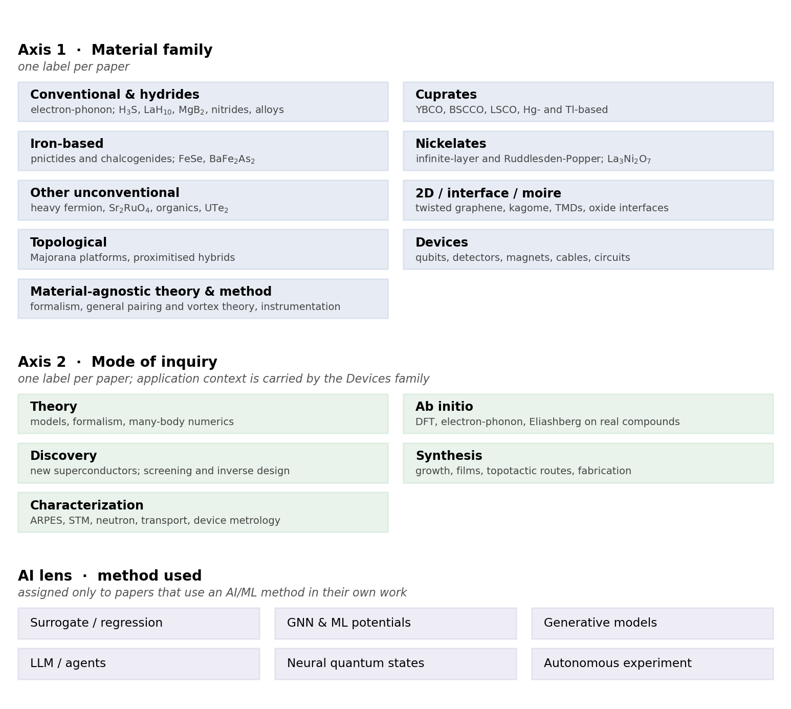
Figure 1: The taxonomy. Every corpus record carries one label from Axis 1 and one from Axis 2; the AI lens applies only to records that use a machine-learning method in their own work.

Positioning relative to existing surveys
Two bodies of review literature already cover parts of this ground, and neither covers the join.
The first is per-family physics reviews. Recent examples treat nickelate superconductivity (Y. Wang et al. 2025; Zhang et al. 2026) and the hydride programme. These are authoritative on mechanism and materials, and they say little about method infrastructure: what data exists, what is measurable at scale, where a model could be trained or tested.
The second is machine-learning-for-superconductors reviews. Recent examples survey materials-informatics approaches to superconductor discovery (Tran et al. 2025), machine-learning searches for new superconductors (Adiga and Waghmare 2025), AI-driven high-throughput screening (Gashmard et al. 2025), and language-model workflows for extraction and property prediction (Itani et al. 2025; Li et al. 2026). These are organised by method, and their material scope is dominated by the one task where tabulated data happens to exist – predicting $T_{c}$ from composition.
This survey takes the join as its subject. It maps the whole field onto a family-by-mode grid, populates that grid from a systematically harvested corpus, and then asks of each cell what would have to be true for a machine-learning method to contribute there. The result is a statement about where the opportunities are not, which the method-organised reviews cannot make because they only look where the methods already are.

Corpus construction
Seed harvest. Every arXiv preprint listed under cond-mat.supr-con, as primary category or cross-list, submitted between 2021-09-01 and 2026-09-07, retrieved month by month through the arXiv API. This is a systematic, not a keyword, harvest: the selection criterion is the category label the authors themselves chose. It yields 10,303 records, of which 6,986 carry cond-mat.supr-con as primary category and 3,317 are cross-listed from elsewhere. Raw responses are cached per month so the harvest is reproducible.
Targeted supplement. The seed necessarily misses AI-for-materials work that never touches the superconductivity category. Two supplementary threads were harvested by keyword: AI applied to superconductivity from adjacent categories, and general AI-for-materials infrastructure needed for Section 6. These add 691 records tagged supplement_t1 and supplement_t2. The supplement is recency-biased by construction – its queries are capped and sorted by submission date – so it is excluded from every growth statistic and from Table 1’s family-by-mode counts, where it appears only as a separate column.
Off-topic filtering. 745 records were flagged as not about superconductivity and excluded from all statistics. Within the systematically harvested seed the rate is 254 of 10,303, or 2.5%, which is this corpus’s measured query-bleed. The rate is far higher in the supplement, as intended: the general AI-for-materials thread was designed to reach outside the field. After exclusion the working corpus is 10,249 records: 10,049 seed and 200 supplement.
Labelling. Both axes and the AI lens were assigned by a language-model pass over title and abstract (gemini-3.5-flash-lite), after keyword rules were measured and found inadequate. Agreement with a hand-labelled 150-record stratified sample:
labels | family | mode of inquiry
keyword rules | 80.1% | 70.5%
language-model pass | 85.6% | 88.4%
Per-class recall for the model is 96% (theory), 92% (characterization), 92% (ab initio), 64% (synthesis) and 54% (discovery). The two small classes are the weak ones, and no claim in this survey rests on their counts alone. The AI lens was validated separately against 120 hand-labelled records, half drawn from each side of the rule-based tag: 88% precision and 81% recall on the AI-versus-not decision, 84% exact agreement on which method.
Annotator disclosure. All hand labels were produced by a single annotator. The figures above are therefore agreement between one human pass and one model pass, not accuracy against an external ground truth. Corpus, labels, prompts and scripts are released so that both passes can be re-run and re-scored.
Citation counts. Citation data comes from OpenAlex, resolved for 8,280 of the records. Over a five-year window raw counts favour older work mechanically, so where this survey ranks papers it ranks by citations per month since submission, and citation counts for work less than a year old are not read as impact at all.
Table 1: Corpus by material family and mode of inquiry. Counts are seed records after off-topic filtering; the supplement is listed separately because it is recency-biased by construction and is excluded from all trend statistics.
Family | Theory | Ab init. | Discov. | Synth. | Charac. | Seed | Suppl.
Conventional | 199 | 237 | 271 | 193 | 589 | 1489 | 15
Cuprate | 445 | 54 | 7 | 58 | 437 | 1001 | 2
Iron-based | 95 | 15 | 4 | 58 | 317 | 489 | 0
Nickelate | 212 | 113 | 20 | 74 | 209 | 628 | 1
Other unconv. | 320 | 10 | 20 | 22 | 306 | 678 | 0
2D / moiré | 594 | 74 | 38 | 65 | 558 | 1329 | 10
Topological | 909 | 14 | 8 | 37 | 276 | 1244 | 9
Devices | 611 | 4 | 2 | 156 | 559 | 1332 | 109
Material-agnostic | 1761 | 9 | 26 | 4 | 59 | 1859 | 54
Total | 5146 | 530 | 396 | 667 | 3310 | 10049 | 200
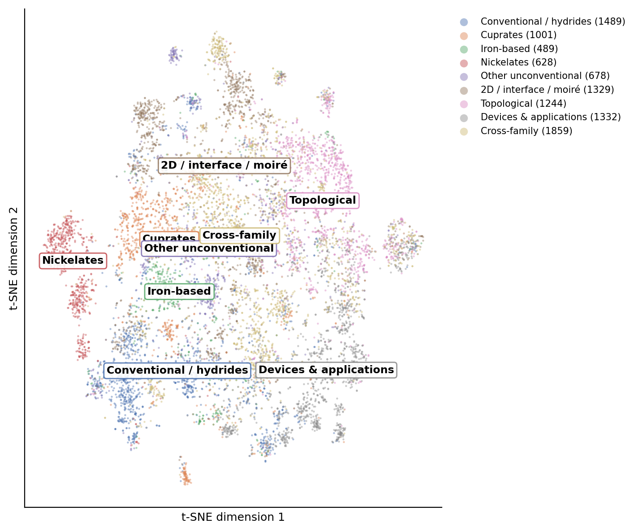
Figure 2: Semantic map of the seed corpus (TF-IDF, truncated SVD, t-SNE), coloured by material family. Per-family counts match Table 1.
Limitations. The corpus is arXiv-only, so it inherits arXiv’s coverage: strong in theory and condensed-matter experiment, weaker in applied-superconductivity engineering that publishes in IEEE venues, and blind to unpublished industrial work, which matters most for the device family. Category self-assignment means a paper whose authors did not cross-list to cond-mat.supr-con is absent from the seed regardless of content. Labels are single-label where reality is often multi-label: a paper that grows a crystal and measures it gets one mode, chosen by which the abstract presents as the contribution.

Material families
This section walks Axis 1. Each family is treated for what it is currently doing, what is open, and – because that is this survey’s purpose – what kind of data it generates. Counts are seed-corpus counts from Table 1 and Figure 2.
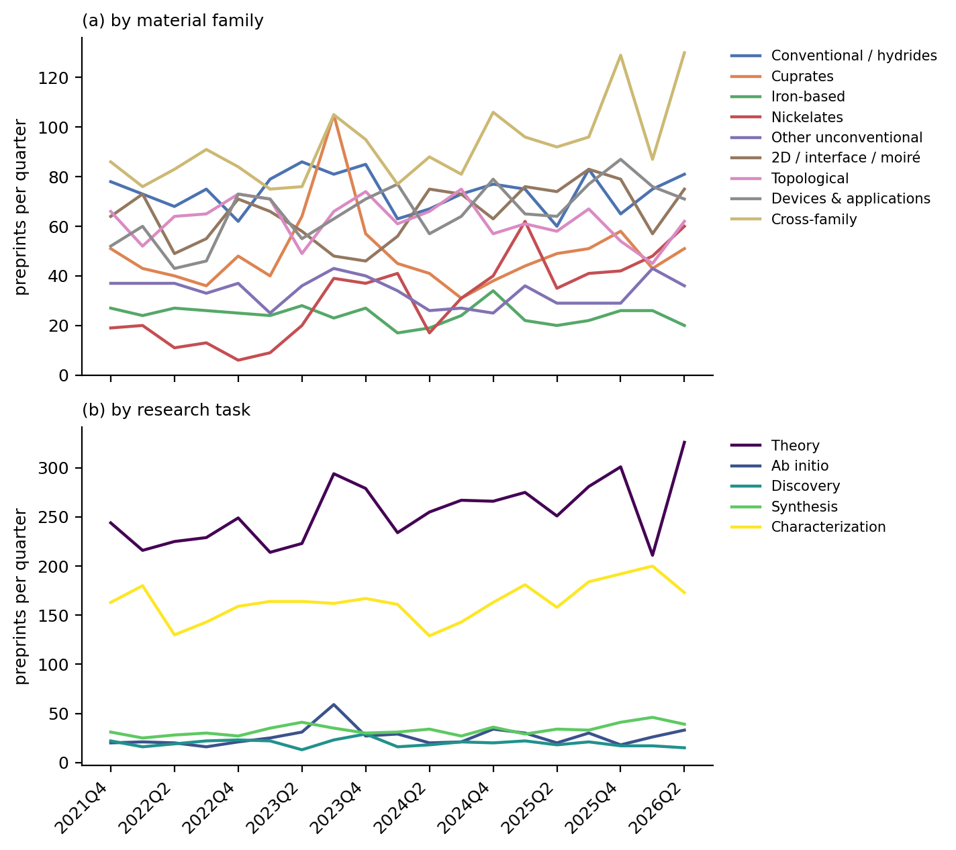
Figure 3: Quarterly submissions by material family (a) and mode of inquiry (b), seed records only. Both partial endpoint quarters are omitted. The cuprate spike in 2023Q3 is the LK-99 replication burst discussed in Section 3.

Nickelates: the fast-moving family
Nickelates are the smallest of the named families in this corpus (628 seed records) and the fastest-growing (Figure 3a). The line begins outside the window with superconductivity in an infinite-layer nickelate thin film (Li et al. 2019), and turns sharply with the report of superconductivity near 80 K in La$​_{3}$Ni$​_{2}$O$​_{7}$ above 14 GPa (Sun et al. 2023).
What followed is a useful case study in how a modern materials claim is stabilised. The original report lacked zero resistance; that was supplied under a liquid pressure medium, together with strange-metal $T$-linear resistivity whose coefficient tracks the superconducting transition under pressure (Zhang et al. 2023). Polycrystalline samples then reproduced the effect, reaching zero resistivity at 9 GPa and 35.6 K at 14.5 GPa (Wang et al. 2023). In parallel, careful high-pressure work reported that the superconductivity is filamentary rather than bulk, and tied the inconsistent reproducibility to oxygen content (Zhou et al. 2023). Bulk superconductivity with zero resistivity and a Meissner signal was subsequently reported in flux-grown La$​_{2}$SmNi$​_{2}$O$​_{7−δ}$ single crystals, at 92 K onset and 73 K zero-resistance at 21.6 GPa (Li et al. 2025).
The pressure requirement is the family’s practical obstacle, and thin-film strain engineering is the route around it. Compressively strained (La,Pr)$​_{3}$Ni$​_{2}$O$​_{7}$ films on SrLaAlO$​_{4}$ gave an ambient-pressure onset of 45 K with a Berezinskii-Kosterlitz-Thouless-like transition at 9 K (Zhou et al. 2024), and a subsequent extreme non-equilibrium growth regime raised the onset to about 63 K with zero resistance near 37 K (Zhou et al. 2025). The gap between onset and zero-resistance temperatures in these films is exactly the definitional issue flagged in Section 2, and it is the reason both numbers are quoted here.
Theory moved at the same pace, converging quickly on bilayer two-orbital models built from first-principles band structures, with $s_{±}$ pairing driven by the Ni $d_{z^{2}}$ orbital and its interlayer exchange (Gu et al. 2023; Luo et al. 2023; Sakakibara et al. 2023; Shen et al. 2023). For AI purposes the nickelate story is instructive in a discouraging way: the rate-limiting steps were sample quality, oxygen stoichiometry and pressure technique. None of them is a prediction problem.

Conventional superconductors and hydrides: prediction that outruns measurement
The conventional family is the corpus’s largest single-material grouping (1,489 seed records) and the only one where computational prediction routinely precedes experiment. Its anchors are the 203 K report in the sulfur hydride system (Drozdov et al. 2015) and the lanthanum superhydride results near 250-260 K (Drozdov et al. 2019; Somayazulu et al. 2019). Within the window the programme continues at megabar pressures, with reports in cerium superhydrides (Semenok et al. 2023; Cao et al. 2024), Ca-Mg ternary superhydrides above 180 K (Cai et al. 2023), and a claim of 298 K in a ternary La-Sc-H system (Song et al. 2025).
This family also carries the field’s heaviest evidential burden. Two prominent claims were retracted (Snider et al. 2020; Dasenbrock-Gammon et al. 2023), and the Lu-N-H episode (Salke et al. 2023) drew both experimental and computational rebuttals: first-principles modelling of the plausible parent structures concluded that the observed Raman spectrum matches LuH$​_{3}$, that the pressure-driven colour change is an optical property of LuH$​_{2}$ requiring no structural transition, and that neither compound superconducts at high temperature (Dangić et al. 2023). Methodological argument continues over what counts as proof at these pressures, including whether flux-trapping magnetisation demonstrates superconductivity in H$​_{3}$S (Tallon 2024).
This family is where AI-assisted screening is concentrated, for a reason Section 6 formalises: the target quantity is the Eliashberg $T_{c}$, which is computable, so a model can be trained and checked without a diamond anvil cell. The distribution in Table 1 shows the consequence – conventional systems carry 237 of the corpus’s 530 ab initio records and 271 of its 396 discovery records, more than any other family in both.

Cuprates: mature physics, and a cautionary spike
Cuprates account for 1,001 seed records, dominated by characterization (437) and theory (445), with only 7 discovery records. Forty years after the original observation (Bednorz and Müller 1986), the open question is still the mechanism, and the work is correspondingly weighted toward precision measurement of known compounds and model studies of the doped Hubbard and $t$-$J$ systems.
The family’s most striking corpus feature is an artefact worth reporting. Ranked by citations per month, the top of the cuprate list is not cuprate physics at all: it is LK-99, the Cu-substituted lead apatite claimed as a room-temperature ambient-pressure superconductor (Lee, J.-H. Kim, et al. 2023; Lee, J. Kim, et al. 2023). The classifier placed these in the cuprate family because the material is a copper oxide compound, which is defensible chemically and wrong physically. The episode is visible in Figure 3a as a sharp cuprate spike in 2023Q3, and it resolved quickly: phase-pure single crystals proved highly insulating and optically transparent with no transition anomalies, ruling out superconductivity (Puphal et al. 2023), while electronic-structure work attributed the flat bands to correlated Cu states rather than to a superconducting mechanism (Griffin 2023). The replication burst is the most compressed example in this corpus of the field’s self-correction working, and of how quickly a high-visibility claim distorts the literature’s shape.

Iron-based superconductors: consolidation
At 489 seed records, iron-based systems are the smallest named family and the most stable in Figure 3a. Fifteen years after the founding report (Kamihara et al. 2008), the work is consolidation: orbital-selective pairing assisted by Hund’s coupling in Ba$​_{1−x}$K$​_{x}$Fe$​_{2}$As$​_{2}$ (Corbae et al. 2025), sign-reversal gap structure in FeTe$​_{0.55}$Se$​_{0.45}$ (Hou et al. 2025), time-reversal-symmetry-breaking states (Bärtl et al. 2025), and vortex-matter studies (Sánchez et al. 2023; Iguchi et al. 2023). The family is characterization-dominated (317 of 489), and it is the one where the phase diagram is best mapped, which makes it the most plausible near-term source of the labelled spectral datasets Section 6 argues for.

Two-dimensional, interface and moiré systems
This family (1,329 seed records) is the corpus’s second-largest and its most methodologically distinctive: superconductivity here is tuned electrostatically rather than chemically. It splits into two active lines. The moiré line descends from magic-angle twisted bilayer graphene (Cao et al. 2018) and now covers Bernal bilayer graphene with strong spin-orbit coupling (Holleis et al. 2023), twisted trilayers, and rhombohedral multilayers, with heavy-fermion-style modelling of the correlated regime (Lau and Coleman 2023). The kagome line runs through AV$​_{3}$Sb$​_{5}$ (Jiang et al. 2021), where charge order and its competition with superconductivity dominate (Kang et al. 2022; Hu et al. 2022), time-reversal-symmetry breaking is contested (Saykin et al. 2022), and unusual flux quantization has been reported in ring devices (Ge et al. 2022). Titanium-based analogues extend the family (Yang et al. 2022).
For this survey the important property is that these systems are device-like: each sample is a fabricated stack, gate-tunable, and measured with electrical transport. That generates dense, structured, parameterised data of exactly the kind a model can use – and simultaneously makes each sample expensive and non-identical, which is why the family scores well on data and poorly on validation cost in Figure 5.

Topological superconductivity
At 1,244 seed records, this family is theory-heavy (909 of 1,244) in a way no other family matches. The experimental programme has consolidated around quantum-dot-based minimal Kitaev chains (Dvir et al. 2022; Tsintzis et al. 2023; Bordin et al. 2023) rather than the earlier bare-nanowire route, which is itself a response to a decade of contested zero-bias-peak evidence. Josephson diode physics runs through this family and into devices (Mazur et al. 2022; Lotfizadeh et al. 2023).
The theory-to-experiment ratio here is the sharpest warning in the corpus about reading activity as progress. It is also, from the AI standpoint, the least tractable cell: what a model would predict is unclear when the disagreement is about what a measurement means.

Other unconventional systems
This family (678 seed records) collects heavy-fermion, ruthenate, organic and noncentrosymmetric compounds. Two currents dominate the window: UTe$​_{2}$, where triplet superconductivity and the fate of time-reversal-symmetry breaking are studied in progressively cleaner crystals (Ajeesh et al. 2023; Wu et al. 2023) following the original spin-triplet report (Ran et al. 2019), and the arrival of altermagnetism as a cross-cutting concept (Mazin 2022), now reaching into diode effects (Schrade et al. 2026) and Cr-based kagome systems (C. Xu et al. 2023; Peng et al. 2024). This family is the clearest case of small-sample physics: crystal quality is the experiment, which is why it is characterization-heavy (306) and nearly synthesis-free in the corpus (22).

Devices and applications
At 1,332 seed records this family is large, and it is the one whose corpus representation is least trustworthy: much applied superconductivity publishes in IEEE venues that arXiv’s cond-mat.supr-con category does not capture, and industrial qubit work is under-posted. What the corpus does capture is materials-limited qubit physics – dielectric loss in nitride films (Deng et al. 2022), niobium film structure and circuit losses (Drimmer et al. 2024), quasiparticle poisoning from phonon bursts (Anthony-Petersen et al. 2022) – along with scaling roadmaps (Mohseni et al. 2024; Aasen et al. 2025).
This is where the survey’s AI story is most positive, and Section 5 explains why: the family’s measurements are machine-generated, standardised and high-volume, so characterization models have a real training signal. It is the only cell in Figure 5 that scores 3 on data availability for a measurement task.

Material-agnostic theory and method
The largest single label in the corpus is not a material at all: 1,859 seed records are material-agnostic theory, formalism and instrumentation. That a residual category is modal is a finding rather than a bookkeeping artefact, and the sample inspection behind Table 1 shows what it contains – Josephson and diode phenomenology (Nadeem et al. 2023; Kochan et al. 2023; Wang et al. 2022), Hubbard-model studies not tied to one compound (H. Xu et al. 2023), topological field theory of the superconducting state (Verresen et al. 2022; Thorngren et al. 2023), quantum-geometric contributions to coupling (Yu et al. 2023), and measurement methodology.
The AI relevance is direct: this is where neural quantum states live (Section 5), and it is the only large cell whose validation is internal to a calculation.

Assessment
Across families, two patterns matter for what follows. First, the families differ less in how much data they produce than in whether that data has a machine-readable target: hydrides have a computable $T_{c}$, devices have instrument telemetry, and cuprates have four decades of spectra with no agreed quantity to predict. Second, the step that gates progress is overwhelmingly experimental – sample quality in nickelates and UTe$​_{2}$, pressure technique in hydrides, stack fabrication in moiré systems, and film chemistry in qubits. Section 4 turns from what is studied to how, and asks what infrastructure each mode of inquiry actually has.

Modes of inquiry and their data infrastructure
Axis 1 says what the field studies. Axis 2 says how, and it is the axis that determines whether a machine-learning method has anything to attach to. This section takes each mode in turn and asks the same question: what does this mode produce that a model could learn from or be tested against?

Theory: 5,146 records, no target quantity
Theory is the corpus’s largest mode – half the seed. It spans model Hamiltonians, pairing symmetry analysis, Ginzburg-Landau and Bogoliubov-de Gennes treatments, quantum Monte Carlo, DMRG and dynamical mean-field theory. The output of a theory paper is an argument, a phase diagram or a mechanism, and none of those is a label.
The exception is where theory is a computation rather than an argument: solving a model whose Hamiltonian is written down but whose ground state is not known. There a model can be trained and scored, which is why neural quantum states occupy this mode (Section 5) and nothing else in the AI literature does. The distinction matters for Section 6: theory is not one cell for AI purposes but two, and only the computational half is addressable today.

Ab initio: 530 records, the field’s one mature pipeline
Ab initio work is the smallest mode after discovery, and it is the only one with an end-to-end, standardised, machine-consumable pipeline: DFT for the electronic structure, density-functional perturbation theory for phonons, Migdal-Eliashberg or superconducting density-functional theory for $T_{c}$, with anharmonicity treated through the stochastic self-consistent harmonic approximation where it matters. The inputs are structures, the outputs are numbers, both are reproducible, and the convergence parameters are arguable but conventional.
This is why the AI-screening literature lives here. A dataset of about 7,000 electron-phonon calculations was sufficient to train a model that then screened 200,000 compounds (Cerqueira et al. 2023); the same infrastructure supported the million-compound search behind the Mg$​_{2}$XH$​_{6}$ proposal (Sanna et al. 2023) and the 36-million-structure hydride exploration (X. Wang et al. 2025). No other mode in this survey has a comparable substrate. The cost is the well-known one: the pipeline is trustworthy for phonon-mediated pairing and does not transfer to the correlated families, which is exactly why 237 of the 530 ab initio records sit in the conventional family and only 54 in cuprates.

Discovery: 396 records, and an ambiguity that matters
Discovery is the smallest mode, and it is internally split in a way the count hides. Some of these papers report a new superconductor that was made and measured; others report a computational screen whose candidates remain unsynthesised. Section 2 fixed the vocabulary for this distinction, and Section 5 shows why it is load-bearing: the screening literature’s headline numbers are all of the second kind.
The data infrastructure for this mode is the weakest part of the field’s machine-learning story, and it is worth being concrete. The workhorse resource is the SuperCon database of composition-$T_{c}$ pairs, which carries no crystal structures. The 3DSC dataset was built specifically to fix that, augmenting superconductors with approximate three-dimensional structures and, importantly, including tested non-superconductors (Sommer et al. 2022). General-purpose materials infrastructure – JARVIS, with more than 80,000 materials, unified force fields and graph-network design tools (Wines et al. 2023); the Materials Project; GNoME’s stable-structure set (Merchant et al. 2023) – supplies structures and formation energies but not superconducting labels. The recent language-model extraction of 78,203 experimental records (Itani et al. 2025) is the largest attempt to close that gap from the literature side.
Two structural problems remain, and neither is a modelling problem. Negative results are scarce: a database of materials that were tried and did not superconduct is worth as much as one of those that did, and the one large compilation of non-superconductors in this corpus was assembled as a deliberate remedy (Gashmard et al. 2025). And the labels are contested at the top of the range, where retractions (Snider et al. 2020; Dasenbrock-Gammon et al. 2023) and unreplicated claims (Lee, J.-H. Kim, et al. 2023) sit precisely in the high-$T_{c}$ region a model is being asked to extrapolate into.

Synthesis: 667 records, and almost no machine-readable trace
Synthesis is where superconductivity is actually rate-limited, as Section 3 found in family after family. It is also the mode with the least usable data infrastructure in the entire survey. A synthesis paper reports a recipe in prose – precursors, temperatures, atmospheres, durations, substrate, annealing schedule – and reports it only for the attempts that worked. Failed attempts are not published, so the negative half of the training set does not exist.
The mode is also technique-diverse in a way that resists automation. The corpus’s synthesis records include topotactic reduction of nickelate films, diamond-anvil-cell synthesis at hundreds of gigapascals, molecular-beam epitaxy, flux growth, and mechanical stacking of exfoliated flakes. The autonomous-laboratory programme (Szymanski et al. 2023) targets none of these; it targets bulk oxide powder synthesis, and even there its claims have been disputed (Leeman et al. 2024).
The corpus’s own signature is stark: one AI-tagged synthesis paper. Section 6 argues that the tractable target here is not automating synthesis but predicting synthesizability.

Characterization: 3,310 records, abundant data in unusable form
Characterization is the second-largest mode and the field’s main empirical output: ARPES, scanning tunnelling spectroscopy, neutron scattering, muon spin rotation, NMR, optical and terahertz spectroscopy, transport, specific heat, and magnetometry.
The data situation here is the survey’s central irony. This mode produces enormous quantities of exactly the structured, high-dimensional data that machine learning handles well, and almost none of it is available in a form a model can consume. Raw spectra are rendered as figures in PDFs; per-group formats are undocumented; supplementary files lack schemas; and there is no community convention for releasing an ARPES cut or an STM map as an array with its acquisition parameters. Where such data does exist as a byproduct of machine operation – qubit readout traces, detector counts – machine-learning methods appeared quickly and work (Section 5).
The tasks are well-posed: inferring a gap structure from a spectrum, separating overlapping phases in a diffraction pattern, denoising quasiparticle interference, segmenting features in a microscopy image. Several are inverse problems with known forward models, which is the most favourable situation a learning method can be handed. What is missing is the dataset, not the method.

Assessment
Ranking the modes by how ready their data is inverts the ranking by how much attention they get from the machine-learning literature. Ab initio work has a mature pipeline and a computable target, and it is where the screening papers concentrate – correctly. Characterization has abundant data, well-posed inverse problems and cheap validation, and it is barely represented. Synthesis has the field’s real bottleneck and essentially no data at all, and it attracts the most ambitious claims. Theory is half-addressable, and the addressable half is quietly productive. Section 6 turns these observations into a per-cell assessment.

What AI has actually done in superconductivity

How rare it still is
The first thing the corpus says about machine learning in superconductivity is how little of it there is. Of the 10,049 on-topic preprints in the systematic seed, 120 use a machine-learning method in their own work: 1.2%. The count grows – 13 in 2022, 19 in 2023, 22 in 2024, 38 in 2025 – but from a base so low that even a tripling leaves the field’s daily practice essentially untouched. A recent review of computational superconductor discovery reaches the same conclusion from the opposite direction, describing AI and machine-learning efforts in this field as remaining “in its infant stage” while the predictive work continues to be carried by Migdal-Eliashberg theory and its first-principles implementations (Tran et al. 2025).
The distribution across modes of inquiry is more revealing than the total. Counting the AI-tagged records across the whole working corpus, seed and supplement together (Figure 4): 124 theory, 64 discovery, 48 characterization, 16 ab initio, and 1 synthesis. Machine learning in this field is something that happens to a calculation or to a dataset, almost never to a furnace.
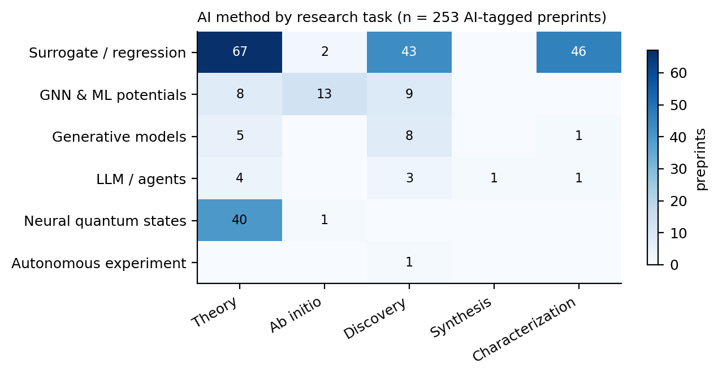
Figure 4: AI-method usage by mode of inquiry across the working corpus. Synthesis carries a single record.

Predicting $T_{c}$, and what the screening pipelines actually deliver
The oldest and densest thread predicts $T_{c}$ from composition or structure. Its anchors predate this survey’s window: a composition-based classifier and regressor trained on the SuperCon database (Stanev et al. 2018), and a widely reused statistical model built on chemical-formula features (Hamidieh 2018). Both are honest about scope. The latter predicts a transition temperature only for materials already known to superconduct, which is a different problem from finding new ones.
Within the window, the productive form of this thread is not the regressor alone but the regressor used as a filter in front of density-functional perturbation theory. The clearest example screens roughly 200,000 metallic compounds on or near the convex hull with a model trained on about 7,000 electron-phonon calculations, validates the survivors with first-principles calculations, and reports 545 compounds with $T_{c}$ above 10 K (Cerqueira et al. 2023). The same group applied the workflow to ambient- pressure hydrides in a set of more than 150,000 compounds, finding around 50 systems above 20 K, and reported that most of them sit slightly off the convex hull, so synthesis would need conditions away from ambient equilibrium (Cerqueira et al. 2024). A companion study screened over a million compounds and proposed the thermodynamically stable Mg$​_{2}$XH$​_{6}$ family, with X = Rh, Ir, Pd or Pt, at 45-80 K and above 100 K with electron doping of the platinum compound (Sanna et al. 2023). A deep-learning framework explored about 36 million ternary hydride structures across 29 elements and identified 144 candidates above 200 K at 200 GPa, 129 of them new (X. Wang et al. 2025).
These are substantial results, and they are all predictions in this survey’s sense. None of the four papers reports a synthesised, measured superconductor. What the machine learning buys is the ratio of candidates examined to calculations run: the model is a cheap surrogate that lets an expensive but trusted method be pointed somewhere useful. That is a real contribution, and it is a narrower one than “AI discovers superconductors” suggests.

Generative and language-model approaches
Generative models entered the field along the path they took in materials science generally. An inverse-design workflow combining pre-trained models, diffusion and first-principles calculation reported 74 dynamically stable materials with model-predicted $T_{c}$ at or above 15 K, singling out B$​_{4}$CN$​_{3}$ at 24.08 K under 5 GPa and B$​_{5}$CN$​_{2}$ at 15.93 K at ambient pressure (Han et al. 2024). The same engine later proposed cubic Li$​_{2}$AuH$​_{6}$, with a calculated ambient-pressure $T_{c}$ near 140 K and a suggested synthesis route from LiAu and LiH (Ouyang et al. 2025). Again: calculated, not measured.
Language models arrived more recently and in two distinct roles. The first is extraction. A language-model workflow built an experimental database of 78,203 records covering 19,058 unique compositions from the literature, then fine-tuned open-source models to classify superconductors, predict $T_{c}$, and generate compositions conditioned on a target $T_{c}$ (Itani et al. 2025). The fine-tuned models performed comparably to feature-based baselines and sometimes better; 28% of the generated compositions were novel; applying the predictors to the GNoME database (Merchant et al. 2023) surfaced unreported candidates above 10 K. The authors label these candidates unverified, which is the correct description and a rarer one than it should be.
The second role is orchestration. An agentic framework couples a billion-parameter atomic model for numerical work to language models for planning, rediscovers 66 experimentally verified superconductors absent from the SuperCon3D database, and screens 2.4 million equilibrium crystals in 28 GPU hours (Li et al. 2026). It then does the thing the rest of this literature does not: four proposed compounds were synthesised and measured – Zr$​_{3}$ScRe$​_{8}$ at $T_{c}$ = 6.5 K, HfZrRe$​_{4}$ at 5.9 K, Zr$​_{4}$VRe$​_{7}$ at 3.5 K, and Hf$​_{21}$Re$​_{25}$ at 2.5 K. These transition temperatures are low, and that is the point worth holding onto. The one clearly closed loop in the recent literature closed on compounds an order of magnitude below the temperatures the screening papers advertise.
The earlier closed-loop demonstration is worth reading alongside it. Four cycles of prediction, experimental test and retraining more than doubled the success rate of superconductor discovery, found a new superconductor in the Zr-In-Ni system, and recovered five superconductors absent from the training data (Pogue et al. 2022). Its lesson is about feedback rather than about model class.

Neural quantum states and the theory side
The largest AI-tagged mode in the corpus is theory, and within it neural quantum states are the most self-contained thread. Building on the demonstration that neural networks can represent many-body wavefunctions (Carleo and Troyer 2017), recent work has pushed the ansatz toward the models superconductivity actually cares about: the two-dimensional $t$-$J$ model at finite doping (Lange et al. 2024), the $t$-$t^{′}$ Hubbard model with symmetry-preserving architectures (Rende et al. 2026), and the Hofstadter-Hubbard model at scale (Roth et al. 2026). This thread is unusual in the survey because its validation is internal: a variational energy can be compared against other methods without anyone growing a crystal. That is precisely why it moves faster than the rest.

Characterization: the quiet, working case
Characterization is where machine learning is least discussed and most routinely useful. The pattern is a model that turns an instrument’s raw output into a physical quantity: unsupervised learning of nematicity from scanning-tunnelling data on magic-angle bilayer graphene (Taranto et al. 2022), convolutional networks detecting charge jumps in superconducting qubits in real time (Gaytan-Villarreal et al. 2026), and machine-learned qubit readout deployed on FPGAs for mid-circuit measurement (Vora et al. 2024; Otting et al. 2026). These papers rarely present themselves as AI-for-science. They are instrument engineering, they are validated against a ground truth the instrument already provides, and they work.

The critical literature
Three strands of criticism bear directly on how the results above should be read, and a survey that omitted them would misrepresent the field.
The first is about what a computational “discovery” is worth. A perspective on the GNoME result argued that scaled-up stability prediction had not been shown to yield the compounds an experimentalist would call new, and questioned how many of the predicted structures are meaningfully distinct (Cheetham and Seshadri 2024). The second concerns autonomous synthesis: an analysis of the A-Lab result (Szymanski et al. 2023) disputed the claim of autonomously discovered novel materials, arguing that the automated phase identification did not support the conclusions drawn from it (Leeman et al. 2024). Neither critique says the programme is worthless. Both say the validation step is where the difficulty lives, which is the same thing this survey’s corpus says about superconductivity specifically.
The third strand is superconductivity’s own reproducibility record, and it is unusually harsh. Two prominent claims in this field’s recent history were retracted: room-temperature superconductivity in carbonaceous sulfur hydride (Snider et al. 2020) and near-ambient superconductivity in nitrogen-doped lutetium hydride (Dasenbrock-Gammon et al. 2023). The LK-99 episode (Lee, J.-H. Kim, et al. 2023) generated a burst of replication attempts visible as a spike in this corpus’s 2023Q3 activity. On the theoretical side, first-principles work found no stable near-ambient phase in the Lu-N-H system capable of supporting high-$T_{c}$ superconductivity, while identifying metastable templates at higher pressure (Fang et al. 2023). The relevant point for this survey is structural: a field whose flagship experimental claims have repeatedly failed replication is a field where a model’s training labels are unreliable in exactly the high-$T_{c}$ region where the predictions matter most.

Assessment
Machine learning in superconductivity is currently a way of making expensive calculations cheaper and instrument data more usable. It has not yet become a way of finding superconductors. The evidence for that reading is the shape of the corpus rather than any single paper: 1.2% penetration in the systematic seed, one AI-tagged synthesis paper, and exactly one recent closed loop – delivering compounds at 2.5 to 6.5 K while the screening literature advertises predictions above 200 K. The next section asks, cell by cell, what would have to change.

An AI-readiness assessment

What is being scored, and what it is not
Section 5 described what has happened. This section asks what could. For each cell of the taxonomy that the survey discusses, Figure 5 scores three properties on a 0-3 scale and names the constraint that currently binds.
Data availability asks whether enough machine-readable, labelled data exists to train or evaluate a model. Benchmark maturity asks whether a shared task with an agreed metric and a held-out set exists, so that two methods can be compared without re-running each other’s pipelines. Cheap validation asks what it costs to find out whether a prediction was right – a score of 3 means a calculation settles it, a 0 means a hard experiment is required. The binding bottleneck names which of data, compute, theory or experiment is the constraint that would have to move first.
These scores are the author’s judgement, not measurements, and they should be read as a structured argument rather than as data. They are stated on a coarse scale precisely because a finer one would imply a precision that is not there. The corpus counts inform them but do not determine them: a cell can be crowded and unready, and Section 7 argues that several are.
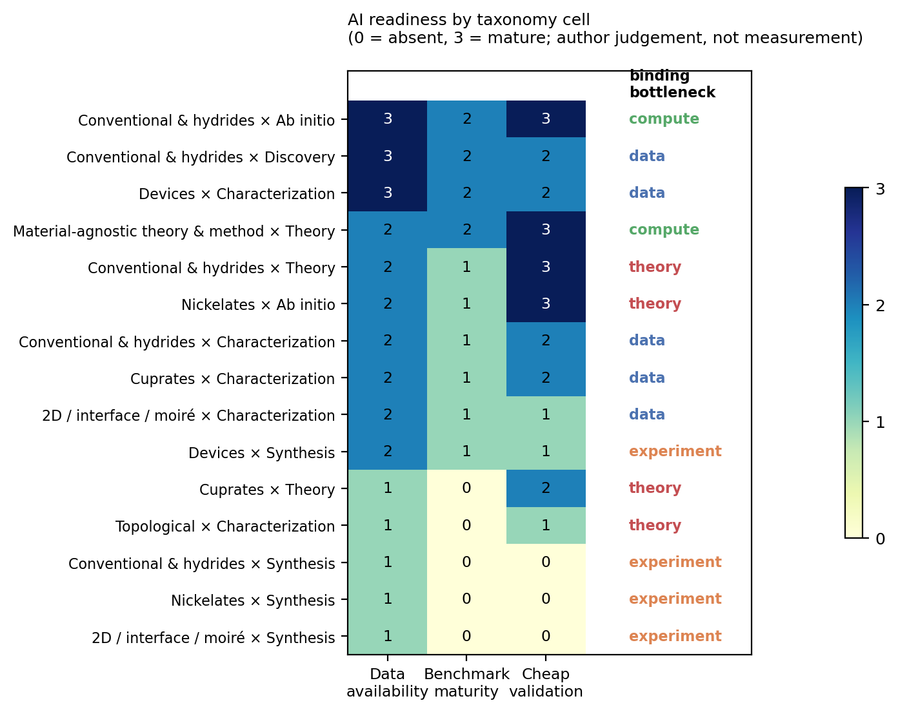
Figure 5: AI readiness by taxonomy cell. Scores are the author’s judgement on a 0-3 scale, not measurements; the appendix states the reasoning for each cell.

The three regimes
Read down Figure 5 and the cells sort into three groups.
Cheap-validation cells, where progress is fastest and already visible. Conventional and hydride ab initio work scores highest: the data exists in the form of hundreds of thousands of electron-phonon calculations, an accepted target quantity exists in the Eliashberg $T_{c}$, and a prediction can be checked by running the calculation the model was trained to approximate. Material-agnostic theory sits alongside it: a neural quantum state’s variational energy is checkable against other methods on the same Hamiltonian. Both cells are compute-limited rather than data-limited, and both are where the corpus already shows the most AI activity. This is not a coincidence, and it is the single strongest regularity in the survey: machine learning has penetrated exactly those cells where a machine can grade its own homework.
Data-limited cells, where the obstacle is that measurements are not in a usable form. Characterization across cuprates, hydrides, two-dimensional systems and devices falls here. The raw material is abundant – decades of ARPES, scanning tunnelling, transport and neutron data – but it lives in figures inside PDFs, in per-group formats, and in supplementary files without schemas. The one recent large-scale attempt to fix this for superconductivity extracted 78,203 records with a language-model workflow (Itani et al. 2025), which is both an encouraging result and a measure of how absent such resources were. Device characterization scores best in this group because qubit and detector metrology already produces standardised, high-volume, machine-generated data, which is why the working applications in Section 5 cluster there.
Experiment-limited cells, where nothing else is the bottleneck. Every synthesis cell scores 1, 0, 0. There is no shared dataset of attempted syntheses with their outcomes, no benchmark, and validation requires making the material. The corpus carries the corresponding signature: one AI-tagged synthesis paper in 10,249 records. This is where the general AI-for-materials programme has invested most visibly, in autonomous laboratories (Szymanski et al. 2023), and where the criticism has been sharpest (Leeman et al. 2024). Superconductivity makes the problem harder than the oxide-powder case those systems target: nickelate films require topotactic reduction, hydrides require diamond anvil cells at hundreds of gigapascals, and moiré devices require stacking with angular precision. None of these is a pipetting robot’s problem.

Where the theory bottleneck sits
Two cells are labelled theory-limited, and the label means something specific: additional data would not help, because there is no target quantity a model could learn to predict. Cuprate theory is the canonical case. Four decades of data have not produced an agreed mechanism, so there is no equivalent of the Eliashberg function to regress against. Nickelate ab initio work has the opposite problem in the same family: the calculations are tractable and increasingly standard, but which calculated quantity predicts $T_{c}$ in a multi-orbital correlated system is exactly what is unsettled.
Machine learning can still contribute in these cells, and the corpus shows how: not by predicting $T_{c}$ but by solving the models themselves. Neural quantum states applied to the $t$-$J$ and Hubbard models (Lange et al. 2024; Rende et al. 2026) address the theory bottleneck directly, because the obstacle there is the cost of solving a well-posed problem rather than the absence of a label.

What the ranking implies
Ordering the cells by summed score produces a priority list, and it is not the list the field’s activity implies. The highest-scoring opportunities are ab initio screening, device characterization and material-agnostic theory – two of which are barely discussed in the machine-learning-for-superconductors literature, which concentrates instead on composition-to-$T_{c}$ regression. The lowest-scoring are the synthesis cells, which is where AI-for-materials rhetoric concentrates most heavily.
Three consequences follow, and each is a claim that could be checked rather than a prediction we are confident in.
Characterization inversion is the most under-exploited opportunity. Spectroscopic and microscopy data is abundant, the mapping from spectrum to physical parameter is well-posed, and validation is cheap because independent measurements of the same sample exist. What is missing is not method but infrastructure: standardised, openly-released, labelled spectra. This is a dataset problem that a coordinated effort could solve in a way that no amount of model development will.
Synthesis will not yield to autonomous laboratories in this field on the current design. The binding constraint is that superconductivity’s important syntheses are extreme-condition and low-throughput. The tractable version of the problem is narrower and more useful: predicting whether a computationally proposed compound can be made at all. The screening literature already generates this need – one study noted that most of its promising ambient-pressure hydrides sit slightly off the convex hull (Cerqueira et al. 2024) – and a synthesizability model trained on attempted syntheses, including the failures, would be worth more to that pipeline than another increment of $T_{c}$-regression accuracy.
The field needs a held-out benchmark with experimental resolution. No cell in Figure 5 scores 3 on benchmark maturity. The screening papers cannot be compared against each other, because each reports its own candidate list validated by its own calculations. A benchmark built from post-2024 experimentally confirmed superconductors, with predictions time-stamped before confirmation, would separate methods that generalise from methods that interpolate their training set. The retraction record (Snider et al. 2020; Dasenbrock-Gammon et al. 2023) makes the label quality problem acute, and therefore makes the benchmark more valuable, not less.

Assessment
The pattern across Figure 5 is that AI adoption in this field tracks validation cost far more closely than it tracks either data volume or scientific importance. Where a calculation can check a prediction, methods have arrived. Where an experiment is needed, they have not, regardless of how much has been written about the cell. If that reading is right, the highest-leverage interventions are the unglamorous ones: release labelled characterization data, build a time-stamped benchmark, and model synthesizability rather than synthesis.

Discussion

Reading the corpus’s own shape
Before interpreting any proportion in this survey, three sampling facts have to be stated, because each of them shapes the numbers.
First, the seed is a category harvest, not a topic harvest. A paper appears because its authors chose cond-mat.supr-con, so the corpus measures what the community files under superconductivity, which is not identical to what is about superconductivity. The measured off-topic rate within the seed is 2.5%.
Second, the supplement is recency-biased by construction and is excluded from every trend statement and from Table 1’s grid.
Third, labels come from a model pass with 85.6% family and 88.4% mode agreement against a single annotator’s hand labels, and the two smallest modes – synthesis at 64% recall and discovery at 54% – are the least reliable. Any statement below that depends on those two counts is stated as a hypothesis.
With those caveats, three features of the corpus seem worth explaining.

Three hypotheses about the field’s shape
The verifiability gradient. AI methods appear in this corpus almost exactly where a prediction can be checked without an experiment. Ab initio screening, where a DFT calculation grades the model, and neural quantum states, where a variational energy does, are the two populated cells; synthesis, where only a furnace can settle the question, has one paper. The hypothesis is that adoption is governed by validation cost rather than by data volume or scientific payoff. It is testable: if it holds, the next AI methods to arrive in this field should show up in characterization inversion tasks, where an independent measurement provides the check, before they show up anywhere in synthesis.
The label-quality trap at the top of the range. A $T_{c}$ model is most valuable where $T_{c}$ is highest, and that is precisely where this field’s experimental record is least reliable – two retracted room-temperature claims (Snider et al. 2020; Dasenbrock-Gammon et al. 2023), an unreplicated ambient-pressure claim (Lee, J.-H. Kim, et al. 2023), and continuing methodological dispute about what constitutes proof under megabar pressure (Tallon 2024). The hypothesis is that supervised models in this domain inherit a systematically noisier label distribution in exactly the region they are asked to extrapolate into. This too is testable: a model trained with and without the contested high-$T_{c}$ entries should differ measurably in its top-ranked candidates.
Institutional role assignment. The AI-tagged work in this corpus is concentrated in the material-agnostic and device families rather than in the correlated-material families, and its authors are frequently from computational or machine-learning-methods groups rather than from the synthesis and spectroscopy groups whose data the methods would need. The hypothesis is that the field’s AI adoption is limited less by method availability than by the absence of overlap between the people who hold the data and the people who build the models. The prediction is that the fastest progress will come from instrument groups adopting methods internally – which is what the qubit-readout literature already looks like – rather than from methods groups acquiring physics data.
None of these is established by this survey. They are the explanations most consistent with the corpus’s shape, offered so that they can be argued with.

What would change the assessment
Three developments would substantially revise Section 6’s conclusions, and it is worth naming them in advance.
A public, standardised corpus of labelled characterization data – ARPES cuts, STM maps, diffraction patterns with acquisition metadata – would move several cells from data-limited to method-limited in one step, and would be the single highest-value intervention identified here.
A registry of attempted syntheses including failures would make synthesizability prediction trainable, which is the tractable form of the synthesis problem.
A time-stamped benchmark of experimentally confirmed superconductors, with model predictions recorded before confirmation, would let the screening literature be compared rather than merely accumulated. Its absence is why no cell in Figure 5 scores 3 on benchmark maturity.

Limitations of this survey
The corpus is arXiv-only and therefore under-represents applied superconductivity published through IEEE venues and industrial device work that is never posted. The window opens in September 2021, so pre-window developments enter only through hand-verified anchor citations. Labels are single-valued where the underlying reality is often multi-valued. The AI-readiness scores in Figure 5 are the author’s judgement on a coarse scale, informed by the corpus but not derived from it, and the appendix states the reasoning for each cell so that individual scores can be contested. All hand labels were produced by one annotator, so the agreement figures quoted throughout measure consistency between one human pass and one model pass, not accuracy against an external standard.

Conclusion
This survey mapped five years of superconductivity research – 10,249 arXiv preprints after off-topic filtering – onto two axes, material family and mode of inquiry, and then asked of each cell what a machine-learning method could contribute there.
The mapping produced three findings. Machine learning has barely entered this field: 1.2% of the systematically harvested seed uses an AI method in its own work. Where it has entered, it clusters where predictions can be checked by calculation rather than by experiment – ab initio screening and neural quantum states – and in device metrology, where instruments generate their own labelled data. And the field’s actual bottleneck, synthesis, is the cell with the least usable data and the fewest methods: one AI-tagged paper in the entire corpus.
The gap between what the screening literature predicts and what has been made and measured is the survey’s most concrete result. Recent screens report candidates above 200 K; the one clearly closed prediction-synthesis-measurement loop in the recent literature delivered superconductors between 2.5 and 6.5 K (Li et al. 2026). Both facts are real, and holding them together is the correct posture toward AI for superconductivity.
For anyone deciding where to apply AI for Science effort in this field, the ranking that follows from Figure 5 is: release labelled characterization data and build inversion models against it; construct a time-stamped benchmark so screening methods can be compared; and model synthesizability rather than attempting to automate synthesis. These are less exciting than inverse-designing a room-temperature superconductor, and they are what the structure of the field currently supports.

Data availability
The corpus, labels, prompts, hand-labelled validation sets and all scripts are released with this manuscript. The archive contains the frozen seed harvest (sc_seed.csv), the canonical labelled corpus (sc_corpus_v1.csv), the raw per-month arXiv responses that reproduce the harvest, the language-model label cache (llm_labels.jsonl), the two hand-labelled validation sets (label_truth.csv, ai_label_truth.csv), and the harvesting, labelling, figure and build scripts. Bibliography entries for corpus papers are generated from the corpus; anchor references outside the harvest window are hand-verified against Crossref and kept separately.

Appendix: reasoning behind the AI-readiness scores
Figure 5 scores each discussed cell on data availability, benchmark maturity and cheap validation, on a 0-3 scale, and names the binding bottleneck. The scores are the author’s judgement. This appendix states the reasoning so that individual cells can be contested; the scoring table itself is in build_concept_figures.py, so a reader who disagrees can change a row and regenerate the figure.
Cell | Reasoning
Conventional × ab initio | Data 3: hundreds of thousands of electron-phonon calculations exist, ~7,000 of them assembled as a single training set (Cerqueira et al. 2023). Benchmark 2: the Eliashberg $T_{c}$ is an accepted target, but no shared held-out set. Validation 3: a DFPT calculation settles it. Bottleneck compute.
Conventional × discovery | Data 3 for composition-$T_{c}$ pairs. Benchmark 2. Validation 2: cheap computationally, expensive experimentally, and the screening literature stops at the computational step. Bottleneck data, specifically the absence of negative results and of verified high-$T_{c}$ labels.
Conventional × synthesis | Data 1: recipes in prose, successes only. Benchmark 0. Validation 0: diamond anvil cell at megabar pressures. Bottleneck experiment.
Conventional × characterization | Data 2, benchmark 1, validation 2. High-pressure measurement is hard but the quantities are conventional. Bottleneck data.
Conventional × theory | Data 2, benchmark 1, validation 3: Migdal-Eliashberg is a well-posed calculation. Bottleneck theory, in the narrow sense that anharmonicity and quantum ionic effects are where the physics is unsettled.
Cuprate × theory | Data 1, benchmark 0, validation 2. Four decades of data with no agreed target quantity to regress against. Bottleneck theory.
Cuprate × characterization | Data 2: abundant spectra, almost none machine-readable. Benchmark 1, validation 2. Bottleneck data.
Nickelate × ab initio | Data 2, benchmark 1, validation 3: the calculations are tractable and increasingly standard. Bottleneck theory: which computed quantity predicts $T_{c}$ in a multi-orbital correlated system is exactly what is unsettled.
Nickelate × synthesis | Data 1, benchmark 0, validation 0. Topotactic reduction and strained epitaxy, with oxygen stoichiometry as the decisive and poorly recorded variable (Zhou et al. 2023). Bottleneck experiment.
2D / interface × characterization | Data 2: gate-tunable transport is parameterised and dense. Benchmark 1. Validation 1: each stack is unique, so re-measurement is not free. Bottleneck data.
2D / interface × synthesis | Data 1, benchmark 0, validation 0. Mechanical stacking with angular precision. Bottleneck experiment.
Topological × characterization | Data 1, benchmark 0, validation 1. The disagreement is about what a measurement means, so a label is not well defined. Bottleneck theory.
Device × characterization | Data 3: qubit and detector metrology is machine-generated, standardised and high-volume. Benchmark 2. Validation 2. Bottleneck data, and the highest-scoring measurement cell in the survey.
Device × synthesis | Data 2: fabrication process data exists in industrial settings, mostly unpublished. Benchmark 1, validation 1. Bottleneck experiment.
Material-agnostic × theory | Data 2, benchmark 2, validation 3: a variational energy is comparable against other methods on the same Hamiltonian. Bottleneck compute.
Aasen, David, Morteza Aghaee, Zulfi Alam, et al. 2025. Roadmap to Fault Tolerant Quantum Computation Using Topological Qubit Arrays. https://arxiv.org/abs/2502.12252.
Adiga, Suhas, and Umesh V. Waghmare. 2025. “Accelerating the Search for Superconductors Using Machine Learning.” Comput. Mater. Sci., 263, 114453 (2026), ahead of print. https://doi.org/10.1016/j.commatsci.2025.114453.
Ajeesh, M. O., M. Bordelon, C. Girod, et al. 2023. The Fate of Time-Reversal Symmetry Breaking in UTe2. https://arxiv.org/abs/2305.00589.
Anthony-Petersen, Robin, Andreas Biekert, Raymond Bunker, et al. 2022. “A Stress Induced Source of Phonon Bursts and Quasiparticle Poisoning.” Nat. Commun. 15, 6444 (2024), ahead of print. https://doi.org/10.48550/arxiv.2208.02790.
Bardeen, J., L. N. Cooper, and J. R. Schrieffer. 1957. “Theory of Superconductivity.” Physical Review 108: 1175–204. https://doi.org/10.1103/PhysRev.108.1175.
Bärtl, Florian, Nadia Stegani, Federico Caglieris, et al. 2025. Evidence of Pseudogap and Absence of Spin Magnetism in the Time-Reversal-Symmetry-Breaking State of Ba$_1-x$k$_x$fe$_2$as$_2$. https://arxiv.org/abs/2501.11936.
Bednorz, J. G., and K. A. Müller. 1986. “Possible High $T_{c}$ Superconductivity in the Ba-La-Cu-O System.” Zeitschrift Für Physik B Condensed Matter 64: 189–93. https://doi.org/10.1007/BF01303701.
Bordin, Alberto, Xiang Li, David van Driel, et al. 2023. “Crossed Andreev Reflection and Elastic Co-Tunneling in a Three-Site Kitaev Chain Nanowire Device.” Physical Review Letters 132, 056602 (2024), ahead of print. https://doi.org/10.48550/arxiv.2306.07696.
Cai, Weizhao, Vasily S. Minkov, Ying Sun, et al. 2023. Superconductivity Above 180 k in Ca-Mg Ternary Superhydrides at Megabar Pressures. https://arxiv.org/abs/2312.06090.
Cao, Yuan, Valla Fatemi, Shiang Fang, et al. 2018. “Unconventional Superconductivity in Magic-Angle Graphene Superlattices.” Nature 556: 43–50. https://doi.org/10.1038/nature26160.
Cao, Zi-Yu, Seokmin Choi, Liu-Cheng Chen, et al. 2024. Probing Superconducting Gap in CeH$_9$ Under Pressure. https://arxiv.org/abs/2401.12682.
Carleo, Giuseppe, and Matthias Troyer. 2017. “Solving the Quantum Many-Body Problem with Artificial Neural Networks.” Science 355: 602–6. https://doi.org/10.1126/science.aag2302.
Cerqueira, Tiago F. T., Yue-Wen Fang, Ion Errea, Antonio Sanna, and Miguel A. L. Marques. 2024. Searching Materials Space for Hydride Superconductors at Ambient Pressure. https://arxiv.org/abs/2403.13496.
Cerqueira, Tiago F. T., Antonio Sanna, and Miguel A. L. Marques. 2023. Sampling the Whole Materials Space for Conventional Superconducting Materials. https://arxiv.org/abs/2307.10728.
Cheetham, Anthony K., and Ram Seshadri. 2024. “Artificial Intelligence Driving Materials Discovery? Perspective on the Article: Scaling Deep Learning for Materials Discovery.” Chemistry of Materials 36: 3490–95. https://doi.org/10.1021/acs.chemmater.4c00643.
Corbae, Elena, Rong Zhang, Cong Li, et al. 2025. Hund’s Coupling Assisted Orbital-Selective Superconductivity in Ba1-xKxFe2As2. https://arxiv.org/abs/2510.06435.
Dangić, ore, Peio Garcia-Goiricelaya, Yue-Wen Fang, Julen Ibañez-Azpiroz, and Ion Errea. 2023. Ab Initio Study of the Structural, Vibrational and Optical Properties of Potential Parent Structures of Nitrogen-Doped Lutetium Hydride. https://arxiv.org/abs/2305.06751.
Dasenbrock-Gammon, Nathan, Elliot Snider, Raymond McBride, et al. 2023. “Evidence of Near-Ambient Superconductivity in a N-Doped Lutetium Hydride.” Nature 615: 244–50. https://doi.org/10.1038/s41586-023-05742-0.
Deng, Hao, Zhijun Song, Ran Gao, et al. 2022. Titanium Nitride Film on Sapphire Substrate with Low Dielectric Loss for Superconducting Qubits. https://arxiv.org/abs/2205.03528.
Drimmer, Maxwell, Sjoerd Telkamp, Felix L. Fischer, et al. 2024. The Effect of Niobium Thin Film Structure on Losses in Superconducting Circuits. https://arxiv.org/abs/2403.12164.
Drozdov, A. P., M. I. Eremets, I. A. Troyan, V. Ksenofontov, and S. I. Shylin. 2015. “Conventional Superconductivity at 203 Kelvin at High Pressures in the Sulfur Hydride System.” Nature 525: 73–76. https://doi.org/10.1038/nature14964.
Drozdov, A. P., P. P. Kong, V. S. Minkov, et al. 2019. “Superconductivity at 250 K in Lanthanum Hydride Under High Pressures.” Nature 569: 528–31. https://doi.org/10.1038/s41586-019-1201-8.
Dvir, Tom, Guanzhong Wang, Nick van Loo, et al. 2022. “Realization of a Minimal Kitaev Chain in Coupled Quantum Dots.” Nature 614, 445-459 (2023), ahead of print. https://doi.org/10.48550/arxiv.2206.08045.
Fang, Yue-Wen, ore Dangić, and Ion Errea. 2023. “Assessing the Feasibility of Near-Ambient Conditions Superconductivity in the Lu-n-h System.” Communications Materials 5, 61 (2024), ahead of print. https://doi.org/10.48550/arxiv.2307.10699.
Gashmard, H., H. Shakeripour, and M. Alaei. 2025. AI-Driven Discovery of High-Temperature Superconductors via Materials Genome Initiative and High-Throughput Screening. https://arxiv.org/abs/2511.03865.
Gaytan-Villarreal, Daniel, Peter Meiring, Daniel Baxter, et al. 2026. Real-Time Detection of Charge Jumps in Superconducting Qubits with a Convolutional Neural Network. https://arxiv.org/abs/2607.14293.
Ge, Jun, Pinyuan Wang, Ying Xing, et al. 2022. “Charge-4e and Charge-6e Flux Quantization and Higher Charge Superconductivity in Kagome Superconductor Ring Devices.” Physical Review X 14, 021025 (2024), ahead of print. https://doi.org/10.48550/arxiv.2201.10352.
Griffin, Sinéad M. 2023. Origin of Correlated Isolated Flat Bands in Copper-Substituted Lead Phosphate Apatite. https://arxiv.org/abs/2307.16892.
Gu, Yuhao, Congcong Le, Zhesen Yang, Xianxin Wu, and Jiangping Hu. 2023. “Effective Model and Pairing Tendency in Bilayer Ni-Based Superconductor La$_3$ni$_2$o$_7$.” Phys. Rev. B 111, 174506 (2025), ahead of print. https://doi.org/10.48550/arxiv.2306.07275.
Hamidieh, Kam. 2018. “A Data-Driven Statistical Model for Predicting the Critical Temperature of a Superconductor.” Computational Materials Science 154: 346–54. https://doi.org/10.1016/j.commatsci.2018.07.052.
Han, Xiao-Qi, Zhenfeng Ouyang, Peng-Jie Guo, Hao Sun, Ze-Feng Gao, and Zhong-Yi Lu. 2024. “InvDesFlow: An AI-Driven Materials Inverse Design Workflow to Explore Possible High-Temperature Superconductors.” Chin. Phys. Lett. 2025,42(4): 047301, ahead of print. https://doi.org/10.48550/arxiv.2409.08065.
Holleis, Ludwig, Caitlin L. Patterson, Yiran Zhang, et al. 2023. Nematicity and Orbital Depairing in Superconducting Bernal Bilayer Graphene with Strong Spin Orbit Coupling. https://arxiv.org/abs/2303.00742.
Hou, Zhiyong, Zhiyuan Shang, Wen Duan, Wei Xie, Huan Yang, and Hai-Hu Wen. 2025. Distinct Modulation Behavior of Superconducting Coherence Peaks Associated with Sign-Reversal Gaps in FeTe$_0.55$se$_0.45$. https://arxiv.org/abs/2512.01703.
Hu, Yong, Xianxin Wu, Brenden R. Ortiz, et al. 2022. “Coexistence of Tri-Hexagonal and Star-of-David Pattern in the Charge Density Wave of the Kagome Superconductor AV$_3$sb$_5$.” Physical Review B 106, L241106 (2022), ahead of print. https://doi.org/10.48550/arxiv.2201.06477.
Iguchi, Yusuke, Ruby Shi, Kunihiro Kihou, et al. 2023. “Observation of Superconducting Vortices Carrying a Temperature-Dependent Fraction of the Flux Quantum.” Science 0,eabp9979 (2023), ahead of print. https://doi.org/10.48550/arxiv.2301.12368.
Itani, Suman, Yibo Zhang, Ranjit Itani, and Jiadong Zang. 2025. Large Language Models for Superconductor Discovery. https://arxiv.org/abs/2512.10847.
Jiang, Kun, Tao Wu, Jia-Xin Yin, et al. 2021. “Kagome Superconductors AV$_3$sb$_5$ (a=k, Rb, Cs).” National Science Review 10: Nwac199 (2023), ahead of print. https://doi.org/10.48550/arxiv.2109.10809.
Kamihara, Yoichi, Takumi Watanabe, Masahiro Hirano, and Hideo Hosono. 2008. “Iron-Based Layered Superconductor La[O$​_{1−x}$F$​_{x}$]FeAs ($x=0.05$–$0.12$) with $T_{c}$ = 26 K.” Journal of the American Chemical Society 130: 3296–97. https://doi.org/10.1021/ja800073m.
Kang, Mingu, Shiang Fang, Jonggyu Yoo, et al. 2022. “Charge Order Landscape and Competition with Superconductivity in Kagome Metals.” Nature Materials (2022), ahead of print. https://doi.org/10.48550/arxiv.2202.01902.
Kochan, Denis, Andreas Costa, Iaroslav Zhumagulov, and Igor Žutić. 2023. Phenomenological Theory of the Supercurrent Diode Effect: The Lifshitz Invariant. https://arxiv.org/abs/2303.11975.
Lange, Hannah, Annika Böhler, Christopher Roth, and Annabelle Bohrdt. 2024. Simulating the Two-Dimensional $t-j$ Model at Finite Doping with Neural Quantum States. https://arxiv.org/abs/2411.10430.
Lau, Liam L. H., and Piers Coleman. 2023. “Topological Mixed Valence Model for Twisted Bilayer Graphene.” Phys. Rev. X 15, 021028 (2025), ahead of print. https://doi.org/10.48550/arxiv.2303.02670.
Lee, Sukbae, Jihoon Kim, Hyun-Tak Kim, Sungyeon Im, SooMin An, and Keun Ho Auh. 2023. Superconductor Pb$_10-x$cu$_x$(PO$_4$)$_6$o Showing Levitation at Room Temperature and Atmospheric Pressure and Mechanism. https://arxiv.org/abs/2307.12037.
Lee, Sukbae, Ji-Hoon Kim, and Young-Wan Kwon. 2023. The First Room-Temperature Ambient-Pressure Superconductor. https://arxiv.org/abs/2307.12008.
Leeman, Josh, Yuhan Liu, Joseph Stiles, et al. 2024. “Challenges in High-Throughput Inorganic Materials Prediction and Autonomous Synthesis.” PRX Energy 3: 011002. https://doi.org/10.1103/PRXEnergy.3.011002.
Li, Danfeng, Kyuho Lee, Bai Yang Wang, et al. 2019. “Superconductivity in an Infinite-Layer Nickelate.” Nature 572: 624–27. https://doi.org/10.1038/s41586-019-1496-5.
Li, Feiyu, Zhenfang Xing, Di Peng, et al. 2025. “Bulk Superconductivity up to 96 k in Pressurized Nickelate Single Crystals.” Nature 649, 871-878 (2026), ahead of print. https://doi.org/10.48550/arxiv.2501.14584.
Li, Mingze, Yu Rong, Songyou Li, et al. 2026. Agentic Fusion of Large Atomic and Language Models to Accelerate Superconductor Discovery. https://arxiv.org/abs/2604.23758.
Lotfizadeh, Neda, William F. Schiela, Barış Pekerten, et al. 2023. “Superconducting Diode Effect Sign Change in Epitaxial Al-InAs Josepshon Junctions.” Communications Physics Volume 7, Article Number: 120 (2024), ahead of print. https://doi.org/10.48550/arxiv.2303.01902.
Luo, Zhihui, Xunwu Hu, Meng Wang, Wéi Wú, and Dao-Xin Yao. 2023. “Bilayer Two-Orbital Model of La$_3$ni$_2$o$_7$ Under Pressure.” PubMed, ahead of print. https://doi.org/10.48550/arxiv.2305.15564.
Mazin, Igor I. 2022. “Notes on Altermagnetism and Superconductivity.” AAPPS Bull. 35, 18 (2025), ahead of print. https://doi.org/10.48550/arxiv.2203.05000.
Mazur, G. P., N. van Loo, D. van Driel, et al. 2022. The Gate-Tunable Josephson Diode. https://arxiv.org/abs/2211.14283.
Merchant, Amil, Simon Batzner, Samuel S. Schoenholz, Muratahan Aykol, Gowoon Cheon, and Ekin Dogus Cubuk. 2023. “Scaling Deep Learning for Materials Discovery.” Nature 624: 80–85. https://doi.org/10.1038/s41586-023-06735-9.
Mohseni, Masoud, Artur Scherer, K. Grace Johnson, et al. 2024. How to Build a Quantum Supercomputer: Scaling from Hundreds to Millions of Qubits. https://arxiv.org/abs/2411.10406.
Nadeem, Muhammad, Michael S. Fuhrer, and Xiaolin Wang. 2023. Superconducting Diode Effect – Fundamental Concepts, Material Aspects, and Device Prospects. https://arxiv.org/abs/2301.13564.
Otting, Luca, Xiaorang Guo, Emmanouil Giortamis, Benjamin Lienhard, Pramod Bhatotia, and Martin Schulz. 2026. Multi-Stage Mamba-Based Architecture for Fast and Scalable Superconducting Qubit Readout. https://arxiv.org/abs/2607.11668.
Ouyang, Zhenfeng, Bo-Wen Yao, Xiao-Qi Han, Peng-Jie Guo, Ze-Feng Gao, and Zhong-Yi Lu. 2025. “High-Temperature Superconductivity in Li$_2$AuH$_6$ Mediated by Strong Electron-Phonon Coupling Under Ambient Pressure.” Phys. Rev. B 111, L140501, 2025, ahead of print. https://doi.org/10.48550/arxiv.2501.12222.
Peng, Shuting, Yulei Han, Yongkai Li, et al. 2024. “Flat Bands and Distinct Density Wave Orders in Correlated Kagome Superconductor CsCr$_3$sb$_5$.” Sci. China Phys. Mech. Astron. 69, 217412 (2026), ahead of print. https://doi.org/10.48550/arxiv.2406.17769.
Pogue, Elizabeth A., Alexander New, Kyle McElroy, et al. 2022. Closed-Loop Machine Learning for Discovery of Novel Superconductors. https://arxiv.org/abs/2212.11855.
Puphal, P., M. Y. P. Akbar, M. Hepting, et al. 2023. Single Crystal Synthesis, Structure, and Magnetism of Pb$_10-x$cu$_x$(PO$_4$)$_6$o. https://arxiv.org/abs/2308.06256.
Ran, Sheng, Chris Eckberg, Qing-Ping Ding, et al. 2019. “Nearly Ferromagnetic Spin-Triplet Superconductivity.” Science 365: 684–87. https://doi.org/10.1126/science.aav8645.
Rende, Riccardo, Luciano Loris Viteritti, and Antoine Georges. 2026. Superconductivity in the $t$-$t’$ Hubbard Model from Symmetry-Preserving Neural-Network Quantum States. https://arxiv.org/abs/2608.12465.
Roth, Christopher, Andrew Millis, and Tomohiro Soejima. 2026. Large Scale Neural Quantum States Reveal the Interplay Between Superconductivity and Quantum Criticality in the Hofstadter-Hubbard Model. https://arxiv.org/abs/2608.02753.
Sakakibara, Hirofumi, Naoya Kitamine, Masayuki Ochi, and Kazuhiko Kuroki. 2023. “Possible High $t_c$ Superconductivity in La$_3$ni$_2$o$_7$ Under High Pressure Through Manifestation of a Nearly-Half-Filled Bilayer Hubbard Model.” Phys. Rev. Lett. 132, 106002 (2024), ahead of print. https://doi.org/10.48550/arxiv.2306.06039.
Salke, Nilesh P., Alexander C. Mark, Muhtar Ahart, and Russell J. Hemley. 2023. Evidence for Near Ambient Superconductivity in the Lu-n-h System. https://arxiv.org/abs/2306.06301.
Sánchez, Jazmín Aragón, Raúl Cortés Maldonado, María Lourdes Amigó, Gladys Nieva, Alejandro Kolton, and Yanina Fasano. 2023. Disordered Hyperuniform Vortex Matter with Rhombic Distortions in FeSe at Low Fields. https://arxiv.org/abs/2303.00846.
Sanna, Antonio, Tiago F. T. Cerqueira, Yue-Wen Fang, Ion Errea, Alfred Ludwig, and Miguel A. L. Marques. 2023. “Prediction of Ambient Pressure Conventional Superconductivity Above 80K in Thermodynamically Stable Hydride Compounds.” Npj Comput Mater 10, 44 (2024), ahead of print. https://doi.org/10.48550/arxiv.2310.06804.
Saykin, David R., Camron Farhang, Erik D. Kountz, et al. 2022. High Resolution Polar Kerr Effect Studies of CsV$_3$sb$_5$: Tests for Time Reversal Symmetry Breaking Below the Charge Order Transition. https://arxiv.org/abs/2209.10570.
Schrade, Constantin, Sujit Manna, and Mathias S. Scheurer. 2026. Altermagnetic Superconducting Diode Effect from Non-Collinear Compensated Magnetism in Mn$_3$pt. https://arxiv.org/abs/2601.03348.
Semenok, Dmitrii, Jianning Guo, Di Zhou, et al. 2023. Evidence for Pseudogap Phase in Cerium Superhydrides: CeH$_10$ and CeH$_9$. https://arxiv.org/abs/2307.11742.
Shen, Yang, Mingpu Qin, and Guang-Ming Zhang. 2023. “Effective Bi-Layer Model Hamiltonian and Density-Matrix Renormalization Group Study for the High-Tc Superconductivity in La$_3$ni$_2$o$_7$ Under High Pressure.” Chinese Physical Letters 40, 127401 (2023), ahead of print. https://doi.org/10.48550/arxiv.2306.07837.
Snider, Elliot, Nathan Dasenbrock-Gammon, Raymond McBride, et al. 2020. “Room-Temperature Superconductivity in a Carbonaceous Sulfur Hydride.” Nature 586: 373–77. https://doi.org/10.1038/s41586-020-2801-z.
Somayazulu, Maddury, Muhtar Ahart, Ajay K. Mishra, et al. 2019. “Evidence for Superconductivity Above 260 K in Lanthanum Superhydride at Megabar Pressures.” Physical Review Letters 122: 027001. https://doi.org/10.1103/PhysRevLett.122.027001.
Sommer, Timo, Roland Willa, Jörg Schmalian, and Pascal Friederich. 2022. 3DSC - a New Dataset of Superconductors Including Crystal Structures. https://arxiv.org/abs/2212.06071.
Song, Yinggang, Chuanheng Ma, Hongbo Wang, et al. 2025. Room-Temperature Superconductivity at 298 k in Ternary La-Sc-h System at High-Pressure Conditions. https://arxiv.org/abs/2510.01273.
Stanev, Valentin, Corey Oses, A. Gilad Kusne, et al. 2018. “Machine Learning Modeling of Superconducting Critical Temperature.” Npj Computational Materials 4: 29. https://doi.org/10.1038/s41524-018-0085-8.
Sun, Hualei, Mengwu Huo, Xunwu Hu, et al. 2023. “Signatures of Superconductivity Near 80 K in a Nickelate Under High Pressure.” Nature 621: 493–98. https://doi.org/10.1038/s41586-023-06408-7.
Szymanski, Nathan J., Bernardus Rendy, Yuxing Fei, et al. 2023. “An Autonomous Laboratory for the Accelerated Synthesis of Novel Materials.” Nature 624: 86–91. https://doi.org/10.1038/s41586-023-06734-w.
Tallon, Jeffery L. 2024. Flux-Trapping Experiments on Ultra-High Pressure Hydrides as Evidence of Superconductivity. https://arxiv.org/abs/2409.12351.
Taranto, William, Samuel Lederer, Youngjoon Choi, et al. 2022. Unsupervised Learning of Two-Component Nematicity from STM Data on Magic Angle Bilayer Graphene. https://arxiv.org/abs/2203.04449.
Thorngren, Ryan, Tibor Rakovszky, Ruben Verresen, and Ashvin Vishwanath. 2023. Higgs Condensates Are Symmetry-Protected Topological Phases: II. $U(1)$ Gauge Theory and Superconductors. https://arxiv.org/abs/2303.08136.
Tran, Huan, Hieu-Chi Dam, Christopher Kuenneth, Tuoc N. Vu, and Hiori Kino. 2025. “Superconductor Discovery in the Emerging Paradigm of Materials Informatics.” Chem. Mater. 36, 10939-10966 (2024), ahead of print. https://doi.org/10.1021/acs.chemmater.4c01757.
Tsintzis, Athanasios, Rubén Seoane Souto, Karsten Flensberg, Jeroen Danon, and Martin Leijnse. 2023. “Roadmap Towards Majorana Qubits and Nonabelian Physics in Quantum Dot-Based Minimal Kitaev Chains.” Phys. Rev. X Quantum 5, 010323 (2024), ahead of print. https://doi.org/10.48550/arxiv.2306.16289.
Verresen, Ruben, Umberto Borla, Ashvin Vishwanath, Sergej Moroz, and Ryan Thorngren. 2022. Higgs Condensates Are Symmetry-Protected Topological Phases: I. Discrete Symmetries. https://arxiv.org/abs/2211.01376.
Vora, Neel R., Yilun Xu, Akel Hashim, et al. 2024. ML-Powered FPGA-Based Real-Time Quantum State Discrimination Enabling Mid-Circuit Measurements. https://arxiv.org/abs/2406.18807.
Wang, Da, Qiang-Hua Wang, and Congjun Wu. 2022. Symmetry Constraints on Direct-Current Josephson Diodes. https://arxiv.org/abs/2209.12646.
Wang, Gang, Ningning Wang, Jun Hou, et al. 2023. “Pressure-Induced Superconductivity in Polycrystalline La3Ni2O7.” Physical Review X 14, 011040 (2024), ahead of print. https://doi.org/10.48550/arxiv.2309.17378.
Wang, Xiaoyang, Chengqian Zhang, Zhenyu Wang, et al. 2025. Discovery of High-Temperature Superconducting Ternary Hydrides via Deep Learning. https://arxiv.org/abs/2502.16558.
Wang, Yuxin, Kun Jiang, Jianjun Ying, et al. 2025. “Recent Progress in Nickelate Superconductors.” National Science Review, Nwaf373 (2025), ahead of print. https://doi.org/10.1093/nsr/nwaf373.
Wines, Daniel, Ramya Gurunathan, Kevin F. Garrity, et al. 2023. “Recent Progress in the JARVIS Infrastructure for Next-Generation Data-Driven Materials Design.” Appl. Phys. Rev. 10, 041302 (2023), ahead of print. https://doi.org/10.48550/arxiv.2305.11842.
Wu, Z., T. I. Weinberger, J. Chen, et al. 2023. “Enhanced Triplet Superconductivity in Next Generation Ultraclean UTe2.” PNAS 121 (37) E2403067121 (2024), ahead of print. https://doi.org/10.48550/arxiv.2305.19033.
Xu, Chenchao, Siqi Wu, Guo-Xiang Zhi, et al. 2023. “Altermagnetic Ground State in Distorted Kagome Metal CsCr$_3$sb$_5$.” Nature Communications 16, 3114(2025), ahead of print. https://doi.org/10.48550/arxiv.2309.14812.
Xu, Hao, Chia-Min Chung, Mingpu Qin, Ulrich Schollwöck, Steven R. White, and Shiwei Zhang. 2023. “Coexistence of Superconductivity with Partially Filled Stripes in the Hubbard Model.” Science 384, Adh7691 (2024), ahead of print. https://doi.org/10.48550/arxiv.2303.08376.
Yang, Haitao, Yuhan Ye, Zhen Zhao, et al. 2022. “Superconductivity and Orbital-Selective Nematic Order in a New Titanium-Based Kagome Metal CsTi3Bi5.” Nat Commun 15, 9626 (2024), ahead of print. https://doi.org/10.48550/arxiv.2211.12264.
Yu, Jiabin, Christopher J. Ciccarino, Raffaello Bianco, Ion Errea, Prineha Narang, and B. Andrei Bernevig. 2023. “Nontrivial Quantum Geometry and the Strength of Electron-Phonon Coupling.” Nat. Phys. (2024), ahead of print. https://doi.org/10.48550/arxiv.2305.02340.
Zhang, Yanan, Dajun Su, Yanen Huang, et al. 2023. “High-Temperature Superconductivity with Zero-Resistance and Strange Metal Behavior in La$_3$ni$_2$o$_7-$δ$$.” Nature Physics 20, 1269-1273 (2024), ahead of print. https://doi.org/10.48550/arxiv.2307.14819.
Zhang, Yang, Ling-Fang Lin, Thomas A. Maier, and Elbio Dagotto. 2026. Superconductivity in Ruddlesden-Popper Nickelates: A Review of Recent Progress, Focusing on Thin Films. https://arxiv.org/abs/2604.18385.
Zhou, Guangdi, Wei Lv, Heng Wang, et al. 2024. “Ambient-Pressure Superconductivity Onset Above 40 k in Bilayer Nickelate Ultrathin Films.” Nature 640, 641-646 (2025), ahead of print. https://doi.org/10.48550/arxiv.2412.16622.
Zhou, Guangdi, Heng Wang, Haoliang Huang, et al. 2025. “Superconductivity Onset Above 60 k in Ambient-Pressure Nickelate Films.” National Science Review, Nwag151 (2026), ahead of print. https://doi.org/10.1093/nsr/nwag151.
Zhou, Yazhou, Jing Guo, Shu Cai, et al. 2023. “Investigations of Key Issues on the Reproducibility of High-Tc Superconductivity Emerging from Compressed La3Ni2O7.” Matter and Radiation at Extremes 10, 027801(2025), ahead of print. https://doi.org/10.48550/arxiv.2311.12361.

