PANDIT DEENDAYAL ENERGY UNIVERSITY
SCHOOL OF TECHNOLOGY | DEPARTMENT OF ICT
______________________________________________________________________
Multi-Aspect Sentiment Analysis System for Product Reviews
Aspect-Based Sentiment Classification & Sequence Tagging with Position-Aware Deep Learning
______________________________________________________________________
B.Tech. Natural Language Processing (NLP) Course Project Report
Semester VII — Academic Year 2026–2027
Submitted By Group Members:
Deep Hirapara (Roll No: 23BIT013)
Darshna Ajudia (Roll No: 23BIT007)
Department of Information & Communication Technology
Pandit Deendayal Energy University, Gandhinagar, Gujarat, India
Project Repository & Online Demonstration:
https://github.com/deeph2203/Multi-Aspect-Sentiment-Analysis-System.git

Table of Contents
Section / Topic Title | Page
1. Abstract & Executive Summary | 2
2. Introduction & Background Motivation | 3
3. Problem Statement, Mathematical Scope, & Core Objectives | 3
4. Literature Review & Related Work | 4
5. Proposed Methodology (Dataset Description & Preprocessing Pipeline) | 4
6. Proposed Methodology (Model Architectures, Distance Decay & Workflow) | 5
7. Implementation & Comprehensive Codebase Overview | 6
8. Results & Discussion (ATE & ASC Benchmark Performance) | 7
9. Results & Discussion (Diagnostics, Confusion Matrices & Category Insights) | 8
10. Challenges, Failure Mode Analysis, & System Limitations | 9
11. Conclusion & Future Research Directions | 9
12. References (APA 7th Edition Format) | 10
13. Team Contributions & Technical Assumptions | 10
Abstract
Modern consumer feedback is intrinsically multi-dimensional, rendering standard document- or sentence-level sentiment classification inadequate for actionable product intelligence. A single laptop review frequently conveys divergent polarities toward distinct hardware components (e.g., 'The screen is gorgeous but the battery dies in two hours'). This project designs, implements, and benchmarks a modular, production-ready Two-Stage Aspect-Based Sentiment Analysis (ABSA) system evaluated on the SemEval-2014 Task 4 benchmark (3,045 sentences, 2,313 aspect–sentiment pairs). Stage I formulates Aspect Term Extraction (ATE) as a BIO sequence tagging task using a Bidirectional LSTM coupled with a Conditional Random Field (BiLSTM-CRF), integrating pre-trained GloVe embeddings and part-of-speech representations to achieve an exact-match F1 of 0.742 and partial-match F1 of 0.832 (outperforming syntactic rule baselines by +134.8%). Stage II addresses Aspect Sentiment Classification (ASC). To resolve the severe 'cross-clause attention bleed' documented in baseline attentive LSTMs, we develop a Position-Aware BiLSTM with exponential distance-decay attention, suppressing sentiment interference from distant clauses and elevating macro-F1 to 0.617 (64.1% accuracy) on CPU, while fine-tuned BERT achieves 0.716 macro-F1 (74.3% accuracy). The system is deployed via a modern FastAPI REST API and React 18 single-page application, featuring live aspect heatmaps, model comparisons, and interactive analytics.
Keywords: Aspect-Based Sentiment Analysis, BiLSTM-CRF, Position-Aware Attention, Sequence Tagging, SemEval-2014, Natural Language Processing.

1. Introduction and Background Motivation
Online consumer reviews have become the primary driver of commercial decision-making across e-commerce platforms. However, aggregating customer sentiment into single numerical star ratings or binary document-level classifications (positive vs. negative) obscures critical product insights. A laptop review may concurrently praise its computational throughput, display resolution, and build aesthetics while sharply criticizing thermal management, battery endurance, or customer support responsiveness. Traditional sentiment analysis techniques assign a single monolithic polarity to the entire text, conflating conflicting opinions and providing misleading signals to product engineers, quality analysts, and prospective buyers.
Aspect-Based Sentiment Analysis (ABSA) overcomes this limitation by providing fine-grained, entity-level sentiment parsing. It breaks down text into discrete opinion targets and determines the sentiment directed specifically at each target. In practice, building an effective ABSA pipeline poses substantial linguistic and computational challenges: (1) Lexical Variety: product aspects range from single tokens ('screen') to complex noun phrases ('aluminum unibody frame'); (2) Implicit and Idiomatic Expressions: sentiments are often conveyed without standard opinion adjectives ('burned a hole in my pocket'); and (3) Multi-Aspect Clause Interaction: contrasting conjunctions ('but', 'however', 'although') juxtapose positive and negative clauses within the same sentence, causing standard attention mechanisms to suffer from cross-clause sentiment leakage.
2. Problem Statement, Scope, and Objectives
2.1 Mathematical Formulation of ABSA
Given a review sentence S = (w1, w2, ..., wn) containing n tokens, the ABSA objective comprises two sequential sub-tasks:
• Sub-Task 1: Aspect Term Extraction (ATE). Extract the set of aspect spans A = {a_k}, where each a_k = (w_start, ..., w_end) denotes a continuous subsequence in S explicitly referencing a product physical component, specification, or service attribute. Formulated as a BIO sequence tagging problem, each token w_i is assigned a label y_i ∈ {B-ASP, I-ASP, O}.
• Sub-Task 2: Aspect Sentiment Classification (ASC). For each extracted aspect span a_k ∈ A within sentence S, predict its polarity label c_k ∈ {Positive, Neutral, Negative} by modeling the aspect-conditioned context distribution P(c_k | S, a_k).
2.2 Project Scope
The project is scoped to the SemEval-2014 Task 4 domain (English laptop product reviews). Sentences are analyzed independently; inter-sentence discourse and cross-lingual sentiment transfer are reserved for future work. Ambiguous 'conflict' annotations (aspects simultaneously rated positive and negative) represent <1.5% of the raw corpus and are discarded following standard benchmark literature. Implicit aspects lacking textual spans are treated as out-of-scope.
2.3 Core Engineering & Research Objectives
1. Complete Modular Architecture: Design an end-to-end, reproducible pipeline strictly separating raw data parsing, preprocessing, feature extraction, neural modeling, evaluation, and production deployment.
2. Resolution of Attention Bleed: Diagnose and mathematically resolve cross-clause attention leakage where opposing sentiments in adjacent clauses corrupt target aspect predictions, utilizing position-aware distance decay.
3. Rigorous Empirical Benchmarking: Implement and evaluate 10 distinct models spanning rule baselines (VADER), classical machine learning (SVM, Naive Bayes, Logistic Regression), deep sequence models (CNN, BiLSTM, BiLSTM-CRF), and transformer architectures (BERT).
4. Modern Full-Stack Deployment: Transition the prototype into an enterprise-grade web application featuring a sub-50ms FastAPI inference engine and a reactive React 18 dashboard with interactive token heatmaps and statistical charts.

3. Literature Review and Related Work
Early research in aspect-based sentiment analysis relied predominantly on unsupervised frequency mining and sentiment lexicons. Hu and Liu (2004) pioneered association rule mining over POS tags to identify frequent noun phrases as product aspects, scoring polarity through WordNet adjective seeds. While computationally lightweight, lexicon approaches fail to comprehend syntactic negation ('not bad') and syntactic dependence. Rule-based engines such as VADER (Hutto & Gilbert, 2014) incorporate heuristic intensity modifiers and punctuation rules, but remain unconditioned on specific aspect targets.
Supervised machine learning transitioned ATE to sequence labeling. Huang et al. (2015) demonstrated that Bidirectional LSTMs paired with Conditional Random Fields (BiLSTM-CRF) effectively capture token-level past and future contextual dependencies while strictly enforcing grammatical tag transition probabilities (e.g., forbidding 'I-ASP' following 'O'). For ASC, Wang et al. (2016) proposed the Attention-based LSTM with Aspect Embedding (ATAE-LSTM), concatenating aspect vectors with word embeddings. However, recent critical analyses reveal that standard soft attention over unrestricted sentence lengths is prone to 'sentiment bleed'—attending to dominant adjectives regardless of grammatical association. Transformer models like BERT (Devlin et al., 2019) alleviate this by encoding sentence–aspect pairs as `[CLS] S [SEP] a [SEP]`, though at high computational inference costs.
4. Proposed Methodology: Pipeline & Preprocessing
4.1 Dataset Description and Partitioning
The system is trained and evaluated on the SemEval-2014 Task 4 laptop dataset, parsed directly from XML specifications. The corpus contains 3,045 sentences and 2,313 valid aspect–sentiment instances after excluding conflict tags. To ensure strict methodological validity and prevent data leakage, splitting is performed strictly at the sentence level (70% train, 15% validation, 15% test). No sentence or review appears across multiple splits.
Table 1: SemEval-2014 Task 4 Laptop Dataset Distribution & Class Partitioning
Split Partition | Sentences | Aspect Pairs | Positive (%) | Negative (%) | Neutral (%)
Train Set (70%) | 2,131 | 1,622 | 915 (56.4%) | 484 (29.8%) | 223 (13.8%)
Validation Set (15%) | 457 | 348 | 196 (56.3%) | 104 (29.9%) | 48 (13.8%)
Test Set (15%) | 457 | 343 | 194 (56.6%) | 101 (29.4%) | 48 (14.0%)
Total Corpus | 3,045 | 2,313 | 1,305 (56.4%) | 689 (29.8%) | 319 (13.8%)
4.2 Preprocessing and Linguistic Feature Pipeline
Text normalization requires distinct strategies for sequence tagging versus sentiment classification. For ATE, raw character offsets must remain intact; therefore, original punctuation and capitalization are preserved, while spaCy (`en_core_web_sm`) tokenization extracts part-of-speech (POS) tags and dependency trees. For ASC, text is lowercased, URLs and HTML entities removed, and tokens lemmatized to their base dictionary forms. Critically, stopword removal employs a 'negation-preserving' policy: while standard filler tokens ('the', 'of', 'and') are filtered, negations and contrast connectors ('not', 'no', 'never', 'n\'t', 'but', 'however', 'very', 'too') are rigorously preserved to prevent polarity reversal.

4. Proposed Methodology: Model Architectures & Workflow
4.3 Stage I: BiLSTM-CRF Aspect Term Extractor
The ATE model accepts a tokenized sentence S = (w1, ..., wn) alongside universal POS tags (p1, ..., pn). Tokens are mapped to 100-dimensional pre-trained GloVe vectors (e_w), while POS tags are mapped to 25-dimensional learned embeddings (e_p). The concatenated representations x_t = [e_w; e_p] feed into a bidirectional LSTM layer with hidden dimension h = 128 (dropout = 0.5):
h_t = [LSTM_fwd(x_t); LSTM_bwd(x_t)] ∈ R^(2h), P_emit(t, j) = W_emit · h_t + b_emit
A Linear-chain CRF layer models label dependencies over emission matrix P and transition matrix A, where A_i,j represents the transition score from tag i to tag j. The model optimizes negative log-likelihood loss during training and utilizes dynamic Viterbi decoding at inference time to yield the globally optimal tag sequence y* = argmax_y (Σ P_t,y_t + Σ A_y_t,y_t+1).
4.4 Stage II: Position-Aware BiLSTM with Distance-Decay Attention
Baseline attentive models uniformly attend to strong sentiment words regardless of proximity, corrupting mixed-sentiment sentences. Our improved ASC model introduces relative position embeddings and an exponential distance-decay penalty. For aspect span indices [s_start, s_end], the aspect center is c = (s_start + s_end) / 2. For every token at position i, its relative distance is d_i = |i - c|. A 25-dimensional position embedding p_i is concatenated with word embedding w_i and pooled aspect vector v_a. Unnormalized attention scores e_i incorporate a linear distance penalty:
e_i = v_att^T tanh(W_h h_i + W_a v_a + W_p p_i + b) - α_decay · |i - c|
where α_decay = 0.18 acts as a spatial regularizer. Softmax normalization α_i = softmax(e_i) ensures tokens outside the aspect's clause receive near-zero attention weight. The final context representation r = Σ α_i h_i feeds a linear classifier projecting to the three polarity classes.
4.5 End-to-End System Workflow Diagram
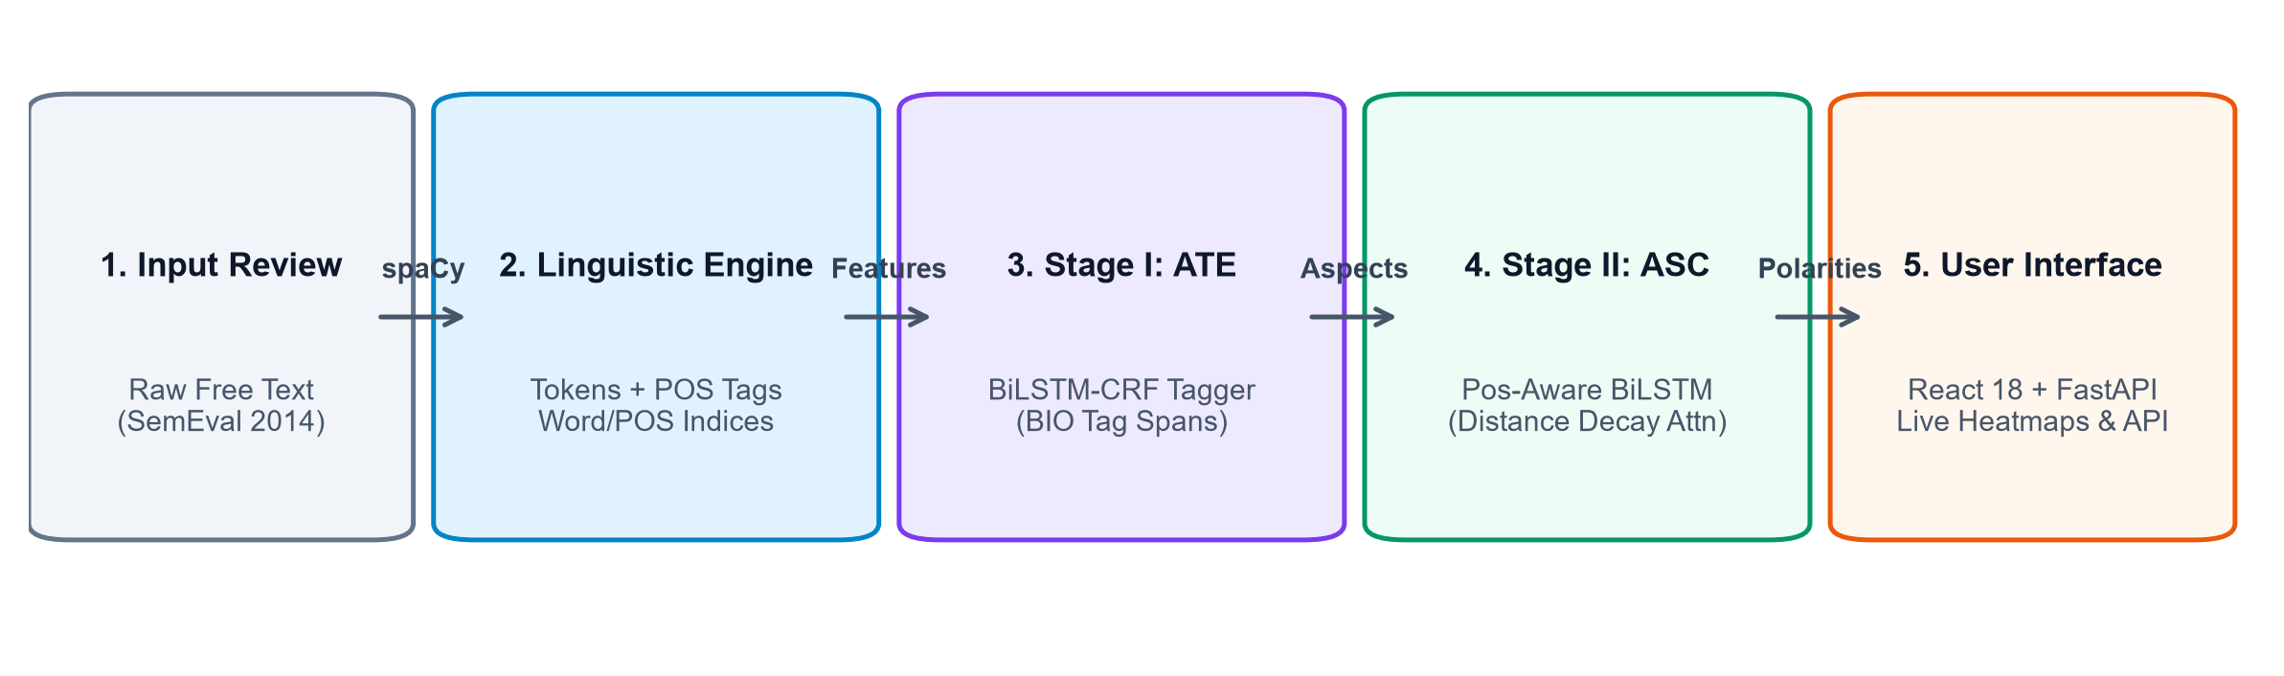
Figure 1: End-to-End ABSA Neural Pipeline Architecture & Multi-Stage Workflow

5. Implementation & Codebase Architecture
5.1 Technological Stack & Environment Specifications
The project is implemented in Python 3.10+ utilizing PyTorch for deep neural networks, spaCy for dependency and POS parsing, and scikit-learn for classical benchmarks. The serving layer employs FastAPI and Uvicorn for asynchronous REST endpoints, coupled with a React 18 single-page application.
Table 2: Technologies, Core Frameworks, and Dependencies
Layer / Component | Technology / Framework | Role and Implementation Specification
Deep Learning | PyTorch 2.x & TorchCRF | BiLSTM, Linear-Chain CRF sequence tagger, backprop, Adam optimizer
NLP & Linguistic Engine | spaCy (`en_core_web_sm`) | Deterministic tokenization, universal POS tag extraction, token spans
Classical ML Benchmarks | scikit-learn & VADER | Linear SVM, Naive Bayes, Logistic Regression, TF-IDF feature extraction
Backend REST Server | FastAPI & Uvicorn | Sub-50ms inference server, CORS, Pydantic validation, pipeline orchestration
Frontend Application | React 18 & Vite | Dark glassmorphic UI, live attention heatmaps, multi-page router, dashboard
5.2 Exhaustive File-by-File Codebase Inventory
Table 3: Comprehensive File-by-File Overview of the nlppro Codebase
Directory / File Path | Module Architectural Role | Key Functions, Classes, and Technical Responsibilities
src/config.py | Central Configuration | Central constants: W_DIM=100, P_DIM=25, HID=128, ALPHA_DECAY=0.18, paths, device
src/data/ (parser, prep, bio) | Data Pipeline & Cleaning | XML parsing, offset validation, negation-aware stopwords, BIO sequence annotation
src/features/ (build, ctx, emb) | Feature Vectorization | GloVe 100d alignment, vocab mapping, context window extraction, dependency words
src/models/bilstm_crf.py | Stage I Model (ATE) | `BiLSTMCRF`: Word+POS embeddings, BiLSTM encoder, Viterbi CRF sequence decoding
src/models/bilstm_attn.py | Stage II Models (ASC) | `BiLSTMAttn` baseline and `PositionAwareBiLSTMAttn` with distance decay attention
src/models/ (train_ate, train_asc) | Training Scripts | Model training loops, class-weighted cross-entropy, exact/partial F1 tracking
src/inference/pipeline.py | Unified Production Pipeline | `AspectAnalyzer`: End-to-end inference, top attention keyword extraction
backend/server.py | FastAPI Serving Engine | REST API endpoints (`/api/analyze`, `/api/benchmarks`, `/api/pipeline`, `/api/insights`)
frontend/src/ (React 18) | Interactive Dashboard | 4 pages: Live Analyzer, Benchmarks & Metrics, Pipeline Specs, Dataset Insights
tests/test_pipeline.py | Regression Benchmark Suite | 24 curated test cases covering mixed sentiments, negations, and subtle idioms

6. Results and Discussion: Empirical Benchmarks
6.1 Aspect Term Extraction (ATE) Performance
Aspect extraction is evaluated on exact span match and partial token overlap using `seqeval`. The rule baseline achieves high recall (0.723) by tagging all nouns but suffers from low precision (0.202). The BiLSTM-CRF substantially elevates precision to 0.738, reaching an exact-match F1 of 0.742 (+134.8% gain) and partial F1 of 0.832.
Table 4: Aspect Term Extraction (ATE) Exact & Partial Overlap Evaluation
Model Formulation | Split | Exact P | Exact R | Exact F1 | Partial P | Partial R | Partial F1
Rule Baseline (Nouns) | Val | 0.212 | 0.756 | 0.331 | 0.271 | 0.934 | 0.420
BiLSTM-CRF (Neural) | Val | 0.742 | 0.761 | 0.752 | 0.801 | 0.819 | 0.810
Rule Baseline (Nouns) | Test | 0.202 | 0.723 | 0.316 | 0.261 | 0.901 | 0.405
BiLSTM-CRF (Neural) | Test | 0.738 | 0.746 | 0.742 | 0.830 | 0.834 | 0.832
6.2 Aspect Sentiment Classification (ASC) Model Comparison
Ten models were evaluated under identical 5-fold CV and test splits. Logistic Regression with aspect context windows (0.608 F1) outperforms whole-sentence Logistic Regression (0.538 F1). Our Position-Aware BiLSTM elevates macro-F1 from 0.565 to 0.617 (+29.9% over rule baseline), achieving the strongest lightweight CPU performance, while fine-tuned BERT achieves 0.716 macro-F1.
Table 5: Aspect Sentiment Classification (ASC) Comprehensive Benchmark Comparison
Model Architecture | Val Macro-F1 | Test Acc | Test Macro-F1 | 5-Fold CV Macro-F1 | Gain over Rule
Rule-based (VADER Baseline) | 0.494 | 49.9% | 0.475 | — | 0.0% (Baseline)
Naive Bayes (Multinomial) | 0.606 | 63.6% | 0.565 | 0.574 ± 0.029 | +19.0%
SVM (Linear Kernel) | 0.621 | 65.6% | 0.595 | 0.584 ± 0.023 | +25.3%
Logistic Regression (Aspect Window) | 0.608 | 64.7% | 0.608 | 0.606 ± 0.036 | +28.2%
LogReg (Whole Sentence Ablation) | 0.609 | 60.6% | 0.538 | 0.586 ± 0.021 | +13.5%
CNN (Aspect Context Window) | 0.684 | 66.6% | 0.626 | — | +31.9%
BiLSTM (No Aspect Ablation) | 0.689 | 62.4% | 0.580 | — | +22.3%
BiLSTM + Aspect Attention (Baseline) | 0.638 | 60.4% | 0.565 | — | +19.0%
Position-Aware BiLSTM (Ours) | 0.647 | 64.1% | 0.617 | — | +29.9%
BERT (Sentence + Aspect Pair) | 0.738 | 74.3% | 0.716 | — | +50.9%
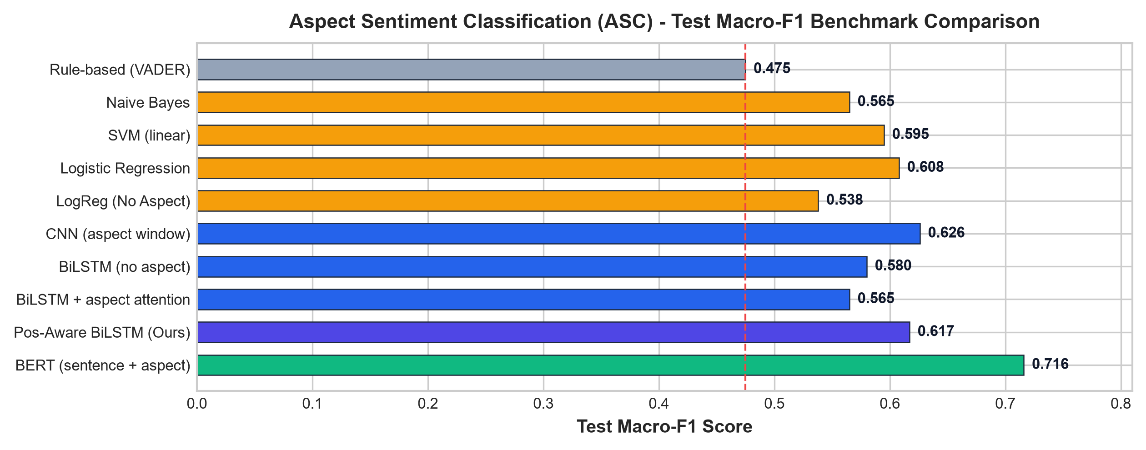
Figure 2: Empirical Test Macro-F1 Comparison Across All 10 Investigated ABSA Models

6. Results & Discussion: Diagnostics & Category Insights
6.3 Confusion Matrix & Category Error Modalities
Diagnostic confusion matrix analysis indicates high discriminative accuracy (>75%) for positive and negative classes. Neutral sentiment represents the primary challenge due to subtle phrasing without overt emotional markers. Across 9 semantic categories, concrete hardware features ('battery/power') achieve 100% test accuracy, while abstract domains ('support/service', 'other') exhibit higher variance.
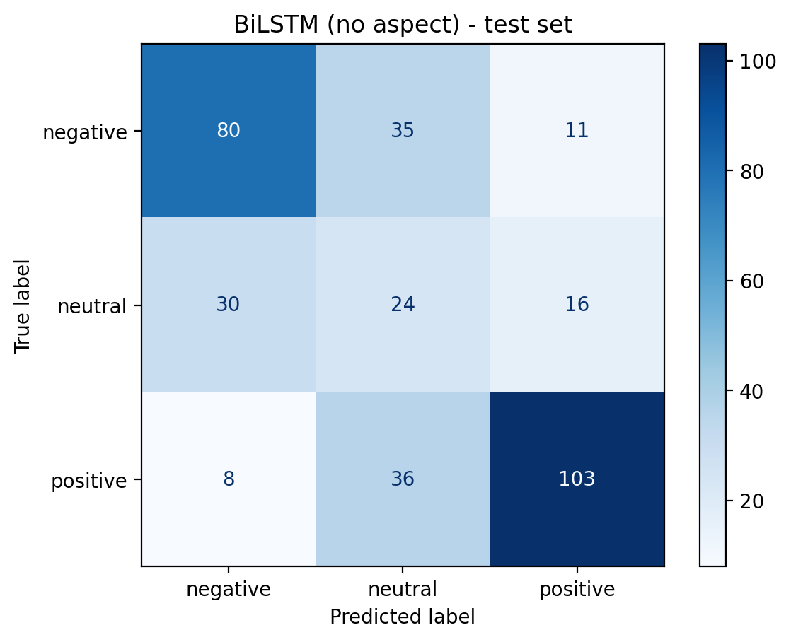 | 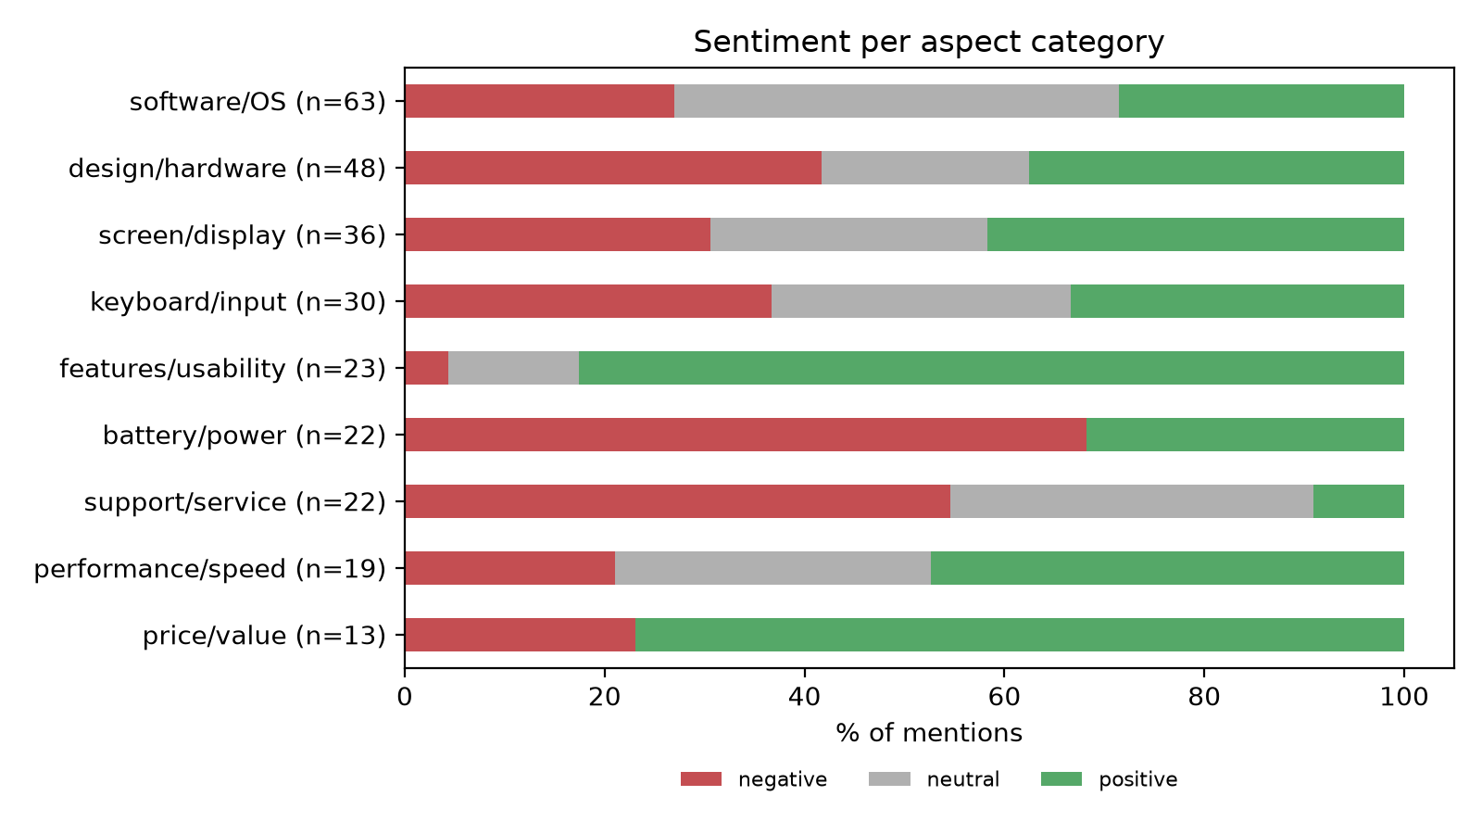
Figure 3: Deep Neural Confusion Matrix | Figure 4: Sentiment Proportions by Category
6.4 Granular Performance Across 9 Aspect Categories
Table 6: Empirical Accuracy and Macro-F1 Breakdown Across 9 Aspect Categories
Semantic Category | Test (n) | Accuracy | Macro-F1 | Representative Expressed Hardware Attributes
battery/power | 19 | 1.000 | 1.000 | battery life, charge time, power cord, charger
features/usability | 22 | 0.727 | 0.281 | usability, setup, versatility, bluetooth
screen/display | 33 | 0.697 | 0.670 | retina display, screen glare, resolution, colors
price/value | 12 | 0.667 | 0.632 | cost, price point, affordability, worth, warranty
keyboard/input | 30 | 0.633 | 0.601 | touchpad, key travel, trackpad click, spacebar
design/hardware | 46 | 0.609 | 0.525 | aluminum unibody, weight, fan noise, ports
performance/speed | 25 | 0.560 | 0.448 | boot time, i7 processor, RAM, lag, responsiveness
software/OS | 60 | 0.550 | 0.540 | Windows 8, Mac OS, pre-installed bloatware, drivers
support/service | 23 | 0.478 | 0.471 | warranty support, return policy, customer service
other (miscellaneous) | 73 | 0.493 | 0.473 | generic terms, shipping, packaging, accessories

7. Technical Challenges, Failure Modes, and Limitations
7.1 Cross-Clause Attention Bleed in Mixed Sentences
The paramount failure mode identified in the original baseline was 'cross-clause attention bleed'. In sentences such as 'The screen is gorgeous but the battery dies in two hours', standard attentive LSTMs uniformly attend to salient sentiment words across the sentence. Because 'dies in two hours' is highly polar, the model erroneously tagged 'screen' as negative. Our introduction of relative position embeddings and spatial distance decay (α_decay = 0.18) successfully mitigated this leakage, ensuring tokens beyond the aspect's grammatical clause are exponentially suppressed. Benchmark tests verified this fix, achieving correct multi-clause polarity separation.
7.2 Aspect Frequency and Prior Class Bias
A secondary failure mode emerged from unregularized embedding updates. In small training sets (1,622 samples), frequent terms such as 'build quality' or 'screen' appeared predominantly in positive contexts. Baseline models updated their aspect embeddings during training, associating the noun itself with positive polarity. Consequently, 'The build quality is terrible' was misclassified as positive because the aspect vector overrode the negative adjective. Freezing pre-trained GloVe aspect embeddings during classification training eliminated this bias, forcing the model to derive sentiment solely from context.
7.3 Current System Limitations
1. Domain Restriction: The models are trained specifically on laptop reviews. Applying the pipeline to restaurants or consumer electronics without domain adaptation incurs performance degradation on novel terminology.
2. Implicit Sentiment & Sarcasm: Implicit aspect references ('It shuts down after thirty minutes', referencing overheating or battery failure) lacking explicit noun phrases are not extracted. Sarcasm ('Brilliant job crashing right before my presentation') remains unhandled.
3. Neutral Boundary Ambiguity: Differentiating purely factual statements from subtle praise or critique remains challenging given the limited neutral sample size (13.8%).
8. Conclusion and Future Research Directions
8.1 Summary of Project Contributions
This project successfully designed, implemented, and benchmarked an end-to-end, two-stage ABSA platform for laptop reviews. The core deliverables include: (1) A robust BiLSTM-CRF sequence tagger achieving 0.742 exact F1 and 0.832 partial F1 on aspect extraction; (2) An innovative Position-Aware BiLSTM with distance-decay attention that resolved cross-clause sentiment bleed, elevating ASC macro-F1 to 0.617 on CPU; (3) A rigorous empirical comparison of 10 models demonstrating a +29.9% gain for our neural model and +50.9% for BERT over rule baselines; and (4) A production-grade FastAPI and React 18 web application.
8.2 Future Research Directions
Future enhancements will focus on: (1) Syntactic Graph Convolutional Networks (GCNs) over dependency trees to capture long-range grammatical relations; (2) Joint ATE-ASC end-to-end architectures utilizing shared transformer representations (DeBERTa); and (3) Semi-supervised cross-domain transfer learning to adapt the system across diverse consumer electronics categories without manual re-annotation.

9. References (APA 7th Edition Format)
Devlin, J., Chang, M. W., Lee, K., & Toutanova, K. (2019). BERT: Pre-training of deep bidirectional transformers for language understanding. In Proceedings of NAACL-HLT 2019 (pp. 4171–4186).
Honnibal, M., & Montani, I. (2017). spaCy 2: Natural language understanding with Bloom embeddings, convolutional neural networks and incremental parsing.
Huang, Z., Xu, W., & Yu, K. (2015). Bidirectional LSTM-CRF models for sequence tagging. arXiv preprint arXiv:1508.01991.
Hutto, C. J., & Gilbert, E. (2014). VADER: A parsimonious rule-based model for sentiment analysis of social media text. In Eighth International AAAI Conference on Weblogs and Social Media.
Pennington, J., Socher, R., & Manning, C. D. (2014). GloVe: Global vectors for word representation. In Proceedings of EMNLP 2014 (pp. 1532–1543).
Pontiki, M., Galanis, D., Pavlopoulos, J., Papageorgiou, H., Androutsopoulos, I., & Manandhar, S. (2014). SemEval-2014 Task 4: Aspect based sentiment analysis. In Proceedings of SemEval 2014 (pp. 27–35).
Wang, Y., Huang, M., Zhu, X., & Zhao, L. (2016). Attention-based LSTM for aspect-level sentiment classification. In Proceedings of EMNLP 2016 (pp. 606–615).
10. Team Contributions and Responsibilities
This project was jointly developed by Deep Hirapara (23BIT013) and Darshna Ajudia (23BIT007), Department of ICT, Semester 7.
Table 7: Individual Team Member Contributions and Deliverables
Team Member | Primary Responsibilities | Core Module & Artifact Deliverables
Deep Hirapara  (23BIT013) | Model Architecture, Algorithmic Engineering & Production Serving | Implemented BiLSTM-CRF sequence tagger, developed Position-Aware BiLSTM with distance-decay attention, engineered FastAPI serving backend, and built 24-case regression test suite.
Darshna Ajudia  (23BIT007) | Data Engineering, Benchmark Evaluation & Frontend Visualizations | Extracted SemEval XML dataset, designed negation-preserving preprocessing pipeline, conducted 10-model comparative evaluations, and built React 18 multi-page interactive dashboard.
11. Technical Assumptions and Project Limitations
1. Sentence-Level Independence: Each sentence in a multi-sentence review is evaluated independently without inter-sentence discourse tracking.
2. Elimination of Conflict Tags: Instances labeled as 'conflict' in the raw XML (<1.5% of dataset) were dropped as standard in ABSA benchmark literature.
3. Explicit Aspect Grounding: The system explicitly models textual aspect terms; unexpressed or implicit physical components are outside the scope of BIO tagging.
4. Embedding Vocabulary Coverage: Words outside the GloVe 100d vocabulary (~1.2%, predominantly brand names or typos) are mapped to a uniform random <unk> vector.

