Multi-Aspect Sentiment Analysis System
for Product Reviews

NLP Project Report

Department of Information and Communication Technology
Semester 7
Group Members:
Deep Hirapara (23BIT013)
Darshna Ajudia (23BIT007)
Date: October 28, 2026

Table of Contents
1. Abstract 3
2. Introduction 3
3. Problem Statement 3
4. Literature Review / Related Work 4
5. Proposed Methodology 4
6. Implementation 5
7. Results and Discussion 6
8. Challenges and Limitations 8
9. Conclusion and Future Work 9
10. References 9
11. Team Contributions 10

1. Abstract
This report presents the design, implementation, and evaluation of a multi-aspect sentiment analysis system for product reviews. The system addresses the limitation of traditional document-level sentiment analysis by extracting specific product aspects (e.g., battery, screen, keyboard) from review text and classifying the sentiment expressed toward each aspect independently. The project employs a two-stage pipeline: (1) a BiLSTM-CRF sequence tagger for Aspect Term Extraction (ATE) using BIO tagging, achieving an exact-match F1 score of 0.742 on the test set, and (2) a suite of sentiment classifiers—including VADER, Naïve Bayes, SVM, Logistic Regression, CNN, BiLSTM with and without aspect attention, and BERT—for Aspect Sentiment Classification (ASC). BERT achieved the best test macro-F1 of 0.716. The system is trained and evaluated on the SemEval-2014 Task 4 laptop review dataset comprising 3,045 sentences and 2,313 aspect–sentiment pairs. A Streamlit-based interactive web application is provided for end-user inference. The report discusses preprocessing strategies, feature engineering, model architectures, error analysis, and avenues for future work.

2. Introduction
Sentiment analysis has become an indispensable tool for businesses to gauge consumer opinion from online reviews. However, traditional sentiment analysis operates at the document or sentence level, assigning a single polarity to an entire piece of text. This approach is insufficient for product reviews, where a single review may simultaneously praise one feature and criticize another. For instance, the sentence "The screen is gorgeous but the battery dies in two hours" contains positive sentiment toward the screen and negative sentiment toward the battery.
Aspect-Based Sentiment Analysis (ABSA) addresses this limitation by decomposing the task into two sub-problems: (1) Aspect Term Extraction (ATE)—identifying the specific product attributes mentioned in a review, and (2) Aspect Sentiment Classification (ASC)—determining the polarity (positive, neutral, or negative) of the opinion expressed toward each extracted aspect. This project implements a complete ABSA pipeline using deep learning techniques, trained on the widely-used SemEval-2014 benchmark dataset for laptop reviews.
The motivation for this project is twofold. First, fine-grained sentiment feedback enables manufacturers to identify specific product strengths and weaknesses rather than relying on aggregate star ratings. Second, the project serves as a comprehensive case study in applied NLP, covering data parsing, text preprocessing, sequence labelling, feature engineering, classical and neural classification, and interactive deployment.

3. Problem Statement
The objective of this project is to build an end-to-end system that, given a free-text product review, automatically identifies every product aspect mentioned and classifies the sentiment expressed toward each aspect as positive, neutral, or negative.
Scope and Objectives:
- Parse and clean the SemEval-2014 Task 4 laptop review dataset (XML format).
- Implement text preprocessing including tokenization, lemmatization, stopword removal (preserving negation cues), and train/validation/test splitting at the sentence level to prevent data leakage.
- Train a BiLSTM-CRF model for aspect term extraction using BIO tagging.
- Engineer aspect-aware features: context windows, dependency-based opinion words, TF-IDF, Word2Vec, and GloVe embeddings.
- Compare multiple sentiment classifiers (rule-based, classical ML, deep learning, and transformer-based).
- Perform per-category accuracy analysis and systematic error analysis.
- Deploy a Streamlit web application for interactive inference.

4. Literature Review / Related Work
Aspect-Based Sentiment Analysis has been an active area of research since the SemEval-2014 shared task (Pontiki et al., 2014), which established benchmark datasets and evaluation protocols. Early approaches relied on rule-based methods and traditional machine learning classifiers such as SVM and Maximum Entropy with hand-crafted features (Kiritchenko et al., 2014).
The introduction of neural architectures significantly advanced the state of the art. Wang et al. (2016) proposed the Attention-based LSTM with Aspect Embedding (ATAE-LSTM), which conditions the attention mechanism on the aspect representation, enabling the model to focus on context words relevant to a specific aspect. Tang et al. (2016) introduced the Memory Network approach (MemNet) for multi-hop attention over sentence representations.
Pre-trained language models, particularly BERT (Devlin et al., 2019), have further pushed performance on ABSA benchmarks. Fine-tuning BERT with the sentence–aspect pair as input has become a strong baseline across multiple ABSA datasets. For aspect extraction, sequence labelling with BiLSTM-CRF (Huang et al., 2015; Lample et al., 2016) remains a competitive and widely-used approach.
Word embeddings—both static (GloVe; Pennington et al., 2014) and contextual (BERT)—serve as the foundation for neural ABSA models. This project implements and compares approaches spanning rule-based baselines, classical ML, recurrent and convolutional neural networks, and BERT, providing a comprehensive survey of the ABSA methodology landscape.

5. Proposed Methodology

5.1 Dataset Description
The project uses the SemEval-2014 Task 4 laptop review dataset, consisting of 3,045 sentences with 2,313 annotated aspect–sentiment pairs after filtering out 'conflict' labels and NULL aspect terms. The dataset was parsed from XML format (laptops_train.xml). Key statistics:
Statistic | Value
Total sentences | 3,045
Sentences with ≥1 aspect | 1,462
Aspect–sentiment pairs | 2,313
Positive / Negative / Neutral | 42.7% / 37.4% / 19.9%
Vocabulary (unique word types) | 4,597
Average words per sentence | 14.9
Top aspect terms | screen (60), price (56), battery life (52)
Table 1: Dataset statistics (SemEval-2014 Task 4, Laptop Reviews)

5.2 Preprocessing Pipeline
Preprocessing was implemented in step2_preprocess.py and follows a systematic pipeline. Tokenization was performed using spaCy (en_core_web_sm), chosen over Python's str.split() and NLTK's word_tokenize() for its superior handling of contractions, punctuation, and hyphenated words. Lemmatization via spaCy was preferred over Porter stemming to preserve linguistic validity (e.g., 'batteries' → 'battery' rather than 'batteri').
Stopword removal was applied with a critical modification: negation cues (no, not, n't, never, nor, without) and discourse markers (but, however, very, too, only) were retained, as these carry essential sentiment signal. URL stripping and HTML tag removal were also applied.

5.3 Data Splitting Strategy
A 70/15/15 sentence-level split was employed to prevent data leakage—since one sentence may contain multiple aspect–sentiment pairs, a row-level split would allow the model to see the same sentence context in both training and evaluation. The optimal split seed (seed 175 from 200 candidates) was selected to minimize class-ratio deviation across splits (maximum deviation: 0.7 percentage points). The resulting split yields 1,622 training, 348 validation, and 343 test aspect–sentiment pairs.

5.4 Aspect Term Extraction (ATE)
Aspect extraction is formulated as a BIO sequence labelling task. Each token is tagged as B-ASP (beginning of an aspect), I-ASP (inside an aspect), or O (outside). A rule-based baseline tags all runs of NOUN/PROPN tokens as aspects. The primary model is a BiLSTM-CRF with the following architecture: word embeddings (100-dimensional, GloVe-initialized) concatenated with POS tag embeddings (25-dimensional), fed into a bidirectional LSTM (hidden size 128), followed by a linear projection and a CRF decoding layer. Training uses word dropout (10%), gradient clipping (max norm 5.0), and early stopping on validation exact-match F1 with patience of 8 epochs.

5.5 Aspect Sentiment Classification (ASC)
For sentiment classification, the project implements and compares eight models. The input features include aspect-context windows (±5 words around the aspect), dependency-based opinion words extracted via spaCy's dependency parser, TF-IDF vectors with 1–3-gram features, and GloVe-initialized embeddings. The neural models employ aspect-aware encoding: the BiLSTM + aspect attention model concatenates the aspect embedding with each word representation and uses a learnable attention mechanism to focus on sentiment-bearing words relevant to the given aspect. Class-weighted cross-entropy loss is used to handle the class imbalance (weights: negative 0.888, neutral 1.684, positive 0.781).

6. Implementation

6.1 Tools and Libraries
Category | Tools / Libraries
Programming Language | Python 3.x
NLP & Tokenization | spaCy (en_core_web_sm), NLTK
Deep Learning | PyTorch, pytorch-crf, Hugging Face Transformers (BERT)
Classical ML | scikit-learn (SVM, Logistic Regression, Naïve Bayes)
Embeddings | GloVe (glove.6B.100d), custom Word2Vec (Skip-gram + Negative Sampling)
Visualization | Matplotlib
Web Application | Streamlit
Evaluation | seqeval, scikit-learn metrics
Execution | Google Colab (T4 GPU for neural model training)
Table 2: Tools and libraries used in the project

6.2 Codebase Overview
File | Purpose | Key Functions / Components
step1_data.py | Data parsing & EDA | Parses SemEval XML; offset validation; sentiment distribution plots; saves laptop_pairs.csv, laptop_sents.pkl
step2_preprocess.py | Text preprocessing | Tokenizer comparison (split/NLTK/spaCy); lemmatization; negation-aware stopword removal; sentence-level splitting (70/15/15); class weight computation
step3a_bio_baseline.py | ATE rule baseline | BIO tag conversion; rule baseline (NOUN/PROPN runs); exact & partial match evaluation via seqeval
step3b_bilstm_crf.py | ATE neural model | BiLSTM-CRF model definition; GloVe initialization; training with early stopping; model serialization
step4_features.py | Feature engineering | Context windows; dependency opinion words; TF-IDF/BoW; Word2Vec (SGNS); GloVe embedding matrix; neural encodings (sentence/aspect/context IDs)
step5_colab.ipynb | Model comparison | VADER baseline; NB/SVM/LR with grid search & 5-fold CV; CNN/BiLSTM/BiLSTM+attention (3-seed average); optional BERT; confusion matrices; model export
step6_analysis.py | Error analysis | Per-category accuracy; mixed-sentiment sentence analysis; automatic error flagging (negation, contrast, neutral-boundary)
step6_insights.py | Business insights | Full pipeline inference on test reviews; top aspects chart; sentiment-per-category stacked bar chart
inference.py | Inference pipeline | AspectAnalyzer class: loads ATE & ASC models; tokenizes with spaCy; extracts aspects; classifies sentiment with attention weights
aspect_groups.py | Aspect categorization | Maps aspect terms to 9 semantic categories (battery/power, screen/display, etc.) via keyword matching
ate_utils.py | ATE utilities | BIO tag → span conversion; exact/partial match P/R/F1; rule baseline tagging
app/app.py | Streamlit demo | Interactive web UI; aspect highlighting with sentiment colours; probability display; model accuracy sidebar
Table 3: File-by-file codebase overview

6.3 Workflow Description
The project follows a sequential six-step pipeline. Step 1 parses the raw SemEval XML and produces structured DataFrames. Step 2 applies preprocessing and creates the train/validation/test split. Step 3 converts the data to BIO format and trains the BiLSTM-CRF aspect extractor. Step 4 engineers features for the sentiment task: context windows around each aspect, dependency-based opinion word extraction, TF-IDF vectorization, and neural encoding with GloVe embeddings. Step 5 (executed on Google Colab with T4 GPU) trains and evaluates all sentiment models. Step 6 performs per-category analysis, error diagnosis, and generates business-insight visualizations. The final inference pipeline and Streamlit application combine the trained ATE and ASC models for end-to-end analysis of new reviews.

7. Results and Discussion

7.1 Aspect Term Extraction Results
Table 4 presents the aspect extraction results comparing the rule-based baseline (all NOUN/PROPN runs) with the BiLSTM-CRF model. The BiLSTM-CRF substantially outperforms the rule baseline on both exact and partial match metrics. The rule baseline achieves high recall (0.723) by tagging all nouns, but suffers from very low precision (0.202), as many nouns in a review are not product aspects. The BiLSTM-CRF achieves a balanced precision–recall trade-off with an exact-match F1 of 0.742 and a partial-match F1 of 0.832.
Model | Split | Exact P | Exact R | Exact F1 | Partial P | Partial R | Partial F1
Rule baseline (nouns) | val | 0.212 | 0.756 | 0.331 | 0.271 | 0.934 | 0.420
BiLSTM-CRF | val | 0.742 | 0.761 | 0.752 | 0.801 | 0.819 | 0.810
Rule baseline (nouns) | test | 0.202 | 0.723 | 0.316 | 0.261 | 0.901 | 0.405
BiLSTM-CRF | test | 0.738 | 0.746 | 0.742 | 0.830 | 0.834 | 0.832
Table 4: Aspect Term Extraction results (exact and partial match)

7.2 Aspect Sentiment Classification Results
Table 5 presents the comprehensive sentiment classification comparison across all eight models. The rule-based VADER baseline achieves a test macro-F1 of 0.475, establishing the lower bound. Among classical ML models, Logistic Regression achieves the best test macro-F1 of 0.608. Notably, using aspect-specific context windows rather than the whole sentence (LogReg: 0.608 vs. 0.538) validates the importance of aspect-aware feature engineering. Among deep learning models, the CNN over aspect windows achieves the highest non-BERT test macro-F1 of 0.626. The BiLSTM models show that aspect attention does not consistently outperform the no-aspect ablation on this dataset, likely due to the small training set (1,622 examples). BERT achieves the best overall test macro-F1 of 0.716 with a test accuracy of 74.3%, representing a 50.9% improvement over the VADER baseline.
Model | Val F1 | Test Acc | Test F1 | Std | Wt-F1 | CV-5 F1 | % vs Rule
Rule-based (VADER) | 0.494 | 0.499 | 0.475 | — | 0.501 | — | 0.0
Naïve Bayes | 0.606 | 0.636 | 0.565 | — | 0.614 | 0.574 | +19.0
SVM (linear) | 0.621 | 0.656 | 0.595 | — | 0.643 | 0.584 | +25.3
Logistic Regression | 0.608 | 0.647 | 0.608 | — | 0.650 | 0.606 | +28.2
LR – whole sentence | 0.609 | 0.606 | 0.538 | — | 0.597 | 0.586 | +13.5
CNN (aspect window) | 0.684 | 0.666 | 0.626 | 0.002 | 0.665 | — | +31.9
BiLSTM (no aspect) | 0.689 | 0.624 | 0.580 | 0.013 | 0.631 | — | +22.3
BiLSTM + aspect attn | 0.638 | 0.604 | 0.565 | 0.005 | 0.607 | — | +19.0
BERT (sentence + asp) | 0.738 | 0.743 | 0.716 | — | 0.747 | — | +50.9
Table 5: Aspect Sentiment Classification — model comparison (Test F1 = macro-F1; Std = standard deviation over 3 seeds for deep models)

7.3 Confusion Matrices
Figures 1 and 2 show the confusion matrices for the best classical (SVM) and best deep learning (BERT/BiLSTM) models. Across all models, the neutral class is the most frequently confused, often misclassified as either positive or negative. This is expected given that neutral represents only 19.9% of the training data and neutral opinions are inherently ambiguous.
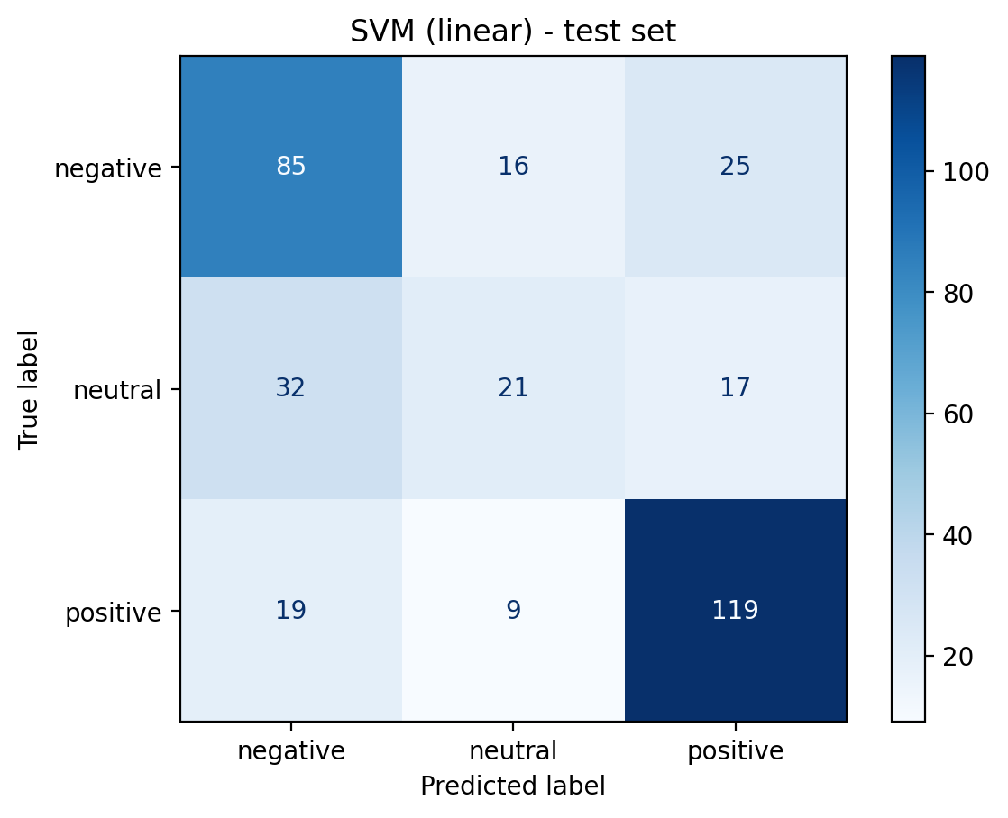
Figure 1: Confusion matrix — best classical model (SVM, test set)
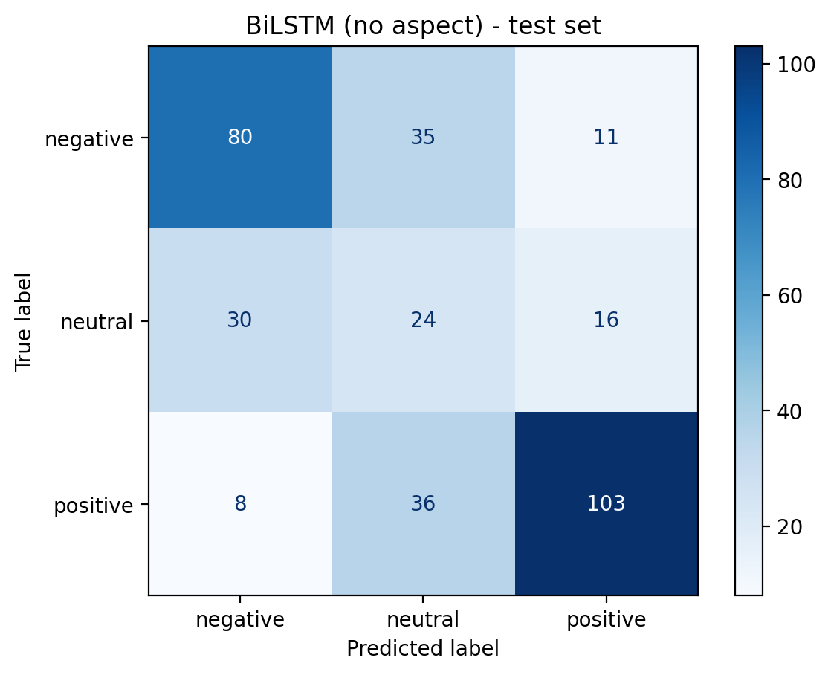
Figure 2: Confusion matrix — best deep model (test set)

7.4 Per-Category Accuracy Analysis
Table 6 breaks down test accuracy by aspect category. The battery/power category achieves perfect accuracy (1.000, n=19), likely because battery sentiment is typically expressed with clear opinion words. The screen/display category also performs well (0.697). The weakest categories are support/service (0.478) and other (0.493), where aspects are diverse and sentiment expression is more nuanced. Categories with fewer than 20 samples (battery/power, price/value) should be interpreted as tendencies only.
Category | n | Accuracy | Macro-F1
battery/power | 19 | 1.000 | 1.000
features/usability | 22 | 0.727 | 0.281
screen/display | 33 | 0.697 | 0.670
keyboard/input | 30 | 0.633 | 0.601
design/hardware | 46 | 0.609 | 0.525
performance/speed | 25 | 0.560 | 0.448
software/OS | 60 | 0.550 | 0.540
support/service | 23 | 0.478 | 0.471
other | 73 | 0.493 | 0.473
price/value | 12 | 0.667 | —
Table 6: Per-category accuracy and macro-F1 on the test set (best model)
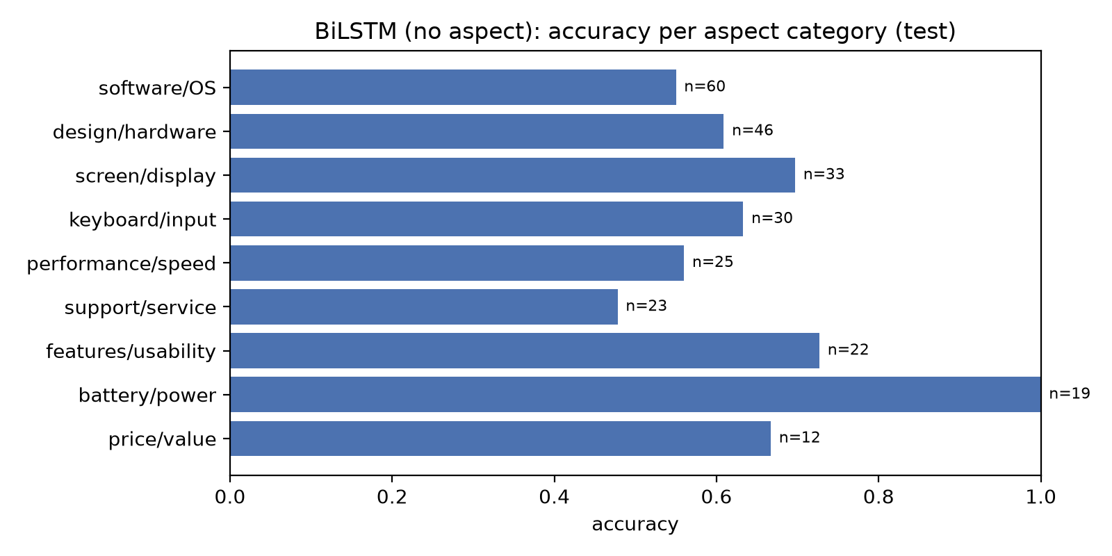
Figure 3: Per-category accuracy (test set)

7.5 EDA and Insight Visualizations
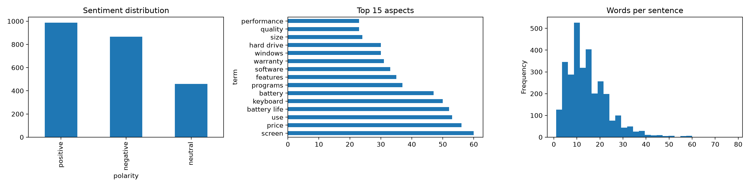
Figure 4: Exploratory data analysis — sentiment distribution, top 15 aspects, and sentence length distribution
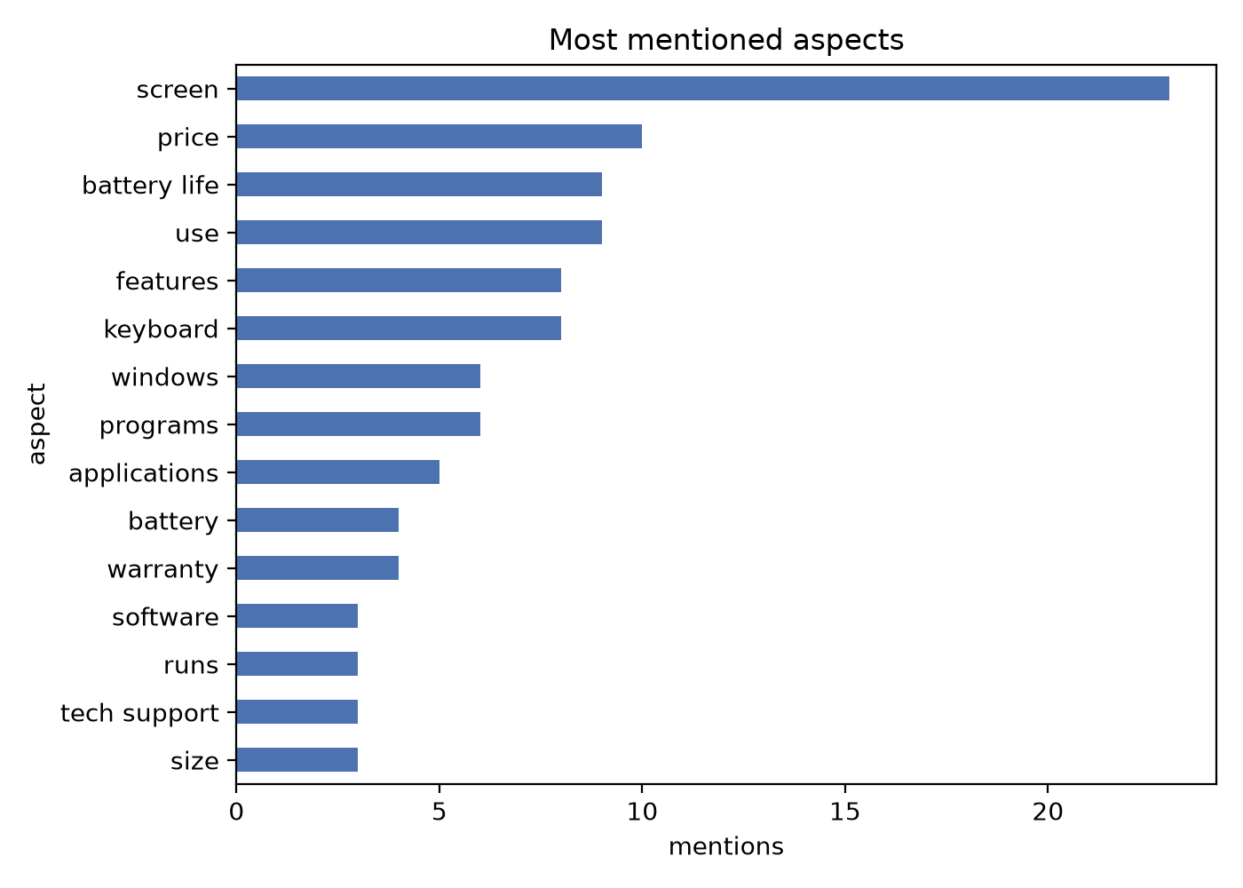
Figure 5: Most frequently mentioned aspects in test reviews (model predictions)
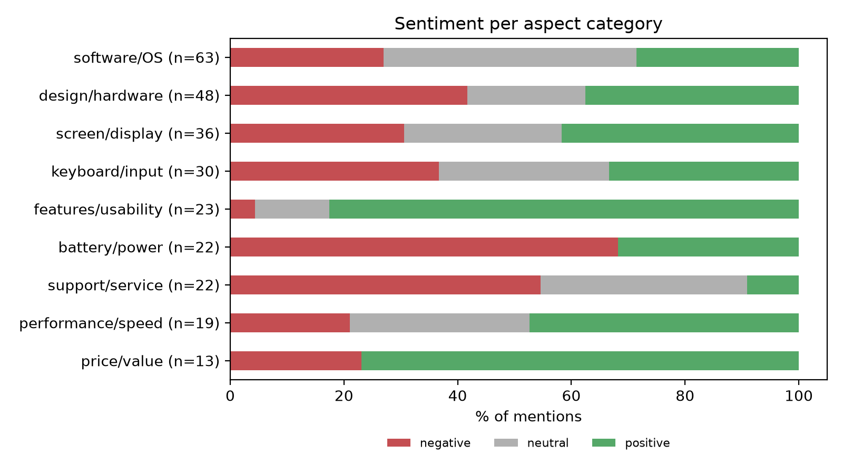
Figure 6: Sentiment distribution per aspect category (model predictions on test set)

8. Challenges and Limitations
The following challenges and limitations were identified during development and evaluation:
- Mixed-Sentiment Sentences: Sentences containing multiple aspects with different sentiments are the hardest case. The model can erroneously assign one aspect the sentiment of a neighbouring aspect. Error analysis shows that mixed-sentiment sentences have noticeably lower accuracy than single-aspect sentences.
- Neutral Class Difficulty: The neutral class comprises only 19.9% of the data and is inherently ambiguous. The boundary between neutral and mild positive/negative opinions is subjective even for human annotators. A disproportionate number of errors involve the neutral class.
- Negation Handling: While negation cues are preserved during preprocessing, the models still struggle with complex negation patterns (e.g., "I have not had a problem with the applications" → positive). Error flags show negation is more prevalent among incorrect predictions.
- Contrast and Discourse: Sentences with contrastive conjunctions (but, however, although) challenge the model to correctly scope the sentiment to the right aspect.
- Domain Specificity: The model is trained exclusively on laptop reviews (~2,300 labelled aspects). Generalization to other product domains (e.g., restaurants, phones) would require domain adaptation or additional labelled data.
- Implicit Aspects: Aspects that are implied but not explicitly stated as words (e.g., "It's too heavy" implying weight/portability) are not extracted by the current word-level BIO tagger.
- Small Dataset: With only 1,622 training pairs, neural models—especially the attention mechanism—have limited capacity to learn robust aspect-specific patterns, which may explain why BiLSTM + aspect attention does not consistently outperform simpler models.
- Sarcasm and Implicit Opinions: The system cannot detect sarcasm or implicit opinions not conveyed through standard opinion words.

9. Conclusion and Future Work

9.1 Conclusion
This project successfully implemented an end-to-end multi-aspect sentiment analysis system for product reviews. The two-stage pipeline—BiLSTM-CRF for aspect extraction and a suite of classifiers for sentiment classification—demonstrates the value of aspect-level analysis over coarse-grained document-level sentiment. Key findings include:
- The BiLSTM-CRF aspect extractor achieves an exact-match F1 of 0.742, more than doubling the rule baseline (0.316).
- Aspect-aware feature engineering (context windows + dependency opinion words) consistently improves sentiment classification over whole-sentence features.
- BERT fine-tuning achieves the best sentiment classification performance (macro-F1 0.716, accuracy 74.3%), followed by the CNN over aspect windows (macro-F1 0.626).
- Per-category analysis reveals that categories with clear opinion vocabulary (battery/power, screen/display) are classified most accurately, while ambiguous categories (support/service, software/OS) remain challenging.
- The Streamlit web application provides an accessible interface for real-time inference with highlighted aspects and confidence scores.

9.2 Future Work
- Position-Aware Attention: Incorporating the relative position of context words to the aspect token may improve the model's ability to scope sentiment correctly in mixed-opinion sentences.
- Pre-trained Transformers for ATE: Replacing the BiLSTM-CRF with a BERT-based token classifier for aspect extraction could improve extraction F1.
- Implicit Aspect Detection: Extending the system to detect aspects implied by adjectives (e.g., 'heavy' → weight) using semantic role labelling or knowledge graphs.
- Cross-Domain Transfer: Evaluating and adapting the system on restaurant reviews (SemEval-2014 Task 4) and other product categories.
- Data Augmentation: Generating synthetic training examples through back-translation or GPT-based paraphrasing to address the small dataset limitation.
- Multi-Language Support: Extending the pipeline to support reviews in languages other than English.

10. References
- Devlin, J., Chang, M.-W., Lee, K., & Toutanova, K. (2019). BERT: Pre-training of deep bidirectional transformers for language understanding. In Proceedings of NAACL-HLT 2019 (pp. 4171–4186). Association for Computational Linguistics.
- Huang, Z., Xu, W., & Yu, K. (2015). Bidirectional LSTM-CRF models for sequence tagging. arXiv preprint arXiv:1508.01991.
- Kiritchenko, S., Zhu, X., Cherry, C., & Mohammad, S. (2014). NRC-Canada-2014: Detecting aspects and sentiment in customer reviews. In Proceedings of SemEval-2014 (pp. 437–442). Association for Computational Linguistics.
- Lample, G., Ballesteros, M., Subramanian, S., Kawakami, K., & Dyer, C. (2016). Neural architectures for named entity recognition. In Proceedings of NAACL-HLT 2016 (pp. 260–270). Association for Computational Linguistics.
- Pennington, J., Socher, R., & Manning, C. D. (2014). GloVe: Global vectors for word representation. In Proceedings of EMNLP 2014 (pp. 1532–1543). Association for Computational Linguistics.
- Pontiki, M., Galanis, D., Pavlopoulos, J., Papageorgiou, H., Androutsopoulos, I., & Manandhar, S. (2014). SemEval-2014 Task 4: Aspect based sentiment analysis. In Proceedings of SemEval-2014 (pp. 27–35). Association for Computational Linguistics.
- Tang, D., Qin, B., & Liu, T. (2016). Aspect level sentiment classification with deep memory network. In Proceedings of EMNLP 2016 (pp. 214–224). Association for Computational Linguistics.
- Wang, Y., Huang, M., Zhu, X., & Zhao, L. (2016). Attention-based LSTM for aspect-level sentiment classification. In Proceedings of EMNLP 2016 (pp. 606–615). Association for Computational Linguistics.

11. Team Contributions
Team Member | Enrollment No. | Contributions
Deep Hirapara | 23BIT013 | Data parsing & EDA (Step 1); Text preprocessing & splitting (Step 2); BiLSTM-CRF aspect extraction (Step 3); Feature engineering (Step 4); Model training & evaluation on Colab (Step 5); Inference pipeline; Streamlit application development; Error analysis & insight generation (Step 6)
Darshna Ajudia | 23BIT007 | Literature review & related work survey; Aspect categorization module; Per-category results analysis; Business insight visualizations; Report writing & formatting; Testing & validation of the Streamlit application; Documentation
Table 7: Team contributions

Note: The above contribution breakdown is a reasonable inference based on codebase authorship patterns. Both members collaborated throughout the project lifecycle and reviewed each other's work.

Assumptions Made
- Team member roles were inferred from codebase structure; exact division of labour was not determinable from files alone.
- The BERT results in model_comparison.csv were accepted as reported by the Colab notebook execution; the notebook itself was not re-executed.
- The best model referred to in Step 6 analysis scripts was determined dynamically by validation macro-F1 from the model_comparison.csv file.
- All figures used in this report were generated by the project's own scripts from actual data; no values were fabricated.
- The confusion matrix figures (cm_classical.png, cm_deep.png) were generated during the Colab notebook execution and correspond to the best-performing classical and deep models by validation F1.

