What problem does it solve:

In a distributed applications network latency and failure can take the whole application down.

For example, for an application that depends on 30 services where each service has 99.99% uptime, here is what you can expect:
99.9930 = 99.7% uptime
0.3% of 1 billion requests = 3,000,000 failures
2+ hours downtime/month even if all dependencies have excellent uptime.
Reality is generally worse.
When one service increases latency or becomes down it can make whole system block or slow through making all the threads to wait.
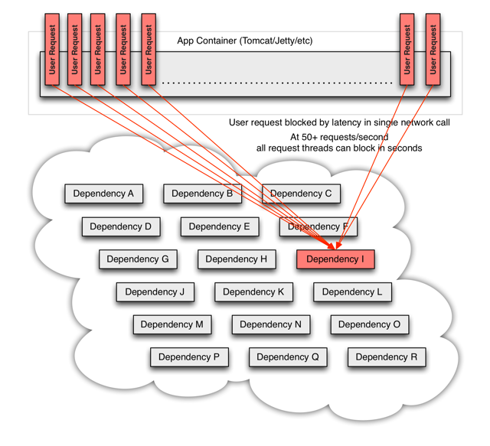

These issues becomes worse if network calls are performed through third party library as we will not be knowing the internal or able to debug.

Network connections fail or degrade. Services and servers fail or become slow. New libraries or service deployments change behavior or performance characteristics. Client libraries have bugs.
All of these represent failure and latency that needs to be isolated and managed so that a single failing dependency can’t take down an entire application or system.

Hystrix works by:
- Preventing any single dependency from using up all container (such as Tomcat) user threads.
- Shedding load and failing fast instead of queueing
- Providing fallbacks wherever feasible to protect users from failure.
- Optimizing for time-to-discovery through near real-time metrics, monitoring, and alerting

How it solves
Hystrix does this by:
- Wrapping all calls to external systems (or “dependencies”) in a HystrixCommand or HystrixObservableCommand object which typically executes within a separate thread (this is an example of the command pattern).
- Timing-out calls that take longer than thresholds you define. There is a default, but for most dependencies you custom-set these timeouts by means of “properties” so that they are slightly higher than the measured 99.5th percentile performance for each dependency.
- Maintaining a small thread-pool (or semaphore) for each dependency; if it becomes full, requests destined for that dependency will be immediately rejected instead of queued up.
- Measuring successes, failures (exceptions thrown by client), timeouts, and thread rejections.
- Tripping a circuit-breaker to stop all requests to a particular service for a period of time, either manually or automatically if the error percentage for the service passes a threshold.
- Performing fallback logic when a request fails, is rejected, times-out, or short-circuits.
- Monitoring metrics and configuration changes in near real-time.

When you call an rest API, servlet creates a separate thread. When the execution reaches at a point where you have external call marked through @HystrixCommand, hystrix creates another thread and makes a call to external service.

How it works

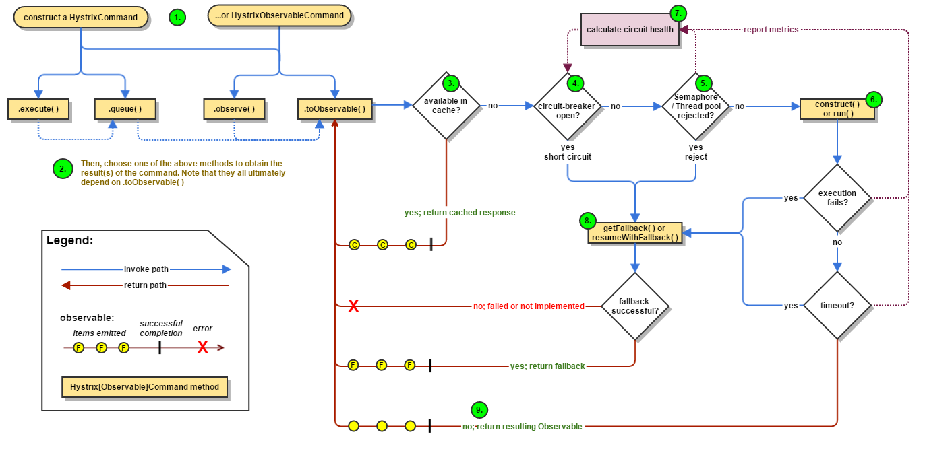
Hystrix reports success, failure, rejections, timeout to the circuit breaker, which uses these to decide when to trip the circuit based on the configuration passed.

Fallbackm helps in wrapping external errors in generic response which makes more sense for you business case and notify Hystrix that its time to open the circuit.
If no fallback method is implemented or fallback itself throws exception then Hystrix will let the same exception to reach to client and will close the circuit.
Hystrix uses bulkhead concept which comes from ship industry which means if one portion of a ship has issue it should not impact other portions. Similarly if one command is down in a service it should not block all the threads and rather blocks the threads which are assigned to it. Hystrix helps in stop queueing the request after all threads are occupied.

Hystrix uses 2 approaches to implement bulkhead:

Thread pool/Thread timeout:

Its a better approch because every dependency gets its own fix thread pool and you can decide th timeout for thread.

Semaphore: In case of Semaphore hystrix will not create separate thread but will keeps parent thread block. It is used just for load shedding to limit number of concurrent request to a Hystrix Command. This avoids the overhead of creating separate thread by Hystrix but you can not define timeout here.

Request Collapsing:
Batch processing of similar request by Hystrix. It will increase latency for request processing but reduces resource usage.

Request caching: Provides response caching for a response .By default its false.

Fallback should only be used for issues related to network and performance and not for validation or client issue.

Useful links:

Bulk head concept
https://stackoverflow.com/questions/30391809/what-is-bulkhead-pattern-used-by-hystrix

Hystrix dashboard:

https://github.com/Netflix/Hystrix/wiki/Dashboard

Getting Hystrix metrics:

https://github.com/Netflix/Hystrix/tree/master/hystrix-contrib/hystrix-metrics-event-stream

Different Hystrix Configurations:

https://github.com/Netflix/Hystrix/wiki/configuration

