Slf4J is logging facade which can be implemented by other loggers.
Some of the popular implementation provided for SLF4J are:
1. Logback
2. Log4J
3. Apache commons logging(JCL)
4. java.util

SLF4j picks up the implementation from the class provided at runtime in class path.

Below pic explains it more clearly:
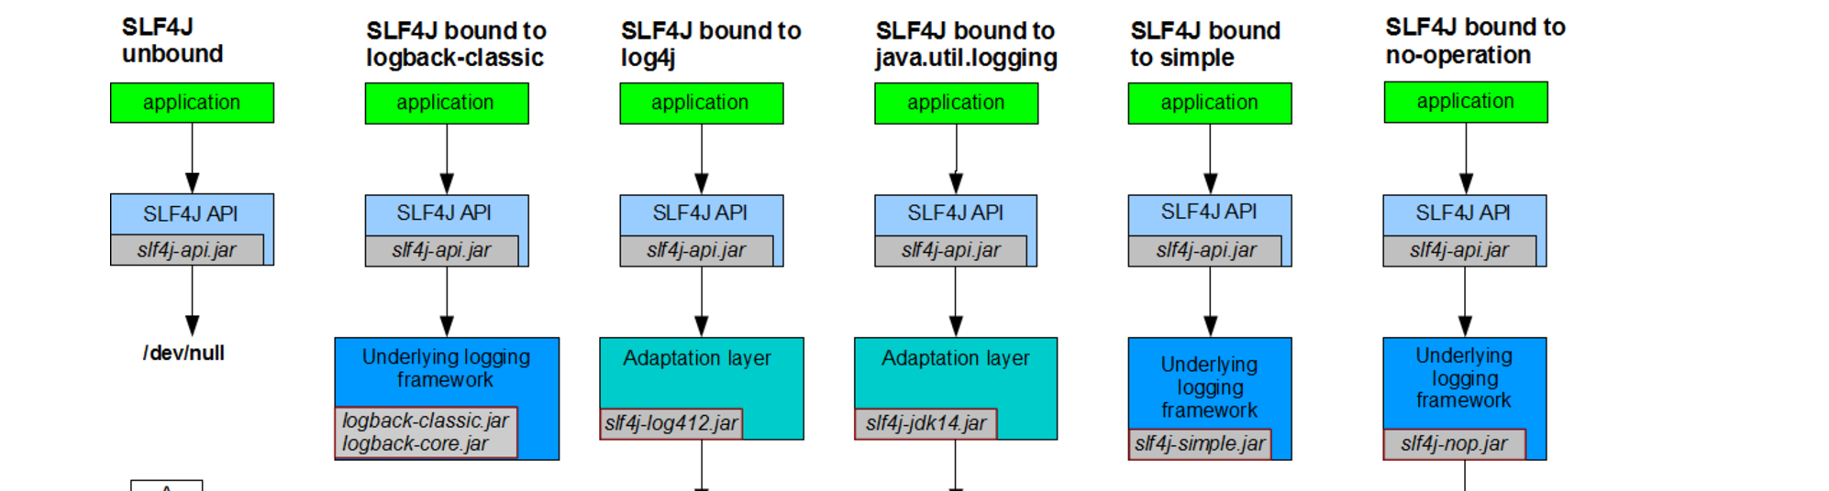
Slf4J picks only one binding at runtime. If no binding is provided then it default to no-op and gives the warning. It will not log any logger statement.
If more than one binding is provided then it will give warning message will randomly pick one binding.

Logback:

Gradle dependency:
compile group: 'ch.qos.logback', name: 'logback-classic', version: '1.2.3'

This will add slf4j-api*.jar, logback-classic*.jar and logback-core*.jar in class path.

At the present time, logback is divided into three modules, logback-core, logback-classic and logback-access.
The core module lays the groundwork for the other two modules. The classic module extends core. The classic module corresponds to a significantly improved version of log4j. Logback-classic natively implements the SLF4J API so that you can readily switch back and forth between logback and other logging systems such as log4j or java.util.logging (JUL) introduced in JDK 1.4. The third module called access integrates with Servlet containers to provide HTTP-access log functionality.

Logback is built upon three main classes: Logger, Appender and Layout.
The Logger class is part of the logback-classic module. On the other hand, the Appender and Layout interfaces are part of logback-core.

Named Hierarchy
A logger is said to be an ancestor of another logger if its name followed by a dot is a prefix of the descendant logger name. A logger is said to be a parent of a child logger if there are no ancestors between itself and the descendant logger.

For example, the logger named "com.foo" is a parent of the logger named "com.foo.Bar". Similarly, "java" is a parent of "java.util" and an ancestor of "java.util.Vector".

Appender Additivity
The output of a log statement of logger L will go to all the appenders in L and its ancestors. This is the meaning of the term "appender additivity".
However, if an ancestor of logger L, say P, has the additivity flag set to false, then L's output will be directed to all the appenders in L and its ancestors up to and including P but not the appenders in any of the ancestors of P.
Loggers have their additivity flag set to true by default.

Sequence of events happening during logging:
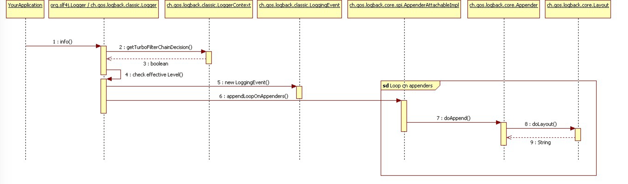
%logger{10}: Only 10 chars
%-5level: Left align with spaces if the level name is less than 5 characters long.

