**Industrial Internship Report on**

**”Energy Monitoring”**

**Prepared by**

**[Deepika Maurya]**

|  |
| --- |
| *Executive Summary* |
| This report provides details of the Industrial Internship provided by upskill Campus and The IoT Academy in collaboration with Industrial Partner UniConverge Technologies Pvt Ltd (UCT).  This internship was focused on a project/problem statement provided by UCT. We had to finish the project including the report in 6 weeks’ time.  My project was (Energy Monitoring App)  This internship gave me a very good opportunity to get exposure to Industrial problems and design/implement solution for that. It was an overall great experience to have this internship. |

**TABLE OF CONTENTS**

1 Preface 3

2 Introduction 4

2.1 About UniConverge Technologies Pvt Ltd 4

2.2 About upskill Campus 8

2.3 Objective 9

2.4 Reference 9

2.5 Glossary 10

3 Problem Statement 11

4 Existing and Proposed solution 12

5 Proposed Design/ Model 13

5.1 High Level Diagram (if applicable) 13

5.2 Low Level Diagram (if applicable) 13

5.3 Interfaces (if applicable) 13

6 Performance Test 14

6.1 Test Plan/ Test Cases 14

6.2 Test Procedure 14

6.3 Performance Outcome 14

7 My learnings 15

8 Future work scope 16

# Preface

Summary of 6-Week Internship

I completed a 6-week internship in the field of App Development. During this internship, I had the opportunity to work on various projects and tasks that provided me with valuable hands-on experience and insights into the industry.

Key Learning Outcomes:

Technical Skills Development: Throughout the internship, I honed my technical skills in area.

Problem-Solving: I encountered various challenges during the internship, including [Example Challenges]. Through guidance from mentors and independent research, I developed problem-solving skills and learned to approach challenges systematically.

Industry Exposure: I gained a deeper understanding of the [Industry/Field] industry by witnessing real-world applications of concepts I learned in my studies. I also had the opportunity to attend that provided insights into current trends and developments in the industry.

Professional Communication: I improved my professional communication skills by interacting with team members, supervisors, and other stakeholders. This included regular progress updates, clarifying project requirements, and presenting my work effectively.

Time Management: Balancing multiple tasks and meeting project deadlines taught me effective time management. I learned to prioritize tasks, allocate resources efficiently, and adapt to changing project requirements.

Future Implications:

This internship experience has equipped me with practical skills and knowledge that I can apply in my future endeavors. It has also deepened my interest in and motivated me to further explore within the industry. I'm excited to leverage the lessons learned during this internship to excel in my academic pursuits and contribute effectively to future projects.

Overall, my 6-week internship with [Company Name] has been an enriching experience that has broadened my horizons and provided a solid foundation for my professional growth.

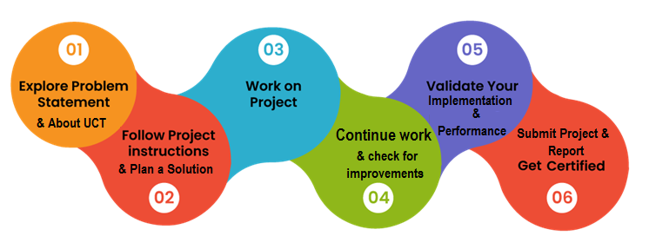

Your Learnings and overall experience.

Thank to all, who have helped you directly or indirectly.

Your message to your juniors and peers.

# Introduction

## About UniConverge Technologies Pvt Ltd

A company established in 2013 and working in Digital Transformation domain and providing Industrial solutions with prime focus on sustainability and RoI.

For developing its products and solutions it is leveraging various**Cutting Edge Technologies e.g. Internet of Things (IoT), Cyber Security, Cloud computing (AWS, Azure), Machine Learning, Communication Technologies (4G/5G/LoRaWAN), Java Full Stack, Python, Front end**etc.

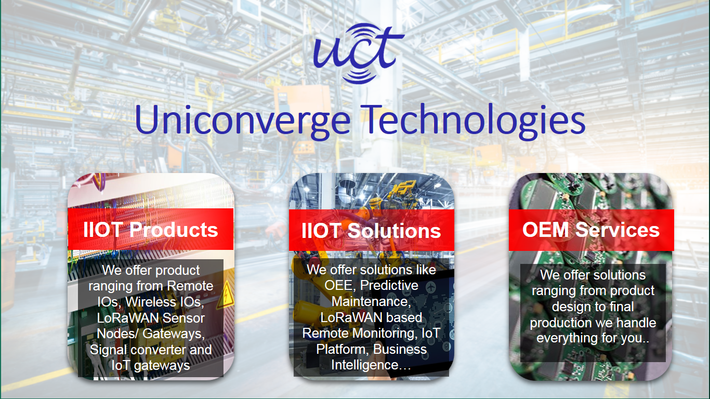

1. UCT IoT Platform **(****)**

**UCT Insight** is an IOT platform designed for quick deployment of IOT applications on the same time providing valuable “insight” for your process/business. It has been built in Java for backend and ReactJS for Front end. It has support for MySQL and various NoSql Databases.

* It enables device connectivity via industry standard IoT protocols - MQTT, CoAP, HTTP, Modbus TCP, OPC UA
* It supports both cloud and on-premises deployments.

It has features to  
• Build Your own dashboard  
• Analytics and Reporting  
• Alert and Notification  
• Integration with third party application(Power BI, SAP, ERP)  
• Rule Engine

 

1. **Smart Factory Platform (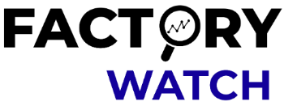)**

Factory watch is a platform for smart factory needs.

It provides Users/ Factory

* with a scalable solution for their Production and asset monitoring
* OEE and predictive maintenance solution scaling up to digital twin for your assets.
* to unleased the true potential of the data that their machines are generating and helps to identify the KPIs and also improve them.
* A modular architecture that allows users to choose the service that they what to start and then can scale to more complex solutions as per their demands.

Its unique SaaS model helps users to save time, cost and money.

 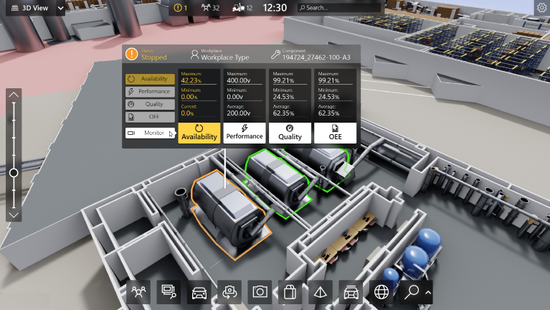

1. 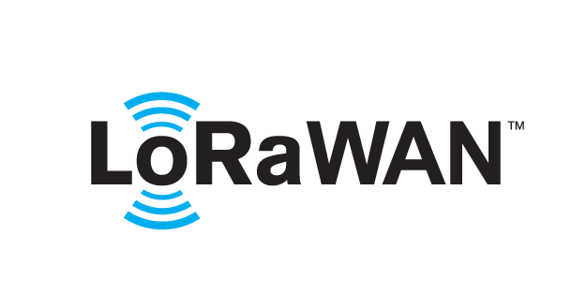 based Solution

UCT is one of the early adopters of LoRAWAN teschnology and providing solution in Agritech, Smart cities, Industrial Monitoring, Smart Street Light, Smart Water/ Gas/ Electricity metering solutions etc.

1. Predictive Maintenance

UCT is providing Industrial Machine health monitoring and Predictive maintenance solution leveraging Embedded system, Industrial IoT and Machine Learning Technologies by finding Remaining useful life time of various Machines used in production process.



## About upskill Campus (USC)

upskill Campus along with The IoT Academy and in association with Uniconverge technologies has facilitated the smooth execution of the complete internship process.

USC is a career development platform that delivers **personalized executive coaching** in a more affordable, scalable and measurable way.



Seeing need of upskilling in self paced manner along-with additional support services e.g. Internship, projects, interaction with Industry experts, Career growth Services

<https://www.upskillcampus.com/>

upSkill Campus aiming to upskill 1 million learners in next 5 year

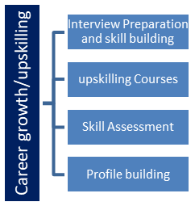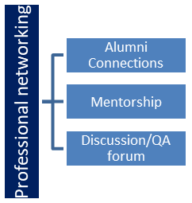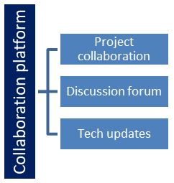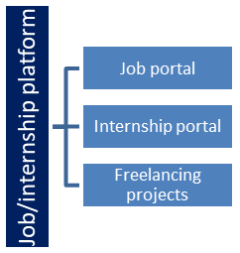

## The IoT Academy

The IoT academy is EdTech Division of UCT that is running long executive certification programs in collaboration with EICT Academy, IITK, IITR and IITG in multiple domains.

## Objectives of this Internship program

The objective for this internship program was to

 ☛ get practical experience of working in the industry.

 ☛ to solve real world problems.

 ☛ to have improved job prospects.

 ☛ to have Improved understanding of our field and its applications.

 ☛ to have Personal growth like better communication and problem solving.

## Reference

[1]

[2]

[3]

## Glossary

|  |  |
| --- | --- |
| Terms | Acronym |
|  |  |
|  |  |
|  |  |
|  |  |
|  |  |

# Problem Statement

1.User Registration and Authentication:

Users should be able to create accounts or log in to the app securely.

Proper authentication mechanisms must be in place to ensure data privacy.

2.Dashboard:

Upon logging in, users should be greeted with a dashboard displaying an overview of their energy consumption.

The dashboard should show current energy consumption, historical trends, and any relevant alerts.

3.Real-time Data Visualization:

The app should fetch and display real-time energy consumption data from connected energy monitoring devices or APIs.

The data should be presented using graphs, charts, or other visualizations for easy interpretation.

# Existing and Proposed solution

Currently, there are various energy monitoring solutions available, both as standalone applications and integrated systems. These solutions vary in terms of complexity, features, and usability.

Data Accuracy: Some solutions rely on user-input data or estimates, leading to potential inaccuracies.

Fragmentation: Different apps for various devices can lead to a fragmented user experience.

Limited Integration: Not all existing solutions provide seamless integration with multiple energy monitoring devices.

**Proposed Solution:**

The proposed energy monitoring mobile app aims to overcome the limitations of existing solutions and provide a comprehensive platform for users to monitor their energy consumption effectively.

Unified Dashboard: The app will offer a unified dashboard displaying real-time energy consumption data, historical trends, and personalized insights.

Device Agnostic: The app will integrate with a wide range of energy monitoring devices and APIs, allowing users to connect various devices seamlessly.

Data Accuracy: By directly integrating with smart meters and IoT devices, the app will provide accurate real-time energy consumption data, reducing the reliance on user inputs.

## Code submission (Github link) : https://github.com/deepiikaa27/upskillcampus

## Report submission (Github link) : https://github.com/deepiikaa27/upskillcampus

# Proposed Design/ Model

Given more details about design flow of your solution. This is applicable for all domains. DS/ML Students can cover it after they have their algorithm implementation. There is always a start, intermediate stages and then final outcome.

## High Level Diagram (if applicable)

Figure 1: HIGH LEVEL DIAGRAM OF THE SYSTEM

## Low Level Diagram (if applicable)

## Interfaces (if applicable)

Update with Block Diagrams, Data flow, protocols, FLOW Charts, State Machines, Memory Buffer Management.

# Performance Test

This is very important part and defines why this work is meant of Real industries, instead of being just academic project.

Here we need to first find the constraints.

How those constraints were taken care in your design?

What were test results around those constraints?

Constraints can be e.g. memory, MIPS (speed, operations per second), accuracy, durability, power consumption etc.

In case you could not test them, but still you should mention how identified constraints can impact your design, and what are recommendations to handle them.

## Test Plan/ Test Cases

## Test Procedure

## Performance Outcome

# My learnings

You should provide summary of your overall learning and how it would help you in your career growth.

# Future work scope

You can put some ideas that you could not work due to time limitation but can be taken in future.