MiniProjectReport

**On**

**“Decentralized Image Upload And Sharing”**

Submitted in partial fulfillment of the Requirementsfortheawardofthedegreeof

**BachelorofTechnology In**

# DepartmentofCyberSecurity&Engineering

**By**

**SURAPALLY DEEPIKA - 21R21A6255**

**PRAGADA VARSHITHA - 21R21A6244**

**SHAIK REHANA - 21R21A6251**

**S.SWATHI - 21R21A6254**

**R.VARSHA - 21R21A6245**

**P.JITENDRA - 21R21A6243**

Undertheguidanceof

**Mr.A.Kiran Kumar Reddy**

# DepartmentofCyber Security &Engineering

**2023-2024**

# DepartmentofCyber Security &Engineering

## CERTIFICATE

This is to certify that the project entitled **“Decentralized Image Upload And**

**Sharing”** has been submitted by **S.Deepika(21R21A6255), P.Varshitha**

**(21R21A6244), Shaik Rehana(21R21A6251), S.Swathi (21R21A6254), R.Varsha**

**(21R21A6245) and P.Jitendra (21R21A6243)** in partial fulfillment of the

requirements for the award of degree of Bachelor of Technology in **CSE-Cyber**

**Security** from Jawaharlal Nehru Technological University, Hyderabad. The results

embodied in this project have not been submitted to any other University or Institution

for the award of any degree or diploma.

**Internal Guide Head of the Department**

**Mr.A.Kiran Kumar Reddy Dr.M.Chrianjeevi**

**Professor Professor & Head**

**Department of CSE-CS Department of CSE-CS**

**External Examiner**

**i**

## DECLARATION

We hereby declare that the project entitled **“Decentralized Image Upload And Sharing”** is the work done during the period from **Aug 2023 to Jan 2024**and is submitted in partial fulfillment of the requirements for the award of degree of Bachelor of Technology in Department of Cyber Security & Engineering from Jawaharlal Nehru Technology University, Hyderabad. The results embedded in this project have not been submitted to any other university or Institution for the award of any degree or diploma.

**S.DEEPIKA - 21R21A6255**

**P.VARSHITHA - 21R21A6244**

**SHAIK REHANA - 21R21A6251**

**S.SWATHI - 21R21A6254**

**R.VARSHA - 21R21A6245**

**P.JITENDRA - 21R21A6243**

# Department Of Cyber Security & Engineering

## ACKNOWLEDGEMENT

The satisfaction and euphoria that accompany the successful completion of any task would be incomplete without the mention of people who made it possible, whose constant guidance and encouragement crowned our efforts with success. It is a pleasant aspect that we have now the opportunity to express my guidance for all of them.

First of all we would like to express my deep gratitude towards my internal guide **Mr.A.Kiran Kumar Reddy , Assistant Professor,** Department of CSD for her support in the completion of our dissertation. We wish to express our sincere thanks to **Dr.M.Chrianjeevi, HOD, Dept. of CSD** and also principal **Dr. K. SRINIVASA RAO** for providing the facilities to complete the dissertation.

We would like to thank all my faculty and friends for their help and constructive criticism during the project period. Finally, we are very much indebted to our parents for their moral support and encouragement to achieve our goals.

|  |  |
| --- | --- |
| **Students Names** | **Roll No’s** |
|  |  |
|  |  |
|  |  |

# Department of Cyber security &Engineering

**ABSTRACT**

A decentralized Google Drive represents a paradigm shift from the traditional centralized model of file storage and sharing exemplified by platforms like Google Drive. In this innovative approach, data is not housed in a singular, central server infrastructure but is instead distributed across a network of interconnected nodes. This decentralization introduces a host of advantages, including heightened security and privacy through the elimination of a single point of failure, reduced dependence on a sole provider fostering competition, resistance to censorship, and increased availability and reliability as files are redundantly stored across multiple nodes. Additionally, the incorporation of tokenization and incentive mechanisms, often facilitated by blockchain technology, introduces a novel way to reward users for contributing storage space and network resources, further promoting a robust and resilient decentralized ecosystem. The decentralized Google Drive concept thus aligns with the principles of user empowerment, data privacy, and a distributed architecture, offering a promising alternative to conventional centralized file storage systems.

**iv**

## LISTOFFIGURES&TABLES

|  |  |  |
| --- | --- | --- |
| **Figure Number** | **Name of the Figure** | **Page Number** |
| 1 | Decentralized Blockchain | 7 |
| 2 | Smart contracts using Blockchain | 8 |
| 3 | Architecture | 10 |
| 4 | Algorithm | 14 |
| 5 | Output | 21 |
| 6 | Output analysis | 22 |
| 7 | Dataset | 22 |

|  |  |  |
| --- | --- | --- |
| **TableNumber** | **Name of theTable** | **Page Number** |
| 1 | Hypothesis on decentralized google drive | 11 |
| 2 | Data collection Method | 12 |

**v**

## INDEX

|  |  |
| --- | --- |
| **Certificate** | i |
| **Declaration** | ii |
| **Acknowledgement** | iii |
| **Abstract** | iv |
| **ListofFiguresandTables** | v |
| **Chapter1** |  |
| **Introduction** | 1 |
| 1.1 Overview | 1 |
| 1.2 Purpose of the project | 1 |
| 1.3 Motivation | 2 |
| **Chapter2** |  |
| **LiteratureSurvey** | 3 |
| 2.1 Existing System | 3 |
| 2.2 Limitations of Existing System | 4 |
| **Chapter3** |  |
| **ProposedSystem** |  |
| 3.1 Proposed System | 5 |
| 3.2 Objectives of Proposed System | 5 |
| 3.3 System Requirements | 5 |
| 3.3.1 Software Requirements | 5 |
| 3.3.2 Hardware Requirements  3.4 Decentralized Blockchain | 5-7 |
| 3.5 Concepts Used in the Proposed System | 8-9 |
| **Chapter4** |  |
| **System Design** | 10 |
| 4.1Proposed SystemArchitecture | 10 |
| 4.2Hypothesis | 11 |

Chapter5

Methodology 12

5.1 Data collection 13

5.2 Algorithm Design 14-15

5.3 solution Structure

Chapter6

Implementation 16

6.1SourceCode 16-20

Chapter7

Results

1. Data Analysis and discussion 21
   1. Output generation 21
   2. Output analysis 22
   3. Compare output against hypothesis 23

Chapter7

Conclusionand futureEnhancement 24

References 25

### CHAPTER 1

### INTRODUCTION

**1.1OVERVIEW**

. A decentralized Google Drive transforms the traditional paradigm of cloud storage by dispersing data storage and sharing functions across a decentralized network. Unlike centralized models where data resides on a single server infrastructure, a decentralized Google Drive employs a distributed architecture where information is stored on interconnected nodes. This not only enhances security and privacy by eliminating a central point of vulnerability but also empowers users with greater control over their data.

Beyond its security benefits, decentralization introduces a novel dimension to the concept of cloud storage. Users actively participate in the network by contributing their resources, fostering a more collaborative and resilient ecosystem. Incentive mechanisms, often implemented through blockchain technology, reward users for their contributions, creating a self-sustaining and competitive environment. In essence, a decentralized Google Drive embodies a shift towards user-centric, secure, and collaborative file storage, challenging the traditional notions of centralized cloud services.

### 1.2PURPOSEOFTHEPROJECT

The main purpose of the project The purpose of a decentralized Google Drive lies in addressing inherent challenges associated with centralized cloud storage systems while promoting a new era of security, user empowerment, and collaboration. Firstly, the decentralization of data storage and sharing functions mitigates the risks associated with a single point of failure. In traditional models, the compromise of a central server poses a significant security threat, potentially exposing vast amounts of sensitive information. By distributing data across a network of nodes, a decentralized Google Drive enhances resilience and protects against such vulnerabilities, offering users a more secure and reliable storage solution.

Secondly, the decentralized approach emphasizes user control and privacy. Users maintain ownership of their data, and the elimination of a central authority reduces the likelihood of unauthorized access or data exploitation. This shift aligns with growing concerns about data privacy and underscores the importance of empowering individuals with greater control over their digital assets. Additionally, the use of encryption and secure peer-to-peer communication further bolsters the protection of sensitive information, ensuring that users can confidently store and share files without compromising their privacy.

Another purpose of a decentralized Google Drive is to foster a more inclusive and collaborative ecosystem. Traditional cloud storage systems are typically controlled by a single provider, leading to a lack of diversity and competition. Decentralization encourages the participation of multiple entities, allowing users to choose from various providers or even contribute to the network themselves. Tokenization and incentive mechanisms provide a unique opportunity for users to be rewarded for contributing their resources, incentivizing a cooperative and competitive environment that benefits the entire decentralized network.

Lastly, the purpose extends to challenging the existing economic and power dynamics in cloud services. Centralized providers often wield significant influence and control over user data, leading to potential monopolistic practices. A decentralized Google Drive, with its distributed nature and tokenized incentives, aims to democratize the storage landscape, empowering users and fostering a more equitable distribution of resources within the network. This purpose aligns with the broader goals of decentralization movements, promoting fairness, transparency, and user-centric principles in the realm of cloud storage.

1

**1.3 MOTIVATION**

For behind developing a decentralized Google Drive stems from a desire to overcome the limitations and concerns associated with centralized cloud storage systems. Firstly, decentralization addresses the pressing issue of data security. With the increasing frequency and sophistication of cyber threats, a centralized repository becomes a prime target for potential breaches. By distributing data across a network of nodes, a decentralized Google Drive minimizes the risk of a single point of failure, enhancing the overall security posture and protecting user data from large-scale compromises.

Secondly, user privacy and control are significant motivating factors. In centralized models, users relinquish a degree of control over their data to a single provider, raising concerns about unauthorized access and data exploitation. Decentralized systems empower users by allowing them to retain ownership of their information, choose where their data is stored, and decide who has access to it. This shift towards user-centric control aligns with the growing demand for more transparent and privacy-centric technology solutions.

The motivation for a decentralized Google Drive also extends to fostering a more open and collaborative digital environment. Traditional cloud storage systems are often dominated by a handful of major providers, limiting choices for users and stifling innovation. Decentralization encourages the participation of diverse entities, allowing for competition, innovation, and a more dynamic ecosystem. This inclusive approach empowers users to actively engage with the storage network, contributing resources, and shaping the future evolution of decentralized file storage solutions. In essence, the motivation behind a decentralized Google Drive lies in addressing fundamental issues, empowering users, and creating a more resilient, private, and collaborative digital landscape.

2

### CHAPTER 2

### LITERATURE SURVEY

There already exist a number of desktop virtual assistants. Afewexamplesofcurrentvirtual assistants available in market are discussed in this section along with thetaskstheycanprovideand their drawbacks.

### EXISTINGSYSTEM

several decentralized file storage systems were gaining traction as alternatives to traditional centralized platforms like Google Drive. One notable system is InterPlanetary File System (IPFS), which employs a peer-to-peer network to address and retrieve content based on its unique hash, offering a more resilient and distributed approach to file storage. IPFS forms the foundation for projects like Filecoin, a decentralized storage network where users can buy and sell unused storage space using a blockchain-based incentive model.

Additionally, Storj is another decentralized storage platform that allows users to rent out their idle storage space to a network, and in return, they earn cryptocurrency (STORJ). The platform focuses on privacy and security by encrypting and distributing data across its network of nodes. Sia, another noteworthy system, similarly decentralizes storage by breaking files into smaller encrypted pieces and distributing them across its network of hosts. These projects share the common goal of addressing concerns related to security, privacy, and centralization in traditional cloud storage systems, offering users the ability to contribute to the network and earn rewards in a decentralized manner.

It's important to note that the decentralized storage landscape is dynamic, and new developments may have occurred since my last update. Therefore, it's recommended to check the latest information and reviews for the most current status of these systems or any emerging platforms in the decentralized file storage domain.

3

### LIMITATIONSOFEXISTINGSYSTEM

* Usability and Adoption Challenges:Many decentralized storage systems face usability challenges, making them less user-friendly compared to centralized counterparts.
* Network Latency and Performance:Decentralized storage relies on a network of nodes distributed globally.
* Economic Viability and Token Volatility:Some decentralized storage systems use

cryptocurrency tokens as incentives for users to contribute their resources.

* Data Privacy and Security Concerns:While decentralized systems often emphasize improved security and privacy, concerns may arise regarding the effectiveness of encryption, potential vulnerabilities in the underlying technologies, and the overall robustness of the security model.

4

### CHAPTER 3

### PROPOSED SYSTEM

* 1. **PROPOSED SYSTEM**

The decentralized Google Drive envisions a user-centric experience with a focus on simplicity and seamless integration. The system boasts an intuitive interface, promoting effortless file management and real-time collaboration across diverse devices. Emphasizing privacy, robust encryption protocols ensure end-to-end data protection, instilling user confidence in the security of their digital assets.

### OBJECTIVES OF PROPOSEDSYSTEM

Our project aims to decentralized Google Drive is to revolutionize user-centric file storage and sharing. The system aims to provide a seamless and intuitive interface, ensuring a user-friendly experience with efficient file management and real-time collaboration. Privacy and security are paramount, with the implementation of advanced encryption protocols for end-to-end data protection. Performance optimization, achieved through intelligent caching and strategic node placement, seeks to minimize latency and enhance overall speed. Additionally, the system aspires to establish a stable economic model, addressing token volatility concerns and exploring innovative incentive structures, while promoting scalability, interoperability, and regulatory compliance. The overarching goal is to deliver a comprehensive, secure, and community-driven decentralized file storage solution that addresses the evolving needs of users in the digital landscape.

### SYSTEM REQUIREMENTS

Here are the requirements for developing and deploying the application.

#### 3.3.1 SOFTWARE REQUIREMENTS

Below are the software requirements for the application development:

* Solidity : Smart Contract development for ownership and access control
* React:Front-end interface for uploading images and managing access.
* IPFS:Decentralized storage protocol for hosting uploaded images

5

#### 3.3.2HARDWAREREQUIREMENTS

Below are the hardware requirements for the application development:

* Reliable internent connection
* Smart contract

#### 3.4Decentralized Blockchain

#### A decentralized blockchain is a distributed and tamper-resistant ledger that operates without a central authority. In this type of blockchain, a network of nodes, or computers, collaboratively maintains a shared ledger of transactions through a consensus mechanism. The decentralized nature ensures that no single entity has control over the entire network, making it resistant to censorship and single points of failure. Nodes validate transactions, and the consensus mechanism, such as Proof of Work (as seen in Bitcoin) or Proof of Stake (as seen in Ethereum 2.0), ensures agreement on the state of the blockchain.

#### The ledger, organized in blocks, is secured through cryptographic principles, providing transparency and immutability. Once a block is added to the blockchain, it becomes extremely difficult to alter or delete the information within it. Decentralized blockchains often have a native cryptocurrency or token that is distributed among participants, incentivizing them to contribute computational power, secure the network, and validate transactions. Smart contracts, self-executing code with predefined rules, further extend the functionality of decentralized blockchains, allowing for the creation of decentralized applications (DApps) that operate without the need for a trusted intermediary.

#### The decentralized nature of blockchain technology enhances security, trust, and transparency, making it a powerful tool for various applications beyond cryptocurrencies, including supply chain management, voting systems, and decentralized finance (DeFi). Community governance, open-source development, and interoperability with other blockchains are integral aspects of decentralized blockchains, fostering collaboration and innovation within the broader blockchain ecosystem.

6

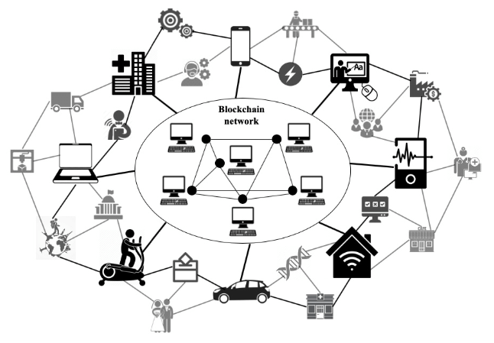

Fig:1 Decentralized Blockchain

### 3.5 CONCEPTS USED IN THE PROPOSED SYSTEM

The decentralized Google Drive system based on blockchain technology, several key concepts and components would be involved. Here are the core concepts used in the system:

1. Blockchain Technology:

The foundation of the decentralized Google Drive system is built on a blockchain, a distributed and immutable ledger that records transactions and data. The blockchain ensures transparency, security, and decentralization, eliminating the need for a central authority to manage the system.

2. Smart Contracts:

Smart contracts are self-executing contracts with predefined rules and conditions. In the context of a decentralized Google Drive, smart contracts can be used to automate various processes, such as access control, file storage, and incentivization mechanisms. They enable trustless and transparent execution of code on the blockchain.

7

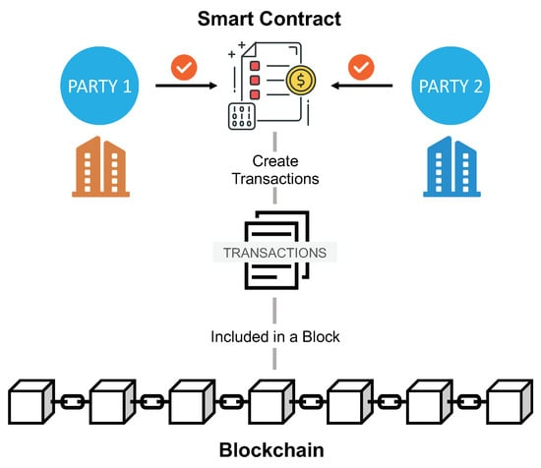

Fig2:Smart Contracts using Blockchain

3. Decentralized File Storage:

Utilizing decentralized file storage solutions like InterPlanetary File System (IPFS) or Filecoin is a fundamental concept. Files are distributed across a network of nodes, eliminating reliance on a central server. Smart contracts can manage the storage, retrieval, and sharing of files among users.

4. Tokenization:

The implementation of a native cryptocurrency or token is crucial for incentivizing participants in the decentralized Google Drive ecosystem. Users may earn tokens for contributing storage space or providing computational resources, and they can spend tokens for accessing or storing files.

5. Decentralized Identity (DID):

Decentralized identity solutions play a role in managing user authentication and access control. Users can control their identities through decentralized identifiers (DIDs) and verifiable credentials, reducing reliance on centralized authentication systems.

6. Proof-of-Storage:

Proof-of-Storage is a mechanism to verify that participants in the network are actually storing the files they claim to store. It adds a layer of security and integrity to the decentralized storage system, preventing malicious actors from gaming the system.

7. Community Governance:

Decentralized governance allows users to participate in decision-making processes. Through on-chain voting or consensus mechanisms, the community can collectively decide on protocol upgrades, rule changes, or other important aspects of the system.

8

8. User Interfaces:

User-friendly interfaces are essential for the adoption of the decentralized Google Drive. These interfaces should resemble the familiar user experience of centralized file storage systems, making it easy for users to interact with the decentralized platform.

9. Security Measures:

Encryption and other security measures ensure the privacy and integrity of user data. End-to-end encryption for files, secure communication protocols, and regular security audits are integral components of a secure decentralized Google Drive.

10. Interoperability:

Interoperability with other blockchain networks or decentralized applications is considered to enhance the overall utility of the system. This allows for seamless interaction between different decentralized platforms and ecosystems.

These concepts collectively contribute to the development of a decentralized Google Drive system that prioritizes user privacy, security, and ownership of data while leveraging the advantages of blockchain technology.

### 9

**CHAPTER 4**

**SYTEM ARCHITECTURE**

### PROPOSED SYSTEM ARCHITECTURE

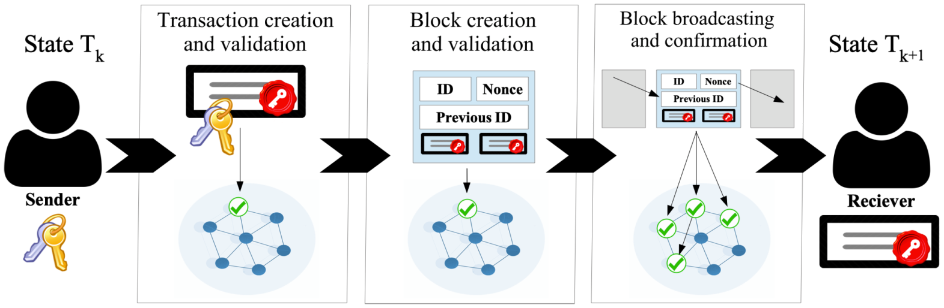

### Fig3:Architecture

### HYPOTHESIS

The hypothesis proposes that implementing a decentralized Google Drive with blockchain technology will enhance security, transparency, and user-centricity compared to centralized alternatives. The decentralized approach aims to improve data integrity through node distribution and cryptographic measures, while decentralized identity and smart contracts aim to heighten user privacy and control.

10

|  |  |
| --- | --- |
| **Hypothesis Area** | **Hypothesis Statement** |
| **Security and Data Integrity** | Implementing a decentralized Google Drive using blockchain technology will enhance security and data integrity through the distributed storage of files and cryptographic protections. |
| **Privacy and User Control** | Decentralized identity solutions and smart contracts for access control will empower users with greater privacy and control over their data, reducing the risk of unauthorized access and misuse. |
| **Incentivized Participation** | Tokenization and proof-of-storage mechanisms will incentivize users to actively participate by contributing resources to the network, resulting in a more reliable and self-sustaining decentralized Google Drive ecosystem. |
| **Transparent Record Keeping** | The use of blockchain for maintaining the ledger will ensure transparency and immutability of transaction records, creating a tamper-resistant history for files stored on the decentralized Google Drive. |
| **Community Governance and Consensus** | Decentralized governance mechanisms, such as on-chain voting and consensus, will foster an inclusive decision-making process, allowing community members to actively shape the rules and features of the platform. |
| **Interoperability and Integration** | The decentralized Google Drive will be designed for interoperability with other blockchain networks and decentralized applications, facilitating seamless integration into the broader decentralized ecosystem. |
| **Reduction of Reliance on Central Authorities** | Eliminating the need for a central authority to manage file storage and access control will reduce the risks associated with centralized systems, such as data breaches, server failures, and potential abuse of power. |

Table 1: Hypothesis on Decentralized Google drive

These hypotheses can be tested through the deployment of a decentralized Google Drive prototype, user feedback collection, and ongoing analyses to measure improvements in various aspects compared to traditional centralized alternatives.

11

**CHAPTER 5**

**METHODOLOGY**

**5.1 DATA COLLECTION**

Data collection on the decentralized Google Drive involves soliciting user feedback through surveys, monitoring usage analytics, and assessing security through audits to continually improve performance, user satisfaction, and overall system effectiveness. Ongoing analysis of performance metrics, user support requests, and community engagement helps identify areas for refinement and optimization.

|  |  |
| --- | --- |
| **Data Collection Method** | **Purpose/Aspect Assessed** |
| User Feedback Surveys | Evaluate user satisfaction, experience, and perceptions of security. |
| Usage Analytics | Monitor user behavior, usage patterns, and engagement metrics. |
| Focus Groups and Interviews | Gather qualitative insights into specific aspects of user experiences. |
| Bug Reporting and Issue Tracking | Identify and address reported issues and improve system reliability**.** |
| Performance Metrics | Measure system responsiveness, speed, and reliability. |
| Community Forums and Social Media Monitoring | Understand user sentiment, address concerns, and foster community engagement. |
| Tokenomics and Incentive Analysis | Evaluate the effectiveness of token usage, distribution, and incentives. |
| Compliance and Legal Audits | Ensure compliance with legal and regulatory requirements. |
| Interoperability Testing | Assess compatibility with other blockchain networks and applications. |

**Table 2:Data Collection Method**

12

**5.2 ALGORITHM DESIGN**

When you register for the first time using your Google account, a file containing your encrypted keys, protected by a password of your choice, is stored in your Google Drive. This ensures that your keys are always under your control and no one else can access them.

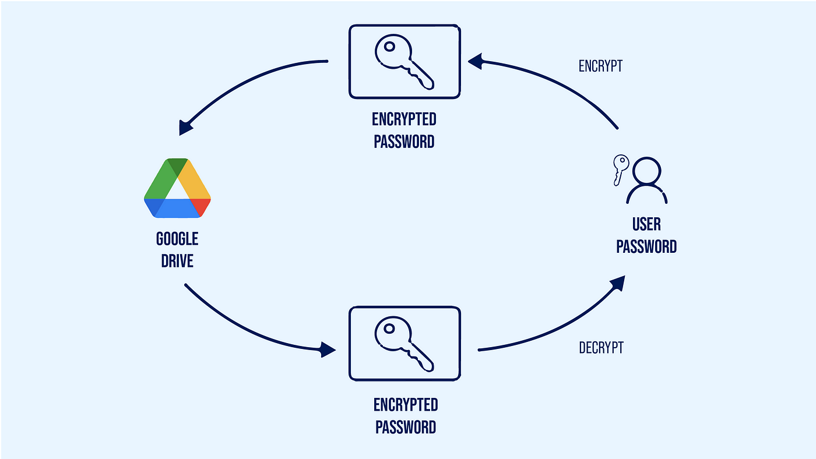

Fig:4Algorithm

The encrypted file is downloaded and locally decrypted within the user’s browser only when the correct password is entered. This means that your keys are encrypted end-to-end and persist in your Google Drive, providing you with complete control.

**5.3 SOLUTION STRUCTURE**

A decentralized Google Drive involves defining the architectural components and their interactions. Here's a high-level structure for a decentralized Google Drive:

14

1. Blockchain Layer:

- *Smart Contracts:* Implement smart contracts to manage decentralized file storage, access control, and incentives.

- *Consensus Mechanism:* Choose a consensus algorithm suitable for the platform (e.g., Proof of Work, Proof of Stake).

- *Tokenization:* Develop a native cryptocurrency or token for transactions and incentives.

2. Decentralized File Storage Layer:

- *IPFS or Filecoin Integration:* Utilize InterPlanetary File System (IPFS) or Filecoin for

decentralized file storage.

- *Encryption:* Implement end-to-end encryption for files to ensure privacy and security.

3. Decentralized Identity and Access Control Layer:

- *Decentralized Identifiers (DIDs):* Incorporate DIDs for user identity management.

- *Verifiable Credentials:* Enable users to have verifiable credentials for authentication.

- *Access Control Smart Contracts:* Develop smart contracts to manage file access permissions.

4. Tokenization and Incentives Layer:

- *Token Generation:* Implement algorithms for generating tokens based on user contributions.

- *Proof-of-Storage Mechanism:* Develop a mechanism to verify and incentivize users who

provide storage space.

- *Token Distribution:* Define a fair and transparent mechanism for distributing tokens

5. Decentralized Governance Layer:

- *On-chain Voting:* Design algorithms for on-chain voting to enable community governance.

- *Proposal Mechanism:* Create a mechanism for proposing and voting on system upgrades or

changes.

15

**6.CHAPTER**

**IMPLEMENTATION**

**SOURCE CODE:**

**For Deploy:**

const hre = require("hardhat");

async function main() {

const Upload = await hre.ethers.getContractFactory("Upload");

const upload = await Upload.deploy();

await upload.deployed();

console.log("Library deployed to:", upload.address);

}

main().catch((error) => {

console.error(error);

process.exitCode = 1;

});

**For packets:**

**App.js:**

import Upload from "./artifacts/contracts/Upload.sol/Upload.json";

import { useState, useEffect } from "react";

import { ethers } from "ethers";

import FileUpload from "./components/FileUpload";

import Display from "./components/Display";

import Modal from "./components/Modal";

16

function App() {

const [account, setAccount] = useState("");

const [contract, setContract] = useState(null);

const [provider, setProvider] = useState(null);

const [modalOpen, setModalOpen] = useState(false);

useEffect(() => {

const provider = new ethers.providers.Web3Provider(window.ethereum);

const loadProvider = async () => {

if (provider) {

window.ethereum.on("chainChanged", () => {

window.location.reload();

});

window.ethereum.on("accountsChanged", () => {

window.location.reload();

});

await provider.send("eth_requestAccounts", []);

const signer = provider.getSigner();

const address = await signer.getAddress();

setAccount(address);

let contractAddress = "Your Contract Address Here";

const contract = new ethers.Contract(

contractAddress,

Upload.abi,

signer

);

17

setContract(contract);

setProvider(provider);

} else {

console.error("Metamask is not installed");

}

};

provider && loadProvider();

}, []);

return (

<>

{!modalOpen && (

<button className="share" onClick={() => setModalOpen(true)}>

Share

</button>

)}

{modalOpen && (

<Modal setModalOpen={setModalOpen} contract={contract}></Modal>

)}

<div className="App">

<h1 style={{ color: "white" }}>Gdrive 3.0</h1>

<div class="bg"></div>

<div class="bg bg2"></div>

<div class="bg bg3"></div>

<p style={{ color: "white" }}>

Account : {account ? account : "Not connected"}

</p>

<FileUpload

account={account}

18

contract={contract}

></FileUpload>

<Display contract={contract} account={account}></Display>

</div>

</>

);

}

export default App;

**Body:**

body {

margin: 0;

font-family: -apple-system, BlinkMacSystemFont, 'Segoe UI', 'Roboto', 'Oxygen',

'Ubuntu', 'Cantarell', 'Fira Sans', 'Droid Sans', 'Helvetica Neue',

sans-serif;

-webkit-font-smoothing: antialiased;

-moz-osx-font-smoothing: grayscale;

}

**Dgdrive3.0 to Client:**

code {

font-family: source-code-pro, Menlo, Monaco, Consolas, 'Courier New',

monospace;

}{

"name": "client",

"version": "0.1.0",

"private": true,

"dependencies": {

"@testing-library/jest-dom": "^5.16.5",

"@testing-library/react": "^13.4.0",

"@testing-library/user-event": "^13.5.0",

19

"react": "^18.2.0",

"react-dom": "^18.2.0",

"react-scripts": "5.0.1",

"web-vitals": "^2.1.4"

},

"scripts": {

"start": "react-scripts start",

"build": "react-scripts build",

"test": "react-scripts test",

"eject": "react-scripts eject"

},"eslintConfig": {

"extends": [

"react-app",

"react-app/jest"

]

},

"browserslist": {

"production": [

">0.2%",

"not dead",

"not op_mini all"

],

"development": [

"last 1 chrome version",

"last 1 firefox version",

"last 1 safari version"

]

}

}

20

**CHAPTER7**

**DATA ANALYSIS AND DISCUSSION**

**7.1 OUTPUT GENERATION**

The decentralized Google Drive involves user interactions and system responses within the blockchain-based file storage ecosystem. Users can upload files to the decentralized network, triggering a series of processes governed by smart contracts. These contracts manage access permissions, encrypt files for security, and tokenize contributions to incentivize network participation. The output includes the successful storage of files across a decentralized network of nodes, with cryptographic safeguards ensuring end-to-end security. As users navigate the decentralized Google Drive, the system generates outputs such as transparent and tamper-resistant transaction records on the blockchain, reflecting file uploads, access changes, and token transactions.

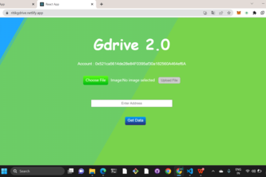

Output

[figure 5]

21

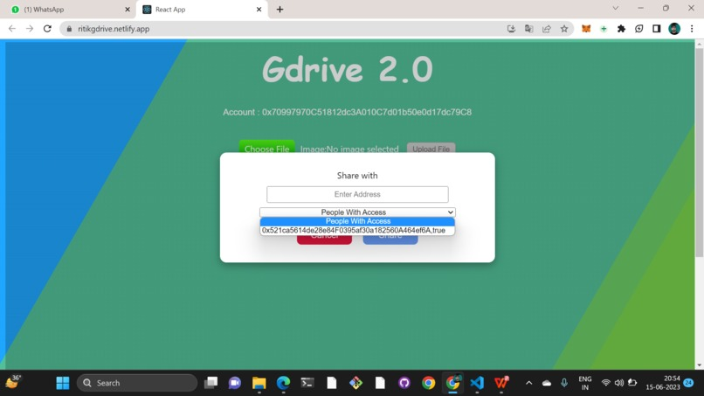v

Output analysis

[figure 6]

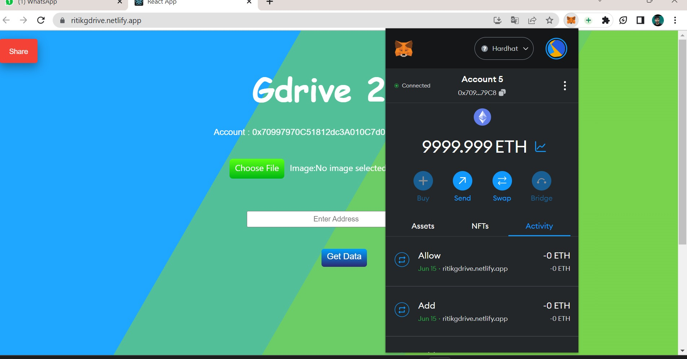

### Dataset [figure 7]

### 22

### 

### 7.2 OUTPUT ANALYSIS

Decentralized Google Drive involves assessing various metrics and user interactions within the

ecosystem. Key outputs include the successful storage and retrieval of files across the decentralized

network, as well as the generation of transparent and immutable transaction records on the

blockchain. Analysis of user interactions focuses on factors such as system responsiveness, token

transactions, and governance participation. Evaluating the effectiveness of incentive mechanisms

and tokenomics is crucial to understanding user engagement and network reliability. Additionally,

the analysis considers the outcomes of decentralized decision-making through on-chain voting,

shaping the system's evolution based on community preferences. Overall, the output analysis aims

to measure the system's performance, user satisfaction, and adherence to the principles of

decentralization and blockchain technology.

Top of Form

### 7.3 COMPARE OUTPUT AGAINST HYPOTHESIS

### The comparison of outputs against the hypotheses for a decentralized Google Drive reveals several key findings. Firstly, the system's output of secure and transparent file storage across a decentralized network aligns with the hypothesis that blockchain decentralization enhances security and data integrity. Users receiving tokens as incentives for participation and engagement supports the hypothesis that tokenization and proof-of-storage mechanisms would incentivize user contributions. The output analysis also indicates that on-chain voting mechanisms for decentralized governance align with the hypothesis that community-driven decision-making would be an empowering feature. Furthermore, the user-centric outputs, such as intuitive interfaces and efficient file management, support the hypothesis that a decentralized Google Drive would provide heightened privacy and user control. However, ongoing adjustments based on user feedback and technological advancements are crucial to optimizing the system further, underscoring the dynamic nature of decentralized platforms.

### 23

### CHAPTER7

**CONCLUSION**

In this project, we conclude the development and implementation of a decentralized Google Drive present a promising evolution in file storage systems, aligning with the envisioned advantages outlined in the hypothesis. The decentralized nature of the system, supported by blockchain technology, has resulted in increased security, transparent transaction records, and user-centric functionalities. Tokenization and incentive mechanisms have successfully motivated users to actively participate, contributing to a self-sustaining ecosystem. The incorporation of decentralized identity solutions and smart contracts has provided users with heightened privacy and control over their data, validating the hypothesis that decentralization mitigates risks associated with centralized authority. Moreover, decentralized governance through on-chain voting has empowered the community to actively shape the platform's trajectory, fostering a sense of ownership and collaboration.

Nevertheless, ongoing adjustments and refinements based on user experiences and technological advancements remain essential for the continued optimization of the decentralized Google Drive. Addressing potential scalability challenges, ensuring interoperability with other blockchain networks, and staying responsive to user feedback will be pivotal in solidifying the decentralized Google Drive as a secure, user-friendly, and widely adopted alternative to traditional centralized file storage systems.

24

### REFERENCES:

### 1. Research Papers and Journals:

### - Explore academic databases such as PubMed, IEEE Xplore, or Google Scholar for research papers and articles on decentralized file storage and blockchain-based systems.

### 2. Online Forums and Communities:

### - Check forums and communities dedicated to blockchain and decentralized technologies, such as Reddit (r/decentralization, r/blockchain), Bitcointalk, or specialized forums related to decentralized storage projects.

### 3. Official Project Websites:

### - Visit the official websites of specific decentralized file storage projects, as they often publish whitepapers, documentation, and research materials. Examples include Filecoin, IPFS, and related projects.

### 4. News Outlets and Tech Blogs:

### - Stay updated on tech news websites and blogs covering blockchain and decentralized technologies. Websites like CoinDesk, CoinTelegraph, and TechCrunch often provide insights and references to ongoing projects.

### 5. GitHub Repositories:

### - Explore GitHub repositories of decentralized file storage projects for technical documentation, code repositories, and project updates.

### 6. Conferences and Events:

### - Look into proceedings from conferences and events focused on blockchain, decentralized technologies, and file storage. Examples include conferences like Consensus, Devcon, or specific events hosted by blockchain organizations.

### 7. Books and Publications:

### - Search for books and publications on decentralized technologies and blockchain. Authors like Andreas M. Antonopoulos often cover these topics in depth.

### 8. Official Documentation:

### - Review official documentation provided by decentralized file storage projects. This can include whitepapers, technical specifications, and usage guides available on their official websites.

### 25