**DevOps**

Day 5

Assignment

Name : DEEPIKA P M

Roll no :22CSR041

PIPELINE

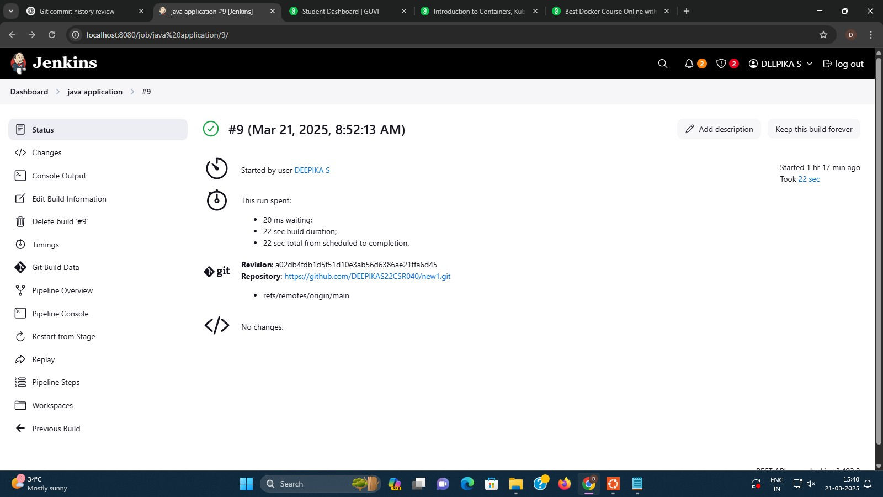



**Visudo:**

1. sudo visudo
2. Add jenkins ALL=(ALL) NOPASSWD: ALL

**ssh installtion:**

1. sudo systemctl restart ssh.service
2. sudo systemctl restart sshd.service
3. sudo apt update
4. sudo apt install openssh-server
5. sudo systemctl restart ssh
6. sudo systemctl status ssh
7. ls /etc/systemd/system/sshd.service or ls /usr/lib/systemd/system/sshd.service
8. sudo systemctl daemon-reload
9. sudo systemctl status ssh

**Deployment:**

1. cd ~/.kube
2. ls
3. cat config
4. sudo vi config
5. i
6. -data
7. cat url | base64 -w 0; echo
8. minikube start
9. kubectl get node

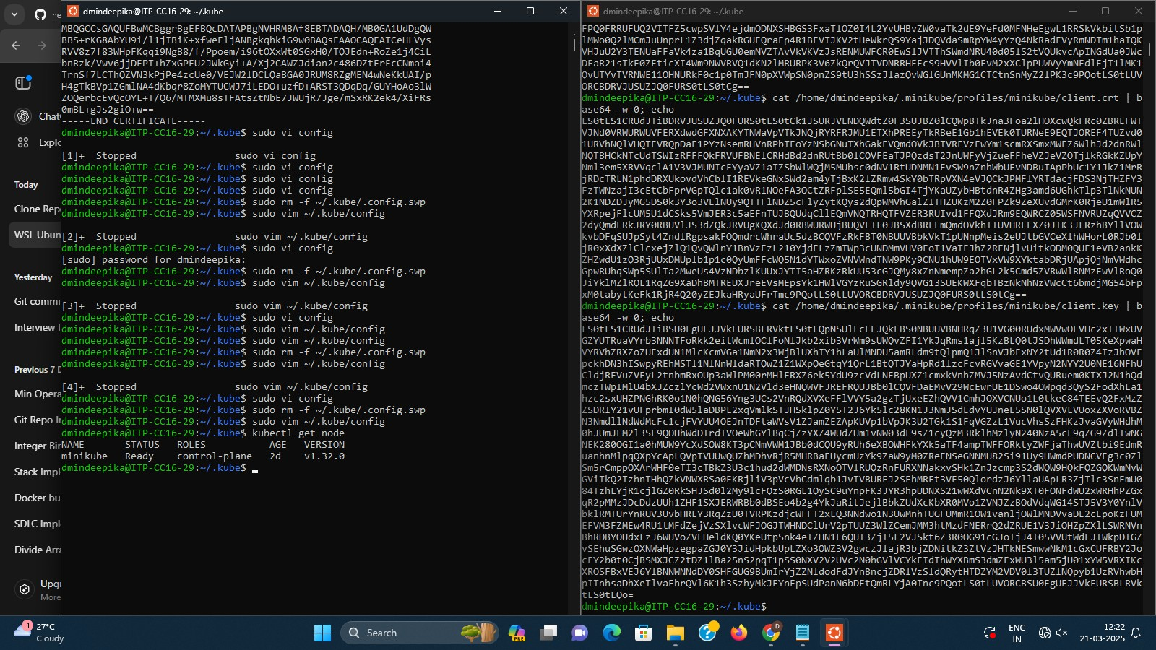

**Deployment.yml**

apiVersion: apps/v1 kind: Deployment metadata:

name: my-deploy

labels: name: my-deploy spec:

replicas: 1 selector:

matchLabels:

apptype: web-backend strategy:

type: RollingUpdate template: metadata:

labels:

apptype: web-backend spec: containers: - name: my-app

image: ports:

- containerPort: 7070

---

apiVersion: v1 kind: Service

metadata: name: my-service

labels: app: my-service type: backend-app spec: type: NodePort

ports: - targetPort: 8080 port: 7070 nodePort: 30002 selector: apptype: web-backend **JenkinsFile - pipeline script** pipeline { agent any

stages { stage('scm') { steps {

git branch: 'main', url: 'https://github.com/DEBEHAA/new1.git'

}

}

stage('build') { steps { sh 'mvn clean' sh 'mvn install'

}

}

stage('build to images') {

steps { script {

sh 'docker build -t deepika040/mysimplewebapplication .'

}

}

}

stage('push to hub') {

steps { script {

withDockerRegistry(credentialsId: 'docker-hub-credential', url: 'https://index.docker.io/v1/') { sh 'docker push DEBEHAA/mysimplewebapplication'

}

}

}

}

}

}