HerokuApp Automation Testing – Portfolio Document
Prepared by: Deepika S
Role: QA Automation Tester (Trainee)

1. Project Overview
Project Name: HerokuApp Functional UI Automation
Tool Used: Selenium with Python, PyTest
Framework Type: Page Object Model (POM)
Test Type: Functional, Smoke, and Regression Testing
Application Under Test (AUT): https://the-internet.herokuapp.com/

2. Objective
To automate multiple web features such as Login, Dropdown, Alerts, and Dynamic Loading on the HerokuApp site using Selenium WebDriver with a structured Page Object Model framework.

3. Tools & Technologies
- Programming Language: Python
- Automation Tool: Selenium WebDriver
- Test Framework: Pytest
- Reporting: pytest-html
- Browser: Chrome
- Design Pattern: Page Object Model (POM)

4. Test Flow
Login → Dropdown → Alerts → Dynamic Loading → Result Validation → Screenshot Capture

5. Project Structure
HerokuApp_Automation/
│
├── pages/
│ ├── base_page.py
│ ├── home_page.py
│ ├── login_page.py
│ ├── dropdown_page.py
│ ├── alert_page.py
│ └── dynamic_loading_page.py
│
├── tests/
│ ├── test_login.py
│ └── test_app_feature.py
│
├── utils/
│ └── screenshot.py
│
├── conftest.py
└── requirements.txt

6. Test Scenarios
Test Case ID | Scenario Description | Expected Result
TC001 | Verify valid login | Login successful message displayed
TC002 | Verify invalid login | Error message displayed
TC003 | Select options in dropdown | Correct option displayed
TC004 | Handle all JavaScript alerts | Alerts handled correctly
TC005 | Verify dynamic content load | ‘Hello World!’ displayed

7. Simulated Bug Example

Simulated Bug Example – HerokuApp Application
Field | Details
Bug Title | Incorrect Error Message Displayed for Invalid Login
Severity | High
Priority | Medium
Tested URL | https://the-internet.herokuapp.com/login
Steps to Reproduce | 1.Go to login page  2.Enter username: tomsmith  3.Enter password: wrongpass  4.Enter Login
Expected Result | Error message should display: “Your password is invalid!”
Actual Result | Error message displayed: “Your username is invalid!”
Screenshot | login_invalid_tomsmith.png
Status | Simulated Bug – Created to demonstrate real-world defect documentation.
Description:
This simulated bug demonstrates a negative login validation mismatch, showcasing critical thinking in identifying text-based UI errors. The automation script test_login.py validates both positive and negative cases.

7. Script Implementation

Base Page
from selenium.webdriver.support.ui import WebDriverWait
from selenium.webdriver.support import expected_conditions as EC
from selenium.webdriver.common.by import By
import os

class BasePage:
def __init__(self, driver):
self.driver = driver
self.wait = WebDriverWait(driver, 20)

def click(self, locator):
self.wait.until(EC.element_to_be_clickable(locator)).click()

def send_keys(self, locator, text):
self.wait.until(EC.element_to_be_clickable(locator)).send_keys(text)

def get_text(self, locator):
return self.wait.until(EC.visibility_of_element_located(locator)).text

Home Page

from selenium.webdriver.common.by import By
from pages.base_page import BasePage

class HomePage(BasePage):

DROPDOWN_LINK = (By.LINK_TEXT, "Dropdown")
ALERTS_LINK = (By.LINK_TEXT, "JavaScript Alerts")
DYNAMIC_LOADING_LINK = (By.LINK_TEXT, "Dynamic Loading")

def open(self):
self.driver.get("https://the-internet.herokuapp.com/")

def go_to_dropdown(self):
self.click(self.DROPDOWN_LINK)

def go_to_alerts(self):
self.click(self.ALERTS_LINK)

def go_to_dynamic_loading(self):
self.click(self.DYNAMIC_LOADING_LINK)

Login Page
from selenium.webdriver.common.by import By
from selenium.webdriver.support.ui import WebDriverWait
from selenium.webdriver.support import expected_conditions as EC

class LoginPage:
URL = "https://the-internet.herokuapp.com/login" # page-specific URL

def __init__(self, driver):
self.driver = driver
self.wait = WebDriverWait(driver, 10)

# Open page
def open(self):
self.driver.get(self.URL)

# Locators
username_input = (By.ID, "username")
password_input = (By.ID, "password")
login_button = (By.CSS_SELECTOR, "button[type='submit']")
success_message = (By.ID, "flash")

# Actions
def enter_username(self, username):
self.wait.until(EC.visibility_of_element_located(self.username_input)).send_keys(username)

def enter_password(self, password):
self.wait.until(EC.visibility_of_element_located(self.password_input)).send_keys(password)

def click_login(self):
self.wait.until(EC.element_to_be_clickable(self.login_button)).click()

def get_success_message(self):
return self.wait.until(EC.visibility_of_element_located(self.success_message)).text

Dropdown Page
from selenium.webdriver.common.by import By
from selenium.webdriver.support.ui import Select
from pages.base_page import BasePage

class DropdownPage(BasePage):
DROPDOWN = (By.ID, "dropdown")

def select_by_text(self, text):
select_element = self.wait.until(lambda d: d.find_element(*self.DROPDOWN))
select = Select(select_element)
select.select_by_visible_text(text)
return select.first_selected_option.text

def select_by_value(self, value):
select_element = self.wait.until(lambda d: d.find_element(*self.DROPDOWN))
select = Select(select_element)
select.select_by_value(value)
return select.first_selected_option.text

Alert Page

from selenium.webdriver.common.by import By
from pages.base_page import BasePage

class AlertPage(BasePage):

JS_ALERT_BTN = (By.XPATH, "//button[text()='Click for JS Alert']")
JS_CONFIRM_BTN = (By.XPATH, "//button[text()='Click for JS Confirm']")
JS_PROMPT_BTN = (By.XPATH, "//button[text()='Click for JS Prompt']")
RESULT_TEXT = (By.ID, "result")

def handle_js_alert(self):
self.click(self.JS_ALERT_BTN)
alert = self.driver.switch_to.alert
alert.accept()
return "JS Alert handled"

def handle_js_confirm(self):
self.click(self.JS_CONFIRM_BTN)
alert = self.driver.switch_to.alert
alert.dismiss()
return "JS Confirm handled"

def handle_js_prompt(self, message):
self.click(self.JS_PROMPT_BTN)
alert = self.driver.switch_to.alert
alert.send_keys(message)
alert.accept()
return self.get_text(self.RESULT_TEXT)

Dynamic Loading Page

from selenium.webdriver.common.by import By
from pages.base_page import BasePage

class DynamicLoadingPage(BasePage):

START_BUTTON = (By.XPATH, "//div[@id='start']/button")
FINISH_TEXT = (By.ID, "finish")
EXAMPLE2_LINK = (By.LINK_TEXT, "Example 2: Element rendered after the fact")

def open_example2(self):
self.click(self.EXAMPLE2_LINK)

def start_loading(self):
self.click(self.START_BUTTON)
return self.get_text(self.FINISH_TEXT)

Conftest

# conftest.py
import os
import pytest
from selenium import webdriver
from selenium.webdriver.chrome.service import Service as ChromeService
from selenium.webdriver.chrome.options import Options as ChromeOptions
from webdriver_manager.chrome import ChromeDriverManager

def create_chrome_driver():
"""Create Chrome driver with all automation warnings and popups disabled."""
chrome_options = ChromeOptions()

# Stable launch arguments
chrome_options.add_argument("--start-maximized")
chrome_options.add_argument("--no-sandbox")
chrome_options.add_argument("--disable-dev-shm-usage")
chrome_options.add_argument("--disable-gpu")
chrome_options.add_argument("--disable-notifications")
chrome_options.add_argument("--disable-infobars")
chrome_options.add_argument("--disable-popup-blocking")

# Disable Chrome password manager + popup
chrome_options.add_experimental_option("prefs", {
"credentials_enable_service": False,
"profile.password_manager_enabled": False
})
chrome_options.add_argument("--disable-save-password-bubble")
chrome_options.add_argument("--disable-password-manager-reauthentication")

# Suppress “Chrome is being controlled by automated test software”
chrome_options.add_experimental_option("excludeSwitches", ["enable-automation"])
chrome_options.add_experimental_option("useAutomationExtension", False)
chrome_options.add_argument("--disable-blink-features=AutomationControlled")

# Create Chrome driver
driver = webdriver.Chrome(
service=ChromeService(ChromeDriverManager().install()),
options=chrome_options
)
return driver

@pytest.fixture
def chrome_driver():
driver = create_chrome_driver()
yield driver
driver.quit()

Test_login

# tests/test_login.py
import pytest
from pages.login_page import LoginPage
from utils.screenshot import take_screenshot

@pytest.mark.parametrize(
"username,password,expected",
[
("tomsmith", "SuperSecretPassword!", True),
("tomsmith", "wrongpass", False),
("wronguser", "SuperSecretPassword!", False)
]
)
def test_login(chrome_driver, username, password, expected):
driver = chrome_driver
login_page = LoginPage(driver)
login_page.open()
take_screenshot(driver, "login_page_opened")
login_page.enter_username(username)
login_page.enter_password(password)
login_page.click_login()
take_screenshot(driver, f"login_after_click_{username}")

flash_text = login_page.get_success_message()
try:
if expected:
assert "You logged into a secure area!" in flash_text
take_screenshot(driver, f"login_success_{username}")
else:
assert "Your username is invalid!" in flash_text or "Your password is invalid!" in flash_text
take_screenshot(driver, f"login_invalid_{username}")
except AssertionError:
take_screenshot(driver, f"login_fail_{username}")
raise

Test_app_feature

import pytest
from pages.home_page import HomePage
from pages.dropdown_page import DropdownPage
from pages.alert_page import AlertPage
from pages.dynamic_loading_page import DynamicLoadingPage
from utils.screenshot import take_screenshot

class TestHerokuApp:

def test_herokuapp_all(self, chrome_driver):
driver = chrome_driver
home = HomePage(driver)
home.open()
take_screenshot(driver,"home_page_opened")

# ---------------- Dropdown ----------------
home.go_to_dropdown()
dropdown = DropdownPage(driver)
assert dropdown.select_by_text("Option 1") == "Option 1"
assert dropdown.select_by_value("2") == "Option 2"
take_screenshot(driver,"dropdown_selected_options")
driver.back()

# ---------------- Alerts ----------------
home.go_to_alerts()
alert_page = AlertPage(driver)
assert alert_page.handle_js_alert() == "JS Alert handled"
assert alert_page.handle_js_confirm() == "JS Confirm handled"
assert "Deepika - QA Tester" in alert_page.handle_js_prompt("Deepika - QA Tester")
take_screenshot(driver,"alerts_all_handled")
driver.back()

# ---------------- Dynamic Loading ----------------
home.go_to_dynamic_loading()
dyn_page = DynamicLoadingPage(driver)
dyn_page.open_example2()
take_screenshot(driver,"dynamic_loading_page_opened")
assert dyn_page.start_loading() == "Hello World!"
take_screenshot(driver,"dynamic_loading_completed")

8. Screenshots
8.1 Login Page Screenshot
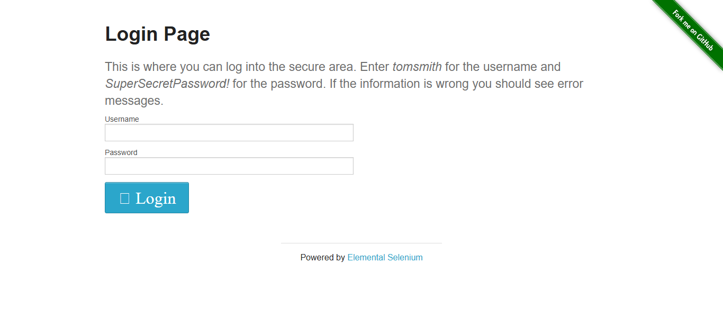
Figure 1: Login Page – HerokuApp Login Screen Opened

8.2 Successful Login Screenshot
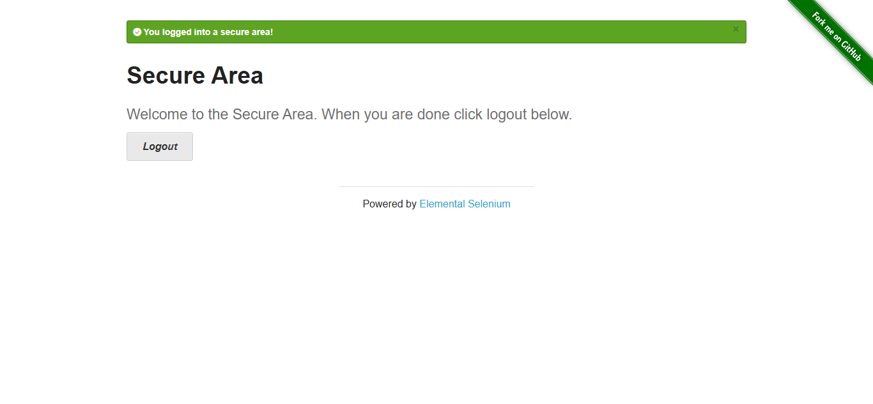Figure 2: Successful Login – Secure Area Message Displayed

8.3 Invalid Login Attempt Screenshot
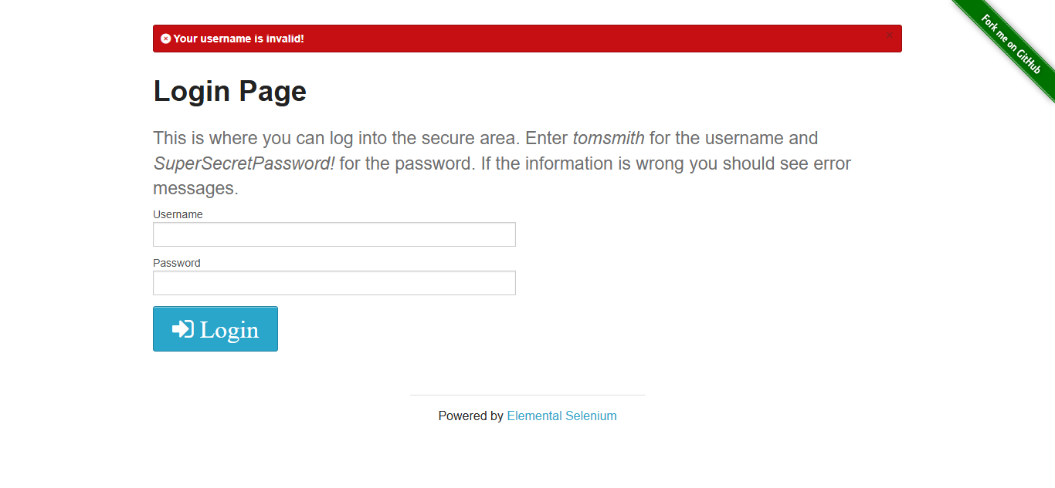
Figure 3: Invalid Login Attempt – Error Message Displayed
8.4 Invalid Login Attempt Screenshot
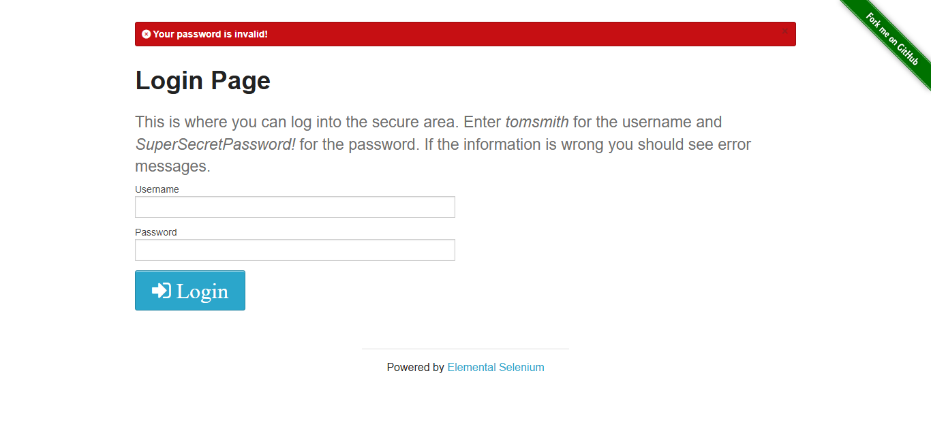
Figure 4: Invalid Login Attempt – Error Message Displayed

8.5 Home Page Screenshot
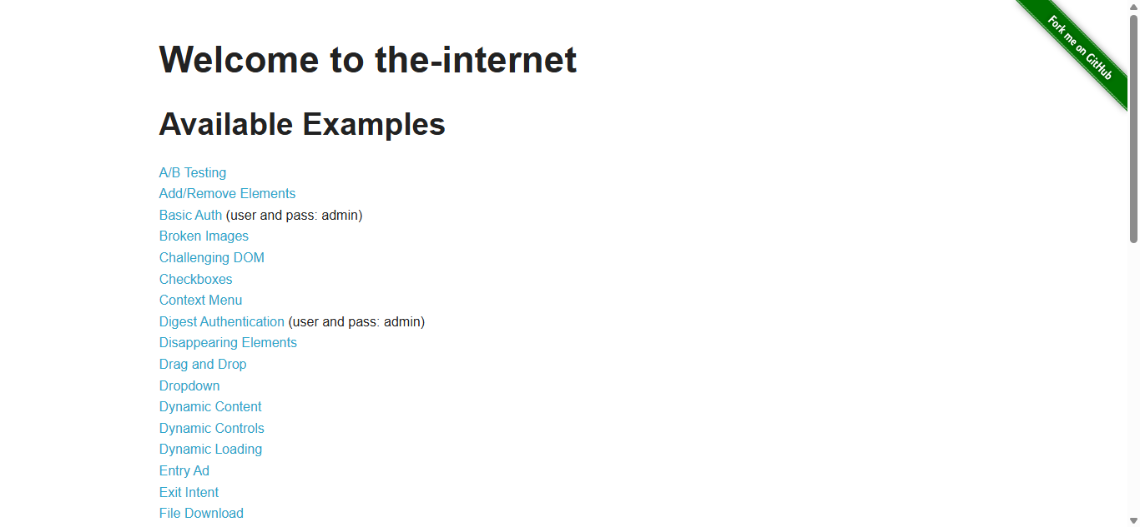
Figure 5: HerokuApp Home Page – Feature Navigation Displayed
8.6 Dropdown Selection Screenshot
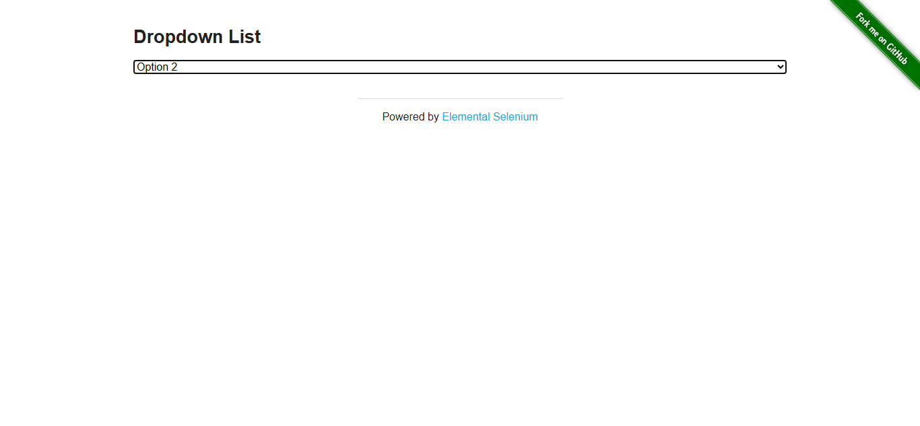Figure 6: Dropdown Feature – Options Selected Successfully

8.7 Alert Handling Screenshot
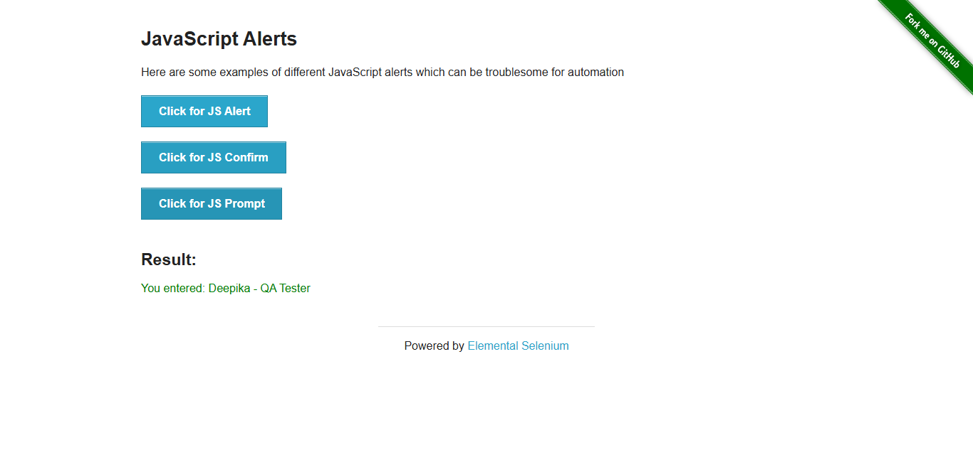
Figure 7: JavaScript Alerts – Handled Successfully
8.8 Dynamic Loading Page Screenshot
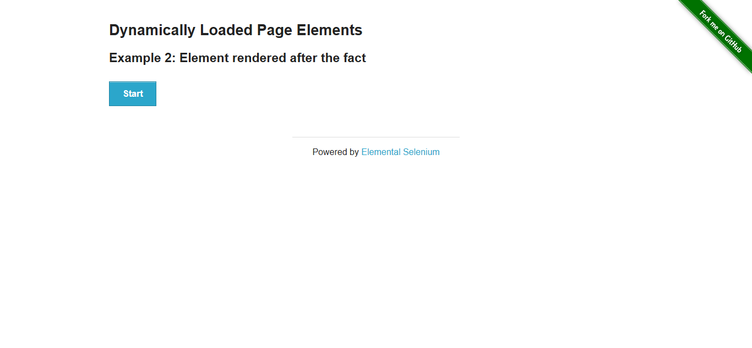Figure 8: Dynamic Loading Page – Example 2 Opened

8.9 Dynamic Loading Completed Screenshot
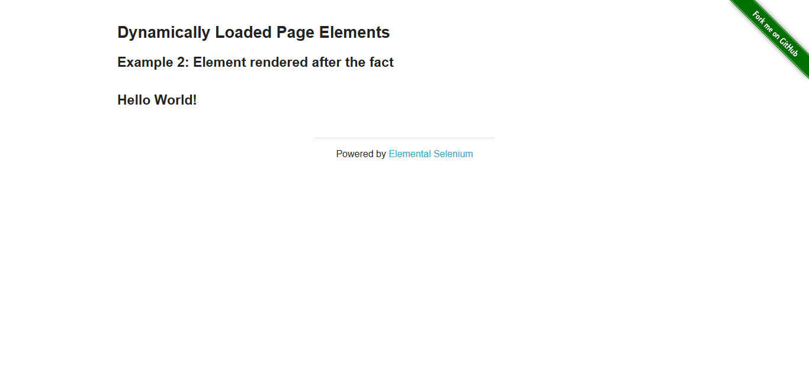Figure 9: Dynamic Loading Completed – “Hello World!” Message Displayed
8.10 Pytest HTML Report Screenshot
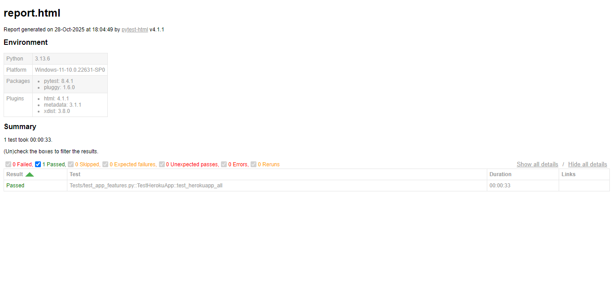
Click here to view the full HTML test reportFINAL AUTOMATION PROJECT1\report.html
Figure 10: Pytest HTML Report – Test Execution Summary

8.11 Folder Structure Screenshot
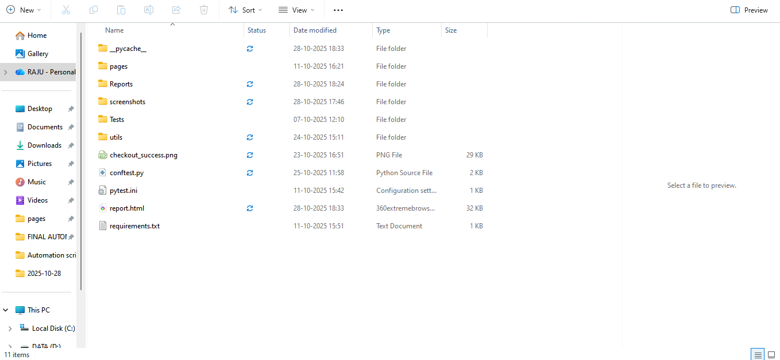
Figure 11: Folder Structure – Organized Project Files (Pages, Tests, Utils)

8.12 Allure Report Screenshots
Purpose: To show advanced reporting integration in your QA automation project.
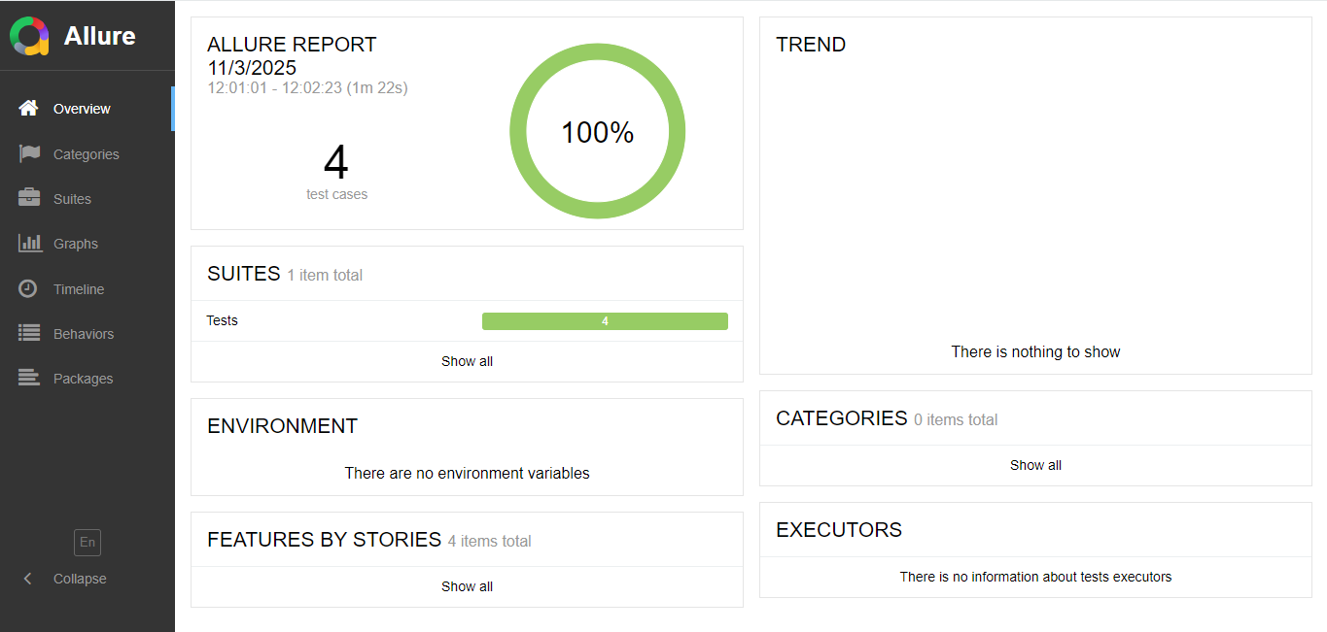
Figure 12: Allure Dashboard Overview – Displays total passed/failed test summary and trend graph.

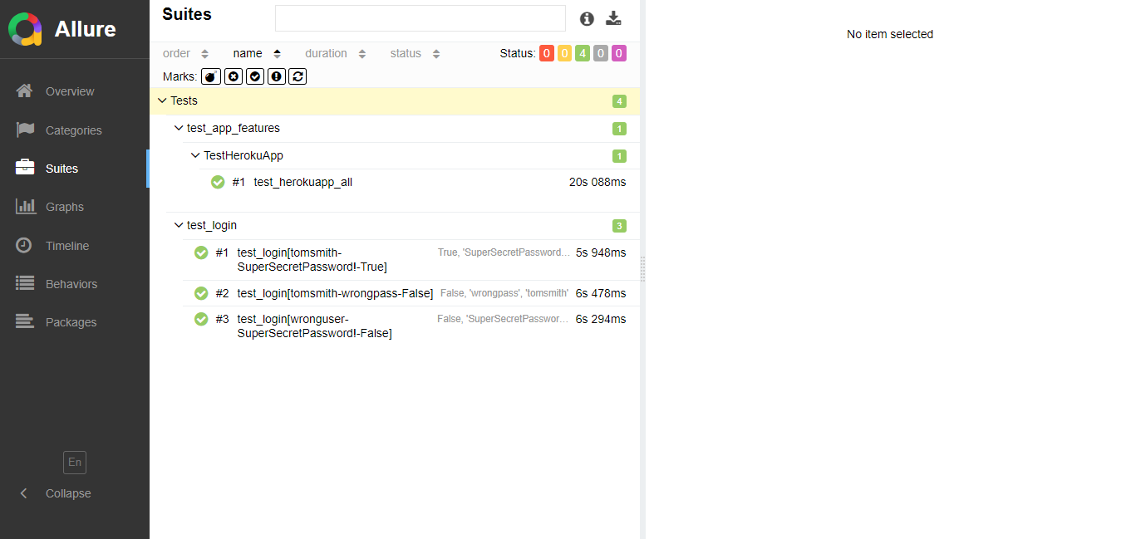
Figure 13: Allure Suites View – Shows organized test suites and their execution status.
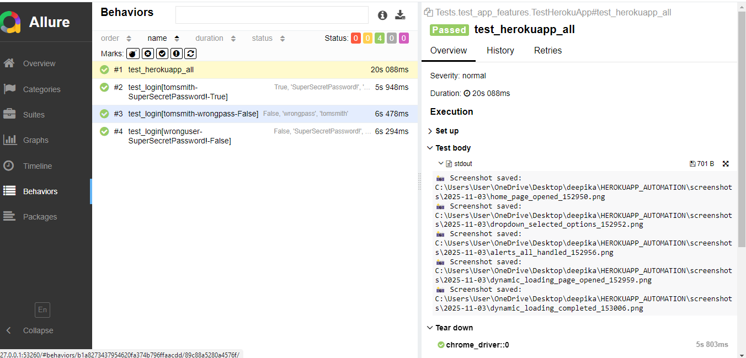
Figure 14: Allure Behaviors View – Represents test coverage based on features and scenarios.
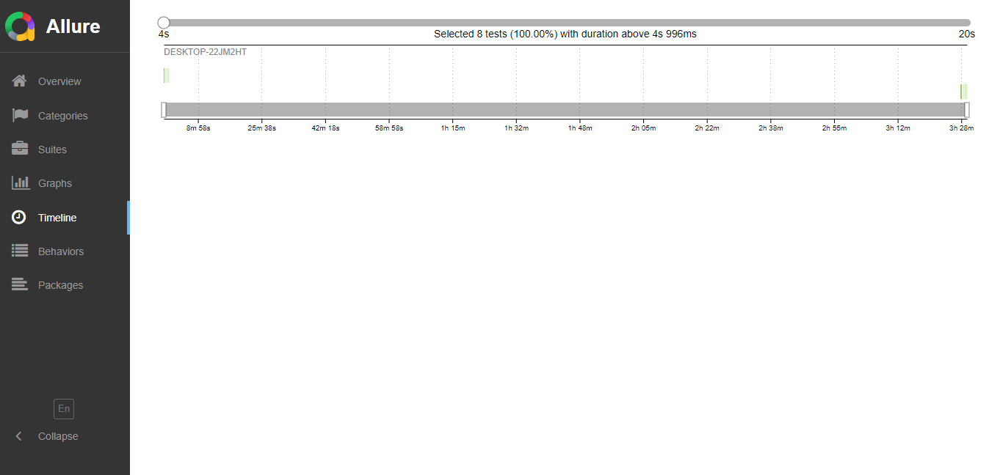
Figure 15: Allure Timeline View – Displays duration and parallel execution of test cases.
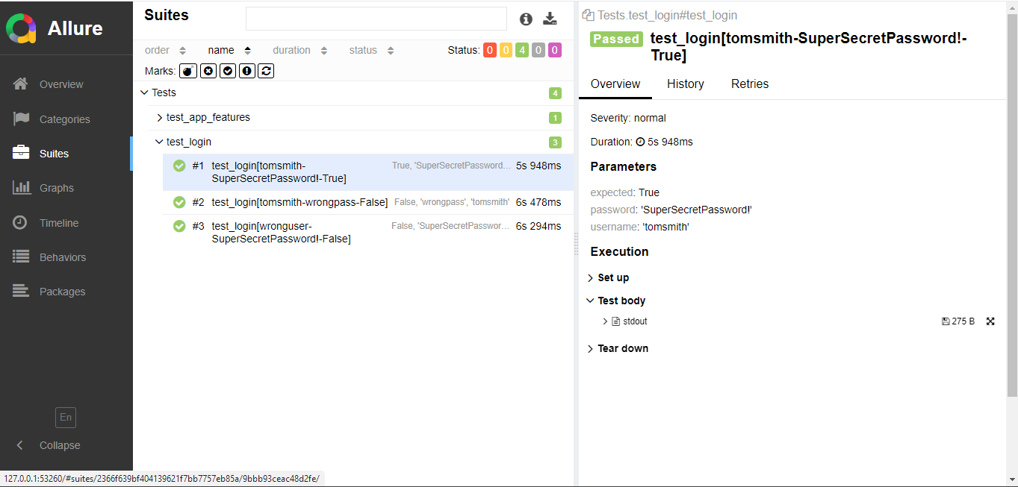
Figure 16: Allure Test Case Detail – Shows step-by-step logs of a specific test case.

9. Result Summary
Total Test Cases | 5
Passed | 5
Failed | 0
Browser | Chrome
Execution Time | ~1.5 minutes

10. Conclusion
This project demonstrates automation of multiple HerokuApp functionalities using Python, Selenium, and Pytest
following the Page Object Model (POM) design pattern. Screenshots are captured at every test step for better traceability,
and test results confirm smooth functional execution across all modules.

11. Future Integrations & Version Control Setup
Integrated Allure Reporting for test visualization
Added requirements.txt for one-click environment setup
Captured and documented Simulated Bug Example
Uploaded project to GitHub (Public Repository) for visibility
Ready for CI/CD integration (GitHub Actions) for continuous testing
GitHub Repository Link:
https://github.com/deepika-sekar-qa/DeepikaS_QA_Automation_Portfolio

