SauceDemo Automation Testing – Portfolio Document
Prepared by: Deepika S
Role: QA Automation Tester (Portfolio Project)

1. Project Overview
Project Name: SauceDemo E2E Automation Testing
Tool Used: Selenium with Python, PyTest
Framework Type: Page Object Model (POM)
Test Type: Functional & End-to-End UI Automation
Application Under Test (AUT): https://www.saucedemo.com/

2. Objective
To automate a complete purchase flow on SauceDemo, starting from login → adding product → checkout → verifying successful order completion.

3. Tools & Technologies
- Programming Language: Python
- Automation Tool: Selenium WebDriver
- Test Framework: Pytest
- Reporting: pytest-html
- Browser: Chrome
- Design Pattern: Page Object Model (POM)

4. Test Flow Diagram (Optional)
Login → Add to Cart → View Cart → Checkout Info → Order Confirmation

5. Project Structure
SauceDemo_Automation/
│
├── Pages/
│ ├── base_page_saucedemo.py
│ ├── login_page_saucedemo.py
│ ├── inventory_page_saucedemo.py
│ ├── cart_page_saucedemo.py
│ └── checkout_page_saucedemo.py
│
├── Tests/
│ └── test_saucedemo_e2e.py
│
├── Reports/
│ ├── report.html
│ └── checkout_success.png

6. Test Scenarios
Test Case ID | Scenario Description | Expected Result
TC001 | Verify successful login | User navigates to inventory page
TC002 | Add product to cart | Product added successfully
TC003 | Proceed to checkout | Checkout page opens
TC004 | Fill checkout info | Info accepted and continued
TC005 | Complete order | “THANK YOU” message displayed

7. Simulated Bug Example

Simulated Bug Example – SauceDemo Application
Field | Details
Bug Title | Incorrect Cart Badge Count After Adding Items
Severity | Medium
Priority | High
Tested URL | https://www.saucedemo.com/
Steps to Reproduce | 1.Loginwith standard_user / secret_sauce  2.Add 2 products to cart  3.Click the cart icon
Expected Result | Cart badge should display “2” items.
Actual Result | Cart badge displays “1” instead of “2”.
Screenshot | cart_bug_simulation.png
Status | Simulated Bug – Added for demonstration of real QA reporting.
Description:
This simulated bug highlights the QA tester’s ability to catch UI-to-logic mismatches in e-commerce workflows. It emphasizes the verification of cart count accuracy, a common defect in web applications.

7. Script Implementation

Base Page
from selenium.webdriver.support.ui import WebDriverWait
from selenium.webdriver.support import expected_conditions as EC

class BasePage:
def __init__(self, driver):
self.driver = driver
self.wait = WebDriverWait(driver, 30)

def open(self, url):
self.driver.get(url)

def click(self, locator):
element = self.wait.until(EC.element_to_be_clickable(locator))
element.click()

def type(self, locator, text):
element = self.wait.until(EC.visibility_of_element_located(locator))
element.clear()
element.send_keys(text)

def get_text(self, locator):
element = self.wait.until(EC.visibility_of_element_located(locator))
return element.text

Login Page
from selenium.webdriver.common.by import By
from pages.base_page_saucedemo import BasePage

class LoginPage(BasePage):
USERNAME = (By.ID, "user-name")
PASSWORD = (By.ID, "password")
LOGIN_BUTTON = (By.ID, "login-button")

def open_login_page(self):
self.open("https://www.saucedemo.com/")

def login(self, username, password):
self.type(self.USERNAME, username)
self.type(self.PASSWORD, password)
self.click(self.LOGIN_BUTTON)

Inventory Page
from selenium.webdriver.common.by import By
from selenium.webdriver.support.ui import WebDriverWait
from selenium.webdriver.support import expected_conditions as EC
from pages.base_page_saucedemo import BasePage

class InventoryPage(BasePage):
ADD_TO_CART_BUTTON = (By.ID, "add-to-cart-sauce-labs-backpack")
CART_ICON = (By.CLASS_NAME, "shopping_cart_link")
INVENTORY_CONTAINER = (By.ID, "inventory_container")

def wait_for_inventory_page(self):
WebDriverWait(self.driver, 10).until(
EC.visibility_of_element_located(self.INVENTORY_CONTAINER)
)

def add_to_cart(self):
print("Trying to click Add to Cart button")
WebDriverWait(self.driver, 10).until(
EC.element_to_be_clickable(self.ADD_TO_CART_BUTTON)
).click()

def go_to_cart(self):
print("Trying to click Cart icon")
cart_icon = WebDriverWait(self.driver, 10).until(
EC.element_to_be_clickable(self.CART_ICON)
)
self.driver.execute_script("arguments[0].click();", cart_icon)
print("Cart icon clicked via JavaScript")

Cart Page
from selenium.webdriver.common.by import By
from selenium.webdriver.support.ui import WebDriverWait
from selenium.webdriver.support import expected_conditions as EC

class CartPage:
CHECKOUT_BUTTON = (By.ID, "checkout")

def __init__(self, driver):
self.driver = driver
self.wait = WebDriverWait(driver, 30)

def proceed_to_checkout(self):
print("Clicking Checkout button safely...")
# Wait until button is clickable
checkout_btn = self.wait.until(EC.element_to_be_clickable(self.CHECKOUT_BUTTON))
# JS click ensures any JS listener works
self.driver.execute_script("arguments[0].click();", checkout_btn)
# Wait until URL changes to checkout-step-one.html
self.wait.until(lambda d: "checkout-step-one.html" in d.current_url)
print("Checkout page navigation triggered")

Checkout Page
from selenium.webdriver.common.by import By
from selenium.webdriver.support.ui import WebDriverWait
from selenium.webdriver.support import expected_conditions as EC
import time

class CheckoutPage:
FIRST_NAME = (By.ID, "first-name")
LAST_NAME = (By.ID, "last-name")
POSTAL_CODE = (By.ID, "postal-code")
CONTINUE_BUTTON = (By.ID, "continue")
FINISH_BUTTON = (By.ID, "finish")
SUCCESS_TEXT = (By.CLASS_NAME, "complete-header")

def __init__(self, driver):
self.driver = driver
self.wait = WebDriverWait(driver, 10)

def _react_type(self, locator, value):
"""React-safe typing method that updates Virtual DOM state"""
element = self.wait.until(EC.element_to_be_clickable(locator))
self.driver.execute_script("arguments[0].scrollIntoView(true);", element)
time.sleep(0.2)

# Focus field
self.driver.execute_script("arguments[0].focus();", element)
time.sleep(0.2)

# Clear any existing text
element.clear()
time.sleep(0.2)

# Set value and trigger React synthetic event
self.driver.execute_script("""
const [el, val] = arguments;
const lastVal = el.value;
el.value = val;
const event = new Event('input', { bubbles: true });
event.simulated = true;

// React 17+ internal event tracker
const tracker = el._valueTracker;
if (tracker) tracker.setValue(lastVal);

el.dispatchEvent(event);
""", element, value)

time.sleep(0.4)
self.driver.execute_script("arguments[0].blur();", element)
time.sleep(0.3)

def fill_checkout_info(self, first_name, last_name, postal_code):
print("Filling checkout info (React-safe typing)...")
self._react_type(self.FIRST_NAME, first_name)
self._react_type(self.LAST_NAME, last_name)
self._react_type(self.POSTAL_CODE, postal_code)

def click_continue(self):
print(" Clicking Continue button...")
btn = self.wait.until(EC.element_to_be_clickable(self.CONTINUE_BUTTON))
self.driver.execute_script("arguments[0].click();", btn)
time.sleep(1)

def click_finish(self):
print("Clicking Finish button...")
btn = self.wait.until(EC.element_to_be_clickable(self.FINISH_BUTTON))
self.driver.execute_script("arguments[0].click();", btn)
time.sleep(1)

def verify_success(self):
print(" Verifying success message...")
success = self.wait.until(EC.visibility_of_element_located(self.SUCCESS_TEXT))
assert "THANK YOU" in success.text.upper(), "Checkout failed"
print(" Checkout successful!")

self.driver.save_screenshot("checkout_success.png")
print("Screenshot saved as checkout_success.png")

Test Script (Pytest)
import time
import pytest
from selenium.webdriver.common.by import By
from selenium.common.exceptions import NoSuchElementException
from pages.login_page_saucedemo import LoginPage
from pages.inventory_page_saucedemo import InventoryPage
from pages.checkout_page_saucedemo import CheckoutPage
from pages.cart_page_saucedemo import CartPage
from utils.screenshot import take_screenshot # Reuse your screenshot utility

# POSITIVE SCENARIO – Valid Login and End-to-End Flow
@pytest.mark.positive
@pytest.mark.smoke
@pytest.mark.regression
def test_saucedemo_e2e(chrome_driver):
driver = chrome_driver

login_page = LoginPage(driver)
inventory_page = InventoryPage(driver)
cart_page = CartPage(driver)
checkout_page = CheckoutPage(driver)

# ---- Login ----
login_page.open_login_page()
login_page.login("standard_user", "secret_sauce")
take_screenshot(driver, "valid_login_success")

# ---- Inventory ----
inventory_page.wait_for_inventory_page()
inventory_page.add_to_cart()
inventory_page.go_to_cart()
take_screenshot(driver, "item_added_to_cart")

# ---- Cart ----
cart_page.proceed_to_checkout()
take_screenshot(driver, "proceed_to_checkout")

# ---- Checkout ----
checkout_page.fill_checkout_info("Deepika", "S", "600100")
checkout_page.click_continue()
checkout_page.click_finish()
checkout_page.verify_success()
take_screenshot(driver, "order_completed")

# NEGATIVE SCENARIO – Missing Username Validation
@pytest.mark.negative
def test_missing_username_validation(chrome_driver):
driver = chrome_driver

# Step 1: Open login page
login_page = LoginPage(driver)
login_page.open_login_page()
take_screenshot(driver, "login_page_opened")

# Step 2: Enter only password (no username)
password_box = driver.find_element(By.ID, "password")
password_box.send_keys("secret_sauce")
take_screenshot(driver, "entered_password_only")

# Step 3: Click Login button
login_button = driver.find_element(By.ID, "login-button")
login_button.click()
time.sleep(2)
take_screenshot(driver, "clicked_login_without_username")

# Step 4: Capture and verify the error message
try:
error_message = driver.find_element(By.CSS_SELECTOR, "h3[data-test='error']").text
print("Displayed Error:", error_message)
take_screenshot(driver, "missing_username_error")
assert "Epic sadface: Username is required" in error_message, \
"BUG FOUND: Expected validation message not displayed!"
print("Validation working correctly — Username is required message shown.")
except NoSuchElementException:
take_screenshot(driver, "error_message_not_found")
print(" BUG FOUND: No validation message displayed.")
raise

8. Test Execution
Command Used:
pytest -s Tests/test_saucedemo_e2e.py --html=Reports/report.html --self-contained-html
Execution Result: Passed

9. Screenshots

9.1. Application Screenshots
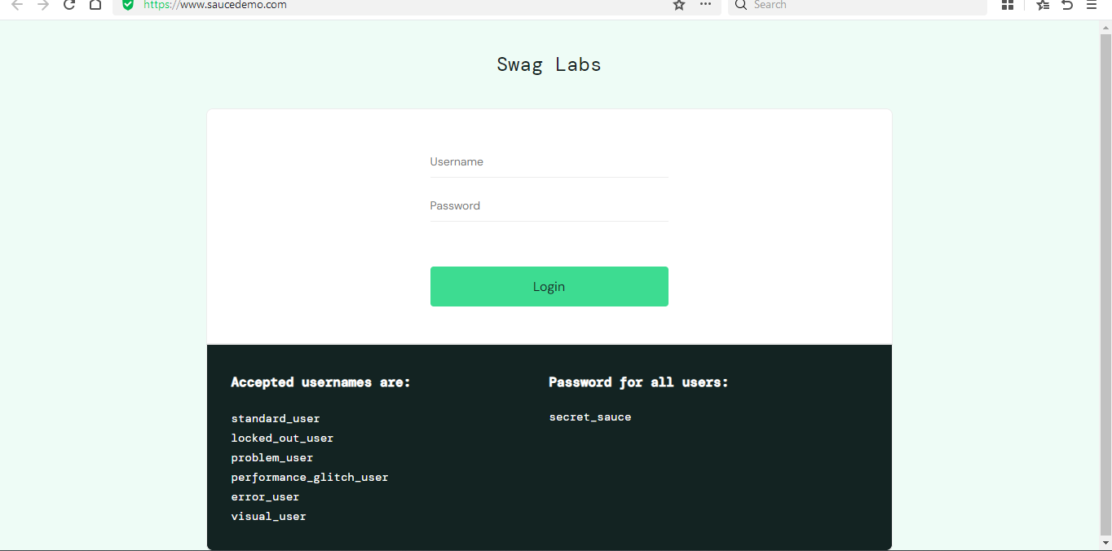
Figure 1: Login Page – SauceDemo Application
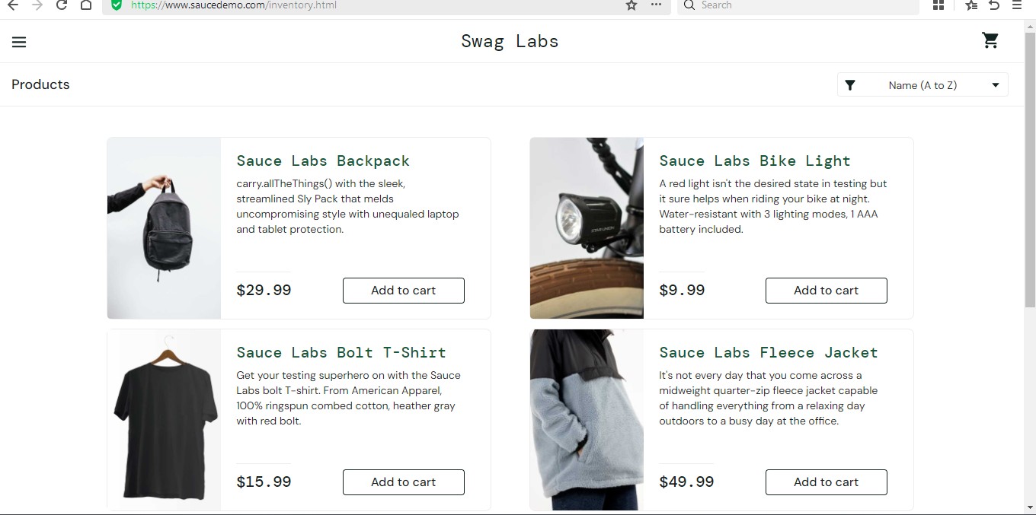
Figure 2: Inventory Page – Product Added to Cart
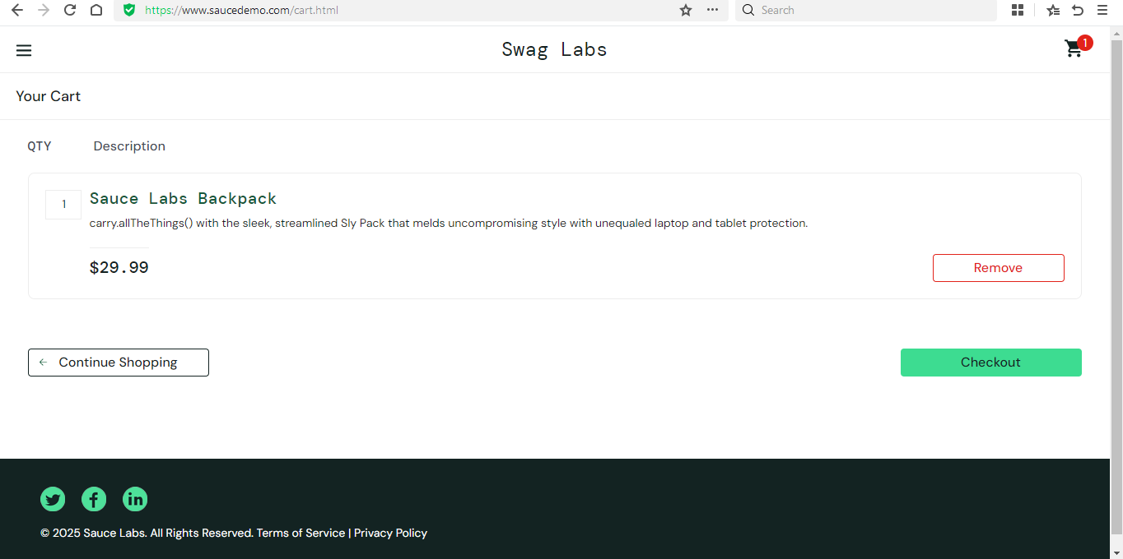
Figure 3: Cart Page – Before Checkout
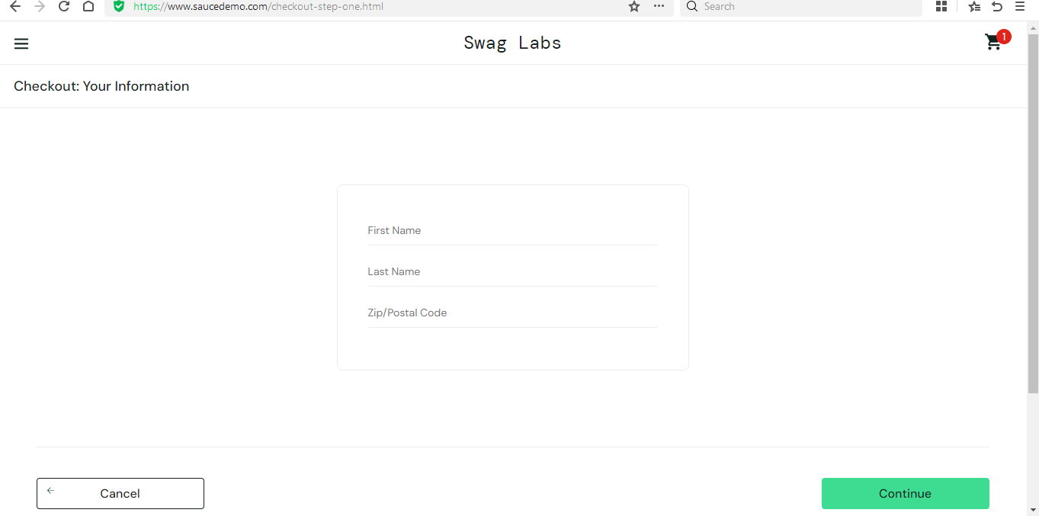
Figure 4: Checkout Information Page – User Details Entry
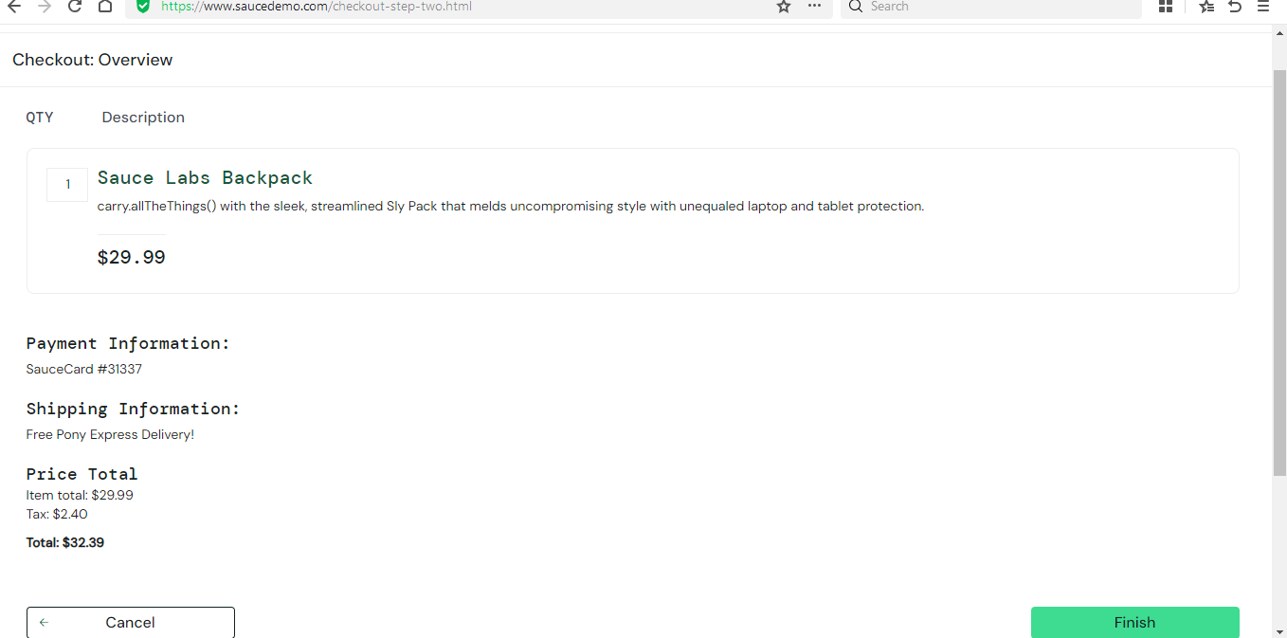
Figure 5: Checkout Overview Page – Order Summary
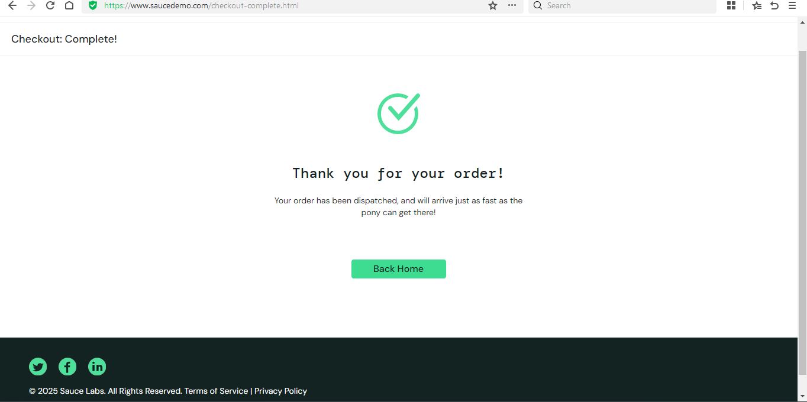
Figure 6: Checkout Success Page – Order Completion Message

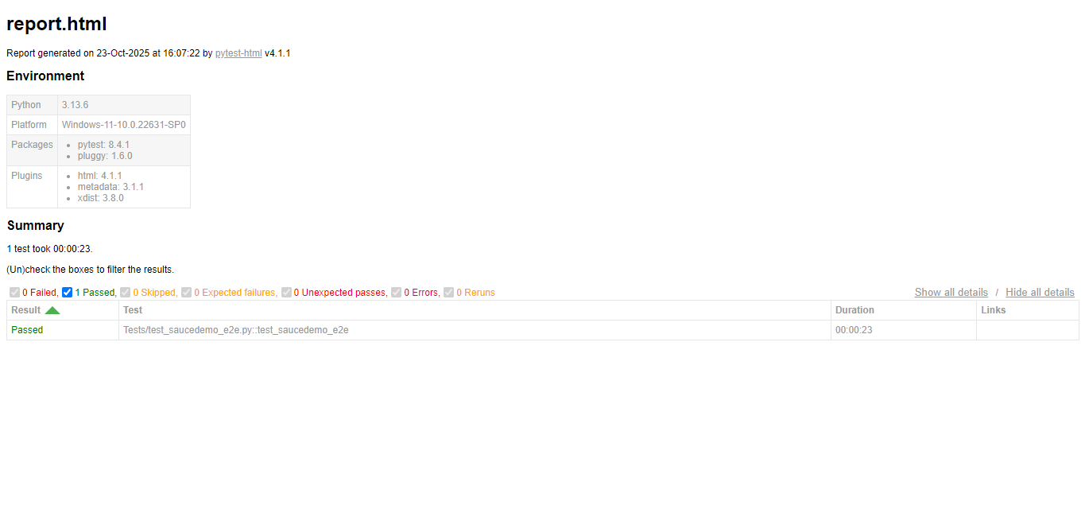
Figure 7: Pytest HTML Report – Test Execution Summary
Click here to view the full HTML test report -FINAL AUTOMATION PROJECT1\report.html

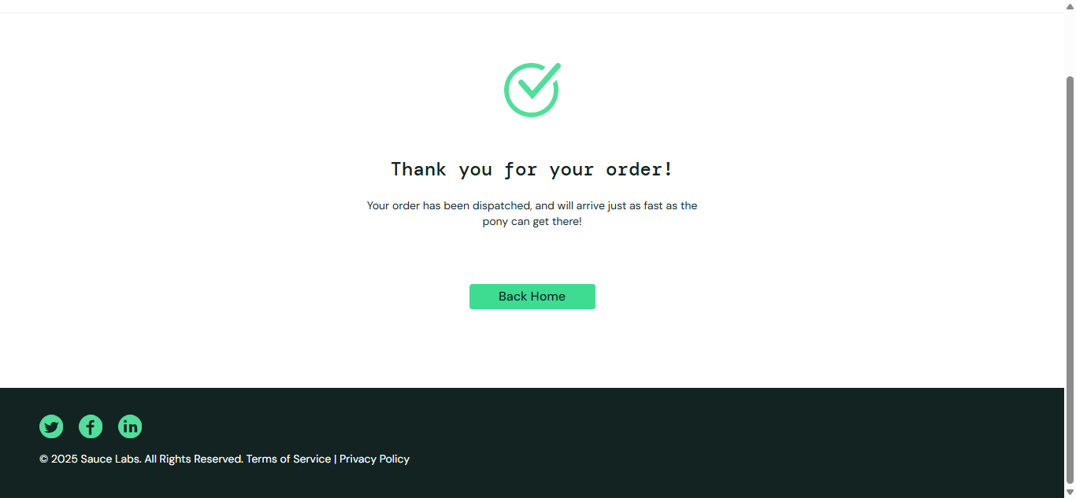
Figure 8: Automation Captured Screenshot – checkout_success.png
Click here to view the success screenshot - FINAL AUTOMATION PROJECT1\checkout_success.png

9. Result Summary
Metric | Value
Total Test Cases | 5
Passed | 5
Failed | 0
Browser | Chrome
Execution Time | ~1 minutes

10. Allure Reporting (Advanced Feature)

10.1 Purpose

To enhance visualization of test execution results using the Allure Reporting Framework — a modern dashboard that displays detailed insights such as passed/failed cases, timelines, and execution duration.

10.2 Commands Used
pytest -s Tests/test_saucedemo_e2e.py --alluredir=Reports/allure-results
allure generate Reports/allure-results -o Reports/allure-report --clean
allure open Reports/allure-report

10.3 Allure Report Screenshots

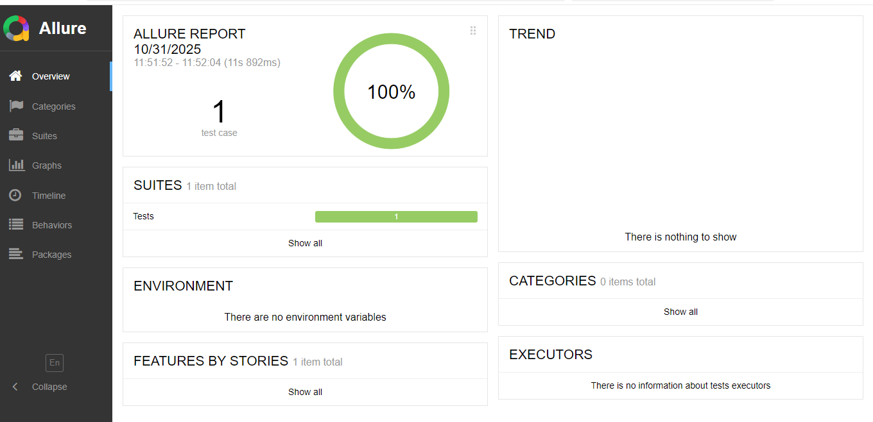
Figure 9: Allure Dashboard – Overall Test Summary

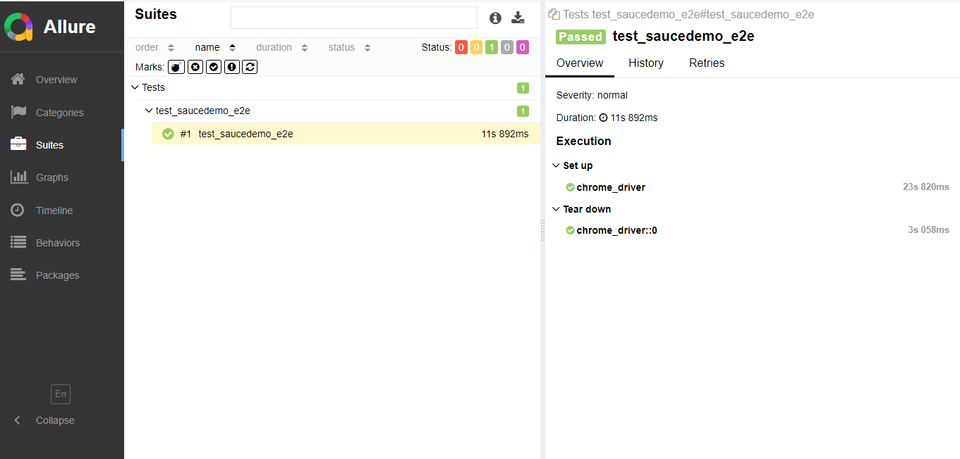
Figure 10: Allure Suites – Test Steps and Assertions

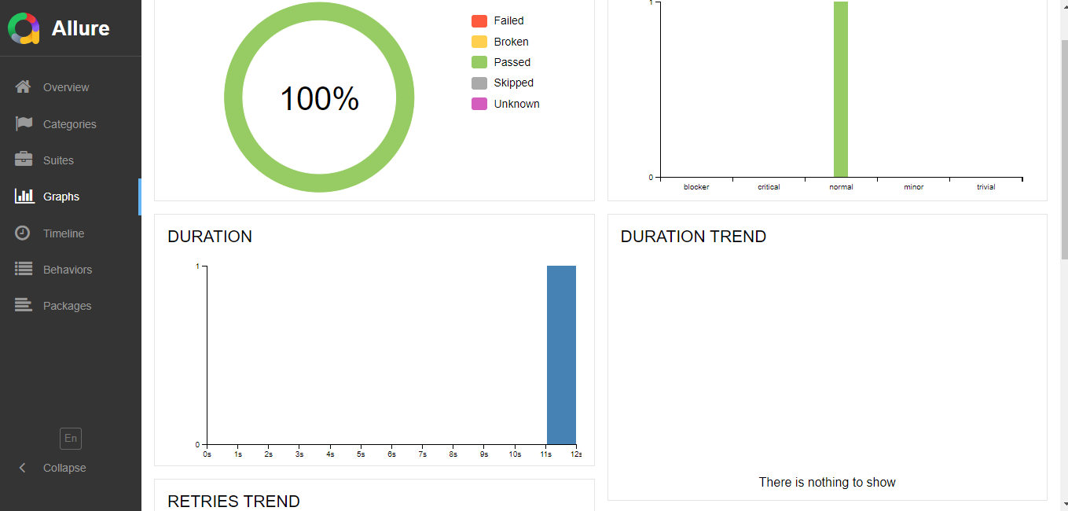
Figure 11: Allure Graph View – Result Analytics

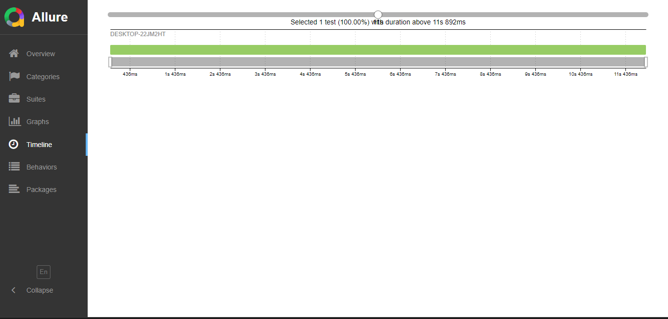
Figure 12: Allure Timeline – Test Execution Duration
10.7 Summary
The Allure Report successfully visualizes all automation test executions with 100% pass rate.Its interactive dashboards and detailed test breakdowns enhance the project’s readability and demonstrate professional-level QA reporting skills.
These reports are now part of Deepika S’s QA Automation Portfolio to showcase advanced reporting expertise to recruiters.

11. Conclusion
Successfully automated the entire purchase flow on SauceDemo using Selenium and Python with POM framework design.
All test cases passed and verified with screenshots and HTML report.

11. Future Integrations & Version Control Setup
✅ Integrated Allure Reporting for test visualization
✅ Added requirements.txt for one-click environment setup
✅ Captured and documented Simulated Bug Example
✅ Uploaded project to GitHub (Public Repository) for global visibility
✅ Ready for CI/CD integration (GitHub Actions) for continuous testing and reporting
GitHub Repository Link:
https://github.com/deepika-sekar-qa/DeepikaS_QA_Automation_Portfolio

