Chapter 1

**INTRODUCTION**

Face recognition by definition can be explained as the computer application that can be used for identifying or verifying an individual using their faces. It can be considered as one of the efficient biometric methods present today. As the importance of security is growing day by day, such biometric systems play an important role. The first face detection system was introduced in the year 1970. Since there were limitations with the computation and the system could not meet the user requirement to identify the real-time passport photographs, it was not a successful system then. The field expanded not just among engineers, it had wide applications in other branches of science as well, especially in the automatic access control areas.

To maintain the attendance record with day-to-day activities is a challenging task. The conventional method of recording each employees name is time consuming and there is always a chance of record being lost sometimes. The following system is based on face recognition to maintain the attendance record of employees. The daily attendance of employees is recorded and stored already by the administrator. As thein- time for arrivial of employees the system automatically starts taking snaps and then apply face detection and recognition technique to the given image and the recognize employees are marked as present and their attendance update with corresponding time and employee id.

We have used deep learning techniques to develop this system, histogram of oriented gradient method is used to detect faces in images and deep learning method is used to compute and compare feature facial of employees to recognize them. Our system is capable to identify multiple faces in real time. The main objective of this project is to develop face recognition based automated employee attendance system. In order to achieve better performance, the test images and training images of this proposed approach are limited to frontal and upright facial images that consist of a single face only. The test images and training images have to be captured by using the same device to ensure no quality difference. In addition, the employees have to register in the database to be recognized. The enrollment can be done on the spot through the user-friendly interface.

1.1 Challenges

As the range of application is expanding day by day, the complexity of the system is increasing as well. This in fact affects the efficiency of the system. We shall discuss the different challenges of face recognition attendance management system that are present today. These challenges are related to the face image which is given as the input to the system. The algorithms used or this process varies from application to application. There are many reasons that are responsible for variation in faces. Some of the challenges are

1. **Illumination :**  Illumination stands for light variations.  The slight change in lighting conditions cause a significant challenge for automated face recognition and can have a significant impact on its results. If the illumination tends to vary, the same individual gets captured with the same sensor and with an almost identical facial expression and pose, the results that emerge may appear quite different.

**2 .Pose variation:**  [Facial Recognition](https://pathpartnerms.wpengine.com/what-is-facial-recognition-technology-and-how-it-works/) Systems are highly sensitive to pose variations. The pose of a face varies when the head movement and viewing angle of the person changes. The movements of head or differing POV of a camera can invariably cause changes in face appearance and generate intra‐class variations making automated face recognition rates drop drastically. It becomes a challenge to identify the real face when the rotation angle goes higher. It may result in faulty recognition or no recognition if the database only has the frontal view of the face.

**3.Occlusion:**Occlusion means blockage, and it occurs when one or other parts of the face are blocked and whole face is not available as an input image. Occlusion is considered one of the most critical challenges in face recognition system.It occurs due to beard, moustache, accessories (goggle, cap, mask, etc.), and it is prevalent in real-world scenario. The presence of such components makes the subject diverse and hence making automated face recognition process a tough nut to crack.

**4.Expressions:**Face is one of the most crucial biometrics as its unique features play a crucial role in providing human identity and emotions. Varying situations cause different moods which result in showing various emotions and eventually change in facial expressions.Human expressions are particularly macro-expressions which are happiness, sadness, anger, disgust, fear, surprise. Micro-expressions are the one which shows the rapid facial patterns and happen involuntarily.Macro and micro expressions find their place on someone's face due to changes in one's emotional state and in the wake of such emotions- which are many- the efficient recognition becomes difficult.

**5.Model Complexity:**Existing state-of-the-art [facial recognition](https://pathpartnerms.wpengine.com/what-is-facial-recognition-technology-and-how-it-works/) methods rely on ‘too-deep’ Convolutional Neural Network (CNN) architecture which is very complex and unsuitable for real-time performance on embedded devices.An ideal face recognition system should be tolerant of variations in illumination, expression, pose, and occlusion. It should be scalable to a large number of users with a need for capturing minimal images during registration while doing away with complex architecture at the same time.

1.2 Objective

Face Recognition Attendance management system is software developed for maintaining the attendance of the employees on the daily basis in the organization. Each staff will be given with a separate username and password based on the subject they handle. An accurate report based on the employees attendance is generated here. This system will also help in evaluating attendance of employee. Report of the employees attendance on day to day basis is generated.

1.3 Problem Definition

To develop an automated attendance system using face recognition. Concept In a organization with large number of employees, it is a very tedious and time consuming task torecord attendance manually. Therefore, we can implement an effective system which will mark the attendance of employees automatically by recognizing their faces.The process of this face recognition system is divided into various steps, but the important steps are detect the face and recognize the face. Firstly, to mark the attendance of employees , the image of employees faces will be required.

This image can be snapped from the camera device, which will be placed in the front of office at a suitable location. This image will act as input to the system. For the effective face detection, the image needs to be enhanced by using some image processing techniques like grayscale conversion of image and histogram equalization. To identify the employee neatly, the histogram equalization of image needs to be done. Hence, there is a need to develop a real time operating employee attendance system which means the identification process must be done within defined time constraints to prevent omission. The extracted features from facial images which represent the identity of the employees have to be consistent towards a change in background, illumination, pose and expression. High accuracy and fast computation time will be the evaluation points of the performance.

Chapter 2

**LITERATURE SURVEY**

A literature review is a piece of discursive prose to find objectivity and facts in the current information. We follow a thorough iterative assessment process to distil information from credible and highly impactful sources.

2.1 Face Detection using Haar-Cascade

It is a machine learning based approach where a cascade function is trained from a lot of positive and negative images (where positive images are those where the object to be detected is present, negative are those where it is not). It is then used to detect objects in other images. OpenCV offers pre-trained Haar cascade algorithms, organized into categories (faces, eyes and so forth), depending on the images they have been trained on.

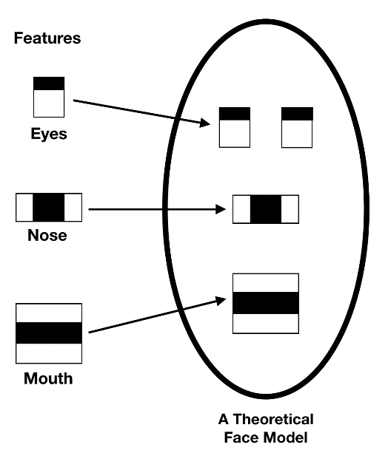

Figure – 2.1.1

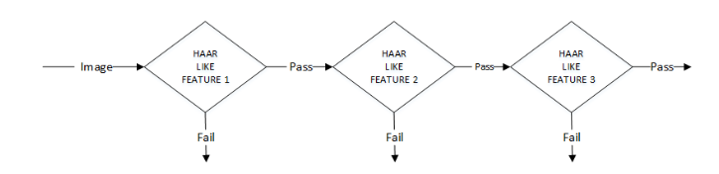

Figure – 2.1.2

2.2 Local Binary Pattern Histogram (LBPH)

Local Binary Pattern (LBP) is a simple yet very efficient texture operator which labels the pixels of an image by thresholding the neighborhood of each pixel and considers the result as a binary number. It has further been determined that when LBP is combined with histograms of oriented gradients (HOG) descriptor, it improves the detection performance considerably on some datasets.

**LBPH algorithm work step by step:**

**1**. **Parameters:** the LBPH uses 4 parameters:

● **Radius:** the radius is used to build the circular local binary pattern and represents the radius around the central pixel. It is usually set to 1.

● **Neighbors:** the number of sample points to build the circular local binary pattern. Keep in mind: the more sample points you include, the higher the computational cost. It is usually set to 8.

● **Grid X:** the number of cells in the horizontal direction. The more cells, the finer the grid, the higher the dimensionality of the resulting feature vector. It is usually set to 8

● **Grid Y:** the number of cells in the vertical direction. The more cells, the finer the grid, the higher the dimensionality of the resulting feature vector. It is usually set to 8

**2** **Training the Algorithm:** First, we need to train the algorithm. To do so, we need to use a dataset with the facial images of the people we want to recognize. We need to also set an ID (it may be a number or the name of the person) for each image, so the algorithm will use this information to recognize an input image and give you an output. Images of the same person must have the same ID. With the training set already constructed, let’s see the LBPH computational steps.

**3.Applying the LBP operation:** The first computational step of the LBPH is to create an intermediate image that describes the original image in a better way, by highlighting the facial characteristics. To do so, the algorithm uses a concept of a sliding window, based on the parameters radius and neighbors. The image below shows this procedure:An example shown in figure 2.2.1

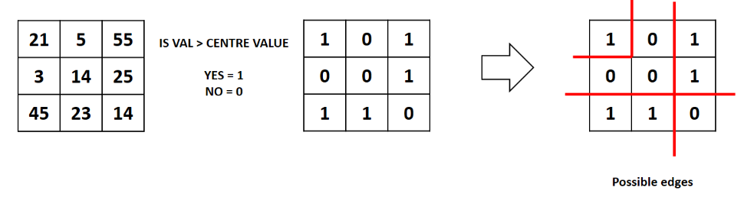

Figure – 2.2.1

2.3  **Eigenface**

Eigenface is based on PCA that classify images to extract features using a set of images. It is important that the images are in the same lighting condition and the eyes match in each image. Also, images used in this method must contain the same number of pixels and in grayscale. For this example, consider an image with n x n pixels as shown in figure 3. Each raw is concatenated to create a vector, resulting a 1 × n2 matrix. All the images in the dataset are stored in a single matrix resulting a matrix with columns corresponding the number of images. The matrix is averaged (normalised) to get an average human face. By subtracting the average face from each image vector unique features to each face are computed. In the resulting matrix, each column is a representation of the difference each face has to the average human face. A simplified illustration can be seen in figure 2.3.1

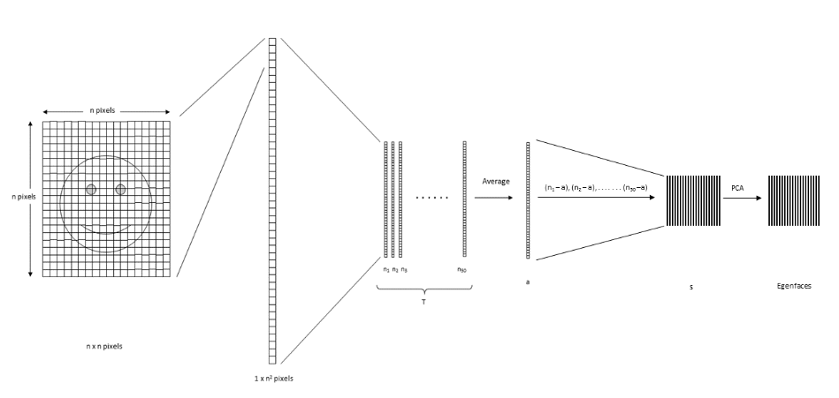

Figure – 2.3.1

2.4 K**-Nearest Neighbors Algorithm**

The k-nearest neighbors algorithm, also known as KNN or k-NN, is a non-parametric, supervised learning classifier, which uses proximity to make classifications or predictions about the grouping of an individual data point. While it can be used for either regression or classification problems, it is typically used as a classification algorithm, working off the assumption that similar points can be found near one another which is observed in figure 2.4.1.

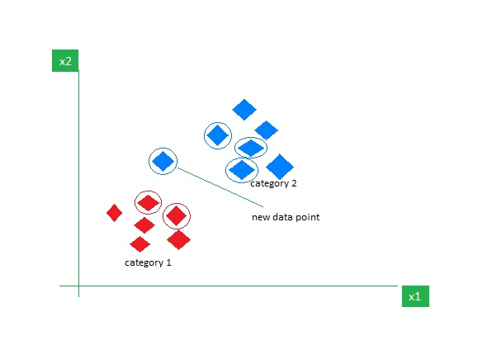

Figure – 2.4.1

Chapter 3

**SOFTWARE REQUIREMENT SPECIFICATION**

3.1 Purpose

The purpose of the project is to build a system that takes the attendances of the employee and detects faces but also recognises them, and this was done using face detection and face recognition algorithms using the HAAR-classifier and the LBPH algorithm respectively. This field has been studied upon since the last few years, not only for the security purposes but also for various others such as Attendance systems, validate identity at ATM’s, find criminals and many other areas. Face recognition attendances management system is one of the fastest method to take attendances and to record the attendances on day to day bases and identify multiple faces at the same time. The major concern which arises here is that face detection and recognition are two separate areas and differ from each other in all the ways.

3.2 Scope

Local Binary Patterns Histograms (LBPH) is a popular method for face recognition, which has been widely used in various applications such as security systems, access control, and surveillance systems. The LBPH algorithm extracts a feature face image by analysing the distribution of Local Binary Patterns in the image.

The scope for face recognition attendance mangement system using LBPH project depends on various factors such as the quality of the input images, the size of the dataset, the computational resources available, and the accuracy requirements of the application.The LBPH algorithm is a robust and efficient technique for face recognition, and it has the potential to be applied to a wide range of applications.

• Using this system we will able to accomplish the task of marking the attendance of the employee automatically and output is obtained in an excel sheet as desired in real-time

• However, in order to develop a dedicated system which can be implemented in an educational institution, a very efficient algorithm which is insensitive to the lighting conditions of the classroom has to be developed.

• Also a camera of the optimum resolution has to be utilised in the system.

• Another important aspect where we can work towards is creating an online database of the attendance and automatic updating of the attendance.

3.3 Software Requirements

To develop a face recognition attendance management system using LBPH, you will need to use software tools that support image processing and machine learning. Here are some of the software requirements for face recognition attendance management using LBPH:

1. Python: Python is a popular programming language used for developing machine learning applications. You will need to install Python on your system to develop and run the LBPH face recognition project.
2. OpenCV: OpenCV is an open-source library that provides various functions for image and video processing. It includes functions for reading, writing, and processing images, as well as for implementing machine learning algorithms. You will need to install OpenCV on your system to implement the LBPH algorithm. In the Artificial Intelligence field, Computer Vision is one of the most interesting and challenging tasks. Computer Vision acts as a bridge between Computer Software and visualizations. Computer Vision allows computer software to understand and learn about the visualizations in the surroundings. Let us understand an example: Based on the shape, colour, and size that determines the fruit. This task is very easy for the human brain but in the Computer Vision pipeline, first, we need to gather the data, then we perform the data processing operations, and then we train and teach the model to understand how to distinguish between the fruits based on its size, shape, and colour of the fruit.
3. NumPy: NumPy is a Python library used for numerical computing. It provides support for large, multi-dimensional arrays and matrices, as well as a wide range of mathematical functions. You will need to install NumPy on your system to handle the image data and perform mathematical operations on the LBPH feature vector.
4. Visual Studio: Visual Studio is an integrated development environment (IDE) developed by Microsoft that is used to create software applications for various platforms, including Windows, Android, iOS, and web applications. It provides a comprehensive set of tools and services for software development, including code editing, debugging, testing, and deployment. Visual Studio supports multiple programming languages such as C++, C#, F#, Visual Basic .NET, and Python, among others. It also includes various templates and libraries that simplify the development process and improve productivity.
5. Html:Html stands for hypertext markup language.HTMLdetermines the structure of web pages. This structure alone is not enough to make a web page look good and interactive. So you'll use assisted technologies such as CSS and JavaScript to make your HTML beautiful and add interactivity, respectively.
6. Flask:Flask is a web framework, it’s a Python module that lets us develop web applications easily. It’s has a small and easy-to-extend core: it’s a microframework that doesn’t include an ORM (Object Relational Manager) or such features.
7. Pandas:Pandas is a Python library used for working with data sets. It has functions for analyzing, cleaning, exploring, and manipulating data.
8. Joblib:Joblib is a Python library for running computationally intensive tasks in paralle**l**. It provides a set of functions for performing operations in parallel on large data sets and for caching the results of computationally expensive functions

3.4 Hardware Requirements

The hardware requirements for a face recognition attendance management system using LBPH algorithm depend on various factors, such as the size of the dataset, the complexity of the model, and the computational resources available. Here are some of the hardware requirements to consider:

1. Processor: A powerful processor is essential for running the face recognition system efficiently. A modern processor with multiple cores, such as an Intel Core i7 or AMD Ryzen 7, is recommended.
2. Memory: The system should have sufficient memory to handle the image data and the LBPH feature vector. At least 8 GB of RAM is recommended, although the specific requirements may vary depending on the size of the dataset.
3. Storage: The system should have sufficient storage space to store the image dataset and the trained model. A solid-state drive (SSD) is recommended for faster data access.
4. Graphics Card: A graphics card with CUDA support can significantly accelerate the LBPH algorithm, especially for large datasets. NVIDIA graphics cards are recommended for CUDA support.
5. Camera: The system should have a good-quality camera for capturing images for face recognition. A high-resolution camera with at least 720p resolution is recommended.
6. Other peripherals: The system may require additional peripherals such as a display, keyboard, and mouse for development and testing.

Overall, the hardware requirements for face recognition attendance management using LBPH project depend on various factors such as the size of the dataset, the complexity of the model, and the computational resources available. It is recommended to choose hardware that meets or exceeds the minimum requirements to ensure smooth and efficient operation of the face recognition system.

3.5 Functional Requirements

The functional requirements for a face recognition attendances management system using LBPH algorithm describe the specific functionalities that the system should perform. Here are some of the functional requirements for face recognition using LBPH project:

1.Data Acquisition: The system should be able to acquire face images from a camera or a database. The system should have the capability to detect and extract the facial features from the acquired images.

2.Face Detection: The system should be able to detect and localize the face in the image. The face detection algorithm should be able to handle variations in lighting conditions, pose, and scale.

3.Feature Extraction: The system should be able to extract relevant features from the detected face region. LBPH is one of the feature extraction methods that can be used for face recognition.

4.Training: The system should be able to train a model using the extracted features. The training process should involve creating a dataset of face images, extracting the features, and then using the extracted features to train a machine learning model.

5.Testing: The system should be able to test the accuracy of the trained model by comparing the predicted labels with the actual labels. The testing process should involve splitting the dataset into training and testing sets and evaluating the performance of the model on the testing set.

6.Recognition: The system should be able to recognize faces in real-time by matching the extracted features of the input face with the features of the trained model.

Chapter 4

**SYSTEM DESIGN**

4.1 Process of Generating Dataset

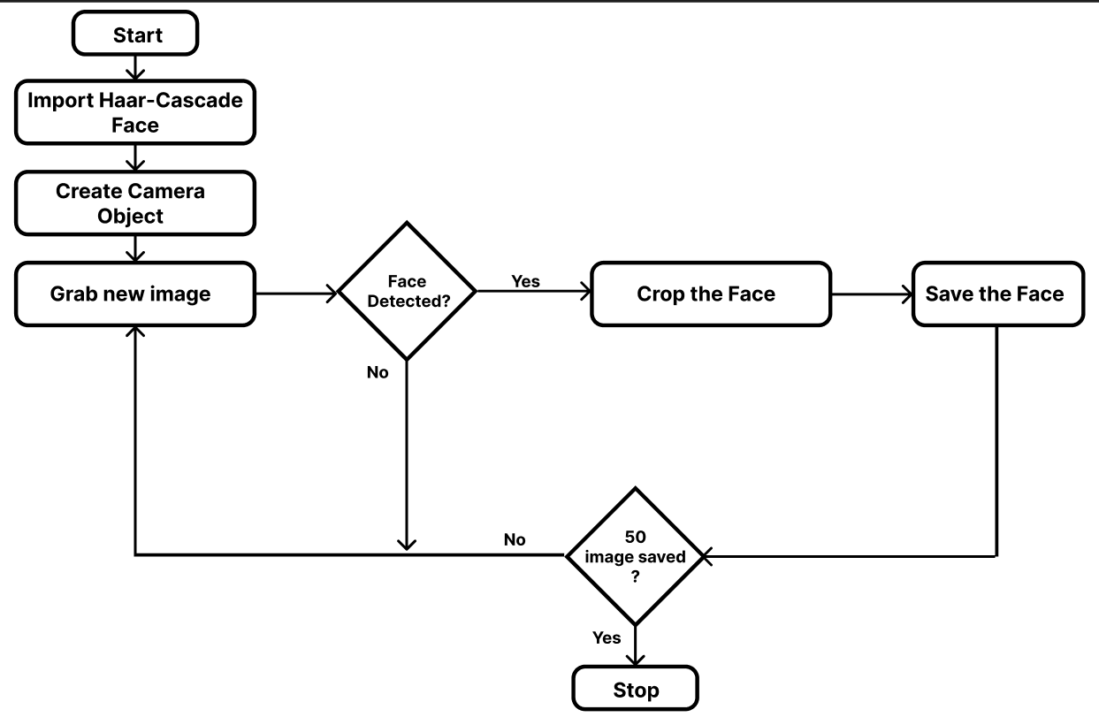

Figure – 4.1.1

4.2 Process of Training Model

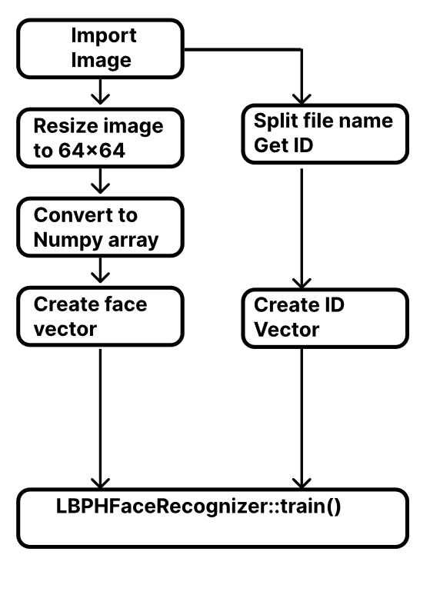

Figure – 4.2.1

4.3 Process Diagram

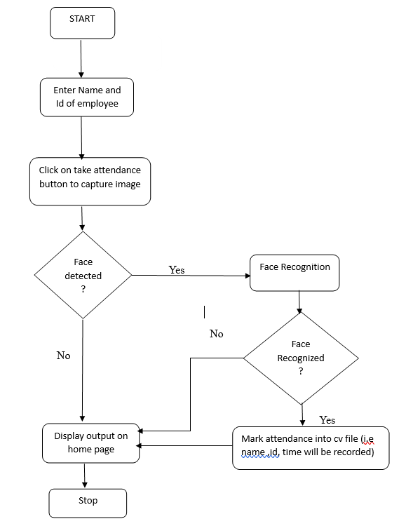

Figure – 4.3.1

Chapter 5

**IMPLEMENTATION**

* 1. Module Explanation

1.0penwebcam: Here the web camera of system will open to capture the image of employee and takes 50 images of each employee in different angles for facial feature identification.

1. Dataset: Here it create its own dataset; the dataset contains 50 face images of each person with 229×229 resolution of each image. It is created based on face detection Make different facial expression and postures to a scene and detect faces.For each employee a separate folder will be created to save the captured images. At this stage, the dataset is pre-processed for the feature extraction process. The dataset images have been converted into grayscale images for features extraction, and then normalized those images for good recognition results. For features detection, Haar modules have been used to detect these local features in a given an input image. Here, the input image refers to the digital image captured by the camera. After detecting features, the classifier will classify the input image as a face image.

3.Take Attendance:If he is a new employee then he must enter his name and employee id to register then click on take attendance button to mark his attendance.If he is already a registered employee then he can directly click on take attendance buttton to mark his attendance.Now,it comapares the captured image of the employee with the stored images present in the database to identify the employee and then marks his attendance i.e employee name ,id, time into a cv file.Here it creates day to day cv files.

5.2 Algorithms

5.2.1 Algorithm for collecting the images of the employee

1. Import the necessary libraries - cv2, numpy, os, datetime,numpy,pandas,flask,joblib.
2. Create a route ‘/add’ in the Flask app
3. In the route function,get the ‘newusername’ and ‘newuserid’ from the form using the ‘request’ module.
4. Create a folder with a name’newusername_newuserid’in the ‘static/faces’ directory.
5. Initialize the ‘VideoCapture’ object to access the web.
6. Set a variable ‘count’ to zero to keep track of the number of images captured.
7. Use the loop to capture images untill the count reaches 50.
8. Within the loop, read frames from the webcam using the ‘VideoCapture’ object and detect faces using the ‘face_detector’ cascade classifier.
9. If a face is detected extract the face using the ‘extract_faces’ function and save it in the folder created in step4 with in the unique name, such as’newusername_newuserid_1.jpg’,’newusername_newuserid_2.jpg’ and so on where the number at the end increments with each image captured.
10. Increment the count by 1 after each image captured.
11. Once the 50 images have been captured,release the ‘VideoCapture’ object and redirect the user to home page
12. In the home page display the message indicating that the user has been added successfully.

5.2.2Algorithm for Recognising the person using web cam

1. Import necessary libraries - cv2, ,numpy, os and knneighbor.
2. Set the size of the face image to be detected (size) and the name of the pre-trained cascade classifier file (haar_file). Also, set the directory containing the face images dataset.
3. Create an LBPH face recognizer model using the cv2.face.LBPHFaceRecognizer_create() method.
4. Create empty lists images, labels and an empty dictionary names and set the id to 0.
5. Loop through all the subdirectories in the datasets directory and read all images in each subdirectory. Append each image to images and its corresponding label to labels. Add each subject's name to the names dictionary and increment the id.
6. Convert images and labels to numpy arrays.
7. Train the LBPH face recognizer model using “model.train(images, labels)”.
8. Set the width and height of the face image to be displayed (width, height). Create a Cascade Classifier object for face detection using the haar_file.
9. Start a while loop and read frames from the video camera. Convert the frames to grayscale and detect faces using face_cascade.detectMultiScale(). Draw rectangles around each detected face.
10. Resize the face image to the specified width and height. Predict the label of the face image using “model.predict(face_resize)”.
11. Display the recognized name of the person by putting text on the frame using “cv2.putText()” method. If the prediction score is less than 200, display the corresponding name, otherwise display 'Unknown'.
12. Display the frame using cv2.imshow(). and release the video camera and destroy all windows.

Chapter 6

**TEST AND RESULTS**

The interface for the Face Recognition Attendance Management System has been created. Using the interface the images of the individual employees is being recorded and stored in the training dataset and their information is stored in the database i.e. excel sheet. Finally the images of the employee is being tracked and recognized and attendances is marked.

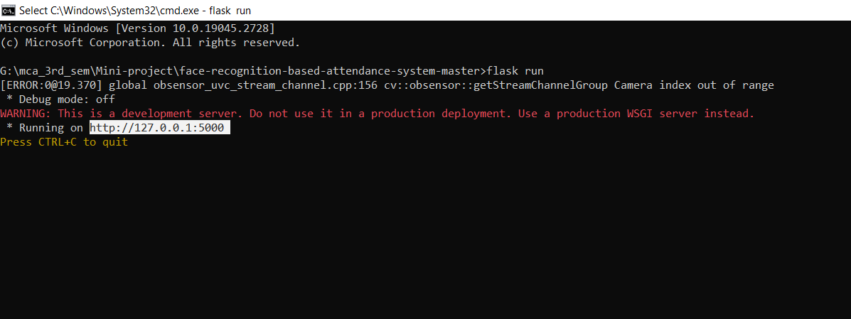

Figure – 1

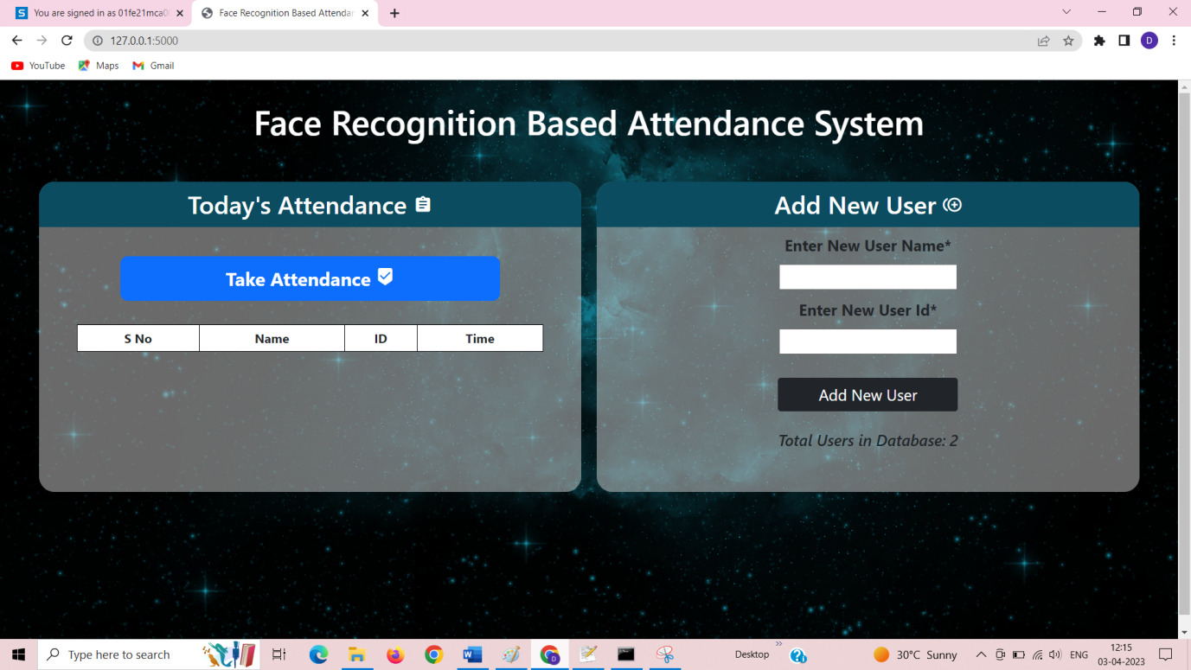

Figure – 2

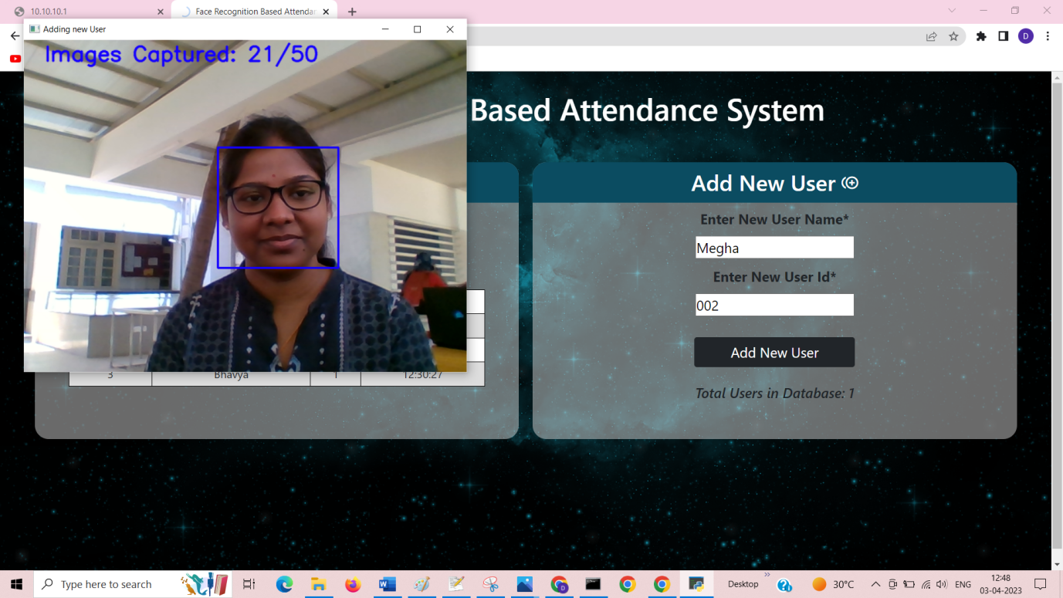

Figure – 3

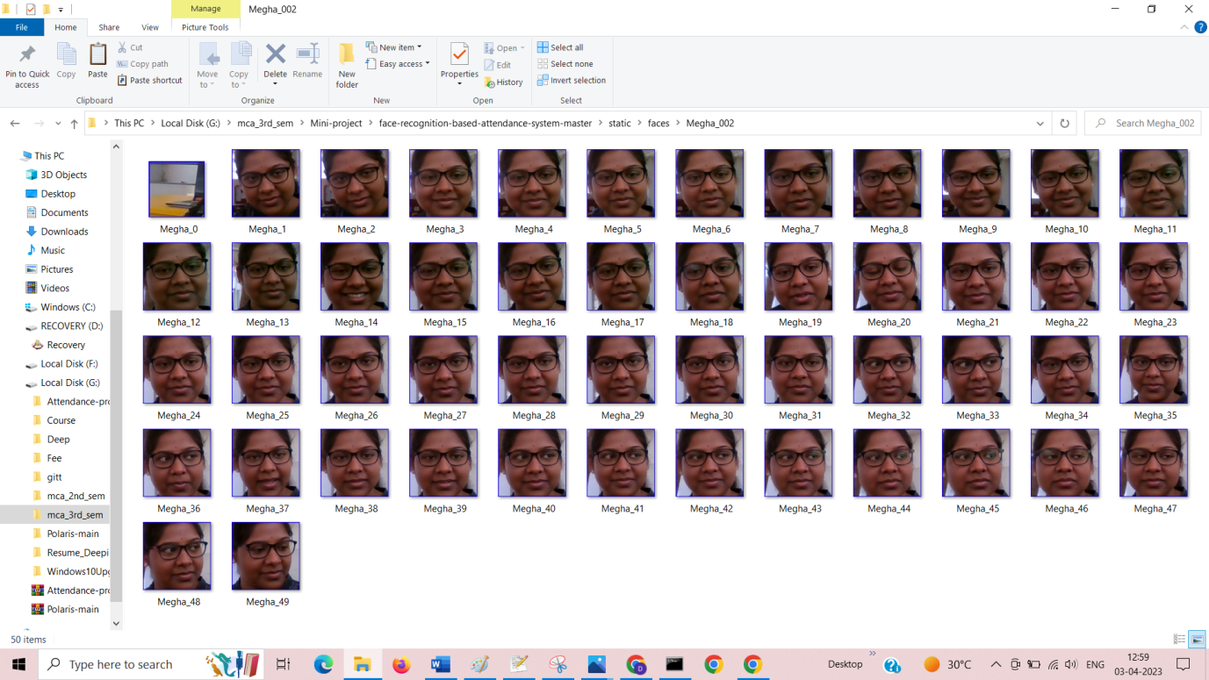

Figure - 4

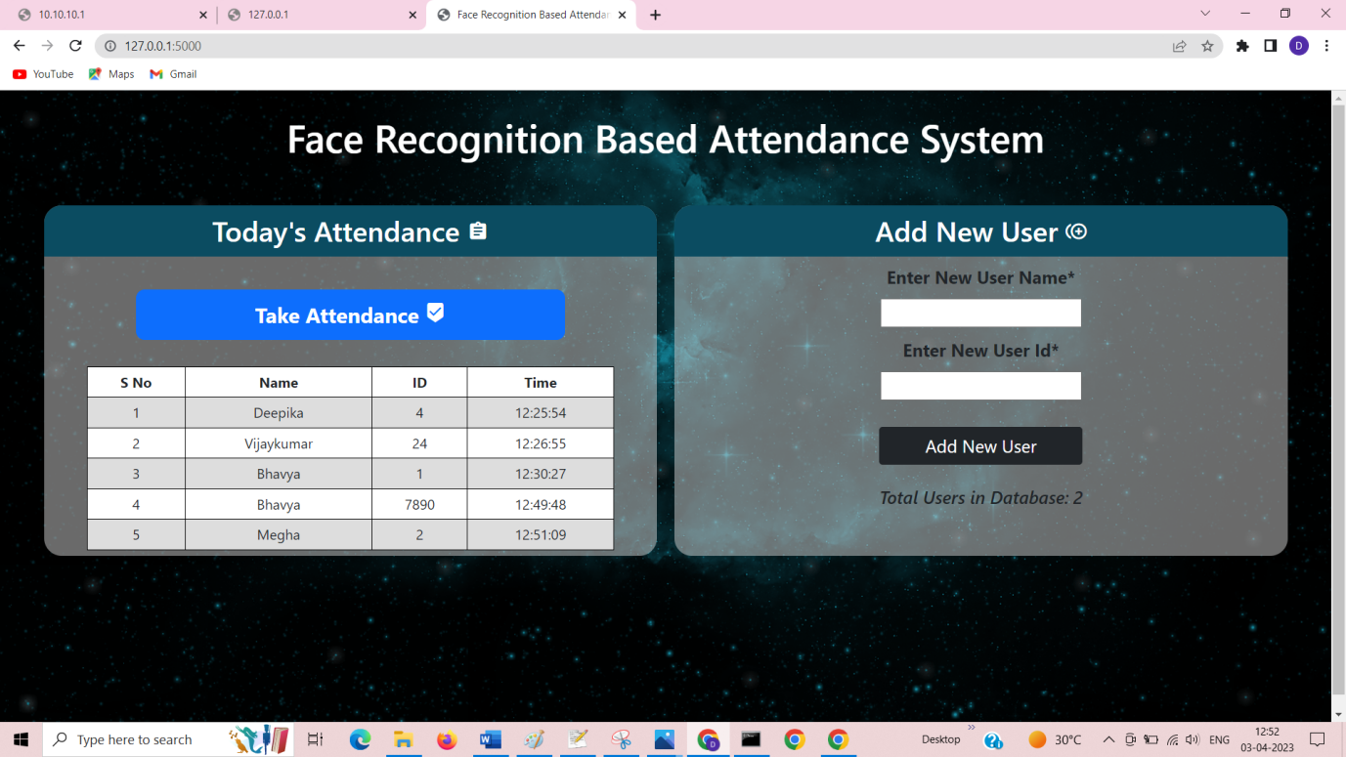

Figure-5



Figure-6

Conclusion and Future Enhancement

Local Binary Patterns Histograms (LBPH) is a popular and effective method for face recognition and recording the attendances that has been widely used in various applications. Despite its successes, LBPH still faces challenges, such as sensitivity to illumination and pose variations. To address these challenges and improve its accuracy and performance, future enhancements such as integrating deep learning techniques, incorporating additional modalities, and optimizing the algorithm for mobile devices can be considered. With ongoing research and technological advancements, LBPH and other face recognition technologies are expected to continue improving, enabling more accurate, reliable, and secure recognition of individuals in various settings.This solution is both cost-effective and efficient when contrasted to other biometric solutions. The cost and time saved are even larger because the data acquired from the face recognition attendance system is accurate in real-time. Because the overall process is automated, human intervention is limited.

Face Recognition Attendance management system using LBPH can be integrated into Android app development to provide a secure and user-friendly authentication mechanism. In the future, enhancements could be made to improve the performance of LBPH on Android devices. One approach could be to optimize the LBPH algorithm for mobile devices with limited computational resources, such as by reducing the size of the feature vectors or using more efficient data structures. Another potential enhancement is the integration of real-time face detection to ensure that the authentication process is fast and accurate, even when the user is moving. Additionally, app developers could leverage advancements in mobile hardware such as improved camera technology to capture more accurate and detailed facial features. Finally, ongoing research in privacy-preserving face recognition could also be integrated into Android apps to improve security and user privacy.A facial recognition attendance system can be employed to recognize employees and confirm or refuse access upon entry.

Bibliography

* 1. LBPH-Face Recognition Attendance Management System -

<https://www.analyticsvidhya.com/blog/2021/11/build-face-recognition-attendance-system-using> python/

2.Face Recognition Attendance Management System -

<https://www.studocu.com/in/document/rajiv-gandhi-university/software-engineering/face-recognition>based-attendance-system-report-final/35852877