DAA Output Of Five Experiments
1. Implementation and Performance Analysis of Interpolation Search

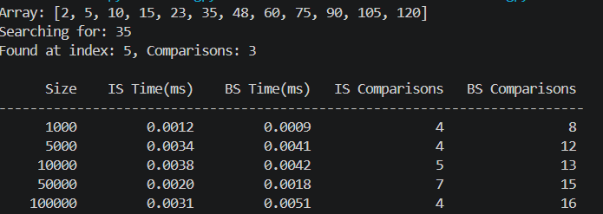

2. Comparative Analysis of Naive, Rabin-Karp, and KMP Algorithms for String Matching
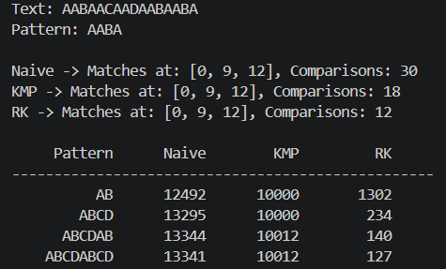
3. Implementation of Kruskal's and Prim's Algorithms for Minimum Spanning Tree
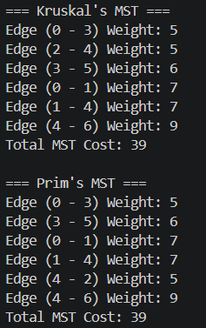

4. Implementation of Single Source Shortest Path Algorithm (Dijkstra's)
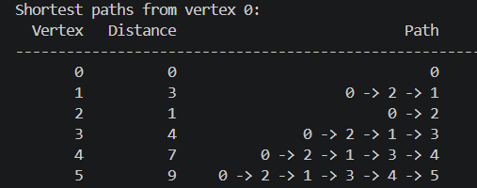
5. To Find Min-Max Value by Applying Divide and Conquer Technique
