Name: Deepika Pampati
Class-Batch-Roll no: A6- B1- 16

DAA Lab Practical 7

Aim: Implement Hamiltonian Cycle using Backtracking.
Problem Statement: The Smart City Transportation Department is designing a night-patrol route for security vehicles. Each area of the city is represented as a vertex in a graph, and a road between two areas is represented as an edge. The goal is to find a route that starts from the main headquarters (Area A), visits each area exactly once, and returns back to the
headquarters — forming a Hamiltonian Cycle.
If such a route is not possible, display a suitable message.
- Adjacency Matrix A B C D E
A 0 1 1 0 1
B 1 0 1 1 0
C 1 1 0 1 0
D 0 1 1 0 1
E 1 0 0 1 0
CODE:
import networkx as nx
import matplotlib.pyplot as plt

# ==========================
# Hamiltonian Cycle Functions # ==========================

def is_safe(v, graph, path, pos):
"""Check if vertex v can be added to the Hamiltonian path."""
# Check adjacency
if graph[path[pos - 1]][v] == 0:

return False
# Check if already visited if v in path:
return False return True

def hamiltonian_cycle_util(graph, path, pos):
"""Recursive helper function for backtracking.""" if pos == len(graph):
# Check if last vertex connects to first return graph[path[pos - 1]][path[0]] == 1

for v in range(1, len(graph)):
if is_safe(v, graph, path, pos): path[pos] = v
if hamiltonian_cycle_util(graph, path, pos + 1): return True
path[pos] = -1 # backtrack return False

def find_hamiltonian_cycle(graph):
"""Main function to find Hamiltonian cycle.""" path = [-1] * len(graph)
path[0] = 0 # start from vertex 0

if not hamiltonian_cycle_util(graph, path, 1): print("❌ No Hamiltonian Cycle exists.") return None
else:
path.append(path[0]) # return to start

print("✅ Hamiltonian Cycle found:")
print(" → ".join(nodes[i] for i in path)) return path

# ==========================
# Graph Definition
# ==========================

nodes = ['A', 'B', 'C', 'D', 'E'] # Areas of the city

adj_matrix = [

 | [0, | 1, | 1, | 0, | 1], | # | A
 | [1, | 0, | 1, | 1, | 0], | # | B
 | [1, | 1, | 0, | 1, | 0], | # | C
 | [0, | 1, | 1, | 0, | 1], | # | D
 | [1, | 0, | 0, | 1, | 0] | # | E
]

# ==========================
# Draw Input Graph
# ==========================

def draw_graph(adj_matrix, title, cycle=None):
"""Draw the graph and optionally highlight the Hamiltonian cycle."""
G = nx.Graph()
G.add_nodes_from(nodes)

# Add edges
for i in range(len(nodes)):

for j in range(i + 1, len(nodes)): if adj_matrix[i][j] == 1:
G.add_edge(nodes[i], nodes[j])

pos = nx.circular_layout(G) plt.figure(figsize=(6, 5))
nx.draw(G, pos, with_labels=True, node_color='skyblue', node_size=1500, font_size=14, edge_color='gray')

if cycle:
# Draw Hamiltonian cycle edges in red
edges_in_cycle = [(nodes[cycle[i]], nodes[cycle[i + 1]]) for i in range(len(cycle) - 1)]
nx.draw_networkx_edges(G, pos, edgelist=edges_in_cycle,
edge_color='red', width=3)

plt.title(title, fontsize=14) plt.show()

# Show the input graph
draw_graph(adj_matrix, "Input Graph (Smart City Patrol Areas)")

# ==========================
# Find and Show Output Graph # ==========================

cycle = find_hamiltonian_cycle(adj_matrix)

# Show the output graph (if cycle exists)

if cycle:
draw_graph(adj_matrix, "Output Graph (Hamiltonian Cycle Highlighted)", cycle)

OUTPUT:
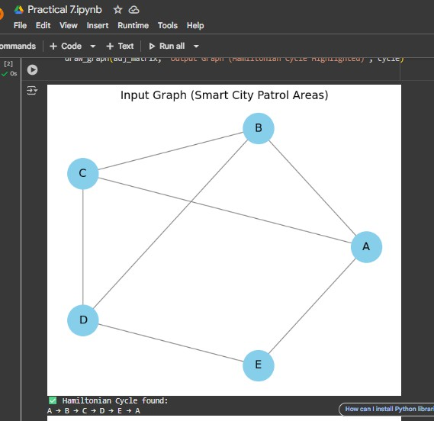

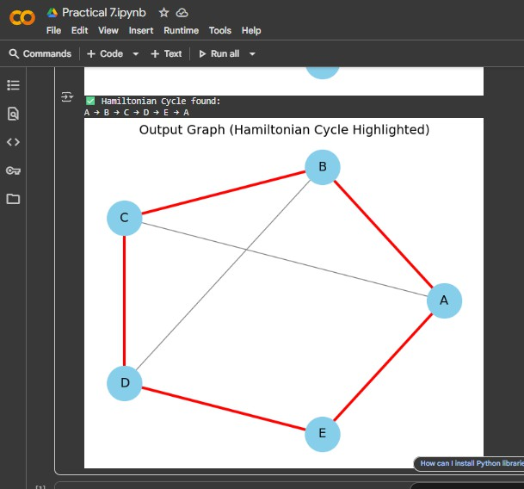
- Adjacency Matrix T M S H C
T 0 1 1 0 1
M 1 0 1 1 0
S 1 1 0 1 1
H 0 1 1 0 1
C 1 0 1 1 0
CODE:
import networkx as nx
import matplotlib.pyplot as plt

# ==========================

# Hamiltonian Cycle Functions # ==========================

def is_safe(v, graph, path, pos):
"""Check if vertex v can be added to the Hamiltonian path.""" # Check adjacency
if graph[path[pos - 1]][v] == 0: return False
# Check if already visited if v in path:
return False return True

def hamiltonian_cycle_util(graph, path, pos): """Recursive helper function for backtracking.""" if pos == len(graph):
# Check if last vertex connects to first return graph[path[pos - 1]][path[0]] == 1

for v in range(1, len(graph)):
if is_safe(v, graph, path, pos): path[pos] = v
if hamiltonian_cycle_util(graph, path, pos + 1): return True
path[pos] = -1 # backtrack return False

def find_hamiltonian_cycle(graph):
"""Main function to find Hamiltonian cycle.""" path = [-1] * len(graph)
path[0] = 0 # start from vertex 0

if not hamiltonian_cycle_util(graph, path, 1): print("❌ No Hamiltonian Cycle exists.") return None
else:
path.append(path[0]) # return to start print("✅ Hamiltonian Cycle found:") print(" → ".join(nodes[i] for i in path))
return path

# ==========================
# Graph Definition
# ==========================

nodes = ['T', 'M', 'S', 'H', 'C'] # Areas of the city

adj_matrix = [

 | [0, | 1, | 1, | 0, | 1], | # | T
 | [1, | 0, | 1, | 1, | 0], | # | M
 | [1, | 1, | 0, | 1, | 1], | # | S
 | [0, | 1, | 1, | 0, | 1], | # | H
 | [1, | 0, | 1, | 1, | 0] | # | C
]

# ==========================
# Draw Input Graph
# ==========================

def draw_graph(adj_matrix, title, cycle=None):
"""Draw the graph and optionally highlight the Hamiltonian cycle."""
G = nx.Graph() G.add_nodes_from(nodes)

# Add edges
for i in range(len(nodes)):
for j in range(i + 1, len(nodes)): if adj_matrix[i][j] == 1:
G.add_edge(nodes[i], nodes[j])

pos = nx.circular_layout(G) plt.figure(figsize=(6, 5))
nx.draw(G, pos, with_labels=True, node_color='skyblue', node_size=1500, font_size=14, edge_color='gray')

if cycle:
# Draw Hamiltonian cycle edges in red
edges_in_cycle = [(nodes[cycle[i]], nodes[cycle[i + 1]]) for i in range(len(cycle) - 1)]
nx.draw_networkx_edges(G, pos, edgelist=edges_in_cycle,
edge_color='red', width=3)

plt.title(title, fontsize=14) plt.show()

# Show the input graph
draw_graph(adj_matrix, "Input Graph (Smart City Patrol Areas)")

# ==========================
# Find and Show Output Graph # ==========================

cycle = find_hamiltonian_cycle(adj_matrix)

# Show the output graph (if cycle exists)

if cycle:
draw_graph(adj_matrix, "Output Graph (Hamiltonian Cycle Highlighted)", cycle)

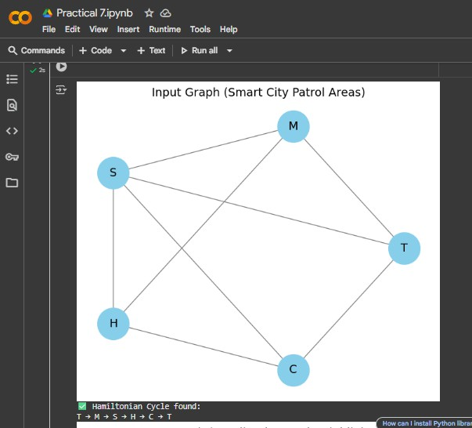
OUTPUT:

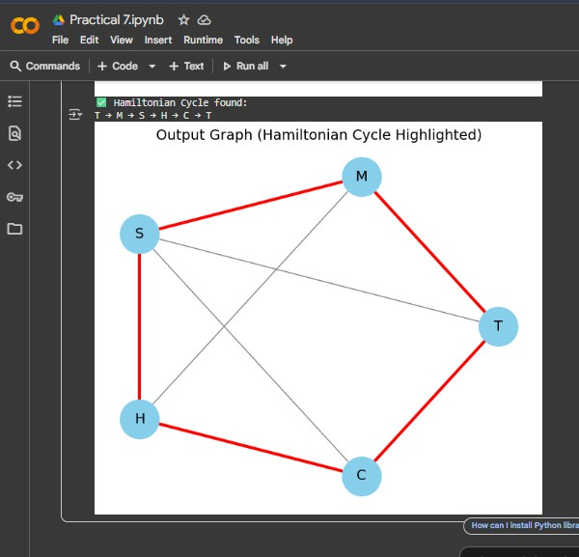

Competitive code link: https://www.geeksforgeeks.org/problems/hamiltonian-path2522/1

