POCKETSMART AI
Simple Project Documentation
Your Smart Budget & Recommendation Assistant
An AI-powered budget planning and recommendation web application
Technologies: FastAPI • Gemini AI • Python • HTML • CSS • JavaScript • Jinja2
Deepika P
Deepika170907@gamil.comdeepa
Deepa P
Deepaparthiban1709@gmail.com
Elizabeth roselin j
Elizabeth25ub01@dbcc.edu.in
Prasan rajan N
Prasanrajan2008@gmail.com
Mithran T
mithran25ub51@dbcc.edu.in

Introduction

Pocketsmart AI is a smart budget and recommendation assistant designed to help users plan everyday lifestyle needs within a selected budget. The system provides personalized recommendations for home interiors, party planning, and jewelry selection. It uses Gemini AI to understand the user's budget, preferences, occasion, and optional images and then produces relevant suggestions.purpose is to reduce the time and effort required to compare products and plan expenses. The project connects the AI recommendation layer with popular shopping and service platforms such as Amazon, Flipkart, IKEA, Swiggy, Zomato, and OYO. The main

2. Objectives
- Provide budget-based recommendations for different lifestyle needs.
- Help users plan home interiors, parties, and jewelry purchases.
- Use AI to understand user preferences and generate personalized suggestions.
- Allow users to save and review previous recommendation history.
- Provide a simple web interface with login and registration.

3. Main Features
- User registration and login.
- Home Interior Budget Planner.
- Party Budget Planner.
- Jewelry Budget Planner with optional outfit image.
- AI-generated product and service recommendations.
- Budget-aware suggestions.
- Recommendation history and personalized session data.

4. Technologies Used
Technology | Purpose
Python | Main programming language
FastAPI | Backend API and routing
Gemini AI | AI reasoning, recommendation and image analysis
HTML / CSS | Frontend interface
JavaScript | Dynamic interaction and result display
Jinja2 | Frontend templates
Uvicorn | Runs the FastAPI application

5. System Architecture
The application follows a simple layered architecture. The frontend collects user input and sends it to FastAPI. FastAPI validates the request and passes the relevant information to the Gemini AI recommendation layer. The generated results are then returned to the frontend and displayed to the user.
- Frontend – HTML, CSS and Jinja2 templates.
- Backend – FastAPI routes, authentication and session handling.
- AI Layer – Gemini model for understanding inputs and generating recommendations.
- External Platforms – Product/service sources such as Amazon, Flipkart, IKEA, Swiggy, Zomato and OYO.

6. Project Modules
User Authentication: Registration, login, logout and token/session handling.
Home Planner: Collects room details, quantities and budget to suggest furniture, lighting and decor.
Party Planner: Uses budget, guest count and event details to suggest food, venue and decoration options.
Jewelry Planner: Uses budget, occasion, style and optional outfit image to recommend suitable jewelry.
Recommendation Engine: Uses Gemini AI to interpret inputs and create structured recommendations.
History: Allows users to review previous recommendation queries and results.

7. How the System Works
1. User opens PocketSmart AI and logs in or creates an account.
2. User selects Home, Party or Jewelry planner.
3. User enters budget and other required preferences.
4. For Jewelry Planner, the user can optionally provide an outfit image.
5. FastAPI receives the request and sends the relevant information to the AI layer.
6. Gemini AI analyzes the information and generates suitable recommendations.
7. The results are displayed as product/service suggestions with relevant details.
8. The user's recommendation activity can be viewed later through history.

8. User Interface Screenshots
The following screenshots are included as examples of the project's main interface and planner pages.



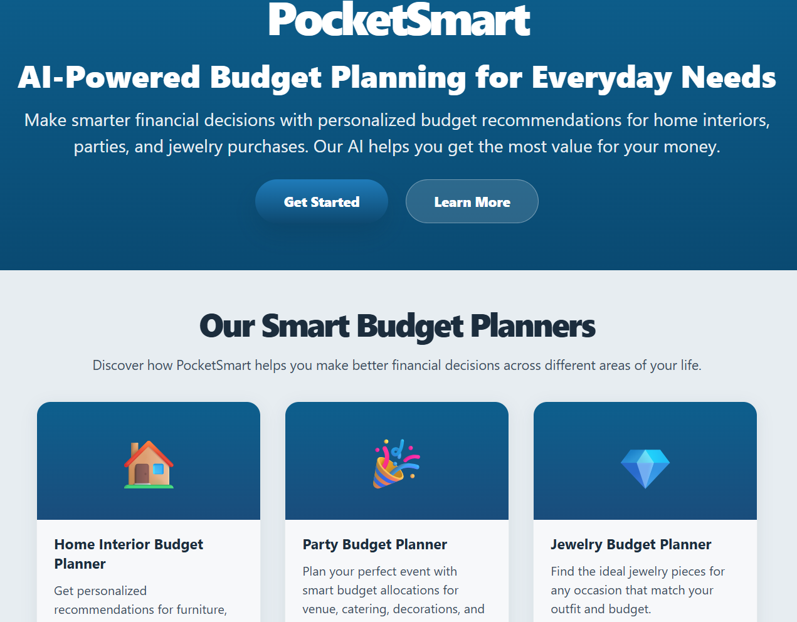
Figure 1: PocketSmart AI Home Page

Figure 2: User Dashboard
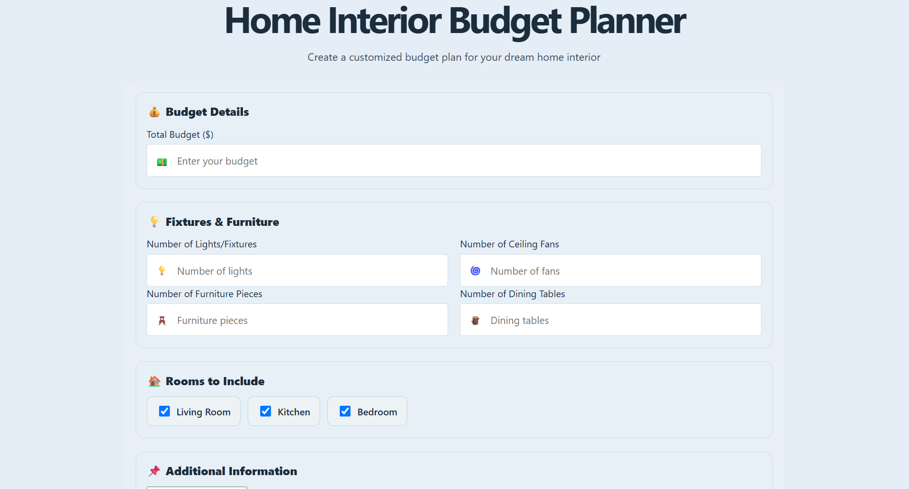
Figure 3: Home Interior Budget Planner
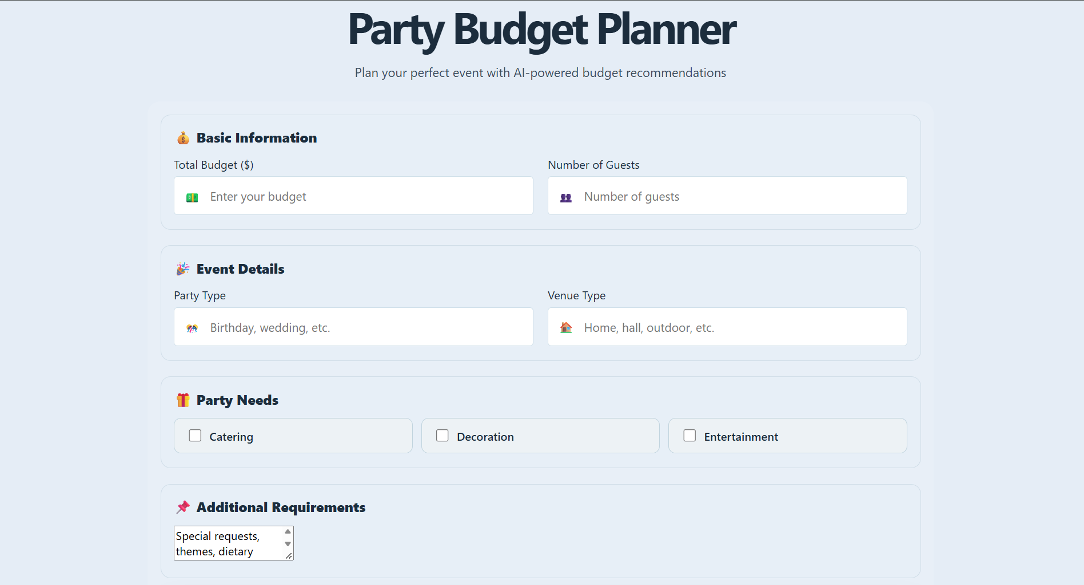
Figure 4: Party Budget Planner
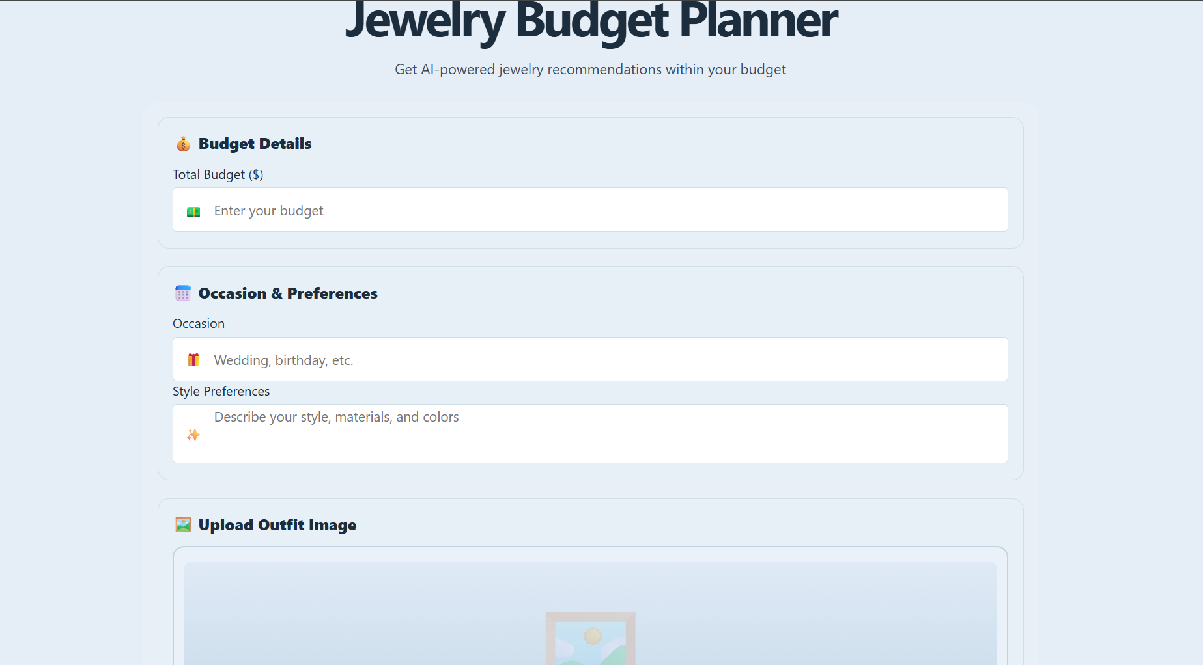
Figure 5: Jewelry Budget Planner

Figure 5 (continued): Jewelry Budget Planner – Recommendations
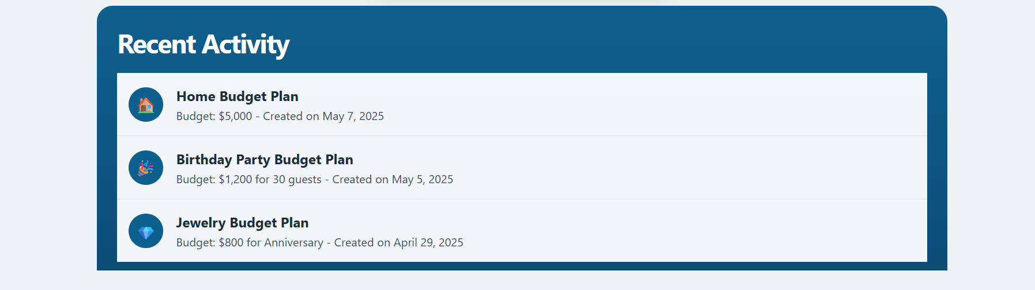
Figure 6: Recommendation History

9. Important Code / Backend Structure
The backend provides separate API routes for the three planners. These routes receive user inputs and connect the request to the recommendation logic.

10 . Role Important API routes
Route | Purpose
/generate-home | Generates home interior recommendations.
/generate-party | Generates party planning recommendations.
/generate-jewelry | Generates jewelry recommendations using text and optional image input.
/register | Creates a new user account.
/login | Authenticates an existing user.
/logout | Ends the current session.
/history | Retrieves previous recommendation activity.

11. Testing
The system is tested using different budgets and user preferences across the Home, Party and Jewelry planners. Testing focuses on whether the generated recommendations match the given budget and context, and whether the frontend displays the returned results correctly.
- Test different budget values.
- Test different room and product quantities.
- Test different party types and guest counts.
- Test jewelry recommendations with and without an image.
- Test login, registration and logout.
- Check recommendation history.

12. Advantages
- Saves time while planning purchases and events.
- Provides recommendations based on a user's budget.
- Supports multiple lifestyle categories in one application.
- Can use image input for jewelry recommendations.
- Provides a personalized user experience.

13. Limitations
- Recommendation quality depends on the AI response and available product information.
- External platform information may change over time.
- An internet connection and valid AI/API configuration are required.
- AI-generated recommendations should be checked before making real purchases.

14. Future Enhancements
- Add more shopping and service platforms.
- Add advanced price comparison and filtering.
- Improve recommendation history and analytics.
- Add more languages and voice interaction.
- Add stronger real-time product availability and price tracking.

15. Conclusion
PocketSmart AI is an AI-powered web application that combines budget planning with personalized recommendations. It supports home interiors, party planning and jewelry selection through a single interface. FastAPI provides the backend services while Gemini AI processes user information and generates recommendations. The project demonstrates how generative AI and web technologies can be combined to make everyday planning easier, faster and more personalized.
Source basis: uploaded PocketSmart AI project documentation.

