

**COLLEGE CODE: 5113**

# APPLIED DATA SCIENCE-phase 4

**AIR QUALITY ANALYSIS AND**

**PREDICTION IN TAMILNADU-project9**

***TEAM MEMBERS:***

* R.AFREEN TAJ-au511321104003
* B.DEEPIKA-au511321104017
* J.DELSI JULIE-au511321104019
* J.DHANU PRIYA-au511321104020

***Description:***

Air quality analysis and prediction in Tamil Nadu, as in many regions around the world, involves monitoring several key air pollutants, including sulfur dioxide (SO2), nitrogen dioxide (NO2), respirable suspended particulate matter (RSPM), and fine particulate matter (PM2.5).

This analysis and prediction are crucial for assessing the impact of air pollution on public health, the environment, and overall quality of life.

***calculate average od So2,No2,RSPM/PM 25***

To calculate average SO2, NO2, and RSPM/PM10 levels across different monitoring stations, cities, or areas and identify pollution trends, we use Python and popular data manipulation libraries like Pandas for data processing and Matplotlib for data visualization**.**

**To compute the average:**

**Gather data:**

Collect data on SO2, NO2, and RSPM concentrations from various monitoring stations or areas, typically recorded at specific time intervals.

**Summation:**

Sum up the values of SO2, NO2, and RSPM over the selected time period or areas.

**Division:**

Divide the total sum of each pollutant by the number of data points or monitoring stations. This calculation yields the average concentration of each pollutant.

**Interpretation:**

The resulting averages provide a quantitative assessment of the typical air quality for SO2, NO2, and RSPM in the specified region during the given time frame.

***Code***

## import pandas as pd

## import matplotlib. pyplot as plt

## import seaborn as sns

## df =pd.read_csv("C:/Users/WIN10/Downloads/cpcb_dly_aq_tamil_nadu-2014.csv")

## average_levels = df.groupby('City/Town/Village/Area')[['SO2', 'NO2', 'RSPM/PM10']].mean()

## print(average_levels)

## sorted_average_levels = average_levels.sort_values(by=['SO2', 'NO2', 'RSPM/PM10'], ascending=False

## print(sorted_average_levels)

**OUTPUT**

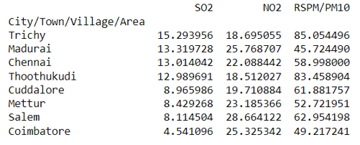

The above is the output for calculating average for the given dataset

**CREATE VISUALIZATION**

* We can also visualize the model prediction for the air quality analysis to gain insight into its performance.
* Interactive graphs can be created which makes it easier to check air quality and increasingly diverse colors can visually highlight the air quality level

# Create bar plots for SO2, NO2, and RSPM/PM10 levels

## plt.figure(figsize=(12, 6)

## plt.bar(sorted_average_levels.index, sorted_average_levels['SO2'], label='SO2')plt.bar(sorted_average_levels.index, sorted_average_levels['NO2'], bottom=sorted_average_levels['SO2'], label='NO2')

## plt.bar(sorted_average_levels.index,sorted_average_levels['RSPM/PM10'],bottom=sorted_average_levels['SO2']sorted_average_levels['NO2'], label='RSPM/PM10')

## plt.xlabel('City/Town/Village/Area')plt.ylabel('Average Levels')

## plt.title('Average Air Quality Levels by Area')

## plt.title('Average Air Quality Levels by Area')

## plt.xticks(rotation=90)

## plt.legend()

## plt.show()

***output***

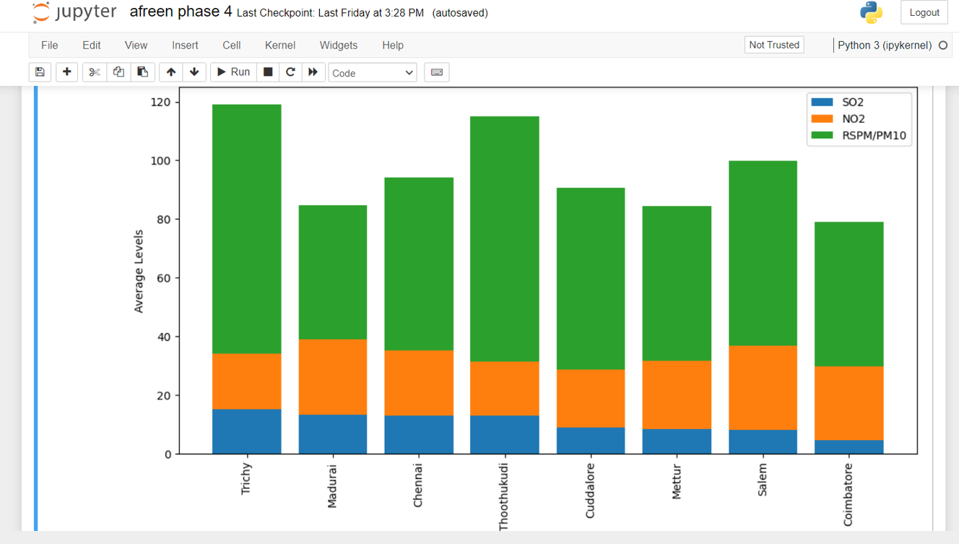

***CONCLUSION***

In conclusion, the average concentrations of SO2, NO2, and RSPM/PM10 provide critical insights into the overall air quality conditions in a specific area.

Averaging these values helps in assessing the general air quality trend over a specific time period, enabling authorities to make informed decisions regarding pollution control measures and public health interventions.

**THANK YOU**