**SHOPMART-A Shopping App   
LOGIN PAGE**

Allows users to authenticate into the system.

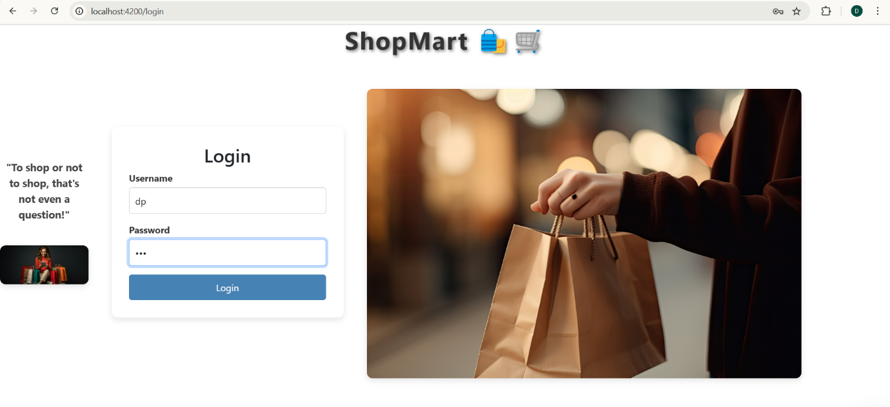

**HOME PAGE**

Displays a list of products fetched from an API.

It consists of list of products with View Details and Add to Cart button.

View Details to go product details page.

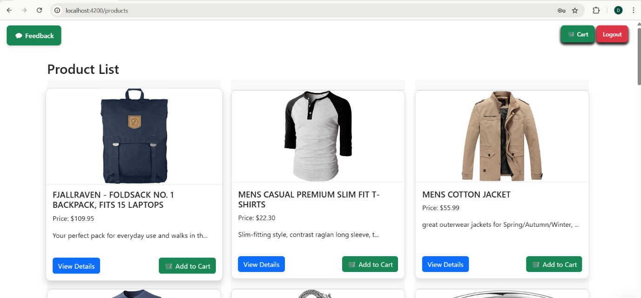

It says that the bag is added to the cart

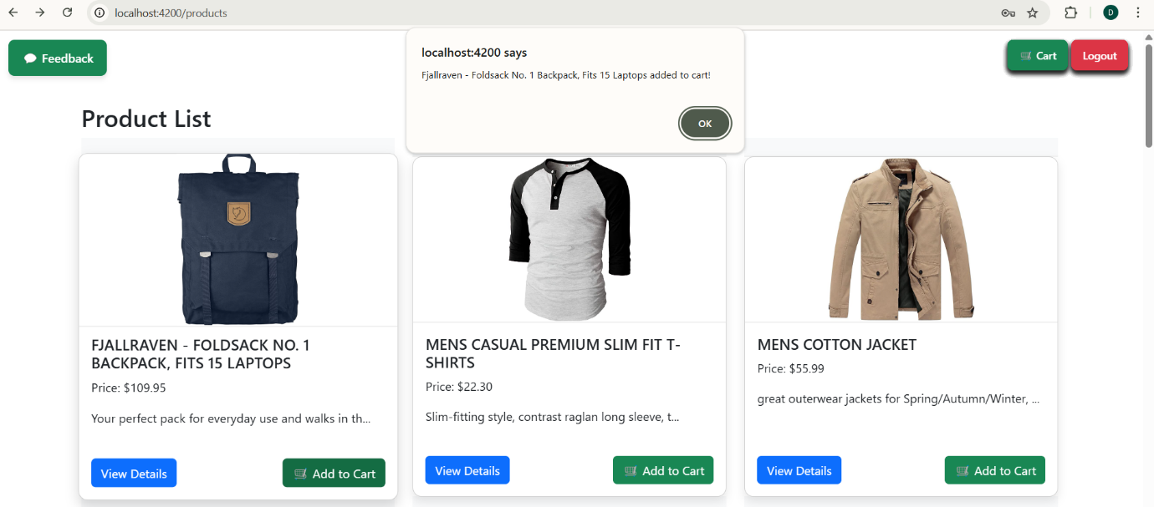

**PRODUCT DETAILS PAGE**

Displays complete product information, including name, price, description, images.

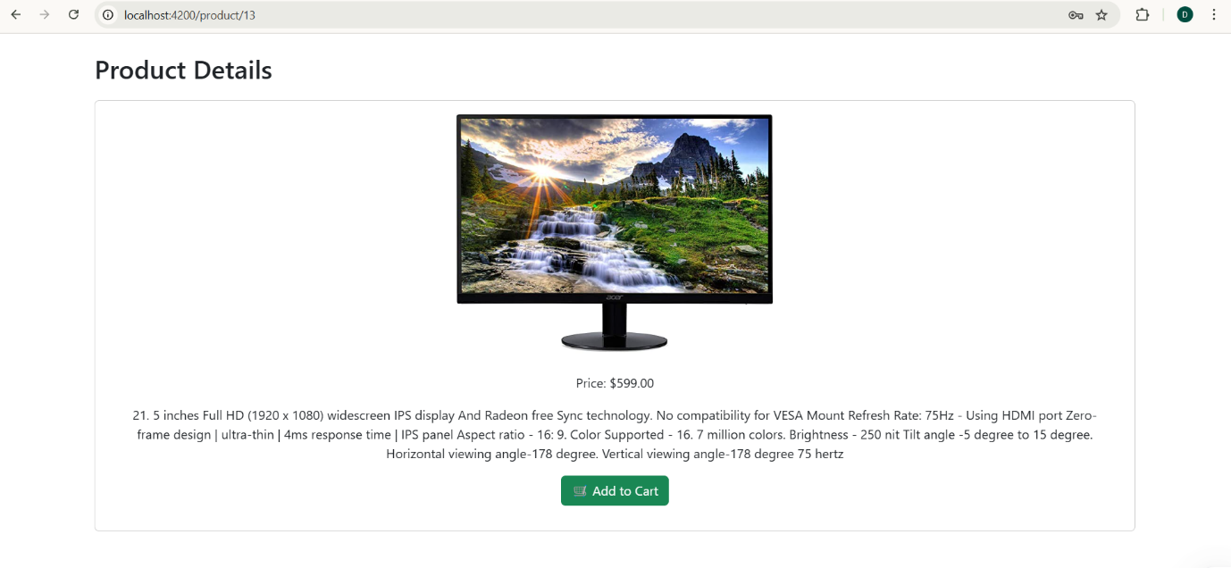

It alerts that the product is added to the cart.

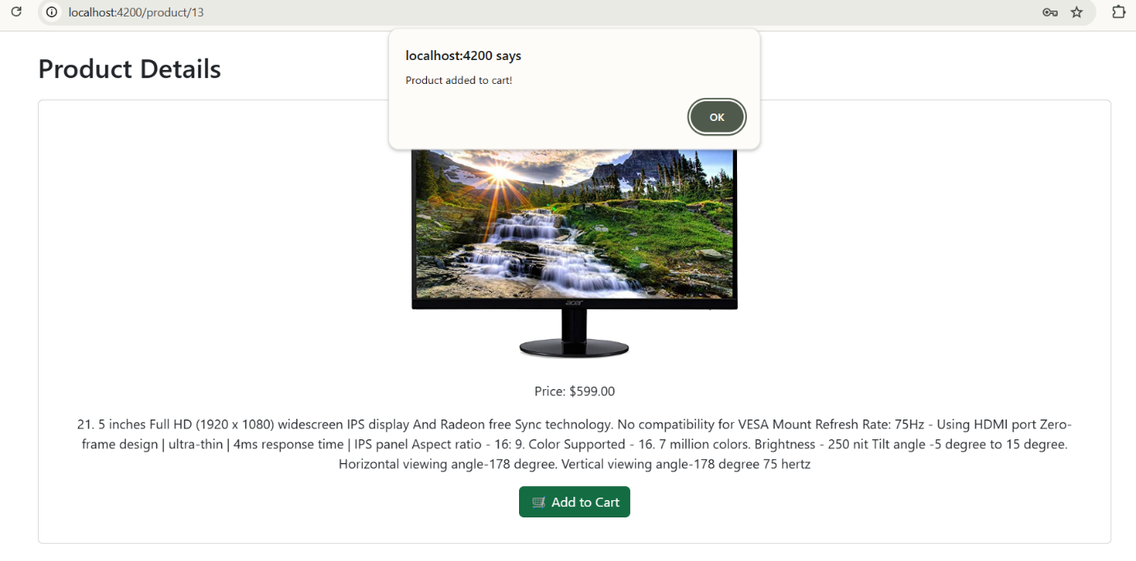

**CART PAGE**

Manages products added to the shopping cart.

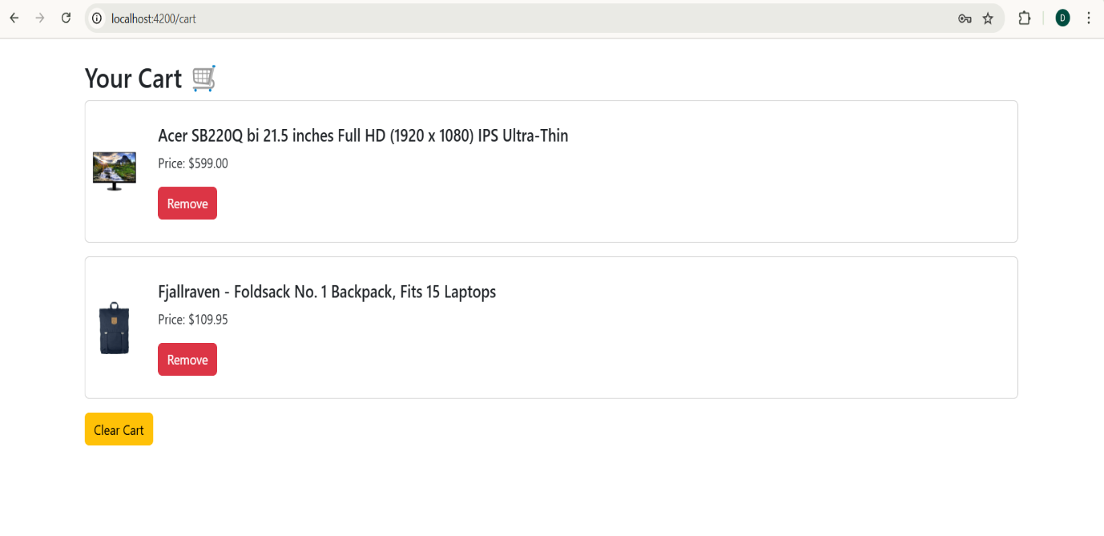

**FEEDBACK form with validation**

The Feedback Page allows users to submit reviews about their shopping experience.

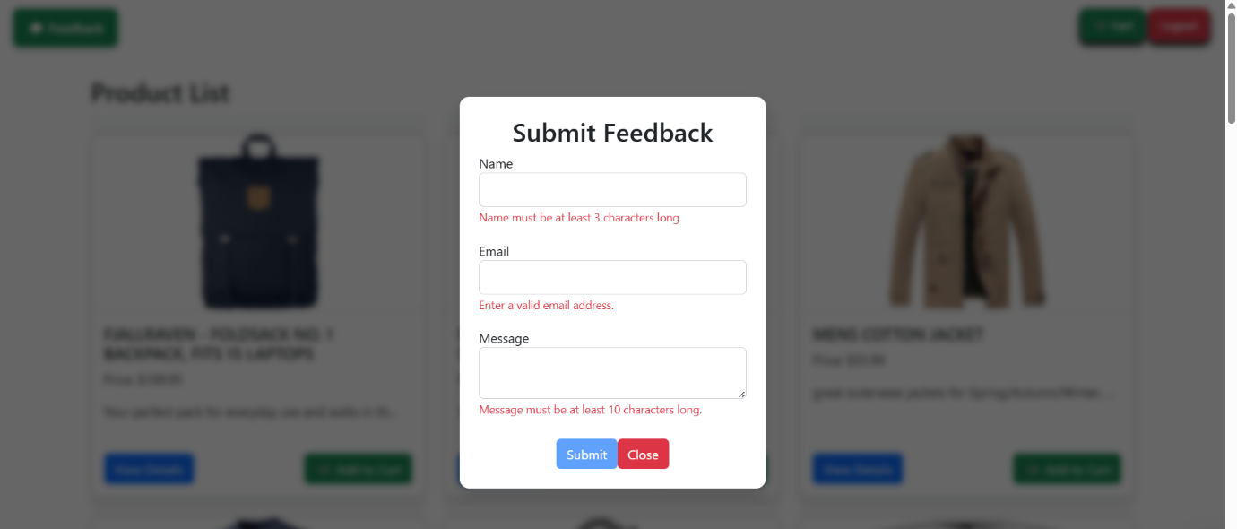

After submitting the form,the details will be stored in the feedback.json file

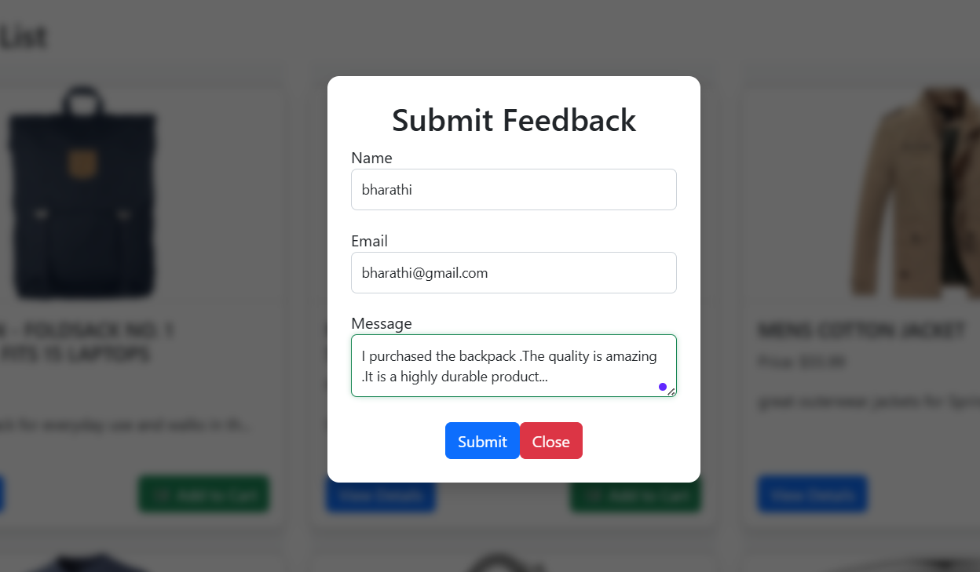

**Feedback.json**

