AUTHOR COMPONENT for **ABOUT ME**

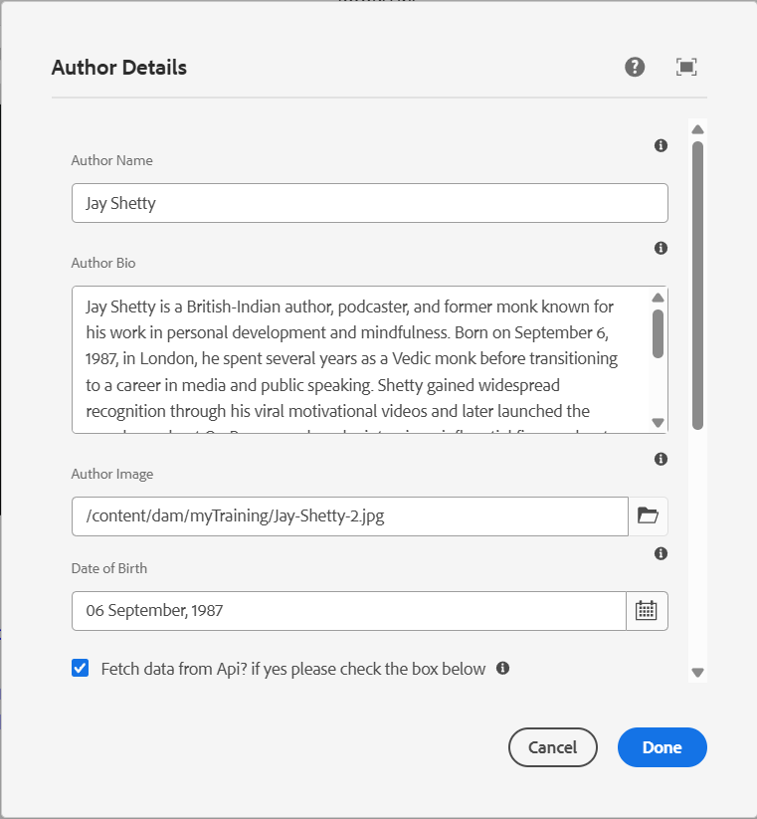

**Contact Me page**

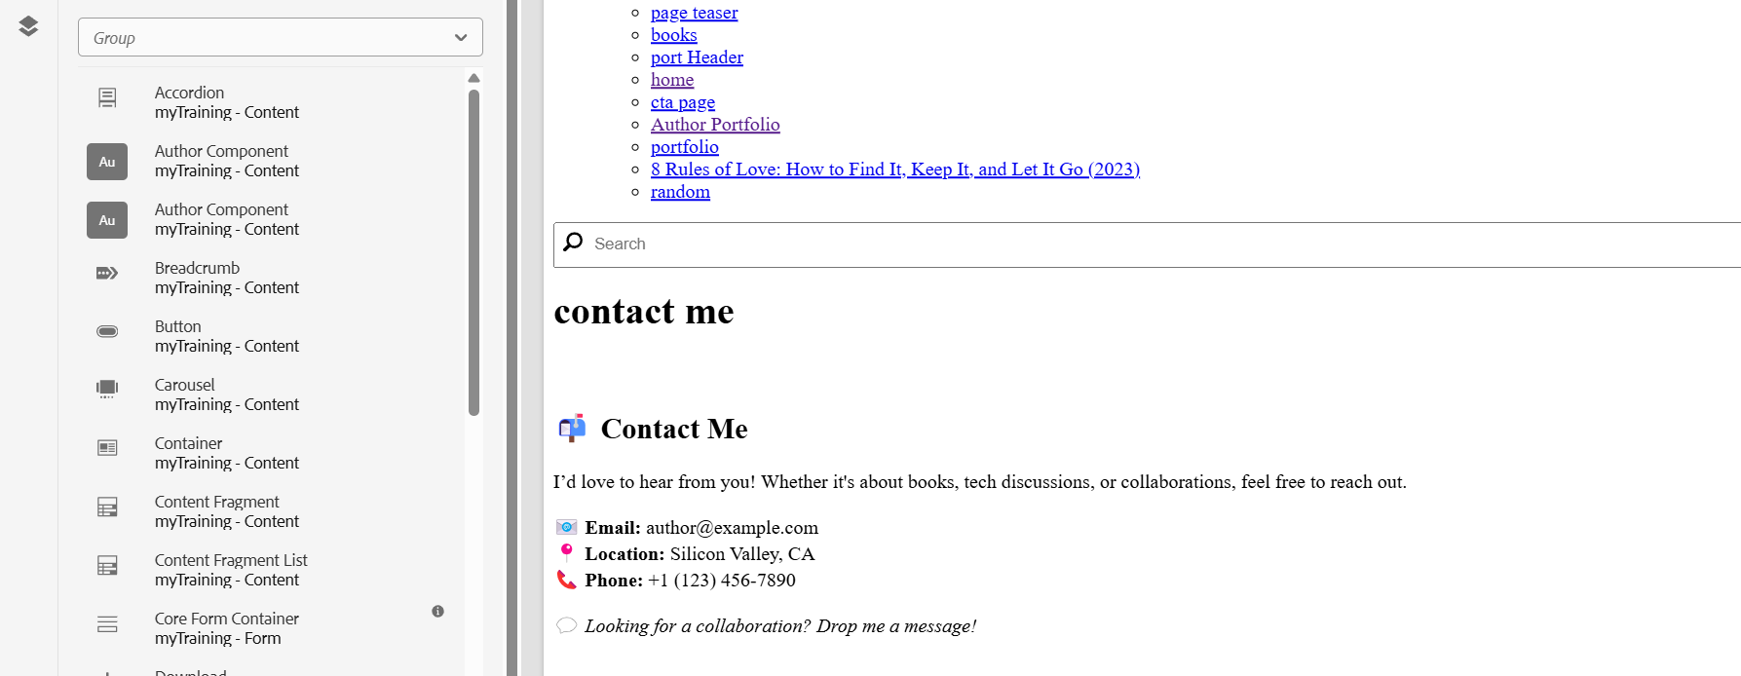

**Social Media Page**

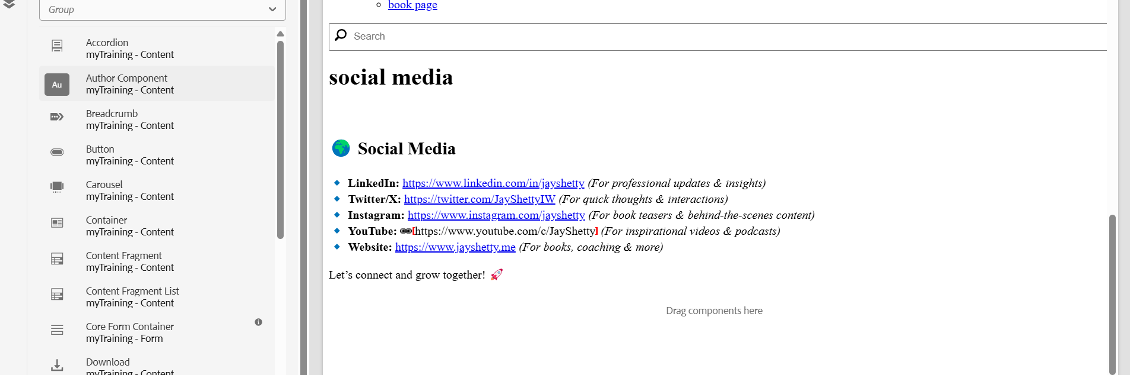

For DropDown

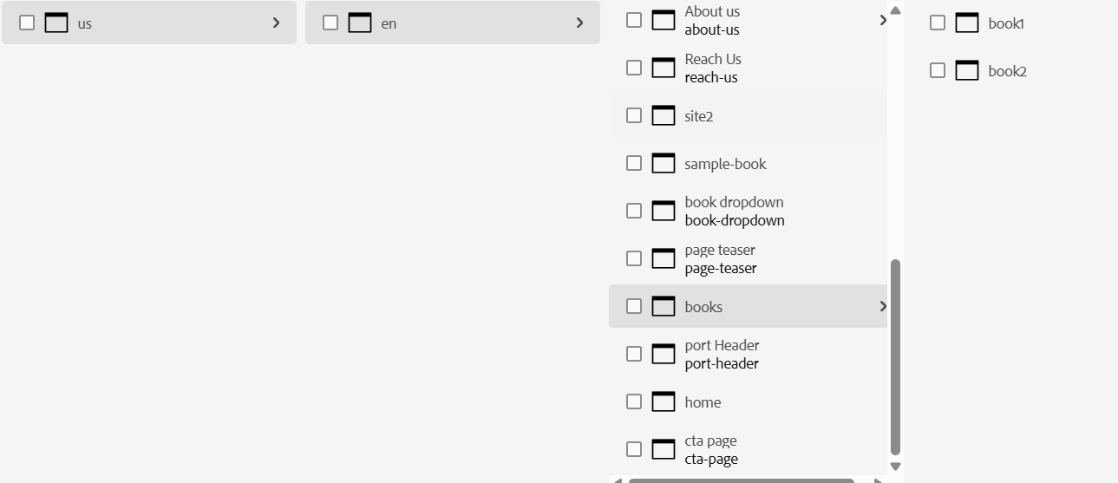

Teaser Component with cta page

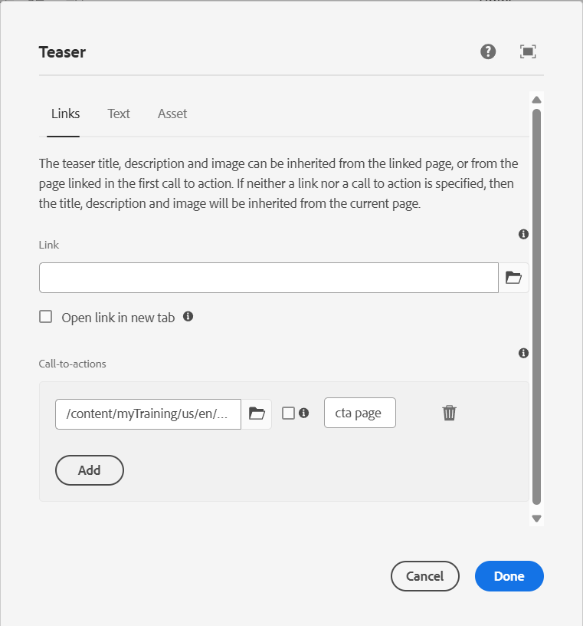

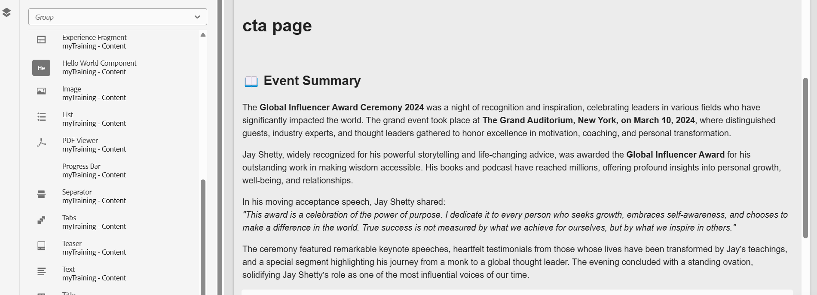

Header  
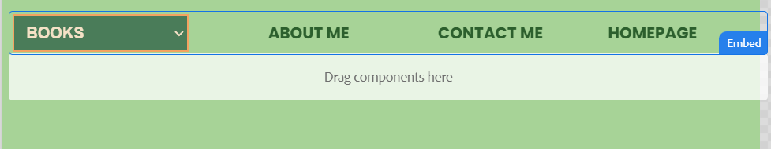

Footer

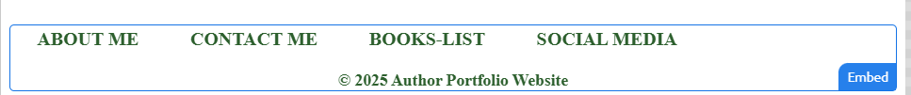

AUTHOR PORTFOLIO(Jay Shetty)

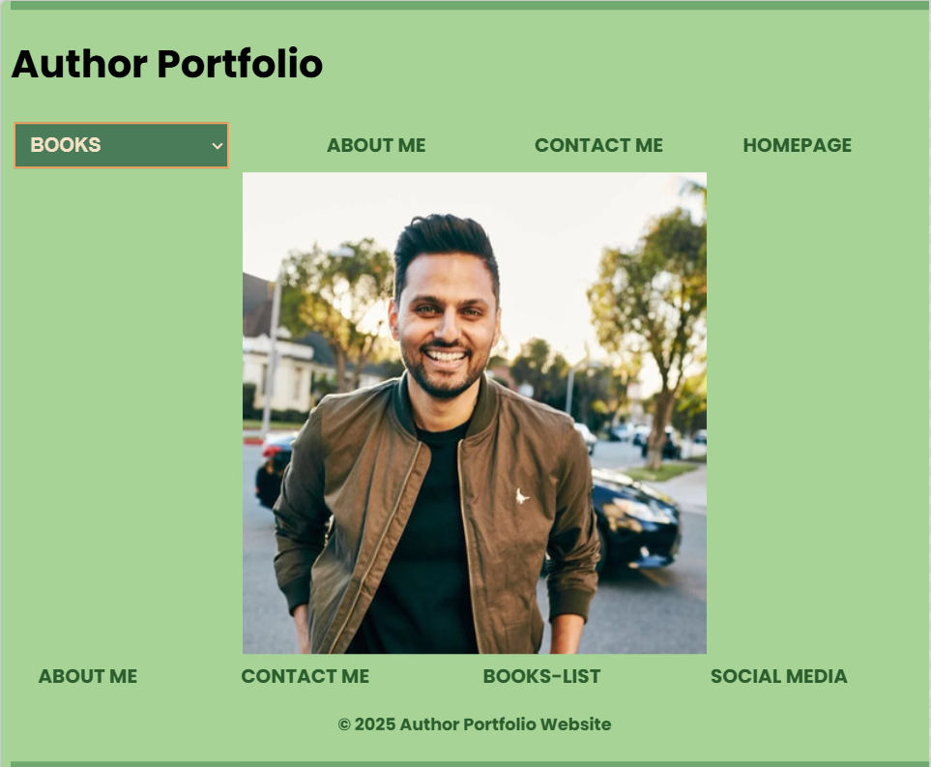

ABOUT ME

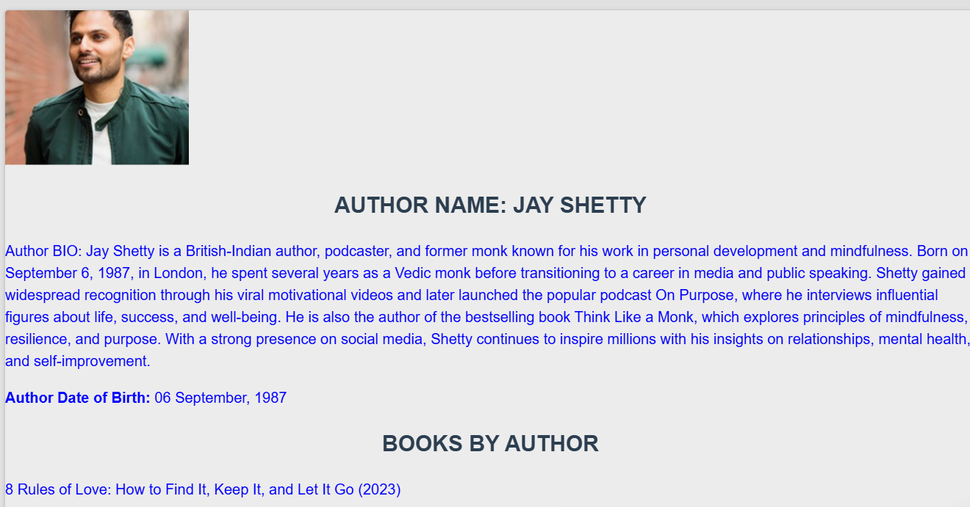

HOME PAGE

Clicking on home page will navigate you to the home page that contains details of the award received by the Author(Jay Shetty)

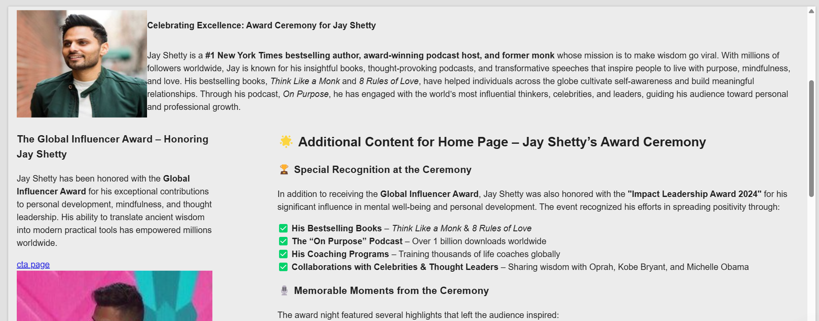

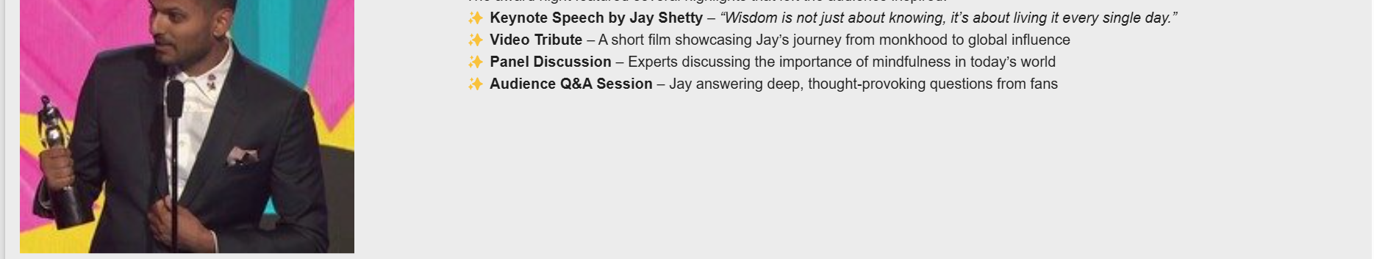

It consists of cta page which will get you to another page which contains additional information.

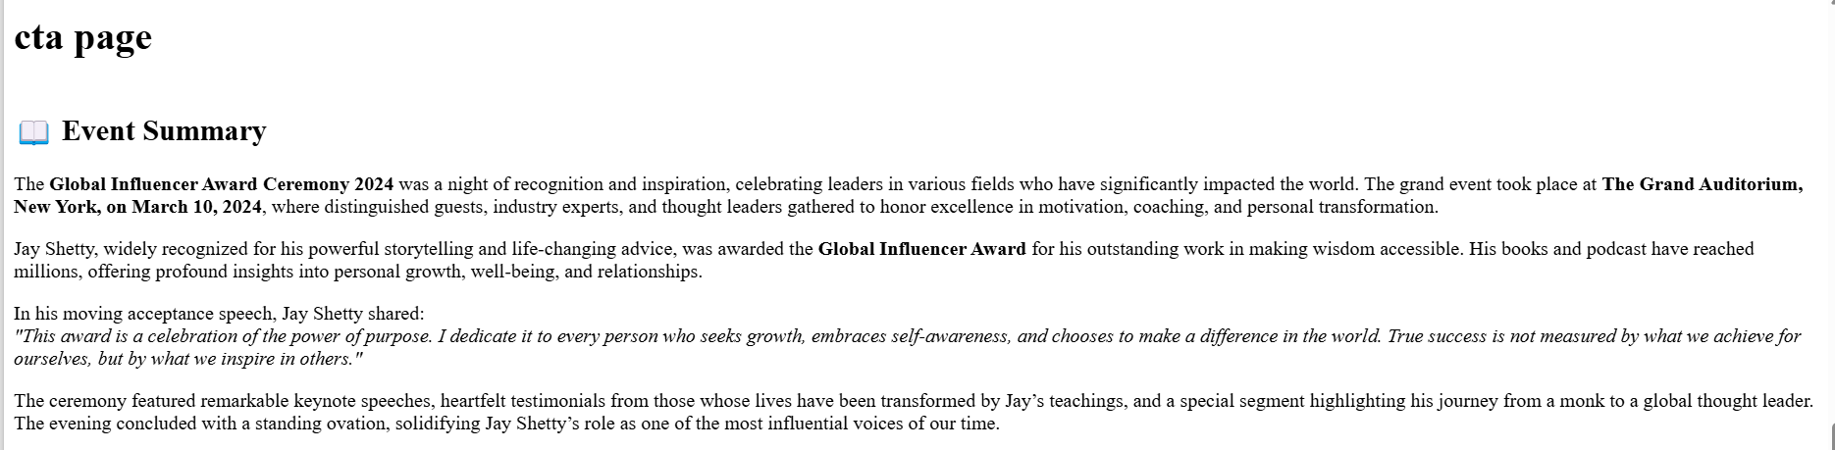

CONTACT ME

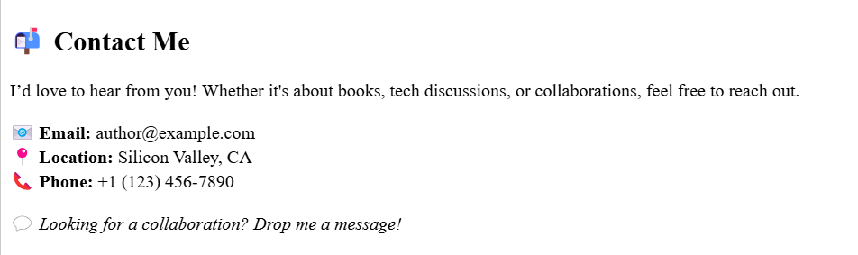

Books(Dropdown list)

Select the Book from the Dropdown which will display the books as cards.

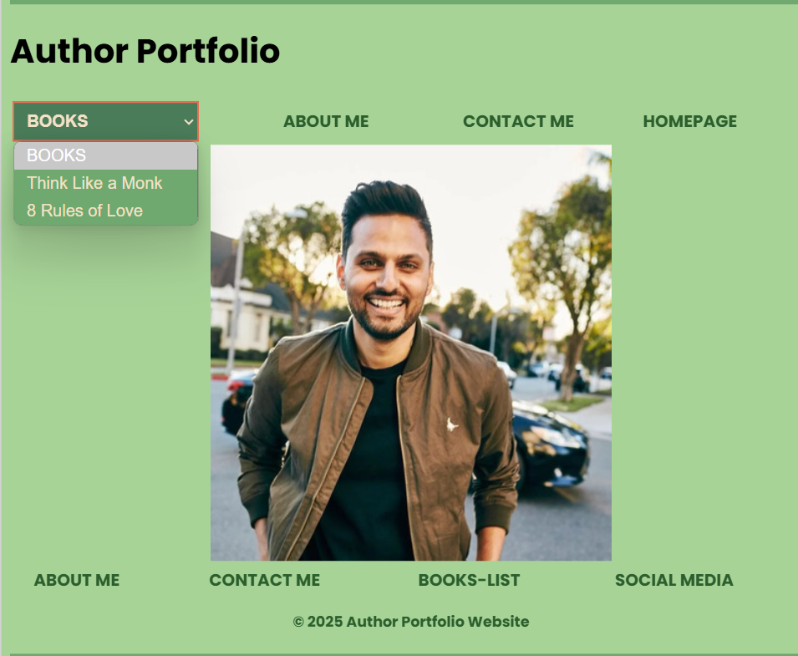

HEADER-BOOKS(Book Cards)

After selecting the book ,it will display the book as cards  
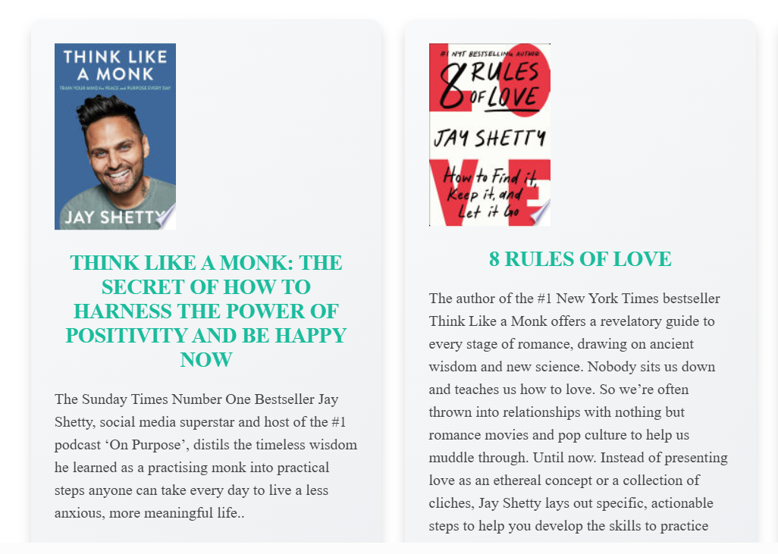

FOOTER-BOOK-LIST

The Book-List with hyperlink in footer section



SOCIAL MEDIA

